Indian Institute of Technology Gandhinagar
ES116 Principles and Applications of Electrical Engineering Lab - 6
Zener Diode Characteristics and Clipper-Clamper Circuits



Lab Report No : 6
Name : Maitreyee Patel Roll no. : 25110185

Name of teammate : Parth Malani Roll no. : 25110186

Name of the TA : Khomendra Sahu

1.Introduction

A. Theory

Zener Diode:
A Zener diode is a unique kind of diode that is heavily doped, allowing it to function safely during reverse breakdown. When connected in the forward direction, it behaves like a standard silicon diode, beginning to conduct significantly after reaching the knee voltage of around 0.7 volts. After this point, the current starts to increase rapidly.

In reverse bias, it initially permits a small leakage current to flow. However, when the reverse voltage hits a specific level known as the Zener voltage (Vz), breakdown occurs. Following this breakdown, the diode maintains a nearly constant voltage even as the current increases. This characteristic is what makes it particularly valuable for voltage regulation.

V–I Characteristics:
In the forward region, a small current flows until it reaches the knee voltage of about 0.7 V, at which point the current begins to rise sharply.

In the reverse region, there is only a minimal leakage current initially. Then, at the breakdown voltage, the current suddenly increases, and the voltage remains relatively constant in this breakdown region.

Clipper Circuits:
A clipper circuit functions by removing part of the input waveform while keeping the rest unchanged. In a positive series clipper, it specifically cuts off the positive half cycle of the input. When the diode is conducting, the output is approximately zero. When the diode is not conducting, the output corresponds to the input. This circuit is beneficial for tasks like wave shaping, voltage limiting, and protecting other circuits.

B. Objectives
● Investigate and graph the V-I characteristics of a Zener diode under both forward and reverse bias.
● Create and evaluate positive clipper circuits.
● Create and evaluate positive clamper circuits.

C. Motivation
The aim of this experiment is to understand how to manage voltage and change signals in actual electronic circuits. Keeping a consistent voltage in these circuits is crucial for their proper functioning and to prevent damage from excessive voltage.

We intend to investigate how a Zener diode operates, as it is frequently utilized for voltage regulation and safeguarding in power supplies. Additionally, we will examine clipper circuits to discover how they can eliminate unwanted sections of a waveform, and clamper circuits to see how they can adjust the DC level of a signal without altering its shape.

Through this experiment, we will acquire hands-on experience with diodes and signal processing techniques that are vital for creating regulated power supplies and communication systems.

D.Components and Tools

- Function Generator
- DC Power Supply
- Breadboard
- Digital Multi-meter (Voltmeter)
- Resistors (10 kΩ, 100 kΩ)
- Zener Diode (C4V7PH)
- Capacitor (10 μF)
- Oscilloscope
- Connecting wires

2. Experiments and Implementation

A. Experiments Performed
We completed three tasks. First, we incorporated a zener diode into a circuit that included an ammeter and a resistor. We examined it under both forward and reverse bias, analyzing the V-I characteristic curves. Then, we built a positive clipper circuit and observed the output waveform, comparing the voltage throughout the entire circuit with the voltage across the resistor.

B. Challenges Encountered

At the start of task 1, we adjusted the voltage peak to peak to 10V. But when we checked the waveform on the DSO, it didn't align with our expectations.

C. Solutions Attempted
Initially, we went over the circuit again to confirm that all the connections were tight. After that, we realized that the peak-to-peak voltage we had set was too high, surpassing the breakdown voltage of our diode. As a result, the waveform didn't clip like we expected. Therefore, we reduced the peak-to-peak voltage to 5V, which provided us with the waveform we wanted.

D. Relevant Diagrams, Algorithms, Codes
Task 1:
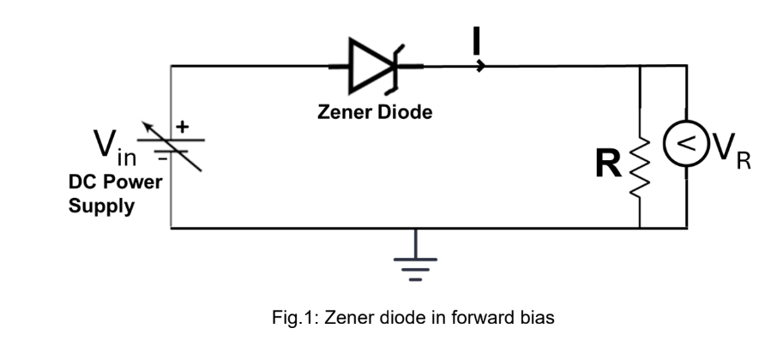
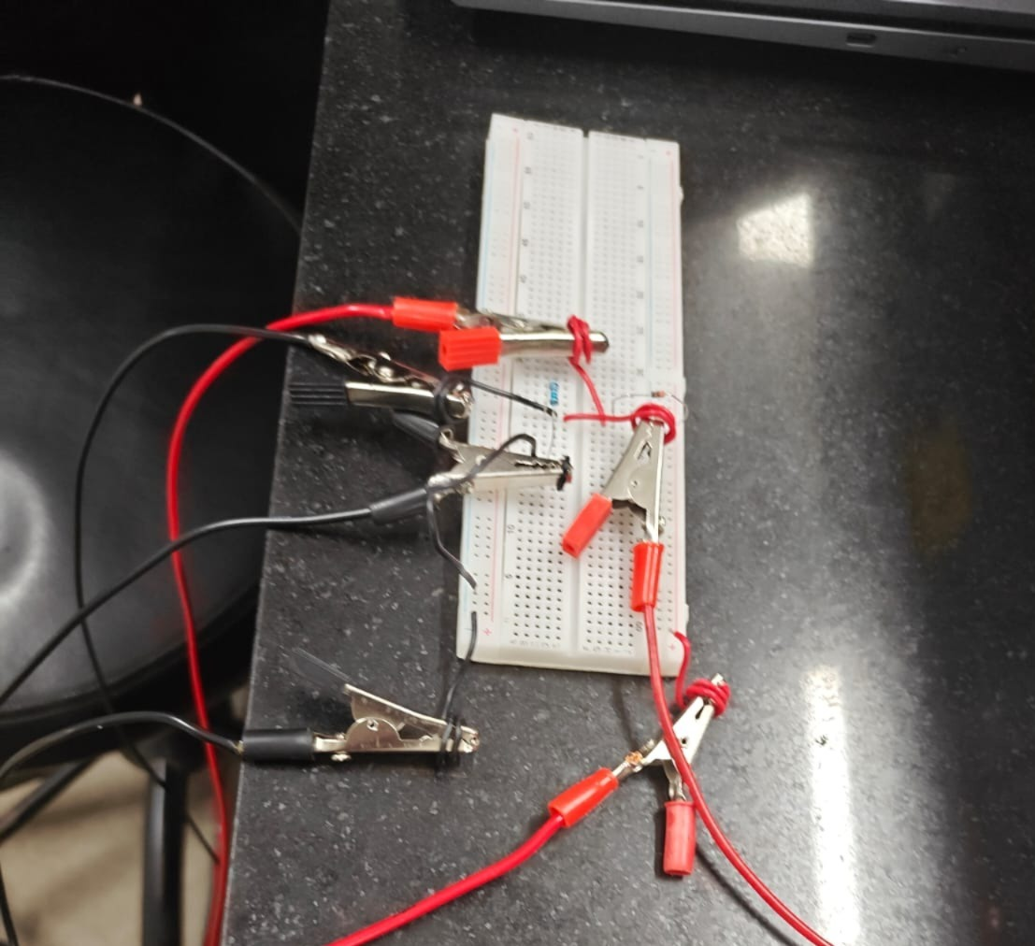
Fig. circuit for task 1

Task 2:
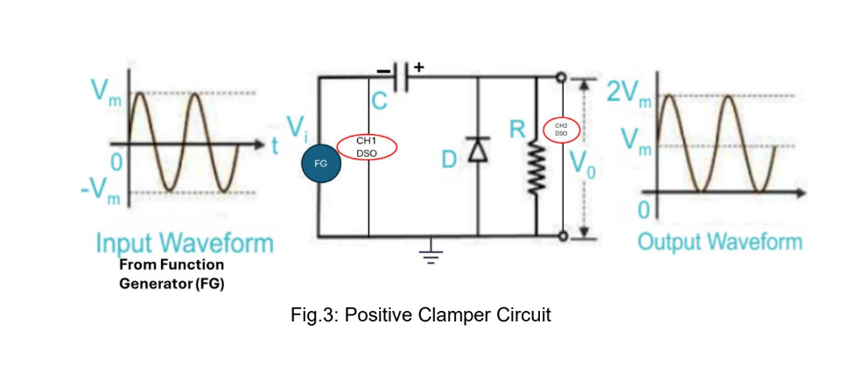
Fig. Series positive clipper circuit

E. Complete Procedure

Task 1:

Forward Bias:

- Set up the circuit for the forward bias characteristics of Zener diodes on the breadboard.

- Before connecting it to the circuit, use a multimeter to check the resistance value.

- Attach the positive terminal of the DC power supply to the positive terminal of the Zener diode.

- Connect the negative terminal of the Zener diode to one end of a 10 kΩ resistor, and link the other end of the resistor to the negative terminal of the DC power supply (ground).

- Switch the multimeter to measure voltage and connect it across the resistor. Gradually adjust the input DC voltage in small steps.

- Record the values as shown in Table 1. Change the input voltage (Vin) and measure the voltage across the resistor (VR) and the current through the resistor (I). To find the voltage drop (VD) across the diode, subtract Vin from VR.

- Begin with the DC power supply at 0 V, then slowly raise it to 8 V. Pay attention to the knee voltage, which is the forward-bias voltage where the diode starts conducting a lot of current.

- Take measurements up to the knee point in 0.1 V increments (like 0.1, 0.2, …, 0.7). After reaching the knee point, record readings at 1 V intervals.

- For each voltage reading across the resistor (VR), calculate the current flowing through the circuit using the formula I = VR / R. - Create a graph of the forward bias characteristics (VD vs.I).

Reverse Bias:
- Connect the positive terminal of the DC power supply to the negative terminal of the zener diode (reverse the connection of the Zener diode).
- Keep all other connections the same as they are for forward bias.
- Start with the DC power supply set to 0 V, then gradually increase it to between 4-7 V. Record the breakdown voltage (this is the reverse-bias voltage at which the diode starts conducting a significant current, keeping a nearly constant voltage).
- Take readings for the breakdown voltage using a 1V step size. Once you reach the breakdown voltage, increase the voltage in 0.1V increments.
- For each reading of resistor voltage (VR), calculate the current flowing in the circuit using the formula I = VR / R before moving to the next reading. This helps determine where the breakdown occurs in the circuit. At the breakdown voltage, the diode conducts substantial current, maintaining nearly constant voltage across its terminals.
- Create a plot of reverse bias characteristics (VD vs. I).

Task 2:
- Assemble the circuit depicted in Fig. 2 on the breadboard for a positive clipper.
- Utilize the function generator to create a sine wave input signal of 5 Vpp and 1kHz. Make sure the DC offset is set to zero.
- Attach the positive terminal of the input signal to the negative terminal of the zener diode. Then, link the positive terminal of the zener diode to one end of the 10 kΩ resistor.
- Connect the negative input signal and the other end of the resistor to the ground on the breadboard.
- Link the input signal to channel 1 (CH1) of the digital storage oscilloscope (DSO) and the output voltage across the resistor to channel 2 (CH2) of the DSO.
- Watch the output waveform across the resistor on the oscilloscope to observe the clipper behavior.
- Capture a snapshot of the output signal.

3.Observations and Results

A. Observations/ Learning Outcomes.

Task 1:
When we applied forward bias to the diode, we observed that the current was at zero and the voltage across the resistor was also zero until the input voltage (Vin) hit 0.5V. We believe this is the knee voltage. After that point, the current surged quickly and almost in a straight line. The voltage across the resistor showed a similar pattern, increasing steadily. At the same time, the voltage across the diode was also going up, but it was rising at a slower pace as Vin continued to increase.

Then, when we switched to reverse bias, the voltage across the diode began to stabilize when Vin exceeded 5.2V. We think this is the breakdown voltage. Even beyond that point, the current continued to rise steadily because we had a resistor in the circuit to prevent the current from becoming too high.

Task 2:
When we set up the positive clipper circuit, we noticed that the positive section of the waveform was being clipped on the DSO. This indicated that our experiment was successful.

B. Plots and Measurements
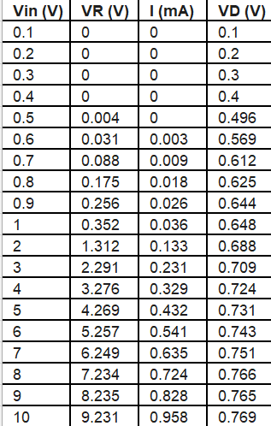
Fig. Forward Bias

Fig. V-I characteristic curve

Fig. V-I characteristic curve near knee voltage

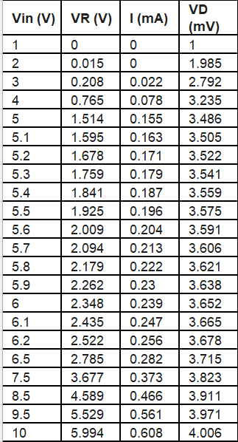
Fig. Reverse Bias

Fig. V-I characteristic curve

Fig. Vin vs Vd curve
Task 2:
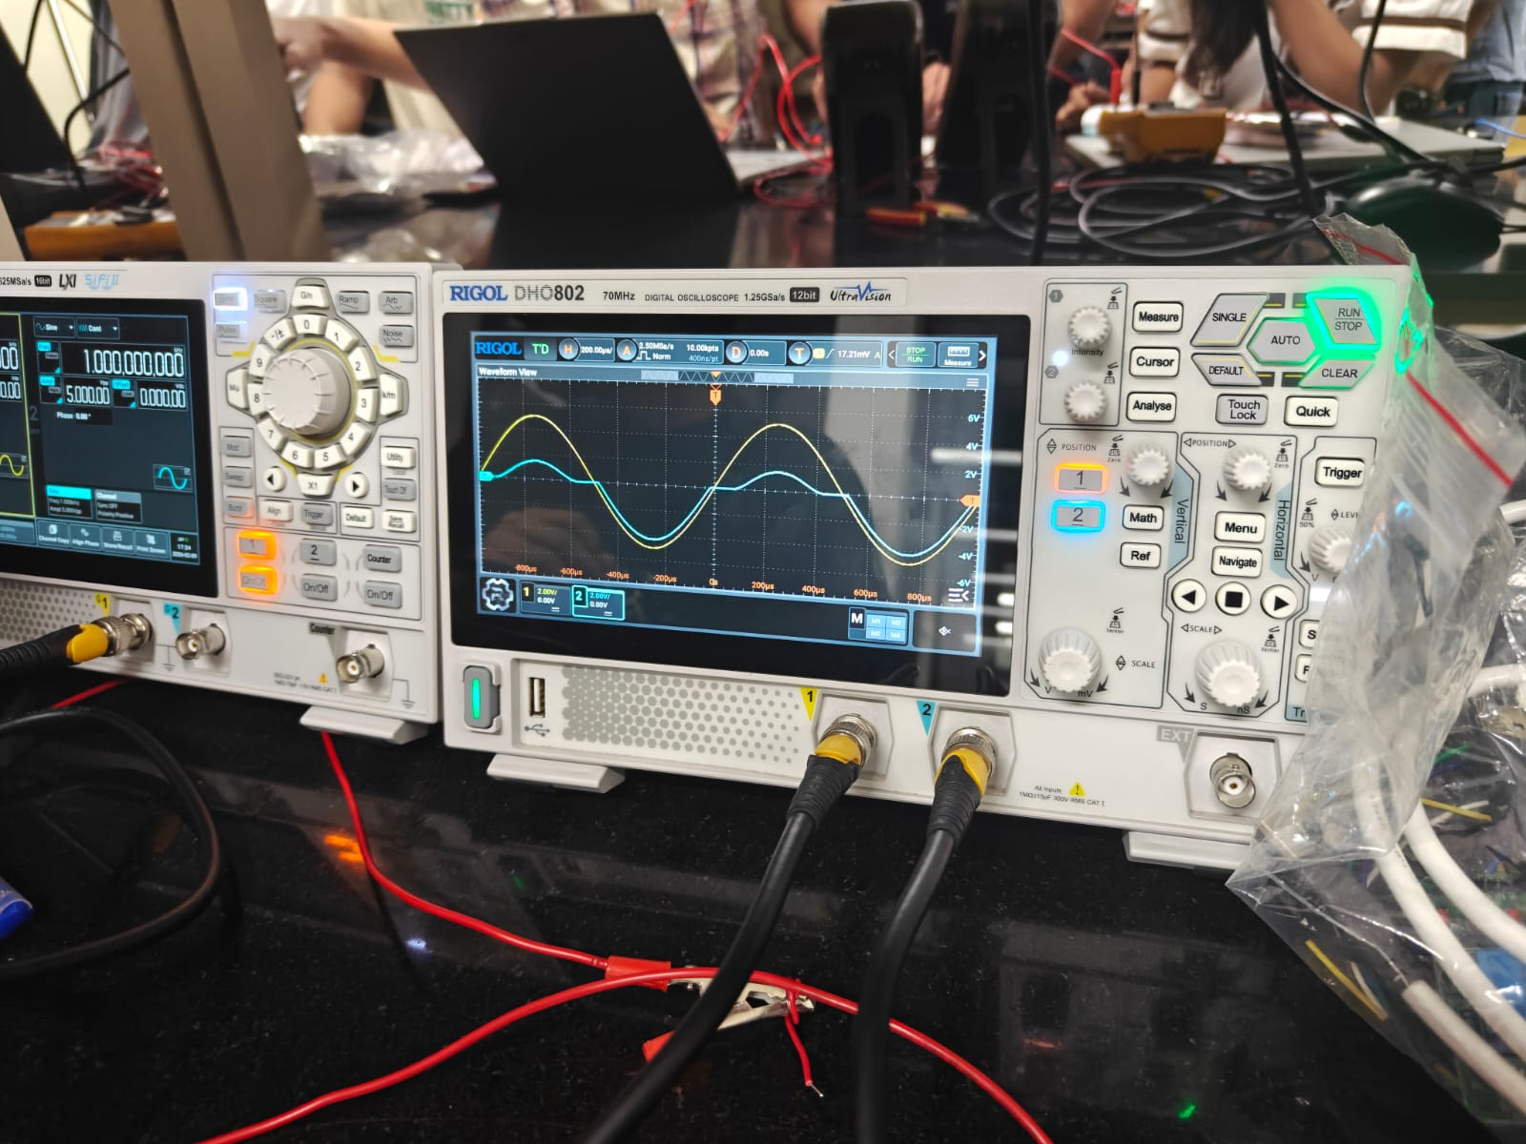
Fig. Positive clipper circuit waveform on DSO

C. Summary of Results

In task 1, we observed the expected changes when the diode was forward biased. Initially, the current was quite low, but after reaching the "knee voltage," it rose significantly. We found the knee voltage to be 0.5V, and as the input voltage (Vin) increased, the voltage across the diode became more stable.

When the diode was reverse biased, the current continued to rise at a consistent rate throughout the experiment. However, it was evident that the voltage (VD) reached a saturation point as Vin increased. We recorded the breakdown voltage at 5.2V.

In task 2, as we expected, the positive part of the waveform was eliminated, resulting in a flat line along the axis during those sections. This confirmed that our experiment was a success.

D. Key Findings

In task 1, we included a resistor in the circuit to safeguard the components from harm when there are current spikes. It turned out great. The current rose gradually rather than suddenly, which is usually the case when the diode is in reverse bias after hitting the breakdown voltage.

In task 2, during the negative half cycle, the diode is reverse biased, meaning it behaves like an open circuit. As a result, we don't receive any output, and this is clearly visible in the waveform on the DSO.

4. Bibliography
ES 116 Lab manual
https://www.geeksforgeeks.org/physics/diode/

Name and Signature with Date
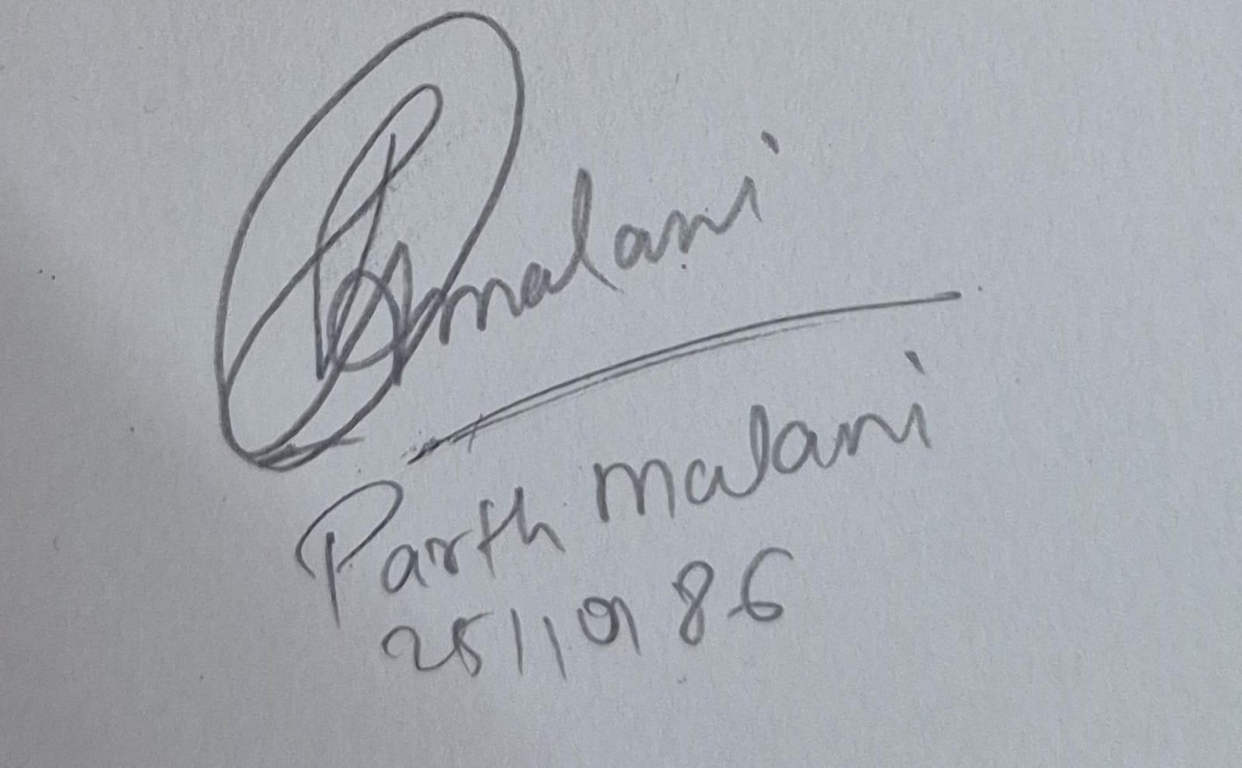
Name and Signature with Date
