What is Distributed Application ?

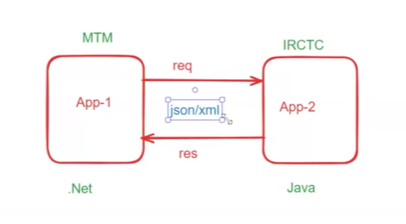

One application is going to communicate with other application that is called distributed application . example make my trip application or IRCTC application .both are used to book the ticket so both project we have to connect with each other . This project may be develop with the same technology or may not dotnet or java.
So , Json/xml data are used as mediator earlier people are using xml data but today we are using josn data to communicate between the application.
Json stands for java script object notation .

======
JSON
======
=> JSON stands for Java Script Object Notation
=> JSON represents data in key-value format
Ex:

{
"id" : 101,
"name" : "Ashok",
"phno" : 12345,
"gender" : "Male"
}

=> JSON is very light weight
=> JSON is platform independent & language independent
=> JSON is used to transfer data over a network
=> Distributed applications will use JSON data for request & response

=========================================
Working with JSON in Java Applications
==========================================
=> Java Applications can use JSON data
=> To work with JSON in Java app, we have third party libraries
a) Jackson
b) Gson
=> By using above libraries we can convert JSON data to Java Object and vice versa
jackson/gson
java obj <----------------------> json data
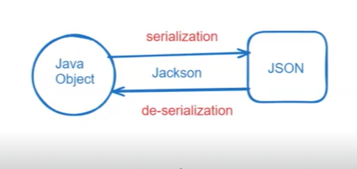

=> The process of converting java obj to json is called as Serialization.
=> The process of converting json data to java obj is called as de-serialization.
==============
Jackson API
==============
1) Add below dependency in pom.xml file
<dependency>
<groupId>com.fasterxml.jackson.core</groupId>
<artifactId>jackson-databind</artifactId>
<version>2.17.0</version>
</dependency>
2) Create binding class to represent data
public class Customer {
private Integer id;
private String name;
private Long phno;}
3) Develop java class convert java to json and json to java
ObjectMapper mapper = new ObjectMapper();
mapper.writeValue(File f, Object obj);
mapper.readValue(File f, Class clz);

=====================================================================================

public class App {
public static void main(String[] args) throws Exception {
App a = new App();
//a.convertJavaToJson();
a.convertJsonToJava();
}

public void convertJsonToJava() throws Exception{
ObjectMapper mapper = new ObjectMapper();
Customer c = mapper.readValue(new File("customer.json"), Customer.class);
System.out.println(c);
}

public void convertJavaToJson() throws Exception {
Customer c = new Customer(101, "John", 9985396677l);
ObjectMapper mapper = new ObjectMapper();
mapper.writeValue(new File("customer.json"), c);
System.out.println("Serialization completed...");
}
}

===================================================================================
===========
GSON API
===========

### Git Hub Rep : https://github.com/ashokitschool/GSON-JSON-APP.git

-----------------------------------------------
<dependency>
<groupId>com.google.code.gson</groupId>
<artifactId>gson</artifactId>
<version>2.3.1</version>
</dependency>
---------------------------------------------

Gson gson = new Gson ( );
gson.toJson(Object obj);
gson.fromJson(File file);

