What is Multi Page Application ?
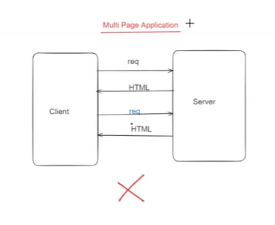
If the client is sent the request and every request server sending html page as response then the page is callled Multilevel page application.
When we go for multipage application entire page will be reloaded.

What is Single Page Application?
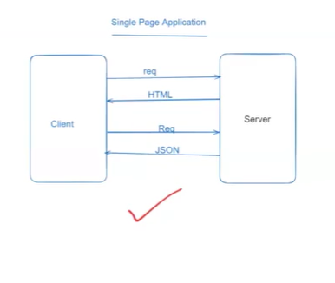
When we go for single page application on first request we get html page as response then second time
The content will be reloaded only.
=====================================
Angular Integration with Spring Boot
=====================================

=> Angular is a client side framework

=> Angular framework developed by Google company

=> Angular developed using TypeScript

=> Angular is free & open source

=> Angular supports multiple browsers

=> Angular is mainley used for SPA (single page app)

Note: Angular JS & Angular framework both are not same.

=> Angular JS developed using Java Script. (Angular 1.x)

=> Google identified some performance issues in Angular jS 1.x version then they re-developed angular is Typescript which is called as Angular framework.

Note: From 2.x version onwards it is called as Angular Framework.

===================
Angular Setup
===================

Step-1 : Download and Install Node

URL : https://nodejs.org/en/

Note: After installation, verify node version

$ node -v

Step-2 : Install Type Script

$ npm install -g typescript

$ tsc -v

Step-3 : Install Angular CLI

$ npm install @angular/cli -g

$ ng v

Step-4 : Download and Install VS Code IDE

URL : https://code.visualstudio.com/download

Step-5: Create Angular Application

$ ng new app1

$ cd app1

$ ng serve --open

Noe: Angular apps will use Live server for execution and it will run on 4200 port number.

==========================================

=> Angular application nothing but collection of components

Ex: menu-component, login-component, register-component, dashboard-component....

=> In angular application by default "app-component" will be created. It is called as Parent Component.

Note: Every component contains 3 files

1) component.ts (logic to handle req & response)

2) component.html (presentation file - template)

3) component.css (styles for specific component)

=> Every Component will have a selector to acess that component.

Ex : <app-root></app-root>

Note: App-Component is the entry point for angular application.

=> index.html page is called as welcome page in angular application.

=> When we run angular application, index.html page will be loaded and it will invoke app-component hence we will get response from app.component.html page.

Note: To apply styles for app-component template we have app-component.css file.

========================
Angular Building Blocks
========================

1) Components
2) Templates
3) Data Binding
4) Directives
5) Pipes
6) Services

=> Component represents small portion of web page

Ex : header component, footer component, menu component, login component, reg component..

=> Template represents view page (html)

Note: Every component will have its own template (html)

=> Data Binding is used to transfer the data between component and template

Component <------------> Template

=> Directives are used to manipulate DOM elements in the template

Ex : ngIf, ngFor, ngModel...

=> Pipes are used to transform the data

Ex : uppercase, lowercase, INR, USD ...

=> Services are used to develop business logic (api calls)
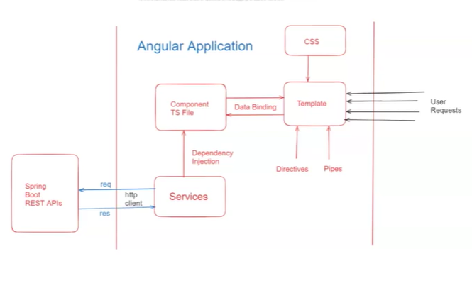
==========
Summary
==========

1) What is Angular

2) Angular Setup

3) Ng First App Development

4) Angular Build blocks

=====================================
Spring Boot with Angular Integration
=====================================

Spring Boot : Used for backend development

Angular : Used for frontend development

Fullstack App : Spring Boot + Angular

===========================
Spring Boot - Rest API
===========================

@SpringBootApplication
@RestController
@CrossOrigin
public class Application {

public static void main(String[] args) {
SpringApplication.run(Application.class, args);
}

@GetMapping("/welcome")
public String getWelcomeMsg() {
return "Welcome To Ashok IT";
}

}

============== Angular Application Development =====================

##Step-1 : Create Angular application

$ ng new app2

##Step-2 : Run angular application

$ ng serve --open

##Step-3 : Configure httpclient details in "app.config.ts" file

-------------------------------------------------------------
export const appConfig: ApplicationConfig = {
providers: [provideRouter(routes), provideHttpClient()]
};
---------------------------------------------------------------

##Step-4: Create Service class and invoke backend rest api

$ ng generate service app

-------------------------------------------------------------
@Injectable({
providedIn: 'root'
})
export class AppService {

private welcomeUrl: string;

constructor(private http: HttpClient) {
this.welcomeUrl = 'http://localhost:8080/welcome';
}

public getWelcomeMsg(){
return this.http.get(this.welcomeUrl, {responseType:'text'});
}
}

----------------------------------------------------------------------------
##Step-5 : Inject service class in app-component
----------------------------------------------------------------------------

import { Component } from '@angular/core';
import { CommonModule } from '@angular/common';
import { RouterOutlet } from '@angular/router';
import { HttpClient, HttpClientModule } from '@angular/common/http';
import { AppService } from './app.service';

@Component({
selector: 'app-root',
standalone: true,
imports: [CommonModule, RouterOutlet, HttpClientModule],
templateUrl: './app.component.html',
styleUrl: './app.component.css'
})
export class AppComponent {
title = 'app1';

msg:string="";

constructor(private appService: AppService){}

getWelcomeMsg(){
this.appService.getWelcomeMsg().subscribe(resp => {
this.msg = resp;
})
}
}
-------------------------------------------------------------
##Step-6 : Write Presentation logic in app-template
-------------------------------------------------------------
<button (click)="getWelcomeMsg()">Get Message</button>

<hr/>

{{msg}}

