**Q.Design a system for a game that displays and increments score by 1 whenever football hits a desired target out of 4 given targets.**

Solution proposed : The targets are being treated as push buttons as when the footballer will hit on the targets which will be containing a push button an input signal is processed which will be shown on the serial monitor

Circuit Diagram

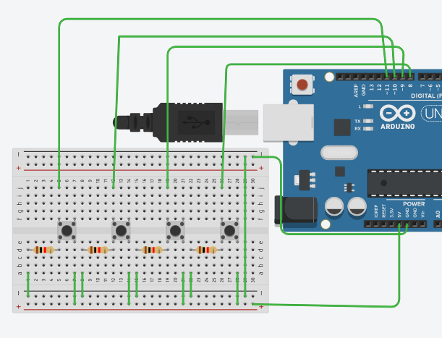

Theory

Concept used:

Various concepts are used in this exp as listed:

1. Push buttons

2. Connection of Arduino uno circuit board

3. The code used to program the micro-controller

The Push button: They give input signal to the Arduino when they are pressed in the form of HIGH or LOW.

Connection of Arduino uno circuit board: In the above circuit , I have connected my push buttons to 8,9,10,11 pins. The ground of each push button is connected via resistance which prevent from signal missing.

The Code used to program the micro-controller:

int c=0;

void setup()

{

Serial.begin(9600);

pinMode(11,INPUT);

pinMode(10,INPUT);

pinMode(9,INPUT);

pinMode(8,INPUT);

}

void loop()

{ int a,b,d,e;

a= digitalRead(8);

b=digitalRead(9);

d=digitalRead(10);

e=digitalRead(11);

if(a==1||b==1 || d==1||e==1)

{

++c;

Serial.print(c);

Serial.println("\n");

delay(500);

}

}In this project we learnt about:

1. We learnt about push buttons.

2. Basic coding used in Arduino uno.

3. Interfacing Push button with Arduino uno board.

4. Displaying on Serial monitor

5.

Observations: **Score getting counted whenever we press either of push buttons.**

Precautions:

1. The circuit’s elements should be properly connected.

2. The Push button should be connected properly in the circuit considering the ground resistance and power supply to it.

Learning Outcomes:

From this project we learn and acquire skills about:

1. Writing basic algorithm we used for real life problems.

2. Working of Arduino along with the push button and serial monitor.

3. Application of digital pins of Arduino Uno Board