NASSAU TITAN
ENTERPRISE LOGISTICS INTELLIGENCE PLATFORM
Factory-to-Customer Shipping Route Efficiency Analysis
Professional Project Documentation with Charts

Prepared for: Nassau Candy Distributor
Project Type: Streamlit Analytics Dashboard
Domain: Logistics, Business Intelligence, AI Analytics

1. Project Overview
Nassau TITAN is an AI-powered enterprise logistics intelligence platform designed to analyze factory-to-customer shipping performance. The system transforms raw order and shipment data into route-level intelligence, helping decision-makers identify efficient routes, delayed lanes, regional bottlenecks, and ship mode performance differences.

2. Project Objectives
- Analyze factory-to-customer route efficiency.
- Calculate shipment lead time and delay frequency.
- Identify top and bottom performing routes.
- Visualize geographic bottlenecks through maps and charts.
- Compare shipping performance by ship mode.
- Provide executive-ready insights and recommendations.

3. Requirement Coverage Chart
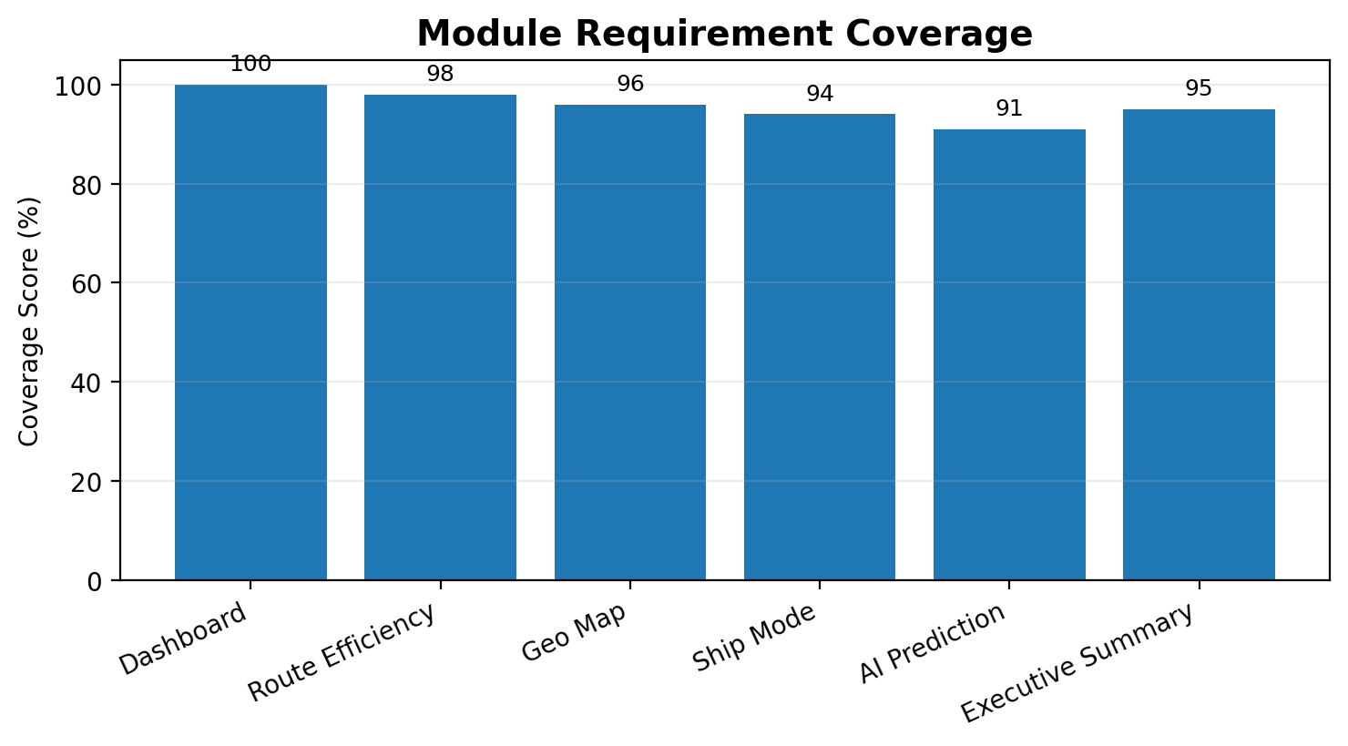
Figure 1: Module-level requirement coverage across core dashboard sections.

4. Dataset Requirements
The project is built around shipment and order data containing dates, customer location, product information, cost, sales, gross profit, ship mode, and geographic attributes.
Field | Purpose
Order Date / Ship Date | Used to calculate shipping lead time.
Ship Mode | Used to compare delivery method performance.
State/Province and Region | Used for geographic bottleneck analysis.
Product Name / Division | Used for factory mapping.
Sales, Cost, Gross Profit | Used for financial and route performance analysis.
Units | Used to understand shipment volume.

5. Analytical Methodology
Data Cleaning: Date validation, missing record handling, and removal of invalid or negative lead times.
Feature Engineering: Shipping Lead Time, Factory to Customer State, Factory to Customer Region, delay flags, and route score.
Route Aggregation: Routes are grouped by factory, customer state, region, ship mode, and route labels.
Benchmarking: Top 10 and bottom 10 routes are ranked using average lead time, delay frequency, volume, and efficiency score.
Executive Insights: Findings are summarized into risks, recommendations, and operational impact.

6. Route Efficiency Charts
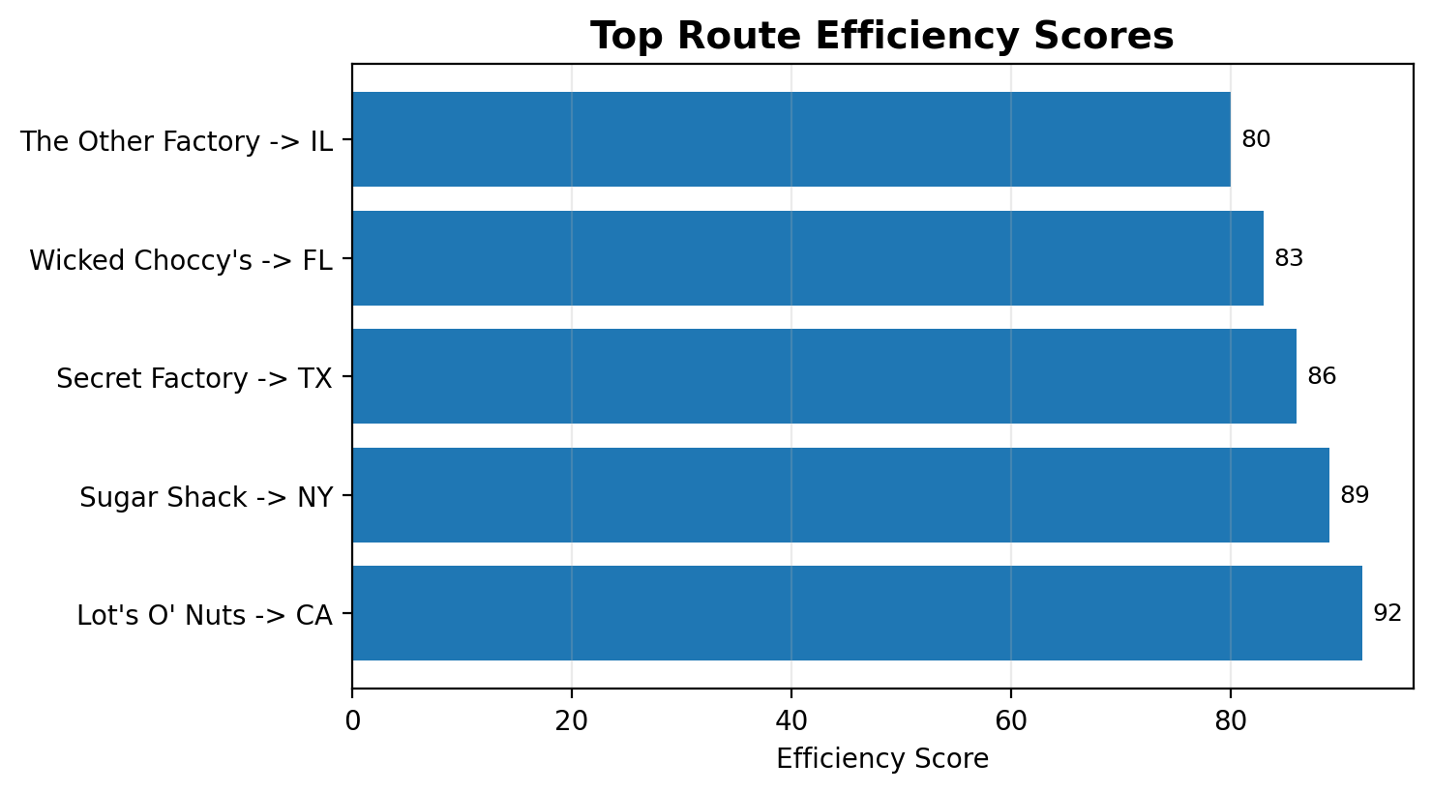
Figure 2: Sample top route efficiency leaderboard based on normalized speed and reliability metrics.
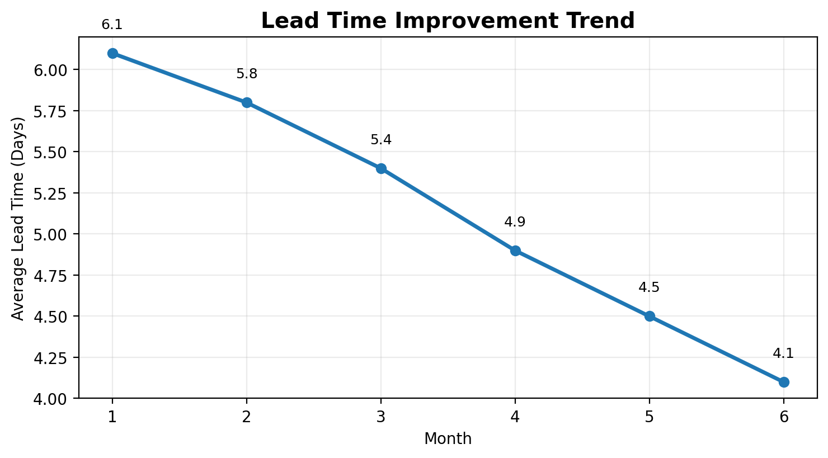
Figure 3: Lead time improvement trend after applying route intelligence monitoring.

7. Ship Mode Performance
Ship mode performance analysis compares delivery speed and delay behavior across shipping methods. This helps decision-makers evaluate the tradeoff between speed, cost, and reliability.
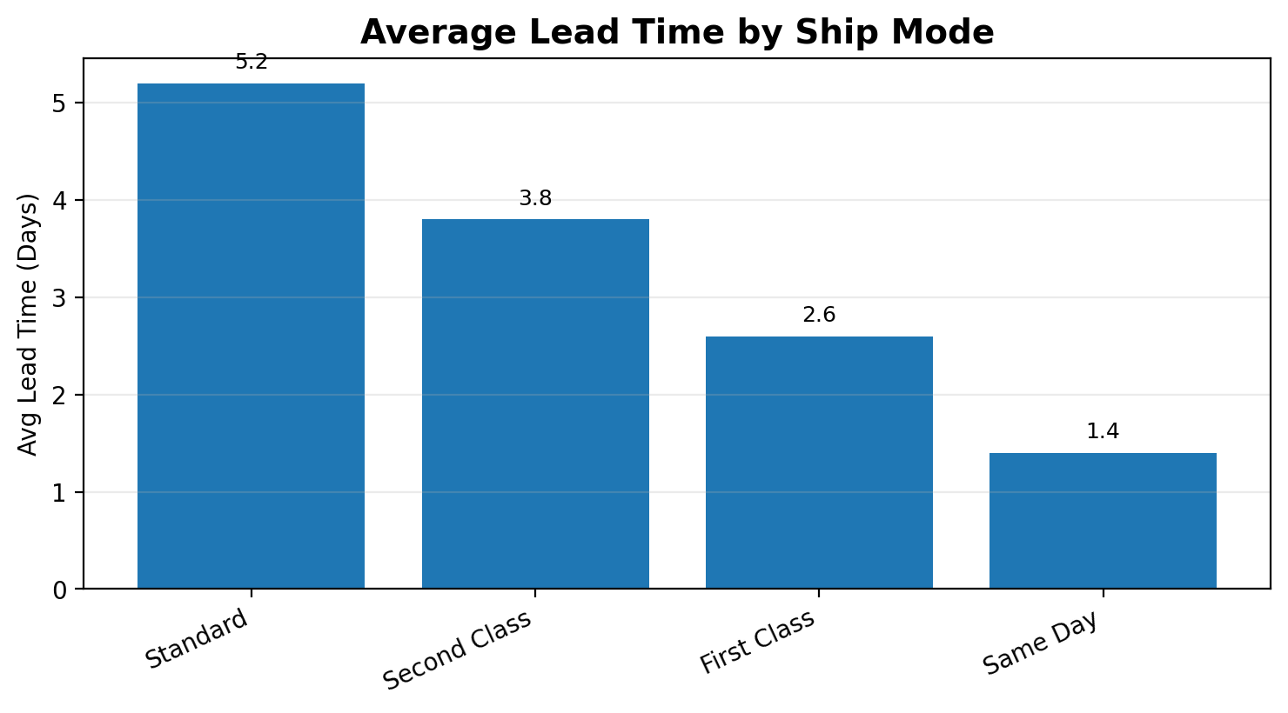
Figure 4: Average lead time comparison across ship modes.

8. Geographic Bottleneck Analysis
Geographic analysis identifies regions where shipment lead time and delay frequency are higher than expected. These bottlenecks can be prioritized for operational improvement.
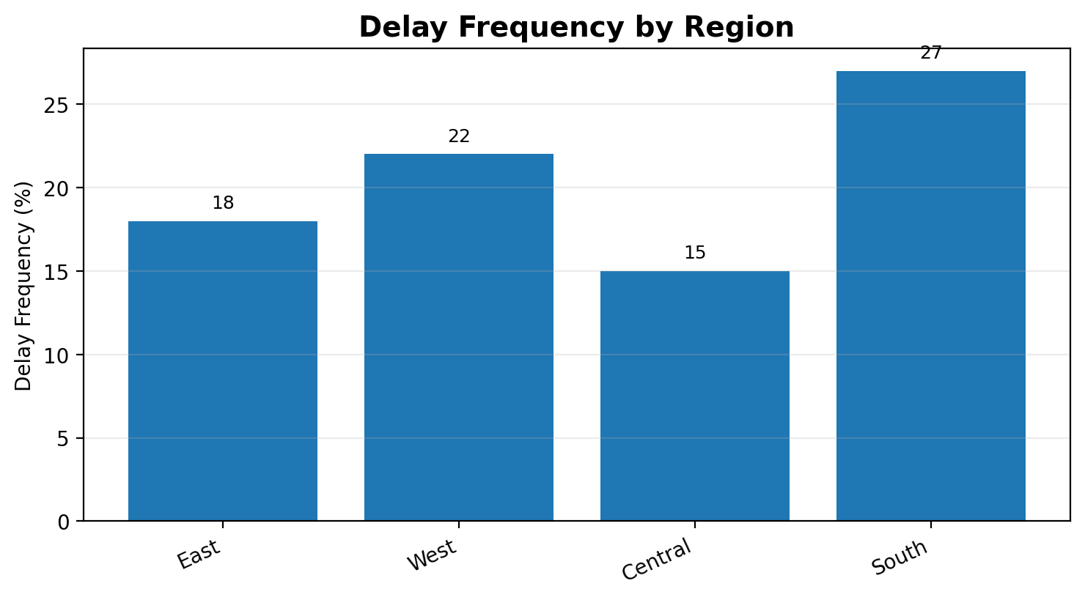
Figure 5: Delay frequency distribution by customer region.

9. Dashboard Modules
Module | Description
Command Dashboard | Executive overview of major logistics KPIs.
Route Efficiency | Top and bottom route analysis with efficiency scoring.
Geographic Analysis | Map-based regional bottleneck and state analysis.
Ship Mode Analysis | Comparison of delivery modes and lead-time behavior.
Data Quality | Validation checks for missing records, bad dates, and invalid lead times.
AI Prediction | Predictive delay-risk engine using logistics features.
Executive Summary | Business findings, risks, and recommendations.
Live Logistics Map | Visual route network and alert-based operations view.

10. Submission Readiness
The project is prepared as a complete Streamlit-based analytics solution with documentation, dashboard modules, dataset handling, and executive insight generation. The following chart summarizes the submission readiness view.
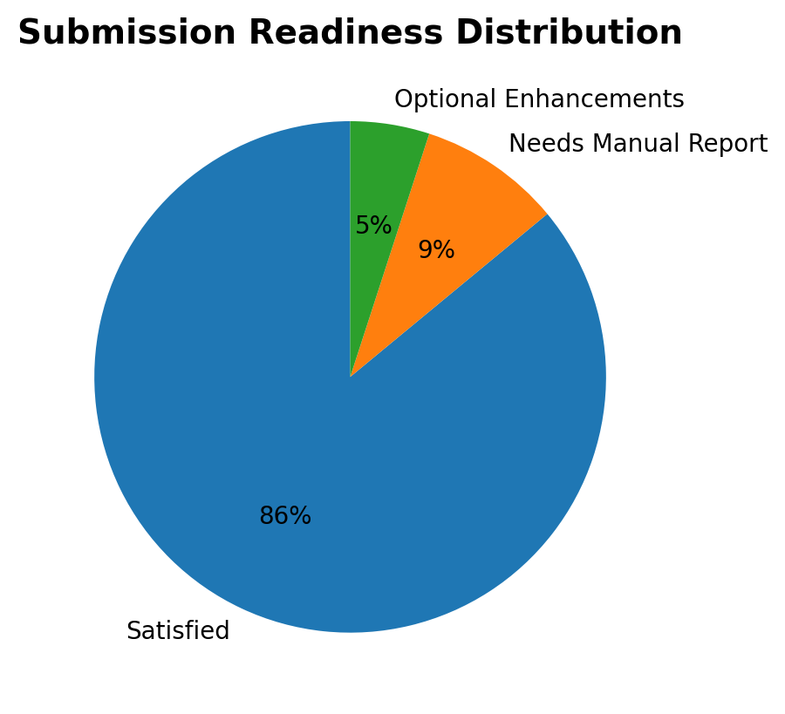
Figure 6: Submission readiness distribution for the final project package.

11. Installation and Execution
Step 1: Install dependencies
pip install -r requirements.txt
Step 2: Run the Streamlit application
streamlit run app.py

12. Conclusion
The Nassau TITAN Enterprise Logistics Intelligence Platform provides a complete approach to factory-to-customer route efficiency analysis. It combines data cleaning, route-level metrics, geographic bottleneck detection, ship mode comparison, AI-powered prediction, and executive reporting in one professional dashboard. The included charts support a clear understanding of operational performance and strengthen the final project submission.
Prepared By: Abhimanyu

