ENGINEERING CASE STUDY

Iris Intelligence Platform
End-to-End Machine Learning Serialization, RESTful Microservice Framework, & Front-End UI Materialization UI Core

Prepared By: Abhimanyu Development Systems

System Class: Predictive Analytics Endpoint Framework

Cloud Cluster Infrastructure:
Render Web Nodes (US-East Region)

Production Endpoint:
https://iris-flask-api-eax0.onrender.com/

Executive Summary & System Topology

The Iris Intelligence Platform is a decoupled, cloud-native intelligence engine built to demonstrate structural prediction tracking over public cloud networks. The application successfully wraps a statistical classification model inside an asynchronous HTTP API mesh layer, making high-performance analytics accessible via normal web protocols.
The overall lifecycle transitions from data ingestion to predictive output across three isolated execution paradigms: model weight parsing, backend request validation routing, and dynamic client UI state transformation.

Technical Architecture & Component Ledger

The software stack utilizes rigid separation of concerns to support rapid frontend iteration cycles without disrupting the core machine learning inference workflows.

Component Identifier Technology Stack Operational Responsibility

Model Workspace
Ingests, normalizes, trains and freezes mathematical weights using a Random Forest ensemble model.

API Microservice Engine

Flask Framework Gunicorn Server
Python 3
Scikit-Learn
HTML5 / CSS3
Asynchronous JS
Exposes a multi-worker production instance gateway designed to handle incoming POST network payloads.

Client UI Portal
Captures form values, dispatches fetch request sequences, and renders contextual response
overlays.

Phase Alpha: Baseline System Materialization

The system's early engineering goal was to prove the data transmission lifecycle: capturing float dimensions, packaging them inside structured JSON strings, and verifying successful
loopbacks over the open internet.
HTTP 200 OK

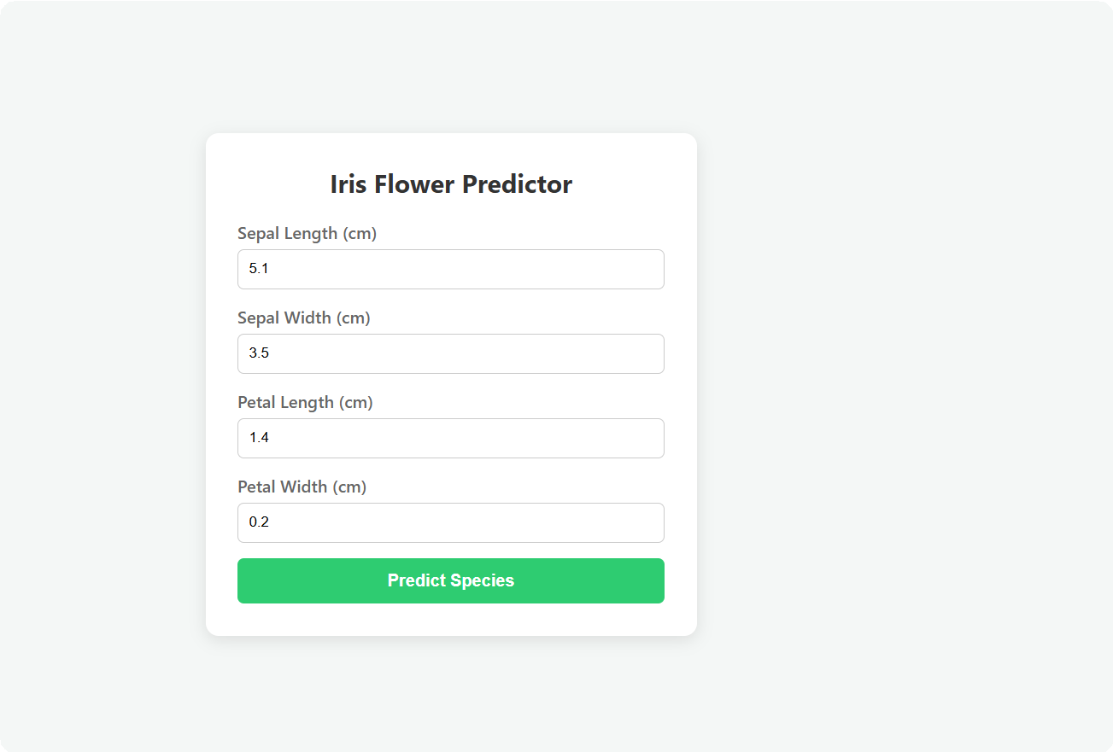

Figure 3.1: Phase Alpha functional blueprint showcasing initial input mapping fields and localized green indicator hooks.

Architectural Review Note: While functional baseline validation passed successfully, Alpha testing revealed high user fatigue parameters under flat lighting conditions. Furthermore, output rendering relied entirely on basic text injection, which didn't provide strong visual context for users.

Phase Beta: Premium Luxury Dark-Mode Re-Engineering
Following initial testing, the user interface layer was completely rewritten to match premium enterprise software design guidelines. The design introduces dark panel contrast framing, metallic accents, and contextual graphics to transform the user experience.
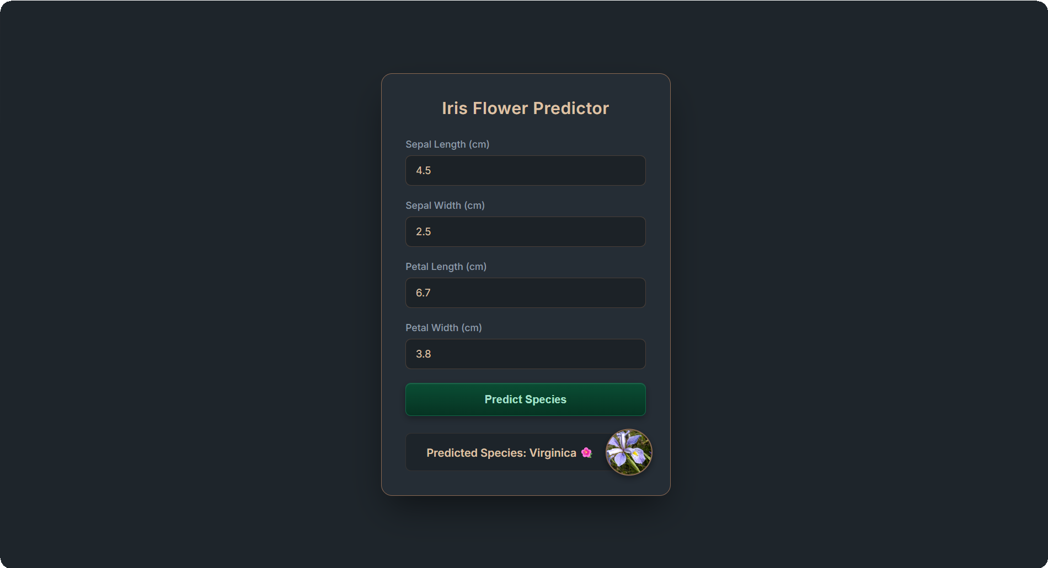

Figure 4.1: Final Phase Beta UI Dashboard featuring glassmorphism elements, copper-metallic lining, and real-time flower illustration overlays.

Premium Visual System Engineering
The upgraded frontend interface utilizes a highly specialized style manifest to optimize visual feedback:
    - Copper Metallic Isolation Framing: Individual analytical input slots are bound by an
#252d35

adjustable opacity border (
#8c6a53
) matching dark slate panels (
). This treatment

preserves sharp text contrast while maintaining an elegant dark palette.
    - Dynamic Response Avatars: The asynchronous callback script maps the returned prediction index to pre-cached flower asset records. Upon validation confirmation, a circular thumbnail pops into view via absolute positioning layout anchors, creating a premium presentation layer.

Production Deployment Pipeline & Continuous Integration
The live web node configuration runs an automated git-hook tracking infrastructure linked to the Render platform. Any updates pushed to the central branch trigger a non-blocking rebuild loop using the settings documented below:

Environment Manifest Setup ( ):
requirements.txt

flask==3.1.3
scikit-learn==1.9.0 joblib==1.5.3 gunicorn==26.0.0

Production Runtime Process Execution:

gunicorn app:app

This continuous deployment loop guarantees zero-downtime updates, letting engineers safely polish frontend design elements without risking system downtime or dropping live prediction requests.

