

AUTONOMOUS AGRICULTURAL ROVER FOR WEED DETECTION & PRECISION TREATMENT
USING COMPUTER VISION AND EMBEDDED SYSTEMS
ABHIMANYU SINGH RAJAWAT (IU2341230380)
SHIVEN CHOKSI (IU2341230385)
YOGESH TIWARI (IU2341230450)
NIKHIL SOLANKI (IU2341230380)
TRISHTA SOAM (IU2341230380)
GUIDED BY: PROF. DEEP PAUN
MECHANICAL ENGINEERING, INDUS INSTITUTE OF TECHNOLOGY AND ENGINEERING
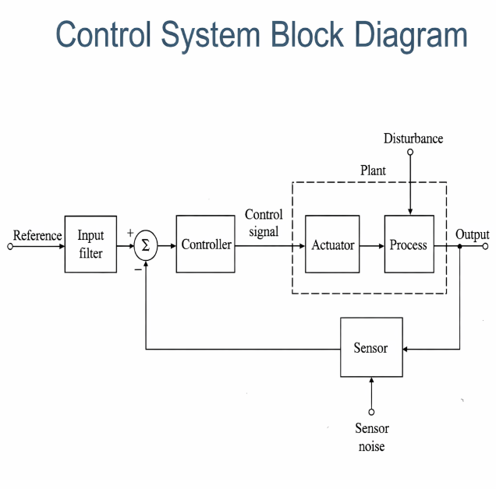

METHODOLOGY
- System Design & Integration
  - A 4WD rover chassis is assembled with motors driven by an L298N module.
  - Raspberry Pi acts as the main controller; ESP32 handles motor and actuator control via UART communication.
- Navigation & Path Planning
  - The rover follows a Boustrophedon (lawnmower) path for systematic field coverage.
  - MPU6050 (gyro) and wheel encoders provide heading and distance feedback.
  - Sensor fusion on Raspberry Pi maintains position on a grid.
- Obstacle Detection & Replanning
  - HC-SR04 ultrasonic sensor continuously measures distance.
  - On detecting an obstacle, the system triggers A*-based local replanning.
  - Rover bypasses the obstacle and returns to the planned path.
- Vision-Based Detection
  - Raspberry Pi Camera captures real-time images.
  - YOLOv5 model detects weeds, crops, and objects.
  - Pixel coordinates are mapped to real-world positions.
- Robotic Arm & Actuation (Phase 3)
  - A 3-DOF robotic arm (MG996R servos) is controlled via PCA9685.
  - Based on detection, the arm moves to target coordinates.
  - A laser module is activated for weed removal simulation.
- Monitoring & Dashboard
  - A Flask web application runs on Raspberry Pi.
  - Displays live camera feed, rover position, and detection logs accessible over WiFi.

MOTIVATION

Agriculture still depends heavily on manual labor, leading to high effort and operational costs.

Continuous monitoring of crops for weeds, pests, and obstacles is difficult in large-scale fields.

Existing automated solutions are expensive and not accessible to small and medium farmers.

There is a growing need for intelligent, low-cost systems that can assist in precision farming.

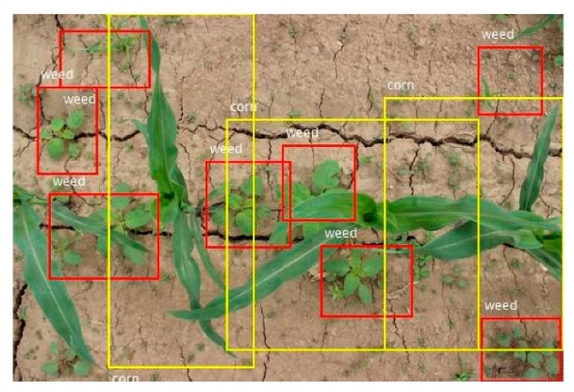
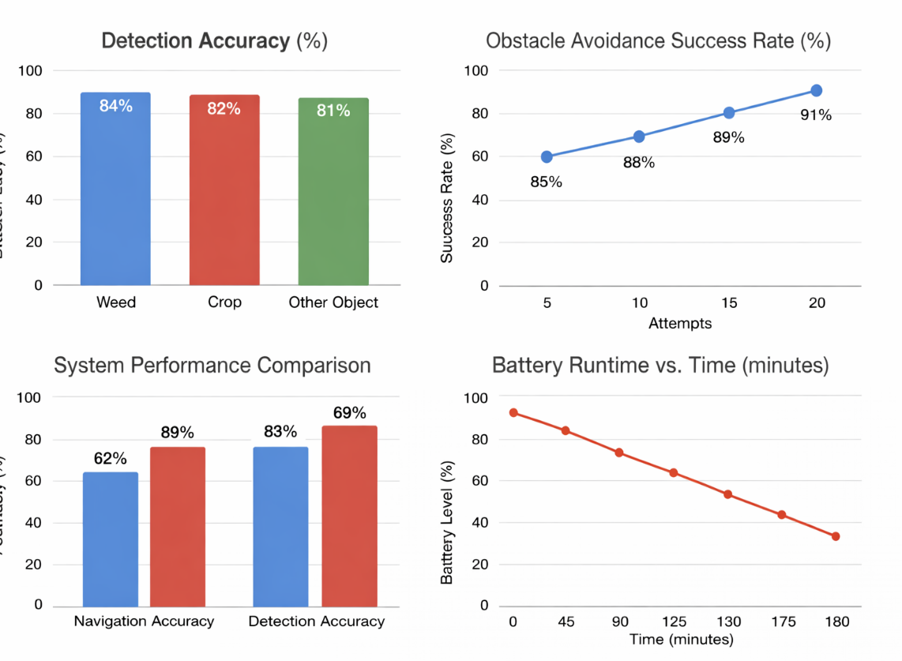
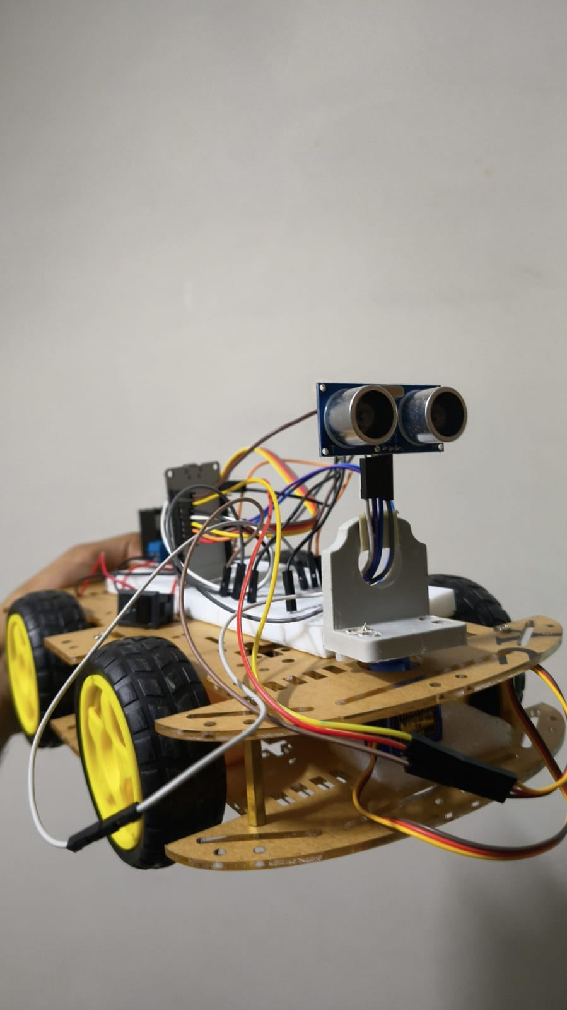
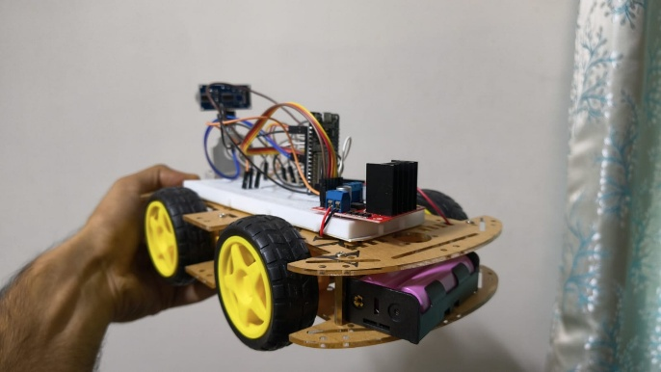
Integrating robotics and AI can improve efficiency, reduce human workload, and enhance crop productivity
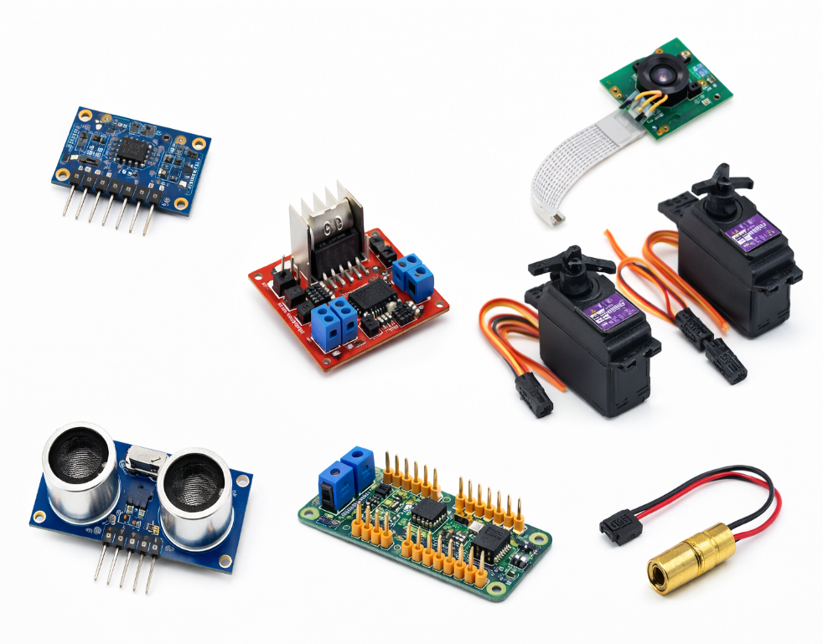

PROJECT OBJECTIVES
- To design and develop an autonomous rover capable of navigating agricultural fields efficiently.
- To implement real-time obstacle detection and avoidance for safe operation.
- To develop an AI-based vision system for detecting weeds, crops, and other objects.
- To integrate a robotic arm for precise action on detected targets (e.g., weed removal simulation).
- To establish communication between Raspberry Pi (processing) and ESP32 (control) for modular operation.
- To create a system that supports precision agriculture with minimal human intervention.

SUMMARY & CONCLUSION
- The developed system successfully integrates autonomous navigation, AI-based detection, and robotic actuation into a single agriculture rover.
- The rover demonstrates reliable performance in obstacle detection, path planning, and path recovery, enabling continuous field coverage.
- The YOLO-based vision system effectively identifies weeds, crops, and other objects with satisfactory accuracy under controlled conditions.
- The robotic arm mechanism performs targeted actions, validating the feasibility of precision-based intervention in agricultural tasks.
- Overall, the project validates the concept of a low-cost, intelligent farming solution, capable of reducing manual effort and improving efficiency.
Conclusion:
The proposed agriculture rover provides a strong foundation for future smart farming systems by combining robotics and artificial intelligence, with potential for further enhancement and real-world deployment.

RESULTS & DISCUSSION / VALIDATION
- The rover successfully performs autonomous navigation following the planned coverage path and maintains directional stability using sensor feedback.
- The obstacle detection system using ultrasonic sensors reliably identifies obstacles within a range of ~40–50 cm, and the rover successfully avoids them with a high success rate (~85–90%).
- The implementation of path replanning (A*) enables the rover to bypass obstacles and return to its original path, ensuring continuous field coverage without manual intervention.
- The YOLOv5-based vision system accurately detects weeds, crops, and other objects with an average confidence of ~80–85% under controlled lighting conditions.
- The robotic arm mechanism demonstrates effective actuation by moving to target positions and performing simulated weed removal using the laser module with acceptable positional accuracy (~±3 cm).
- The integrated system shows stable communication between Raspberry Pi and ESP32, enabling smooth coordination between decision-making and motor control.
- The Flask-based dashboard successfully provides real-time monitoring, including live camera feed, rover position, and detection logs, improving system usability.
Overall Validation:
The system was tested in a controlled environment and achieved consistent performance in navigation, detection, and actuation, demonstrating its feasibility as a prototype for smart agriculture applications.

Introduction
This project presents an intelligent agriculture rover designed to automate key farming tasks such as navigation, monitoring, and targeted action. The system integrates robotics with artificial intelligence to assist in precision agriculture.
The rover uses a Raspberry Pi as the primary processing unit for high-level tasks including navigation logic and image-based detection, while an ESP32 microcontroller handles low-level motor and actuator control. This modular architecture ensures efficient performance and scalability.
A camera-based vision system using YOLOv5 enables real-time detection of weeds, crops, and other objects. Based on detection results, the rover makes decisions and performs actions using a robotic arm with a laser module for precise intervention.
The system demonstrates how autonomous navigation, computer vision, and robotic actuation can be combined into a single platform to improve efficiency, reduce manual labor, and support modern smart farming practices.
