**WEEK 4 : CLOUD AND API DEPLOYMENT**

**Name :** Abhimanyu Gangani

**Batch Code :** LISUM15

**Submission Date : 1 December 2022**

**Submission To : Data Glacier**

1. **Creating a model using sklearn library:**

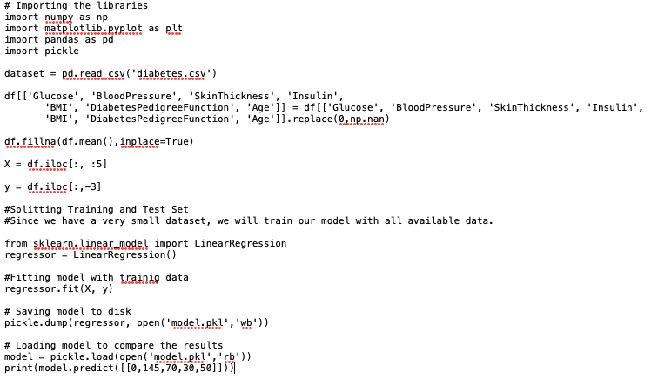

1. **Creating a flask application using python library**

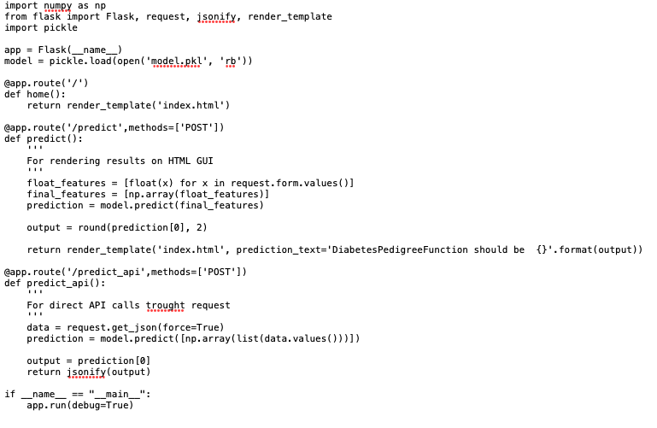

1. **Creating the request file:**

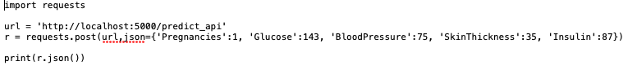

1. **Create a HTML file and save it to Templates folder in same folder where python files are located:**

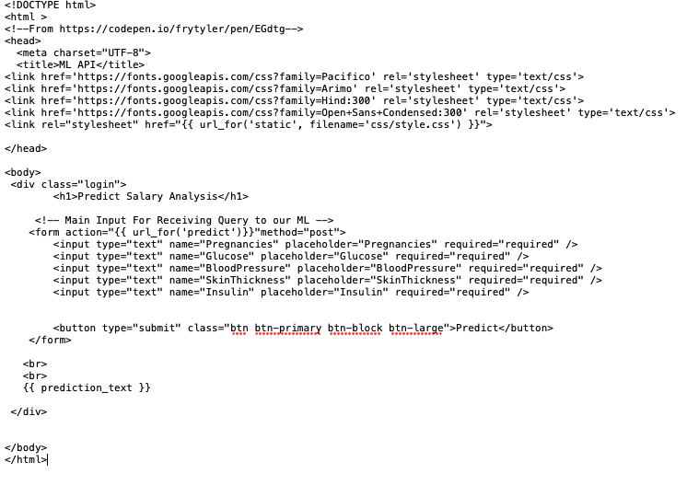

1. **Create css file for styling in static/css folder as style.css :**

@import url(https://fonts.googleapis.com/css?family=Open+Sans);

.btn { display: inline-block; *display: inline; *zoom: 1; padding: 4px 10px 4px; margin-bottom: 0; font-size: 13px; line-height: 18px; color: #333333; text-align: center;text-shadow: 0 1px 1px rgba(255, 255, 255, 0.75); vertical-align: middle; background-color: #f5f5f5; background-image: -moz-linear-gradient(top, #ffffff, #e6e6e6); background-image: -ms-linear-gradient(top, #ffffff, #e6e6e6); background-image: -webkit-gradient(linear, 0 0, 0 100%, from(#ffffff), to(#e6e6e6)); background-image: -webkit-linear-gradient(top, #ffffff, #e6e6e6); background-image: -o-linear-gradient(top, #ffffff, #e6e6e6); background-image: linear-gradient(top, #ffffff, #e6e6e6); background-repeat: repeat-x; filter: progid:dximagetransform.microsoft.gradient(startColorstr=#ffffff, endColorstr=#e6e6e6, GradientType=0); border-color: #e6e6e6 #e6e6e6 #e6e6e6; border-color: rgba(0, 0, 0, 0.1) rgba(0, 0, 0, 0.1) rgba(0, 0, 0, 0.25); border: 1px solid #e6e6e6; -webkit-border-radius: 4px; -moz-border-radius: 4px; border-radius: 4px; -webkit-box-shadow: inset 0 1px 0 rgba(255, 255, 255, 0.2), 0 1px 2px rgba(0, 0, 0, 0.05); -moz-box-shadow: inset 0 1px 0 rgba(255, 255, 255, 0.2), 0 1px 2px rgba(0, 0, 0, 0.05); box-shadow: inset 0 1px 0 rgba(255, 255, 255, 0.2), 0 1px 2px rgba(0, 0, 0, 0.05); cursor: pointer; *margin-left: .3em; }

.btn:hover, .btn:active, .btn.active, .btn.disabled, .btn[disabled] { background-color: #e6e6e6; }

.btn-large { padding: 9px 14px; font-size: 15px; line-height: normal; -webkit-border-radius: 5px; -moz-border-radius: 5px; border-radius: 5px; }

.btn:hover { color: #333333; text-decoration: none; background-color: #e6e6e6; background-position: 0 -15px; -webkit-transition: background-position 0.1s linear; -moz-transition: background-position 0.1s linear; -ms-transition: background-position 0.1s linear; -o-transition: background-position 0.1s linear; transition: background-position 0.1s linear; }

.btn-primary, .btn-primary:hover { text-shadow: 0 -1px 0 rgba(0, 0, 0, 0.25); color: #ffffff; }

.btn-primary.active { color: rgba(255, 255, 255, 0.75); }

.btn-primary { background-color: #4a77d4; background-image: -moz-linear-gradient(top, #6eb6de, #4a77d4); background-image: -ms-linear-gradient(top, #6eb6de, #4a77d4); background-image: -webkit-gradient(linear, 0 0, 0 100%, from(#6eb6de), to(#4a77d4)); background-image: -webkit-linear-gradient(top, #6eb6de, #4a77d4); background-image: -o-linear-gradient(top, #6eb6de, #4a77d4); background-image: linear-gradient(top, #6eb6de, #4a77d4); background-repeat: repeat-x; filter: progid:dximagetransform.microsoft.gradient(startColorstr=#6eb6de, endColorstr=#4a77d4, GradientType=0); border: 1px solid #3762bc; text-shadow: 1px 1px 1px rgba(0,0,0,0.4); box-shadow: inset 0 1px 0 rgba(255, 255, 255, 0.2), 0 1px 2px rgba(0, 0, 0, 0.5); }

.btn-primary:hover, .btn-primary:active, .btn-primary.active, .btn-primary.disabled, .btn-primary[disabled] { filter: none; background-color: #4a77d4; }

.btn-block { width: 100%; display:block; }

* { -webkit-box-sizing:border-box; -moz-box-sizing:border-box; -ms-box-sizing:border-box; -o-box-sizing:border-box; box-sizing:border-box; }

html { width: 100%; height:100%; overflow:hidden; }

body {

width: 100%;

height:100%;

font-family: 'Open Sans', sans-serif;

background: #092756;

color: #fff;

font-size: 18px;

text-align:center;

letter-spacing:1.2px;

background: -moz-radial-gradient(0% 100%, ellipse cover, rgba(104,128,138,.4) 10%,rgba(138,114,76,0) 40%),-moz-linear-gradient(top, rgba(57,173,219,.25) 0%, rgba(42,60,87,.4) 100%), -moz-linear-gradient(-45deg, #670d10 0%, #092756 100%);

background: -webkit-radial-gradient(0% 100%, ellipse cover, rgba(104,128,138,.4) 10%,rgba(138,114,76,0) 40%), -webkit-linear-gradient(top, rgba(57,173,219,.25) 0%,rgba(42,60,87,.4) 100%), -webkit-linear-gradient(-45deg, #670d10 0%,#092756 100%);

background: -o-radial-gradient(0% 100%, ellipse cover, rgba(104,128,138,.4) 10%,rgba(138,114,76,0) 40%), -o-linear-gradient(top, rgba(57,173,219,.25) 0%,rgba(42,60,87,.4) 100%), -o-linear-gradient(-45deg, #670d10 0%,#092756 100%);

background: -ms-radial-gradient(0% 100%, ellipse cover, rgba(104,128,138,.4) 10%,rgba(138,114,76,0) 40%), -ms-linear-gradient(top, rgba(57,173,219,.25) 0%,rgba(42,60,87,.4) 100%), -ms-linear-gradient(-45deg, #670d10 0%,#092756 100%);

background: -webkit-radial-gradient(0% 100%, ellipse cover, rgba(104,128,138,.4) 10%,rgba(138,114,76,0) 40%), linear-gradient(to bottom, rgba(57,173,219,.25) 0%,rgba(42,60,87,.4) 100%), linear-gradient(135deg, #670d10 0%,#092756 100%);

filter: progid:DXImageTransform.Microsoft.gradient( startColorstr='#3E1D6D', endColorstr='#092756',GradientType=1 );

}

.login {

position: absolute;

top: 40%;

left: 50%;

margin: -150px 0 0 -150px;

width:400px;

height:400px;

}

.login h1 { color: #fff; text-shadow: 0 0 10px rgba(0,0,0,0.3); letter-spacing:1px; text-align:center; }

input {

width: 100%;

margin-bottom: 10px;

background: rgba(0,0,0,0.3);

border: none;

outline: none;

padding: 10px;

font-size: 13px;

color: #fff;

text-shadow: 1px 1px 1px rgba(0,0,0,0.3);

border: 1px solid rgba(0,0,0,0.3);

border-radius: 4px;

box-shadow: inset 0 -5px 45px rgba(100,100,100,0.2), 0 1px 1px rgba(255,255,255,0.2);

-webkit-transition: box-shadow .5s ease;

-moz-transition: box-shadow .5s ease;

-o-transition: box-shadow .5s ease;

-ms-transition: box-shadow .5s ease;

transition: box-shadow .5s ease;

}

input:focus { box-shadow: inset 0 -5px 45px rgba(100,100,100,0.4), 0 1px 1px rgba(255,255,255,0.2); }

1. **Open terminal and run the flask application file :**

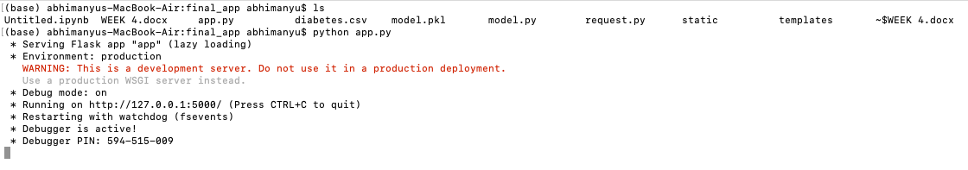

1. **Use the URL to access the application :**

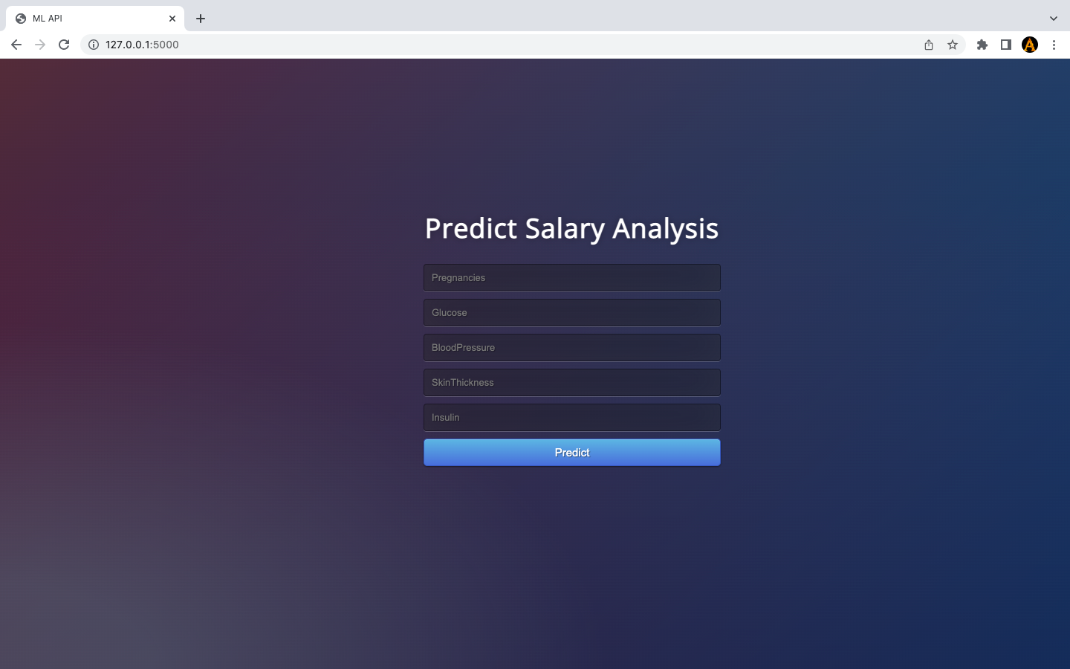

1. **Enter any experience value to predict the salary :**

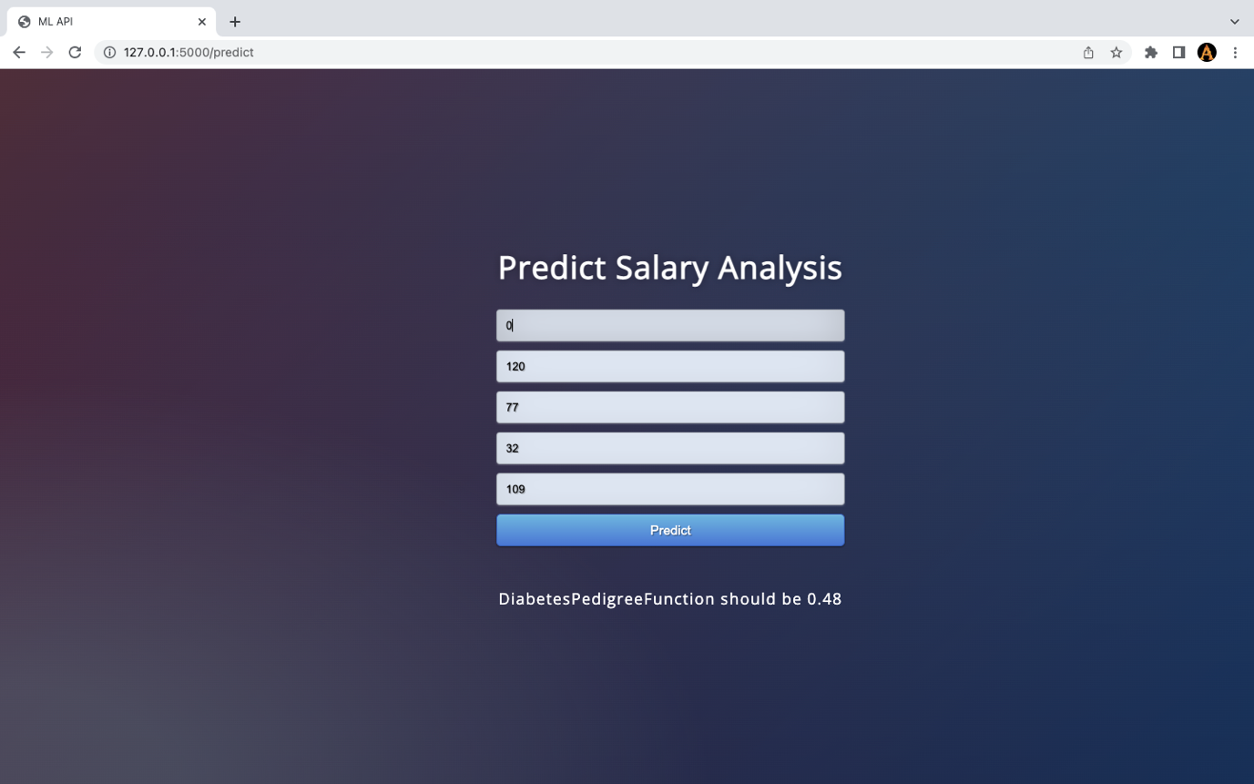

Our application is running fine on the local machine lets try to deploy it on the Heroku cloud.

**Steps to deploy on Heroku:**

1. **Create account on Heroku cloud.**
2. **Open terminal on your machine and install pipenv**

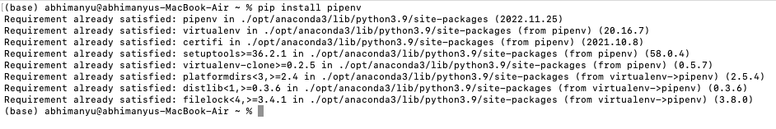

1. **Create a virtual environment with pipenv and install Flask and Gunicorn .**

**(in directory where your files are present).**

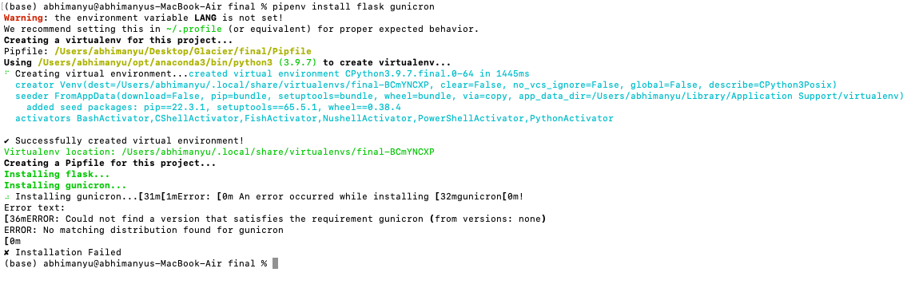

1. **Create a ProcFile and write following code**



1. **Create a requirement.txt file and mention all the versions required for application in that.**

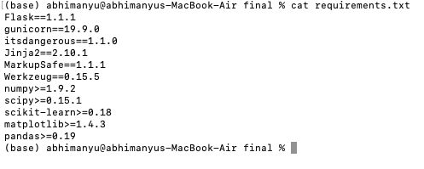

1. **Run command pipenv shell**



1. **Initialize an empty repo, add the files in the repo and commit all the changes.**

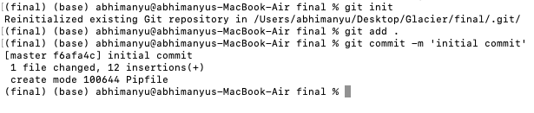

1. **Install Heroku CLI and run Heroku login**



1. **Run command git push Heroku master.**



1. **Run the app using Heroku**

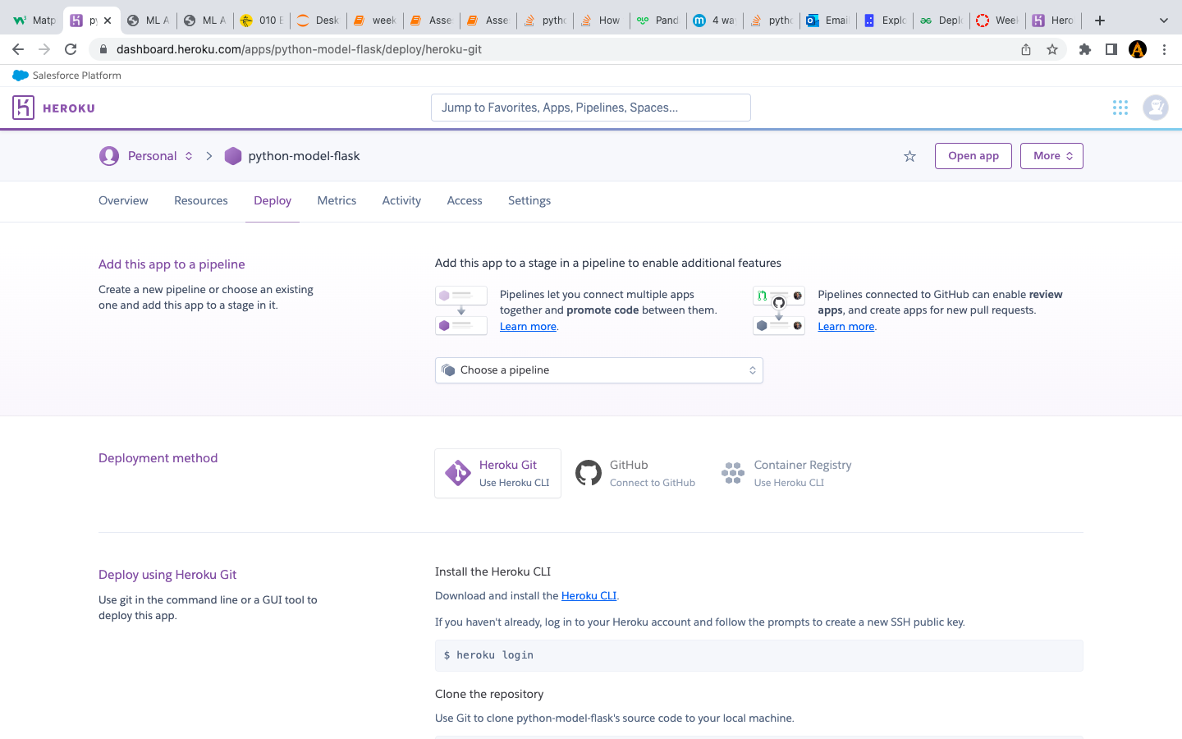

1. **Check the application and try running it**

