Write a query to display the unique appointment information of all the patients. Give an alias name as 'Appointment_Info' for the appointment information of all the patients.

Sort the results based on the Appointment_Info in descending order.

**Sample Data:**

**p_first_name** has an appointment with Dr.**dr_first_name**

**Sample Output:**

**Appointment_Info**

Angel has an appointment with Dr.Santner

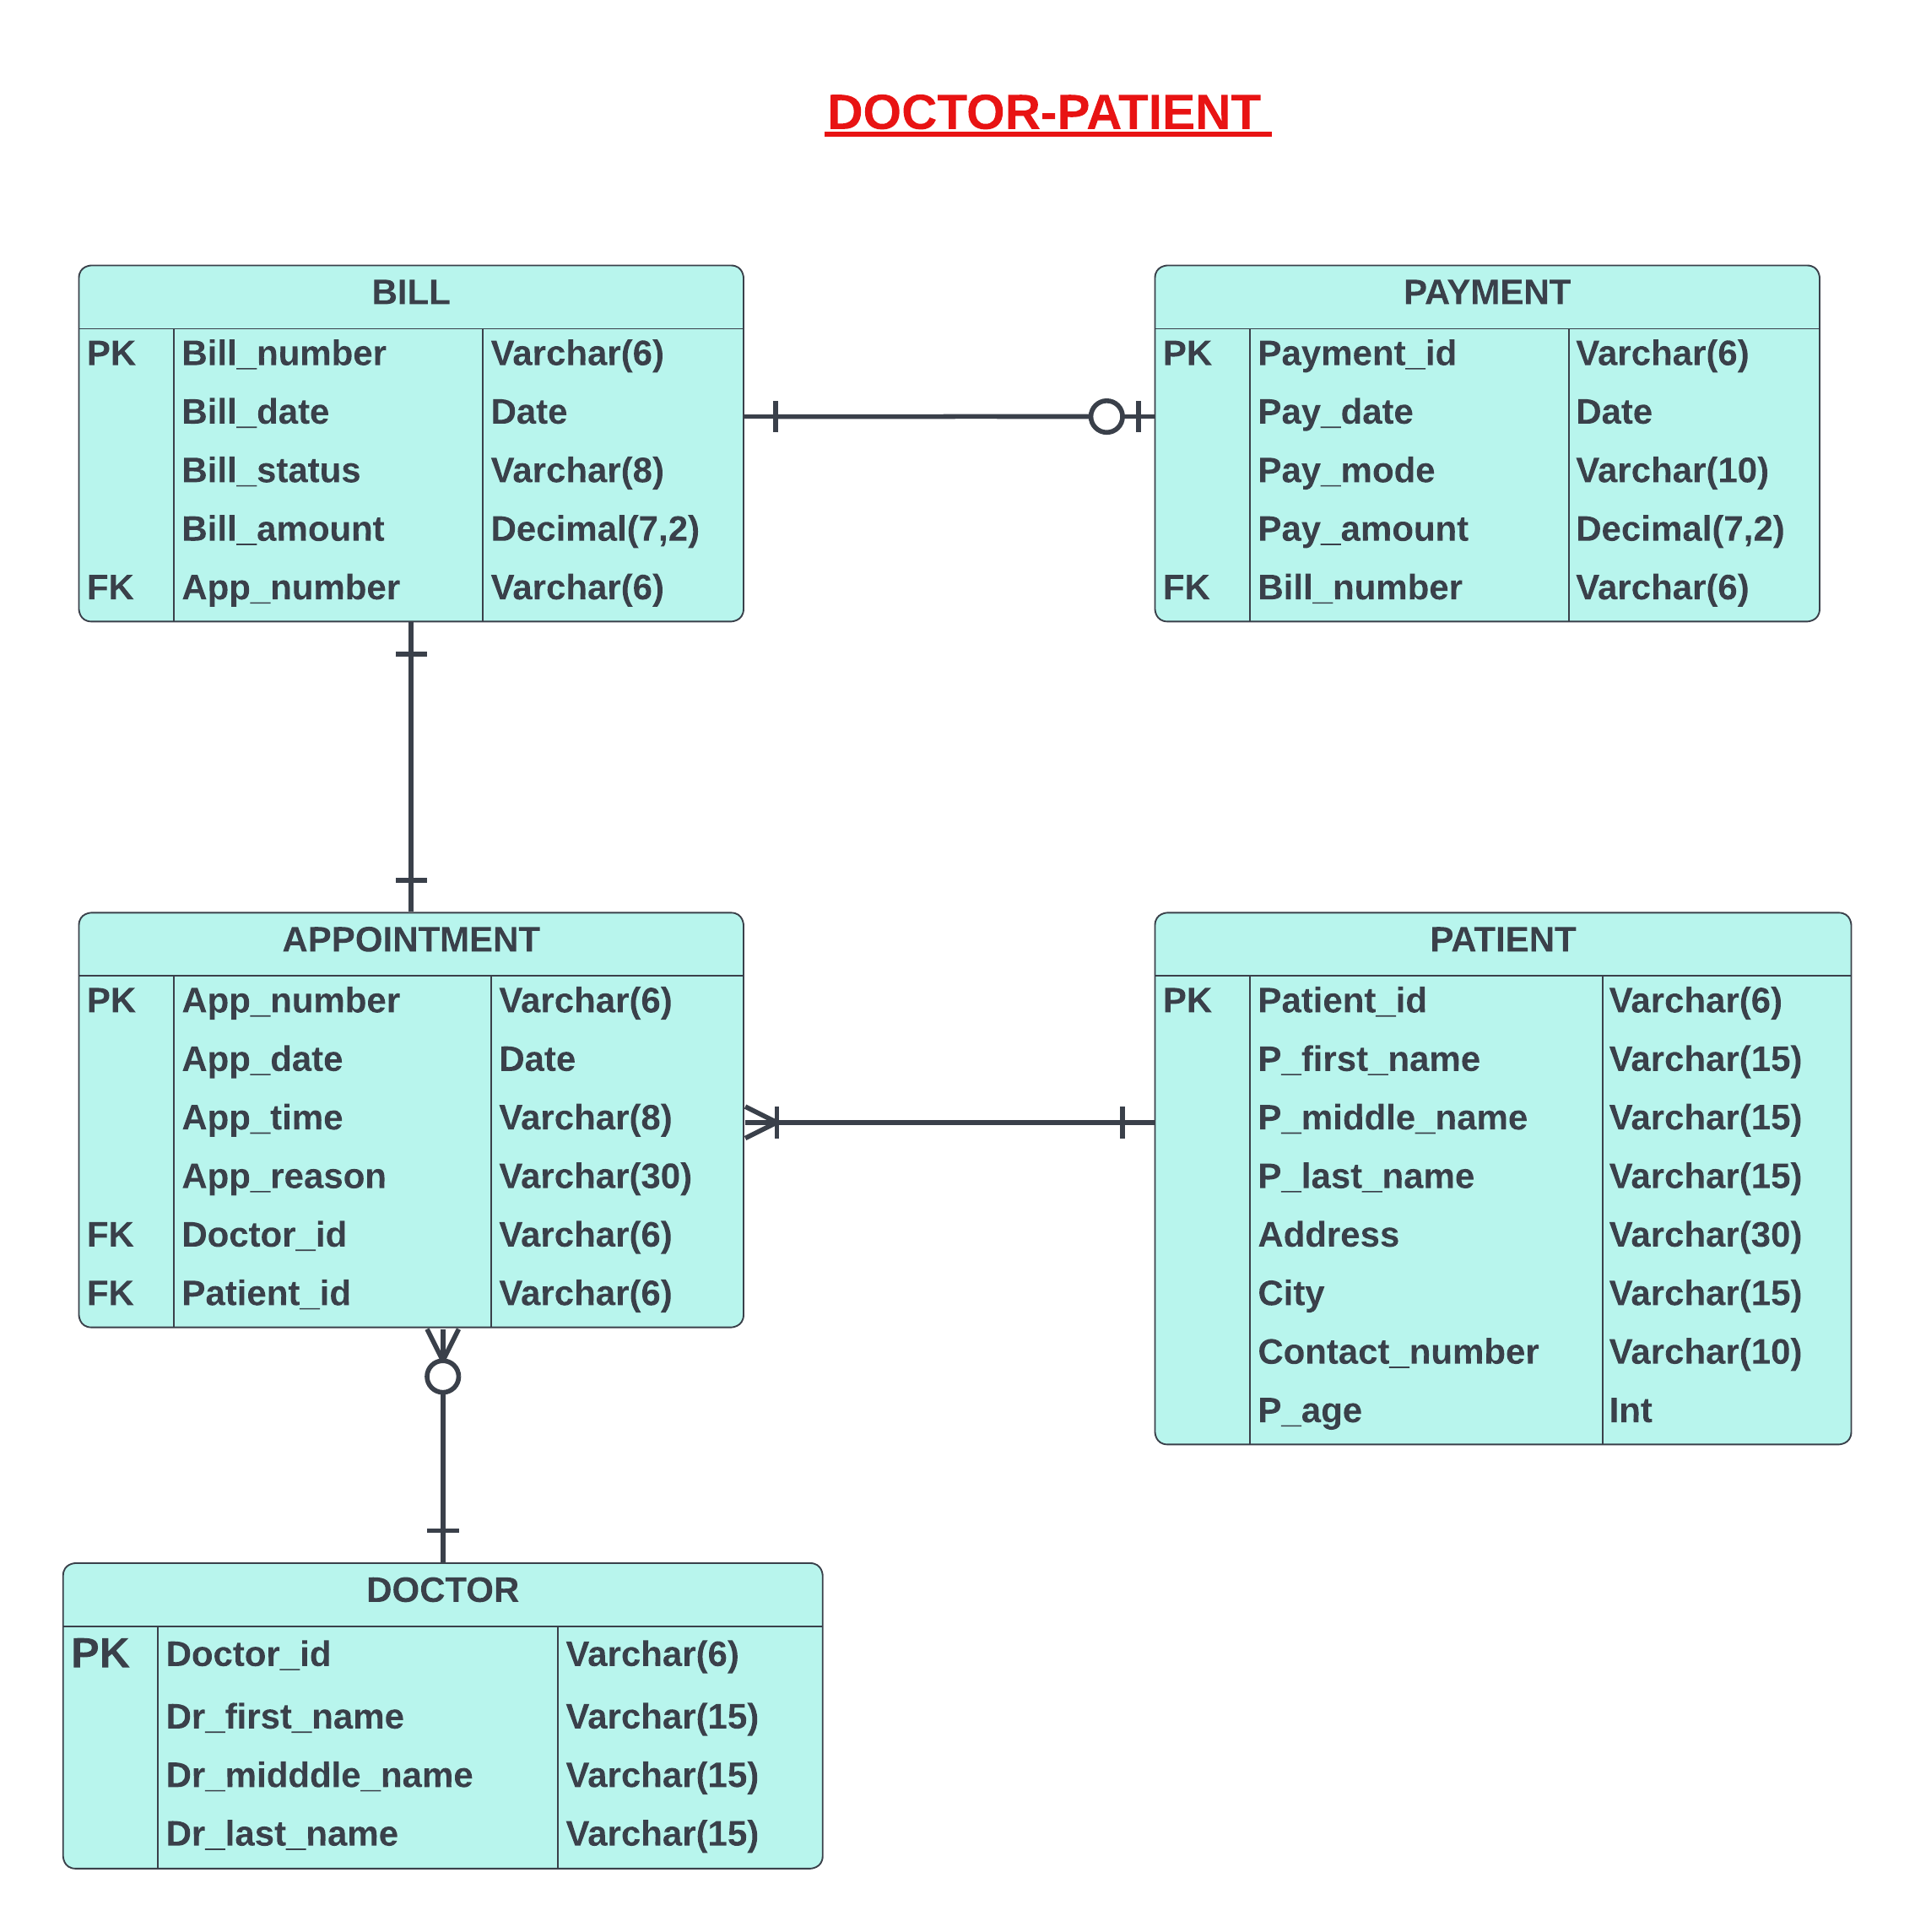

Answer

SELECT DISTINCT CONCAT(p_first_name," ","has an appointment with Dr.",dr_first_name," ") AS Appointment_Info

FROM patient p

JOIN appointment a ON p.patient_id=a.patient_id

JOIN doctor d ON a.doctor_id=d.doctor_id

ORDER BY Appointment_Info desc

Write a query to display the patient's first name and bill amount of all the patients who paid the bills on the billed date.

Sort the records based on the patient's first name in descending order.

**Sample Data**

**p_first_name             bill_amount           bill_date            pay_date**

Adam                          300                       12-08-2022        14-08-2022

Archer                         450                       17-11-2022        17-11-2022

Mathew                      700                       26-10-2022        26-10-2022

**Sample Output:**

**p_first_name             bill_amount**

Archer                         450

Mathew                      700



Answer

select p.p_first_name,b.bill_amount

from Patient p join Appointment a on

p.patient_id=a.patient_id join

Bill b on

a.app_number=b.app_number join

payment pm on b.bill_number=pm.bill_number

where(b.bill_date=pm.pay_date)

order by p.p_first_name desc;

Write a query to display the Recharge Information. Give an alias name as "RECHARGE_INFO".

Sort the records based on the RECHARGE_INFO in ascending order.

**Sample Data:**

**RECHARGE_INFO**

On**Recharge_Date, Customer_Name** recharged his/her phone number

**Sample Output:**

**RECHARGE_INFO**

On April, Justin Geller recharged his/her phone number

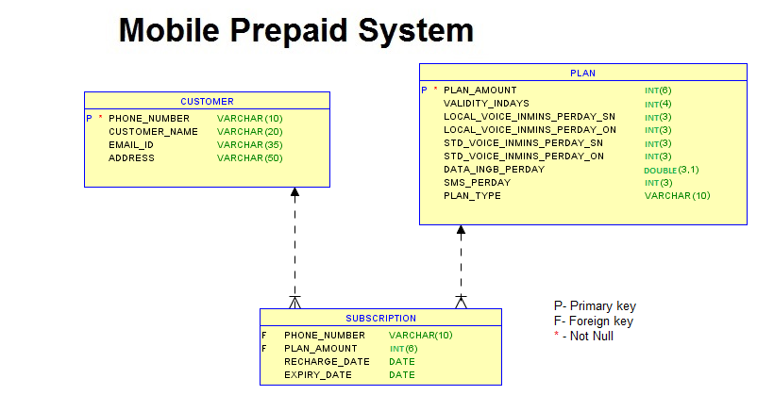

Answer

select CONCAT("On ",date_format(r.recharge_date,'%M'),",",c.customer_name," recharged his/her phone number")

as RECHARGE_INFO

from subscription r join customer c

on r.phone_number=c.phone_number

order by RECHARGE_INFO asc;

The shop manager likes to take a list of customers who ordered cakes from 'February' to 'August'. Write a query to display the unique customer name, email id and phone number of all customers.

Sort the results based on the customer name in ascending order.

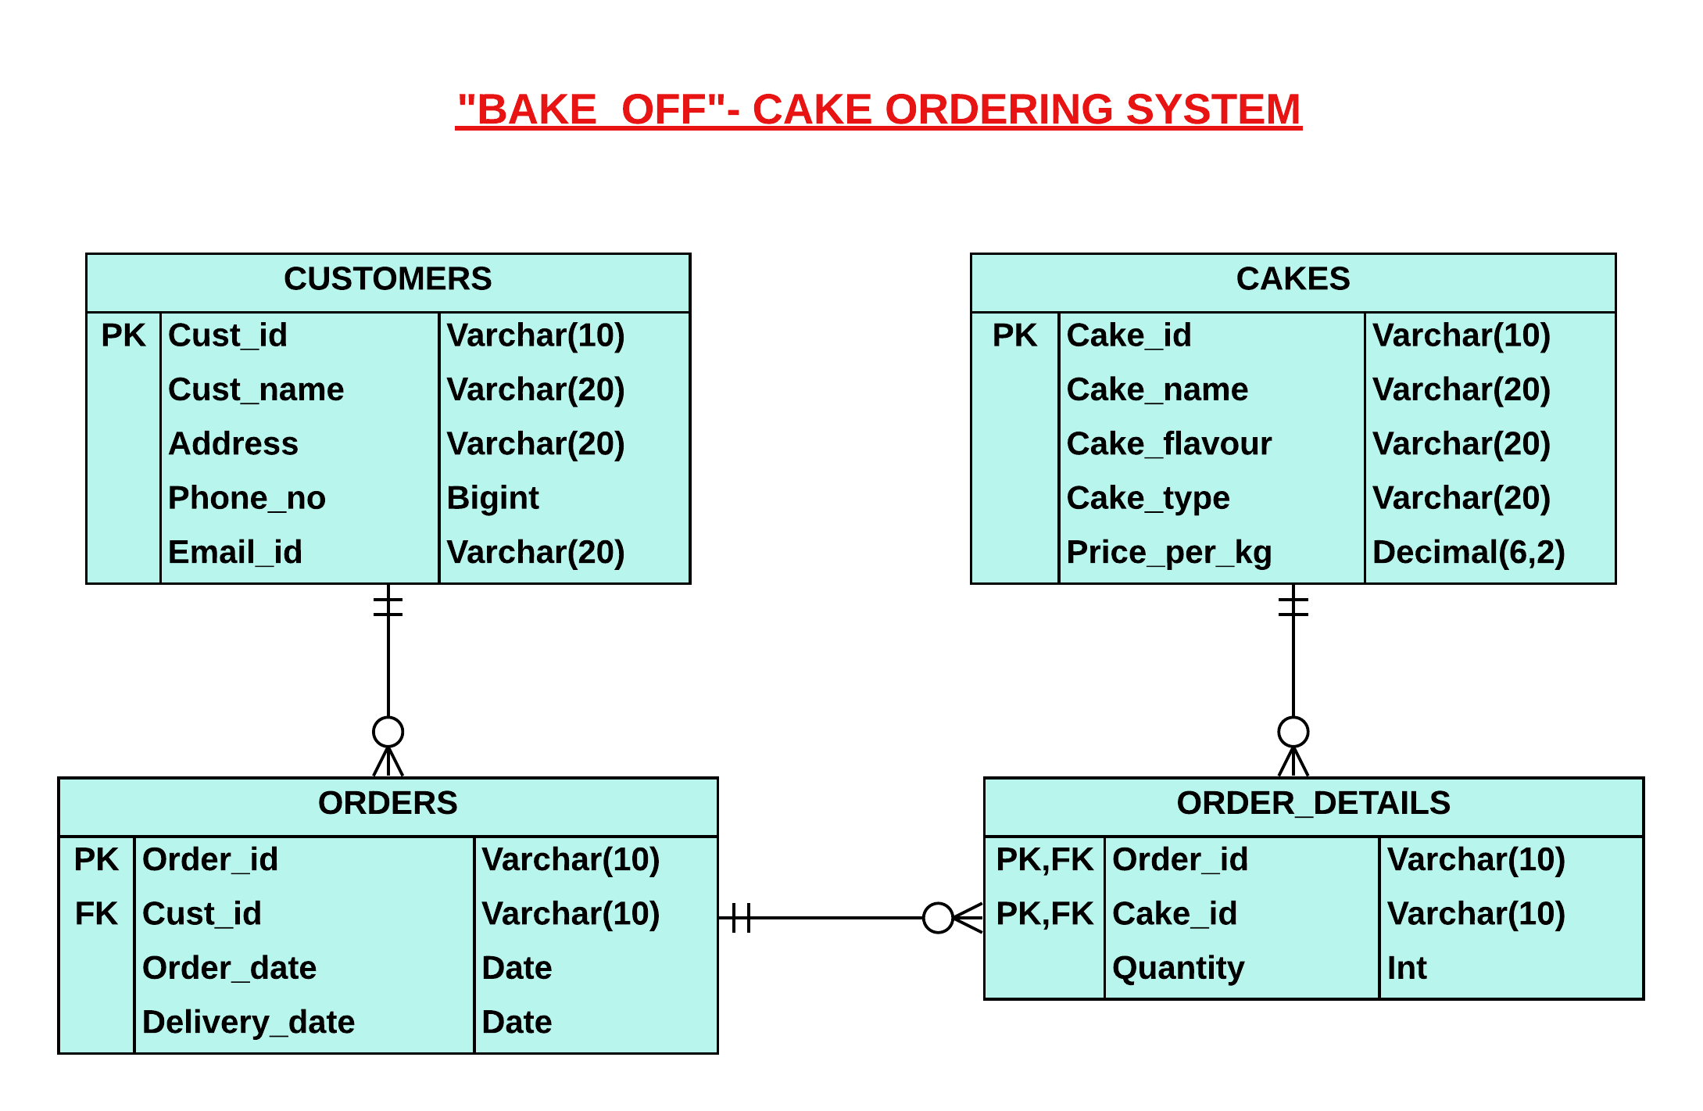

Answer

select distinct Cust_name, email_id, Phone_no

from customers

join orders on orders.cust_id = customers.cust_id

where month(orders.Order_date) >= 2 and month(orders.Order_date) <=8

order by customers.Cust_name;

The government has increased the minimum premium amount based on the minimum year of a policy.

Write a query to display the policy id, policy name, bonus percentage and Updated_Premium_Amount of all the policies.

Sort the results based on the policy id in descending order.

Updated_Premium_Amount is calculated based on the following conditions:

If the minimum year of policy is in the range of 1 to 15, then add 100 to the minimum premium amount.

Otherwise, add 150 to the minimum premium amount.

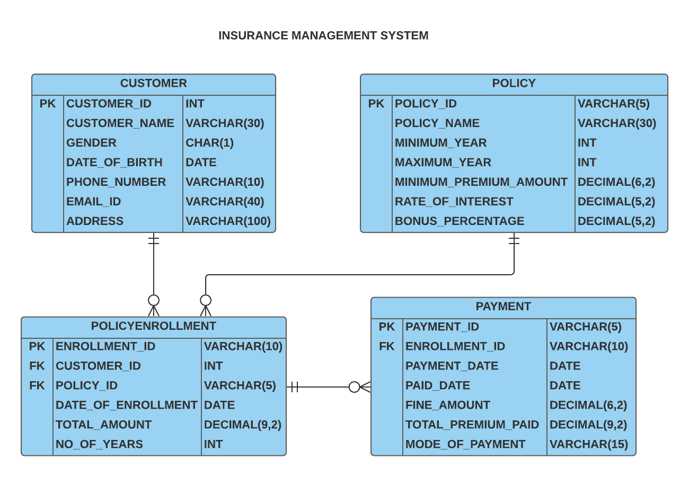

Answer

select POLICY_ID, POLICY_NAME, BONUS_PERCENTAGE, case

when(minimum_year between 1 and 15) then (minimum_premium_amount +100)

else (minimum_premium_amount + 150)

end as Updated_Premium_Amount from policy

order by POLICY_ID DESC;

Write a query to display the customer id, customer name and birth month of all the customers whose addresses don't contain 'Street'. Give an alias name for the birth month as 'BIRTH_MONTH'.

Sort the results based on the customer id in descending order.

(Note: Data is case-sensitive.)



Answer

select CUSTOMER_ID,CUSTOMER_NAME,Month(DATE_OF_BIRTH)

as BIRTH_MONTH from CUSTOMER where ADDRESS

not like '%Street%' order by CUSTOMER_ID desc;

Write a query to display the movie name and released month as given in the sample output. Give an alias name as "MOVIE_MONTH**"**

Sort the records based on the **MOVIE_MONTH** in ascending order.

**Sample Data:**

**MOVIE_NAME**released on **FROM_DATE**

**Sample Output:**

**MOVIE_MONTH**

Avatar2 released on December

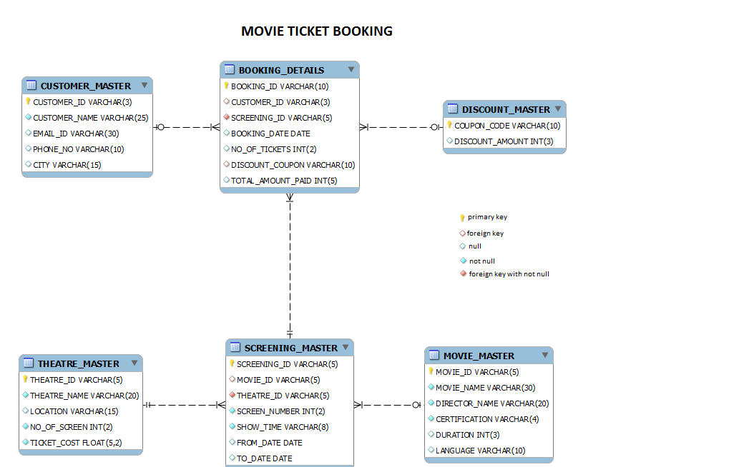

Answer

SELECT CONCAT(MOVIE_NAME,'released on ', DATE_FORMAT(FROM_DATE,'%M'))AS MOVIE_MONTH FROM SCREENING_MASTER

INNER JOIN MOVIE_MASTER ON SCREENING_MASTER.MOVIE_ID=MOVIE_MASTER.MOVIE_ID

ORDER BY MOVIE_MONTH;

Write a query to display the name and source of all the flights that arrive in the same city,if and only if the flight doesn't arrive in 'Chicago'.

Sort the results based on the destination in ascending order and the name in ascending order.

(Note:Data is case sensitive.)

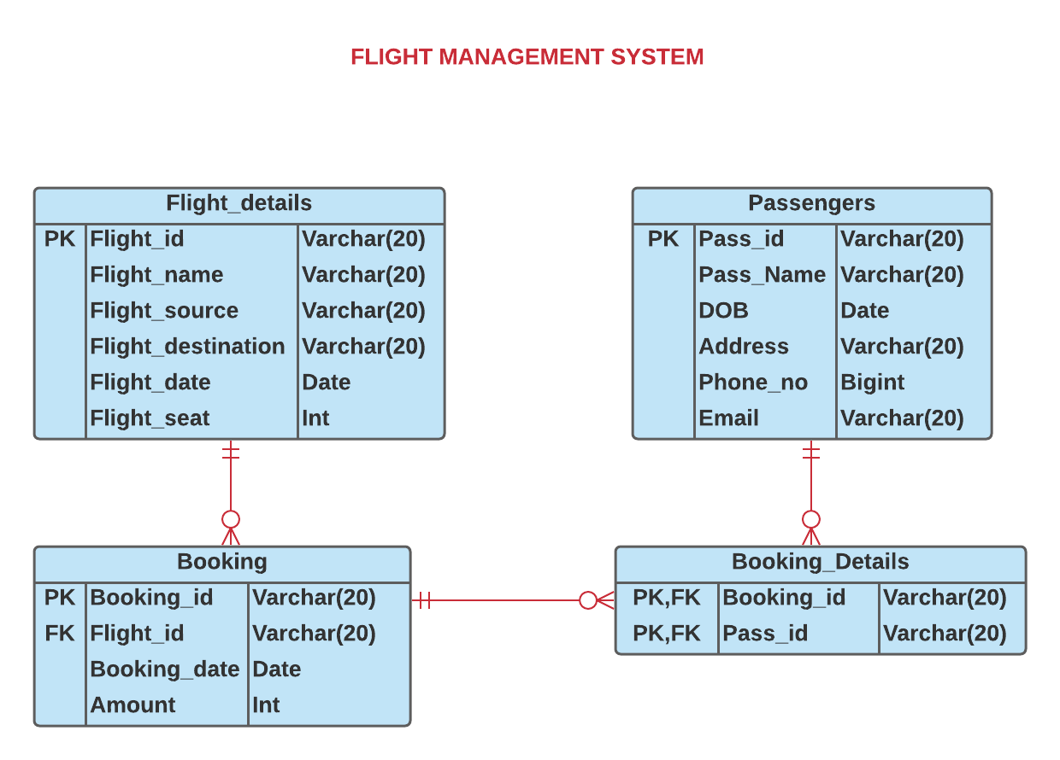

Answer

SELECT Flight_name,Flight_source

FROM Flight_details

where Flight_destination IN(Select Flight_destination FROM Flight_details where Flight_destination <>"Chicago"

GROUP BY Flight_destination HAVING COUNT(DISTINCT Flight_name)>1)

order by Flight_destination asc,Flight_name asc;

Write a query to display the city and number of customers from each city other than 'Mysore'. Give an alias name as 'NO_OF_CUSTOMERS' for the number of customers from each city.

Sort the results based on the city in descending order.

(Note: Data is case sensitive.)

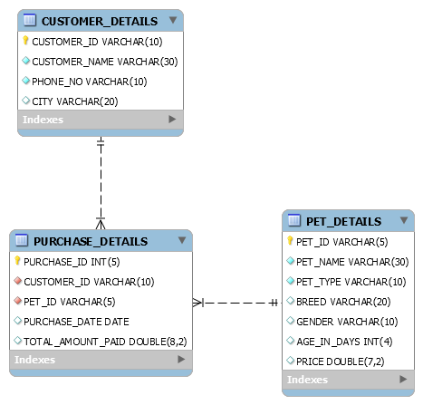

Answer

SELECT CITY,Count(Customer_Name) AS NO_OF_CUSTOMERS

FROM CUSTOMER_DETAILS

WHERE CITY <>'Mysore'

Group by CITY

order by CITY DESC;