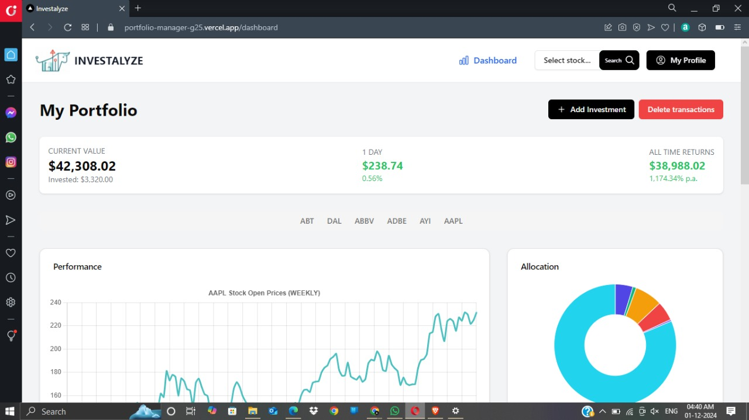

Resolution- 1366\*768 Version:- 78.0.4093.147 Opera Stable System:Windows 10 64-bit

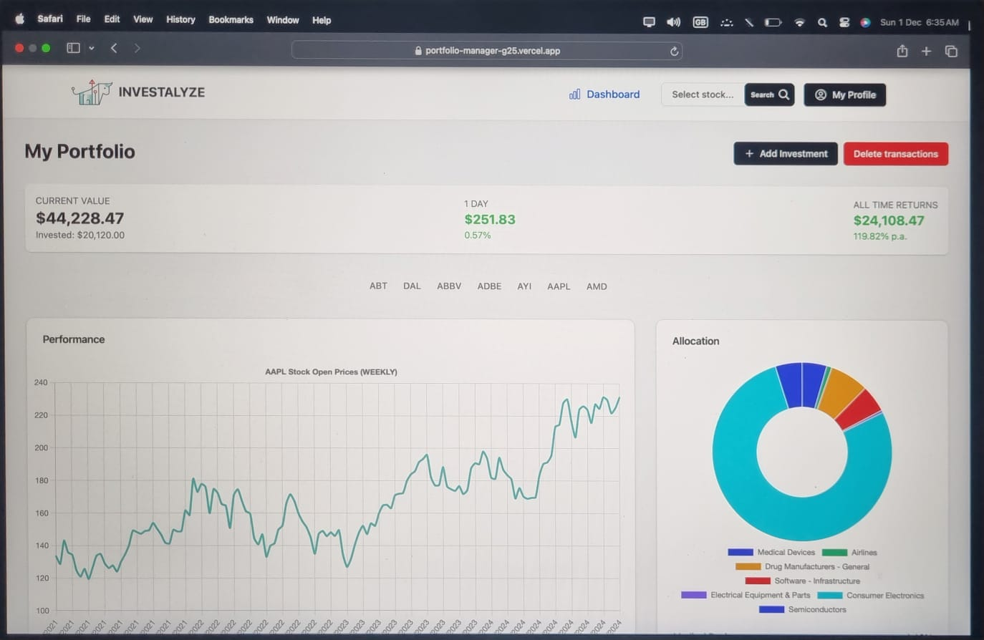

Resolution- 2560\*1664 Version:- safari 17.3 (19617.2.4.11.8)

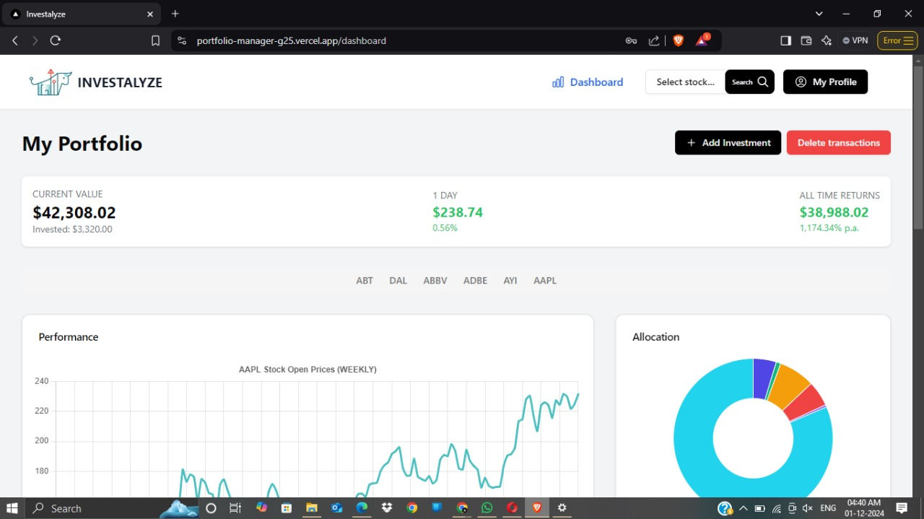

Resolution- 1366\*768 Version:- 1.73.91 Chromium: 131.0.6778.85 (Official Build) (64-bit)

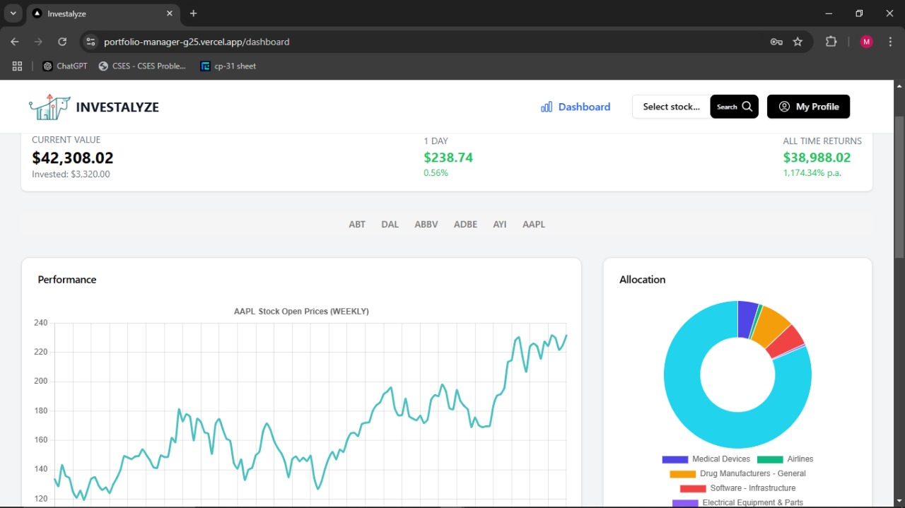

Resolution- 1366\*768 Version:- 131.0.6778.86 (Official Build) (64-bit)

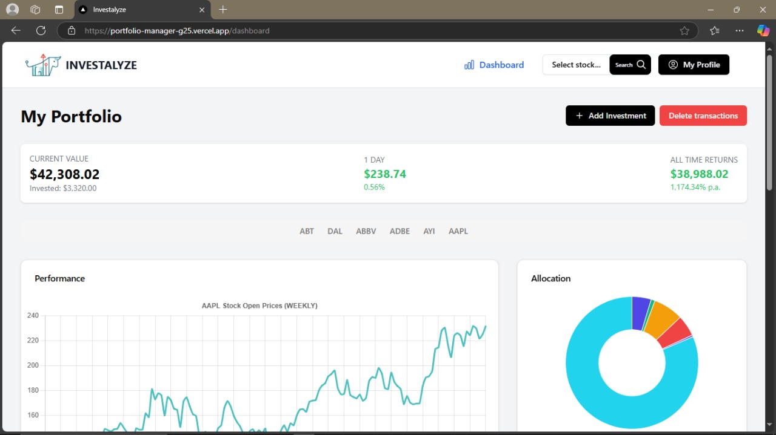

Resolution- 1366\*768 Version:- 131.0.2903.70 (Official build) (64-bit)