

**Late Bhausaheb Hiray S.S Trust’s**

**Institute of Compute Application**

**C E R T I F I C A T E**

This is to certify that Abhijeet Tulshiram Ghanvat of MCA Semester - I with Roll No MCA2024067 has completed all practical’s of Advanced Java Lab under the guidance of Dr. Rashmita Pradhan in this college during the Academic year 2024-2025.

|  |  |  |  |  |  |
| --- | --- | --- | --- | --- | --- |
| CO | Attendance | Performance during Lab session | Innovation in problem solving techniques | Mock Viva during Lab session | Journal |
| CO1 |  |  |  |  |  |
| CO2 |  |  |  |  |  |
| CO3 |  |  |  |  |  |
| CO4 |  |  |  |  |  |
| CO5 |  |  |  |  |  |
| CO6 |  |  |  |  |  |

**Subject In-Charge Director**

**External Examiner**

|  |  |  |  |  |
| --- | --- | --- | --- | --- |
| **MCAL12 Advanced Java**    **INDEX** | | | | |
| **Sr.No.** | **Practical** | **Date** | **CO** | **Sign** |
| **1** | **Practical on Java Generics** |  |  |  |
|  | 1. **Write a Java Program to demonstrate a Generic Class.** 2. **Write a Java Program to demonstrate Generic Methods.** 3. **Write a Java Program to demonstrate Wildcards in Java Generics.** | 26-09-2024 | **CO1** |  |
| **2** | **Practical on list Interface** |  |  |  |
|  | 1. **Write a Java program to create List containing list of items of type String and use for-each loop to print the items of the list.** 2. **Write a Java program to create List containing list of items and use ListIterator interface to print items present in the list. Also print the list in reverse / backward direction.** | 30-09-2024 | **CO1** |  |
|  | **Practical on set Interface** |  |  |  |
| **3** | 1. **Write a Java program to create a Set containing list of items of type String and print the items in the list using Iterator interface. Also print the list in reverse / backward direction.** 2. **Write a Java program using Set interface containing list of items and perform the following operations:** 3. **Add items in the set.** 4. **Insert items of one set in to other set.** 5. **Remove items from the set**   **d. Search the specified item in the set** | 01-10-2024 | **CO1** |  |
| **4** | **Practical on Map Interface** |  |  |  |
|  | 1. **Write a Java program using Map interface containing list of items having keys and associated values and perform the following operations:** 2. **Add items in the map.** 3. **Remove items from the map** 4. **Search specific key from the map** 5. **Get value of the specified key** 6. **Insert map elements of one map in to other map.** 7. **Print all keys and values of the map.** | 08-10-2024 | **CO1** |  |
| **5** | **Practical on Lambda Expression** |  |  |  |
|  | 1. **WAP using Lambda Expression to print “Hello World”.** 2. **Write a Java program using Lambda Expression to concatenate two strings.**   **3. WAP using Lambda Expression with single parameters.**  **4. Write a Java program using Lambda Expression with multiple parameters to add two numbers.**  **5. Write a Java program using Lambda Expression to calculate the following:**   1. **Convert Fahrenheit to Celsius** 2. **Convert Kilometers to Miles.**   **6. Write a Java program using Lambda Expression with or without return keyword.** | 15-10-2024 | **CO1** |  |
| **6** | **Practical based on web application development using JSP** |  |  |  |
|  | 1. **Create a Telephone directory using JSP and store all the information within a database, so that later could be retrieved as per the requirement. Make your own assumptions.** 2. **Write a JSP page to display the Registration form (Make your own assumptions)** 3. **Write a JSP program to add, delete and display the records from StudentMaster (RollNo, Name, Semester, Course) table.** 4. **Design Loan calculator using JSP which accepts Period of Time (in years) and Principal Loan Amount. Display the payment amount for each loan and then list the loan balance and interest paid for each payment over the term of the loan for the following time period and interest rate: a) 1 to 7 year at 5.35% b) 8 to 15 year at 5.5% c) 16 to 30 year at 5.75%** 5. **Write a program using JSP that displays a webpage consisting an Application form for change of Study Center which can be filled by any student who wants to change his/ her study center. Make necessary assumptions.** 6. **Write a JSP program that demonstrates the use of JSP declaration, scriptlet, directives, expression, header and footer.** | 22-10--2024 | **CO2** |  |
| **7** | **Practical based Spring Framework** |  |  |  |
|  | 1. **Write a program to print “Hello World” using spring framework.** 2. **Write a program to demonstrate dependency injection via setter**   **method.**   1. **Write a program to demonstrate dependency injection via Constructor.** 2. **Write a program to demonstrate Autowiring.** | 16-11-2024 | **CO3** |  |
| **8** | **Practical based Aspect Oriented Programming** |  |  |  |
|  | 1. **Write a program to demonstrate Spring AOP – before advice.** 2. **Write a program to demonstrate Spring AOP – after advice.** 3. **Write a program to demonstrate Spring AOP – around advice.** 4. **Write a program to demonstrate Spring AOP – after returning advice.** 5. **Write a program to demonstrate Spring AOP – after throwing advice.** 6. **Write a program to demonstrate Spring AOP – pointcuts.** | 19-11-2024 | **CO4** |  |
| **9** | **Practical based Spring JDBC** |  |  |  |
|  | 1. **Write a program to insert, update and delete records from the given table.** 2. **Write a program to demonstrate PreparedStatement in Spring JdbcTemplate** 3. **Write a program in Spring JDBC to demonstrate ResultSetExtractor Interface** 4. **Write a program to demonstrate RowMapper interface to fetch the records from the database.** | 07-12-2024 | **CO5** |  |
| **10** | **Practical based Spring Boot and RESTful web services** |  |  |  |
|  | 1. **Write a program to create a simple Spring Boot application that prints a message.** 2. **Write a program to demonstrate RESTful Web Services with spring boot.** 3. **Write a program to demonstrate Database Connection with spring boot.** | 09-12-2024 | **CO6** |  |

# Practical 1.1

/* Understand the Generic class

* Write a Java Program to demonstrate a Generic Class
* Author: Yash Malekar
* rollno:
* div:

* */ Solution

**public class** GenericClassExample <T>{

**private** T dvariable;

**public** T getDvariable() {

**return** dvariable;

}

**public void** setDvariable(T dvariable) {

**this**.dvariable = dvariable;

}

**public static void** main(String []args)

{

GenericClassExample<Integer> intvar=**new** GenericClassExample<>(); intvar.setDvariable(50);

System.***out***.println("Variable value="+intvar.getDvariable());

GenericClassExample<String> strvar=**new** GenericClassExample<>(); strvar.setDvariable("Yash");

System.***out***.println("Variable value="+strvar.getDvariable());

}

}

**Output**



# Practical 1.2

/*

* + Practical b1
  + Write a program in java that will use Generic methods
  + There are following kind of Generic Types
  + T Type
  + E Element
  + k Key
  + v Value
  + N Number

*/

**public class** GenericMethod1 {

//print array is generic method

**public static** <E> **void** printArray(E[] inputArray)

{

//display array element

**for**(E element:inputArray)

{

System.***out***.printf("%s,",element);

}

System.***out***.println();

}

**public static void** main(String[] args) {

// **TODO** Auto-generated method stub Integer [] intArray= {10,12,46,48,49};

Double [] doubleArray= {3.45,5.5,6.25,9.6,7.6}; Character [] charArray= {'Y','A','S','H',}; *printArray*(intArray);

*printArray*(doubleArray); *printArray*(charArray);

}

}

Output



# Practical 1.2a

/*

* Write a program in java that will use Generic methods
* There are following kind of Generic Types
* T Type
* E Element
* k Key
* v Value
* N Number
* understand the use of k,v types
* S,V

*/

class Pair<K,V>

{

private K key; private V value;

public Pair(K key, V value) { this.key = key; this.value = value;

}

public K getKey() { return key;

}

public void setKey(K key) { this.key = key;

}

public V getValue() { return value;

}

public void setValue(V value) { this.value = value;

}

}

public class GenericMethod2 {

public static <K,V> boolean compare(Pair<K,V>p1,Pair<K,V>p2) { return p1.getKey().equals(p2.getKey()) &&

p1.getValue().equals(p2.getValue());

};

public static void main(String[] args) {

// TODO Auto-generated method stub Pair<Integer,String>p1=new Pair<>(1,"yash"); Pair<Integer,String>p2=new Pair<>(2,"malekar"); boolean result=GenericMethod2.compare(p1, p2); System.out.println(result);

}

}

Output



# Practical 1.3

Write a program to demonstrate unbound Wildcard in List Interface

import java.util.ArrayList; import java.util.Iterator; import java.util.List;

/*

* Write a program in java to understand the use
* of unbound wildcards ?

*/

public class unboundWildcardExample {

public static void printArray(List<?> mylist)

{

Iterator itr=mylist.iterator(); while(itr.hasNext())

{

System.out.println(itr.next());

}

System.out.println(" ");

}

public static void main(String[] args) {

// TODO Auto-generated method stub

ArrayList <Integer>mynumberlist=new ArrayList<Integer>(); mynumberlist.add(25);

mynumberlist.add(35); mynumberlist.add(50);

mynumberlist.add(100); printArray(mynumberlist);

ArrayList <String>mynamelist=new ArrayList<String>(); mynamelist.add("Yash");

mynamelist.add("Heramb"); mynamelist.add("Vishal"); mynamelist.add("Manoj");

mynamelist.add("Jyotish");printArray(mynamelist);

}

}

**Output**

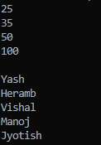

# Practical 1.3a

Write a program to demonstrate upper Wildcard in List Interface

import java.util.ArrayList; import java.util.Iterator; import java.util.List;

/*

* Write a program in java to understand the use
* of upperbound wildcards ? extends

*/

public class upperboundWildcardExample {

public static void sumofElements(List<? extends Number> numberlist)

{

double sum=0.0;

for (Number n : numberlist) sum += n.doubleValue(); System.out.println("Sum of all elements is="+sum);

}

public static void main(String []args) {

ArrayList <Integer>intlist=new ArrayList<Integer>(); intlist.add(50);

intlist.add(80); intlist.add(90); sumofElements(intlist);

ArrayList <Double>dblist=new ArrayList<Double>(); dblist.add(56.25);

dblist.add(78.34); dblist.add(156.79); dblist.add(133.54); sumofElements(dblist);

}

}

Output



**Practical 2.1**

Write a Java program to create List containing list of items

of type String and use for-each loop to print the items of the list

**import** java.util.ArrayList;

**import** java.util.List;

/* Practical 2-1

* Author: Yash Malekar

*

* Write a Java program to create List containing list of items
* of type String and use for-each loop to print the items of the
* list.

*/

**public class** ListInterfaceExample1 {

**public static void** main(String[] args) {

// **TODO** Auto-generated method stub List<String> mylist=**new** ArrayList<String>(); mylist.add("Yash");

mylist.add("Manoj"); mylist.add("Vishal"); mylist.add("Jyotish");

**for**(String item: mylist) { System.***out***.println(item);

}

}

}

Output

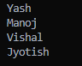

# Practical 2.2

Write a Java program to create List containing list of items and use List Iterator interface to print items present in the list. Also print the list in reverse/ backward direction.

**import** java.util.ArrayList; **import** java.util.Collections; **import** java.util.Iterator; **import** java.util.List;

/*

* Write a Java program to create List containing list of items
* and use List Iterator interface to print items present in the
* list. Also print the list in reverse/ backward direction.

*/

**public class** ListInterfaceRevFor {

**public static void** main(String[] args) {

// **TODO** Auto-generated method stub

List<Integer> numberlist=**new** ArrayList<Integer>();

//Generating list of 10 numbers

**for**(**int** i=1;i<=10;i++) numberlist.add(i);

// printing the list using iterator Iterator<Integer> itr=numberlist.iterator(); **while**(itr.hasNext())

{

System.***out***.println(itr.next());

}

// printing the list using iterator in reverse order System.***out***.println("Reverse order"); Collections.*reverse*(numberlist);

Iterator<Integer> itr2=numberlist.iterator();

**while**(itr2.hasNext())

{

System.***out***.println(itr2.next());

}

}

}

Output

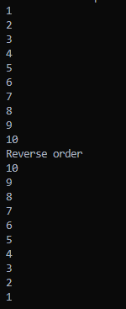

# Practical 3.1

**Problem Statement**

1. Write a Java program to create a Set containing list of items of type String and print the items in the list using Iterator interface. Also print the list in reverse/ backward direction.

Student.java

package com.hiraymca; public class Student {

int rollno; String name;

Double percentage;

public Student(int rollno, String name, Double percentage) { this.rollno = rollno;

this.name = name; this.percentage = percentage;

}

public Student()

{

}

public int getRollno() { return rollno;

}

public void setRollno(int rollno) { this.rollno = rollno;

}

public String getName() { return name;

}

public void setName(String name) { this.name = name;

}

public Double getPercentage() { return percentage;

}

public void setPercentage(Double percentage) { this.percentage = percentage;

}

}

setExample.java package com.hiraymca;

import java.util.ArrayList; import java.util.Collection; import java.util.Collections;

import static java.util.Collections.list; import java.util.Comparator;

import java.util.HashSet; import java.util.Iterator; import java.util.List;

import java.util.ListIterator; import java.util.NavigableSet; import java.util.Scanner; import java.util.TreeSet;

/**

*

* @author YASH MALEKAR

*/

public class setExample {

public static void main(String []args)

{

String ans=null; int rn;

String sn; double per;

Scanner sc=new Scanner(System.in); Student s=new Student();

int choice;

//Creating set of students HashSet<Student>studentSet=new HashSet<Student>(); Iterator i;

//Creating Students

do

{

System.out.println("Menu"); System.out.println("1.Adding student"); System.out.println("2.List all students"); System.out.println("3.List in reverse direction"); System.out.println("4.Exit"); System.out.print("Enter your choice(1..4)"); choice=sc.nextInt();

int flag=0; switch(choice)

{

case 1:

System.out.print("Enter rollno"); rn=sc.nextInt(); System.out.print("Enter name"); sn=sc.next();

System.out.print("Enter percentage"); per=sc.nextDouble();

s=new Student(rn,sn,per); studentSet.add(s);

break;

case 2:

System.out.println("Rollno"+"\t"+"Name"+"\t"+"Percentage"); studentSet.forEach((s1) -> { System.out.println(s1.getRollno()+"\t"+s1.getName()+"\t"+s1.getPercentage());

});

break; case 3:

Comparator<Student> c= Comparator.comparing(Student::getRollno,Comparator.reverseOrder()).thenComparing(Student::getNa me,Comparator.reverseOrder());

List<Student>list=new ArrayList<>(studentSet);

list.sort(c);

System.out.println("Rollno"+"\t"+"Name"+"\t"+"Percentage"); for(Student s2:list)

{

System.out.println(s2.getRollno()+"\t"+s2.getName()+"\t"+s2.getPercentage());

}

break; case 4:

System.exit(0); break;

}

//adding student in HashSet

System.out.print("Do you wish to continue(y/n)"); ans=sc.next();

}while(ans.equals("Y")||ans.equals("y"));

//reteriving the student from set

}

}

**Output:**

Menu

1.Adding student

2.List all students

3.List in reverse direction

4.Exit

Enter your choice(1..4)1

Enter rollno128

Enter nameyash

Enter percentage87

Do you wish to continue(y/n)y

Menu

1.Adding student

2.List all students

3.List in reverse direction

4.Exit

Enter your choice(1..4)2

Rollno Name Percentage

87 jyotish 17.0

128 yash 87.0

Menu

1.Adding student

2.List all students

3.List in reverse direction

4.Exit

Enter your choice(1..4)3

Rollno Name Percentage

128 yash 87.0

87 jyotish 17.0

# Practical 3.2

##### Problem Statement

1. Write a Java program using Set interface containing list of items and perform the following operations:
   1. Add items in the set.
   2. Insert items of one set in to other set.
   3. Remove items from the set
   4. Search the specified item in the set

##### Student.java

package com.hiraymca; public class Student {

int rollno; String name;

Double percentage;

public Student(int rollno, String name, Double percentage) { this.rollno = rollno;

this.name = name; this.percentage = percentage;

}

public Student()

{

}

public int getRollno() { return rollno;

}

public void setRollno(int rollno) { this.rollno = rollno;

}

public String getName() { return name;

}

public void setName(String name) { this.name = name;

}

public Double getPercentage() { return percentage;

}

public void setPercentage(Double percentage) { this.percentage = percentage;

}

}

##### setExample.java

package com.hiraymca;

import java.util.HashSet; import java.util.Iterator; import java.util.Scanner;

import java.util.function.Predicate;

/**

*

* @author YASH MALEKAR

*/

public class setExample {

public static void main(String []args)

{

String ans=null; int rn;

String sn; double per;

Scanner sc=new Scanner(System.in); Student s=new Student();

int choice;

//Creating set of students HashSet<Student>studentSet=new HashSet<Student>(); Iterator i;

//Creating Students

do

{

System.out.println("Menu"); System.out.println("1.Adding student"); System.out.println("2.Removing student"); System.out.println("3.Search student"); System.out.println("4.List all students"); System.out.println("5.Exit"); System.out.print("Enter your choice(1..4)"); choice=sc.nextInt();

int flag=0; switch(choice)

{

case 1:

System.out.print("Enter rollno"); rn=sc.nextInt(); System.out.print("Enter name"); sn=sc.next();

System.out.print("Enter percentage"); per=sc.nextDouble();

s=new Student(rn,sn,per); studentSet.add(s);

break; case 2:

System.out.print("Enter roll no to remove element"); rn=sc.nextInt();

i=studentSet.iterator(); while(i.hasNext())

{

s=(Student)i.next(); if(s.getRollno()==rn)

{

* + 1. remove();

System.out.println("Element is successfully removed"); break;

}

else

{

System.out.println("Rollno="+rn);

}

}

break; case 3:

System.out.println("Enter the name of student"); sn=sc.next();

i=studentSet.iterator(); if(!i.hasNext())

{

System.out.println("List is empty");

}

while(i.hasNext())

{

s=(Student)i.next(); if(s.getName().equals(sn))

{

System.out.println("Record found");

System.out.println(s.getRollno()+" "+s.getName()+" "+s.getPercentage()); flag=1;

break;

}

if(flag!=1)

{

System.out.println("Record not found search again");

}

}

break;

case 4:

System.out.println("Rollno"+"\t"+"Name"+"\t"+"Percentage"); studentSet.forEach((s1) -> {

System.out.println(s1.getRollno()+" "+s1.getName()+" "+s1.getPercentage());

});

break; case 5:

System.exit(0); break;

}

//adding student in HashSet

System.out.print("Do you wish to continue(y/n)"); ans=sc.next();

}while(ans.equals("Y")||ans.equals("y"));

//reteriving the student from set

}

}

##### Output

Menu

1.Adding student

2.Removing student

3.Search student

4.List all students

5.Exit

Enter your choice(1..4)1

Enter rollno128

Enter nameYash

Enter percentage88

Do you wish to continue(y/n)y

Menu

1.Adding student

2.Removing student

3.Search student

4.List all students

5.Exit

Enter your choice(1..4)1

Enter rollno125

Enter nameVishal

Enter percentage77

Do you wish to continue(y/n)y

Menu

1.Adding student

2.Removing student

3.Search student

4.List all students

5.Exit

Enter your choice(1..4)4

Rollno Name Percentage

125 Vishal 77.0

128 Yash 88.0

Do you wish to continue(y/n)y

Menu

1.Adding student

2.Removing student

3.Search student

4.List all students

5.Exit

Enter your choice(1..4)3

Enter the name of student

Yash

Record not found search again

Record found

128 Yash 88.0

Do you wish to continue(y/n)y

Menu

1.Adding student

2.Removing student

3.Search student

4.List all students

5.Exit

Enter your choice(1..4)2

Enter roll no to remove element125

Element is successfully removed

Do you wish to continue(y/n)n

# Practical 4

Write a Java program using Map interface containing list of items having keys and associated values and perform the following operations:

* 1. Add items in the map.
  2. Remove items from the map
  3. Search specific key from the map
  4. Get value of the specified key
  5. Insert map elements of one map in to other map.
  6. Print all keys and values of the map.

Book.java

package com.hiraymca;

/**

*

* @author YASH MALKEAR

*/

public class Book { private int id; private String name; private String author;

public Book()

{

}

public Book(int id, String name, String author) { this.id = id;

this.name = name; this.author = author;

}

public int getId() { return id;

}

public void setId(int id) { this.id = id;

}

public String getName() { return name;

}

public void setName(String name) { this.name = name;

}

public String getAuthor() { return author;

}

public void setAuthor(String author) { this.author = author;

}

}

mapExample.java package com.hiraymca1;

import java.util.HashMap; import java.util.Map; import java.util.Scanner;

/**

*

* @author YASH MALEKAR

*/

public class mapExample {

public static void main(String []args)

{

//Creating map of books

Map<Integer,Book>map=new HashMap<Integer,Book>();

//Creating books

Book b1=new Book(101,"Let us C","Yashwant Kanetkar");

Book b2=new Book(102,"Data communication & Networking","Forouzan"); Book b3=new Book(103,"Operating System","Achuyut Godbole");

Book b=new Book();

//Adding books to map map.put(1,b1);

map.put(2,b2);

map.put(3,b3);

//Traversing the map

for(Map.Entry<Integer, Book> entry:map.entrySet()){ int key=entry.getKey();

b=entry.getValue();

System.out.println(b.getId()+" "+b.getName()+" "+b.getAuthor());

}

//Removing element from map map.remove(2);

//Traversing the map after removing System.out.println();

System.out.println("Traversing map after removing 2nd element"); for(Map.Entry<Integer, Book> entry:map.entrySet()){

int key=entry.getKey(); b=entry.getValue();

System.out.println(b.getId()+" "+b.getName()+" "+b.getAuthor());

}

//searching for specific entry int mykey;

Scanner sc=new Scanner(System.in); System.out.print("Enter the key "); mykey=sc.nextInt();

for(Map.Entry<Integer, Book> entry:map.entrySet()){ int key=entry.getKey();

b=entry.getValue();

System.out.println(b.getId()+" "+b.getName()+" "+b.getAuthor());

}

}

}

Output run:

102 Data communication & Networking Forouzan

103 Operating System Achuyut Godbole

Traversing map after removing 2nd element

102 Data communication & Networking Forouzan

103 Operating System Achuyut Godbole

Enter the key 101

102 Data communication & Networking Forouzan

103 Operating System Achuyut Godbole

# Practical 5.1

/* @author YASH MALEKAR

* Write a Java program using Lambda Expression with single parameters.

*/

interface HelloWorld {

void sayHello();

}

public class LambdaExpressionExample { public static void main(String args[]){

HelloWorld helloworld=()->{System.out.println("Hello World");}; helloworld.sayHello();

}

}

Output 

**Practical 5.2**

* Write a Java program using Lambda Expression with single parameters

interface findCube

{

int cube(int num);

}

public class Practical52 {

/**

* + @param args the command line arguments

*/

public static void main(String[] args) {

// TODO code application logic here findCube cubeobj=(int x)->{return x*x*x;}; int result=cubeobj.cube(5);

System.out.println("Cube of Enter number is="+result);

}

}

Output



# Practical 5.3

* Write a Java program using Lambda Expression
* with multiple parameters to add two numbers.

*/

interface Calculator

{

int add(int x,int y);

}

public class Practical53 {

/**

* + @param args the command line arguments

*/

public static void main(String[] args) {

// TODO code application logic here int num1=50,num2=70;

Calculator calc=(int n1,int n2)->{return num1+num2;}; int result=calc.add(num1, num2);

System.out.println("Addition of two number is ="+result);

}

}

Output



# Practical 5.6

interface Constr{

String addstr(String fname,String lname);

}

public class Practical56 {

/**

* + @param args the command line arguments

*/

public static void main(String[] args) {

// TODO code application logic here String fname="Yash";

String lname="Malekar";

Constr ctr=(String f,String l)->{return f+" "+l;}; String fullstring=ctr.addstr(fname,lname); System.out.println("My Full name is "+fullstring);

}

}

Output



## Practical 6.1

Index.jsp

<%--

Document : index

Created on : 11-Dec-2024, 9:31:03 pm

Author : YASH MALEKAR

Create a Telephone directory using JSP and store all the information within a database, so that later could be retrieved as per the requirement. Make your own assumptions.

--%>

<%@page contentType="text/html" pageEncoding="UTF-8"%>

<!DOCTYPE html>

<html>

<head>

<meta http-equiv="Content-Type" content="text/html; charset=UTF-8">

<title>Practical 6-1</title>

</head>

<body>

<form action="Process.jsp">

<table align="center">

<tr align="center">

<td style="color:red;padding:10px">${param.message}</td>

</tr>

</table>

<table border="1" align="center" cellpadding="10px">

<thead>

<tr align="center">

<th colspan="2" style="background-color: yellow; padding: 10px">Telephone-Entry-

Form</th>

</tr>

</thead>

<tbody>

<tr>

<td>Name</td>

<td><input type="text" name="txtName" value="" /></td>

</tr>

<tr>

<td>Telephone Number</td>

<td><input type="text" name="txtTel" value="" /></td>

</tr>

<tr>

<td><input type="submit" value="Add Entry" /></td>

<td><input type="reset" value="Reset" /></td>

</tr>

</tbody>

</table>

</form>

</body>

</html>

Output

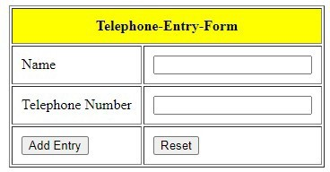

**Process.jsp**

<%--

Document : Process

--%>

<%@page import="java.sql.ResultSet"%>

<%@page import="java.sql.SQLException"%>

<%@page import="java.sql.DriverManager"%>

<%@page import="java.sql.Statement"%>

<%@page import="java.sql.PreparedStatement"%>

<%@page import="java.sql.Connection"%>

<%@page contentType="text/html" pageEncoding="UTF-8"%>

<!DOCTYPE html>

<html>

<head>

<meta http-equiv="Content-Type" content="text/html; charset=UTF-8">

<title>Process</title>

</head>

<body>

<%

String url="jdbc:mysql://localhost:3306/studentdb?zeroDateTimeBehavior=convertToNull"; String user="root";

String password="";

String uname=request.getParameter("txtName"); String tel=request.getParameter("txtTel"); Connection conn;

PreparedStatement ps; Statement st; ResultSet rs;

// connection Initialization Class.forName("com.mysql.jdbc.Driver"); conn=DriverManager.getConnection(url, user, password); try

{

//checking the record already exist in database or not st=conn.createStatement(); rs=st.executeQuery("select * from teldir"); while(rs.next())

{

if(rs.getString(2).equals(uname)&& rs.getString(3).equals(tel))

{%>

<jsp:forward page="index.jsp">

<jsp:param name="message" value="User is already exits, Give New Entry !!!" />

</jsp:forward>

<%

}

}

//inserting record in database

String sql="insert into teldir(name,telephone) values(?,?)"; ps=conn.prepareStatement(sql);

ps.setString(1,uname); ps.setString(2,tel); ps.executeUpdate();

conn.close();

out.println("<h3 align='center'>"); out.println("Record inserted successfully"); out.println("</h3>");

out.println("<h3 align='center'>");

out.println("Click "+"<a href='index.jsp'>here</a>"+"to Enter another record"); out.println("</h3>");

}

catch(SQLException e)

{

e.printStackTrace();

}

%>

</body>

</html>

Output

**If user is already exist**

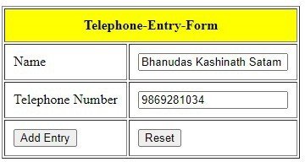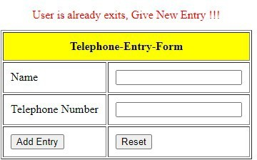

**New Entry**

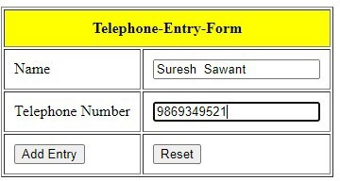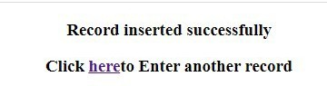

# Practical 6.2

Index.jsp

<%--

Document : index

Created on : Mar 19, 2021, 12:54:11 PM Author : YASH MALEKAR

Write a JSP page to display the Registration form

--%>

<%@page contentType="text/html" pageEncoding="UTF-8"%>

<!DOCTYPE html>

<html>

<head>

<meta http-equiv="Content-Type" content="text/html; charset=UTF-8">

<title>Registration Form </title>

<link rel="stylesheet" href="https://code.jquery.com/ui/1.12.1/themes/base/jquery-ui.css">

<script src="https://code.jquery.com/jquery-1.12.4.js"></script>

<script src="https://code.jquery.com/ui/1.12.1/jquery-ui.js"></script>

<script>

$( function() {

$.datepicker.setDefaults({ onClose:function(date, inst){

$("#selectedDtaeVal").html(date);

}

});

$( "#datepicker" ).datepicker();});

</script>

</head>

<body>

<form action="process.jsp">

<table border="1" cellpadding="10px" align="center">

<thead>

<tr>

<th colspan="2" style="background-color: yellow" padding="10px">Registration Form</th>

</tr>

</thead>

<tbody>

<tr>

<td>Full Name</td>

<td><input type="text" name="txtName" value="" /></td>

</tr>

<tr>

<td>Email</td>

<td><input type="text" name="txtEmail" value="" /></td>

</tr>

<tr>

<td>Date of Birth</td>

<td><input type="text" name="txtbdate" id="datepicker"></td>

</tr>

<tr>

<td>Educational Qualification</td>

<td><select name="opt-qualify">

<option>HSC</option>

<option>Diploma</option>

<option>Graduate</option>

<option>Post-Graduate</option>

</select></td>

</tr>

<tr>

<td>Languages Known</td>

<td><input type="checkbox" name="lk" value="English"/>English

<input type="checkbox" name="lk" value="Marathi" />Marathi

<input type="checkbox" name="lk" value="Hindi" />Hindi

</td>

</tr>

<tr>

<td valign="top">Write about yourself</td>

<td><textarea name="about" rows="8" cols="30" >

</textarea></td>

</tr>

<tr>

<td>Gender </td>

<td><input type="radio" name="gen" value="Male" />Male

<input type="radio" name="gen" value="Female" />Female

<input type="radio" name="gen" value="Tgen" />Tgen</td>

</tr>

<tr>

<td><input type="submit" value="Submit" /></td>

<td><input type="reset" value="Reset" /></td>

</tr>

</tbody>

</table>

</form>

</body>

</html>

Output

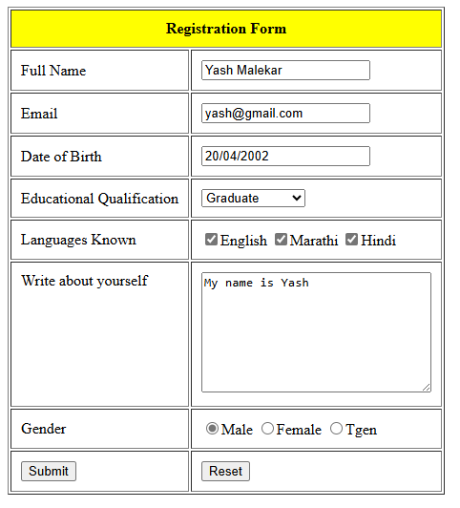

process.jsp

<%--

Document : process

Created on : Mar 19, 2021, 2:16:48 PM Author : BHANUDAS SATAM

--%>

<%@page import="java.util.Arrays"%>

<%@page import="java.util.List"%>

<%@page contentType="text/html" pageEncoding="UTF-8"%>

<!DOCTYPE html>

<html>

<head>

<meta http-equiv="Content-Type" content="text/html; charset=UTF-8">

<title>Practical6-2</title>

</head>

<body>

<h1>You are successfully Registered </h1>

<h4>Your details are as follows </h4>

<% String name,email,dob,equalify,lang,yourself,gen; name=request.getParameter("txtName"); email=request.getParameter("txtEmail"); dob=request.getParameter("txtbdate"); equalify=request.getParameter("opt-qualify"); lang=request.getParameter("English"); yourself=request.getParameter("about"); gen=request.getParameter("gen");

String [] lknown=request.getParameterValues("lk"); List list=Arrays.asList(lknown); request.setAttribute("lknown",list);

List<String> lk = (List<String>)request.getAttribute("lknown"); out.println("<table border='1' cellpadding='15px'>");

out.print("<tr>");

out.print("<td>");

out.print("Name");

out.print("</td>");

out.print("<td>"); out.print(name);

out.print("</td>");

out.print("</tr>");

out.print("<tr>");

out.print("<td>");

out.print("Email");

out.print("</td>");

out.print("<td>"); out.print(email); out.print("</td>");

out.print("</tr>");

out.print("<tr>");

out.print("<td>"); out.print("Date of Birth"); out.print("</td>");

out.print("<td>"); out.print(dob); out.print("</td>");

out.print("</tr>");

out.println("<tr>"); out.println("<td>"); out.println("Educational Qualifiation"); out.println("</td>"); out.println("<td>"); out.println(equalify); out.println("</td>"); out.println("</tr>");

out.println("<tr>"); out.println("<td>"); out.println("Gender"); out.println("</td>"); out.println("<td>"); out.println(gen); out.println("</td>"); out.println("</tr>");

out.println("<tr>"); out.println("<td>"); out.println("Languages known");

out.println("</td>"); out.println("<td>"); for(String item:lk)

{

out.println(item);

}

out.println("</td>"); out.println("</tr>");

out.println("<tr>"); out.println("<td>"); out.println("About yourself"); out.println("</td>"); out.println("<td>"); out.println(yourself); out.println("</td>"); out.println("</tr>"); out.println("</table>");

%>

</body>

</html>

Output

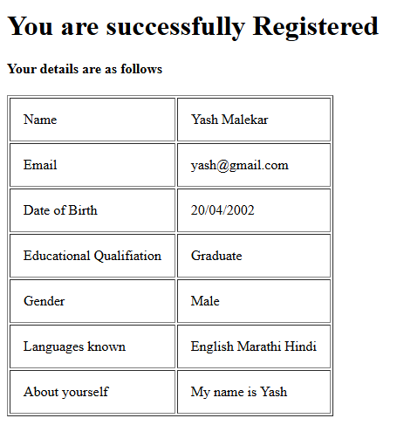

## Practical 6.3

add.jsp

<%--

Document : index

Author : YASH MALEKAR

--%>

<%@page contentType="text/html" pageEncoding="UTF-8"%>

<!DOCTYPE html>

<html>

<head>

<meta http-equiv="Content-Type" content="text/html; charset=UTF-8">

<title>Index page</title>

<style>

#content

{

margin-top:10px;

}

#tablehead

{

background-color: yellow; padding:10px;

}

</style>

</head>

<body>

<%@include file="header.jsp" %>

<div id="content">

<h2 align="center">Adding Record </h2>

<table align="center">

<tr align="center" style="color:blue">

<td>${param.message}</td>

</tr>

</table>

<form action="addrecord.jsp">

<table border="1" align="center" cellpadding="10px">

<thead>

<tr id='tablehead'>

<th colspan="2">Student Master Form</th>

</tr>

</thead>

<tbody>

<tr>

<td>Name</td>

<td><input type="text" name="txtname" value="" /></td>

</tr>

<tr>

<td>Semester</td>

<td><select name="optsem">

<option>Sem I</option>

<option>Sem II</option>

<option>Sem III</option>

<option>Sem IV</option>

</select></td>

</tr>

<tr>

<td>Course</td>

<td><select name="optcourse">

<option>MCA</option>

<option>M.Sc[Comp.Sc]</option>

<option>M.Sc[I.T.]</option>

</select></td>

</tr>

<tr>

<td><input type="submit" value="Add Record" /></td>

<td><input type="reset" value="Reset" /></td>

</tr>

</tbody>

</table>

</form>

<%@include file="footer.jsp" %>

</body>

</html>

Addrecord.jsp

<%--

Document : addrecord

Author : YASH MALEKAR

--%>

<%@page import="java.sql.ResultSetMetaData"%>

<%@page import="java.sql.Statement"%>

<%@page import="java.sql.DriverManager"%>

<%@page import="java.sql.PreparedStatement"%>

<%@page import="java.sql.Connection"%>

<%@page import="java.sql.ResultSet"%>

<%@page contentType="text/html" pageEncoding="UTF-8"%>

<!DOCTYPE html>

<html>

<head>

<meta http-equiv="Content-Type" content="text/html; charset=UTF-8">

<title>Add Record process</title>

</head>

<body>

<%

String sname=request.getParameter("txtname"); String sem=request.getParameter("optsem"); String course=request.getParameter("optcourse"); Connection conn;

PreparedStatement ps;

String url="jdbc:mysql://localhost:3306/studentdb"; String user="root";

String password="";

//step 1 try

{

Class.forName("com.mysql.jdbc.Driver"); conn=DriverManager.getConnection(url, user, password);

String sql="insert into student(sname,semester,course)value(?,?,?)";

ps=conn.prepareStatement(sql); ps.setString(1, sname); ps.setString(2, sem); ps.setString(3, course); ps.executeUpdate(); conn.close();

}catch(ClassNotFoundException e)

{

e.printStackTrace();

}catch(Exception e)

{

e.printStackTrace();

}

%>

<jsp:forward page="add.jsp">

<jsp:param name="message" value="record inserted successfully" />

</jsp:forward>

</body>

</html>

Output

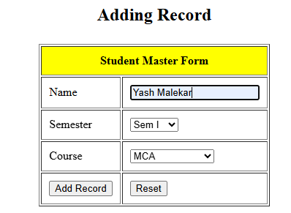

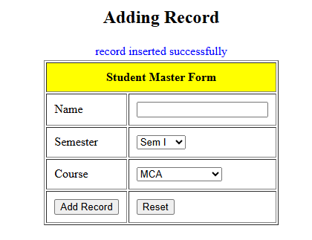

**display.jsp**

<%--

Document : index

Created on : Mar 18, 2021, 8:49:16 AM Author : BHANUDAS SATAM

--%>

<%@page import="java.sql.ResultSetMetaData"%>

<%@page import="java.sql.Statement"%>

<%@page import="java.sql.SQLException"%>

<%@page import="java.sql.ResultSet"%>

<%@page import="java.sql.PreparedStatement"%>

<%@page import="java.sql.DriverManager"%>

<%@page import="java.sql.Connection"%>

<%@page contentType="text/html" pageEncoding="UTF-8"%>

<!DOCTYPE html>

<html>

<head>

<meta http-equiv="Content-Type" content="text/html; charset=UTF-8">

<title>Index page</title>

<style>

#content

{

margin-top:10px;

}

.tablehead

{

background-color: yellow; padding:10px;

}

</style>

</head>

<body>

<%

String rollno=request.getParameter("optrollno"); Connection conn;

ResultSetMetaData rsmd; ResultSet rs1=null,rs2=null; Statement st; PreparedStatement ps;

String rn=null,nam=null,sam=null,co=null; try

{

conn=DriverManager.getConnection("jdbc:mysql://localhost:3306/studentdb","root",""); st=conn.createStatement();

rs1=st.executeQuery("select rollno from student"); ps=conn.prepareStatement("select * from student where rollno=?"); ps.setInt(1, Integer.parseInt(rollno));

rs2=ps.executeQuery(); rs2.next(); rn=rs2.getString(1); nam=rs2.getString(2); sam=rs2.getString(3); co=rs2.getString(4);

}catch(NumberFormatException e)

{

e.printStackTrace();

}

catch(SQLException e)

{

e.printStackTrace();

}

%>

<%@include file="header.jsp" %>

<div id="content">

<h4 align="center">Selecting Record </h4>

<form action="display.jsp" name="myform">

<table border="1" align="center" cellpadding="10px">

<thead>

<tr class='tablehead'>

<th colspan="2">Display Record</th>

</tr>

</thead>

<tbody>

<tr>

<td>Choose Rollno</td>

<td><select name="optrollno" onchange="document.myform.submit()">

<%

rsmd=rs1.getMetaData();

int tcol=rsmd.getColumnCount();

out.println("<option>"); out.println("Select Rollno"); out.println("</option>"); while(rs1.next())

{

out.println("<option>"); out.println(rs1.getString(1)); out.println("</option>");

}

%>

</select></td>

</tr>

</tbody>

</table>

<br>

<div id="output">

<table border="1" align="center" cellpadding="10px">

<thead>

<tr>

<th colspan="4" align="center" class="tablehead">Record </th>

</tr>

</thead>

<tbody>

<tr>

<th>Roll No</th>

<th>Name</th>

<th>Semester</th>

<th>Course</th>

</tr>

<tr>

<td><%= rn%></td>

<td><%= nam%></td>

<td><%= sam%></td>

<td><%= co%></td>

</tr>

</tbody>

</table>

</div>

</form>

<%@include file="footer.jsp" %>

</body>

</html>

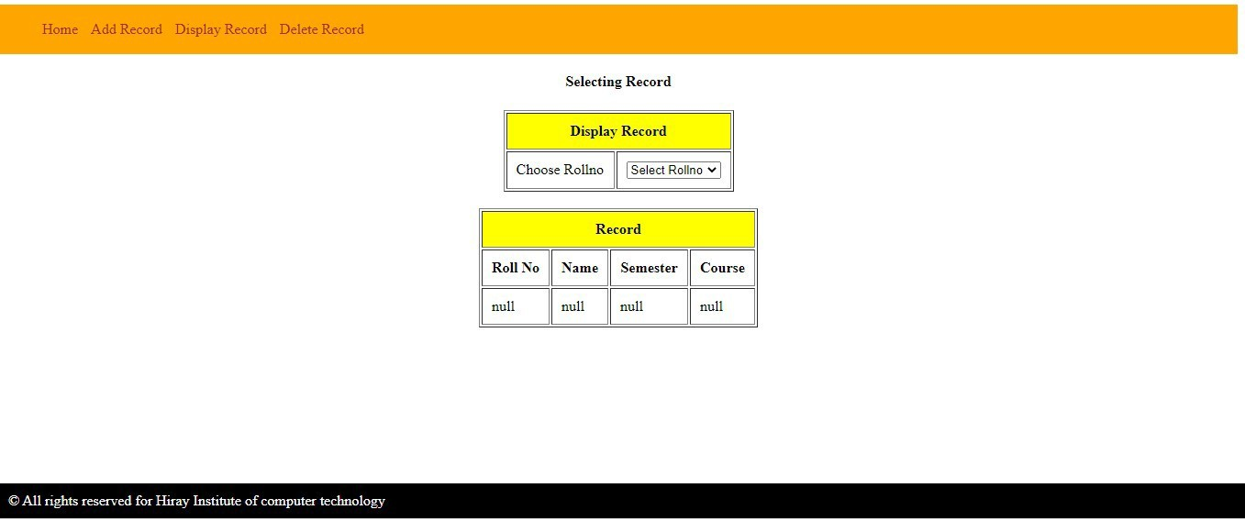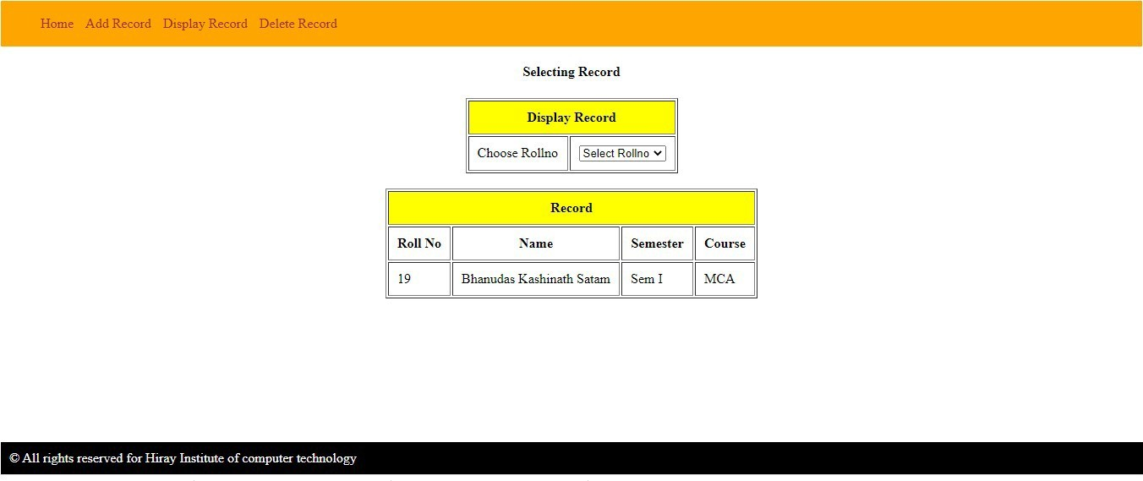Output

Delete.jsp

<%--

Document : index

Created on : Mar 18, 2021, 8:49:16 AM Author : YASH MALEKAR

--%>

<%@page import="java.sql.SQLException"%>

<%@page import="java.sql.DriverManager"%>

<%@page import="java.sql.Statement"%>

<%@page import="java.sql.ResultSet"%>

<%@page import="java.sql.Connection"%>

<%@page import="java.sql.ResultSetMetaData"%>

<%@page contentType="text/html" pageEncoding="UTF-8"%>

<!DOCTYPE html>

<html>

<head>

<meta http-equiv="Content-Type" content="text/html; charset=UTF-8">

<title>Index page</title>

<style>

#content

{

margin-top:10px;

}

.tablehead

{

background-color: yellow; padding:10px;

}

</style>

</head>

<body>

<%

String rollno=request.getParameter("optrollno"); Connection conn;

ResultSetMetaData rsmd; ResultSet rs=null; Statement st;

try

{

conn=DriverManager.getConnection("jdbc:mysql://localhost:3306/studentdb","root",""); st=conn.createStatement();

rs=st.executeQuery("select rollno from student");

}catch(NumberFormatException e)

{

e.printStackTrace();

}

catch(SQLException e)

{

e.printStackTrace();

}

%>

<%@include file="header.jsp" %>

<div id="content">

<h4 align="center">Deleting Record </h4>

<form action="deleterecord.jsp" name="myform">

<table border="1" align="center" cellpadding="10px">

<thead>

<tr class='tablehead'>

<th colspan="2">Delete Record</th>

</tr>

</thead>

<tbody>

<tr>

<td>Choose Rollno</td>

<td><select name="optrollno" onchange="document.myform.submit();">

<%

rsmd=rs.getMetaData();

int tcol=rsmd.getColumnCount(); out.println("<option>"); out.println("Select Rollno"); out.println("</option>"); while(rs.next())

{

out.println("<option>"); out.println(rs.getString(1)); out.println("</option>");

}

%>

</select></td>

</tr>

</tbody>

</table>

<table align="center">

<tr>

<td colspan="2">${param.message}</td>

</tr>

</table>

<%@include file="footer.jsp" %>

</body>

</html>

Deleterecord.jsp

<%--

Document : deleterecord

Created on : Mar 18, 2021, 9:19:27 AM Author : BHANUDAS SATAM

--%>

<%@page import="java.sql.SQLException"%>

<%@page import="java.sql.DriverManager"%>

<%@page import="java.sql.PreparedStatement"%>

<%@page import="java.sql.ResultSet"%>

<%@page import="java.sql.Connection"%>

<%@page import="java.sql.ResultSetMetaData"%>

<%@page contentType="text/html" pageEncoding="UTF-8"%>

<!DOCTYPE html>

<html>

<head>

<meta http-equiv="Content-Type" content="text/html; charset=UTF-8">

<title>JSP Page</title>

</head>

<body>

<%

String rollno=request.getParameter("optrollno"); Connection conn;

PreparedStatement ps;

try

{

conn=DriverManager.getConnection("jdbc:mysql://localhost:3306/studentdb","root",""); ps=conn.prepareStatement("delete from student where rollno = ?");

ps.setInt(1, Integer.parseInt(rollno)); ps.executeUpdate();

conn.commit(); conn.close();

}catch(NumberFormatException e)

{

e.printStackTrace();

}

catch(SQLException e)

{

e.printStackTrace();

}

%>

<jsp:forward page="delete.jsp">

<jsp:param name="message" value="Records Deleted successfully"/>

</jsp:forward>

</body>

</html>

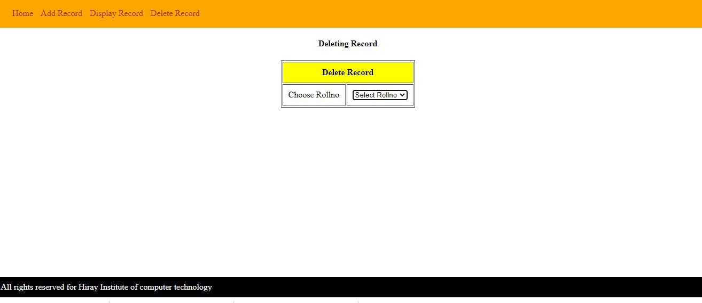**Output**

# Practical 6.5

Index.jsp

<%--

Document : index

Created on : Mar 23, 2021, 7:31:15 AM Author : YASH MALEKAR

Write a program using JSP that displays a webpage consisting Application form for change of Study Center which can be filled by any student who wants to change his/her study center.

Make necessary assumptions

--%>

<%@page contentType="text/html" pageEncoding="UTF-8"%>

<!DOCTYPE html>

<html>

<head>

<meta http-equiv="Content-Type" content="text/html; charset=UTF-8">

<title>Practical 6-5</title>

</head>

<body>

<h1 align="Center">Application form for Change of Study Center</h1>

<form action="Process.jsp">

<table border="1" align="center" cellpadding="20px">

<tbody>

<tr>

<td>Registration id</td>

<td><input type="text" name="txtRegid" value="" /></td>

</tr>

<tr>

<td>Name</td>

<td><input type="text" name="txtName" value="" /></td>

</tr>

<tr>

<td>Old Study center address</td>

<td><textarea name="txtOldaddress" rows="4" cols="20">

</textarea></td>

</tr>

<tr>

<td>New Study center address</td>

<td><textarea name="txtNewaddress" rows="4" cols="20">

</textarea></td>

</tr>

<tr>

<td><input type="submit" value="Change It" /></td>

<td><input type="reset" value="Reset" /></td>

</tr>

</tbody>

</table>

</form>

</body>

</html>

Process.jsp

<%--

Document : Process

Created on : Mar 23, 2021, 7:36:34 AM Author : YASH MALEKAR

--%>

<%@page contentType="text/html" pageEncoding="UTF-8"%>

<!DOCTYPE html>

<html>

<head>

<meta http-equiv="Content-Type" content="text/html; charset=UTF-8">

<title>JSP Page</title>

</head>

<body>

<h1 align="center">Address is Successfully change</h1>

<%

String regid=request.getParameter("txtRegid"); String name=request.getParameter("txtName");

String oldadd=request.getParameter("txtOldaddress"); String newadd=request.getParameter("txtNewaddress");

out.println("<table border='1' align='center' cellpadding='20px' ");

out.println("<tr>"); out.println("<td>"); out.println("Registration Id"); out.println("</td>"); out.println("<td>"); out.println(regid);

out.println("</td>"); out.println("</tr>");

out.println("<tr>"); out.println("<td>"); out.println("Name"); out.println("</td>"); out.println("<td>"); out.println(name); out.println("</td>"); out.println("</tr>");

out.println("<tr>"); out.println("<td>"); out.println("Old address"); out.println("</td>"); out.println("<td>"); out.println(oldadd); out.println("</td>"); out.println("</tr>");

out.println("<tr>"); out.println("<td>"); out.println("New address"); out.println("</td>"); out.println("<td>"); out.println(newadd); out.println("</td>"); out.println("</tr>");

out.println("</table>");

%>

</body>

</html>

Output

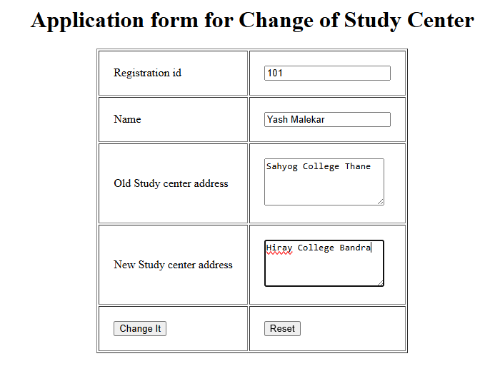

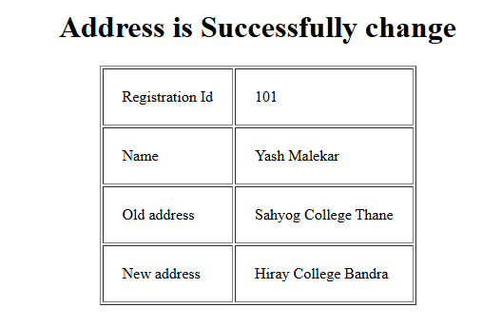

# Practical 6.6

index.jsp

<%--

Document : index

Created on : Mar 18, 2021, 8:10:33 AM Author : YASH MALEKAR

Write a JSP program that demonstrates the use of JSP declaration, scriptlet, directives, expression, header and footer.

--%>

<%@page contentType="text/html" pageEncoding="UTF-8"%>

<!DOCTYPE html>

<html>

<head>

<meta http-equiv="Content-Type" content="text/html; charset=UTF-8">

<title>Practical 6-6</title>

<style>

#content

{

margin-top:10px;

}

</style>

</head>

<body>

<!--use of Include Directives as header -->

<%@include file="header.jsp" %>

<div id="content">

<!--JSP Declaration -->

<%! int number1=10,number2=20;%> Value of number is= <%= number1%> <br>

<!-- use of JSP scriptlet -->

Today's Date is <% out.println(new java.util.Date()); %><br>

<!-- use of expression --> Number1=<%=number1%><br> Number2=<%=number2%><br>

Addition of two numbers are <%=number1+number2%><br>

</div>

<!--use of Include Directives as footer-->

<%@include file="footer.jsp" %>

</body>

</html>

header.jsp

<%--

Document : header

Created on : Mar 18, 2021, 8:24:06 AM Author : YASH MALEKAR

--%>

<%@page contentType="text/html" pageEncoding="UTF-8"%>

<!DOCTYPE html>

<html>

<head>

<meta http-equiv="Content-Type" content="text/html; charset=UTF-8">

<title>JSP Page</title>

<style>

#menu

{

background-color:orange; padding: 2px;

}

li

{

display:inline; padding:5px;

}

a

{

text-decoration: none; color:brown;

}

</style>

</head>

<body>

<div id="menu">

<ul>

<li> <a href="#">Home</a></li>

<li> <a href="#">Service</a></li>

<li> <a href="#">Contact us </a></li>

<li> <a href="#">About us</a></li>

</ul>

</div>

</body>

</html>

footer.jsp

<%--

Document : footer

Created on : Mar 18, 2021, 8:16:07 AM Author : YASH MALEKAR

--%>

<%@page contentType="text/html" pageEncoding="UTF-8"%>

<!DOCTYPE html>

<html>

<head>

<meta http-equiv="Content-Type" content="text/html; charset=UTF-8">

<title>JSP Page</title>

<style>

#foot

{

color:white;

background-color: black; margin-top:200px; padding:10px;

}

</style>

</head>

<body>

<div id="foot">

&COPY; All rights reserved for Hiray Institute of computer technology </div>

</body>

</html>

Output

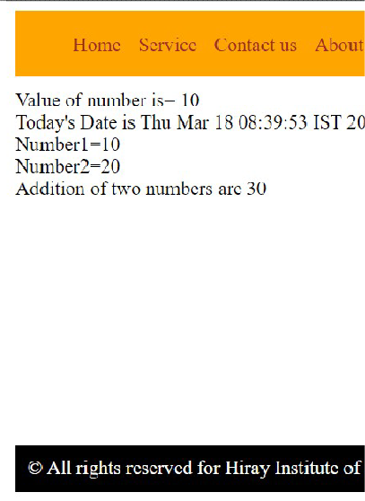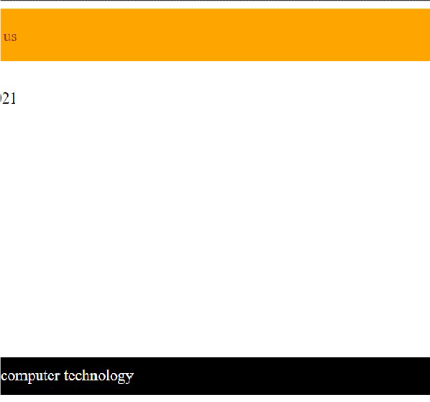

## Practical 7.1

##### 1 Write a program to print “Hello World” using spring HelloWorld.java

**package** com.hiraymca;

**public class** HelloWorld {

**private** String message;

**public void** getMessage() { System.***out***.println("Your message="+message);

}

**public void** setMessage(String message) {

**this**.message = message;

}

}

##### MainApp.java

**package** com.hiraymca;

**import** org.springframework.context.ApplicationContext;

##### import

org.springframework.context.support.ClassPathXmlApplicationContext;

**public class** MainApp {

**public static void** main(String[] args) {

// **TODO** Auto-generated method stub ApplicationContext context=**new**

ClassPathXmlApplicationContext("Beans.xml");

HelloWorld obj=(HelloWorld)context.getBean("helloworld"); obj.setMessage("Hello World");

obj.getMessage();

}

}

Beans.xml

<?xml version=*"1.0"* encoding=*"UTF-8"*?>

<beans xmlns=*"*[*http://www.springframework.org/schema/beans*](http://www.springframework.org/schema/beans)*"* xmlns:xsi=*"*[*http://www.w3.org/2001/XMLSchema-instance*](http://www.w3.org/2001/XMLSchema-instance)*"* xsi:schemaLocation=*"*[*http://www.springframework.org/schema/beans*](http://www.springframework.org/schema/beans)

[*http://www.springframework.org/schema/beans/spring-beans.xsd*](http://www.springframework.org/schema/beans/spring-beans.xsd)*"*>

<bean id=*"helloworld"* class=*"com.hiraymca.HelloWorld"* />

</beans>

Output

Your message=Hello World

## Practical 7.2

##### Write a program to demonstrate dependency injection via setter method.

**Employee.java**

**package** com.hiraymca;

**public class** Employee { **private** String ename; **private int** eage; **private int** esal;

**public** String getEname() {

**return** ename;

}

**public void** setEname(String ename) {

**this**.ename = ename;

}

**public int** getEage() {

**return** eage;

}

**public void** setEage(**int** eage) {

**this**.eage = eage;

}

**public int** getEsal() {

**return** esal;

}

**public void** setEsal(**int** esal) {

**this**.esal = esal;

}

**public void** display()

{

System.***out***.println("Name="+ename+"\n"+"Age="+eage+"\n"+"Salary="+ esal);

}

}

MainApp.java

**package** com.hiraymca;

**import** org.springframework.context.ApplicationContext;

##### import

org.springframework.context.support.ClassPathXmlApplicationContext;

**public class** MainApp {

**public static void** main(String[] args) {

// **TODO** Auto-generated method stub ApplicationContext context=**new**

ClassPathXmlApplicationContext("Beans.xml");

Employee e=(Employee)context.getBean("employee"); e.display();

}

}

Beans.xml

<?xml version=*"1.0"* encoding=*"UTF-8"*?>

<beans xmlns=*"*[*http://www.springframework.org/schema/beans*](http://www.springframework.org/schema/beans)*"* xmlns:xsi=*"*[*http://www.w3.org/2001/XMLSchema-instance*](http://www.w3.org/2001/XMLSchema-instance)*"* xsi:schemaLocation=*"*[*http://www.springframework.org/schema/beans*](http://www.springframework.org/schema/beans)

[*http://www.springframework.org/schema/beans/spring-beans.xsd*](http://www.springframework.org/schema/beans/spring-beans.xsd)*"*>

<bean id=*"employee"* class=*"com.hiraymca.Employee"*>

<property name=*"ename"* value=*"YASH"*></property>

<property name=*"eage"* value=*"22"*> </property>

<property name=*"esal"* value=*"50000"*></property>

</bean>

</beans> Output

Name=YASH Age=22 Salary=50000

## Practical 7.2b

##### Write a program to demonstrate dependency injection via setter method using beanfactory container

Employee.java

**package** com.hiraymca;

**public class** Employee { **private** String ename; **private int** eage; **private int** esal;

**public** Employee(String ename, **int** eage, **int** esal) {

**super**();

**this**.ename = ename; **this**.eage = eage; **this**.esal = esal;

}

**public** Employee() { **this**.ename="YASH"; **this**.eage=22; **this**.esal=55000;

}

**public** String getEname() {

**return** ename;

}

**public void** setEname(String ename) {

**this**.ename = ename;

}

**public int** getEage() {

**return** eage;

}

**public void** setEage(**int** eage) {

**this**.eage = eage;

}

**public int** getEsal() {

**return** esal;

}

**public void** setEsal(**int** esal) {

**this**.esal = esal;

}

**public void** display()

{

System.***out***.println("Name="+ename);

System.***out***.println("Age="+eage); System.***out***.println("Salary="+esal);

}

}

Beans.xml

<?xml version=*"1.0"* encoding=*"UTF-8"*?>

<beans xmlns=*"*[*http://www.springframework.org/schema/beans*](http://www.springframework.org/schema/beans)*"* xmlns:xsi=*"*[*http://www.w3.org/2001/XMLSchema-instance*](http://www.w3.org/2001/XMLSchema-instance)*"* xsi:schemaLocation=*"*[*http://www.springframework.org/schema/beans*](http://www.springframework.org/schema/beans)

[*http://www.springframework.org/schema/beans/spring-beans.xsd*](http://www.springframework.org/schema/beans/spring-beans.xsd)*"*>

<bean id=*"emp"* class=*"com.hiraymca.Employee"* > </bean>

</beans>

MainApp.java

package com.hiraymca;

import org.springframework.beans.factory.BeanFactory;

import org.springframework.context.support.ClassPathXmlApplicationContext;

public class MainApp {

public static void main(String[] args) {

// TODO Auto-generated method stub

BeanFactory factory=new ClassPathXmlApplicationContext("Beans.xml"); Employee e=(Employee)factory.getBean("emp");

e.display();

}

}

##### Output

Name=YASH Age=22 Salary=55000

# Practical 7.3

Write a program to demonstrate dependency injection via Constructor.

##### Employee.java

**package** com.hiraymca;

**public class** Employee { **private** String ename; **private int** eage; **private int** esal;

**public** Employee(String ename, **int** eage, **int** esal) {

**super**();

**this**.ename = ename; **this**.eage = eage; **this**.esal = esal;

}

**public** Employee()

{

**this**.ename="YASH"; **this**.eage=22; **this**.esal=60000;

}

**public** String getEname() {

**return** ename;

}

**public void** setEname(String ename) {

**this**.ename = ename;

}

**public int** getEage() {

**return** eage;

}

**public void** setEage(**int** eage) {

**this**.eage = eage;

}

**public int** getEsal() {

**return** esal;

}

**public void** setEsal(**int** esal) {

**this**.esal = esal;

}

**public void** display()

{

System.***out***.println("Name="+ename); System.***out***.println("Age="+eage);

System.***out***.println("Salary="+esal);

}

}

MainApp.java

package com.hiraymca;

import org.springframework.beans.factory.BeanFactory;

import org.springframework.context.support.ClassPathXmlApplicationContext; public class MainApp {

public static void main(String[] args) {

// TODO Auto-generated method stub

BeanFactory factory=new ClassPathXmlApplicationContext("Beans.xml"); Employee e=(Employee)factory.getBean("emp");

e.display();

}

Beans.xml

<?xml version=*"1.0"* encoding=*"UTF-8"*?>

<beans xmlns=*"*[*http://www.springframework.org/schema/beans*](http://www.springframework.org/schema/beans)*"* xmlns:xsi=*"*[*http://www.w3.org/2001/XMLSchema-instance*](http://www.w3.org/2001/XMLSchema-instance)*"* xsi:schemaLocation=*"*[*http://www.springframework.org/schema/beans*](http://www.springframework.org/schema/beans)

[*http://www.springframework.org/schema/beans/spring-beans.xsd*](http://www.springframework.org/schema/beans/spring-beans.xsd)*"*>

<bean id=*"emp"* class=*"com.hiraymca.Employee"* >

<constructor-arg index=*"0"* value=*"YASH"*/>

<constructor-arg index=*"1"* value=*"22"*/>

<constructor-arg index=*"2"* value=*"60000"*/>

</bean>

Output

Name=YASH Age=22 Salary=60000

# Practical 8.0

XML Schema Based AOP with Spring

To use the AOP namespace tags described in this section, you need to import the springAOP schema as described

<?xml version = "1.0" encoding = "UTF-8"?>

<beans xmlns = "<http://www.springframework.org/schema/beans>" xmlns:xsi = "<http://www.w3.org/2001/XMLSchema-instance>" xmlns:aop = "<http://www.springframework.org/schema/aop>" xsi:schemaLocation = "<http://www.springframework.org/schema/beans> <http://www.springframework.org/schema/beans/spring-beans-3.0.xsd> <http://www.springframework.org/schema/aop> <http://www.springframework.org/schema/aop/spring-aop-3.0.xsd> ">

<!-- bean definition & AOP specific configuration -->

</beans>

You will also need the following AspectJ libraries on the CLASSPATH of your application. These libraries are available in the 'lib' directory of an AspectJ installation, otherwise you can download them from the internet.

* aspectjrt.jar
* aspectjweaver.jar
* aspectj.jar
* aopalliance.jar

Logging.java

package com.hiraymca;

public class Logging {

/**

* This is the method which I would like to execute
* before a selected method execution.

*/

public void beforeAdvice(){

System.out.println("Going to setup student profile.");

}

/**

* This is the method which I would like to execute
* after a selected method execution.

*/

public void afterAdvice(){

System.out.println("Student profile has been setup.");

}

/**

* This is the method which I would like to execute
* when any method returns.

*/

public void afterReturningAdvice(Object retVal) { System.out.println("Returning:" + retVal.toString() );

}

/**

* This is the method which I would like to execute
* if there is an exception raised.

*/

public void AfterThrowingAdvice(IllegalArgumentException ex){ System.out.println("There has been an exception: " + ex.toString());

}

}

Student.java

package com.hiraymca;

public class Student { private Integer age; private String name;

public void setAge(Integer age) { this.age = age;

}

public Integer getAge() { System.out.println("Age : " + age );

return age;

}

public void setName(String name) { this.name = name;

}

public String getName() { System.out.println("Name : " + name ); return name;

}

public void printThrowException(){ System.out.println("Exception raised");

throw new IllegalArgumentException();

}

}

MainApp.java

package com.hiraymca;

import org.springframework.context.ApplicationContext;

import org.springframework.context.support.ClassPathXmlApplicationContext;

public class MainApp {

public static void main(String[] args) { ApplicationContext context = new

ClassPathXmlApplicationContext("Beans.xml");

Student student = (Student) context.getBean("student"); student.getName();

student.getAge(); student.printThrowException();

}

}

**Beans.xml**

<?xml version = "1.0" encoding = "UTF-8"?>

<beans xmlns = "<http://www.springframework.org/schema/beans>" xmlns:xsi = "<http://www.w3.org/2001/XMLSchema-instance>" xmlns:aop = "<http://www.springframework.org/schema/aop>" xsi:schemaLocation = "<http://www.springframework.org/schema/beans> <http://www.springframework.org/schema/beans/spring-beans-3.0.xsd> <http://www.springframework.org/schema/aop> <http://www.springframework.org/schema/aop/spring-aop-3.0.xsd> ">

<aop:config>

<aop:aspect id = "log" ref = "logging">

<aop:pointcut id = "selectAll"

expression = "execution(* com.tutorialspoint.*.*(..))"/>

<aop:before pointcut-ref = "selectAll" method = "beforeAdvice"/>

<aop:after pointcut-ref = "selectAll" method = "afterAdvice"/>

<aop:after-returning pointcut-ref = "selectAll" returning = "retVal" method = "afterReturningAdvice"/>

<aop:after-throwing pointcut-ref = "selectAll" throwing = "ex" method = "AfterThrowingAdvice"/>

</aop:aspect>

</aop:config>

<!-- Definition for student bean -->

<bean id = "student" class = "com.tutorialspoint.Student">

<property name = "name" value = "YASH" />

<property name = "age" value = "22"/>

</bean>

<!-- Definition for logging aspect -->

<bean id = "logging" class = "com.tutorialspoint.Logging"/>

</beans>

Output

Going to setup student profile. Name : YASH

Student profile has been setup. Returning:YASH

Going to setup student profile. Age : 22

Student profile has been setup. Returning:22

Going to setup student profile. Exception raised

Student profile has been setup.

There has been an exception: java.lang.IllegalArgumentException

.....other exception content

# Practical 8.1

Spring AOP – before advice

Write a program to demonstrate Spring AOP – before advice.

**Logging.java**

**package** com.hiraymca;

**public class** Logging {

//Types of Advice

//1 beforeAdvice

**public void** beforeAdvice()

{

System.***out***.println("Setuping Student Profile ");

}

}

##### Student.java

**package** com.hiraymca;

**public class** Student { **private int** age; **private** String name; **public int** getAge() {

System.***out***.println("Age-"+age);

**return** age;

}

**public void** setAge(**int** age) {

**this**.age = age;

}

**public** String getName() { System.***out***.println("Name="+name); **return** name;

}

**public void** setName(String name) {

**this**.name = name;

}

}

##### MainApp.java

package com.hiraymca;

import org.springframework.context.ApplicationContext;

import org.springframework.context.support.ClassPathXmlApplicationContext;

public class MainApp {

public static void main(String[] args) {

// TODO Auto-generated method stub ApplicationContext context=new

ClassPathXmlApplicationContext("Beans.xml");

Student s=(Student)context.getBean("student"); s.getName();

s.getAge();

}

}

##### Beans.xml

<?xml version=*"1.0"* encoding=*"UTF-8"*?>

<beans xmlns=*"*[*http://www.springframework.org/schema/beans*](http://www.springframework.org/schema/beans)*"* xmlns:xsi=*"*[*http://www.w3.org/2001/XMLSchema-instance*](http://www.w3.org/2001/XMLSchema-instance)*"* xmlns:aop=*"*[*http://www.springframework.org/schema/aop*](http://www.springframework.org/schema/aop)*"* xmlns:c=*"*[*http://www.springframework.org/schema/c*](http://www.springframework.org/schema/c)*"* xmlns:lang=*"*[*http://www.springframework.org/schema/lang*](http://www.springframework.org/schema/lang)*"* xmlns:util=*"*[*http://www.springframework.org/schema/util*](http://www.springframework.org/schema/util)*"* xsi:schemaLocation=*"*[*http://www.springframework.org/schema/beans*](http://www.springframework.org/schema/beans)

[*http://www.springframework.org/schema/beans/spring-beans.xsd*](http://www.springframework.org/schema/beans/spring-beans.xsd)[*http://www.springframework.org/schema/lang*](http://www.springframework.org/schema/lang)

[*http://www.springframework.org/schema/lang/spring-lang-4.3.xsd*](http://www.springframework.org/schema/lang/spring-lang-4.3.xsd)[*http://www.springframework.org/schema/aop*](http://www.springframework.org/schema/aop)

[*http://www.springframework.org/schema/aop/spring-aop-4.3.xsd*](http://www.springframework.org/schema/aop/spring-aop-4.3.xsd)[*http://www.springframework.org/schema/util*](http://www.springframework.org/schema/util)

[*http://www.springframework.org/schema/util/spring-util-4.3.xsd*](http://www.springframework.org/schema/util/spring-util-4.3.xsd)*"*>

<aop:config>

<aop:aspect id=*"log"* ref=*"logging"*>

<aop:pointcut expression=*"execution(* com.hiraymca.*.*(..))"* id=*"myid"*/>

<aop:before method=*"beforeAdvice"* pointcut-ref=*"myid"*

/>

</aop:aspect>

</aop:config>

<bean id=*"student"* class=*"com.hiraymca.Student"*>

<property name=*"name"* value=*"YASHMALEKAR"*></property>

<property name=*"age"* value=*"22"*></property>

</bean>

<bean id=*"logging"* class=*"com.hiraymca.Logging"*></bean>

</beans>

##### Output

Setuping Student Profile Name=YASHMALEKAR

Setuping Student Profile Age-22

# Practical 8.2

Spring AOP – after advice

Write a program to demonstrate Spring AOP – after advice.

**Logging.java**

**package** com.hiraymca;

**public class** Logging {

//Types of Advice

//1 beforeAdvice

**public void** afterAdvice()

{

System.***out***.println("Student Profile done ");

}

}

##### Student.java

**package** com.hiraymca;

**public class** Student { **private int** age; **private** String name; **public int** getAge() {

System.***out***.println("Age-"+age);

**return** age;

}

**public void** setAge(**int** age) {

**this**.age = age;

}

**public** String getName() { System.***out***.println("Name="+name); **return** name;

}

**public void** setName(String name) {

**this**.name = name;

}

}

##### MainApp.java

package com.hiraymca;

import org.springframework.context.ApplicationContext;

import org.springframework.context.support.ClassPathXmlApplicationContext;

public class MainApp {

public static void main(String[] args) {

// TODO Auto-generated method stub ApplicationContext context=new

ClassPathXmlApplicationContext("Beans.xml");

Student s=(Student)context.getBean("student"); s.getName();

s.getAge();

}

}

##### Beans.xml

<?xml version=*"1.0"* encoding=*"UTF-8"*?>

<beans xmlns=*"*[*http://www.springframework.org/schema/beans*](http://www.springframework.org/schema/beans)*"* xmlns:xsi=*"*[*http://www.w3.org/2001/XMLSchema-instance*](http://www.w3.org/2001/XMLSchema-instance)*"* xmlns:aop=*"*[*http://www.springframework.org/schema/aop*](http://www.springframework.org/schema/aop)*"* xmlns:c=*"*[*http://www.springframework.org/schema/c*](http://www.springframework.org/schema/c)*"* xmlns:lang=*"*[*http://www.springframework.org/schema/lang*](http://www.springframework.org/schema/lang)*"* xmlns:util=*"*[*http://www.springframework.org/schema/util*](http://www.springframework.org/schema/util)*"* xsi:schemaLocation=*"*[*http://www.springframework.org/schema/beans*](http://www.springframework.org/schema/beans)

[*http://www.springframework.org/schema/beans/spring-beans.xsd*](http://www.springframework.org/schema/beans/spring-beans.xsd)[*http://www.springframework.org/schema/lang*](http://www.springframework.org/schema/lang)

[*http://www.springframework.org/schema/lang/spring-lang-4.3.xsd*](http://www.springframework.org/schema/lang/spring-lang-4.3.xsd)[*http://www.springframework.org/schema/aop*](http://www.springframework.org/schema/aop)

[*http://www.springframework.org/schema/aop/spring-aop-4.3.xsd*](http://www.springframework.org/schema/aop/spring-aop-4.3.xsd)[*http://www.springframework.org/schema/util*](http://www.springframework.org/schema/util)

[*http://www.springframework.org/schema/util/spring-util-4.3.xsd*](http://www.springframework.org/schema/util/spring-util-4.3.xsd)*"*>

<aop:config>

<aop:aspect id=*"log"* ref=*"logging"*>

<aop:pointcut expression=*"execution(* com.hiraymca.*.*(..))"* id=*"myid"*/>

<aop:after method=*"afterAdvice"* pointcut-ref=*"myid"* />

</aop:aspect>

</aop:config>

<bean id=*"student"* class=*"com.hiraymca.Student"*>

<property name=*"name"* value=*"YASHMALEKAR"*></property>

<property name=*"age"* value=*"22"*></property>

</bean>

<bean id=*"logging"* class=*"com.hiraymca.Logging"*></bean>

</beans>

##### Output

Name=YASHMALEKAR Student Profile done Age-22

Student Profile done

# Practical 9.1

Write a program to insert, update and delete records from the given table

**Student Interface iStudent.java**

package com.hiraymca; import java.util.List;

import javax.sql.DataSource; public interface IStudent {

//setting data source

public void setDataSource(DataSource datasource);

//creating records- inserting record into table public void create(int rollno,String name, int age);

//reading specific records

public Student readStudent(int id);

//reading all the records from table public List<Student> listStudents();

//update record

public void update(int id,int rollno,String name, int age);

//delete record

public void delete(int id);

}

### Student.java

package com.hiraymca; import java.util.List;

import javax.sql.DataSource;

public class Student { int id;

int rollno; String sname; int age;

public int getId() {

return id;

}

public void setId(int id) { this.id = id;

}

public int getRollno() { return rollno;

}

public void setRollno(int rollno) { this.rollno = rollno;

}

public String getSname() { return sname;

}

public void setSname(String sname) { this.sname = sname;

}

public int getAge() { return age;

}

public void setAge(int age) { this.age = age;

}

}

**StudentJDBCTemplate.java** package com.hiraymca; import java.util.List;

import javax.sql.DataSource;

import org.springframework.jdbc.core.JdbcTemplate;

public class StudentJDBCTemplate implements IStudent { private DataSource dataSource;

private JdbcTemplate jdbcTemplateObject;

@Override

public void setDataSource(DataSource datasource) {

// TODO Auto-generated method stub this.dataSource=datasource; this.jdbcTemplateObject=new JdbcTemplate(datasource);

}

@Override

//inserting a new record into database

public void create(int rollno, String name, int age) {

// TODO Auto-generated method stub

String sql="insert into student2(rollno,sname,age)values(?,?,?)"; jdbcTemplateObject.update(sql,rollno,name,age); System.out.println("Record inserted successfully");

}

@Override

public Student readStudent(int id) {

// TODO Auto-generated method stub

String sql="select * from student2 where id=?";

Student student=(Student)jdbcTemplateObject.queryForObject(sql,new Object[]

{id},new StudentMapper());

return student;

}

@Override

public List<Student> listStudents() {

// TODO Auto-generated method stub String sql="select * from student2";

List<Student> students=jdbcTemplateObject.query(sql, new StudentMapper());

return students;

}

@Override

public void update(int id, int rollno, String sname, int age) {

// TODO Auto-generated method stub

String SQL = "update Student2 set rollno=?,sname=?,age = ? where id = ?";

jdbcTemplateObject.update(SQL, rollno,sname,age,id); System.out.println("Updated Record with ID = " + id ); return;

}

@Override

public void delete(int id) {

// TODO Auto-generated method stub

String SQL = "delete from Student2 where id = ?"; jdbcTemplateObject.update(SQL, id); System.out.println("Deleted Record with ID = " + id );

}

}

**StudentMapper.java** package com.hiraymca; import java.sql.ResultSet; import java.sql.SQLException; import java.util.List;

import javax.sql.DataSource;

import org.springframework.jdbc.core.RowMapper;

public class StudentMapper implements RowMapper<Student>

{

public Student mapRow(ResultSet rs, int rowNum) throws SQLException {

Student student = new Student(); student.setId(rs.getInt("id")); student.setRollno(rs.getInt("rollno")); student.setSname(rs.getString("sname")); student.setAge(rs.getInt("age"));

return student;

}

}

### Beans.xml

<?xml version=*"1.0"* encoding=*"UTF-8"*?>

<beans xmlns=*"*[*http://www.springframework.org/schema/beans*](http://www.springframework.org/schema/beans)*"* xmlns:xsi=*"*[*http://www.w3.org/2001/XMLSchema-instance*](http://www.w3.org/2001/XMLSchema-instance)*"* xsi:schemaLocation=*"*[*http://www.springframework.org/schema/beans*](http://www.springframework.org/schema/beans)

[*http://www.springframework.org/schema/beans/spring-beans.xsd*](http://www.springframework.org/schema/beans/spring-beans.xsd)*"*>

<bean id=*"dataSource"*

###### class = "org.springframework.jdbc.datasource.DriverManagerDataSource">

<property name = *"driverClassName"* value = *"com.mysql.jdbc.Driver"*/>

<property name = *"url"* value =

###### "jdbc:mysql://localhost:3306/studentdb"/>

<property name = *"username"* value = *"root"*/>

<property name = *"password"* value = *""*/>

</bean>

<bean id=*"studentJDBCTemplate"* class=*"com.hiraymca.StudentJDBCTemplate"*>

<property name=*'dataSource'* ref=*"dataSource"*></property>

</bean>

</beans>

MainApp.java

package com.hiraymca; import java.util.List; import java.util.Scanner; import java.util.ArrayList;

import org.springframework.context.ApplicationContext; import

org.springframework.context.support.ClassPathXmlApplicationContext; import org.springframework.dao.EmptyResultDataAccessException;

public class MainApp {

public static void main(String[] args) {

// TODO Auto-generated method stub ApplicationContext context=new

ClassPathXmlApplicationContext("Beans.xml"); StudentJDBCTemplate studentJDBCTemplate;

studentJDBCTemplate=(StudentJDBCTemplate)context.getBean("stude ntJDBCTemplate");

int choice; int id;

int rollno; String sname; int age;

String ans=null;

Scanner sc=new Scanner(System.in); do

{

System.out.println("Select the choice"); System.out.println("1.Insert record "); System.out.println("2.Read record"); System.out.println("3.List all the records"); System.out.println("4.Delete the record"); System.out.println("5.Exit"); System.out.print("Enter your choice(1..5):"); choice=sc.nextInt();

switch(choice)

{

case 1:

//inserting a record

System.out.print("Enter roll no"); rollno=sc.nextInt(); System.out.println("Enter name"); sname=sc.next(); System.out.println("Enter age"); age=sc.nextInt();

studentJDBCTemplate.create(rollno, sname, age); break;

case 2:

//reading a record

Student student; System.out.println("Enter record id"); id=sc.nextInt();

try

{

student=studentJDBCTemplate.readStudent(id); System.out.println("id="+student.getId()); System.out.println("Rollno="+student.rollno); System.out.println("Name="+student.getSname()); System.out.println("Age="+student.getAge());

}catch(Exception ex)

{

}

case 3:

System.out.println("Record not found"); break;

//listing all the records List<Student>

students=studentJDBCTemplate.listStudents();

System.out.println("id"+"\t"+"Rollno"+"\t"+"Name"+"\t\t"+"Age"); for (Student record : students) {

System.out.println(record.getId()+"\t"+record.getRollno()+"\t"+record. getSname()+"\t\t"+record.getAge());

}

break;

case 4:

// delete the record System.out.println("Enter record id"); id=sc.nextInt();

try

{

studentJDBCTemplate.delete(id);

}

catch(Exception ex)

{

}

case 5:

}

System.out.println("Record not found"); break;

System.exit(0); break;

System.out.println("Do you wish to continue(y/n)"); ans=sc.next();

}while(ans.equals("Y")||ans.equals("y"));

}

}

Output:-

Select the choice

1.Insert record

2.Read record

3.List all the records

4.Delete the record

5.Exit

Enter your choice(1..5):1

Enter roll no127

Enter name

Vishal

Enter age

22

Record inserted successfully

Do you wish to continue(y/n)

# Practical 9.2

Write a program to demonstrate PreparedStatement in Spring JdbcTemplate

IStudent.java

package com.hiraymca; java.util.List;

import javax.sql.DataSource; public interface IStudent {

//setting data source

public void setDataSource(DataSource datasource);

//creating records- inserting record into table public void create(int rollno,String name, int age);

//listing all records

public List<Student> listStudents();

}

Student.java

package com.hiraymca; import java.util.List;

import javax.sql.DataSource;

public class Student { int id;

int rollno; String sname; int age;

public Student(int rollno, String sname, int age) {

this.rollno = rollno; this.sname = sname; this.age = age;

}

public int getId() {

return id;

}

public void setId(int id) {

this.id = id;

}

public int getRollno() {

return rollno;

}

public void setRollno(int rollno) { this.rollno = rollno;

}

public String getSname() {

return sname;

}

public void setSname(String sname) { this.sname = sname;

}

public int getAge() {

return age;

}

public void setAge(int age) { this.age = age;

}

}

StudentDAO.java

**package** com.hiraymca;

**import** java.sql.PreparedStatement;

**import** java.sql.SQLException;

**import** org.springframework.dao.DataAccessException;

**import** org.springframework.jdbc.core.JdbcTemplate;

**import** org.springframework.jdbc.core.PreparedStatementCallback;

**public class** StudentDAO {

**private** JdbcTemplate jdbcTemplate;

**public void** setJdbcTemplate(JdbcTemplate jdbcTemplate) {

**this**.jdbcTemplate = jdbcTemplate;

}

**public** Boolean saveStudent(**final** Student s)

{

String query="insert into

student2(rollno,sname,age)values(?,?,?)";

**return** jdbcTemplate.execute(query,**new** PreparedStatementCallback<Boolean>() {

@Override

**public** Boolean doInPreparedStatement(PreparedStatement

ps)

**throws** SQLException, DataAccessException {

ps.setInt(1,s.getRollno()); ps.setString(2,s.getSname()); ps.setFloat(3,s.getAge());

**return** ps.execute();

}

});

}

}

MainApp.java

package com.hiraymca; import java.util.List; import java.util.Scanner; import java.util.ArrayList;

import org.springframework.context.ApplicationContext;

import org.springframework.context.support.ClassPathXmlApplicationContext; import org.springframework.dao.EmptyResultDataAccessException;

public class MainApp {

private static int rollno; private static String sname; private static int age;

public static void main(String[] args) {

// TODO Auto-generated method stub

ApplicationContext context=new ClassPathXmlApplicationContext("Beans.xml"); Scanner sc=new Scanner(System.in);

StudentDAO stud=(StudentDAO)context.getBean("studentDAO"); System.out.println("Enter rollno");

rollno=sc.nextInt(); System.out.println("Enter student name"); sname=sc.next(); System.out.println("Enter age"); age=sc.nextInt();

stud.saveStudent(new Student(rollno,sname,age)); System.out.println("Record inserted successfully");

}

}

Beans.xml

<?xml version=*"1.0"* encoding=*"UTF-8"*?>

<beans xmlns=*"*[*http://www.springframework.org/schema/beans*](http://www.springframework.org/schema/beans)*"* xmlns:xsi=*"*[*http://www.w3.org/2001/XMLSchema-instance*](http://www.w3.org/2001/XMLSchema-instance)*"* xsi:schemaLocation=*"*[*http://www.springframework.org/schema/beans*](http://www.springframework.org/schema/beans)

[*http://www.springframework.org/schema/beans/spring-beans.xsd*](http://www.springframework.org/schema/beans/spring-beans.xsd)*"*>

<bean id=*"ds"*

class =

###### "org.springframework.jdbc.datasource.DriverManagerDataSource">

<property name = *"driverClassName"* value =

*"com.mysql.jdbc.Driver"*/>

<property name = *"url"* value =

###### "jdbc:mysql://localhost:3306/studentdb"/>

<property name = *"username"* value = *"root"*/>

<property name = *"password"* value = *""*/>

</bean>

<bean id=*"jdbcTemplate"* class=*"org.springframework.jdbc.core.JdbcTemplate"*>

<property name=*"dataSource"* ref=*"ds"*></property>

</bean>

<bean id=*"studentDAO"* class=*"com.hiraymca.StudentDAO"*>

<property name=*'jdbcTemplate'* ref=*"jdbcTemplate"*></property>

</bean>

</beans>

**Output**

Enter rollno 128

Enter student name yash

Enter age 22

Record inserted successfully

# Practical 9.3

#### Write a program in Spring JDBC to demonstrate ResultSetExtractor Interface

iStudent.java [Student interface]

package com.hiraymca; import java.util.List;

import javax.sql.DataSource; public interface IStudent {

//setting data source

public void setDataSource(DataSource datasource);

//creating records- inserting record into table public void create(int rollno,String name, int age);

//listing all records

public List<Student> listStudents();

}

Student.java

package com.hiraymca; import java.util.List;

import javax.sql.DataSource; public class Student {

int id;

int rollno; String sname; int age;

public Student()

{

}

public Student(int rollno, String sname, int age) {

this.rollno = rollno; this.sname = sname; this.age = age;

}

public int getId() {

return id;

}

public void setId(int id) {

this.id = id;

}

public int getRollno() {

return rollno;

}

public void setRollno(int rollno) { this.rollno = rollno;

}

public String getSname() {

return sname;

}

public void setSname(String sname) { this.sname = sname;

}

public int getAge() {

return age;

}

public void setAge(int age) { this.age = age;

}

}

StudentDAO.java

**package** com.hiraymca;

**import** java.sql.PreparedStatement; **import** java.sql.SQLException; **import** java.util.ArrayList;

**import** java.util.List;

**import** java.sql.ResultSet;

**import** org.springframework.dao.DataAccessException;

**import** org.springframework.jdbc.core.JdbcTemplate;

**import** org.springframework.jdbc.core.PreparedStatementCallback;

**import** org.springframework.jdbc.core.ResultSetExtractor;

**public class** StudentDAO {

**private** JdbcTemplate jdbcTemplate;

**public void** setJdbcTemplate(JdbcTemplate jdbcTemplate) {

**this**.jdbcTemplate = jdbcTemplate;

}

**public** Boolean saveStudent(**final** Student s)

{

String query="insert into student3(rollno,sname,age)values(?,?,?)";

**return** jdbcTemplate.execute(query,**new** PreparedStatementCallback<Boolean>() {

@Override

**public** Boolean doInPreparedStatement(PreparedStatement

ps)

**throws** SQLException, DataAccessException {

ps.setInt(1,s.getRollno()); ps.setString(2,s.getSname()); ps.setFloat(3,s.getAge());

**return** ps.execute();

}

});

}

**public** List<Student> getAllStudents(){

**return** jdbcTemplate.query("select * from student3",

**new** ResultSetExtractor<List<Student>>() {

@Override

**public** List<Student> extractData(ResultSet rs)

**throws** SQLException, DataAccessException {

// **TODO** Auto-generated method stub List<Student>list=**new** ArrayList<Student>(); **while**(rs.next())

{

Student s=**new** Student();

s.setRollno(rs.getInt(1)); s.setSname(rs.getString(2)); s.setAge(rs.getInt(3)); list.add(s);

}

**return** list;

}

});

}

}

MainApp.java

package com.hiraymca; import java.util.List; import java.util.Scanner; import java.util.ArrayList; import java.util.Iterator;

import org.springframework.context.ApplicationContext; import

org.springframework.context.support.ClassPathXmlApplicationContext; import org.springframework.dao.EmptyResultDataAccessException;

public class MainApp {

private static int rollno; private static String sname; private static int age; private static int choice; private static String ans;

public static void main(String[] args) {

// TODO Auto-generated method stub

ApplicationContext context=new ClassPathXmlApplicationContext("Beans.xml");

Scanner sc=new Scanner(System.in);

StudentDAO stud=(StudentDAO)context.getBean("studentDAO"); do

{

System.out.println("1.Insert record"); System.out.println("2.List all record"); System.out.println("3.Exit"); System.out.print("Enter your choice(1..3)"); choice=sc.nextInt();

switch(choice)

{

case 1:

//inserting record System.out.print("Enter rollno"); rollno=sc.nextInt(); System.out.print("Enter student name"); sname=sc.next(); System.out.print("Enter age"); age=sc.nextInt();

stud.saveStudent(new Student(rollno,sname,age)); System.out.println("Record inserted successfully"); break;

case 2:

//listing record List<Student>slist=stud.getAllStudents(); System.out.println("Rollno"+"\t"+"Name"+"\t"+"Age"); for (Student student : slist) {

System.out.println(student.getRollno()+"\t"+student.getSname()+"\ t"+student.getAge());

}

break; case 3:

//exiting from application System.exit(0);

}

System.out.print("Do you wish to cotinue(y/n) "); ans=sc.next();

}while(ans.equals("y")||ans.equals("Y"));

}

}

Beans.xml

<?xml version=*"1.0"* encoding=*"UTF-8"*?>

<beans xmlns=*"*[*http://www.springframework.org/schema/beans*](http://www.springframework.org/schema/beans)*"* xmlns:xsi=*"*[*http://www.w3.org/2001/XMLSchema-instance*](http://www.w3.org/2001/XMLSchema-instance)*"* xsi:schemaLocation=*"*[*http://www.springframework.org/schema/beans*](http://www.springframework.org/schema/beans)

[*http://www.springframework.org/schema/beans/spring-beans.xsd*](http://www.springframework.org/schema/beans/spring-beans.xsd)*"*>

<bean id=*"ds"*

class =

*"org.springframework.jdbc.datasource.DriverManagerDataSource"*>

<property name = *"driverClassName"* value =

*"com.mysql.jdbc.Driver"*/>

<property name = *"url"* value =

###### "jdbc:mysql://localhost:3306/studentdb2"/>

<property name = *"username"* value = *"root"*/>

<property name = *"password"* value = *""*/>

</bean>

<bean id=*"jdbcTemplate"* class=*"org.springframework.jdbc.core.JdbcTemplate"*>

<property name=*"dataSource"* ref=*"ds"*></property>

</bean>

<bean id=*"studentDAO"* class=*"com.hiraymca.StudentDAO"*>

<property name=*'jdbcTemplate'* ref=*"jdbcTemplate"*></property>

</bean>

</beans>

**Output**

1.Insert record

2.List all record

3.Exit

Enter your choice(1..3)2

Rollno Name Age

128 yash 22

127 Vishal 21

81 Manoj 22

Do you wish to cotinue(y/n)

# Practical 9.4

#### Write a program in Spring JDBC to demonstrate ResultSetExtractor Interface

iStudent.java [Student interface]

package com.hiraymca; import java.util.List;

import javax.sql.DataSource; public interface IStudent {

//setting data source

public void setDataSource(DataSource datasource);

//creating records- inserting record into table public void create(int rollno,String name, int age);

//listing all records

public List<Student> listStudents();

}

Student.java

package com.hiraymca; import java.util.List;

import javax.sql.DataSource; public class Student {

int id;

int rollno; String sname; int age;

public Student()

{

}

public Student(int rollno, String sname, int age) {

this.rollno = rollno; this.sname = sname; this.age = age;

}

public int getId() {

return id;

}

public void setId(int id) {

this.id = id;

}

public int getRollno() {

return rollno;

}

public void setRollno(int rollno) { this.rollno = rollno;

}

public String getSname() {

return sname;

}

public void setSname(String sname) { this.sname = sname;

}

public int getAge() {

return age;

}

public void setAge(int age) { this.age = age;

}

}

StudentDAO.java

package com.hiraymca;

import java.sql.PreparedStatement; import java.sql.SQLException; import java.util.ArrayList;

import java.util.List; import java.sql.ResultSet;

import org.springframework.dao.DataAccessException;

import org.springframework.jdbc.core.JdbcTemplate;

import org.springframework.jdbc.core.PreparedStatementCallback; import org.springframework.jdbc.core.ResultSetExtractor;

public class StudentDAO {

private JdbcTemplate jdbcTemplate;

public void setJdbcTemplate(JdbcTemplate jdbcTemplate) { this.jdbcTemplate = jdbcTemplate;

}

public Boolean saveStudent(final Student s)

{

String query="insert into student4(rollno,sname,age)values(?,?,?)";

return jdbcTemplate.execute(query,new PreparedStatementCallback<Boolean>() {

@Override

public Boolean doInPreparedStatement(PreparedStatement

ps)

throws SQLException, DataAccessException {

ps.setInt(1,s.getRollno()); ps.setString(2,s.getSname()); ps.setFloat(3,s.getAge());

return ps.execute();

}

});

}

public List<Student> listStudents() {

// TODO Auto-generated method stub String sql="select * from student4";

List<Student> students=jdbcTemplate.query(sql, new StudentMapper());

return students;

}

}

MainApp.java

package com.hiraymca; import java.util.List; import java.util.Scanner; import java.util.ArrayList; import java.util.Iterator;

import org.springframework.context.ApplicationContext; import

org.springframework.context.support.ClassPathXmlApplicationContext; import org.springframework.dao.EmptyResultDataAccessException;

public class MainApp {

private static int rollno; private static String sname; private static int age; private static int choice; private static String ans;

public static void main(String[] args) {

// TODO Auto-generated method stub

ApplicationContext context=new ClassPathXmlApplicationContext("Beans.xml");

Scanner sc=new Scanner(System.in);

StudentDAO stud=(StudentDAO)context.getBean("studentDAO"); do

{

System.out.println("1.Insert record"); System.out.println("2.List all record"); System.out.println("3.Exit"); System.out.print("Enter your choice(1..3)"); choice=sc.nextInt();

switch(choice)

{

case 1:

//inserting record System.out.print("Enter rollno"); rollno=sc.nextInt(); System.out.print("Enter student name"); sname=sc.next(); System.out.print("Enter age"); age=sc.nextInt();

stud.saveStudent(new Student(rollno,sname,age)); System.out.println("Record inserted successfully"); break;

case 2:

//listing record List<Student>slist=stud.listStudents(); System.out.println("Rollno"+"\t"+"Name"+"\t"+"Age"); for (Student student : slist) {

System.out.println(student.getRollno()+"\t"+student.getSname()+"\ t"+student.getAge());

}

break; case 3:

//exiting from application System.exit(0);

}

System.out.print("Do you wish to cotinue(y/n) "); ans=sc.next();

}while(ans.equals("y")||ans.equals("Y"));

}

}

Beans.xml

<?xml version=*"1.0"* encoding=*"UTF-8"*?>

<beans xmlns=*"*[*http://www.springframework.org/schema/beans*](http://www.springframework.org/schema/beans)*"* xmlns:xsi=*"*[*http://www.w3.org/2001/XMLSchema-instance*](http://www.w3.org/2001/XMLSchema-instance)*"* xsi:schemaLocation=*"*[*http://www.springframework.org/schema/beans*](http://www.springframework.org/schema/beans)

[*http://www.springframework.org/schema/beans/spring-beans.xsd*](http://www.springframework.org/schema/beans/spring-beans.xsd)*"*>

<bean id=*"ds"*

class =

*"org.springframework.jdbc.datasource.DriverManagerDataSource"*>

<property name = *"driverClassName"* value =

*"com.mysql.jdbc.Driver"*/>

<property name = *"url"* value =

###### "jdbc:mysql://localhost:3306/studentdb3"/>

<property name = *"username"* value = *"root"*/>

<property name = *"password"* value = *""*/>

</bean>

<bean id=*"jdbcTemplate"* class=*"org.springframework.jdbc.core.JdbcTemplate"*>

<property name=*"dataSource"* ref=*"ds"*></property>

</bean>

<bean id=*"studentDAO"* class=*"com.hiraymca.StudentDAO"*>

<property name=*'jdbcTemplate'* ref=*"jdbcTemplate"*></property>

</bean>

</beans>

**Output**

1.Insert record 2.List all record 3.Exit

Enter your choice(1..3)2 Rollno Name Age

1. Yash 22
2. Vishal 22
3. Manoj 21

Do you wish to continue(y/n)

# Practical 10.1

Write a program to create a simple Spring Boot application that prints a message.

**SpringBootDemoApplication.java package** com.example.demo;

**import** org.springframework.boot.SpringApplication;

**import** org.springframework.boot.autoconfigure.EnableAutoConfiguration; **import** org.springframework.boot.autoconfigure.SpringBootApplication; **import** org.springframework.web.bind.annotation.RestController;

**import** org.springframework.web.bind.annotation.RequestMapping; @RestController

@EnableAutoConfiguration @SpringBootApplication

**public class** SpringBootDemoApplication {

**public static void** main(String[] args) { SpringApplication.*run*(SpringBootDemoApplication.**class**,

args);

}

@RequestMapping("/")

**public** String home()

{

**return** "Hello World Spring boot";

}

}

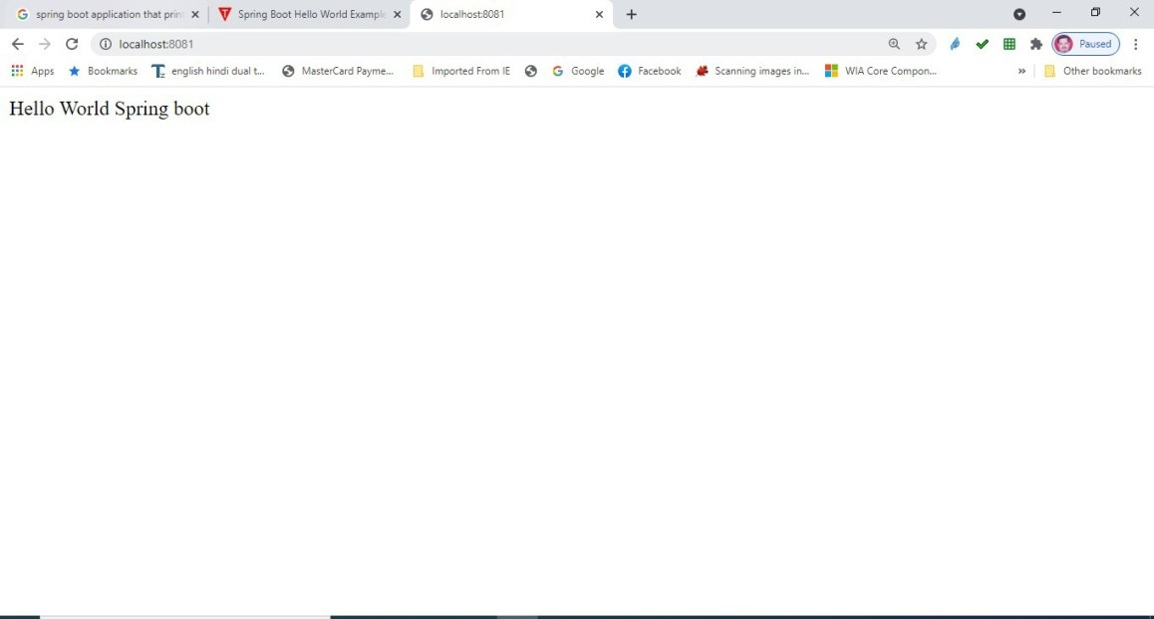Output

# Practical 10.2

Write a program to demonstrate RESTful Web Services with spring boot.

**Product.java**

**package** com.example.demo;

**public class** Product {

**private** String id;

**private** String name;

**public** String getId() {

**return** id;

}

**public void** setId(String id) {

**this**.id = id;

}

**public** String getName() {

**return** name;

}

**public void** setName(String name) {

**this**.name = name;

}

}

ProductServiceController.java

**package** com.example.demo;

**import** java.util.HashMap;

**import** java.util.Map;

**import** org.springframework.http.HttpStatus;

**import** org.springframework.http.ResponseEntity;

**import** org.springframework.web.bind.annotation.PathVariable; **import** org.springframework.web.bind.annotation.RequestBody; **import** org.springframework.web.bind.annotation.RequestMapping; **import** org.springframework.web.bind.annotation.RequestMethod; **import** org.springframework.web.bind.annotation.RestController;

@RestController

**public class** ProductServiceController {

**private static** Map<String, Product> *productRepo* = **new**

HashMap<>();

**static** {

Product honey = **new** Product(); honey.setId("1");

honey.setName("Honey");

*productRepo*.put(honey.getId(), honey);

Product almond = **new** Product(); almond.setId("2"); almond.setName("Almond"); *productRepo*.put(almond.getId(), almond);

}

@RequestMapping(value = "/products")

**public** ResponseEntity<Object> getProduct() {

**return new** ResponseEntity<>(*productRepo*.values(), HttpStatus.***OK***);

}

@RequestMapping(value = "/products/{id}", method = RequestMethod.***PUT***)

**public** ResponseEntity<Object> updateProduct(@PathVariable("id") String id, @RequestBody Product product) {

*productRepo*.remove(id); product.setId(id); *productRepo*.put(id, product);

**return new** ResponseEntity<>("Product is updated successsfully", HttpStatus.***OK***);

}

@RequestMapping(value = "/products/{id}", method = RequestMethod.***DELETE***)

**public** ResponseEntity<Object> delete(@PathVariable("id") String id) {

*productRepo*.remove(id);

**return new** ResponseEntity<>("Product is deleted successsfully", HttpStatus.***OK***);

}

@RequestMapping(value = "/products", method = RequestMethod.***POST***)

**public** ResponseEntity<Object> createProduct(@RequestBody Product product) {

*productRepo*.put(product.getId(), product);

**return new** ResponseEntity<>("Product is created successfully", HttpStatus.***CREATED***);

}

}

SpringBootRestfulServiceDemoApplication.java

package com.example.demo;

import org.springframework.boot.SpringApplication;

import org.springframework.boot.autoconfigure.SpringBootApplication; @SpringBootApplication

public class SpringBootRestfulServiceDemoApplication { public static void main(String[] args) {

SpringApplication.run(SpringBootRestfulServiceDemoApplication.class, args);

}

}

##### Output

POST API URL is: **http:mocalho,st.:8080/products**

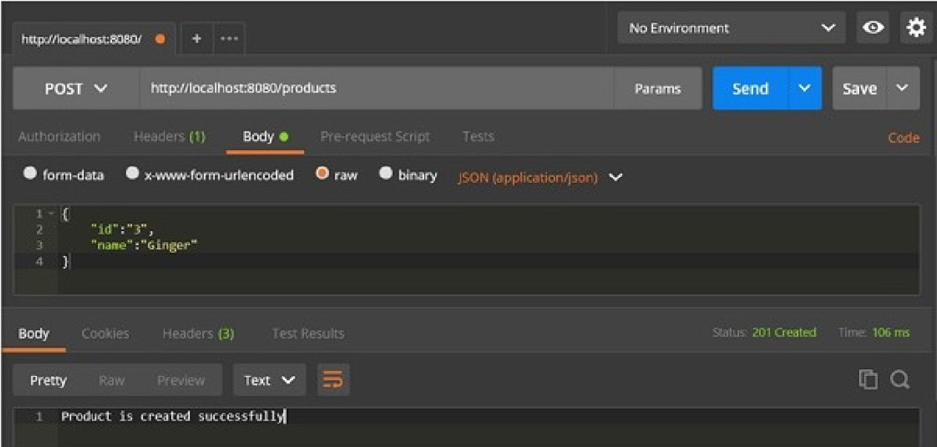

PUT API URL is: **htt1p:llil,ocalhos:t: B0 80/products/3**

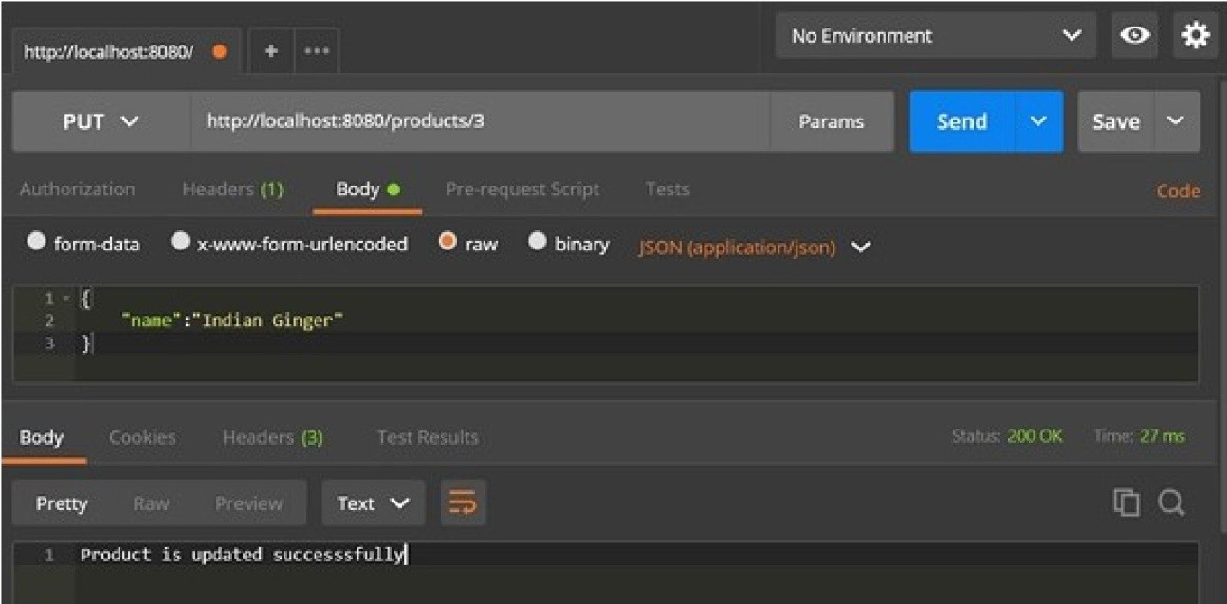

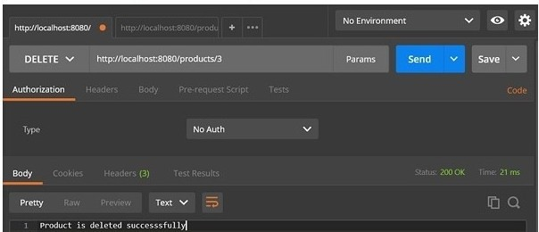DELETE API URL is: **http:lllocalhost:8080/products/3**