How to use it🡪

Command-🡪

1. Git init or git clone 🡪

git init command is used to initialise the new git repository in your local by using git bash command in your local.

OR

If you are working in current on going project then use the git clone command in git bash to get the initaiate the project in the local.

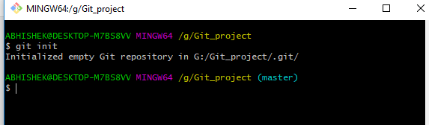

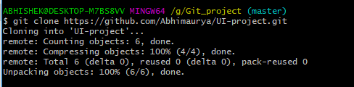

2 -Now link the remote things with local one by the command as shown below—



3-now pull the code from the master origin to local origin.

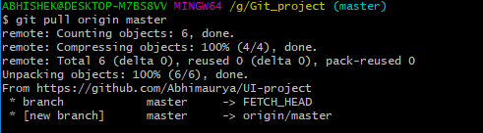

4-push yor own changes into central repository..

1. Now add one text file to see the changes in the central repository.

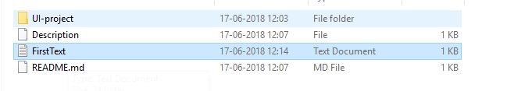

Here the FirstText is there in above local Repository.

1. Now see the file to be added in by using the command git status.

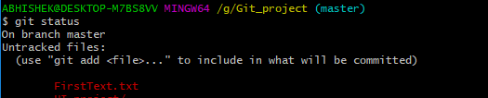

1. Now use commamnd git add “filename” And check the status after that as shown

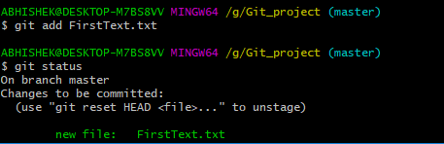

1. Now commit the file to be changed as seen as shown below

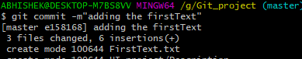

1. For adding multiple file ,create 2 more file as shown by name SecondText,ThirdText.

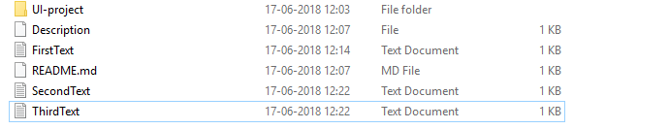

1. Now check the git status again to see the file need to be added.

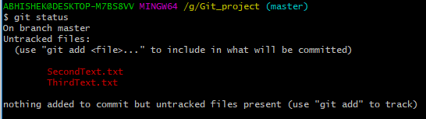

1. Adding the multiple file and commit it by using below command



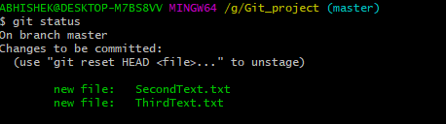

Commit For two files🡪

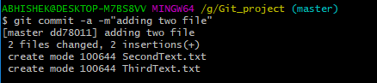

1. To see the log of the file use the command git log as shown below🡪

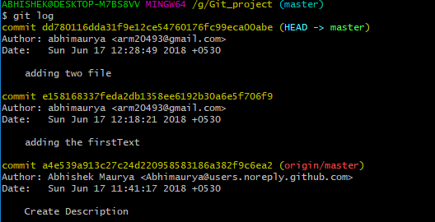

 🡪This digit hexadeciamal digit or SHA used in github.

5) Parallel development or non linear development 🡪

A)Branching :

Branches are point to specific commit

Branches are of two types

1. local branches 🡪 These are the branches which is used only in local repository.
2. Remote Tracking Branches🡪 These branches connect the local repository with the central repository.
3. Let’s discuss with the practical scenario..



Right now we are in master branch of local as shown above.

1. Now create one branch named as TestBranch .



The TestBranch has been created ,all the codes that are present in the master branch will be present in the TestBranch as it has been created by master branch.

1. Switch the branch from master to TestBranch

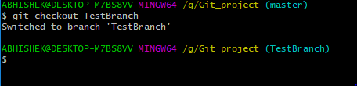

1. Lets’ create some new file into TestBranch

I have added two more file into the TestBranch as shown named as FourthText, FifthText.

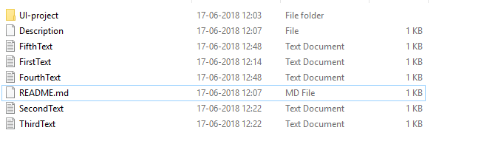

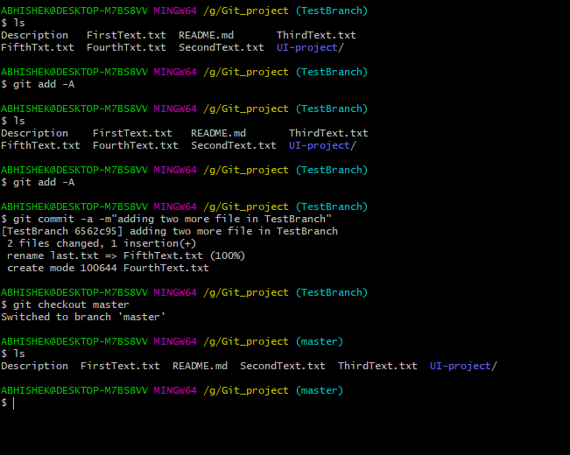

Now you can see the difference the files added in the TestBranch and Master Branch .Here in above we are working in two different branch one is TestBranch and Other is Master branch .

1. I had added two file name as FourthText.txt and FifthText.txt file into TestBranch which is not reflecting into the master branch.
2. Note-🡪 Before switching the branch you need to add and comit the files added into the particular branch(Here TeatBranch) otherwise the same file will also reflect in master branch .

1. If you want to merge the TestBranch into master use the bmerge command used below as shown..

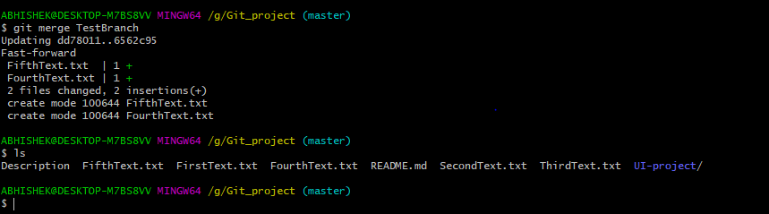

1. Now push your code into the Origin TestBranch (named).

