**Inferring the insights using Tableau**

1. How the cabs are charging the price per mile?
2. Which type of cabs in both Uber and Lyft are having lowest and highest average price per mile?

* Is it better to take Uberpool or Shared Lyft to get charged less price?

1. How these companies are charging at different times and when is the right time to take the Uber or Lyft for getting charged the lowest?

* At what time these companies are charging the highest?

1. How these companies are charging averagely for the month of November and December?

* If we see overall for a month, is it better to take Uber or Lyft to get charged less?

1. What is Average surge Multiplier?
2. Does Rain and Clouds effect the Average surge multiplier? If so, how?
3. How does the distance effect the Average surge multiplier?
4. Does the region have anything to do with Average surge multiplier?

* Which areas are having highest Average surge multiplier?
* How the clouds effect the Average surge Multiplier in different area?

**Question 1 and 2:**

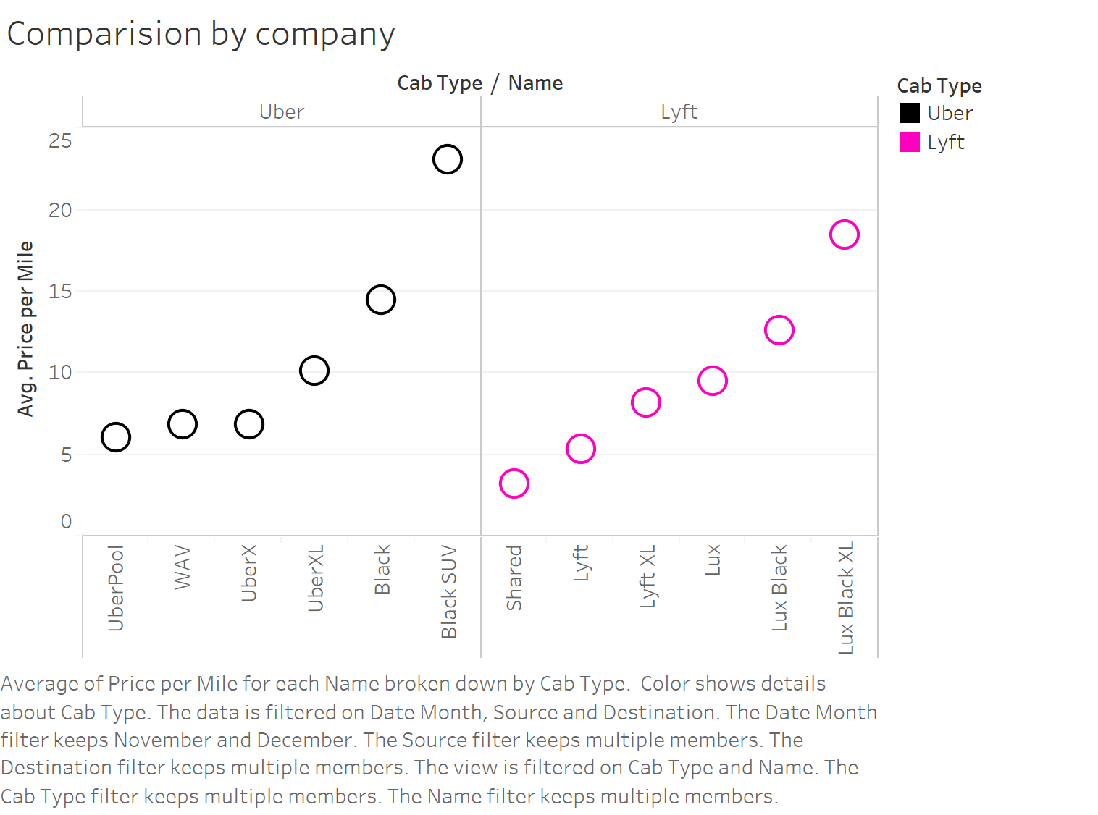

* In Uber, the lowest Average price per mile is for Uberpool and the price is $6.07 and the highest is for Black SUV and the price is $23.09.
* In Lyft, the lowest Average price per mile is for shared Lyft and the price is $3.21 and the highest is for LUX Black XL and the price is $18.48.

**Conclusion:**

* We can clearly see that shared Lyft is charging less than Uberpool, if we opt for pooling.
* We can clearly see that LUX Black XL is charging less than Black SUV, if we opt for Luxury cars.

**Question 3:**

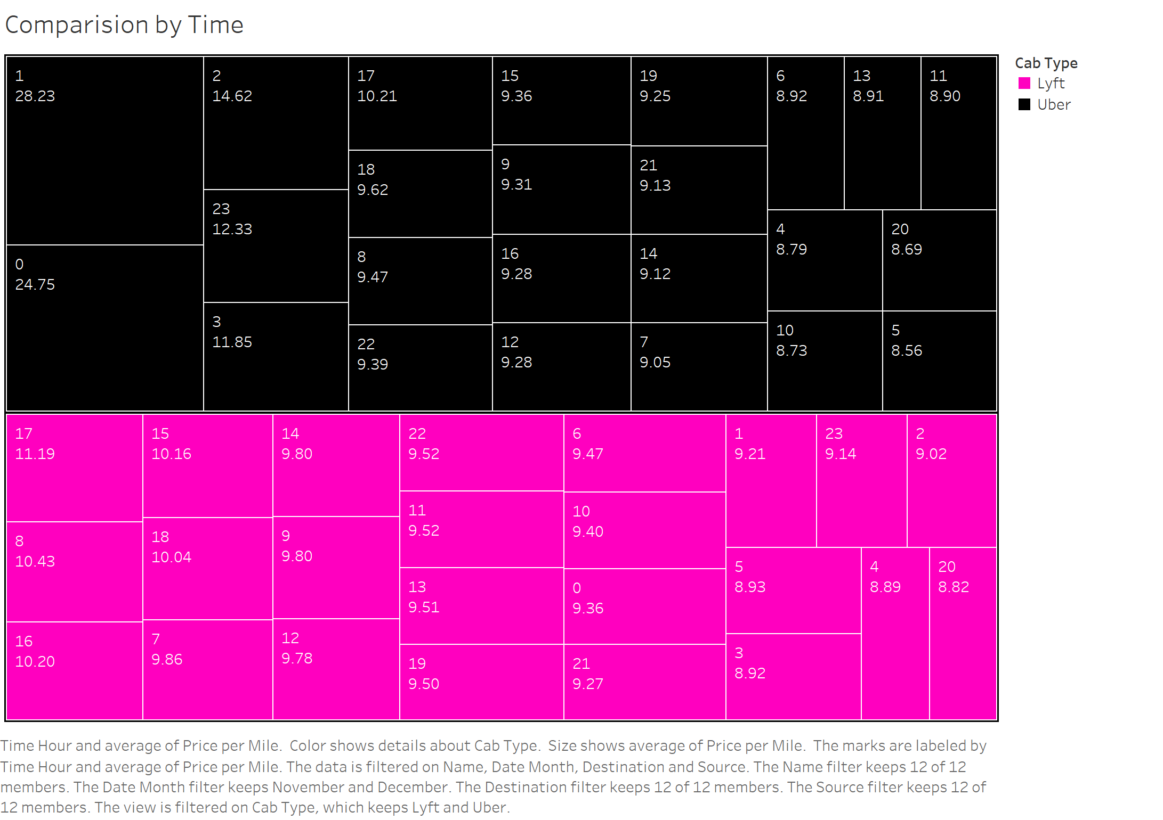

* We can see the prices charged for the given time of the day.
* At 1AM, Uber is charging highest of $23.23 while Lyft is charging only $ 9.21.
* At 5PM, Lyft is charging highest of $11.19 while Uber is charging $10.21.

**Conclusion:**

* Overall, if we are planning to take cabs in the evening, it doesn’t really matter which cab we take.
* Overall, if we are planning to take the cabs at night, Uber is charging much higher than Lyft and its better to take Lyft to avoid high prices.

**Question 4:**

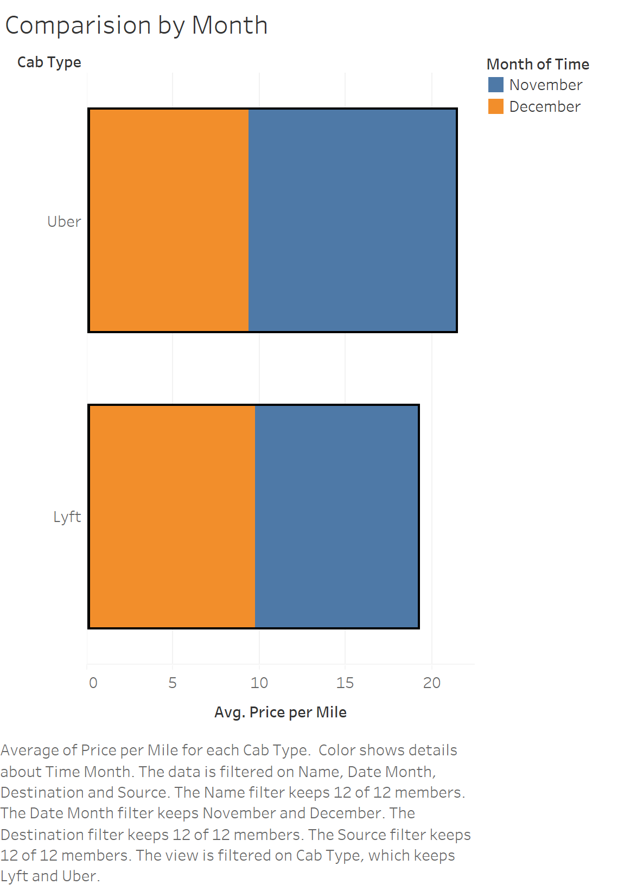

* Average price per mile for Uber for the month of November and December are $9.364 and $12.022.
* Average price per mile for Lyft for the month of November and December are $9.776 and $9.403

**Conclusion:**

* Average price per mile has increased drastically in Uber but not in Lyft.
* Lyft charges less Average price per mile during December.

**Question 5:**

**Average surge Multiplier:**

There are times when so many people are requesting rides that there aren’t enough cars on the road to help take them all. Bad weather, rush hour, and special events, for instance, may cause unusually large numbers of people to want to request a ride with Uber all at the same time.

In these cases of very high demand, prices may increase to help ensure that those who need a ride can get one. This system is called surge pricing, and it lets the app continue to be a reliable choice.

**Question 6:**

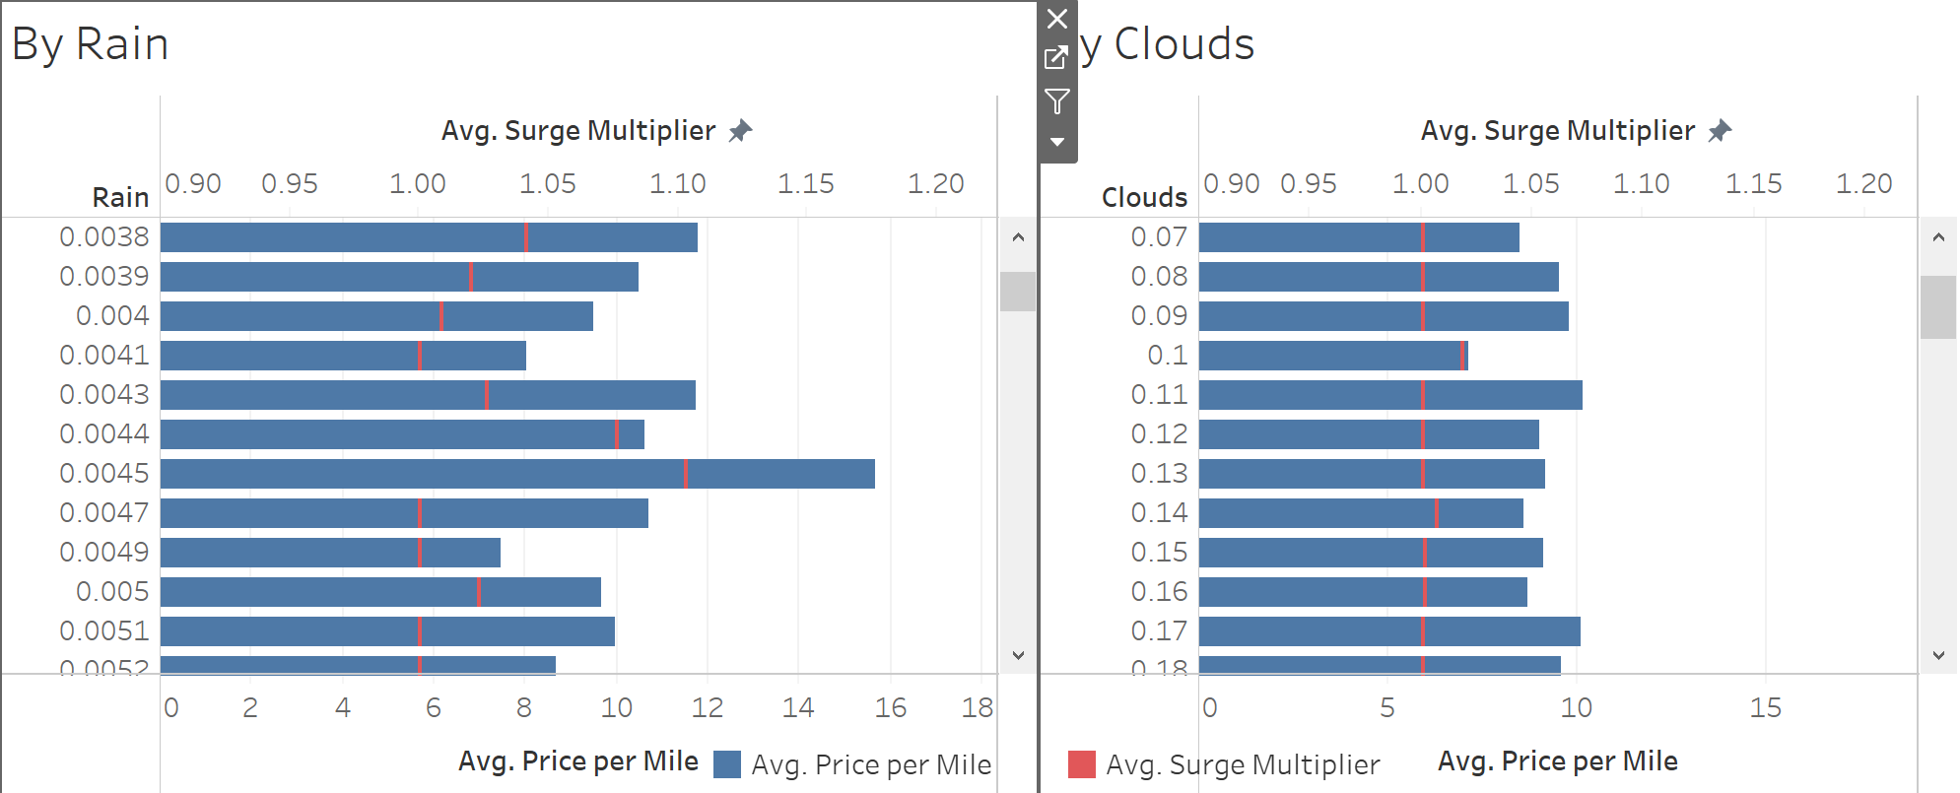

* We can clearly see that, as the rain or clouds increasing surge multiplier is fluctuating between 1.0 to 1.8 times the original price.

**Question 7:**

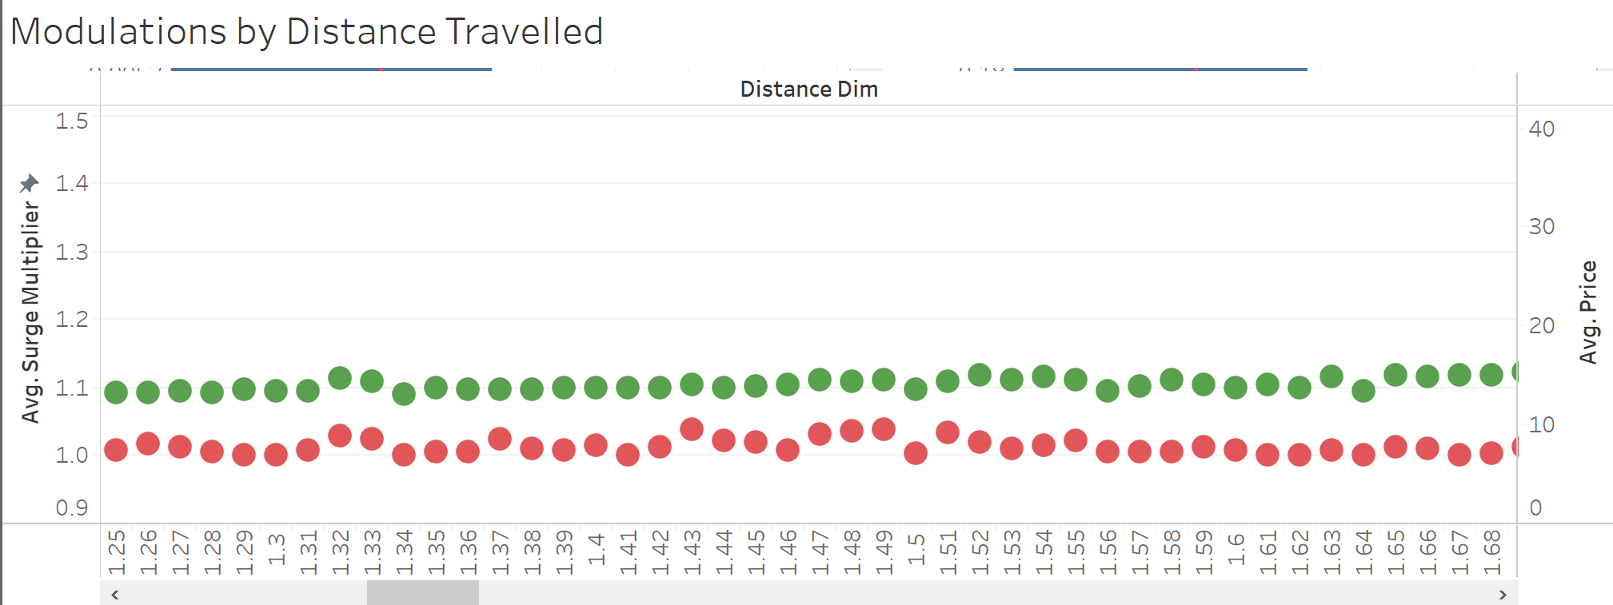

* From the above trend, we can observe that the average surge multiplier and the average price both increasing as the distance to travel increases.

**Conclusion:**

* For travelling longer distances, companies are charging more prices and surge multipliers than for shorter distances

**Question 8:**

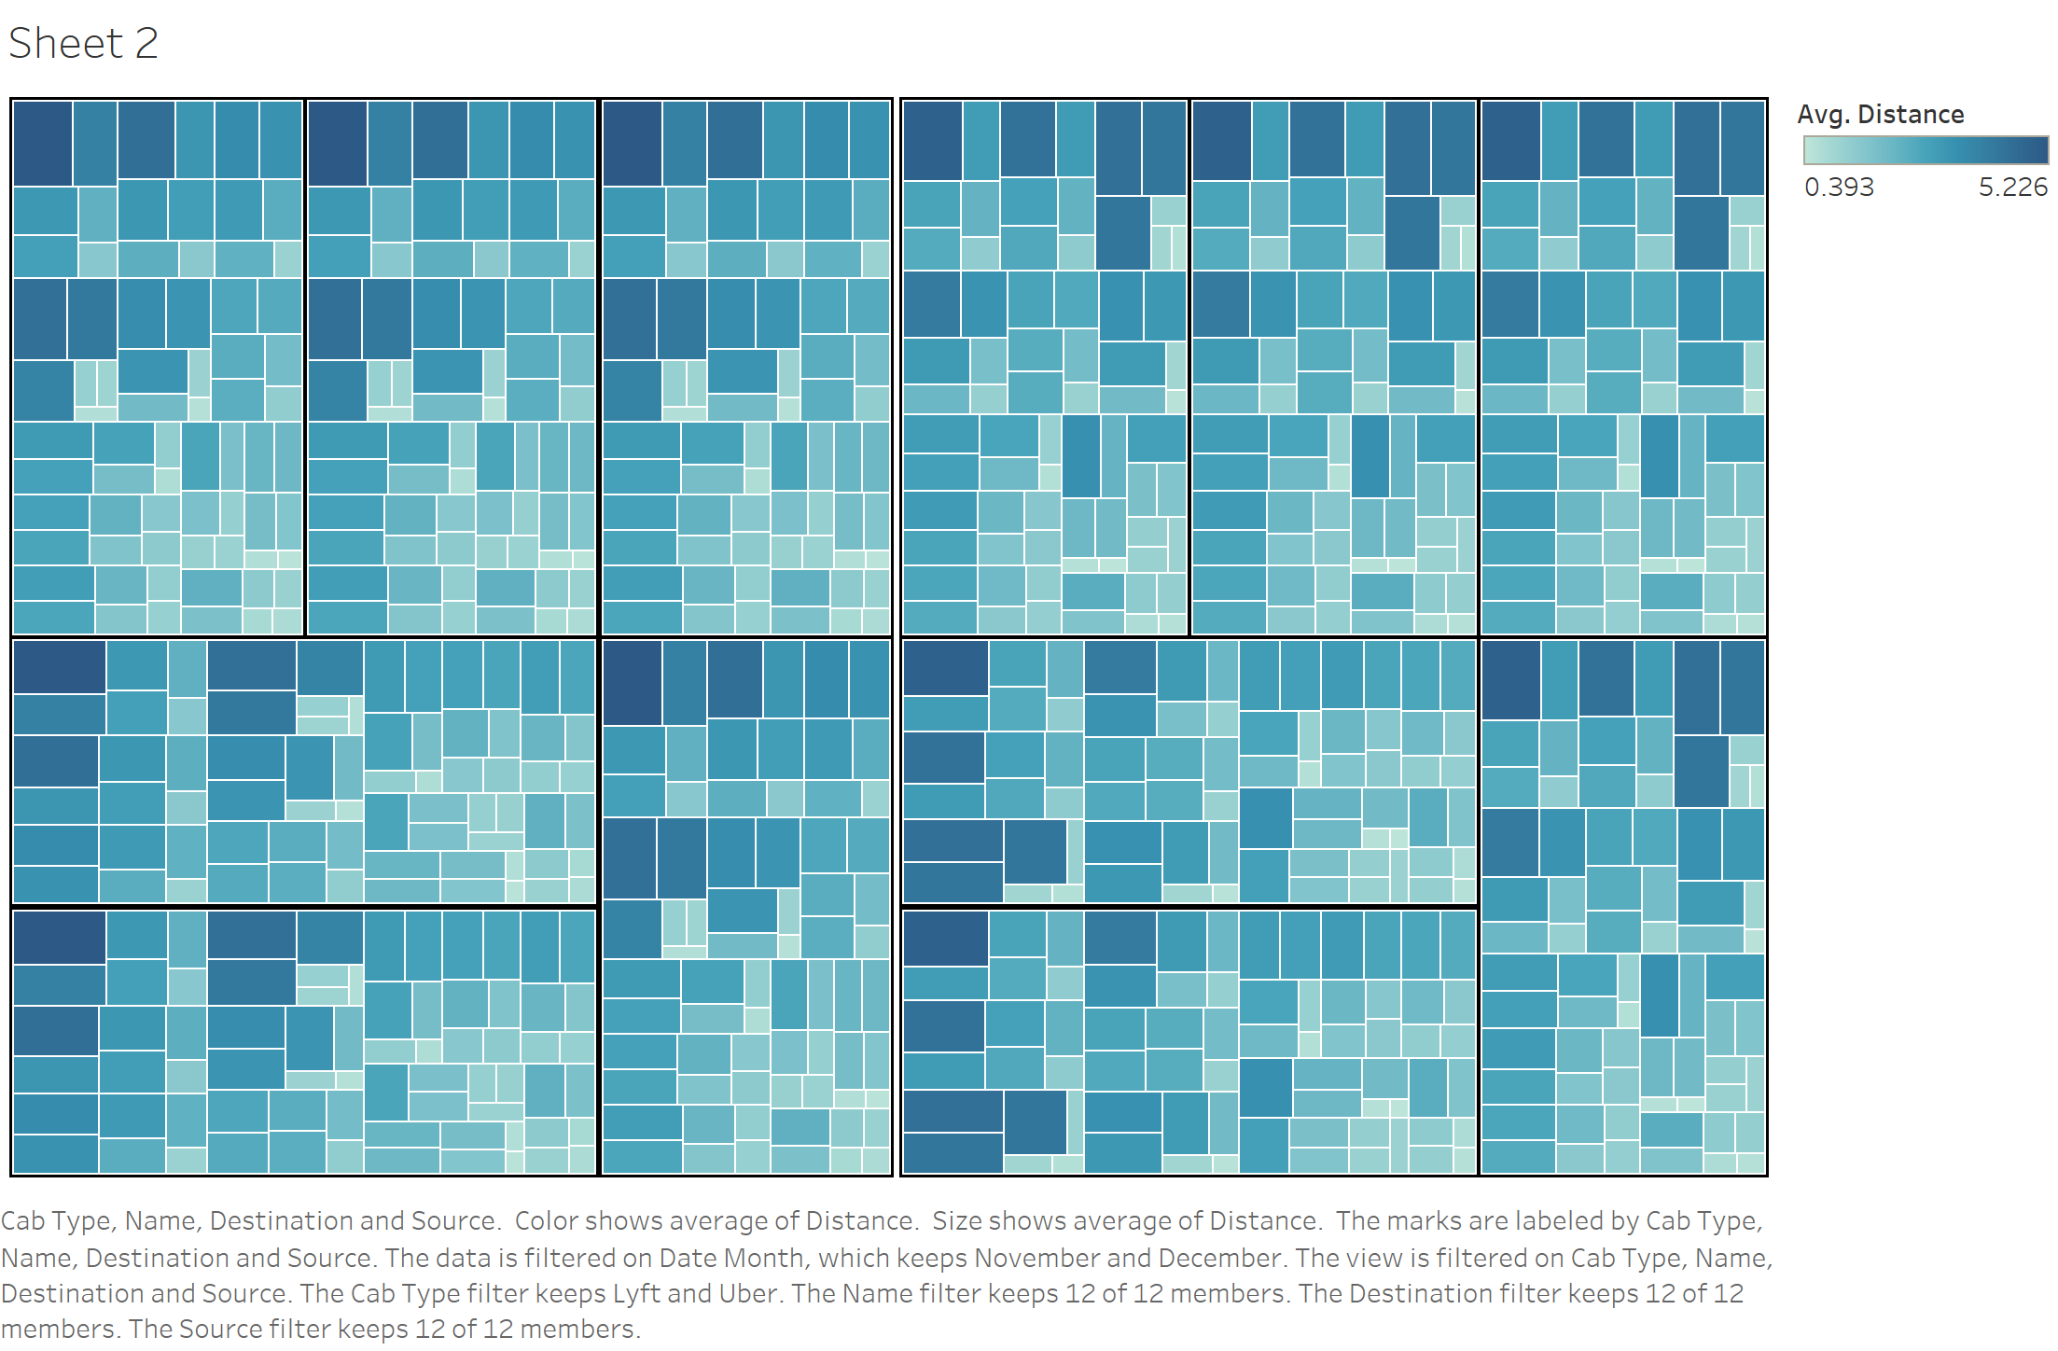

* The above heatmap depicts the average surge multipliers for different source and destinations with darker color indicating higher rates of surge multipliers

**Conclusion:**

* For travelling to Boston University, companies are charging more prices and surge multipliers than for other destinations.

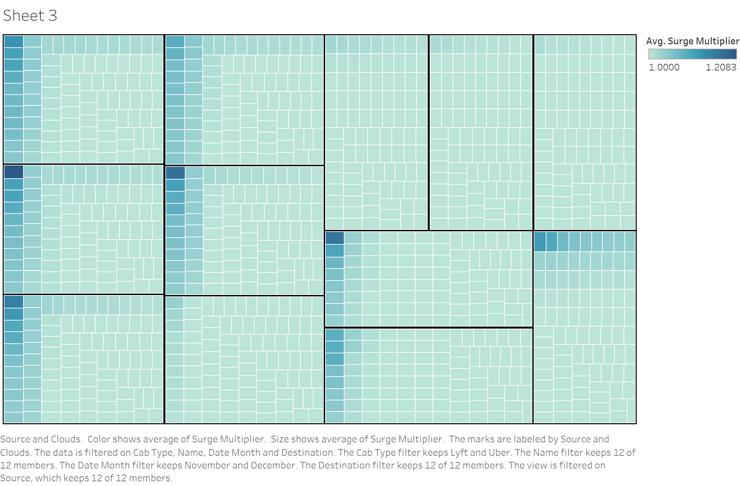

* The above heatmap depicts the average surge multipliers for different humidity with darker color indicating higher rates of surge multipliers.

**Conclusion:**

* With increase in the humidity of clouds, the surge Multiplier is going up mainly in the North Eastern University, Back bay and Financial District.