TRIBHUVAN UNIVERSITY
INSTITUTE OF SCIENCE AND TECHNOLOGY

Final Year Project Report on
“कानुन” - APPLICATION FOR PERFORMING RAG OPERATION ON CONSTITUTION OF NEPAL
For the partial fulfillment of the requirements of the degree of
Bachelor of Science in Computer Science and Information Technology (B.Sc.CSIT)
awarded by Tribhuvan University
Submitted By:
Abhinab Shrestha (T.U. Exam Roll No. 25818/77)
Manish Kumar Rajbanshi (T.U. Exam Roll No. 27251/077)

ST. XAVIER’S COLLEGE
Maitighar, Kathmandu, Nepal
Submitted To:
Office of the Dean
Institute of Science and Technology
Tribhuvan University
Kathmandu
Feb, 2025



SUPERVISOR RECOMMENDATION
This is to certify that the final year project entitled "कानुन" - APPLICATION FOR PERFORMING RAG OPERATION ON CONSTITUTION OF NEPAL is an academic work completed by Abhinab Shrestha (T.U. Exam Roll No. 25818/77) and Manish Kumar Rajbanshi (T.U. Exam Roll No. 27251/077) submitted in the partial fulfillment of the requirements for the degree of Bachelor of Science in Computer Science and Information Technology awarded by Institute of Science and Technology, Tribhuvan University under my guidance and supervision.
The information presented by them in the project report has not been submitted earlier to the best of my knowledge.

…………………………..
Er. Bishnu KC
Lecturer
St. Xavier’s College
Maitighar, Kathmandu


CERTIFICATE OF APPROVAL
The undersigned certify that they have read and recommended to the Department of Computer Science, St. Xavier’s College for acceptance, a Final Year Project Report entitled "कानुन" - APPLICATION FOR PERFORMING RAG OPERATION ON CONSTITUTION OF NEPAL submitted by Abhinab Shrestha (T.U. Exam Roll No. 25818/77) and Manish Kumar Rajbanshi (T.U. Exam Roll No. 27251/077) for the partial fulfillment of the requirement for the degree of Bachelor of Science in Computer Science and Information Technology awarded by Tribhuvan University.

…………………………….. ……………………………..
Er. Bishnu KC Er. Rajan Karmacharya
Project Supervisor Internal Examiner
Lecturer Chief Technology Officer
St. Xavier’s College St. Xavier’s College

…………………………….
Mr. Ganesh Yogi
HoD, Department of Computer Science
St. Xavier’s College
……………………………..
External Examin

ACKNOWLEDGEMENT

First and foremost, we are most grateful to be students of Computer Science here in St. Xavier’s college, utterly packed by expertise of the respective field, greatly supportive to the lemurs. We would like to express our sincere gratitude to Er. Bishnu KC, our supervisor for creating a virtuous academic and social environment to foster this project. We would like to express our innermost thanks to him for providing us with all the crucial advice, guidance and resources for the accomplishment of this project.
We would also like to express our gratitude to Mr. Ganesh Yogi - Head of Department for his constant support and encouragement throughout the completion of this project.
We are grateful to the entire Computer science department of St. Xavier’s College for their constant support and guidance. At the same time, we would like to express our sincere thanks to all our friends and others who helped us directly or indirectly during this project work.

ABSTRACT
The Constitution is the foundation of a nation's legal system, justice, equality, and the protection of citizens' rights. Despite its significance, the complexity of constitutional language often creates a knowledge gap, leaving citizens, legal professionals, and government officials struggling to access and comprehend key provisions. “कानुन” (Kanun) is an LLM based Chat Application built on Open AI’s “gpt-4o-mini-2024-07-18” model. This innovative platform is designed to understand Nepal's Constitution which provides accurate, accessible, and contextually relevant information. Through advanced RAG techniques, “कानुन” bridges the gap between legal language and its users, empowering them with knowledge about their constitutional rights and responsibilities.
The application employs a user-friendly interface and robust query-processing capabilities to deliver precise answers to user inquiries. By leveraging research in AI and legal informatics, the system is tailored to address the challenges of interpreting legal texts while maintaining high levels of accuracy and reliability. This report details the problem statement, objectives, and methodology behind the development of “कानुन” It also explores the potential of LangChain to transform legal services by making constitutional knowledge more accessible, promoting legal literacy and encouraging adherence to constitutional principles.

Keywords: LangChain, Constitution, Legal Literacy, Natural Language Processing (NLP), AI Chat Application, Nepal

TABLE OF CONTENTS

ACKNOWLEDGEMENT i
ABSTRACT ii
TABLE OF CONTENTS iii
LIST OF ABBREVIATIONS vi
LIST OF FIGURES vii
LIST OF TABLES ix
CHAPTER 1: INTRODUCTION 1
1.1 Introduction 1
1.2 Problem Statement 1
1.3 Objective 2
1.4 Scope and Limitations 2
1.4.1 Scope 2
1.5 Development Methodology 3
1.6 Report Organization 4
CHAPTER 2: BACKGROUND STUDY AND LITERATURE REVIEW 5
2.1 Background Study 5
2.1.1 Challenges in Accessing Legal Information 5
2.1.2 Retrieval Augmented Generation 5
2.1.3 Vector Database 5
2.1.4 Vector Search And Semantic Retrival AI 6
2.1.5 RAG For Constitutional Assistants 6
2.1.6 LLM Training Stages 6
2.2 Literature Review 6
CHAPTER 3: SYSTEM ANALYSIS 12
3.1 System Analysis 12
3.1.1 Requirement Analysis 12
3.1.2 Feasibility Study 21
3.1.3 ANALYSIS 24
CHAPTER 4: SYSTEM DESIGN 31
4.1 System Design 31
4.1.1. Refinement of Activity diagrams 31
4.1.1 Component Diagram 32
4.1.2 Deployment Diagram 33
4.2 Algorithm Details 33
4.2.1 PDF to JSON Conversion Algorithm 33
4.2.2 Algorithm for Chunking, Embedding and Injesting a Document into a vector Store 34
4.2.3 Cosine Similarity Search Algorithm 35
4.2.4 Retrieval Augmented Generation 35
CHAPTER 5: IMPLEMENTATION AND TESTING 38
5.1 Implementation 38
5.1.1 TOOLS USED 38
5.2 Testing 40
5.2.1 Unit Testing 40
5.2.2 System Testing 49
5.3 Result Analysis 50
5.3.1 Proposed Model 50
5.3.2 Advantage of Proposed Model 51
5.3.3 Disadvantages of Proposed Model 51
5.3.4 Relevant Screenshot 52
CHAPTER 6: CONCLUSION AND FUTURE RECOMMENDATION 58
6.1 Conclusion 58
6.2 Future Recommendation 58
REFERENCES 59

LIST OF ABBREVIATIONS
API Application Programming Interface
LLM Large Language Model
HTML Hyper Text Markup Language
CSS Cascading Style Sheets
DBMS Database Management System
IG Information Gain
JSON JavaScript Object Notation
SQLite3 Standard Query Language

LIST OF FIGURES
Figure 1: Incremental Development 3
Figure 2: Use Case Diagram for Normal User 14
Figure 3: Use Case Diagram for Staff Management 15
Figure 4: Use Case Diagram For Admin Control 15
Figure 5: Use Case diagram for AI Processing 16
Figure 6: Gantt Chart of system development schedule 23
Figure 7: Object Modeling using Class Diagram for Kanun 24
Figure 8: Dynamic modeling of Normal User Authentication Flow using sequence diagram 26
Figure 9: Dynamic modeling of Staff User Workflow using sequence diagram 27
Figure 10: Dynamic modeling of Super User Workflow using sequence diagram 28
Figure 11: Activity Diagram of Kanun Application 30
Figure 12: Refinement of Activity Diagram 31
Figure 13: Use Case diagram for AI Processing 32
Figure 14: Deployment Diagram 33
Figure 15: User creating a New Account 41
Figure 16: User redirected to Login Page 41
Figure 17: Error message popup with username already exist. 42
Figure 18: Error message popup with please fill out this field 42
Figure 19: User successfully Login to dashboard 43
Figure 20: Login Fail due to invalid username and password 44
Figure 21:Error message popup with please fill this field 44
Figure 22: Error Message popup with please fill this field 45
Figure 23: Giving Query to the KANUN 47
Figure 24: Fetched Content From vector database 47
Figure 25: Generated Response 48
Figure 26: New Chat was created 48
Figure 27: The conversation was saved in chat History 49
Figure 28: Cover Page 52
Figure 29: Cover Page - Introduction 52
Figure 30: Cover Page - Contact 53
Figure 31: Login Page 53
Figure 32Registration Page 54
Figure 33: Dashboard Page 54
Figure 34: User Management 55
Figure 35: Chat Log 55
Figure 36: Injestion Page 56
Figure 37: Conversation Page 56
Figure 38: Chat PAge 57
Figure 39: News Page 57

LIST OF TABLES
Table 1: Use Case Login Table 16
Table 2: Use Case Register Table 17
Table 3: Use Case Dashboard Table 17
Table 4: Use Case Generate Text/Image Table 18
Table 5: Use Case Convert PDF to JSON Table 19
Table 6: Use Case User Management Table 19
Table 7: Use Case Logout Table 20
Table 8: Time Schedule 23
Table 9: Test Case For User Registration 40
Table 10: Test Case For User Login 42
Table 12: Test Case For Chat Module 45
Table 14: System Testing 49

CHAPTER 1: INTRODUCTION

Introduction
The Constitution is a basic principle or law of a country that citizens of the country guide how everything works and ensure justice for everyone. The Constitution is a fundamental requirement for citizens, legal professionals, and government officials hence it helps protect their human rights and responsibilities. Although complication in legal language can create a knowledge gap and make it difficult for the citizens of the country to access and interpret constitutional information[1].
“कानुन” (KANUN) is a Retrieval-Augmented Generation (RAG)-based system designed to simplify access to constitutional information with precision and reliability. Large Language Models (LLMs) had an advanced retrieval framework through its capabilities helps in max utilization. “कानुन” ensures that the information provided is not only relevant but also rooted in authentic sources, such as the Constitution of Nepal. The Traditional AI models that depend mainly on pre-existing data where “कानुन” diligently searches for and retrieves relevant portions of the constitution before creating responses. This method improves accuracy, keeps legal classification aligned with official documents and gives users clear and accurate information about constitutional provisions.
Using retrieval methods and advanced language models, “कानुन” gives a well-structured and clear solution for exploring constitutional law. Its ability to provide direct and accurate references makes it a valuable tool for legal experts, students, and anyone pursuing clarity on Constitutional law of Nepal.

Problem Statement
The Constitution act is the backbone of the legal system serving the rights of the citizens, ensuring justice and responsibilities. Constitution plays a vital role in governing the country as the rules and regulations are based on this framework.
However, accessing and understanding constitution acts is quite challenging due to its following reasons:
- complexity structure of legal documents and which leads to a knowledge gap where citizens are not fully aware of their constitutional acts rights and responsibilities.
- Absence of an accessible and interactive tool to address constitution related queries where, citizens will be unaware of their constitutional rights and legal actions.

Objective
The major objective of the “कानुन” (KANUN) is to create an interactive framework for making an interactive application based on RAG which is able to generate information of Constitution. After the successful completion of the project, this project aims to achieve the following objectives:
- To parse the constitutional PDF data into JSON format consisting of parts, articles, clauses, sub-clauses, explanation by matching regex pattern.
- To provide a secured and user friendly interface for prompting queries regarding the constitution of Nepal.
- To provide an information interface for understanding the functioning of LLM operation related to RAG operation happening in real time.

Scope and Limitations

1.4.1 Scope
The scope of the system includes:
- The project focuses on developing Kanun applications, especially for users to easily search and retrieve constitutional laws.
- The system consists of two features: file injection and image generation, which converts pdf files into JSON and text inputs into image generation.
- The primary goal is to assist citizens and government officials to understand their rights and responsibilities without the complexity of legal documents.
- The user-friendly interfaces were designed for citizens, students and government officials to be easily accessible without any struggle.
1.4.2 Limitation
The limitation of the system include:
- The system fails to understand questions or provides incomplete information due to complex legal language.
- The application is not suitable for professional legal advice but can be used as a guide.
- There are no accessible features for the disabled users in the project such as screen readers or voice commands.
- The system does not include any data privacy or security measures for sensitive legal information.

Development Methodology
This application uses an Incremental development model, which means the project is developed step by step. First and foremost a simple version is created and shared with the citizen for feedback. Through their input, the application is improved and updated step by step until it becomes fully functional and meets the needs of the citizens.[2]
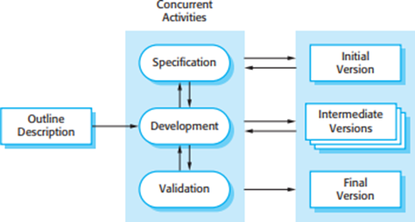
Figure 1: Incremental Development

1 Requirement Analysis:
This is the first phase of the incremental model, the developer identified the requirements. And the system functional requirements are understood. To develop the software under the incremental model, this phase performs a crucial role

2 Design and Development:
In this phase of the Incremental model of SDLC, the design of the system functionality and the development method are finished with success. When software develops new practicality, the incremental model uses style and development phase.

3 Testing:
In the incremental model of the SDLC, the testing phase checks the performance of each existing function as well as additional functionality. In the testing phase, the various methods are used to test the behavior of each task.

4 Implementation:
Implementation phase of SDLC, where the actual coding of the system takes place. It involves scripting the final code based on design from the initial phase and testing the functionality in the testing phase. After this phase, the number of the product working is improved and upgraded up to the final system product

Report Organization
The report contains details about "कानुन"-application for performing RAG operation on Constitution of Nepal in a structured manner i.e. they are divided into chapters and each chapter presents different aspects involved during the research and development of the project. This project contains 6 chapters.
- Chapter 1: Introduction
This chapter if for a short introduction about the project, the objectives of the project as well as a problem statement for the project. The scope and limitations for the project are also written in the chapter.
- Chapter 2: Background Study and Literature Review
This chapter examines the project’s background and covers the various research papers related to the project and similar existing systems that already existed.
- Chapter 3: System Analysis
This chapter introduces a detailed analysis of the system requirements: functional and non-functional requirements along with a feasibility analysis of the system.
- Chapter 4: System Design
This chapter consists of details about the system design using use case diagrams, class diagrams, object diagrams, sequence diagrams, activity diagrams, component diagrams, and deployment diagrams. These diagrams provide information about the different components in detail.
- Chapter 5: Implementation and Testing
This chapter gives information about the tools used for implementing the projects as well as the testing carried out to increase the efficiency of the system.
- Chapter 6: Conclusion and Future Recommendations
This chapter concludes the report with the system’s result and provides recommendations for future improvement.

CHAPTER 2: BACKGROUND STUDY AND LITERATURE REVIEW

2.1 Background Study
Access to legal information, particularly constitutional law, has traditionally been challenging due to its complex language and structure. Individuals often rely on legal professionals or extensive document searches to find relevant legal information. However, Natural Language Processing (NLP) advancements, particularly Retrieval-Augmented Generation (RAG), have enabled AI-powered legal assistants to provide more efficient and context-aware responses to constitutional queries [3].

2.1.1 Challenges in Accessing Legal Information
Legal documents contain technical language, making it difficult for non-experts to understand them. Furthermore, conventional search engines that operate using keyword-based search often return irrelevant or incomplete results if the exact wording differs from the search query. In Nepal, language barriers and the lack of structured digital legal databases further hinder access to legal knowledge. Research has shown that AI-driven legal assistants can bridge this gap by offering automated and accessible legal support [4].

2.1.2 Retrieval Augmented Generation
The RAG (Retrieval-Augmented Generation) model is designed for text generation tasks, performing a process that involves retrieving information from given source data and utilizing that information to generate desired text. RAG model consists of the data processing pipeline for RAG usage, involving breaking down the original data into smaller chunks and converting text data into numerical vectors through embedding, which are then stored in a vector repository[5]

2.1.3 Vector Database
A vector database is a novel type of database developed to address the problem of long-term memory deficiency in LLMs. This database is specialized in efficiently storing and managing high-dimensional real-valued vector indices. Unlike traditional databases, a vector database represents queries in the form of real-valued vectors (embeddings) and supports a method to extract data with similar vectors. Therefore, it is optimized for storing and utilizing vectors obtained as results from AI models. [5]

2.1.4 Vector Search And Semantic Retrival AI
Traditional search methods rely on exact word matching, which is inefficient for legal research. Vector embedding, which represent text as numerical vectors, have transformed legal information retrieval by enabling semantic similarity-based searches. By applying cosine similarity, legal queries can be matched with relevant constitutional texts regardless of variations in wording [4]. Vector databases, such as FAISS and Pinecone, are widely used to store and retrieve vectored legal documents, significantly enhancing search accuracy and efficiency [6].

2.1.5 RAG For Constitutional Assistants
The RAG framework integrates retrieval-based search with AI-powered response generation. Unlike traditional virtual assistants that rely on predefined responses, RAG-based systems dynamically retrieve the most relevant constitutional provisions and generate structured, legally accurate responses. This approach ensures that users receive fact-based, context-aware answers instead of purely generated text without legal grounding [6].

2.1.6 LLM Training Stages
LLM training stages consists of following stages: First of all data is gathered(Data Corpus), data extraction, splitting chunks, embedding, vector store, prompt & search & generation
In Nepal, the need for such a solution is significant considering the complexities of the legal system. The purpose of LangChain based application “कानुन” aims to address this necessity by leveraging cutting-edge AI technology and natural language processing. “कानुन” intends to be a dependable and user-friendly platform for answering constitutional related questions, warning citizens, legal experts and government representatives alike.

2.2 Literature Review
The LLMs are utilized for the development of applications and their capabilities in a range of tasks, with OpenAI’s ChatGPT being popular among millions of users. Large Language Models (LLMs) are used as a type of model in LangChain to accept a text string (prompt) and output a text string. As a stateless model, each transaction to the LLMs API endpoint is independent. Vector stores and retrievers can take multiple forms as memory insertion. The use case of common end-to-end applications includes autonomous agents, chatbots, code understanding agents, extraction question answering over documents, and analyzing structured data [8].
The recent advancements in generative AI technology addresses the challenge of information scarcity and proposes remedies by harnessing the LLMs capabilities. There is liberal framework for implementing generative AI service by effectively combining and orchestrating various technologies. The implementation procedure of the RAG model includes source data collection and extraction, chunk generation, embedding, building the vector database, integration of prompt and search results. The LLM and RAG models requires reducing of the size and complexity of LLM models to achieve effective results with smaller and simpler models. The combined efforts of these initiatives are expected to expand the utilization of generative AI technology which will be practical in the real world[9].
The large language models (LLMs) plays important role in providing substantial assistance to various stakeholders, including decision-makers, administrators, and citizens. The working mechanisms of legal assistant tailored for interacting with legal resources can be observed in the regulatory activities of major industrial powers. An unexpected outcome of scaling LLMs has been a qualitative shift in their behavior, affecting their capabilities. Furthermore, developing and testing the LLM-based system with complex legal questions remains a challenge. The authors highlight the future potential of these systems in effectively performing legal tasks[10].
Large Language Models(LLMs) are evaluated for their efficiency amd repeatability in automating question-answering tasks across multiple documents. Prompt formatting may always not meet the satisfactory criteria. In order to improve the performance of LLM, optimization of embeddings and vector database can be done. Additionally, using OpenAI models via API calls helps reduce response times when upgrading local infrastructure is not feasible. The focus is on leveraging AI to improve human efficiency rather than merely validating its output[11].
A RAG-based system is developed in order to address two key challenges in the legal domain: the risk of generating inaccurate content or opacity of AI-driven tools. The framework assists users in querying legal documents and providing reliable answers. The cleaned legal dataset with expert-verified questions, answers and, references is used for benchmarking the created system. The system is made publicly accessible, mainly for benefiting law students and legal professionals[12].
A RAG-based method is mainly used in the field of professional knowledge-based question answering, where model companies, embedding, and chat API interfaces and frameworks like LangChain have already integrated the RAG process. There are limitations in using the RAG approach, such as ranking issues, token limits, and fine segmentation drawbacks, which affect information retrieval. The effect of PDF recognition on RAG through various settings, data preparation, and extractive question results can be measured. Comparisons with deep learning-based document parsing methods provide a deeper understanding of the relationship between RAG quality and document parsing accuracy[13].
Traditional journalism has been highly affected by the growing LLM usage. Around 17,000 jobs lost in the past eight years and the market value of newspapers are decreasing. the common objection that lawyers have always adapted to technological changes, and these changes will lead to legal action regarding the proper scope and demand for legal services. Regulatory barriers may not prevent machine intelligence from challenging the lawyers' monopoly, but restrictions on the unauthorized practice of law create obstacles for AI in providing legal services to non-lawyers. Ultimately, the rise of machine intelligence is expected to make legal services more transparent and affordable[14].
The IQLS framework mainly focuses on optimizing models to fulfill this task on given required data in a structured format. Retrieving, consolidating and applying the right data is therefore a huge task. The IQLS system is designed to handle various complex and diverse queries with ease. Its ability to handle language ambiguity is one of its key features which enhances user experience by accurately. The IQLS extends the capabilities of LLMs to advanced tasks like route planning while utilizing available data structures. The adaptability of the models depends on data mapping, where the schema influences query results. This study provides practical testing in real-world environments, and future research could focus on developing more error-proof methods for parsing complex structured outputs from LLMs to enable broader applications[15].
A legal judgment prediction system is designed to predict and explain court decisions as cases are adjudicated. The study enhances prediction accuracy by applying grounded legal principles. It utilizes Hierarchical BiLSTM-CRF classifiers to extract relevant sentences based on rhetorical roles in legal judgments. The model processes inputs in segments of 2048 words, generating predictions efficiently within a token limit of 4096. A key limitation is its exclusive focus on Supreme Court of India judgments, which may reduce its applicability to other courts or jurisdictions. The study also explores the effectiveness of various LLMs and transformer architectures using the ILDC-multi dataset[16].
The Legal Reasoner framework enhances legal judgment prediction by integrating legal knowledge infusion, case-law retrieval, multi-hop reasoning, judgment synthesis, training, and optimization. It improves upon state-of-the-art models, achieving a 7.8% average accuracy increase across datasets. The system predicts legal case outcomes based on facts, relevant statutes, and historical precedents. By combining multiple innovative components, the framework enhances AI-assisted legal decision-making, improving efficiency and consistency in legal processes[17].
AI and machine learning are increasingly shaping the legal field, improving human capabilities and automating legal processes. The methodology involves analyzing legal information based on semantics, making legal predictions, and assisting judicial automation to improve efficiency at a lower cost. The paper estimates that within the next 20 years, over 100,000 legal jobs could be automated, with AI handling 22% of a lawyer’s tasks and 35% of a clerk’s duties. The study emphasizes the need for legal professionals to embrace AI-driven transformations.[18]
AI and machine learning are revolutionizing the legal field by enhancing human capabilities and streamlining legal processes. This study explores the latest advancements and emerging research trends in AI-driven legal applications. The methodology involves analyzing legal information based on semantics, making legal predictions, and assisting judicial automation to improve efficiency at a lower cost. The paper estimates that within the next 20 years, over 100,000 legal jobs could be automated, with AI handling 22% of a lawyer’s tasks and 35% of a clerk’s duties. The study emphasizes the need for legal professionals to embrace AI-driven transformations.[19]
The impact of AI-produced legal documents is transforming how legal experts and students assess the credibility and standards of written content. This study examines the preferences of legal professionals when analyzing documents they perceive as either AI-generated or human-written. 75 legal professionals and law students were asked to assess the precision and linguistic quality of legal documents. The findings reveal a clear preference for materials believed to be authored by humans. The study emphasizes the necessity of thoughtfully incorporating AI into legal writing and calls for additional research into how legal practices should adapt to the rise of AI-generated content.[20]
In a research, the benchmark designed to evaluate the retrieval step of RAG pipelines within the legal space. It serves as a critical tool for companies and researchers focused on enhancing the accuracy and performance of RAG systems in the legal domain. In this paper methodology is used to extract highly relevant text snippets from legal documents rather than retrieving entire documents and retracing the context used in LegalBench queries back to their original location in a legal corpus. The limitation or research gaps in the research manuscript is focusing on the four sources of dataset include NDAs, M&A agreements, various commercial contracts and privacy policies of consumer-facing online companies. The creation of both LegalBench-RAG and its lightweight counterpart and LegalBench-RAG-mini addresses a critical gap in the evaluation of RAG system particularly in contexts where legal accuracy is paramount.[21]
Open-source models are transforming legal language modeling and analysis, offering efficient ways to process complex legal texts. This study explores the use of open-source models from Hugging Face to analyze legal documents, with a focus on the Indian Constitution. The methodology involves preprocessing constitutional data, segmenting it into smaller chunks, and utilizing Milvus/Pinecone and LangChain Vector Stores for data storage and management. This approach streamlines model creation while ensuring that the resulting language models are specifically adapted to the nuances of legal texts. The study also emphasizes privacy protection through data access control, minimal data exposure, and limited dependencies. By applying these techniques, the research highlights how legal professionals and policymakers can better navigate and interpret extensive legal texts.[22].
Although chat bots have existed for decades, the emergence of transformer-based large language models (LLMs) has captivated the world through the most recent wave of artificial intelligence chat bots, including ChatGPT. Transformers are a type of neural network architecture that enables better contextual understanding of language and efficient training on massive amounts of unlabeled data, such as unstructured text from the internet. As LLMs have increased in size, their improved performance and emergent abilities have revolutionized natural language processing. Since language is integral to human thought, applications based on LLMs have transformative potential in many industries. In fact, LLM-based chatbots have demonstrated human-level performance on many professional benchmarks, including in radiology. LLMs offer numerous clinical and research applications in radiology, several of which have been explored in the literature with encouraging results. Multimodal LLMs can simultaneously interpret text and images to generate reports, closely mimicking current diagnostic pathways in radiology. Thus, from requisition to report, LLMs have the opportunity to positively impact nearly every step of the radiology journey. Yet, these impressive models are not without limitations. This article reviews the limitations of LLMs and mitigation strategies, as well as potential uses of LLMs, including multimodal models. Also reviewed are existing LLM-based applications that can enhance efficiency in supervised settings.
In conclusion, LLM integration into the legal domain holds great promise for democratizing the access to legal knowledge all over the glove. However, the complexity and interpretation ability might be the factor to choose the correct requirements.

CHAPTER 3: SYSTEM ANALYSIS

3.1 System Analysis
System analysis is a problem-solving method that involves examining the broader system, deconstructing its components, and understanding how it operates to achieve specific goals. The first step in addressing a system-related problem is to analyze the system itself [23]. This process includes breaking down the system into its constituent parts and evaluating how these parts function collectively. In some cases, understanding a system may involve disabling certain components to observe the impact or modifying parts to analyze the resulting changes.
System analysis is conducted to study a system or its components to identify its objectives. It focuses on improving application performance and ensures all components work efficiently to achieve their goals[24]. It includes analyzing business processes, gathering operational data, understanding the flow of information and developing solutions to overcome system weaknesses. It supports the achievement of organizational goals.
Furthermore, system analysis includes subdividing complex processes involving the entire system, identifying data stores, and analyzing manual processes. According to the Merriam-Webster Dictionary, system analysis is defined as “the process of studying a procedure or business in order to identify its goals and purposes and create systems and procedures that will achieve them in an efficient way” [25].

3.1.1 Requirement Analysis
Requirement analysis is a critical phase in system development that require identifying, documenting, and understanding the requirement and expectations of stakeholders to ensure the application achieves its goals. This phase focuses on figuring out what the system should do, the constraints it must operate within, and how it will interact with other systems [26].Requirements analysis involves various tasks that help engineers understand stakeholder demands and explain them in simple and visual ways. It is essential to a software or system project's success.
For a project to be successful, its requirements must be testable, actionable, documented, measurable, traceable. Requirements analysis involves various stakeholders, such as project sponsors, throughout the project as well as end users whose inputs are most important. The best results typically occur when all parties work together to develop a high-quality requirements document .
There are many requirements of the system which should be analyzed so that effective output can be produced with available resources. Following requirement analysis is carried out for the effectiveness of our system.

Functional Requirements
Functional requirements describe the features and functions that must be implemented to accomplish the system’s requirements. It’s important to make them sort out both for the development team and the stakeholders.[27]
Functional Requirements help as a comprehensive and detailed set of specifications, outlining the specific tasks and functionalities that a software system or its components must perform. These requirements define how the system should behave, including how it processes inputs, generates output, and handles the important steps for specific functions. The main goal of functional requirement is to lead the design and development of the software, ensuring it meets the requirement of its users
Functional requirement gathers and analyzes the functional part of the system. In ‘The LangChain Based Chat Application System’, users are allowed to view laws and regulations or sign up and log in the dashboard. The users are allowed to search for constitutional queries. The users are allowed to give the text as an input to the system. Once the input is passed, the given text is then processed through various NLP techniques. The system analyzes the input into relevant articles and clauses from the Constitution of Nepal. Functional requirement of the system can be described with the help of use case diagram as following:

Use Case Diagram

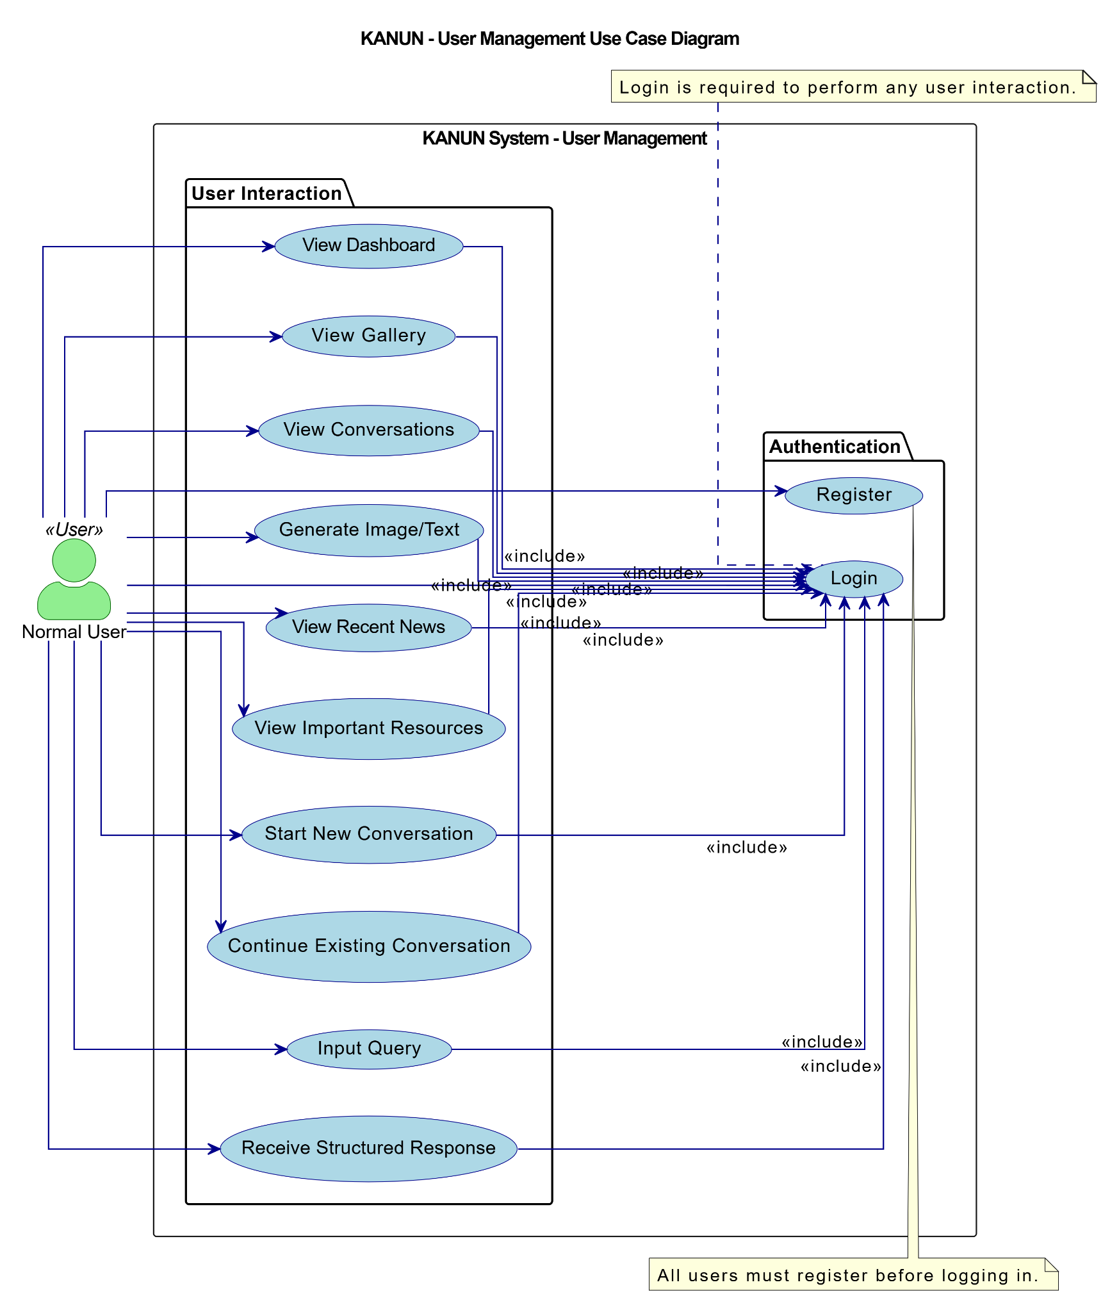
Figure 2: Use Case Diagram for Normal User
Above use case diagram illustrates the interaction between normal user and the system. Here, the normal user is able to view dash board, view Gallery, View Conversations, View recent news, etc. after login and registration

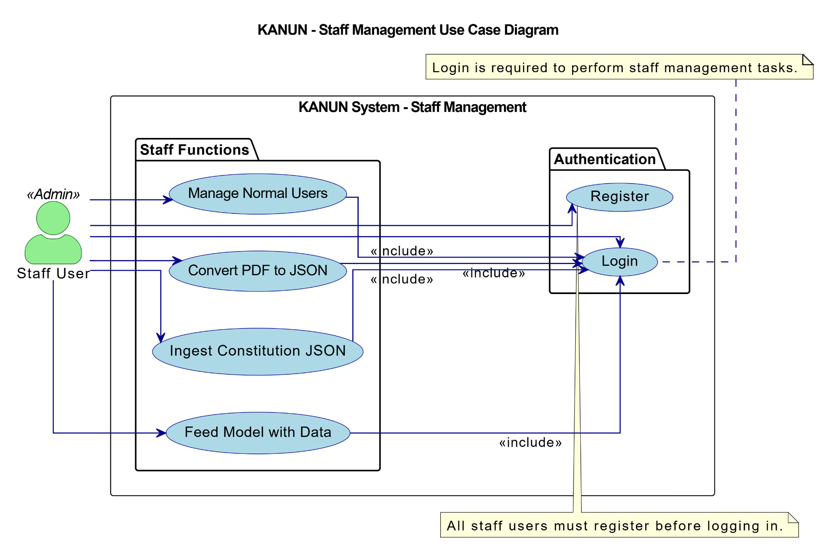
Figure 3: Use Case Diagram for Staff Management
Above use case diagram illustrates the interaction between staff user and the system. Here, the staff user is able to view manage normal user, convert PDF to JSON, Injest Constitution, and Feed model after Login .

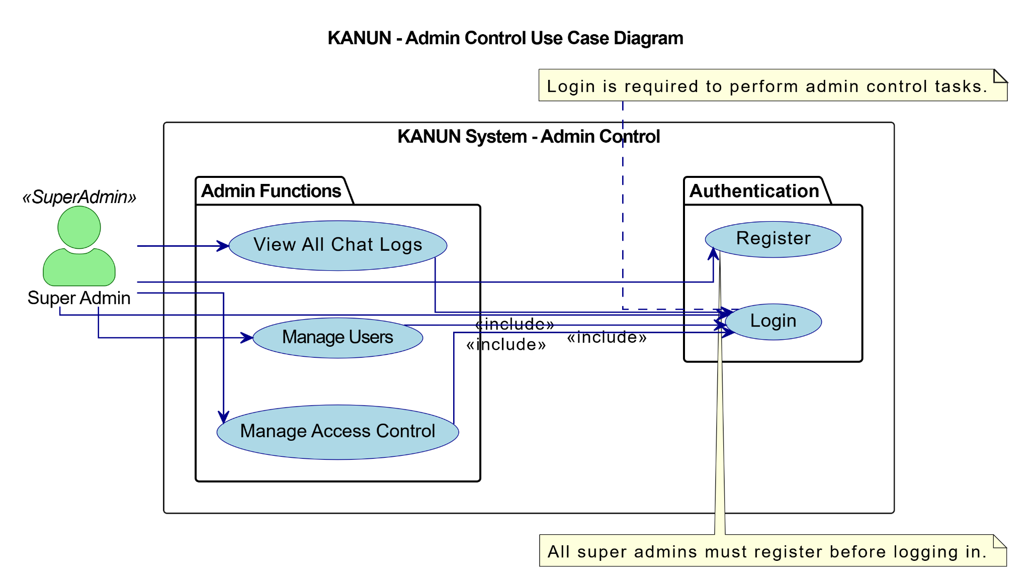
Figure 4: Use Case Diagram For Admin Control
Above use case diagram illustrates the interaction between Super admin user and the system. Here, the Super Admin is able to view all chat logs, manage users, Manage access control.

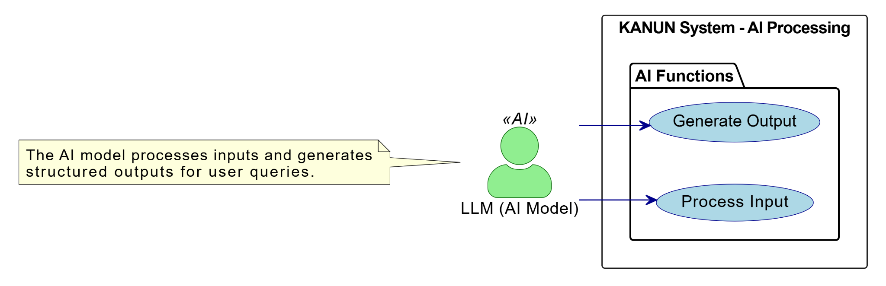
Figure 5: Use Case diagram for AI Processing
Above use case diagram shows the LLM interacting with the system

Use-case Table

Table 1: Use Case Login Table
Fields | Details
Use Case | Login
Actor(s) | Normal User, Staff User, Admin
Description | This use case allows users to log in to the system using their credentials
Priority | High
Status | Implemented
Pre-Condition | The user must have valid login credentials stored in the system
Post-Condition | The user is authenticated and redirected to their respective dashboard
Main Flow | The user enters their credentials, submits the login form, and is authenticated by the system
Alternate Flow | If the user enters incorrect credentials, an error message is displayed, and they can retry
Exceptional Flow | If the system encounters an error (e.g- server downtime), an error message is displayed.

Table 2: Use Case Register Table
Fields | Details
Use Case | Register
Actor(s) | Normal User
Description | This use case allows users to register for an account in the system.
Priority | Medium
Status | Implemented
Pre-Condition | The system must allow registration and the user must provide valid details(e.g- email, password).
Post-Condition | The new user account is created and stored in the system and users can login.
Main Flow | The user fills out the registration form with required details and submits it. The system validates the input and creates the account.
Alternate Flow | If the user provides incomplete or invalid details, the system displays an error message.
Exceptional Flow | If account creation fails due to a system error, the user is prompted to retry later.

Table 3: Use Case Dashboard Table
Fields | Details
Use Case | Dashboard
Actor(s) | Normal User, Staff User
Description | This use case allows users to view their personal dashboard which includes token usage, recent news, quiz game and resources.
Priority | Medium
Status | Implemented
Pre-Condition | The user must have register credentials with valid user id and password.
Post-Condition | The user can perform necessary action in the system after successful login.
Main Flow | The user navigates to the dashboard and the system displays the dashboard features and content.
Alternate Flow | If no data is available then the system displays a default message.
Exceptional Flow | If the dashboard fails to load then the login failed message has to be displayed.

Table 4: Use Case Generate Text/Image Table
Fields | Details
Use Case | Generate Text/Image
Actor(s) | Normal User
Description | This use case allows users to generate text or images using the LLM.
Priority | Medium
Status | Implemented
Pre-Condition | The user must be logged in.
Post-Condition | The generated text/image is displayed to the users.
Main Flow | The user inputs a prompt,submits it and the LLM generates the output.
Alternate Flow | If the user input is invalid then the system displays an error message.
Exceptional Flow | If generation fails then the system logs the error and displays a message.

Table 5: Use Case Convert PDF to JSON Table
Fields | Details
Use Case | Convert PDF to JSON
Actor(s) | Staff User
Description | This use case allows staff users to convert PDF files into JSON format for ingestion.
Priority | Medium
Status | Implemented
Pre-Condition | The PDF files must be uploaded to the system.
Post-Condition | The PDF is converted into JSON format and stored into the system.
Main Flow | The staff user uploads the PDF and the system convert it into JSON.
Alternate Flow | If the PDF is invalid, the system displays an error message.
Exceptional Flow | If conversion fails, the system logs the error and displays a message.

Table 6: Use Case User Management Table
Fields | Details
Use Case | User Management
Actor(s) | Admin
Description | This use case allows super users to manage user accounts, including adding, editing and deleting users and assigning roles.
Priority | High
Status | Implemented
Pre-Condition | The actor must be logged in with appropriate permissions.
Post-Condition | User accounts are updated, added or removed from the system.
Main Flow | The actor navigates to ‘User Management’, performs an action and confirms the update.
Alternate Flow | If the action is canceled, no changes are made.
Exceptional Flow | If an account management fails, the system logs the error and displays a message.

Table 7: Use Case Logout Table
Fields | Details
Use Case | Logout
Actor(s) | Normal User, Staff User, Admin
Description | This use case allows users to log out of the system.
Priority | High
Status | Implemented
Pre-Condition | The user must be logged in.
Post-Condition | The user session is terminated and they are redirected to the login page.
Main Flow | The user clicks the logout button and the system terminates their session.
Alternate Flow | If the logout action is canceled then the session remains active.
Exceptional Flow | If logout fails due to a system error, the session remains active and the system logs the error.

Non Functional Requirements
The non-functional requirements define the attributes or qualities that a system or software should have, in addition to what it does. It is concerned with the performance, usability, and other additional qualities of the system. The non-functional requirements often apply to the system as a whole.[28]
The non-functional requirements of this RAG-based application are as follows:
- Performance: Since backend handles all the complex tasks, users will be able to access the query application easily and fast with minimum hardware and average internet connection using the frontend.
- Look and feel: The user interface is easy to use and light colors are used with beautiful design to enhance usability.
- Security: Users must login with valid credentials to access advanced features. Their credentials are stored securely into a database using robust hashing techniques to ensure data privacy and security.
- Reliability: The constitutional articles and clauses are stored in the database for quick retrieval. So, every time a user met with accurate and relevant information without delays making the system highly dependable.

3.1.2 Feasibility Study
A feasibility study evaluates the project whether it is practical and achievable in terms of technical, economic, legal, operational and time feasibility factors. The study is also intended to identify possible challenges and problems that we may encounter while completing the project.[29]
Feasibility study helped the authors to determine the strength and weakness of our system. The contents and recommendation of this feasibility study helped us a sound basis for determining how to proceed further. It also helped in making decisions regarding which software to use, hardware combination etc. Some feasibility studies carried out are as follows.

i. Technical Feasibility
Technically, the system is a RAG-application which is developed to solve Constitutional Queries using LLM, RAG, vector stores and Django Python as core programming language. The backend will use SQLite3 for database management. The frontend is written using HTML, CSS and Bootstrap. The technologies that are needed for the development of the application.

ii. Operational Feasibility
The operational feasibility of the “कानुन” (KANUN) application relies on several key factors. A strong foundation requires robust infrastructure, such as servers, compatible software (like the Django framework, a language model, and possibly a vector database), and reliable internet. Skilled human resources are important like technical staff and legal experts for accurate content and smooth operation. Operational processes, including data updates, system maintenance, and user support, must be well-defined and consistently executed. Security and privacy are critical with strong measures and regulatory compliance ensuring users trust. Scalability and a sustainable funding model are essential for the application’s long-term success. A detailed assessment of resources, costs and risks is needed before starting successful implementation. Regular monitoring will help to improve the application and keep it effective over time.
iii. Economic Feasibility
The economic feasibility of “कानुन” considers the cost associated with developing, implementing, and maintaining the RAG-based application, as well as the potential returns and savings it can generate. Preprocessing and classifying textual documents for performing RAG operations on the Constitution of Nepal is a task that modern hardware can efficiently handle. The system is lightweight and doesn’t require much bandwidth so low-cost servers can also be used. So, this system is economically feasible.
iv. Schedule Feasibility
This system has been developed to partially fulfill requirements of BSc. CSIT course. We had 3-4 months to complete the system. The lifecycle of the system can be executed as shown in the schedule below.
Table 8: Time Schedule
Name | Begin Date | End Date | Duration (Days)
Brainstorming | 09/25/2024 | 10/02/2024 | 8
Project Planning | 10/03/2024 | 10/12/2024 | 10
Requirement Analysis | 10/13/2024 | 10/19/2024 | 7
Collecting Resources | 10/20/2024 | 10/28/2024 | 9
Developing the System | 10/29/2024 | 01/15/2025 | 79
Testing | 01/16/2025 | 02/10/2025 | 26
Documentation | 09/25/2024 | 02/28/2025 | 157

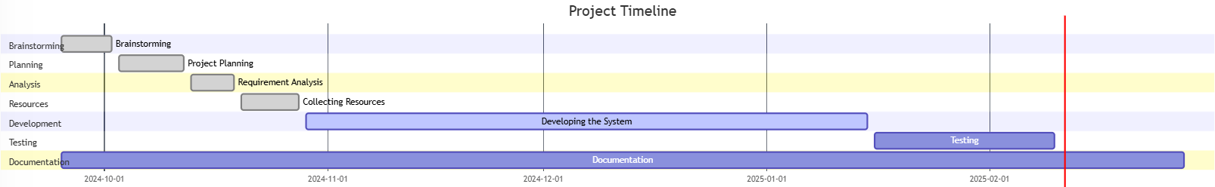
Figure 6: Gantt Chart of system development schedule

3.1.3 ANALYSIS

3.1.3.1 Class Diagram
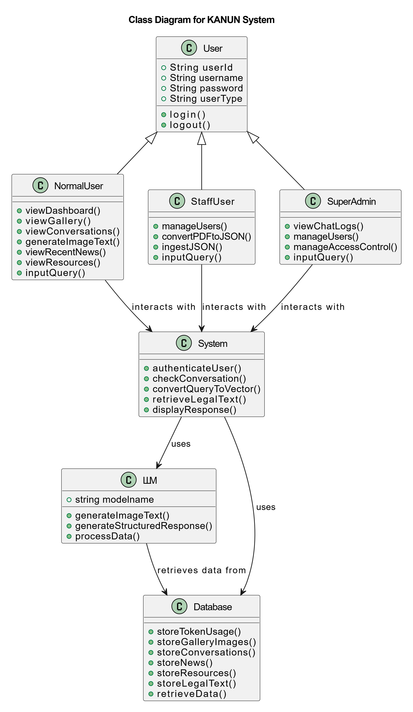
Figure 7: Object Modeling using Class Diagram for Kanun
The above diagram illustrates Class diagram of the Kanun Application. The Kanun applications mainly consists of User, System LLM and database and main classes. The reader will get an in-depth understanding of the object model and its elements. The basic factors of an object model are classes and objects. An object is a physical component in the object-oriented domain which may be tangible such as a person, car or intangible such as a project. A class is a representation of objects, It represents a group of objects that have similar properties and exhibit an expected behavior. [30]

3.1.3.2 Dynamic Modeling
System diagrams are tools that help you to understand how complex systems work. They’re particularly helpful for showing you how a change in one factor may impact elsewhere. They’re excellent tools for flushing out the long-term impacts of a change. Importantly, a good systems diagram will show how changing a factor may affect itself. Drawing a systems diagram is a good way of starting to design a computer model. The technique helps you to plan the structure of the system as per required to model. It highlights the factors and their relationships that are important, and helps you to start measuring the linkages between factors The sequence diagram below shows the sequence in which objects in the system operate with one another.
A normal user visits the dashboard by entering a query or interacting with the system. The query is sent to the backend which is processed through LangChain and RAG pipeline. Relevant articles and clauses are fetched from the Constitution Database and contextual data is retrieved from the Vector Store. The processed response is then displayed to the users. Users can also upload raw PDF files containing constitutional text which are ingested and processed into the Vector Store for future queries or conversation.[31]
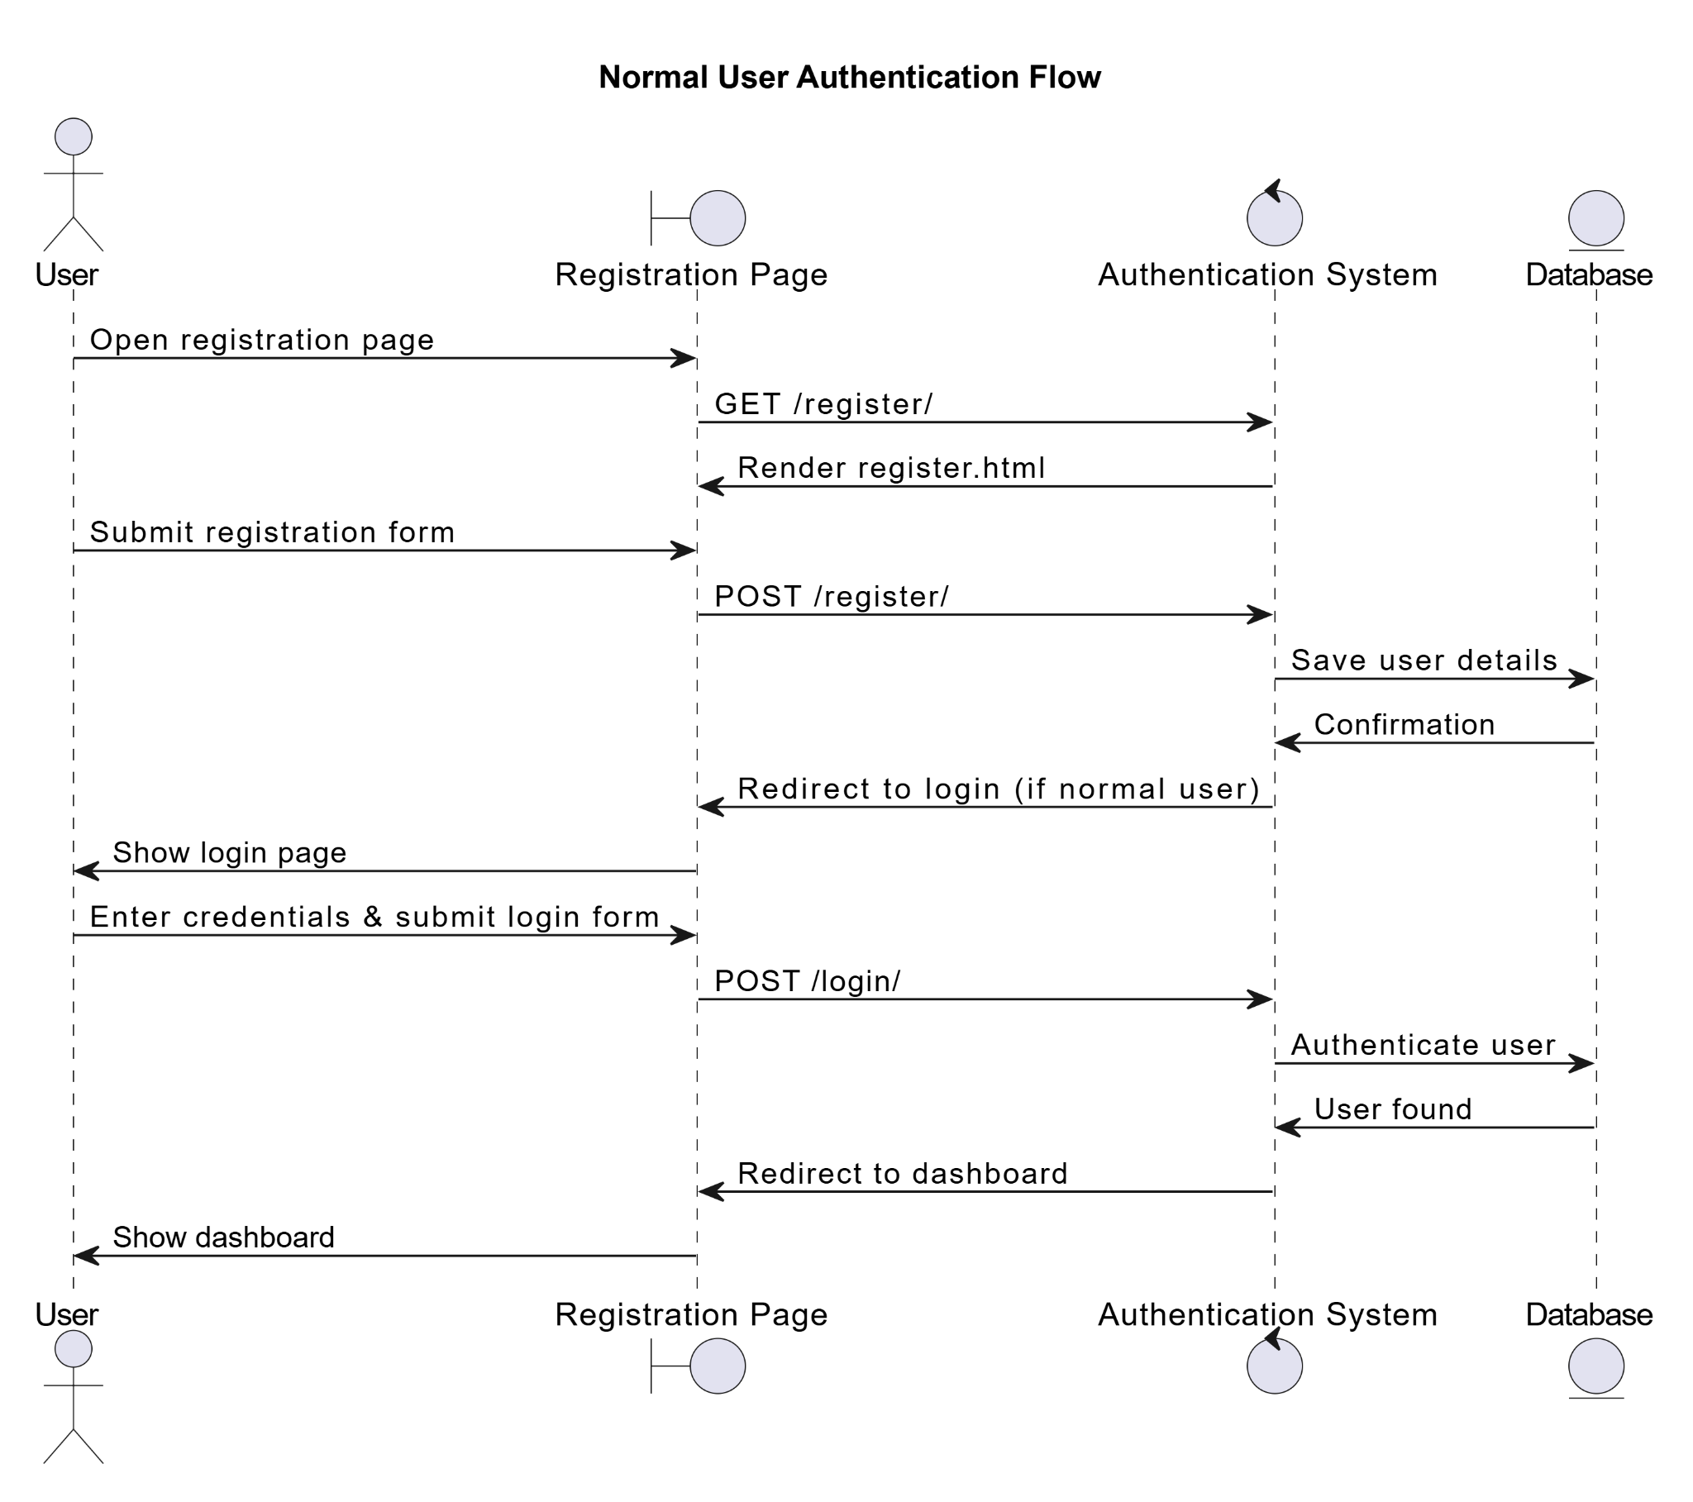
Figure 8: Dynamic modeling of Normal User Authentication Flow using sequence diagram
The above sequence diagram illustrates the interaction between User, Registration, Authentication and database. The process begins when the user opens the registration page and ends with the user being redirected to their dashboard. The process begins when the User accesses the registration page through the Browser. Browser sends request to the system. The system generates the registration form and sends it back to the Browser for displaying. The User fills out the form and submits it. The system processes this information, saving it in the Database , which confirms the operation. Afterward, the system redirects the Browser to the login page. The User enters their credentials and submits the form, triggering a request. The system verifies the credentials against the Database , and upon successful authentication, redirects the Browser to the dashboard, completing the flow.
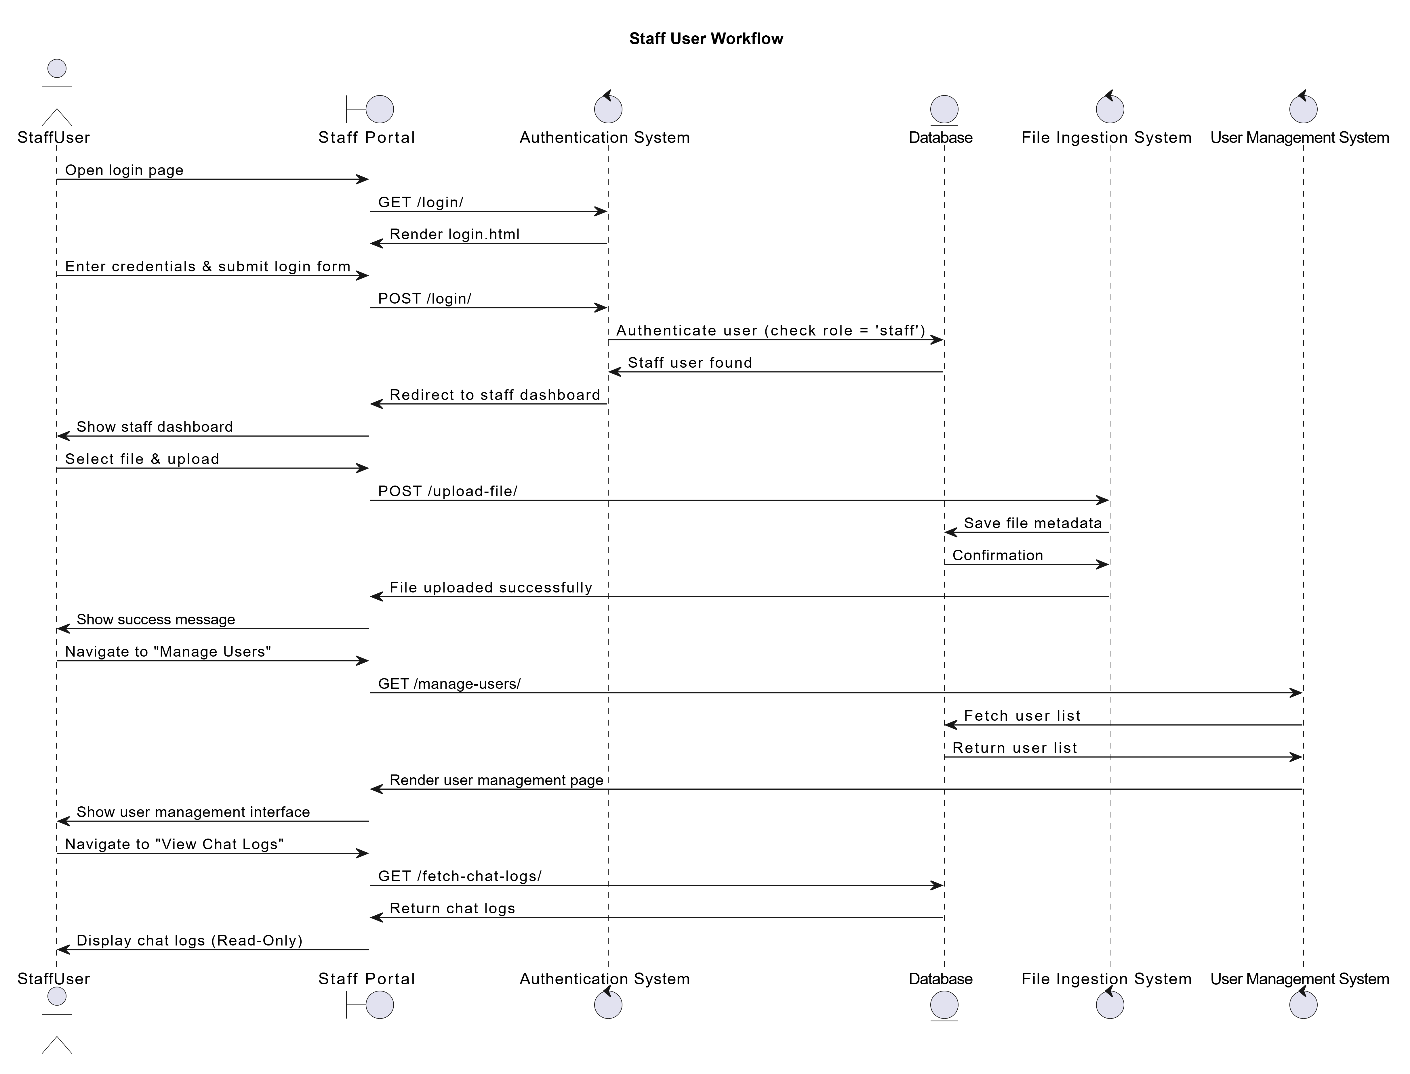
Figure 9: Dynamic modeling of Staff User Workflow using sequence diagram
Using the Authentication System and Database, the Staff User initiates authentication. When they enter the Staff Portal after successfully logging in, they are taken to the dashboard, where they may monitor chat logs, manage users, or upload files. While user management retrieves and updates information, file uploads store metadata in the database. It is possible to view, edit, and save chat logs back into the system. This process guarantees smooth staff operations for administrative, data management, and authentication duties.
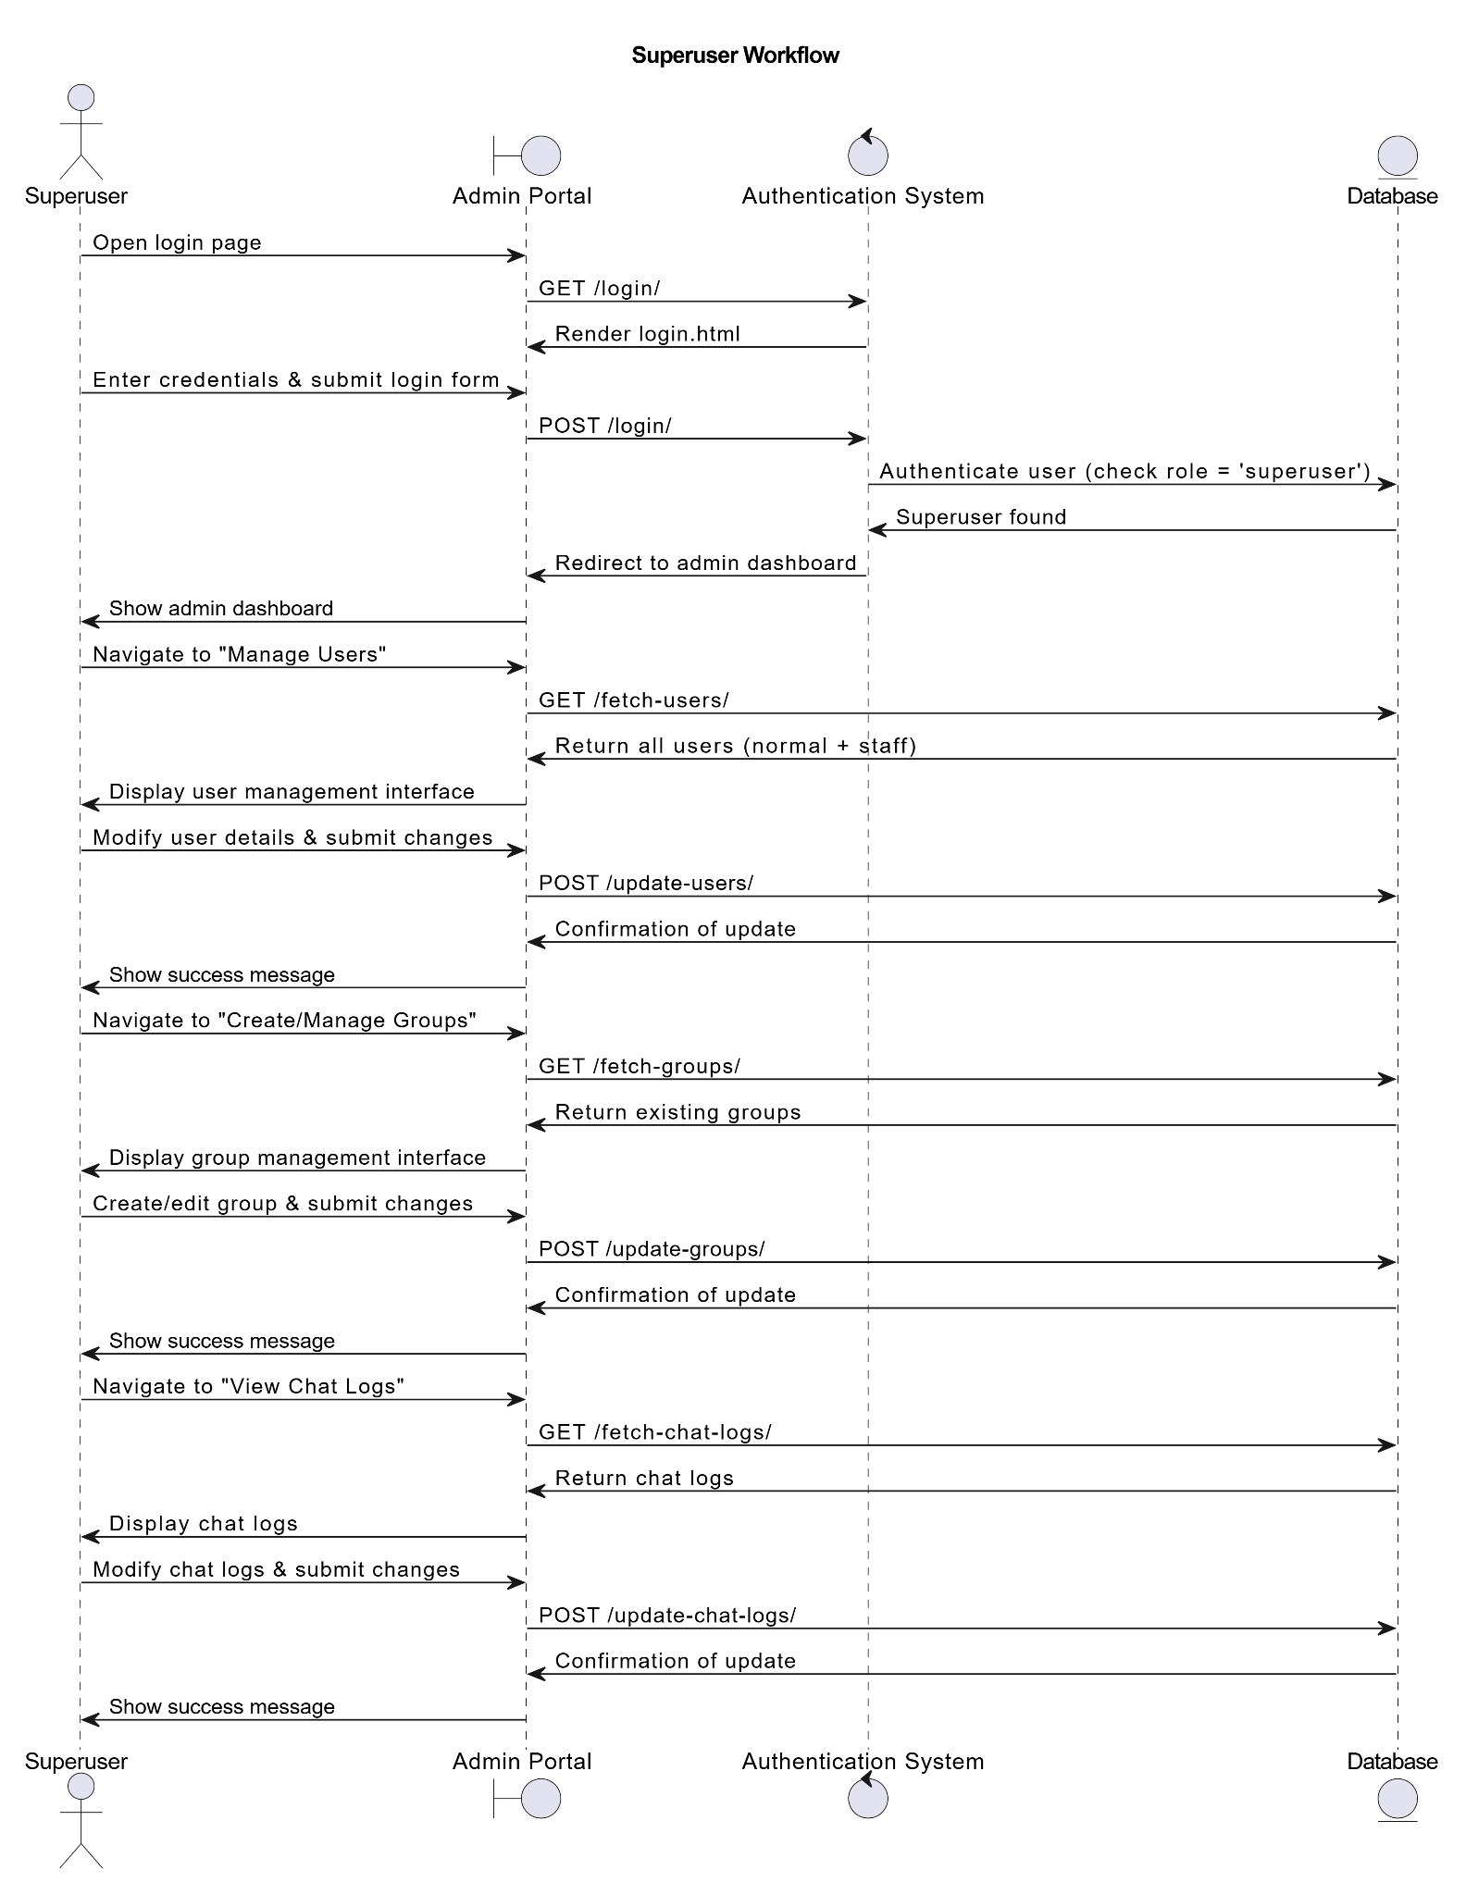
Figure 10: Dynamic modeling of Super User Workflow using sequence diagram
The Superuser Workflow begins when the Superuser accesses the login page via the Admin Portal , prompting the system to retrieve and display the login form. The Superuser enters their credentials and submits the form, which the system verifies against the Database , ensuring the user has the "superuser" role. Upon successful authentication, the system redirects the Superuser to the admin dashboard. From there, the Superuser can manage all users, including normal users and staff users, by navigating to the "Manage Users" section. The system fetches the complete user list from the Database and displays it for modification. After making changes, the Superuser submits the updates, which are saved to the Database , and the system confirms the operation with a success message. Optionally, the Superuser can create or manage groups by accessing the "Create/Manage Groups" section, where the system retrieves existing groups from the Database and allows for creation or editing. Similarly, the Superuser can view chat logs by navigating to the "View Chat Logs" section, where the system retrieves and displays logs. If needed, the Superuser can also modify chat logs, submitting updates that are saved to the Database , with the system confirming the changes. This workflow ensures seamless interaction for the Superuser , enabling comprehensive management of users, groups, and chat logs while providing clear feedback at each step.
3.1.3.3 Process Modeling
Process modeling is the representation of business processes or workflows. A process model allows visualization of business processes which helps organizations see and understand their internal business procedures by making it easier to be managed and improve efficiently [32].
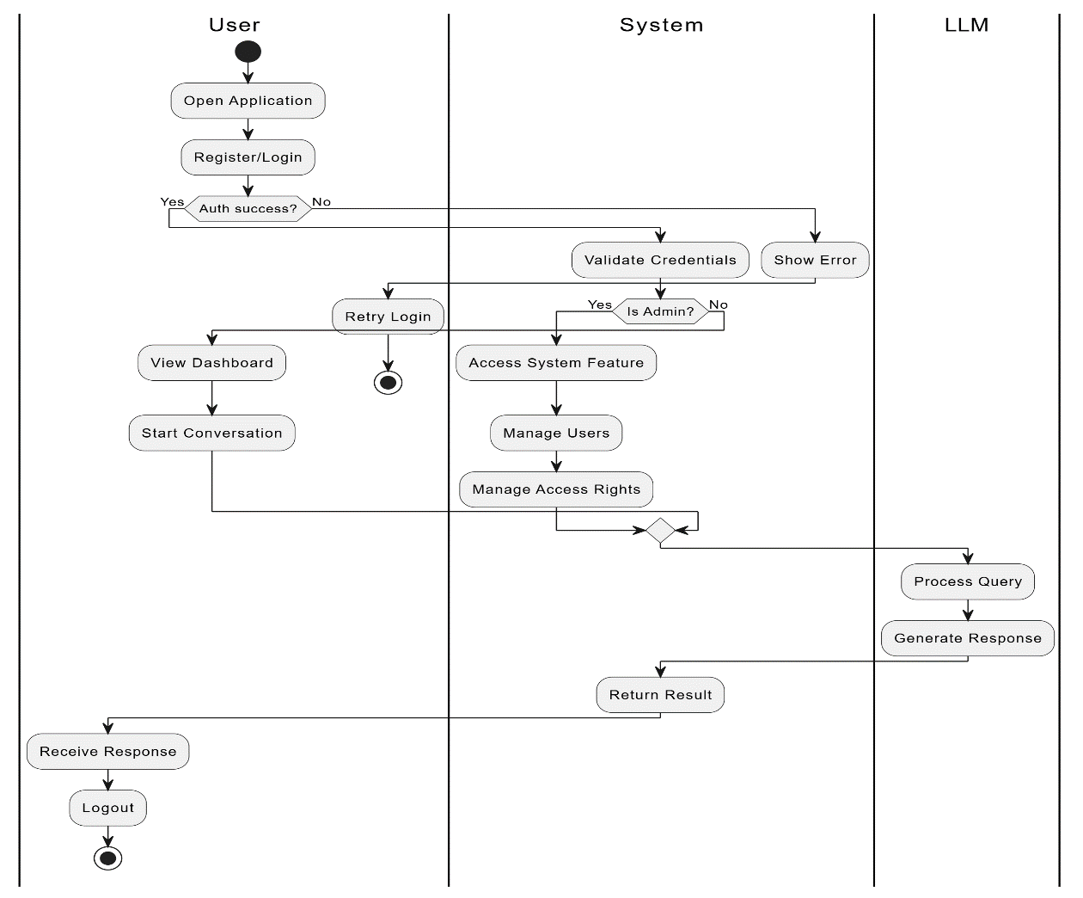
Figure 11: Activity Diagram of Kanun Application
The above activity diagram illustrates the workflow of the Kanun application performing the RAG operation on Constitution of Nepal across the three different swimlanes: User, System, and LLM (Large Language Model). The process begins with the user opening the application and attempting to log in. If the credentials were invalid, the system displays an error and suggesting user to login again. Otherwise, authentication proceeds. The user can view the dashboard and start a conversation. If the user was an admin then they can manage users and permissions, with the system by handling these tasks. Non-admin users directly moves to submits queries. When a user process a query or start conversation, the system forwards it to the LLM for processing.
The system interacts with an LLM for handling user queries. LLM generates a response which was send back to the system and response was displayed to the users. Finally, the process concludes when the user logout. Throughout the workflow, decision points ensure that users only access features appropriate to their roles. The integration of LLM model enhances the system’s ability to process complex queries efficiently, creating smooth interaction between the user, system, and LLM.

CHAPTER 4: SYSTEM DESIGN

4.1 System Design

4.1.1. Refinement of Activity diagrams
Figure 12: Refinement of Activity Diagram
The above figure illustrates the refinement of the activity diagram that gives information about the proper workflow of the system. It begins with the user opening the application and attempting to log in. If the credentials are invalid, the system displays an error; otherwise, authentication proceeds. Once logged in, the user can access system features, and the system validates credentials before granting access. The user can then manage data, view the dashboard, and input information, which the system processes and updates in the database. At this stage, a feature extraction mechanism may be triggered to analyze and process data.
The system also interacts with an LLM for handling user queries. When a user submits a query, the system forwards it to the LLM, which retrieves relevant data and generates a response. The system returns this response to the user. The user can acknowledge changes or submissions. Finally, the process concludes when the user logs out. Throughout the workflow, decision points ensure that only valid inputs proceed, and data handling is structured. The integration of an AI model enhances the system’s ability to process complex queries efficiently, creating smooth interaction between the user, system, and LLM.

4.1.1 Component Diagram
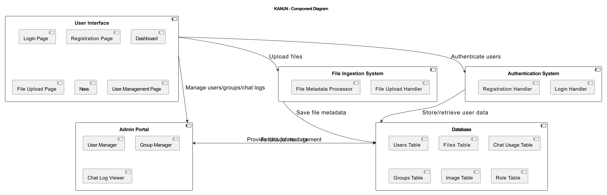
Figure 13: Use Case diagram for AI Processing
The above component diagram illustrates the high level design of the system and the relationship between the components. For this system, the components include User interface, Admin portal, File Ingestion System, Authentication and Database. The user interface components with sub-components like login page, register page, dashboard, file upload page, news, user management page, which provides the file uploading features, display latest news and maintains the chat history. The Authentication System components contain registration handler and login handler as sub-components which are responsible for validate credentials before granting access. The File ingestion System contains File metadata processor and file upload handler that save files metadata and manages to upload the raw data files which converted into JSON files.

4.1.2 Deployment Diagram
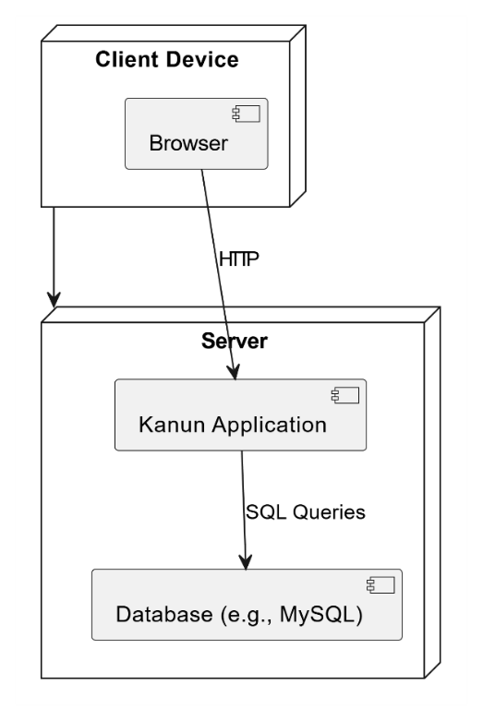
Figure 14: Deployment Diagram
The above diagram illustrates the deployment diagram for the Kanun application and relationship between the components. This system consists three main components include Client Device, Server and Database. Through client device such as computer or mobile which allows user to access Kanun application through browser through http protocol which send request to the server. The server hosts Kanun application for processes queries, retrieves relevant articles and generates responses from the constitution of Nepal. It uses the SQL queries to search for the important constitutional information. The database stores the constitution of Nepal to provide accurate responses while using the application

4.2 Algorithm Details

4.2.1 PDF to JSON Conversion Algorithm
PDF to JSON Conversion algorithm is used to convert the readable PDF file into JSON format
Algorithm:
Step 1: File Upload: First, allow users to upload PDF files to the Application
Step 2: PDF Processing: Extract the text from PDF(use pdfplumber)
Step 3: Match Pattern using Regex: The PDF file is matched with specific metadata such as(part, numbering, etc).
Step 4: JSON Conversion: Convert the matched pattern into JSON format

4.2.2 Algorithm for Chunking, Embedding and Injesting a Document into a vector Store
The algorithm requires JSON object that contains data about various parts, articles, clauses, explanations, and sub-clauses of a document.
Algorithm
Step 1: Chunk the Articles from the JSON:
Goal : Extract and organize the constitutional data into chunks of Articles.
Process:
- Initialize an empty list chunks.
- Loop through each part in the json_data:
- For each article in the "Articles" part:
- Start with the article's title as the base text.
- Loop through the clauses of the article:
  - Add the clause's text.
  - If an "Explanation" exists for the clause, append it.
  - If "Subclauses" exist, append their text as well.
- Append each chunk as a dictionary with a unique ID and text to the chunks list.
Step 2:Embed Text
Goal: Convert each chunk of articles into an embedding using a specific embedding model.
Process: Pass the text through the embedding model to generate an embedding(text-embedding-ada-002)
Step 3: Injest Document into Vector store
Goal: Convert the chunks into embeddings and store them in a vector store for future retrieval.
Process
- Store the chunk’s id, embedding, and text in the vector store (or index).
- The vector store (or index) is updated using the upsert method.

4.2.3 Cosine Similarity Search Algorithm
Cosine similarity is a metric used to measure how similar the documents are irrespective of the size. Mathematically, it measures the cosine of the angle between two vectors projected in a multi-dimensional space. The cosine similarity is advantageous because even if the two similar documents are far apart by the Euclidean distance there will be a chance where they may still be oriented closer together.[34]
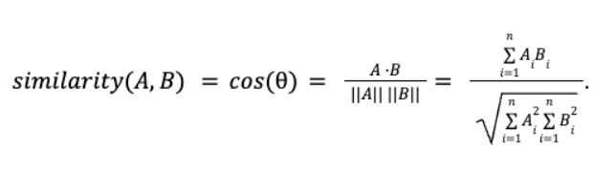
The value of cosine similarity ranges from -1 to 1:
- 1 indicates that the vectors are perfectly aligned and point in the same direction (maximum similarity).
- 0 suggests the vectors are orthogonal (perpendicular), meaning they share no similarity.
- -1 shows that the vectors are diametrically opposed (point in opposite directions).

4.2.4 Retrieval Augmented Generation
RAG(Retrieval Augmented Generation) is a Generative AI architecture that enhances Large Language Models (LLMs) by combining information retrieval with generative capabilities, using fresh and trusted data from authoritative internal knowledge bases and enterprise systems to produce more accurate, contextually relevant, and up-to-date responses.[35 ]
Goal: To fetch the correct results from the vector store as per the user’s query and Generate the answer using LLM capabilities.
Algorithm:
Step 1: Retrieve the query from the user.
Step 2: Preprocess the Query
- Trim the white space
- Convert the query into lowercase
Step 3: Validate the Query
- Check if the query contains at least two words.
- If invalid, return an error response.
Step 4: Embed the Query into Vector Form
- Use the `text-embedding-ada-002` model to generate vector embeddings.
Step 5: Retrieve Relevant Documents Using Vector Search
- Perform a cosine similarity search on the vector database.
- Retrieve the most relevant documents.
- Extract document ID and content from the retrieved documents.
- Format the Document ID and content into a structured context.
Step 6: Rephrase the Query (If Chat History Exists)
- Format previous chat history (if available).
- Insert the user query into a prompt containing chat history and context.
Step 7: Select Appropriate Prompt Based on Chat History
- If no chat history, use a prompt with an empty chat history.
- If chat history exists, use a prompt with chat history, input, and context.
Step 8: Generate Response Using LLM
- Feed the final prompt to the LLM (ChatOpenAI).
- Generate a response based on chat history, input, and context.
Step 9: Return the Response to the User
- Log the interaction (query, response, token usage, cost).
- Append the response to chat history and save the conversation.
- Render the response in the chat UI.

CHAPTER 5: IMPLEMENTATION AND TESTING

5.1 Implementation
A LangChain based application was developed to perform Retrieval-Augmented Generation (RAG) operations on the Constitution of Nepal. The development of the system was carried out in three phases. The first phase involved the integration of LangChain for building the retrieval system and incorporating preprocessors for handling constitutional data. The second phase focused on implementing the backend API and connecting it to the database for efficient data retrieval and storage. The final phase was the development of the frontend, which included the creation of a user-friendly interface for seamless interaction with the system that allows users to query the Constitution and receive accurate responses.

5.1.1 TOOLS USED
The tools used to create this we based visual demonstration of the proposed system are as follows:

5.1.1.1 Programming Language
i. HTML and CSS
HTML and CSS were used to design and styling the frontend for the project. HTML was very simple to edit as there was no need for a special interface or platform to edit. It can be simply edited in any editor and also has added flexibility and interactivity. It is used for developing and styling the structure of webpage, contents and layout.
ii. Python
Python played an important role in this project, particularly for implementation of LangChain Framework for performing Retrieval-Augmented Generation (RAG) operations on the Constitution of Nepal Python’s extensive libraries and frameworks which enabled efficient development, testing and deploying such applications making it more powerful tools for both beginners and experts in the field of technology.
iii. Django Framework
Django was used for LangChain and RAG ensures that the application can effectively process and generate answers based on the Constitution of Nepal which made it a valuable tool for legal research and education. Django has the ability to handle database management, user authentication, API integration and security makes it an ideal choice for the project. User-friendly interface was created from Django which allows users to query the constitution and receive accurate, contextually relevant responses.
iv. SQLite3 Database
SQLite Database was used as the database to store constitutional data and user’s data. It was chosen for its simplicity and ability to handle rational data efficiently in the embedded format. It provided a lightweight and reliable data storage solution, ensuring quick access to monitoring data while maintaining data integrity.
v. LangChain
LangChain was used in the system for performing Retrieval-Augmented Generation (RAG) operations on the Constitution of Nepal. It provides great utility for a variety of user cases from straightforward question-answering and text generation tasks to more complex solutions that use an LLM as a “reasoning engine”.
vi. Visual Studio Code
Visual Studio code offers a comprehensive suite of tools and features that streamline the entire software development lifecycle, from coding and debugging to testing and deployment. It was used to write and manage the django framework and python scripts that handle RAG operations for the Constitution of Nepal.
vii. GitHub
GitHub was used to ensure proper changes and collaboration among the team members and to avoid code conflicts during the development processes.
viii. Draw.io
draw.io was used as diagramming tools for creating visual representations of the system components and relationships. Those tools were used for creating flowcharts, activity diagrams, class diagrams, and various other diagrams so that they provide clear visualization of the various system components, workflow and interaction between the different components.

5.2 Testing
Software testing is a process of examining the functionality of a software which is under test to improve its performance and capabilities. This process helps in verifying and validating the actual software with the expected requirements to ensure that the product is built in the right way and is defect free. It involves identifying product bugs and requirements that have not been met. It also involves execution of software/system components using manual or automated tools to evaluate one or more properties of interest. The purpose of software testing is to identify errors, gaps or missing requirements in contrast to actual requirements.

5.2.1 Unit Testing
Unit testing is a software testing technique in which individual units or components of an application are tested in isolation from the rest of the application to ensure that they function as intended. In unit testing, each unit is tested separately to verify that it behaves as expected and produces the correct output for a given input.

5.2.1.1 Test Case 1
Table 9: Test Case For User Registration
Test Case ID | Test Case Description | Test Data | Expected Outcome | Pass/Fail Criteria
TC_REG_001 | To verify the user gets registered with valid details. | Username:Ram Email:  ram@gmail.com, Password: ram@1111 | Users redirected to Login page | Pass
TC_REG_002 | To verify the registrations whether it fails with multiple repetition of username. | Username:Raju Email: raju@gmail.com,  Password:raju@123 | Error message: A user with that username already exists. | Pass
TC_REG_003 | To verify registration failure when the username input field is empty. | Username:``, Email: sita@gmail.com  Password: sita@122 | Error message: Please fill out field | Pass

Evidence for Test Case 1
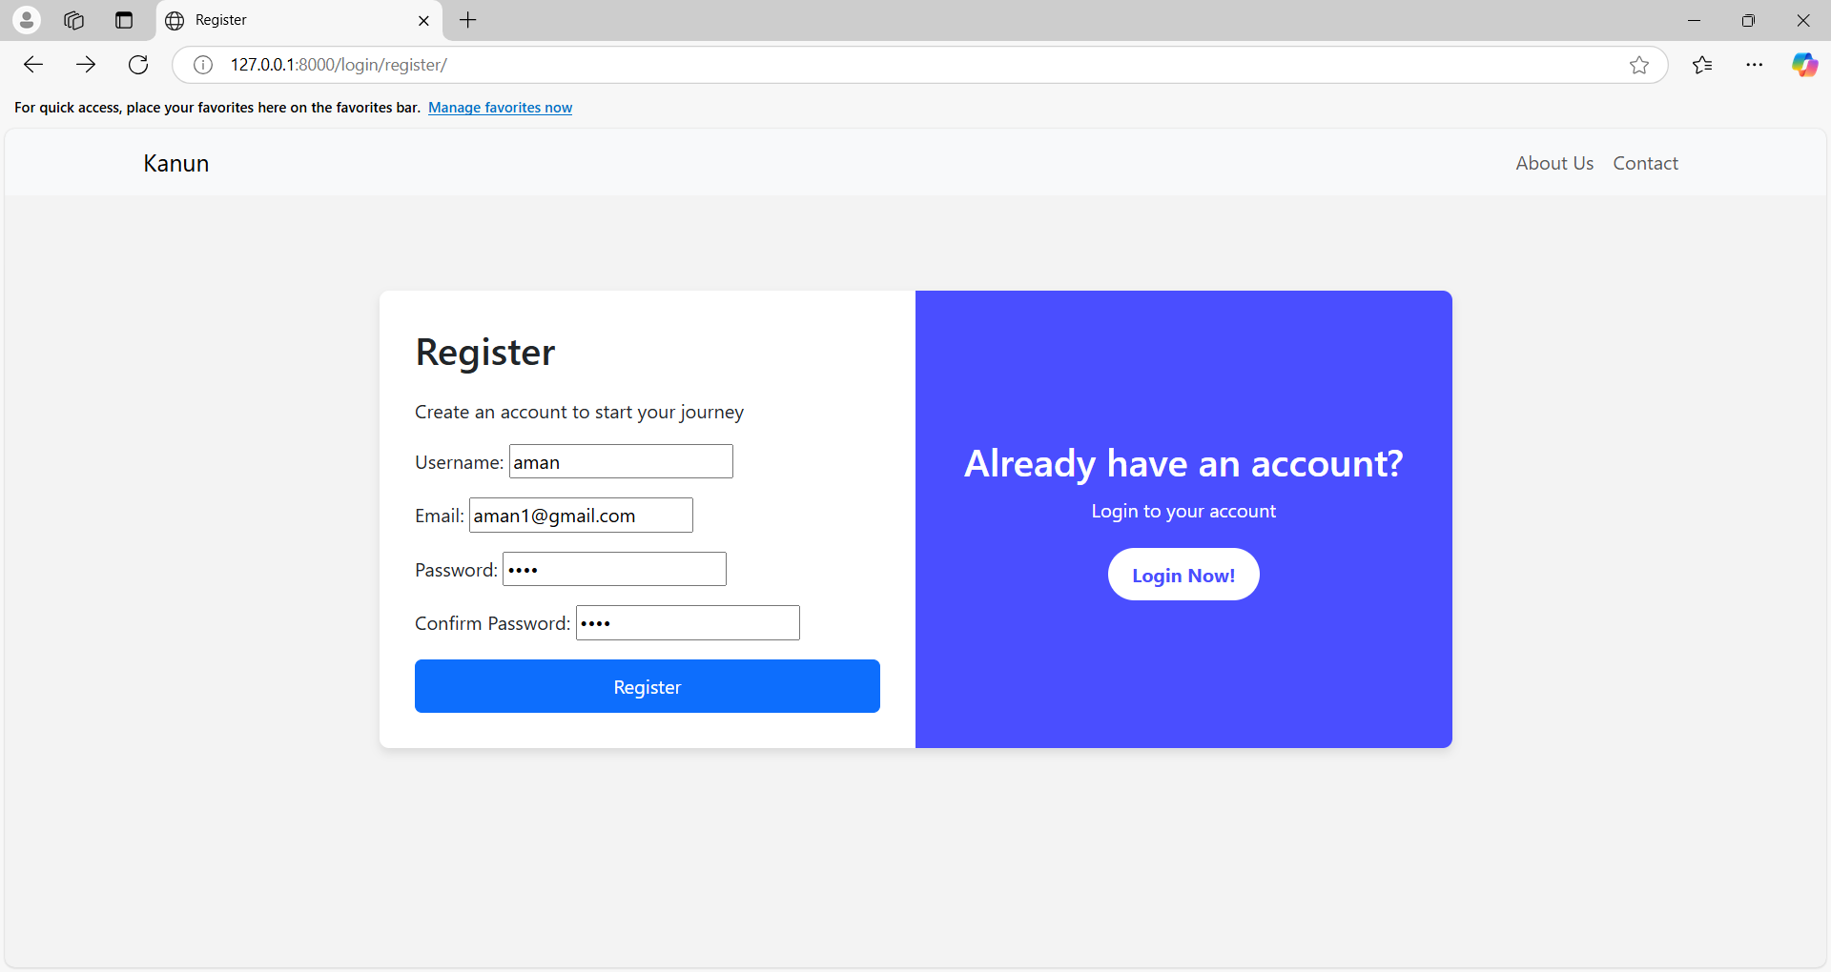
Figure 15: User creating a New Account
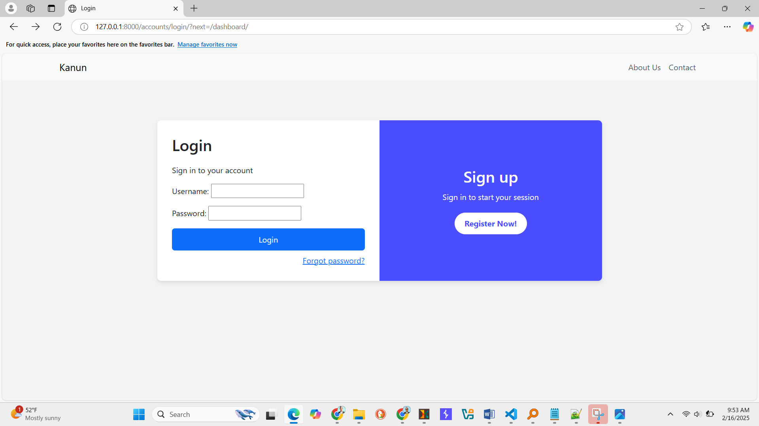
Figure 16: User redirected to Login Page

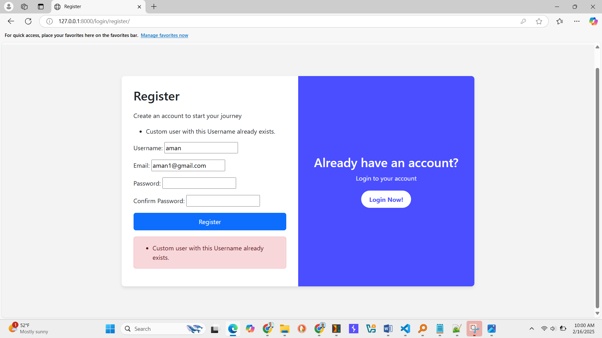
Figure 17: Error message popup with username already exist.

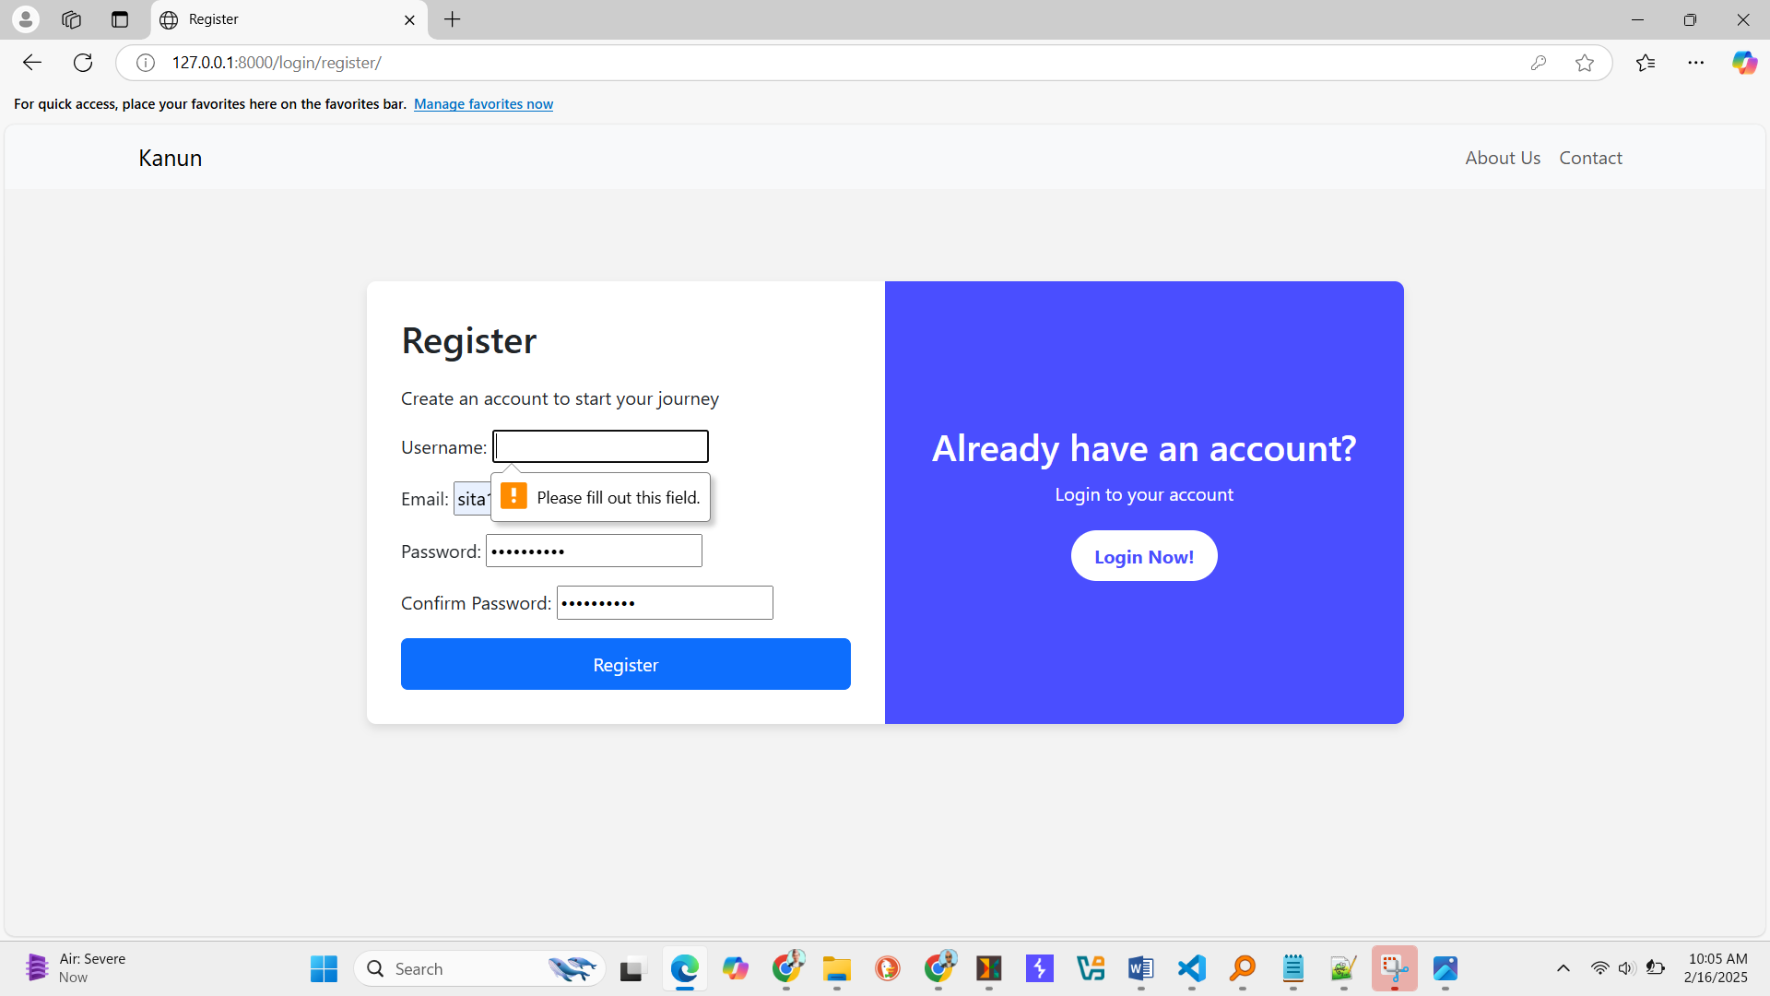
Figure 18: Error message popup with please fill out this field

5.2.1.2 Test Case 2
Table 10: Test Case For User Login
Test Case ID | Test Case Description | Test Data | Expected Outcome | Pass/Fail Criteria
TC_LOG_001 | Verify that a user can Login with valid credentials. | Username: Ram Password: ram@1111 | Users successfully log in. to dashboard | Pass
TC_LOG_002 | Verify Login failure with an incorrect password | Username: Raju  Password:raju@123 | Please enter a correct username and password. Note that both fields may be case-sensitive. | Pass
TC_LOG_004 | Verify Login failure when password field is empty. | Username: hari,  Password: | Error message: Please fill out this field | Pass
TC_LOG_005 | Verify Login failure whether both username and password field are empty. | Username:  password: | Error Message: Please fill out this field | Pass
Evidence of Test Case 2
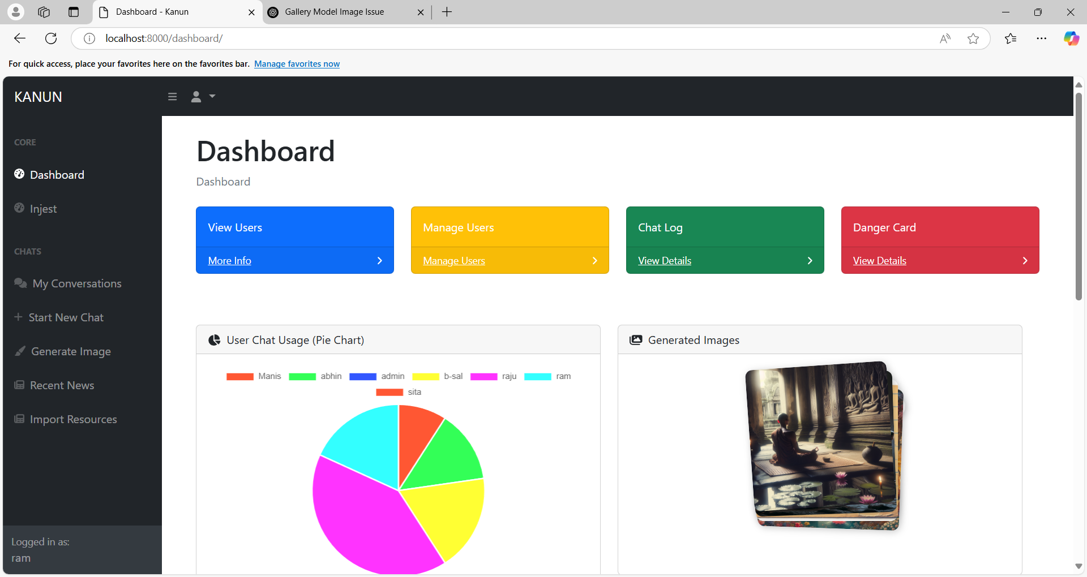
Figure 19: User successfully Login to dashboard

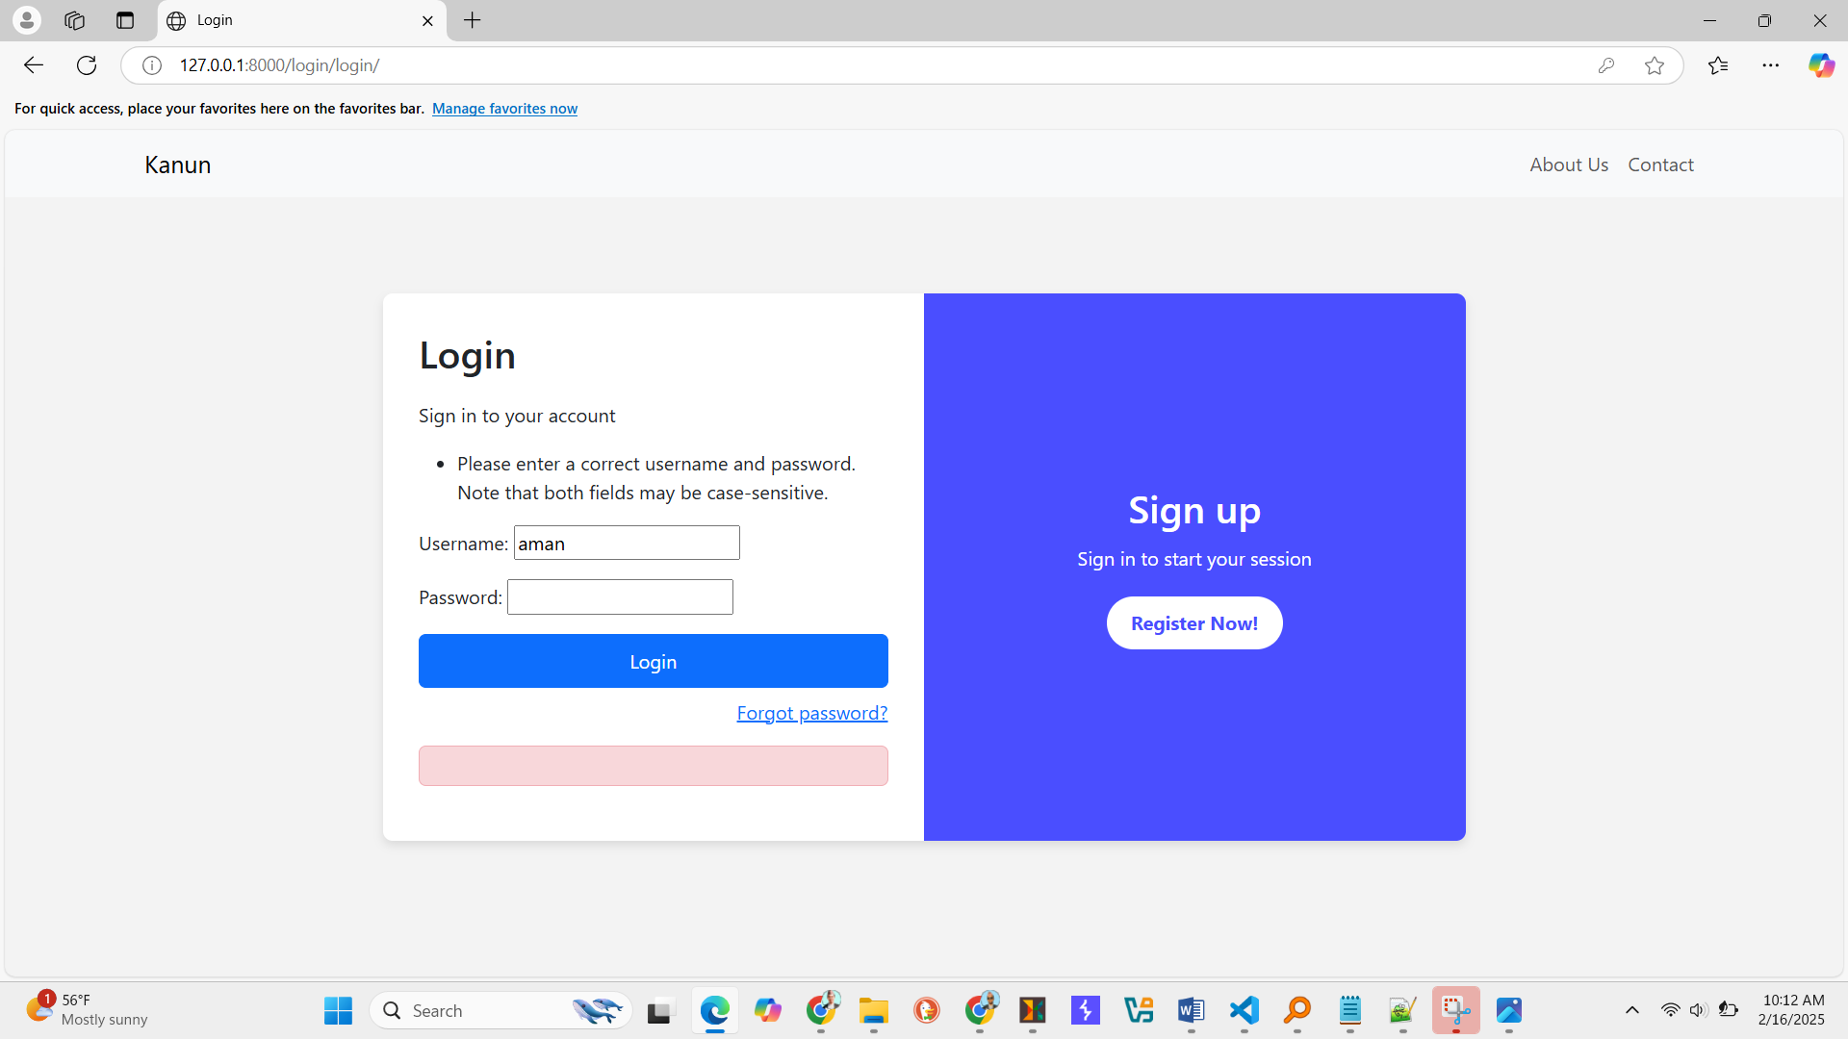
Figure 20: Login Fail due to invalid username and password

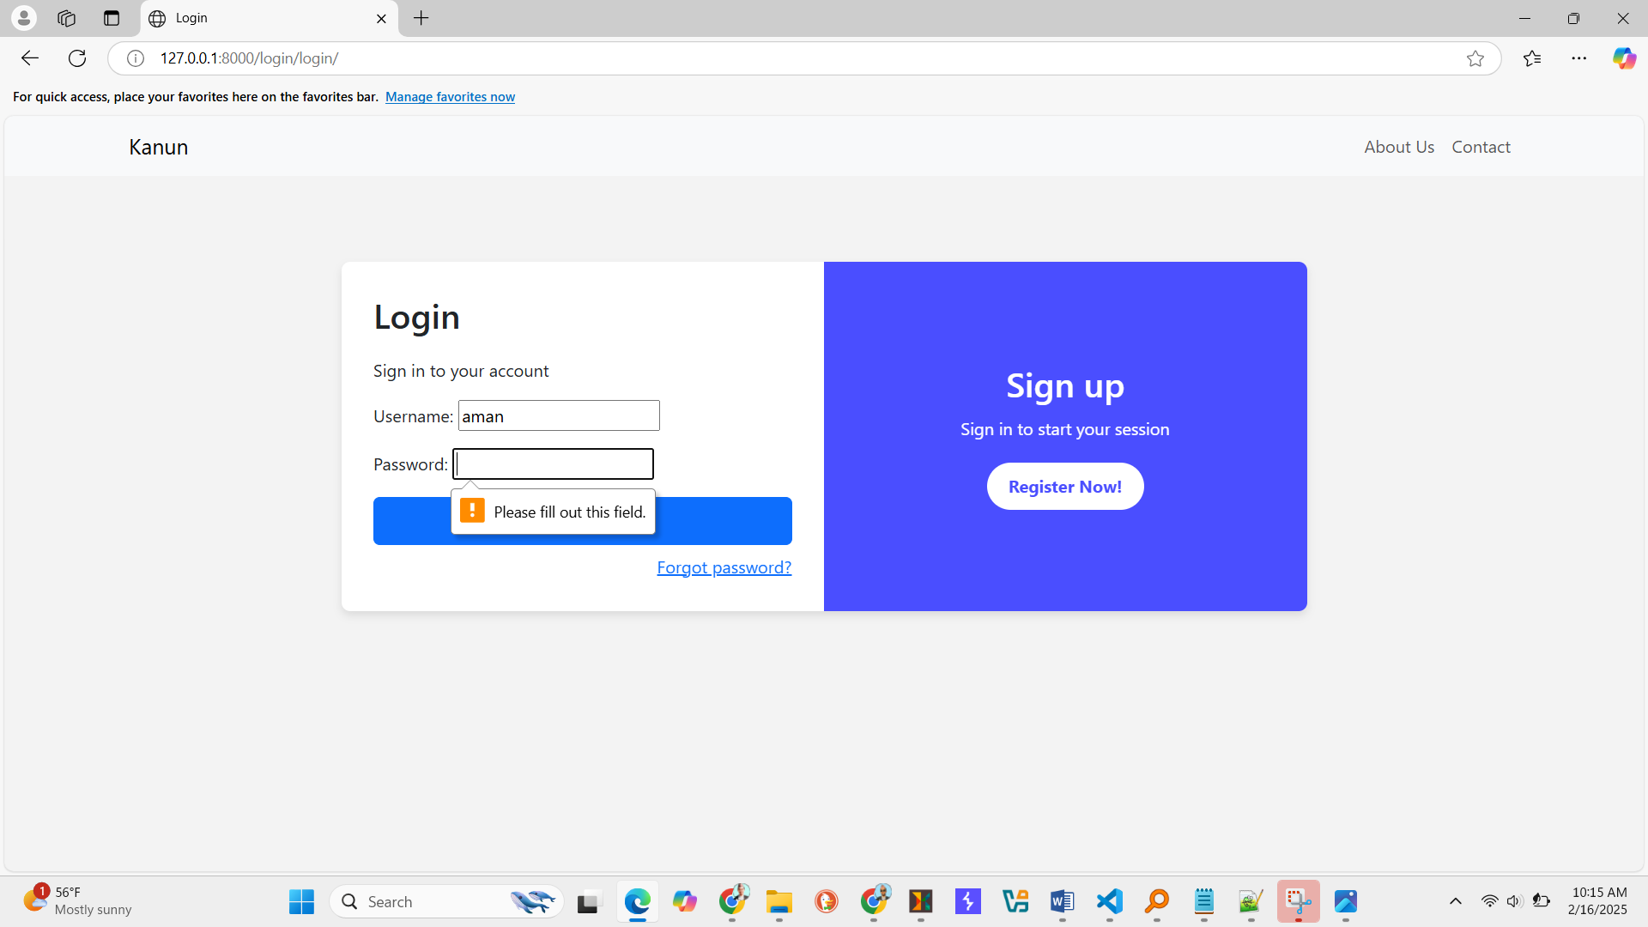
Figure 21:Error message popup with please fill this field

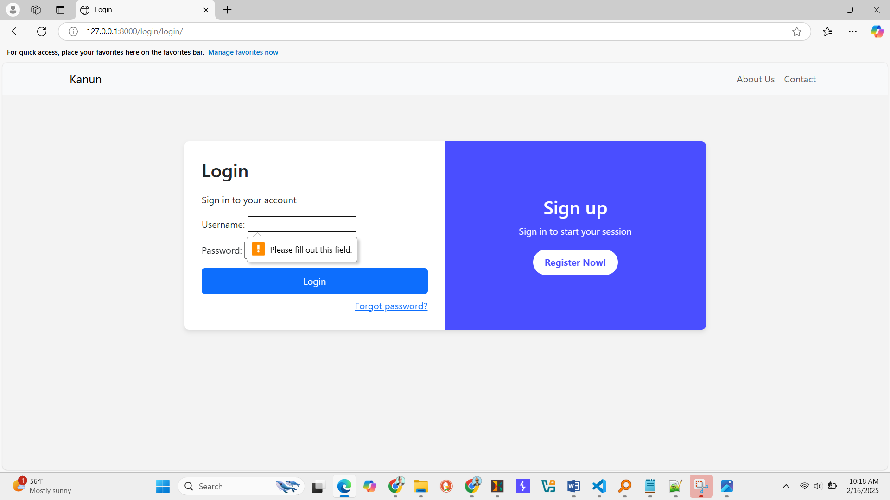
Figure 22: Error Message popup with please fill this field
5.2.1.3 Test Case 3
Table 11: Test Case For Chat Module
Test Case ID | Test Case Description | Test Data | Expected Outcome | Pass/Fail Criteria
TC_CHAT_01 | Verify that a user can start a new chat. | Click on start new chat and type a question related to Constitution of Nepal | Chat initializes and the system responds with relevant constitutional information. | Pass
TC_CHAT_02 | Verify that it answers the constitution related question or not. | Enter question about Constitution of Nepal | System should reject the query with an “ I don't know how to respond ” message. | pass.
TC_CHAT_03 | Verify chat history was saved. | Start the conversation and ask multiple questions. | The chat history should display previous queries and responses. | Pass
TC_CHAT_04 | Verify the real-time response generation. | Ask the constitution related question | System should generate and response within a reasonable time | Pass
TC_CHAT05 | Verify responsiveness for mobile and desktop | Access chat modules from different devices. | Chat interface should adjust for screen size | Pass
TC_CHAT_06 | Verify logout clears chat history and saved into my conversation | Logout and login again | Previous chat history should be visible in my conversation. | Pass

Evidence of Test case 3
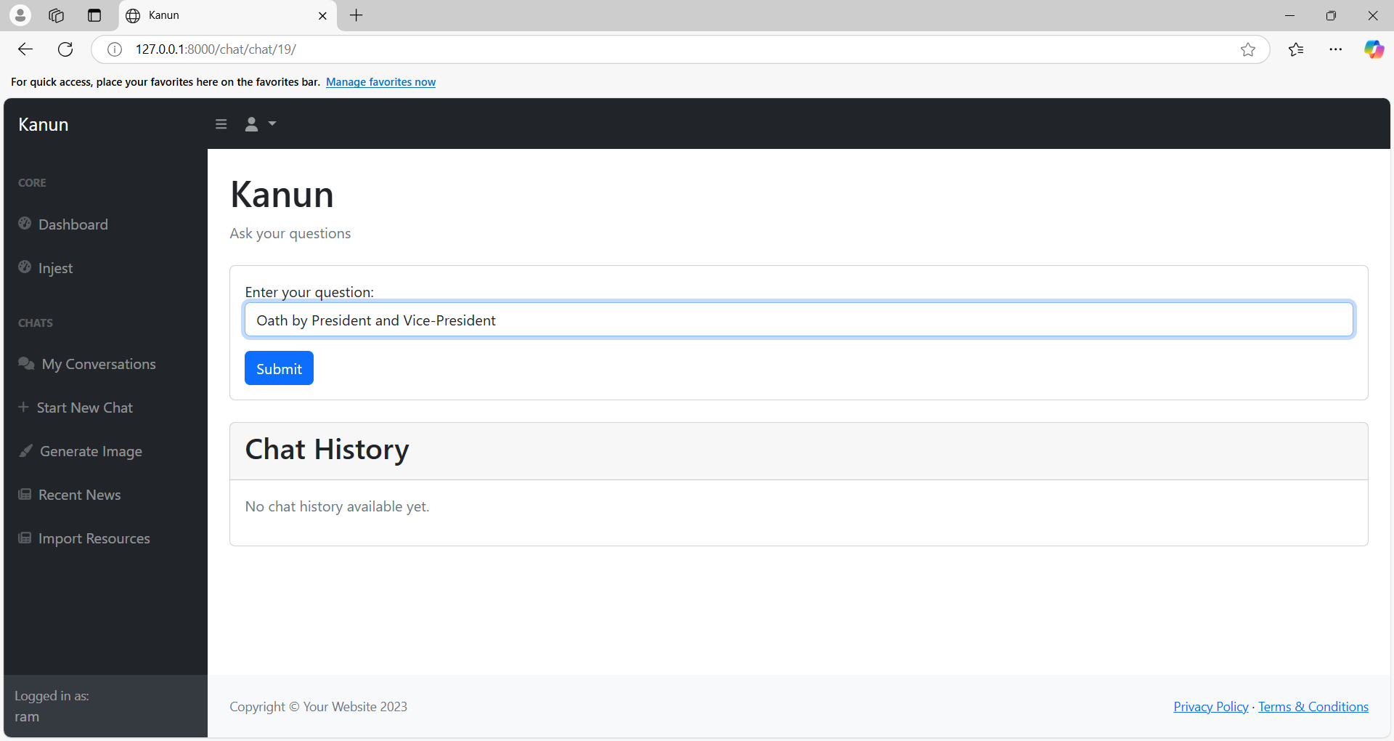
Figure 23: Giving Query to the KANUN
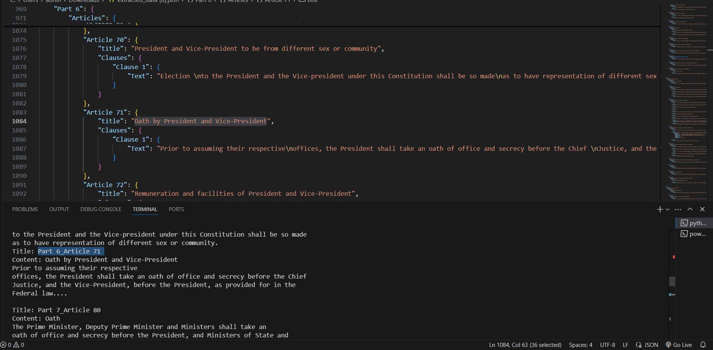
Figure 24: Fetched Content From vector database
Figure 24: Fetched Content From vector database
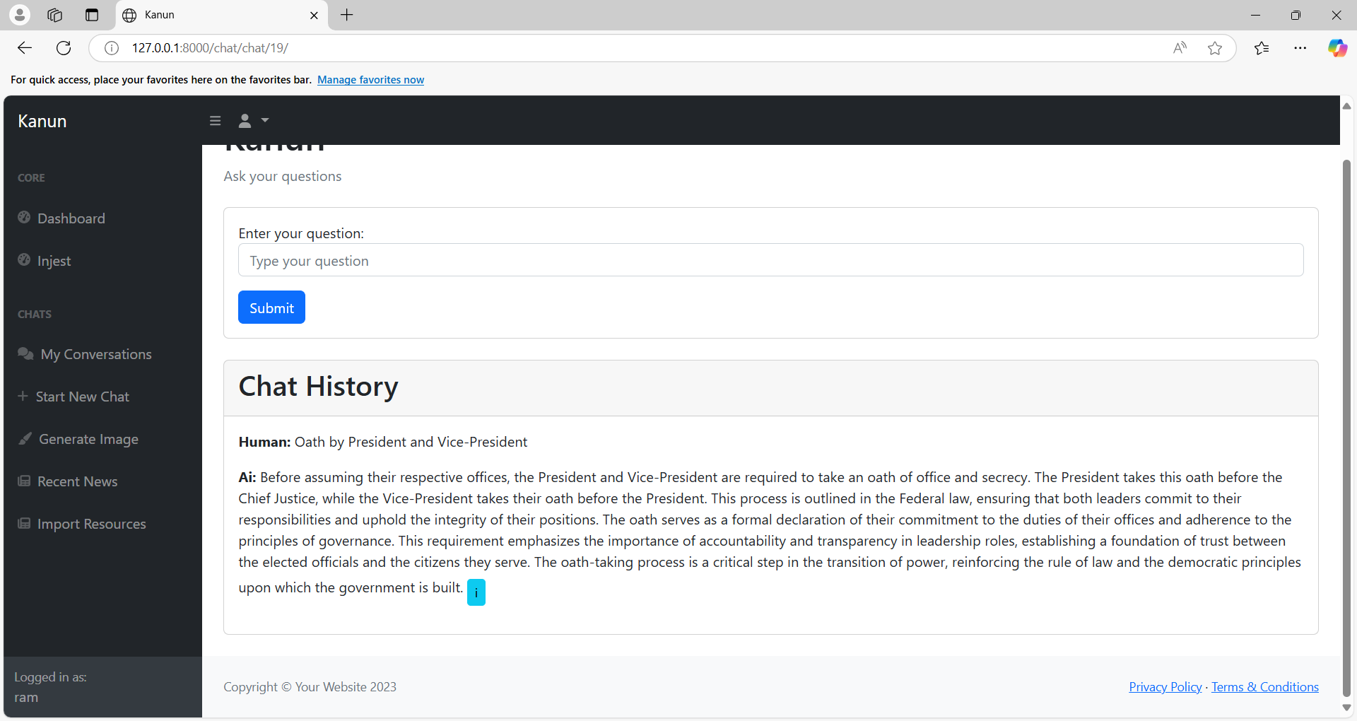
Figure 25: Generated Response
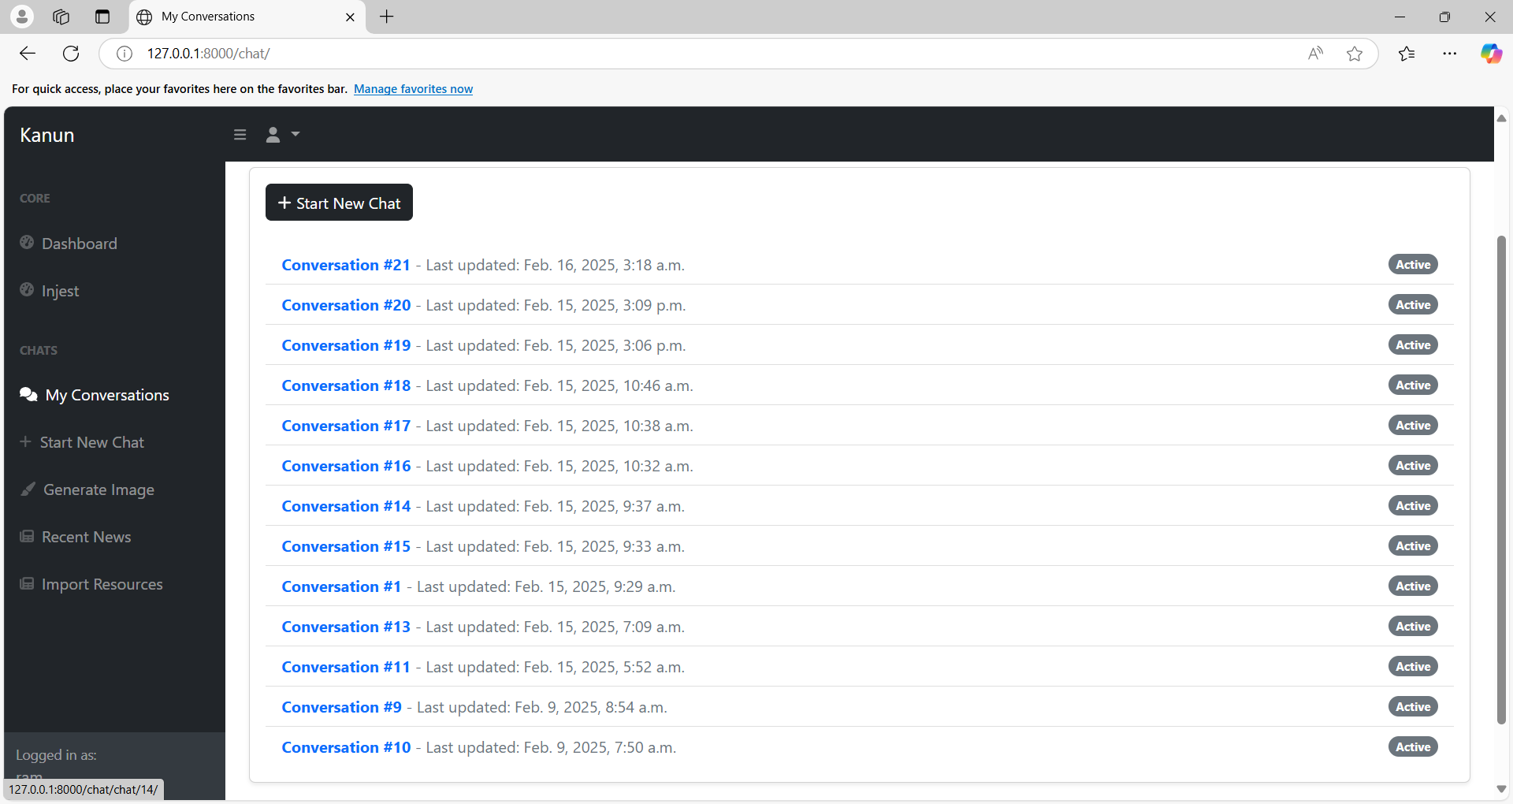
Figure 26: New Chat was created
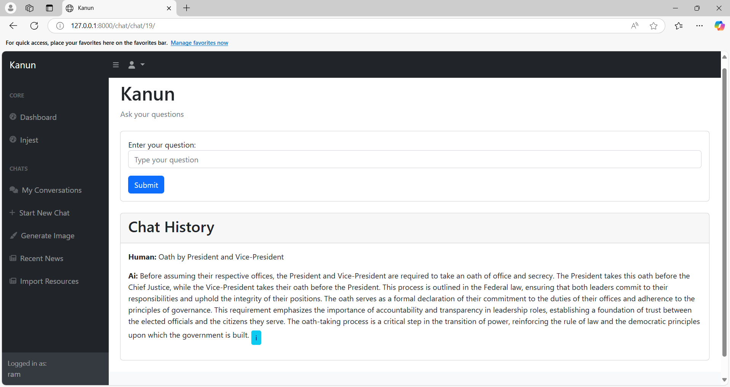
Figure 27: The conversation was saved in chat History

5.2.2 System Testing
System testing is a software testing technique used to evaluate the behavior of an entire software system or application, typically by testing the system as a whole rather than individual components or modules. The goal of system testing is to ensure that the software system works as intended, meets the specified requirements, and is free from defects and bugs that could negatively affect its functionality or usability
Table 12: System Testing
Test Case | Test Scenario | Steps to Execute | Expected Result | Actual Result | Status
Login | Verify that user can login successfully | 1.Go to the Login  2. Fill out the form with valid details  3.Display dashboard to user | The user should be logged in and redirected to their dashboard. | Successfully login to the user dashboard | Pass
Registration | Verify that user can register successfully | 1.Go to the /sign up or /register page.  2.Fill out the form with valid details.  3.Submit the form | The users should be registered and see a success message. | Users successfully register the application. | Pass
User Management | Verify that staff can access the details | 1.Login with staff valid details.  2.Go to the user management  3.Details of valid users. | The staff user should be accessing the user details with the edit, delete and add button. | Staff users successfully get access to user details . | Pass
Chat Module | Verify that user can start new chat | 1.Click on the start new chat  2. Type related queries to Constitution of Nepal | The user can initialize the chat and respond with relevant constitutional information. | User successfully get respond with relevant constitutional information | Pass

5.3 Result Analysis
Result analysis is the process involved in software development which involves the evaluation of the outcomes of various stages in the software development life cycle to ensure that project meets the objective and targeted requirements.

5.3.1 Proposed Model
The proposed model for Kanun application is a secured and legal information retrieval system that works on Retrieval-Augmented Generation (RAG) concept. The application is designed to help the user to retrieve the most relevant and accurate legal information. The Constitution of Nepal has been preprocessed into chunks which are converted into vector embedding using a pre-trained language model of OpenAI. A generative model then synthesizes these retrieved sections into coherent, human-readable responses and contextual explanation.
The Django framework as the backend handles the API requests and responses where a responsive frontend allows users to interact with the system via a web browser. This application enhances accessibility to legal information which makes it easier for citizens to get through the Constitution of Nepal including those without legal expertise to understand human rights and obligations. In Nepal, the proposed of Kanun application could help to acknowledge the citizen right toward the Nation.
Additionally, the use of RAG technology could increase the transparency and people can access rules and regulations as they need. The Application provides a powerful tool for citizens, legal professionals and policymakers in Nepal. However, implementing Kanun application using RAG technology in Nepal would require overcoming several challenges, such as ensuring secure and reliable internet connectivity and building trust among citizens in the new application.Therefore, careful planning and collaboration among stakeholders, including government agencies, civil society would be essential to successfully implementing the proposed Kanun application in Nepal. Kanun had the potential to revolutionize how people interact with the Constitution of Nepal allowing them to recognize their rights and fulfill their responsibilities with full confidence against any crime.

5.3.2 Advantage of Proposed Model
The proposed Kanun query application using RAG technology offers several advantages over the traditional learning systems. It ensures that responses are precise and accurate in the original text. A user-friendly interface designed by Django makes it easier for the people and the citizens of Nepal to submit queries and receive detailed information about the Constitution of Nepal. Citizens can learn their legal rights and values from anywhere in the world, making the process more accessible and convenient. The application can reduce the costs associated with the traditional learning systems. The need for books, legal advisors and libraries is eliminated, reducing the overall cost of the traditional learning system.

5.3.3 Disadvantages of Proposed Model
As the application is based on RAG, it requires a large database of pre-processed data, which can be an extensive resource commitment. Similarly, in order to store the embedded data of the documents requires complex setup of vector database and interactions are complex that can cause additional latency in the system. It requires specialized expertise for development and maintenance. Furthermore, the accuracy of responses hinges on the quality and completeness of the underlying data. If the training dataset is flawed or incomplete, the AI may generate inaccurate or misleading information, potentially leading to user confusion and misinterpretations of constitutional articles. This reliance on data quality also highlights the critical importance of robust data governance and curation processes. Finally, the handling of sensitive legal queries raises serious concerns about data privacy and security, demanding stringent safeguards to protect confidential information and prevent misuse. Addressing these challenges is crucial for the responsible and effective deployment of AI-powered legal tools.

5.3.4 Relevant Screenshot

Figure 28: Cover Page
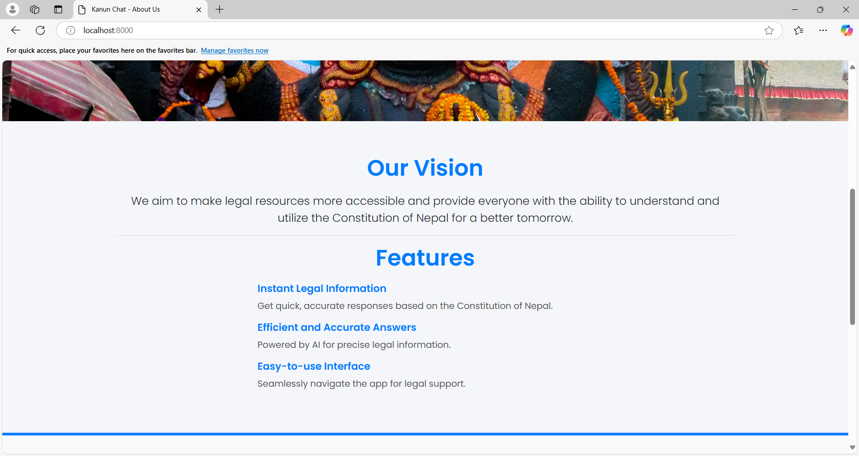
Figure 29: Cover Page - Introduction
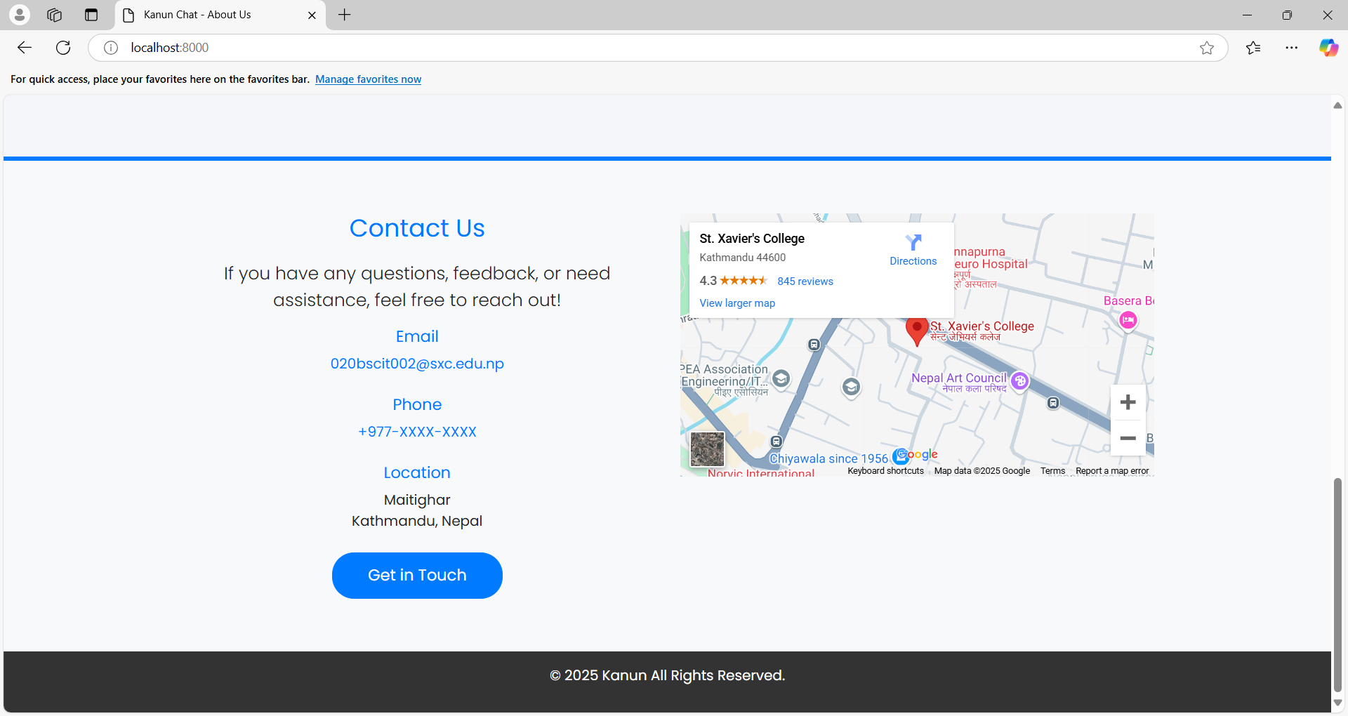
Figure 30: Cover Page - Contact
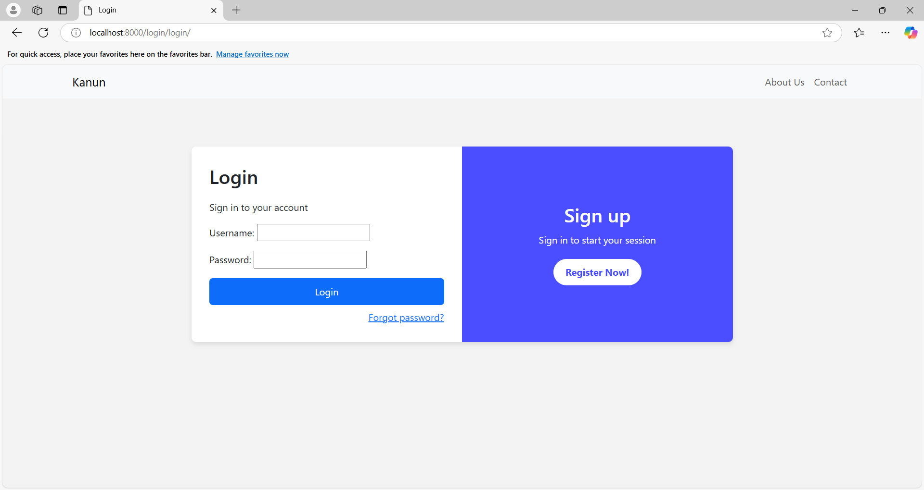
Figure 31: Login Page
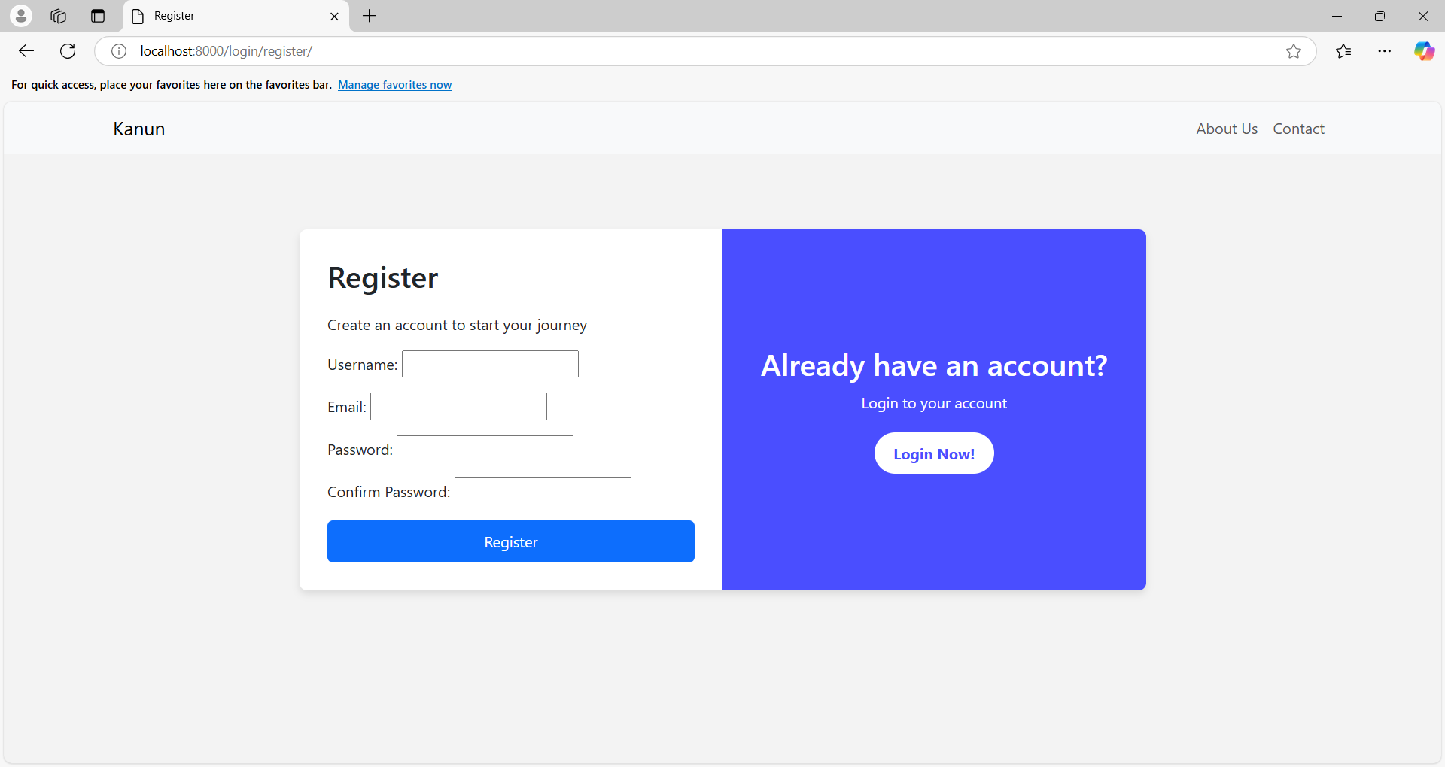
Figure 32Registration Page
Figure 33: Dashboard Page
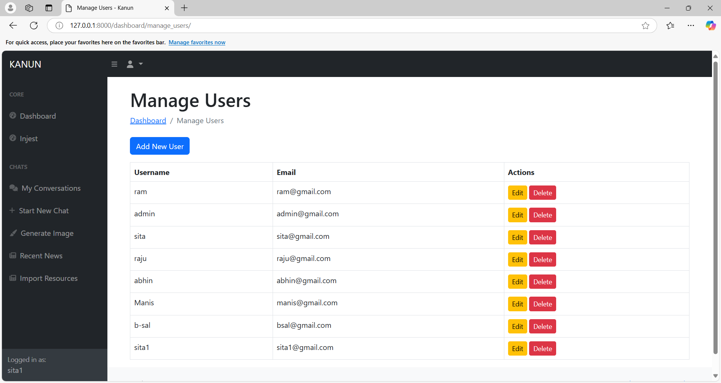
Figure 34: User Management
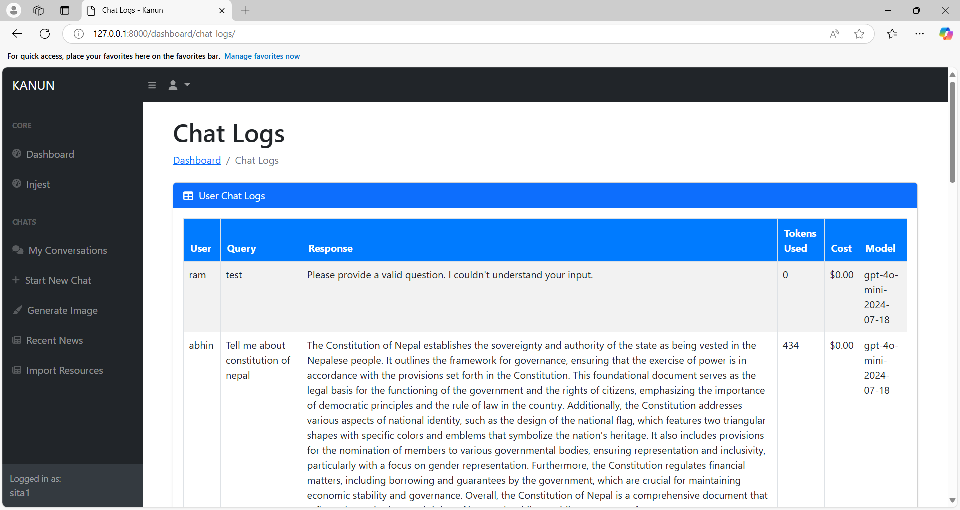
Figure 35: Chat Log

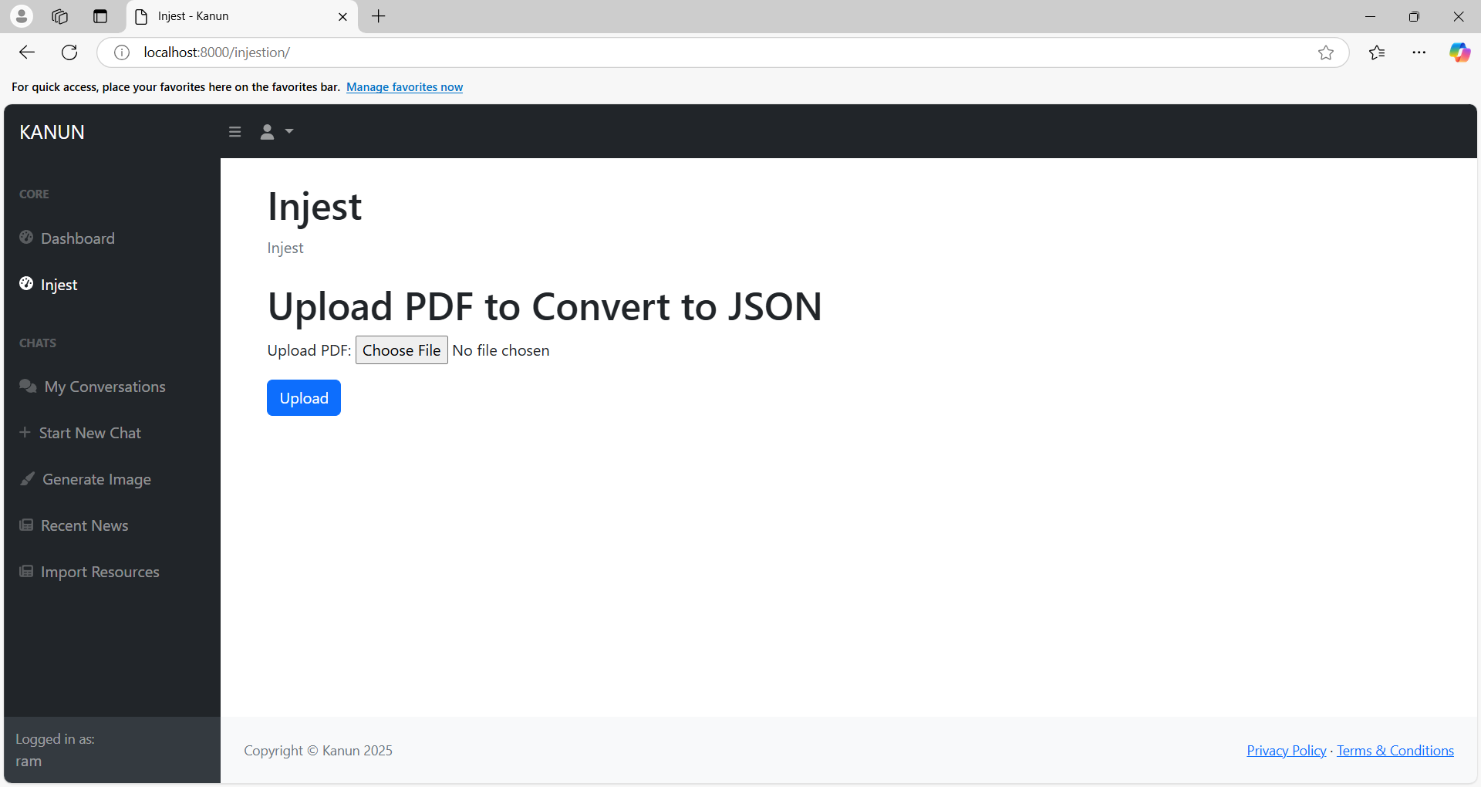
Figure 36: Injestion Page

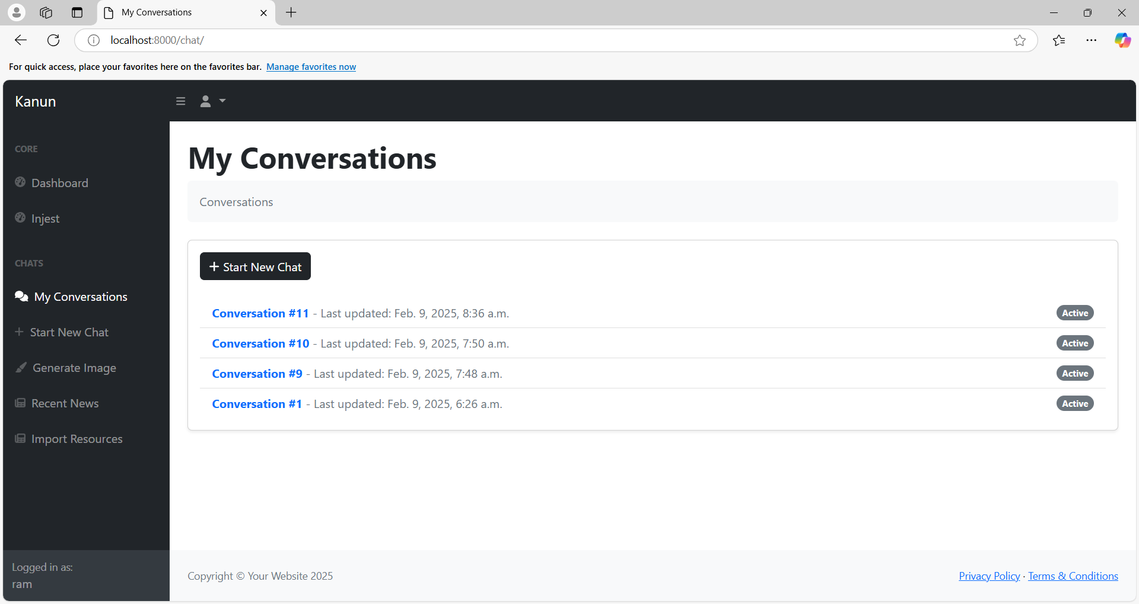
Figure 37: Conversation Page

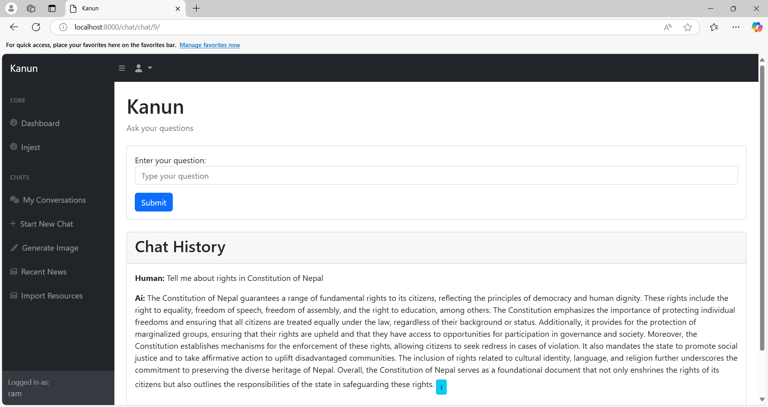
Figure 38: Chat PAge
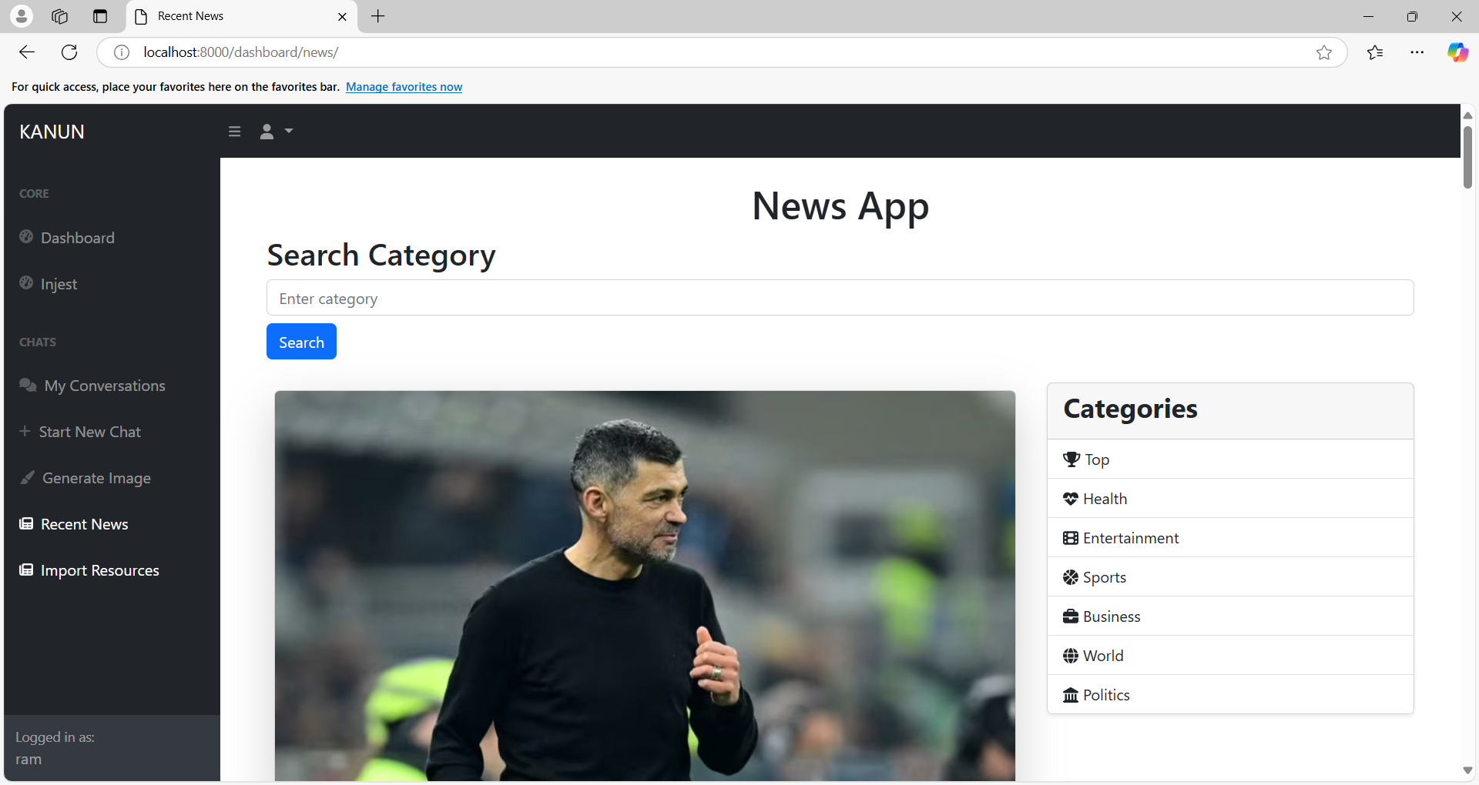
Figure 39: News Page

CHAPTER 6: CONCLUSION AND FUTURE RECOMMENDATION

6.1 Conclusion
The “कानुन” Kanun application, powered by Retrieval-Augmented Generation (RAG) technology for Nepal's Constitution. It is designed centered around pre-processed constitutional text, whichis feed to LLM through RAG and allows for the generation of clear and contextual responses to user inquiries. This approach aims to bridge the gap between complex legal language and the everyday citizen, fostering a deeper understanding of fundamental rights and obligations. The Django-based interface further simplifies interaction also this enhanced accessibility has the potential to cultivate greater transparency and citizen's participation and empowering individuals to navigate the legal framework with increased confidence. While the benefits are clear, including improved accuracy and cost-effectiveness compared to traditional legal resources, certain implementation hurdles must be addressed. These include the considerable effort required for data preparation and storage, the technical expertise needed for ongoing maintenance, and the paramount importance of data integrity for ensuring reliable outputs. Similarly, data management and security protocols are vital to safeguard sensitive information and build public trust. Overcoming these challenges is essential to fully realize the transformative potential of the Kanun application and its impact on legal literacy in Nepal. Despite these complexities, the Kanun application offers a promising avenue for reshaping the way citizens engage with the Constitution, ultimately fostering a more informed and empowered populace.

6.2 Future Recommendation
Looking forward, several important recommendations are essential for the ongoing growth and enhancement of the Kanun application. Considering multilingual support is necessary to increase accessibility for a broader audience. Furthermore, incorporating advanced retrieval methodologies, such as Recursive Abstractive Processing for Tree Organized Retrieval, has significant promise for enhancing the system's capability to efficiently explore and summarize intricate legal information. Developing a mobile application, along with enabling offline access to vital information, is crucial for connecting with users in remote locations that have limited internet access. Implementing a strong user feedback system will be invaluable for collecting insights and steering future development initiatives. Lastly, promoting collaboration with legal experts, government entities, and local communities is key to ensuring the accuracy, relevance, and overall effectiveness of the Kanun application.

REFERENCES
[1]Narayani Law Firm, "Constitution of Nepal 2072" [Online], Available: https://narayanilawfirm.org.np/constitution-of-nepal-2072/ [Accessed: 4-Nov-2024].
[2]I. Sommerville, Software Engineering, 9th ed. Boston, MA, USA: Addison-Wesley, 2011, p. 32. [Accessed: 8-Nov-2024].
[3].K. D. Ashley, Artificial Intelligence and Legal Analytics: New Tools for Law Practice in the Digital Age. Cambridge, U.K.: Cambridge University Press, 2017. [Accessed: 8-Nov-2024].
[4] R. Susskind, Online Courts and the Future of Justice. Oxford, U.K.: Oxford University Press, 2019. [Accessed: 8-Nov-2024].
[5] Pinecone, “What is a Vector Database & How Does it Work? Use Cases + Examples” [Online], Available: https://www.pinecone.io/learn/vector-database [Accessed: 12-Nov-2024].
[6] P. Goyal, J. Chou, J. Liu, and N. Brown, “Efficient legal text retrieval using FAISS-based vector search,” in Proc. AI & Law Conf., 2021. [Accessed: 14-Nov-2024].
[7] M. Lewis, A. Piktus, and S. Riedel, “Retrieval-augmented generation for knowledge-intensive NLP tasks,” in Proc. NeurIPS, 2020. [Accessed: 14-Nov-2024].
[8] Topsakal, O. and Akinci, T.C., 2023, July. Creating large language model applications utilizing langchain: A primer on developing llm apps fast. In International Conference on Applied Engineering and Natural Sciences (Vol. 1, No. 1, pp. 1050-1056). [Accessed: 14-Nov-2024].
[9] Jeong, C., 2023. A study on the implementation of generative ai services using an enterprise data-based llm application architecture. arXiv preprint arXiv:2309.01105 e: https://arxiv.org/pdf/2309.01105 [Accessed: 14-Nov-2024].
[10] M. E. Mamalis, E. Kalampokis, F. Fitsilis, G. Theodorakopoulos, and K. Tarabanis, “A Large Language Model Agent-Based Legal Assistant for Governance Applications,” in Electronic Government: 23rd IFIP WG 8.5 International Conference, EGOV 2024, Ghent-Leuven, Belgium, September 3–5, 2024, Proceedings, vol. 14841, Springer, 2024, pp. 286–301, 10.1007/978-3-031-70274-7_18. [Accessed: 14-Nov-2024].
[11] Filipovska, E., Mladenovska, A., Bajrami, M., Dobreva, J., Hillman, V., Lameski, P. and Zdravevski, E., 2024, September. Benchmarking OpenAI’s APIs and other Large Language Models for Repeatable and Efficient Question Answering Across Multiple Documents. In 2024 19th Conference on Computer Science and Intelligence Systems (FedCSIS) (pp. 107-117), https://annals-csis.org/Volume_39/drp/pdf/3979.pdf [Accessed: 14-Nov-2024].
[12] Chia, H., Zhang, G.Z., Russo-Batterham, D., Shrestha, K.M., Quang, U.T., Wang, Z. and Paterson, J.M., LEGAL (Leveraging Expert Guidance for AI in Law): A RAG-Based System for Legal Document Navigation, https://alta2024.alta.asn.au/assets/papers/39.pdf [Accessed: 14-Nov-2024].
[13] Lin, D., 2024. Revolutionizing retrieval-augmented generation with enhanced PDF structure recognition. arXiv preprint arXiv:2401.12599, https://arxiv.org/pdf/2401.12599 [Accessed: 15-Nov-2024].
[14] McGinnis, John O., and Russell G. Pearce., 2013. “The great disruption: How machine intelligence will transform the role of lawyers in the delivery of legal services.” Fordham L. Rev., 82, p.3041., https://heinonline.org/HOL/LandingPage?handle=hein.journals/flr82&div=96&id=&page [Accessed: 15-Nov-2024].
[15] Azirar, S., Gabbar, H.A. and Regoui, C., 2024. “IQLS: Framework for leveraging Metadata to enable Large Language Model based queries to complex, versatile Data.” arXiv preprint arXiv:2405.15792., https://arxiv.org/pdf/2405.15792 [Accessed: 25-Nov-2024].

[16] Nigam, S.K., Deroy, A., Maity, S. and Bhattacharya, A., 2024. “Rethinking legal judgement prediction in a realistic scenario in the era of large language models.” arXiv preprint arXiv:2410.10542., https://arxiv.org/pdf/2410.10542 [Accessed: 25-Nov-2024].
[17] Wang, X., Zhang, X., Hoo, V., Shao, Z. and Zhang, X., 2024. LegalReasoner: A Multi-Stage Framework for Legal Judgment Prediction via Large Language Models and Knowledge Integration. IEEE Access., https://ieeexplore.ieee.org/stamp/stamp.jsp?arnumber=10750819 [Accessed: 25-Nov-2024].
[18] Sil, R., Roy, A., Bhushan, B. and Mazumdar, A.K., 2019, October. Artificial intelligence and machine learning based legal application: the state-of-the-art and future research trends. In 2019 International Conference on Computing, Communication, and Intelligent Systems (ICCCIS) (pp. 57-62). IEEE., Available: https://www.researchgate.net/profile/Riya-Sil/publication/338938049_Artificial_Intel ligence_and_Machine_Learning_based_Legal_Application_The_State-of-the-Art_and _Future_Research_Trends/links/5e896f1f4585150839c0d5fa/Artificial-Intelligence-and-Machine-Learning-based-Legal-Application-The-State-of-the-Art-and-Future-Research-Trends.pdf [Accessed: 25-Nov-2024].
[19] Cheong, I., Xia, K., Feng, K.K., Chen, Q.Z. and Zhang, A.X., 2024, June. “(A) I Am Not a Lawyer, But...: Engaging Legal Experts towards Responsible LLM Policies for Legal Advice.” In The 2024 ACM Conference on Fairness, Accountability, and Transparency (pp. 2454-2469)., Available: https://dl.acm.org/doi/pdf/10.1145/3630106.3659048 [Accessed: 25-Nov-2024].
[20] Harasta, J., Novotná, T. and Savelka, J., 2024. It cannot be right if it was written by AI: on lawyers’ preferences of documents perceived as authored by an LLM vs a human. Artificial Intelligence and Law, pp.1-38., Available:https://arxiv.org/pdf/2407.06798 [Accessed: 1- Dec-2024].
[21] Pipitone, N. and Alami, G.H., 2024. LegalBench-RAG: A Benchmark for Retrieval-Augmented Generation in the Legal Domain. arXiv preprint arXiv:2408.10343., Available: https://arxiv.org/pdf/2408.10343v1 [Accessed: 3- Dec-2024].
[22] Gupta, V., 2024. Leveraging open-source models for legal language modeling and analysis: a case study on the Indian constitution. arXiv preprint arXiv:2404.06751., Available: https://arxiv.org/pdf/2404.06751 [Accessed: 3- Dec-2024].
[23] "Systems Analysis: Definition & Example," Study.com, 2017. [Online]. Available: https://study.com/academy/lesson/systems-analysis-definition-example.html. [Accessed: 2-Feb-2025].
[24] J. Bishop, Systems Analysis and Design. Boston, MA: Course Technology, 2011. [Accessed: 3- Dec-2024].
[25] Merriam-Webster’s Dictionary of English Usage. Springfield, MA: Merriam-Webster, 1989. [Accessed: 7- Dec-2024].
[26] J. Bishop, Systems Analysis and Design. Boston, MA: Course Technology, 2011. [Accessed: 7- Dec-2024].
[27]Editor (2019) Functional and non-functional requirements: Specification and types, AltexSoft. AltexSoft. Available at: https://www.altexsoft.com/blog/business/functional-and-non-functional-requirements specification-and-types/ [Accessed: 1-Jan -2025].
[28] Scaled Agile framework, "Nonfunctional Requirements," [Online]. Available: https://scaledagileframework.com/nonfunctional-requirements/. [Accessed: 7- Dec-2024].
[29] J. Bridges, "What Is a Feasibility Study? How to Conduct One for Your Project," [Online], https://www.projectmanager.com/training/how-to-conduct-a-feasibility-study. [Accessed: 1-Jan -2025].

[30] The basics of the Object Model (no date) Section. Available at: https://www.section.io/engineering-education/basics-of-the-object-model/ [Accessed: 1-Jan -2025].
[31] Lucidchart, "UML Sequence Diagram Tutorial," [Online]. Available: https://www.lucidchart.com/pages/uml-sequence-diagram[Accessed: 7- Dec-2024].
[32] Vanner, C. (ed.) What is process modeling?What is process modeling? 6 essential questions answered. Available at: https://www.bizagi.com/en/blog/what-is-process-modeling [Accessed: 3- Dec-2024].
[33] Machine Learning, "Cosine Similarity – Understanding the math and how it works (with python codes)"[Online], Available:https://www.machinelearningplus.com/nlp/cosine-similarity/[Accessed: 1-Jan -2025].
[34] TypingMind Blog, "RAG for Beginners: The Complete Guide to Retrieval Augmented Generation" [Online], Available: https://blog.typingmind.com/rag-for-beginners/ [Accessed: 7-Jan -2025].

