**The Dashboard:**

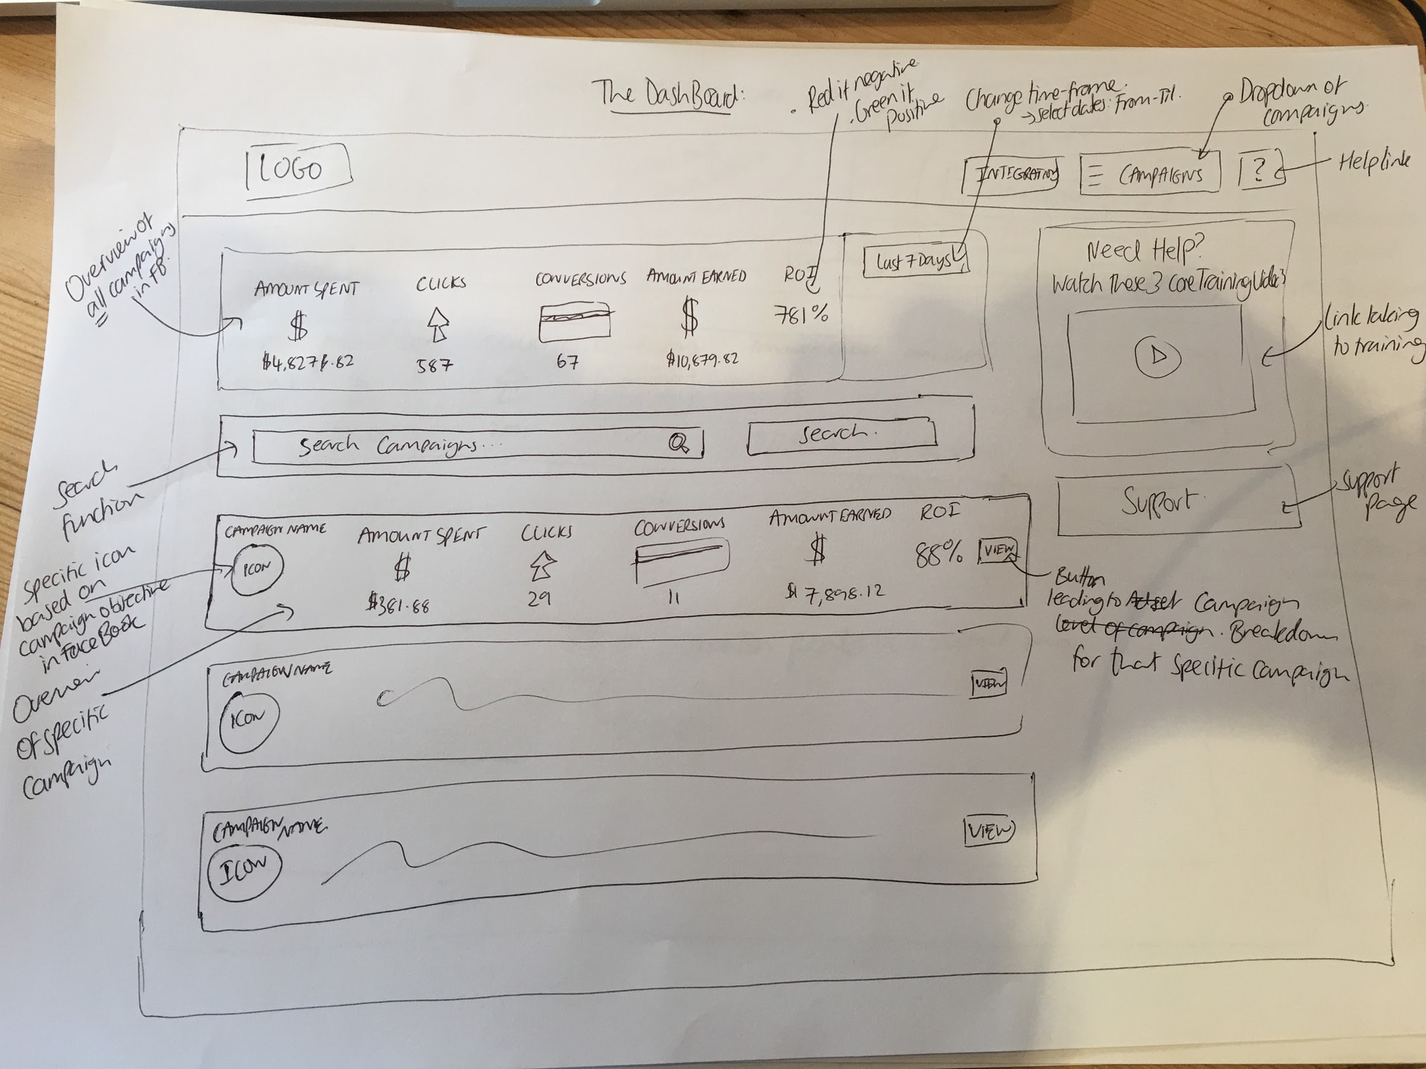

**The Header Menu:**

The header menu is where the logo is, and also the series of buttons in the top right hand corner. This menu should stay at the top of each page. The buttons and drop-down menu’s on the right should be easy to read, and include fave icons to easily identify themselves.

Here’s an example to model (not copy):

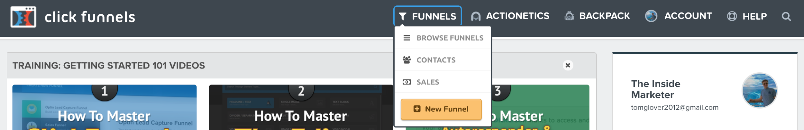

1) **Integrations:** This should be a dropdown menu from a button called “My Account” (where they can edit their accounts information, such as name, email, payments, subscriptions, etc). The Integrations button will take them to a separate page where they can connect their lead & sales managment systems by logging into them.

Then, in the Campaign Breakdown, they will be able to assign which lead and sales campaigns work with that specific campaign, so they can be using real data (instead of FB’s slightly inaccurate lead & sale data). For starters, let’s use the integration of ClickFunnels: It can track their leads, and their sales. I can give you access to my account for you to experiment with it.

2) **The Campaign Dropdown:** A dropdown menu at the top of the page which they can click on to easily see all of the campaigns they’re running in their FB ads manager. When they click on the campaign, it’ll take them to the correct Campaign Breakdown page.

3) **The Help Link**: This should be another simple button -- easily identified with a help favicon which will take them to a simple support page which we can create later on.

4) **Overview Of All Campaigns In FaceBook:** This is one of the main parts of this page, and should display 5 main parts of data: “Total Spent”, “Clicks”, “Conversions”, “Leads”, “Sales” “Amount Earned”, and “ROI”.

The “Total Spent”, “Clicks” and “Conversions” will be data which has been pulled from FB. The “Amount Earned” should be data which has been pulled from the sales managment system they set up in the “Campaign Breakdown” stage (or from FaceBook if they decide not to integrate theirs).

And finally -- the ROI should be calculated from the “Amount Earned” (Pulled from their sales managment system they integrated) and the “Amount Spent” (Pulled from FB). If the ROI is positive, it should show in green. If it’s negative, it should show in red.

The information this is presenting is the combined data for **all of their FB ads** within their account.

There should then also be a dropdown menu where they can select the date range. Much like the one built within FB. They should have the option to select “Today”, “Yesterday”, “Last 7 Days”, “Last 14 Days”, “Last 30 Days”, “Last Month”, “This Month” and “Custom” (Where they can select the date range from a calendar like below):

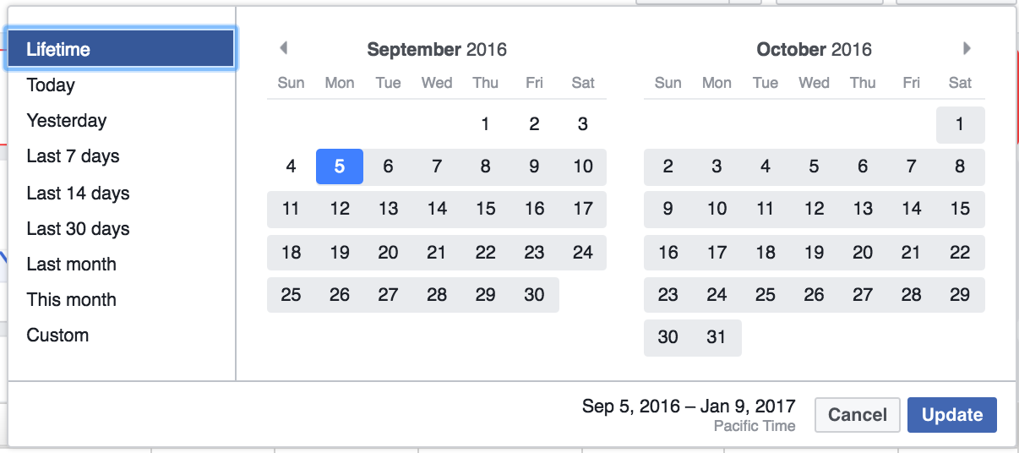

5) **Banners To The Right:** To the right hand side -- you’ll see that there’s two banners. The first should be a simple square shaped box which says “Need Help? Watch These 3 Core Video’s”, and then an image of one of the video’s, with a play button over it, which highlights if they hover over it. Click on it, and it’ll take them to the support page.

Don’t worry about creating the support button. Later we may add a new banner on the right hand side.

6) **The Search Function:** This is a function where the user should be able to enter in specific keywords, or phrases which will help them locate the campaign they’re looking for.

Within FB -- you name your campaigns, so if we called ours “Campaign A”, as we start typing that into the search bar, it should remove all the others, and only show the campaigns which have the words that we type into the search bar.

7) **The Specific Campaign Overviews:** Finally, on this page -- there will be a series of other campaigns which they’re running. This tab will be identical to the “Overall Campaign Overview” box. The only difference is:

First -- the data will be for each specific campaign, rather than the total of all the campaigns. Again, the “Total Spent”, “Clicks”, “Conversions” will be pulled from FB. The “Amount Earned” will be pulled from the sales managment system they set up within that specific Campaign Breakdown, and the ROI will be calculated, and shown in red if negative, and green if positive.

Second -- on the left, there will be a specific icon that’s related to the campaign objective they select within FB. These icons are already populated within FB, so the software will pull through the one that’s specific to the campaign their running:

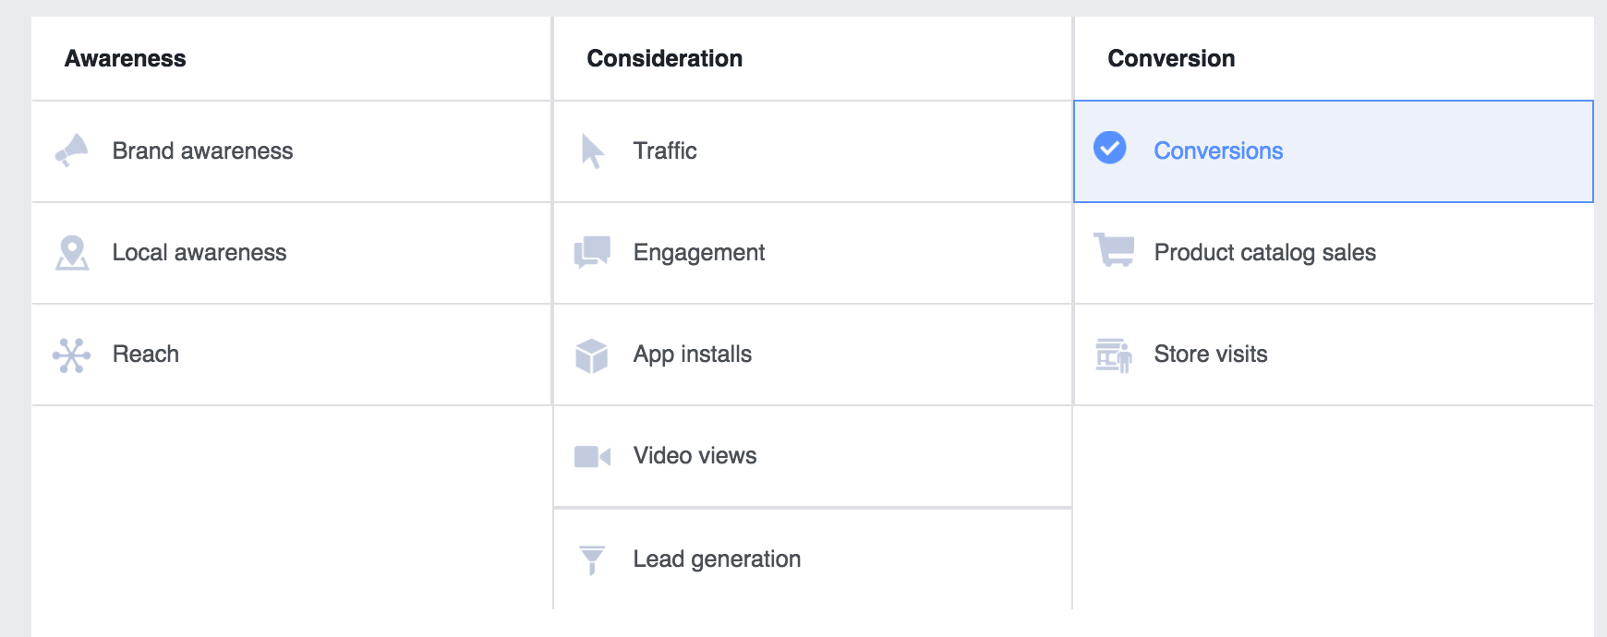

And finally -- there will be a “VIEW” button they can click on which will take them to the Campaign Breakdown for that specific campaign.

**The Campaign Breakdown:**

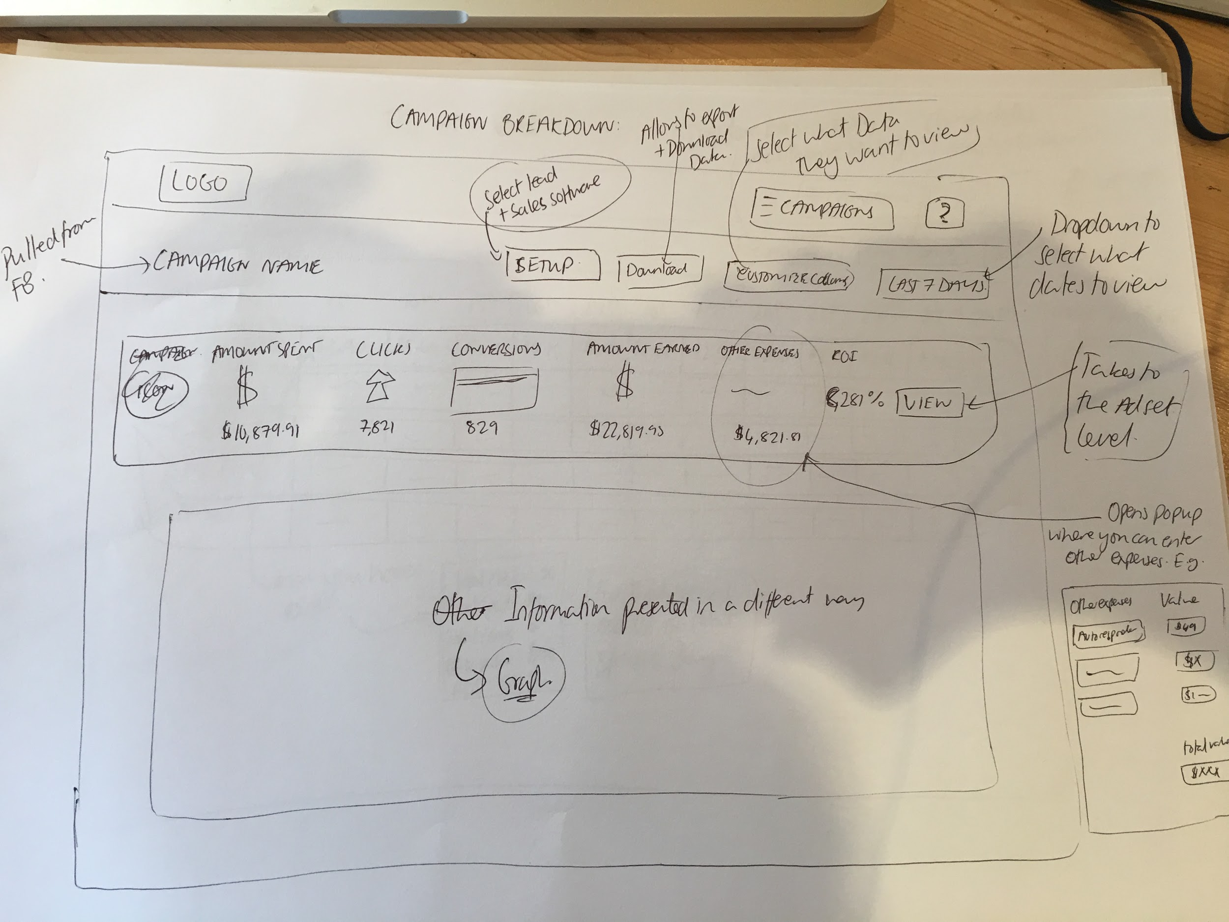

Like on the previous page -- the header menu should stay the same, with the logo on the left hand side, and the buttons & drop-down menu’s on the right.

1) **The Sub-Head Menu:** This sub head menu is where most of the setup will be completed for this specific campaign.

First -- on the left, there should be the name of the campaign clearly presented. This should be the exact campaign name which they have setup inside of FB, so the software should pull that through.

Within **the “Setup” button**, it should pop up a box where we can input important data:

Lead Source: The first setting they will need to set up for this **specific campaign** is they need to choose what Lead Source they’re going to be using (so they can know specifically how many leads the campaigns generated for them).

Because, using the top bar, they have already used the “Integrations” section to hook up their lead & sales managment systems, in this specific setting -- the software will need to communicate with their lead management system via API, and select what **campaign** the lead’s being added to.

Sales: The next setting they will need to choose for this **specific campaign** is where they should track their sales. Again, based on the sales management system’s they added in the integration settings -- the API will allow them to access their sales managment system, and select what sales this specific campaign should be tracking.

Next is the **View P&L Button** (It says “Download” on the image, but we changed). When they click on this, it should open up a popup which will present the information in the typical Profit & Loss Account spreadsheet style. Including their traffic expenses and their other expenses (manually added in).

It should have the option for them to select the date range (like on the Dashboard), and also a button for them to download/print their spreadsheet, so they can easily identify whether their campaign is profitable, or not.

If they made profit -- it should be shown in green. If they did not, it should be shown in red.

In the **customise columns** section, this is where they can select what Data they want to view. By adding new options, it will update the view below, so they can have a detailed look at their campaign.

In FaceBook, in their “Customise Columns” section, they have a whole ton of options. Would it be too hard to use all of these? If so, let me know, and I’ll come up with the most important ones to include.

Then finally, in the sub-header bar, there should also be a date range where they can select what dates they’d like to view, similar to the one on the “Dashboard” with the date ranges & options previously outlined.

2) **The Campaign Overview:** This is the overview part of the campaign where it shows all the data from which you’ve selected from the “Customise Columns” section.

This should be like the previous one on the “Dashboard”, with the View button taking them to the Ad Set Level.

The only difference is there should be an “Other Expenses” tab, which when they click on, will pop up a box, like shown in the picture where they can input other expenses they have to pay. They should be able to name them on the left, such as “Auto-responder”, “Web Hosting”, or whatever they choose, and on the right, they should be able to enter in the amount they have to pay: E.g. “$97”.

They should also have the option to select whether this is a one time fee, or a monthly charge (maybe a checkbox next to the amount of money they enter). There should then be a total of the “other expenses” they incur.

When they click submit, these other expenses should be added to their campaign overview, and included in the P&L account and also the total ROI for the campaign.

3) **The Information Presented In Another Way:** This will be like on the ad set level breakdown:

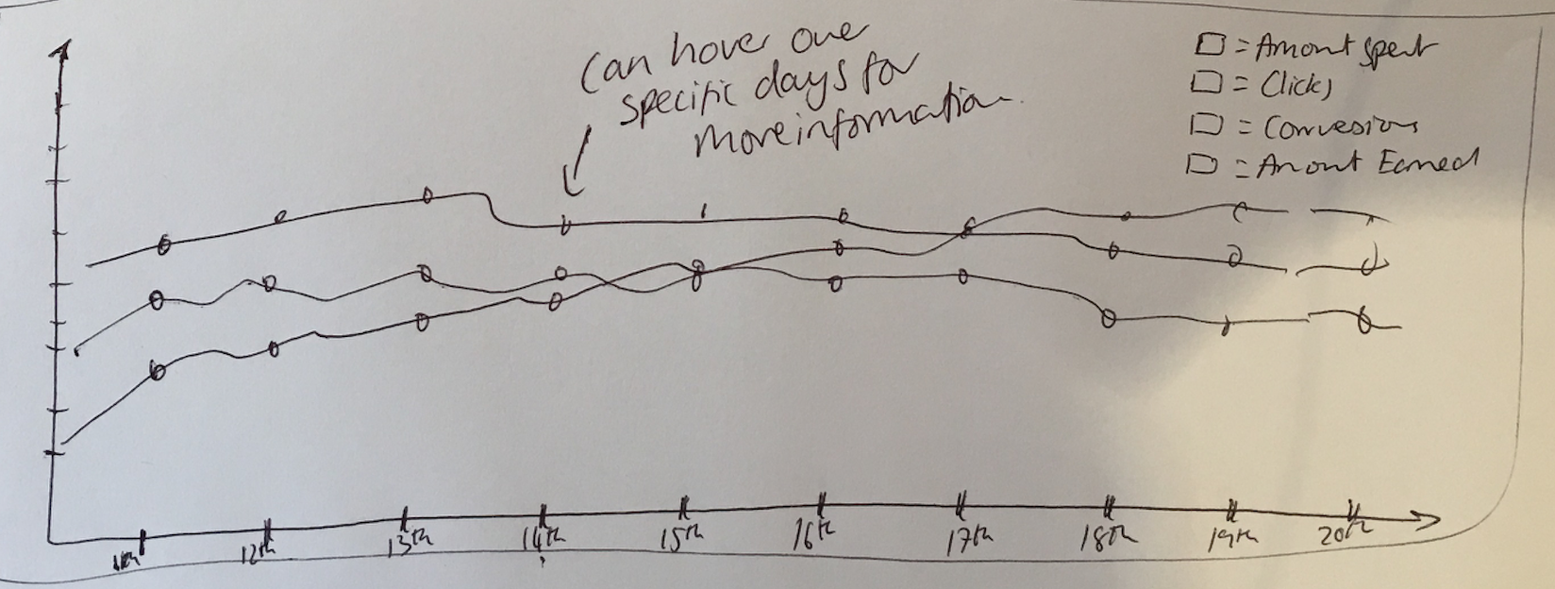

As you can see -- it a visual graph/bar chart, so we can see what’s been going on with this campaign over time. On the Y axis is numbers, such as “50” “100” “150”, etc.

On the X axis is the dates. When the date range changes in the sub-header section, this graph/bar chart will automatically update.

For the lines on the graph/bar chart, in the top right -- there should be a couple of boxes which you can tick to choose what you want to display on the graph/bar chart. When you check the box, the colour co-ordinated line should appear on the graph/bar chart.

These boxes should include: “Amount Spent”, “Clicks”, “Conversions” (All pulled from FB) and “Amount Earned”, “Sales” (Pulled from sales management integration) and “Leads” (Pulled from Lead management integration) & ROI.

**The Ad Set Level:**

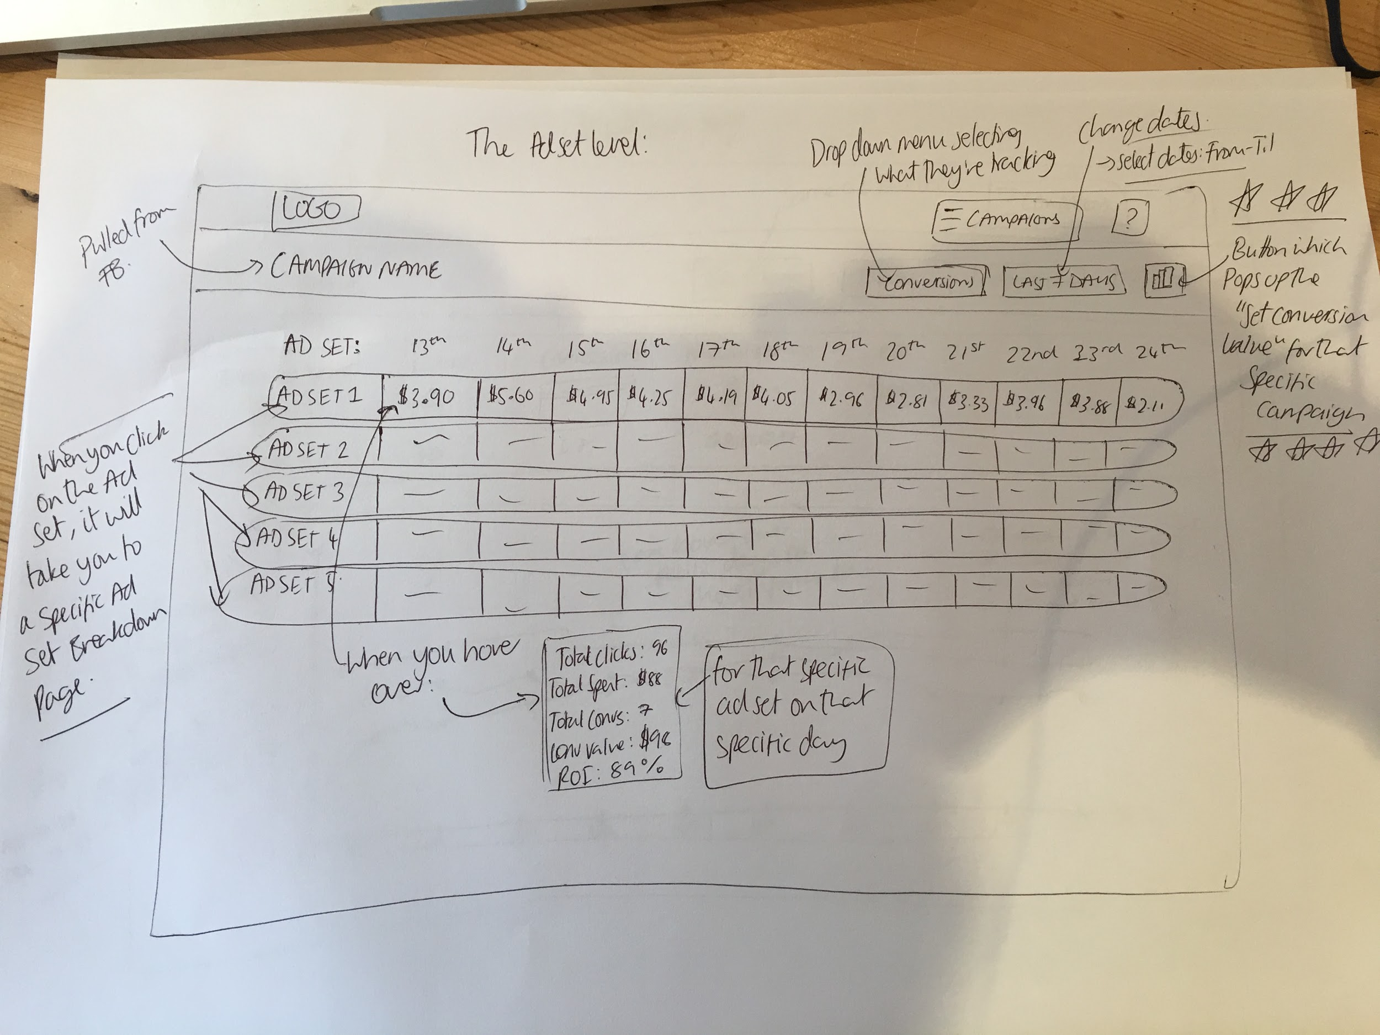

Again, at the top will include the main header menu.

1) **The Sub-Header Menu:** First, on the left -- there should be the campaign name clearly displayed. This should be the exact campaign name which has been pulled through from FaceBook.

The first button should be a dropdown menu which will allow the user to select what metric their tracking. They should be able to track a couple of different things:

-- Conversions (Pulled from FB)

-- Leads (Pulled from their lead management integration. To work out how much the lead cost was for that day, the software will take the total ad spend for that day **divided by** the total number of leads for that day).

-- Sales (Pulled from their sales management integration: To work out how much the sales cost was for that day, the software will take the total ad spend for that day **divided by** the total number of sales for that day).

Next, there should also be the date range changer, so we can view the results of “Today”, “Yesterday”, “Last 7 Days”, “Last 14 Days”, “Last 30 Days”, “Last Month”, “This Month” and “Custom” (Where they can select the date range from a calendar like below):



Then there should also be a button which when clicked on will bring a popup up which will allow them to input their **desired conversion value for that specific campaign.**

There should be 3 numbers to enter, and 3 categories:

Category 1: Conversion Value

Category 2: Lead Value

Category 3: Sale Value

Number 1: The Green Value.  
Number 2: The Orange Value.  
Number 3: The Red Value.

The green value is the **best case scenario** for their campaign. E.g. if their desired conversion value was $5 per lead, they would enter in the green value $0 -- $5.00. This is because these numbers are **under** their goal, so they are green lit.

The orange value is **alright results** for their campaign. E.g. if their desired conversion value was $5 per lead, this would be $5.01 -- $6.50 (for example). This is because if they’re generating leads within this range -- they will be orange lit, as they are **close** to the goal, but not green.

And finally -- the Red Value is **poor results** for the campaign. E.g. if their desired conversions value was $5 per lead, this may be $6.50+. As these costs are **a lot** **higher** than their goal -- they would be red lit, so the user would know these ad sets are not performing well.

After entering this data -- it will update the tracking on the Ad Set Level page. Depending on what data their tracking (Conversions, Leads or Sales), the software will colour in each of the boxes for that specific day in the corresponding colour for the parameters set in the settings above, so we can easily see what ad sets are doing well (green), what ones are doing ok (orange), and what ones are doing poorly (red).

2) **The Main Ad Set Tracking:** This is the main part of the page. We need all of the data to be easily shown, and presented in the clearest, and most simple way possible.

This section will be filled in with different colours (green, orange or red) depending on how well the ad set is performing. The number of days displayed will be dependant on the date range selected in the sub-header.

When you hover over a specific day, a little popup box should come up with the overall stats for that ad set, on the highlighted day (as you’ll see in the design above).

It should show: “Amount Spent”, “Clicks”, “Conversions” (All pulled from FB) and “Amount Earned”, “Sales” (Pulled from sales management integration) and “Leads” (Pulled from Lead management integration), and “ROI” -- calculated from the total amount spent, the total amount earned, and the other expenses on the campaign breakdown page.

And, finally -- on the left -- if you click onto any of the ad set names (which will be pulled from FB), it’ll take you to the Ad Set Breakdown for that particular ad set…

**The Ad Set Breakdown:**

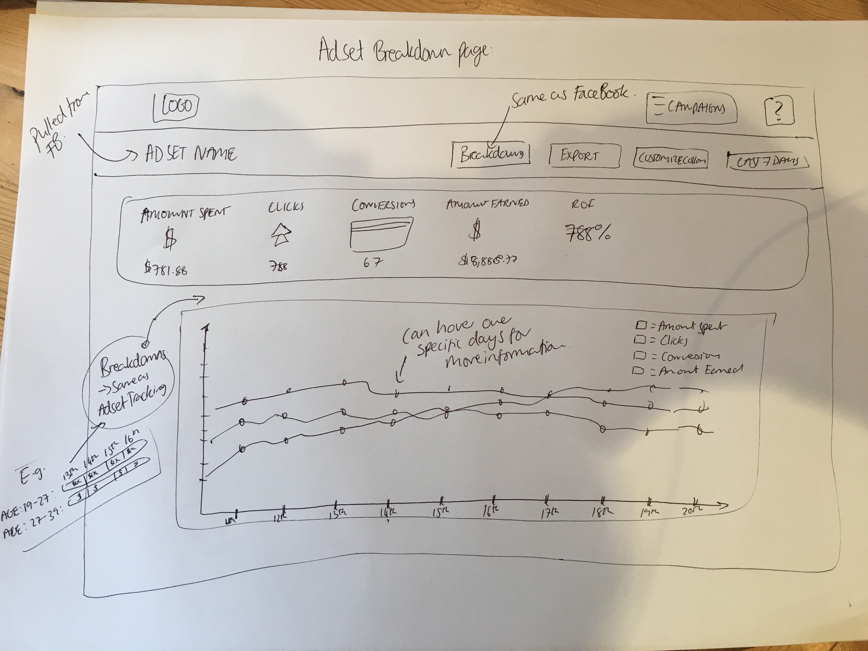

Again -- this page will have the main header menu at the top.

1) **The Sub-Header Menu:**

First - it will have the ad set name clearly displayed on the left hand side, which will be the exact one that’s pulled through from FB.

Then, the first button will be the “Breakdowns” tab. When you click on it (just like FB), there will be some different options which you can click on which will alter the data presented in the “Breakdown Section”.

Here’s what it looks like in FB. It will be the same in the software:

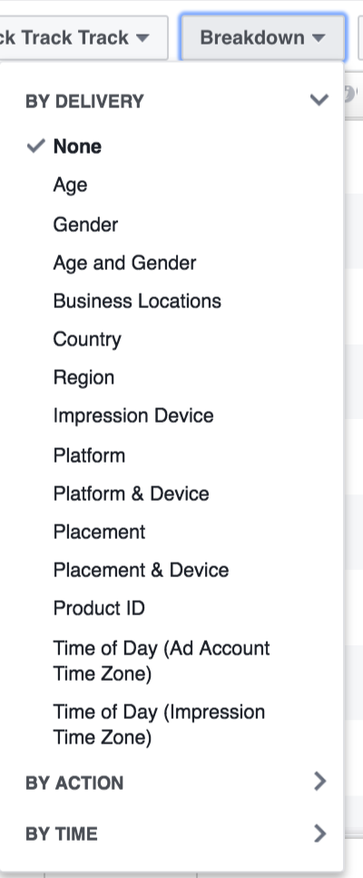

When you select “Gender”, for example, the software will change the “Ad Set Breakdown” section into the gender categories FB provides:

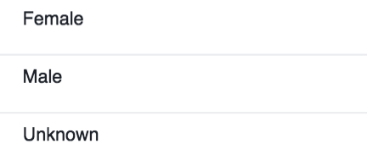

Now, the software will create 2 sections in the “Ad Set Breakdown”, and we’ll easily be able to see the results of the Female, the Male & the Unknown. These results (like in the Ad Set Level) will be colour coded depending on the green, orange & red lights.

The Export button will be changed to the “Information” button, which will bring up a popup, like on the Ad Set Level that’ll display all of the data for that ad set in a clear fashion. Including: “Amount Spent”, “Clicks”, “Conversions” (All pulled from FB) and “Amount Earned”, “Sales” (Pulled from sales management integration) and “Leads” (Pulled from Lead management integration), and “ROI” -- calculated from the total amount spent, the total amount earned, and the other expenses on the campaign breakdown page.

There will also be the dropdown menu (Like on the Ad Set Level), where they can select to show either the Conversions, the Leads, or the Sales in the Ad Set Breakdown section.

The Customise Columns will be like on the Campaign Breakdown section, where you can select what data you want to view in the ad set overview display below.

Then finally, there will be a date display, like before, with the usual format.

2) **The Ad Set Overview:** This part is the overview of the campaign, which automatically shows: “Amount Spent”, “Clicks”, “Conversions”, “Leads”, “Sales”, “Amount Earned” & “ROI”, and can add/remove columns from the “Customise Columns” tab.

3) **The Ad Set Breakdown:** This is where, based on the settings selected in the “Breakdowns” drop down (whether it’s age, gender, location, etc), this section will update depending on the breakdown selected.

E.g. if “Gender” is selected, there will be 3 rows. Male, Female & Unknown.

Each row will include the amount it cost for each conversion (or whatever is selected from the “conversions” dropdown menu in the sub-head menu).

They will either be green, orange, or red -- based upon the settings you created in the Ad Set Level.

This will be very helpful, so we can see what age, gender, location, etc is working well for us (green), what ones are doing alright (orange), and what ones are doing poor (red).

**-- The “Conversions”** will be pulled from FB.

**-- The “Leads”** will be the total amount spent (pulled from FB), divided by the leads generated (pulled from their integrated lead management software).

**-- The “Sales”** will be the total amount spent (pulled from FB), divided by the sales generated (pulled from their integrated sales management software).

4) **The Visual Graph/Bar Chart:** And finally, like on the Campaign Breakdown, there will be a graph/bar chart, so we can visually see how well this ad set is performing.

On the top right, there should be some checkboxes which we can select to view different data on the graph/bar chart. Including: “Amount Spent”, “Clicks”, “Conversions” (All pulled from FB) and “Amount Earned”, “Sales” (Pulled from sales management integration) and “Leads” (Pulled from Lead management integration) & ROI.

These values will be assigned to the specific date (on the bottom of the graph/bar chart), and the date range can be changed using the date selector in the sub-header menu.