Name: _____Abhina premachandran Bindu_______________________________________

Python for Data Analytics

1. What is Python and why is it useful?

Python is a strong and dynamically typed language. It is very useful as it is interactive, object oriented, focused on reliability and productivity. It is a very powerful programming language and is useful in data analytics.

1. Are the following variable names allowed in python?
   1. 1_message **not allowed**
   2. Greeting_message **allowed**
   3. Message_1 **allowed**
   4. First name **not allowed**
   5. Full_name **allowed**
2. Create a variable that holds the string “hello there!”

greetings = "hello there!"

1. Create a variable for first name, last name and an email extension. Concatenating all three together to form an email address. For example: [firstnamelastname@gmail.com](mailto:firstnamelastname@gmail.com)

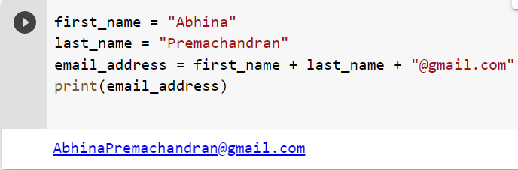

1. Store someone you know name in a variable called name. Print their name in lower and uppercase using a method.

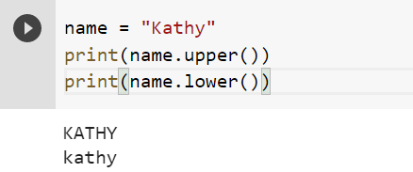

1. Using a variable, ask your friend if they want to hang out on the 15th of the month. For example, “Do you want to hang out on the 15th of this month?” You should have to convert the number to a string.

