Player Scouting & Similarity Tool
Clustering players into roles, finding “the next [player]” and cheaper replacements
Project type: Sports analytics portfolio project (Project 2)
Prepared by: Abhi
Data: FBref-style player statistics, 2024-25 season, Big 5 European leagues; Transfermarkt market values
Tools: Python, pandas, scikit-learn, rapidfuzz, matplotlib, Google Colab

1. Project overview
Football clubs scout from thousands of players, and traditional scouting does not scale. This project builds a data-driven shortlist tool that does two things:
- Role discovery: groups outfield players into playing roles (for example “deep playmaker” or “penalty-box striker”) using only their per-90 statistics, instead of relying on the coarse DF/MF/FW position labels.
- Player search: finds “the next [player]” (the most similar players, optionally restricted to young players) and cheaper replacements (similar players with a much lower market value).
The tool is designed as a shortlist generator that supports a scout's judgement. It does not replace it.

2. Data
Source | Content | Used for
FBref-style season aggregates (players_data-2024_2025) | 2,854 player-club rows and 267 columns covering shooting, passing, possession, defending, creation and playing time for the 2024-25 Big 5 league season | Features for role clustering and similarity
Transfermarkt players.csv | Player profiles: birth date, sub-position, foot, height, contract expiry, current club | Joining players and adding profile fields
Transfermarkt player_valuations.csv | Dated market valuations (656,301 records) | Market value for cheaper replacements

The other Transfermarkt files supplied (game events, lineups, games, transfers, countries, national teams) were reviewed but not used. They do not contain per-player passing, progression or defensive statistics, which are what the role model needs.

3. Methodology

3.1 Cleaning
- Goalkeepers were removed, because they need their own feature set (saves, PSxG, distribution).
- Each player's primary position is the first position listed (for example “FW,MF” becomes FW).
- Players who changed clubs mid-season appear in two rows, so these rows were merged into one.
- Only players with at least 900 minutes were kept, to avoid noisy small samples. This leaves 1,457 players: 617 defenders, 494 midfielders and 346 forwards.

3.2 Features
Counting statistics were converted to per-90 rates. About 30 features describe how a player contributes: shooting (npxG, shots, shots on target), creation (xAG, key passes, shot-creating actions, passes into the penalty area), progression (progressive passes, carries and receptions), dribbling, touches in and around the box, crossing, defending (tackles, interceptions, blocks, clearances, recoveries) and aerial duels.

3.3 Role clustering
Each position group was clustered separately, so that a striker is never compared with a centre-back. For each group the features were standardised, reduced with PCA (keeping 90% of the variance) and clustered with k-means. The silhouette score was used to compare values of k:
Group | k=3 | k=4 | k=5 | k=6 | k=7
Defenders | 0.204 | 0.197 | 0.177 | 0.122 | 0.118
Midfielders | 0.232 | 0.196 | 0.173 | 0.130 | 0.127
Forwards | 0.201 | 0.147 | 0.139 | 0.138 | 0.127

Silhouette scores are low everywhere, which is normal for football data: roles form a continuum with no sharp boundaries. k=3 scored slightly higher, but k=4 was chosen for every group because it separates distinct football roles (for example splitting attacking and crossing full-backs from the two centre-back types). This was a judgement based on interpretability, not on the score alone.

3.4 Similarity search
Similarity is the cosine similarity between players in the PCA space, computed within the same position group. The function can filter results by age, league and role.

3.5 Adding market values
FBref players were matched to Transfermarkt in three passes, because names differ between the sources (accents, nicknames, shortened names):
- Exact match on normalised name (lowercase, accents removed) plus birth year.
- Fuzzy name match (token-sort ratio of at least 88) within the same birth year.
- Surname plus birth year, using club-name similarity to choose between candidates.
Match type | Players
Exact | 1,357
Fuzzy | 29
Surname + club | 45
Unmatched | 26
With a market value | 1,425 of 1,457 (98%)

For each matched player the latest Transfermarkt valuation is used. The valuation at the end of the 2024-25 season is also stored, for comparisons at prices from the same period as the statistics.

3.6 Cheaper replacements
A cheaper replacement is a player whose similarity to the target is above a threshold (default 0.80) and whose market value is at most a set fraction of the target's (default 50%). Results can be filtered by age, league and role, and show contract expiry, which is useful because players with little time left on their contract are usually cheaper.

4. Results

4.1 Discovered roles
The clusters correspond to recognisable football roles. Names were assigned by inspecting each cluster's highest and lowest statistics and its best-known players.
Pos | Role (n) | Defining statistics | Example players
DF | Attacking full-back (87) | High xAG, touches in box, key passes, progressive carries | Daniel Muñoz, Antonee Robinson, Rayan Aït-Nouri
DF | Aerial centre-back (237) | High clearances, aerials won, interceptions | Nathan Collins, Max Kilman, Nikola Milenković
DF | Crossing full-back (183) | High crosses, key passes, progressive carries, tackles | Milos Kerkez, Giovanni Di Lorenzo, Aaron Wan-Bissaka
DF | Ball-playing centre-back (110) | High touches, progressive passes, recoveries | Virgil van Dijk, Joško Gvardiol, Levi Colwill
MF | Defensive midfielder (206) | High clearances, interceptions, tackles, aerials | Moisés Caicedo, Remo Freuler, Idrissa Gana Gueye
MF | Box-crashing 8 (130) | High box touches, dribbles, npxG, shots | Tijjani Reijnders, Scott McTominay, Aimar Oroz
MF | Deep playmaker (94) | High touches, progressive passes, recoveries, key passes | Vitinha, Bruno Guimarães, Federico Valverde
MF | Attacking creator (64) | High xAG, shots, box touches, npxG | Cole Palmer, Bruno Fernandes, Mikkel Damsgaard
FW | Penalty-box striker (61) | High npxG, shots, box touches, aerials | Erling Haaland, Alexander Isak, Robert Lewandowski
FW | Hard-working wide forward (126) | High recoveries, interceptions, crosses, tackles | Bryan Mbeumo, Antoine Semenyo, Jarrod Bowen
FW | Creative wide forward (58) | High touches, progressive passes, key passes, xAG | Mohamed Salah, Kylian Mbappé, Lamine Yamal
FW | Target man (101) | High aerials, clearances, shots; low key passes | Chris Wood, Ante Budimir, Andrea Pinamonti

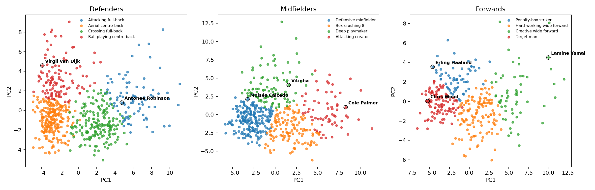
Figure 1. Roles for each position group, shown on the first two principal components. Clusters overlap because roles are a continuum.

4.2 “The next [player]”
The tool returns plausible neighbours for well-known players:
Player | Most similar players (cosine similarity)
Cole Palmer | Phil Foden (0.956), Marco Asensio (0.908), Matheus Cunha (0.899), Hákon Arnar Haraldsson (0.891), Fermín López (0.886)
Virgil van Dijk | Stefan de Vrij (0.930), Lilian Brassier (0.928), Julian Chabot (0.901), Eric Dier (0.893), Amir Rrahmani (0.893)
Lamine Yamal | Khvicha Kvaratskhelia (0.922), Michael Olise (0.899), Nicolas Pépé (0.890), Ousmane Dembélé (0.879), Rafael Leão (0.873)
Vitinha | Nicolò Barella (0.842), Pedri (0.841), João Neves (0.818), Fabián Ruiz (0.804), Joshua Kimmich (0.804)
Erling Haaland | Ermedin Demirović (0.954), Ollie Watkins (0.929), Robert Lewandowski (0.921), Emanuel Emegha (0.905), Patrik Schick (0.897)

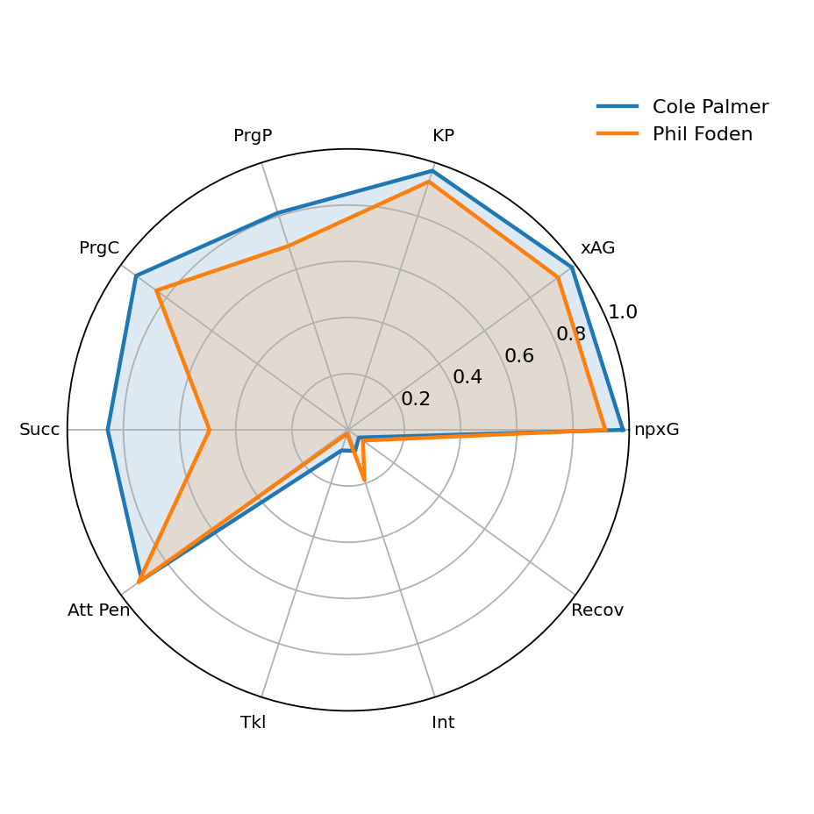
Figure 2. Percentile profiles of Cole Palmer and Phil Foden compared with all midfielders.

4.3 Cheaper replacements
Example: players similar to Cole Palmer (market value about €100m) at no more than half his value. Market values are the latest Transfermarkt valuations in the dataset (mostly from late May to early June 2026).
Player | Club | Age | Similarity | Value (€m) | Saving
Marco Asensio | Aston Villa | 28 | 0.908 | 15.0 | 85%
Hákon Arnar Haraldsson | Lille | 21 | 0.891 | 25.0 | 75%
Kevin De Bruyne | Manchester City | 33 | 0.878 | 8.0 | 92%
Dilane Bakwa | Strasbourg | 21 | 0.867 | 28.0 | 72%
Badredine Bouanani | Nice | 19 | 0.860 | 10.0 | 90%
Alassane Pléa | Gladbach | 31 | 0.841 | 2.5 | 98%

Clubs shown are those the players represented in 2024-25. Young players such as Haraldsson, Bakwa and Bouanani are the most interesting for a club looking for long-term value, while older players such as De Bruyne and Pléa are cheap because of age.

5. Validation
There is no ground truth for “similar player”, so the model was checked with sanity tests on well-known players:
- Neighbours of ball-playing centre-backs, deep playmakers and creative wide forwards are the same type of player a scout would name.
- Roles are consistent with the position group: no striker appears as a neighbour of a centre-back, because comparisons are made within position groups.
- The most extreme profiles (Haaland, Yamal) sit at the edges of their clusters, as expected.
A stronger test, which has not been done yet, would be to compare the model's neighbours with recognised scouting comparisons or with real transfer targets.

6. Limitations
- Team style: per-90 statistics reflect the team as well as the player. A player at a possession-dominant club will look different from the same player elsewhere.
- Missing information: event statistics do not capture off-ball movement, pressing intelligence, physical attributes or tactical discipline.
- One season: a single season is noisy. Multiple seasons would give more stable profiles.
- Coarse positions: only the first listed position is used, so players who move between positions are assigned to one group.
- Overlapping clusters: silhouette scores are low, and some clusters mix related styles (for example the hard-working wide forward group).
- Matching errors: a few of the surname-plus-club matches are likely wrong, for example when a player moved clubs. They can be reviewed and removed in the notebook.
- Timing mismatch: statistics are from 2024-25 but market values are from mid-2026, so a player's club in the table may differ from where he plays now.
- Leagues: only the Big 5 leagues are covered, so players from other leagues cannot be found.

7. Future work
- Normalise statistics by team possession and opponent strength to reduce the team-style effect.
- Add more seasons and track how a player's profile changes over time.
- Split wide forwards into wingers and inside forwards with additional features.
- Add a value-for-money score and filters for contract expiry and wages.
- Integrate the xG model from Project 1 as a shot-quality feature.
- Build a Streamlit app so a user can pick a player, set filters and see results with radar charts.

Appendix: running the project
- Open player_scouting_colab_v2.ipynb in Google Colab.
- Run the cells from the top and, when prompted, upload the FBref CSV, players.csv and player_valuations.csv.
- Look at the discovered roles and adjust ROLE_NAMES if your clusters differ.
- Use find_similar("Player", max_age=23) for “the next [player]”.
- Use find_cheaper("Player", max_value_ratio=0.5) for cheaper replacements.
- Use radar(["Player A", "Player B"]) to compare two players.

