End-to-End Data Management Pipeline for a Recommendation System
DM4ML – Assignment 2 | Name: Abhinand NTK | ID: 2025ag05637 | Repo: https://github.com/Abhinand-NTK/Recommendation-pipeline

1. Problem and dataset
The goal is to recommend movies a user is likely to enjoy, using past ratings and item/user metadata. The pipeline uses the public MovieLens-1M dataset (6,040 users, 3,883 movies, 1,000,209 ratings on a 1–5 scale, 2000–2003), which provides all three required entities: user details (gender, age band, occupation, zip code), item details (title, year, genres) and timestamped user–item interactions. Because the real data is already clean, ingestion appends a documented, seeded set of 2,475 corrupt records (missing/invalid ratings, bad timestamps, duplicates, orphan IDs) so the validation layer is exercised on realistic failures; this can be switched off in the config.

2. Architecture and design decisions
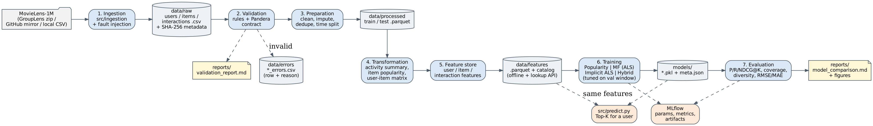
Each stage is an independent module with a run(cfg) entry point that reads its inputs from disk and writes versioned outputs, so stages can be re-run in isolation and orchestrated as a DAG. All parameters live in one YAML config. Key decisions:
- Layered storage – raw (CSV, kept as text so type errors survive) → validated → processed (Parquet) → features → models, plus a separate error layer. Raw files are SHA-256 hashed.
- Validation – 29 rules across three tables. ERROR-severity rows are moved to data/errors/ with a machine-readable reason, WARNING rows (e.g. missing gender/genre) are kept and imputed later. Referential integrity is checked against the validated user/item tables, and a Pandera schema contract guards the clean output. Result: users 99.51%, items 99.49%, interactions 99.76% pass; 2,400 interactions rejected.
- Time-based split – a global cut-off at the 80th time percentile (2000-12-02): 800,164 train vs 200,045 test rows. This mimics production (train on the past, predict the future) and prevents leakage; a per-user chronological split is available as an option.
- Feature store – a custom, file-based layer: 34 user, 31 item and 7 interaction features computed as-of the cut-off from train data only. A Python registry is the single source of truth and generates the feature catalog. The FeatureStore API (with defaults for cold users) is used by the hybrid model during training, by tuning, and by predict.py at serving time.
- Tuning without test leakage – hybrid weights are grid-searched on the last 10% of the train period with features rebuilt for that window; best: genre 0.1, popularity 3.0. Every grid point is a nested MLflow run.
- Orchestration – a Prefect 3 flow with explicit task dependencies, retries on ingestion and an optional daily schedule; plus a dependency-aware plain-Python runner (--from-stage, --only).
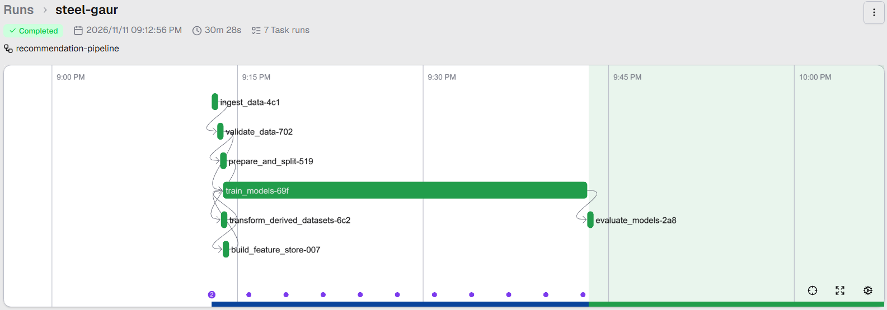
Successful Prefect run (steel-gaur): all 7 tasks Completed in dependency order, 30 m 28 s.

3. Models
Model | Description
Popularity (baseline) | Ranks items by number of ratings; Bayesian-average rating as rating prediction
Matrix factorization | Explicit biased MF, r = μ + b_u + b_i + p_u·q_i, 64 factors, ALS, 15 iterations
Implicit ALS | Weighted MF on implicit 'watched' feedback (Hu et al., 2008), 128 factors, λ=100
Hybrid | z-score blend of implicit-ALS score + user–item genre affinity (feature store) + popularity prior

4. Results
Evaluated on 1,122 warm-start test users (relevant = rating ≥ 4; candidates exclude items already seen in training).
Model | P@10 | R@10 | NDCG@10 | Coverage | Diversity | RMSE | MAE
popularity | 0.1995 | 0.0493 | 0.2141 | 0.0374 | 0.6550 | 0.9608 | 0.7611
matrix_factorization | 0.0989 | 0.0273 | 0.1052 | 0.1592 | 0.7346 | 0.8939 | 0.6958
implicit_als | 0.2129 | 0.0617 | 0.2344 | 0.1043 | 0.6745 | n/a | n/a
hybrid | 0.2189 | 0.0619 | 0.2380 | 0.0609 | 0.6913 | n/a | n/a

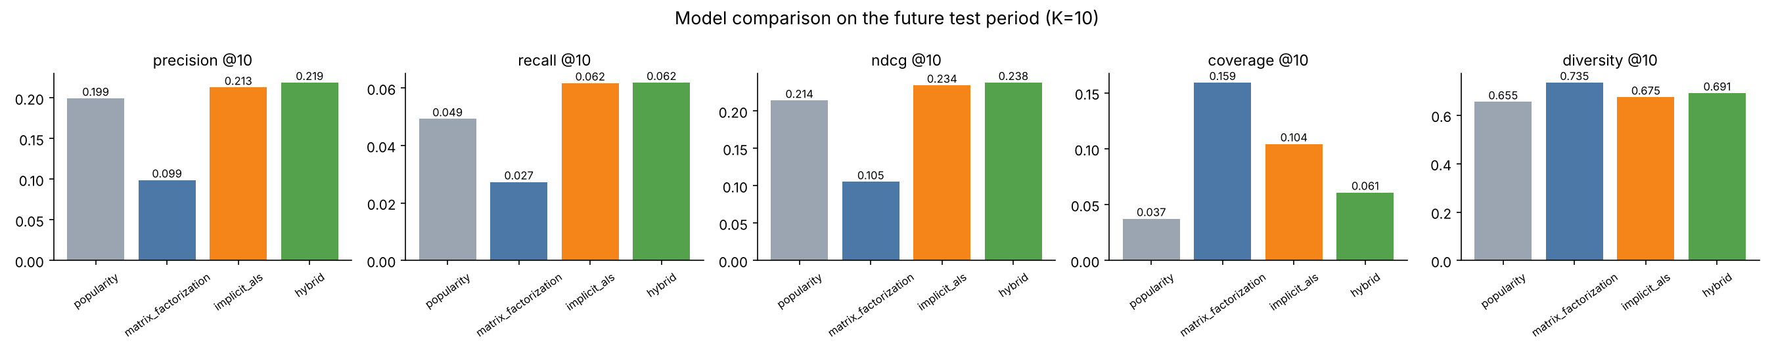
Findings. (1) Under a strict future split, popularity is a strong baseline: the test period is dominated by heavily-rated titles. (2) Explicit MF gives the best rating accuracy (RMSE 0.894 vs 0.961) but ranks poorly, because predicting a 5-star rating for a niche film is different from predicting what a user will watch next. (3) Implicit ALS, which models what users choose, beats popularity on every accuracy metric while covering ~3× more of the catalogue. (4) The hybrid gives the best precision, recall and NDCG, at the cost of coverage – a classic accuracy vs. coverage trade-off that the weights control. The genre signal adds little on top of collaborative filtering for warm users.

5. Limitations and future work
- Only warm users are ranked; cold-start users (in test but not train) would need the content/demographic features as a fallback model.
- Hybrid tuning favours popularity, which lowers catalogue coverage; a diversity or coverage term in the objective (or re-ranking) would balance this.
- MovieLens-1M is dated and dense; fault injection simulates, but does not fully reproduce, real production data issues. The feature store is file-based (no online low-latency serving); Feast or a DB-backed store would be the next step.
- Hyper-parameters for the MF models were set by hand; a broader search (e.g. Optuna) on the validation window could improve results.

6. Tools
Python 3.13, Pandas, NumPy/SciPy (ALS implementations), Pandera (schema contracts), PyArrow/Parquet (storage), MLflow (tracking: params, metrics, artifacts, nested tuning runs), Prefect 3 (orchestration), Matplotlib & Graphviz (figures), pytest (unit tests).

Appendix – Evidence of execution
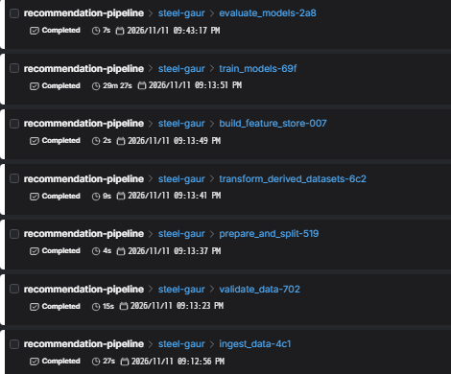  A1 – Prefect task runs: all 7 tasks Completed | 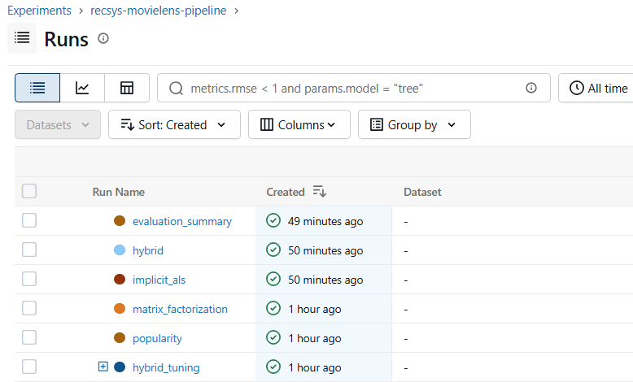  A2 – MLflow: one tracked run per model + nested tuning runs
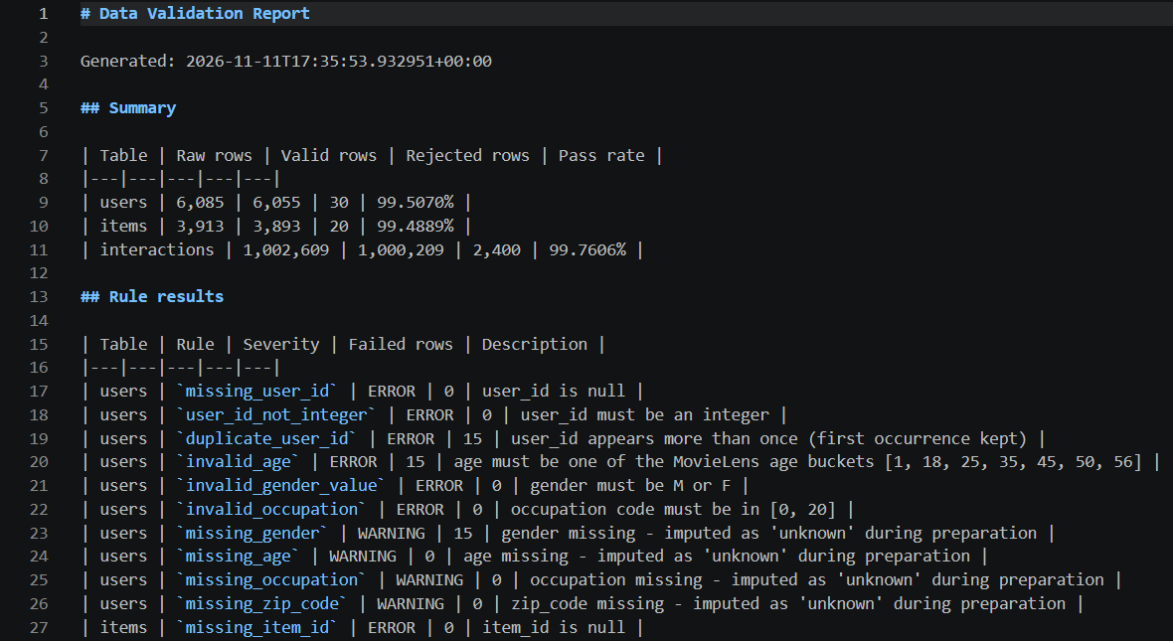  A3 – Validation report (reports/validation_report.md) | 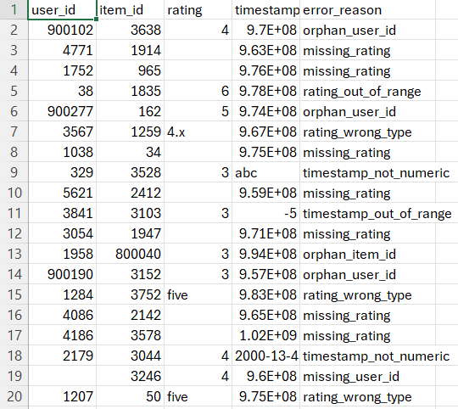  A4 – Error dataset with error_reason (data/errors/)
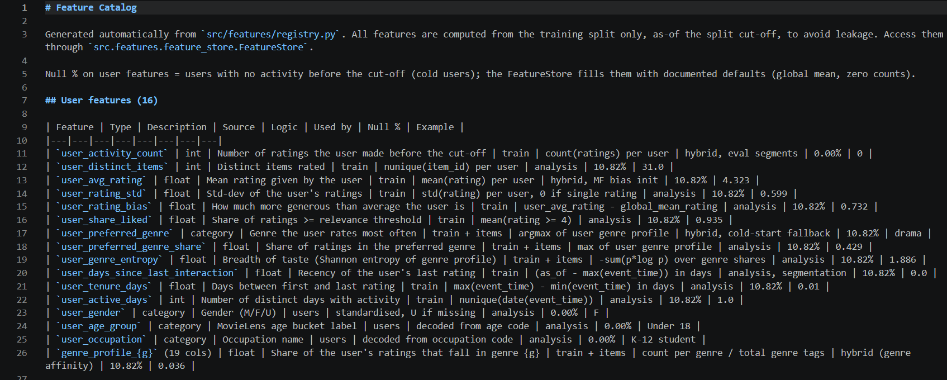
A5 – Feature catalog generated from the registry (reports/feature_catalog.md)

