MINE SWEEPER
About
Minesweeper is a single-player puzzle video game. The objective of the game is to clear a rectangular board containing hidden "mines" or bombs without detonating any of them, with help from clues about the number of neighboring mines in each field. The game originates from the 1960s, and has been written for many computing platforms in use today. It has many variations and offshoots.
How to play
1.Left Click on a box to open it
2.Right click to mark danger.Click again if you are not sure,it will be marked as a question mark.Click again to remove all marks
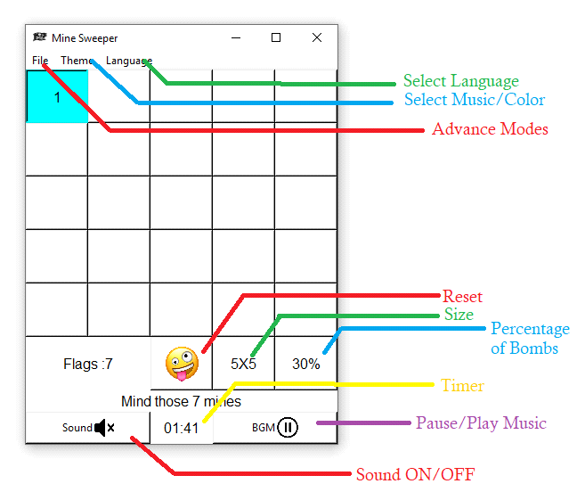
Modes
Activate THANOS : THANOS Wipes half of the boxes randomly ,this mode can be activated only once
50% : An extra difficult 50 percent bomb spawning mode for advanced level players
Cheat Button : Provides a button which when pressed opens 1 question mark which is not a bomb
Kill Cheat Button : Removes the Cheat Button
Themes
Goku : Plays super saiyan 3 theme as background music and intially buttons will be light color
Batman : Plays dark knight theme as background music and intially buttons will be dark color
Languages
മലയാളം : All writings will be in malayalam
English : All writings will be in english

