Analyst
Capgemini Technology Services India Limited
Training Report
Submitted in partial fulfilment of the requirements for the award of degree of
Bachelors of Technology
Submitted to
LOVELY PROFESSIONAL UNIVERSITY

PHAGWARA, PUNJAB



From 17/12/2025 to 20/05/2026

SUBMITTED BY

Name of student: Abhinandan Sah
Registration Number: 12202699

Student Declaration

To whom so ever it may concern
I, Abhinandan Sah, 12202699, hereby declare that the work done by me on “Analyst” from 17 December, 2025 to 20 May 2026, under the supervision of Ravleen Kaur, Senior Manager & Mentor and Sami Anand, Associate Dean & Assistant Professor, Lovely professional University, Phagwara, Punjab, is a record of original work for the partial fulfilment of the requirements for the award of the degree, Bachelors of Technology.

Abhinandan Sah
12202699

Acknowledgement

The training opportunity I had with Capgemini Technology Services India Limited. was a great chance for learning and professional development. Therefore, I consider myself as a very lucky individual as I was provided with an opportunity to be a part of it. I am also grateful for having a chance to meet so many wonderful people and professionals who led me though this internship period.
Bearing in mind previous I am using this opportunity to express my deepest gratitude and special thanks to Ravleen Kaur [Senior Manager & Tech Mentor] who in spite of being extraordinarily busy with her duties, took time out to hear, guide and keep me on the correct path and allowing me to carry out my project at their esteemed organization and extending during the training.
I express my deepest thanks to Mr. Sami Anand, [Associate Dean & Assistant Professor] for taking part in useful decision & giving necessary advices and guidance and arranged all facilities to make life easier. I choose this moment to acknowledge his/her contribution gratefully.

Abhinandan Sah
12202699

Letter of Intent

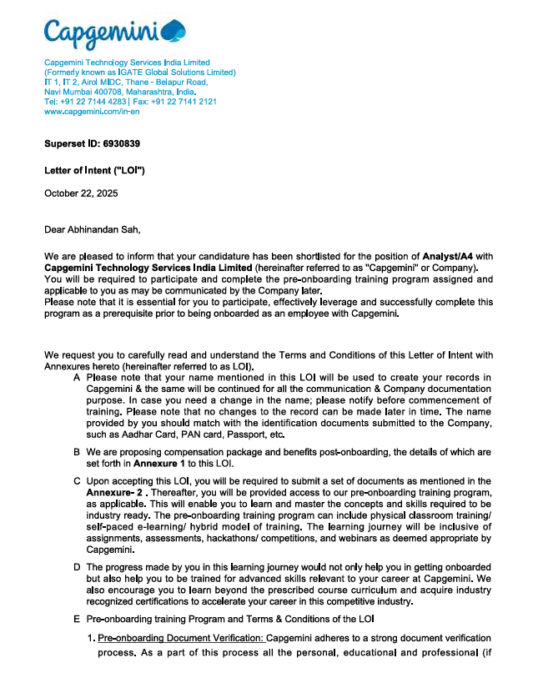

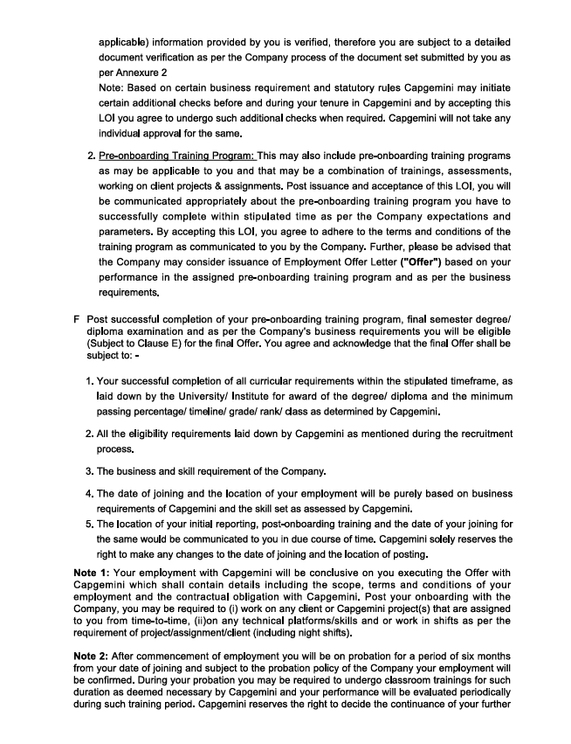

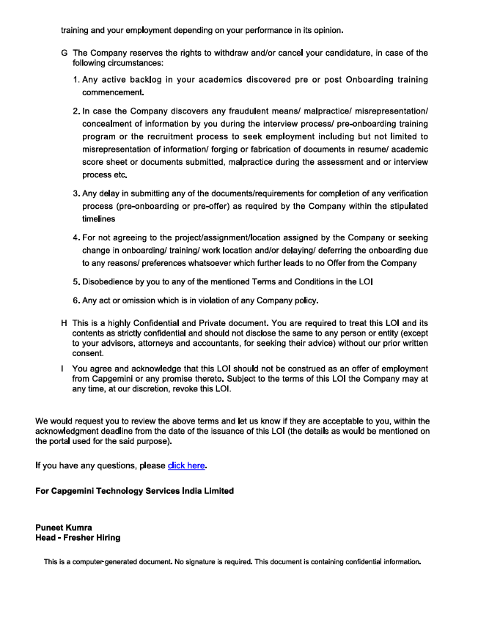


Undertaking by the student for submitting Final Certificate of OJT

Reg. No. 12202699 Student Name Abhinandan Sah
Program Name B. Tech CSE Batch Year 2022 – 2026
Course Code CSE441 Mobile No 9155366612

I understand that I have been provisionally allowed to appear for the ETP viva and I hereby declare that since I am on OJT, thus I shall submit my final certificate of OJT to university after completion of my OJT but not later than July 2026. I am aware that in case, I am unable to submit the same till the abovementioned date, my final evaluation of Internship/OJT shall be discarded by the university and I grade shall be awarded in the result.

----------------------- ----------------------------- -------------------------
Signature of Student Signature of TPC-School Signature of HOS

Table Of Contents Page no
1. Capgemini Technology Services India Limited 10
2. INTRODUCTION OF THE PROJECT UNDERTAKEN 17
3. INTRODUCTION TO TECHNOLOGIES UNDERTAKEN 27
4. DESCRIPTION OF WORK DONE 33
5. CONCLUSION 37

1. Capgemini Technology Services India Limited

INTRODUCTION:


Capgemini Technology Services India Limited is a leading global information technology services and consulting company committed to delivering innovative, reliable, and scalable digital solutions to businesses worldwide. The company focuses on enabling organizations to accelerate digital transformation through advanced technologies, strategic consulting, and industry-specific solutions.
As a technology consulting and services company, Capgemini specializes in digital engineering, cloud services, application development, automation, cybersecurity, and enterprise modernization. The company is recognized globally for helping clients transform their businesses using cutting-edge technologies and sustainable innovation.
Capgemini emphasizes customer-centricity, collaboration, and technological excellence. By understanding client challenges and delivering tailored digital solutions, the company builds long-term partnerships and helps organizations achieve operational efficiency and business growth.
With a strong global presence, highly skilled workforce, and extensive industry expertise, Capgemini continues to lead in delivering modern, scalable, and cost-effective IT solutions.

Company Background & Overview

Capgemini Technology Services India Limited is recognized globally for its technical expertise, innovation-driven approach, and commitment to quality delivery. As a multinational IT consulting and services company, it provides end-to-end digital transformation services that help clients modernize systems, improve operational efficiency, and adopt emerging technologies effectively.
The company operates through a structured methodology that includes requirement analysis, planning, development, testing, deployment, and continuous support. This systematic approach ensures that projects meet global industry standards and client expectations.
As one of the leading IT service providers, Capgemini leverages its global delivery model, experienced professionals, and advanced technological capabilities to deliver large-scale and complex projects efficiently. The company serves clients across multiple industries, including banking, healthcare, manufacturing, retail, telecommunications, and public services.
Capgemini is publicly recognized under IT Services & Consulting and provides a wide range of technology solutions designed to support digital transformation, innovation, and sustainable business growth.

Mission, Vision & Core Values
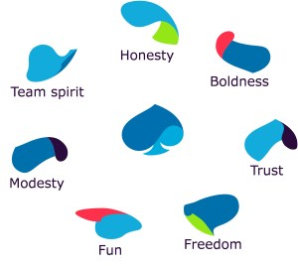
Mission
To help organizations transform and manage their businesses through technology, innovation, and sustainable digital solutions while delivering measurable business value.
Vision
To become a global leader in technology services and digital transformation by driving innovation, operational excellence, and customer success.
Core Values
- Innovation – Continuously adopting emerging technologies and modern practices.
- Integrity – Maintaining transparency, ethics, and trust in all business operations.
- Client-Centricity – Delivering customized solutions aligned with client requirements.
- Excellence – Ensuring high-quality service delivery and operational efficiency.
- Collaboration – Encouraging teamwork, inclusion, and knowledge sharing.
- Continuous Learning – Promoting skill development and technological advancement.
These values define Capgemini’s organizational culture and guide its approach toward clients, employees, and business partners.

Services and Offerings

Capgemini Technology Services India Limited operates across multiple domains of IT consulting and digital transformation. Its services support enterprises seeking scalable, secure, and innovative technological solutions.
- IT Consulting
The company provides strategic consulting services to help businesses improve operational processes and adopt modern technologies. Services include:
- Digital transformation consulting
- Enterprise architecture planning
- Technology modernization strategies
- Process optimization
- IT audits and assessments

- Software Development
Custom software development is one of Capgemini’s core service areas, including:
- Web application development
- Enterprise software development
- Backend API development
- Cloud-native application development
- Frontend user interface development
- Dashboard and analytics solutions
- Third-party system integration
- Cloud Solutions
Capgemini provides cloud services that help organizations improve scalability, flexibility, and security. Services include:
- Cloud architecture design
- Cloud migration services
- Infrastructure management
- Database hosting and optimization
- Hybrid and multi-cloud solutions
- Legacy application modernization
- Maintenance and Support
Providing continuous support, application monitoring, debugging, optimization, and enhancement services for enterprise systems.
- Project-Based Development
Managing complete software development lifecycles from requirement gathering to deployment and support.

Organizational Structure

Capgemini Technology Services India Limited maintains a well-defined organizational hierarchy to support global operations and efficient project execution.
1. Management / Leadership Team
Responsible for strategic planning, business development, client management, and organizational growth.
2. Technical Team
Includes software engineers, cloud specialists, data analysts, cybersecurity experts, testers, and system architects responsible for development, deployment, and maintenance activities.
3. Project Management Team
Handles resource allocation, project timelines, client communication, documentation, and delivery management.
4. Support Team
Provides technical assistance, incident management, troubleshooting, and production support services.
This organizational structure ensures effective collaboration, streamlined workflows, and clear communication across departments.

Work Culture & Environment


The work culture at Capgemini is built around innovation, diversity, collaboration, and continuous learning. Employees are encouraged to explore new technologies, improve problem-solving skills, and contribute innovative ideas.
Key characteristics of the company’s culture include:
- Collaborative and inclusive work environment
- Learning-driven culture with training and mentorship programs
- Team-based project execution for improved efficiency
- Opportunities for professional and technical growth
- Agile and flexible working methodologies
- Focus on employee well-being and work-life balance
The company fosters a professional environment that motivates employees to perform with accountability, creativity, and excellence.

Projects & Capabilities

Capgemini works on a wide range of projects across industries and technologies. The company specializes in:
- Enterprise application development
- Digital transformation projects
- Cloud migration and modernization
- Full-stack application development
- Data analytics and AI solutions
- Cybersecurity implementation
- API integration projects
- Maintenance and support services
- Proof-of-concept and innovation projects
The company follows a structured software development lifecycle:
- Requirement Gathering
- System Design
- Development
- Testing
- Deployment
- Support and Maintenance
This systematic approach ensures successful project delivery with high quality and minimal risk.

SWOT Analysis

A SWOT analysis gives a strategic view of the company’s strengths and challenges:
Strengths
- Strong global brand presence
- Highly skilled and experienced workforce
- Advanced technological capabilities
- Strong client relationships
- Expertise across multiple industries
- Large-scale project execution capabilities

Weaknesses
- Complex organizational structure may slow decision-making
- High competition in the global IT services market
- Dependence on global economic conditions

Opportunities
- Growing demand for digital transformation services
- Expansion in AI, cloud computing, and cybersecurity
- Increasing adoption of automation technologies
- Opportunities for strategic global partnerships

Threats
- Intense competition from global IT companies
- Rapid technological advancements requiring continuous upskilling
- Economic uncertainties affecting IT investments
- Cybersecurity and data privacy challenges

2. INTRODUCTION OF THE PROJECT UNDERTAKEN

OVERVIEW - E-COMMERCE PRODUCT MANAGEMENT SYSTEM

The E-Commerce Product Management System is a modern web-based product management platform developed to automate and streamline product catalog management, inventory control, pricing updates, product approval workflows, media management, user administration, and operational reporting using a scalable microservices architecture. The system was developed based on enterprise-level software requirements and implemented from scratch using modern full-stack technologies.
The application enables users to browse products, view product details, manage product categories, create and update products, maintain product variants, upload product media assets, manage inventory and pricing information, and monitor product approval workflows. Administrative users can manage system users, assign roles, review audit trails, monitor product reports, and supervise overall product management activities.
The system follows a distributed microservices architecture in which each business functionality operates independently. Major services include Identity Service, Catalog Service, Workflow Service, Reporting Service, and a centralized API Gateway. These services communicate through asynchronous event-driven communication using RabbitMQ and are routed through an Ocelot API Gateway.
The frontend application was developed using Angular with modern UI architecture and responsive design principles, while the backend services were developed using ASP.NET Core (.NET 8) and SQL Server databases with Entity Framework Core Code-First approach.
The project focuses on enterprise-level software engineering concepts including:
- Microservices Architecture
- Event-Driven Communication
- JWT Authentication & Authorization
- API Gateway Routing
- Product Catalog Management
- Inventory and Pricing Management
- Database-per-Service Architecture
- Secure Role-Based Access Control
- Centralized Logging & Exception Handling
- Modular Frontend Architecture
The E-Commerce Product Management System was designed to be scalable, maintainable, secure, and cloud-ready while providing efficient product management and catalog operation capabilities.
OBJECTIVES OF THE PROJECT
The major objectives of the E-Commerce Product Management System are:
• To digitize and automate product catalog management.
• To develop a scalable product management platform using microservices architecture.
• To provide centralized management of products, categories, variants, pricing, and inventory.
• To implement secure JWT-based authentication and role-based authorization.
• To automate product approval workflows using event-driven communication.
• To provide centralized API routing through Ocelot API Gateway.
• To reduce manual product coordination through structured workflow management.
• To develop responsive frontend interfaces using Angular.
• To implement modular and maintainable backend services.
• To gain practical exposure to enterprise-level full-stack software development.

PROBLEM STATEMENT
Traditional e-commerce product management systems often suffer from tightly coupled architectures, poor scalability, inconsistent product information, limited workflow control, and inefficient communication between different modules. Many existing systems rely heavily on manual product updates, resulting in delays, data inconsistency, poor inventory visibility, and difficulty in managing large product catalogs efficiently.
The E-Commerce Product Management System was developed to overcome these challenges by implementing a distributed microservices-based product management platform capable of handling authentication, catalog management, workflow approval, inventory updates, pricing control, reporting, and audit tracking independently across services while maintaining secure and efficient communication between them.
The project also addresses problems such as:
• Lack of centralized product catalog management
• Poor inventory and pricing visibility
• Limited scalability in monolithic systems
• Complex maintenance and deployment
• Weak authentication and authorization mechanisms
• Delayed product approval workflows
• Difficulty in tracking product-related changes and audit logs

PROJECT FEATURES
1. User Authentication & Authorization
• User registration and login
• JWT authentication
• Refresh token mechanism
• Password reset functionality
• Role-based access control
• Secure route protection
• User profile management
2. Product Catalog Management
• Product creation and management
• Product category management
• Product variant management
• SKU generation
• Product search and filtering
• Product status management
• Product detail viewing
3. Inventory and Pricing Management
• Inventory quantity management
• Product stock updates
• Pricing updates
• Price and inventory workflow control
• Product availability monitoring
3. Product Workflow Management
• Product approval process
• Approval status tracking
• Product publishing workflow
• Workflow timeline display
• Status update management
• Role-based approval actions
5. API Gateway
• Centralized API routing
• Request forwarding
• Service-based routing
• Cross-Origin Resource Sharing
• Gateway-level exception handling
6. Event-Driven Communication
• RabbitMQ integration
• Asynchronous service communication
• Product status event publishing
• Product report event consumption
• User count update events
• Decoupled service interaction
7. Admin & Reporting Features
• Admin dashboard
• User management
• Product reports
• Dashboard analytics
• Audit trail monitoring
• Operational reporting
• Product status reporting
7. Media Management
• Product image uploads
• Product media asset management
• Media metadata management
• Product image display
• Media association with catalog items
8. Modern Frontend Features
• Angular standalone components
• Lazy-loaded modules
• Route Guards
• Responsive UI design
• Role-based dashboards
• Product management forms
• Storefront product browsing interface

PRODUCT MANAGEMENT LIFECYCLE
The E-Commerce Product Management System follows a structured product lifecycle process:
Draft → Pending Approval → Approved → Published
Additional Product States:
• Rejected
• Archived
• Inactive
• Out of Stock
This lifecycle ensures systematic product creation, review, approval, publishing, and monitoring throughout the product management workflow.

SYSTEM ARCHITECTURE
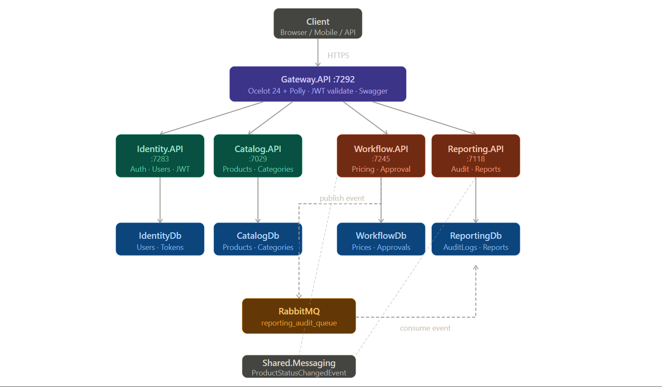
Ecommerce Product Management follows a distributed microservices architecture consisting of multiple independently deployable services.
Major System Components
1. API Gateway Service
- Handles centralized routing
- Acts as a single-entry point
- Routes frontend requests to microservices
- Provides gateway-level request forwarding and exception handling

2. Identity Service
- User authentication
- JWT token generation
- Refresh token management
- User profile management
- Password reset functionality
3. Catalog Service
- Product creation and management
- Category management
- Product variant management
- SKU generation
- Product media asset management
- Product search and filtering
4. Workflow Service
- Product approval workflow management
- Product status updates
- Pricing update management
- Inventory update management
- Approval status tracking
5. Reporting Service
- Dashboard data management
- Product Reports generation
- Analytics dashboard support
- Product status reporting
6. RabbitMQ Message Broker
- Asynchronous inter-service communication
- Event publishing and consumption
- Product status change event handling
- Audit and reporting event synchronization
7. Angular Frontend
- Customer, admin, and product manager interfaces
- Role-based dashboards
- Product catalog management screens
- Storefront product browsing
- Workflow and approval screens
- Reporting and audit trail interfaces

TECHNOLOGIES USED
Category | Technologies Used
Backend Framework | ASP.NET Core (.NET 10)
Programming Language | C#
Frontend Framework | Angular 21
Database | SQL Server
ORM | Entity Framework Core
API Gateway | Ocelot
Authentication | JWT Authentication
Messaging Queue | RabbitMQ + MassTransit
Logging | Serilog
API Testing | Postman
API Documentation | Swagger
Backend Testing | NUnit
Quality Tools | SonarQube / SonarLint
Version Control | Git & GitHub

DEVELOPMENT METHODOLOGY
The project was developed using a structured software development lifecycle consisting of:
- Requirement Analysis
- System Design
- Microservices Planning
- Database Design
- Backend API Development
- Frontend Development
- Service Integration
- Testing & Debugging
- Documentation
- Deployment Preparation

LEARNING OUTCOMES
During the development of Ecommerce Product Management, the following technical skills and practical experiences were gained:
- Enterprise-level microservices development
- ASP.NET Core backend development
- Angular frontend development
- JWT authentication implementation
- RabbitMQ event-driven architecture
- API Gateway configuration
- SQL Server database management
- Entity Framework Core migrations
- REST API development
- Full-stack application integration
- Distributed system design
- Real-world debugging and testing

3. INTRODUCTION TO TECHNOLOGIES UNDERTAKEN

ASP.NET Core (.NET 10)
ASP.NET Core is a modern, open-source, cross-platform framework developed by Microsoft for building scalable web APIs and enterprise applications. In Ecommerce Product Management, ASP.NET Core was used for developing all backend microservices including authentication, shipment management, tracking, administration, and document services.
Features Used
- REST API Development
- Middleware Architecture
- Dependency Injection
- Authentication & Authorization
- Exception Handling Middleware
- Configuration Management
Advantages
- High performance
- Scalability
- Cross-platform support
- Enterprise-level security
- Modular architecture

Angular 21
Angular 21 was used for developing the frontend interface of the E-Commerce Product Management System. The frontend provides dashboards, product management interfaces, authentication pages, workflow screens, reporting pages, and administrative panels.

Angular Features Used
- Standalone Components
- Angular Signals
- Lazy Loading
- Route Guards
- Reactive Forms
- HTTP Interceptors
Benefits
- Component-based architecture
- Faster UI rendering
- Better maintainability
- Responsive design support

SQL Server
SQL Server was used as the relational database management system for storing and managing application data. Each microservice maintained its own dedicated database following the database-per-service architecture.
Responsibilities
- Data storage
- Relationship management
- Query execution
- Data consistency
- Secure data handling

Entity Framework Core
Entity Framework Core (EF Core) was used as the Object Relational Mapper (ORM) for handling database interactions.
Responsibilities
- Database migrations
- Entity mapping
- LINQ query execution
- Data persistence
- Relationship handling
Code-First Workflow
Models → DbContext → Migrations → Update Database → Verification in SSMS

RabbitMQ & MassTransit
RabbitMQ was implemented as the message broker for asynchronous communication between microservices. MassTransit was used for message publishing and event consumption.
Features Implemented
- Shipment event publishing
- Tracking event consumption
- Asynchronous workflows
- Event-driven communication
Advantages
- Loose coupling between services
- Improved scalability
- Better system reliability
- Faster communication
JWT Authentication
JWT (JSON Web Token) authentication was implemented to secure backend APIs and manage user sessions.
Features
- Secure token validation
- Stateless authentication
- Role-based authorization
- Refresh token support

Ocelot API Gateway
Ocelot API Gateway acts as the centralized entry point for all frontend API requests.
Responsibilities
- Request routing
- Gateway security
- CORS management
- API aggregation

Serilog
Serilog was implemented for structured logging and debugging.
Benefits
- Daily rolling log files
- Better debugging
- Error tracking
- Production monitoring

Swagger & Postman
Swagger and Postman were used for API testing and documentation.
Usage
- API documentation
- Endpoint testing
- Request validation
- Backend debugging

NUnit
NUnit was used for backend unit testing.
Testing Areas
- Service layer testing
- Repository testing
- Business logic validation

SOFTWARE REQUIRED
Frontend
- Node.js LTS
- Angular CLI
- VS Code
Backend
- .NET SDK
- Visual Studio 2022

Database
- SQL Server Developer
- SQL Server Management Studio (SSMS)

4. DESCRIPTION OF WORK DONE

During the internship/project development period, the E-Commerce Product Management System was completely designed and developed from scratch based on the provided enterprise case study requirements.
The project involved full-stack development responsibilities including architecture planning, backend development, frontend development, database design, service integration, testing, debugging, and documentation.

Requirement Analysis
Initially, the complete case study requirements were analyzed to identify:
- User roles and permissions
- Shipment workflows
- Authentication requirements
- Product approval requirements
- Inventory and pricing requirements
- Reporting requirements
- Service communication requirements
Based on these requirements, a scalable microservices architecture was planned and designed.

System Design & Architecture Planning
The overall architecture of Ecommerce Product Management was designed using microservices principles by separating functionalities into independent services.
The planned services included:
- Identity Service
- Catalog Service
- Workflow Service
- Reporting Service
- API Gateway Service

An Ocelot API Gateway was introduced to manage centralized routing while RabbitMQ was selected for asynchronous event-driven communication.

Backend Development
All backend services were developed using ASP.NET Core (.NET 10).
Major Backend Tasks Performed
- Designing REST APIs
- Implementing business logic
- Creating entities and DTOs
- Developing repository patterns
- Service layer implementation
- JWT authentication setup
- Refresh token implementation
- Global exception middleware
- Role-based authorization
- RabbitMQ integration
- Event publishing and consumption
- API Gateway integration
- Logging configuration using Serilog

Frontend Development
The frontend application was developed using Angular 21.
Frontend Tasks Performed
- Designing responsive UI components
- Implementing authentication pages
- Dashboard development
- Product catalog management interfaces
- Product creation and editing forms
- Product variant management
- Media asset management
- Reporting dashboard interfaces
- Route Guard implementation
- HTTP interceptor setup
- API integration
- Angular Signals state management

Database Design
Separate SQL Server databases were created for each microservice following the database-per-service architecture.
Database Tasks
- Entity relationship design
- DbContext creation
- Database migrations
- Query optimization
- Data validation implementation

RabbitMQ Integration
RabbitMQ was integrated for asynchronous communication between services.
Features Implemented
- Product status change events
- User count update events
- Event consumers
- Event publishers
- Workflow-based product updates

API Gateway Configuration
Ocelot API Gateway was configured for:
- Request routing
- Centralized communication
- Secure API access
- CORS policy management
- Gateway-level exception handling

Testing & Debugging
Extensive testing and debugging were performed during development.
Backend Testing
- API testing
- Authentication testing
- Service testing
- Event communication testing
Tools Used
- Swagger
- Postman
- NUnit

Documentation
Detailed project documentation was prepared including:
- API documentation
- System architecture
- Database structure
- Workflow diagrams
- Service communication flow
- Testing reports

The project enhanced my full-stack development expertise and helped me understand how to build enterprise-level product management platforms with high reliability, scalability, maintainability, and performance.

5. CONCLUSION

In conclusion, the E-Commerce Product Management System project has been an extremely valuable part of my learning journey in full-stack software development and enterprise application engineering. Working with modern technologies such as ASP.NET Core / .NET 10, Angular 21, SQL Server, RabbitMQ, Ocelot API Gateway, Entity Framework Core, JWT Authentication, and Serilog significantly strengthened my technical foundation and enhanced my understanding of real-world software development practices.
Developing a scalable microservices-based e-commerce product management platform completely from scratch allowed me to gain practical experience in backend development, frontend development, database management, API integration, event-driven communication, and distributed system architecture. The project helped me understand how enterprise applications are designed, developed, secured, and maintained using modern software engineering approaches.
Throughout the development lifecycle, I gained hands-on experience in implementing REST APIs, configuring JWT authentication and authorization, integrating RabbitMQ for asynchronous communication, designing SQL Server databases using Entity Framework Core Code-First approach, and developing responsive frontend interfaces using Angular 21. These experiences improved my problem-solving abilities, debugging skills, architectural thinking, and confidence in handling large-scale applications.
A major highlight of this project was the opportunity to independently design and develop all modules of the application, including backend services, frontend interfaces, database structures, API Gateway routing, and inter-service communication workflows. I also gained practical experience in implementing product catalog management, inventory and pricing management, product approval workflows, reporting dashboards, audit trails, and role-based access control. Working on the complete project lifecycle, from requirement analysis and architecture planning to testing, debugging, and documentation, greatly enhanced my practical development skills and professional confidence.
Apart from technical knowledge, this project also improved my professional skills such as documentation, communication, analytical thinking, time management, and structured development practices. Overall, the E-Commerce Product Management System project served as an excellent learning experience that strengthened both my technical and professional capabilities and prepared me for future opportunities in full-stack and enterprise software development.

