Project Requirement Document
ECommerce Product Management System
Angular + ASP.NET Core Microservices + Ocelot + SQL Server + EF Core + JWT

Document Type | Corporate Training Project Requirement Document
Primary Topic | Product lifecycle management for ecommerce catalog operations
Core Roles | Admin, Product Manager, Content Executive, Customer (preview)
Architecture | 4 Microservices with Ocelot API Gateway
Quality Goal | JWT security, EF Core code-first, >=90% backend coverage

Prepared for structured project execution, architecture planning, UI wireframing, testing, and student deliverables.

A) Application Overview
The ECommerce Product Management System is designed to centralize the way an online business creates, enriches, approves, prices, publishes, and monitors products across its digital storefront. In many ecommerce teams, product data is scattered across spreadsheets, image folders, email approvals, and disconnected admin screens. This creates delays in product launches, inconsistent pricing, incorrect inventory visibility, and poor customer experience on the storefront.
This project solves that problem by introducing a structured Angular-based product management portal backed by ASP.NET Core microservices. The application gives administrators and product operations teams a controlled workflow for product creation, media upload, pricing, stock updates, approval, publishing, reporting, and audit tracking. A storefront preview is also included so the business can validate how a product will look before it is released to customers.
The system uses exactly four microservices with Ocelot API Gateway, JWT-based security, EF Core code-first persistence, and SQL Server. It is suitable for corporate training because it covers real-world product lifecycle management while also exposing students to enterprise architecture, API design, testing strategy, and documentation practices.

B) Objective
- Provide a fast and structured product onboarding experience for ecommerce operations teams.
- Enable secure role-based login and controlled access to product, pricing, inventory, and reporting features.
- Reduce product launch errors by validating mandatory catalog data, pricing rules, stock availability, and approval status before publishing.
- Design a scalable microservices architecture that separates identity, catalog, workflow, and reporting responsibilities.
- Support reporting, exports, and auditability so the business can monitor product quality and operational health.

C) Roles & Access Control

Business Roles
Role | Key Access | Typical Actions | Security Note
Customer (Preview User) | Read-only preview pages | View product listing, details, stock message, and purchase-facing presentation | Protected only where internal preview links are used
Admin | Full administrative control | Approve products, manage users, publish/unpublish items, bulk updates, dashboards, exports | Admin-only APIs via [Authorize(Roles="Admin")]
Product Manager | Catalog ownership | Create products, edit metadata, submit for approval, monitor quality issues | JWT role claim limits access to catalog and workflow functions
Content Executive | Data enrichment | Upload images, descriptions, attributes, SEO text, and tags | Restricted from final approval/publish actions

Security Implementation
- Angular route guards protect /auth/*, /customer/*, and /admin/* routes based on authenticated role and token presence.
- JWT Bearer authentication is used on all secured ASP.NET Core endpoints.
- Sensitive endpoints such as product approval, publish, bulk status change, and report exports are restricted to Admin role.
- DTO models are exchanged through APIs so EF Core entities are never exposed directly to the client.

D) UI Design Architecture (Angular)
The frontend is designed as an Angular single-page application with clear separation between reusable infrastructure and feature modules. The UI supports both product administration and storefront preview workflows.
- CoreModule - application shell, interceptors, guards, environment configuration, and global services.
- SharedModule - reusable cards, badges, modals, tables, form controls, validation summaries, spinners, and toast notifications.
- AuthModule - signup, login, forgot password, token refresh handling, and unauthorized screen.
- CustomerModule - product listing, product details, preview cart flow, and product history preview.
- AdminModule - dashboard, product CRUD, pricing, inventory, approval workflow, bulk upload, audit views.
- ReportsModule (optional) - charts, exports, KPI widgets, and operational reports.
Routing follows /auth/*, /customer/*, and /admin/* paths. A JWT interceptor appends bearer tokens to protected requests, while a global error handler converts backend failures into standardized notifications. Reusable components include product cards, filter sidebar, pagination, image gallery, stock badge, publish status badge, wizard footer, confirmation dialog, and alert banner.

UI Design Pattern (1 pattern)
Chosen Pattern: Wizard / Stepper Pattern. This pattern is applied to the product publish flow because product onboarding typically happens in stages. The stepper guides the user through Basic Information -> Media -> Pricing -> Inventory -> Review -> Publish. It prevents incomplete product launches, surfaces validation messages at the correct step, and creates a more teachable UI flow for students.

E) Page-by-Page Functional Requirements

1. Landing / Home
- Purpose - Present the overall product management console and operational KPIs.
- UI Components - Dashboard cards, quick links, alert panel, recent products, left navigation.
- Fields + Validations - No direct form fields; filters may include date range and business unit.
- API Calls - GET dashboard summary, GET pending alerts via Admin/Reporting service through /gateway/admin/*.
- Success / Error Messages - Show success tiles on successful load; show retry banner on API failure.
- Navigation Rules - Unauthenticated users are redirected to Login; authenticated admins land here after login.

2. Signup
- Purpose - Create a new internal product operations user.
- UI Components - Registration form, role dropdown, terms checkbox, password rules panel.
- Fields + Validations - Name required; email format; password complexity; confirm password match.
- API Calls - POST signup via Identity/Auth service.
- Success / Error Messages - Display account created message or duplicate email error.
- Navigation Rules - After success navigate to Login.

3. Login
- Purpose - Authenticate the user and issue JWT token.
- UI Components - Email field, password field, remember me, login button.
- Fields + Validations - Required email/password; lockout message after configured failures.
- API Calls - POST login via Identity/Auth service.
- Success / Error Messages - Show login success, invalid credential error, inactive user error.
- Navigation Rules - Route based on role to /admin/dashboard or permitted module.

4. Product Listing (PLP)
- Purpose - Allow users to search, filter, sort, and manage product catalog entries.
- UI Components - Search box, filter sidebar, table/cards, status chips, bulk selection.
- Fields + Validations - Search text optional; filter values controlled; bulk action requires selected rows.
- API Calls - GET products, GET categories, GET search facets via Catalog service.
- Success / Error Messages - No records message, filter applied message, service unavailable banner.
- Navigation Rules - Clicking a row navigates to Product Details/Edit.

5. Product Details
- Purpose - View and edit a product including metadata, images, and variants.
- UI Components - Image gallery, tabbed sections, basic info form, attribute matrix, save buttons.
- Fields + Validations - Product name, SKU, category required; image type validation; attribute constraints.
- API Calls - GET product detail, PUT product update, POST media upload.
- Success / Error Messages - Save success toast, duplicate SKU error, file upload error.
- Navigation Rules - Back to listing, next to Pricing/Inventory step.

6. Cart / Storefront Preview
- Purpose - Show how the product appears in a customer-facing shopping context.
- UI Components - Preview card, price snapshot, stock message, CTA area, validation notes.
- Fields + Validations - Read-only preview; system validates whether required publish fields exist.
- API Calls - GET preview model via Catalog service.
- Success / Error Messages - Display preview generated or missing field alerts.
- Navigation Rules - Return to Product Details or launch publish wizard.

7. Checkout / Publish Wizard
- Purpose - Guide the business user through publish readiness verification.
- UI Components - Stepper header, section forms, review card, completeness score.
- Fields + Validations - Mandatory checks for media, pricing, tax, inventory, and description completeness.
- API Calls - GET publish checklist, PUT step data, POST submit for approval via Product Workflow service.
- Success / Error Messages - Show step save success, incomplete step error, conflict warning.
- Navigation Rules - Next/previous navigation inside wizard; finish submits for approval.

8. Payment (integration stub) / Pricing Approval
- Purpose - Simulate external dependency behavior for training purposes.
- UI Components - Approval stub panel, pricing confirmation, audit comments.
- Fields + Validations - Approval remark required on reject; price range rules enforced.
- API Calls - POST pricing approval simulation via Product Workflow service.
- Success / Error Messages - Approved/rejected messages and audit trail entry.
- Navigation Rules - On success return to workflow summary.

9. Order Confirmation / Publish Confirmation
- Purpose - Confirm the product has been approved or published.
- UI Components - Summary card, product snapshot, timestamp, next actions.
- Fields + Validations - No input; acknowledgment only.
- API Calls - POST final publish or GET confirmation details via Product Workflow service.
- Success / Error Messages - Publish success message or downstream failure rollback message.
- Navigation Rules - Navigate to Product History or Dashboard.

10. Order History + Order Details / Product Audit History
- Purpose - Track all changes made to the product.
- UI Components - Audit table, filters, detail side panel, before/after view.
- Fields + Validations - Date filters optional; export format required when exporting.
- API Calls - GET audit history and GET audit detail via Admin/Reporting service.
- Success / Error Messages - No history message or download successful message.
- Navigation Rules - Drill into specific entry details.

11. Admin Dashboard
- Purpose - Give leadership view of catalog and workflow health.
- UI Components - KPI cards, charts, approval queue, low stock alerts, publish trend.
- Fields + Validations - Filter by date, category, brand, owner.
- API Calls - GET reporting summary via Admin/Reporting service.
- Success / Error Messages - Load success, empty state, partial data warning.
- Navigation Rules - Links to product management, approvals, reports.

12. Admin Product Management (CRUD)
- Purpose - Support create, read, update, delete, clone, bulk upload, and archive actions.
- UI Components - Toolbar, editable grid, modal dialogs, import/export panel.
- Fields + Validations - Mandatory product identity fields; delete requires confirmation; import file type checks.
- API Calls - POST/PUT/DELETE via Catalog service and Product Workflow service.
- Success / Error Messages - Saved, archived, imported, or conflict error messages.
- Navigation Rules - Action buttons vary by role and status.

13. Admin Orders Management / Product Status Management
- Purpose - Manage lifecycle states such as Draft, In Review, Approved, Published, Rejected, Archived.
- UI Components - Queue table, detail panel, status action buttons, remarks modal.
- Fields + Validations - Reject/archive requires reason; publish requires checklist pass.
- API Calls - PUT status update via Product Workflow service.
- Success / Error Messages - Status changed message or forbidden 403 message.
- Navigation Rules - Return to dashboard queue or product detail.

14. Admin Reports
- Purpose - Generate reports on price changes, product readiness, low stock, and catalog quality.
- UI Components - Report filters, chart area, export buttons.
- Fields + Validations - At least one filter required for large export jobs.
- API Calls - GET report data, POST export request via Admin/Reporting service.
- Success / Error Messages - Export ready message or timeout warning.
- Navigation Rules - Remain on same page after export request.

F) Status Lifecycle
For this project, the main lifecycle is the product publish lifecycle. A clean status flow reduces confusion and ensures only validated products reach the storefront.
Status | Meaning | Who Can Change | Typical Transition
Draft | Product record exists but is incomplete. | Product Manager / Content Executive | Created -> In Enrichment
In Enrichment | Images, attributes, SEO, pricing, and stock are being added. | Product Manager / Content Executive | Draft -> In Enrichment -> Ready for Review
Ready for Review | Mandatory fields are complete and waiting for approval. | Product Manager | In Enrichment -> Ready for Review
Approved | Business validation completed successfully. | Admin | Ready for Review -> Approved
Published | Product is visible on storefront read model. | Admin | Approved -> Published
Rejected | Review failed; corrections are needed. | Admin | Ready for Review -> Rejected -> In Enrichment
Archived | Product removed from active operational use. | Admin | Published/Rejected -> Archived
Optional training branch: Published products can later enter Price Change Pending or Stock Hold as future enhancements. Students may mention future async event-driven updates for these extended states.

G) Microservices System Architecture (4 Services + Ocelot)
The application uses exactly four microservices. Inter-service communication begins with REST APIs for clarity and easier testing. Future enhancement can introduce asynchronous events for publish notifications, stock synchronization, and pricing updates.
- 1) Identity/Auth Service - signup, login, JWT generation, claims/roles, user status management.
- 2) Catalog Service - products, categories, attributes, media metadata, search, storefront read model.
- 3) Product Workflow Service - pricing, inventory, approval workflow, publish readiness, status management.
- 4) Admin/Reporting Service - dashboard aggregation, reports, exports, audit logs, operational alerts.
- Ocelot API Gateway routes all frontend traffic to the correct downstream service using /gateway/auth/*, /gateway/catalog/*, /gateway/workflow/*, and /gateway/admin/* paths.
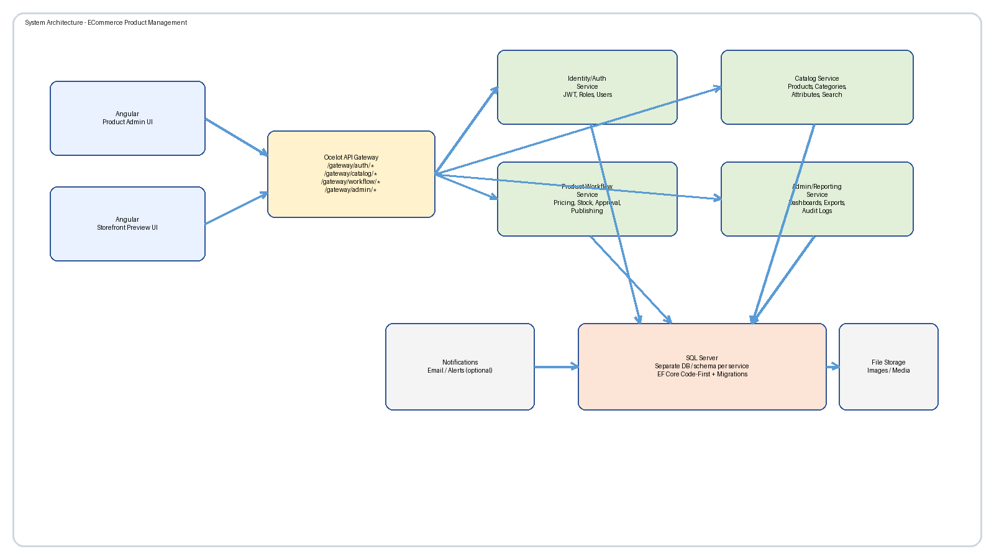
Figure G1. High-level architecture showing Angular UIs, Ocelot gateway, four microservices, SQL Server, optional notifications, and file storage.

H) Database Design (SQL Server + EF Core Code-First)
Each microservice owns its entity models, DbContext, migrations, and repository/service layers. SQL Server is the primary relational database. Students must use EF Core Code-First only.
- Suggested entities: Users, Roles, Categories, Products, ProductVariants, Prices, Inventory, MediaAssets, Approvals, AuditLogs.
- Relationships: Category 1..* Products, Product 1..* Variants, Variant 1..1 Inventory, Product 1..* MediaAssets, Product 1..* Approvals.
- Code-first flow: Create entity models -> configure DbContext -> add migrations -> update database -> verify schema in SSMS.
- Note: ER diagram below is a sample; students can design their own variant as long as it supports the required workflow.
- Note: DTO models should be used for data transactions; EF entities should not be exposed directly.
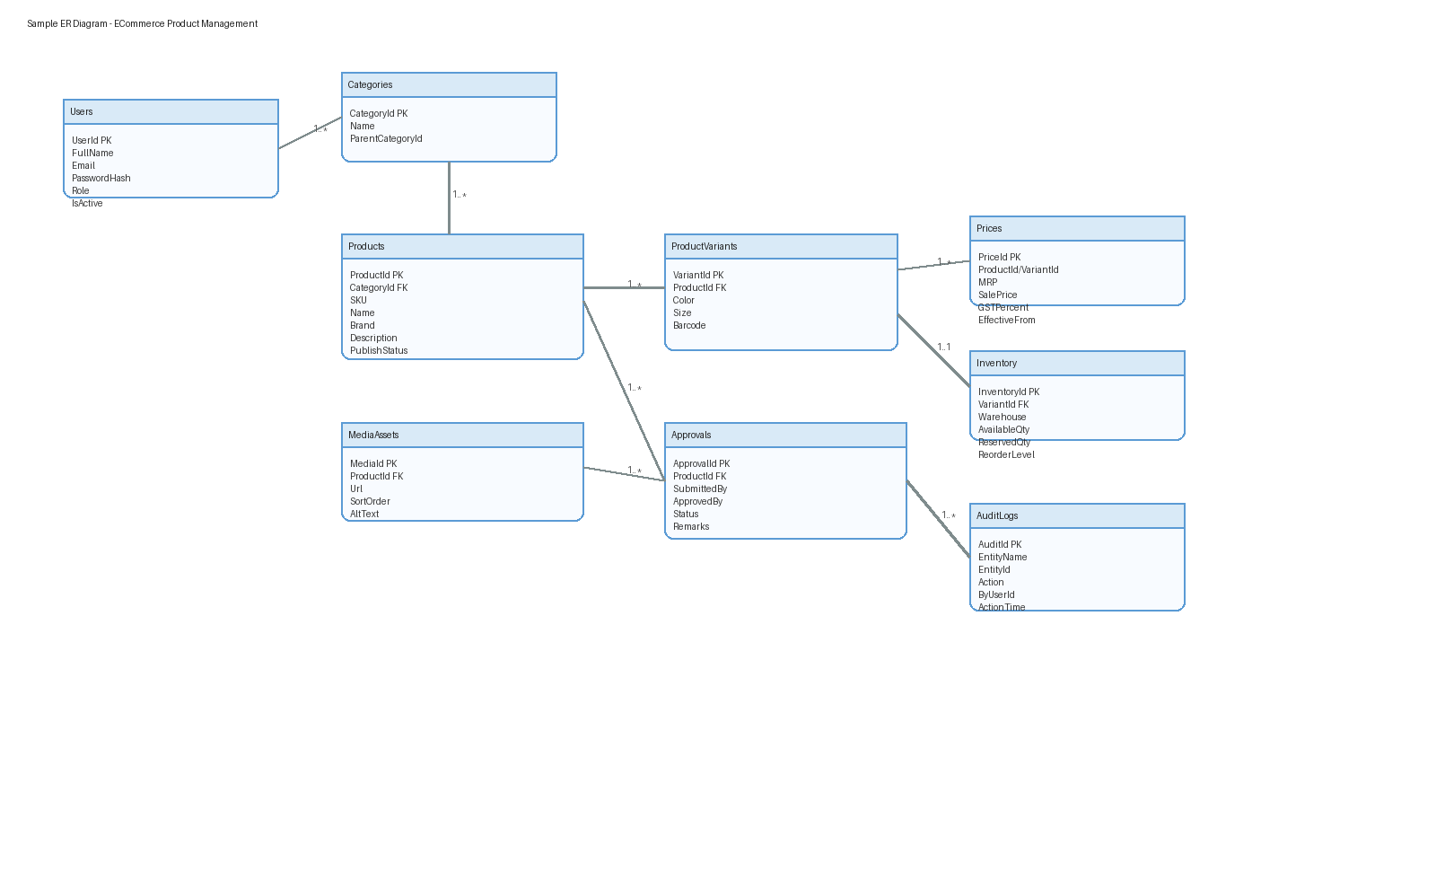
Figure H1. Sample ER diagram for the product management domain.

I) REST API Summary (By Service + Gateway)
Postman and Swagger/OpenAPI should be used for endpoint testing and documentation.
Service | Method + Route | Purpose | Gateway Example
Identity/Auth | POST /api/auth/signup | Create user account | /gateway/auth/signup
Identity/Auth | POST /api/auth/login | Validate credentials and issue JWT | /gateway/auth/login
Catalog | GET /api/products | List/search products | /gateway/catalog/products
Catalog | GET /api/products/{id} | Fetch product detail | /gateway/catalog/products/{id}
Catalog | POST /api/products | Create a product | /gateway/catalog/products
Catalog | PUT /api/products/{id} | Update product metadata | /gateway/catalog/products/{id}
Product Workflow | PUT /api/workflow/products/{id}/pricing | Save or update pricing | /gateway/workflow/products/{id}/pricing
Product Workflow | PUT /api/workflow/products/{id}/inventory | Save stock data | /gateway/workflow/products/{id}/inventory
Product Workflow | POST /api/workflow/products/{id}/submit | Submit product for review | /gateway/workflow/products/{id}/submit
Product Workflow | PUT /api/workflow/products/{id}/status | Approve/reject/publish/archive | /gateway/workflow/products/{id}/status
Admin/Reporting | GET /api/reports/dashboard | Load dashboard KPIs | /gateway/admin/reports/dashboard
Admin/Reporting | GET /api/audit/products/{id} | Load product audit history | /gateway/admin/audit/products/{id}

J) Software Required
- Angular CLI and Node.js LTS
- Visual Studio 2022 and/or Visual Studio Code
- .NET SDK compatible with ASP.NET Core target version
- Microsoft SQL Server Developer Edition and SQL Server Management Studio (SSMS)
- Ocelot NuGet package for API Gateway
- Postman and Swagger/OpenAPI for API testing
- Git, GitHub/Azure Repos, and package managers (npm / NuGet)

K) Testing & Quality Plan

Backend - NUnit
- Unit tests for service classes, validation rules, repositories, and workflow transitions.
- Target backend code coverage of at least 90% using coverlet and reportgenerator.
- Test JWT issuance, role validation, pricing rules, duplicate SKU checks, and publish readiness logic.

Frontend - Jasmine + Karma
- Component tests for product listing, product details, wizard step validation, and dashboard cards.
- Service tests with mocked HTTP calls.
- Guard tests for role-based routes such as /admin/* and preview access.

Quality / Vulnerability
- Use SonarQube if available; otherwise use SonarLint, dotnet analyzers, and npm audit.
- Check for package vulnerabilities and maintain coding standards.
- Add practical static checks such as nullable reference analysis, API contract validation, and DTO mapping reviews.

L) Student Deliverables (Diagrams + Planning)
- Use Case Diagram
- Class Diagram
- Sequence Diagram for key flow: Add Product -> Enrich -> Submit -> Approve -> Publish
- ER Diagram
- Work Breakdown Structure (WBS)
- Agile sprint plan in Azure Boards / Jira / Trello
- Sprint-wise backlog with story points or effort hours, sprint goal, and Definition of Done
Recommended sprint model: 2-week sprints. Suggested Sprint 1 covers authentication and catalog base. Sprint 2 covers pricing, inventory, and workflow. Sprint 3 covers reporting, testing, and hardening.

M) Test Cases (Table Format)
Test Case | Role | Steps | Expected Result | Type | Related Service
TC01 Login Success | Admin | Enter valid email and password | JWT token issued and dashboard opens | Positive | Identity/Auth
TC02 Login Failure | Admin | Enter wrong password | Error message shown; no token issued | Negative | Identity/Auth
TC03 Search Product | Product Manager | Search by SKU/name | Matching products listed | Functional | Catalog
TC04 Create Product | Product Manager | Enter mandatory product data and save | Product stored in Draft state | Functional | Catalog
TC05 Duplicate SKU | Product Manager | Create another product with same SKU | Validation error blocks save | Negative | Catalog
TC06 Upload Invalid Image | Content Executive | Upload unsupported file type | File rejected with message | Negative | Catalog
TC07 Save Pricing | Product Manager | Enter valid MRP and sale price | Pricing saved and audit captured | Functional | Product Workflow
Table M1. Core authentication, catalog, pricing, and submission test cases.

M) Test Cases (Table Format) - Continued
Test Case | Role | Steps | Expected Result | Type | Related Service
TC08 Invalid Price Rule | Product Manager | Enter sale price higher than MRP | Validation error displayed | Negative | Product Workflow
TC09 Submit for Review | Product Manager | Complete checklist and submit | Status becomes Ready for Review | Functional | Product Workflow
TC10 Admin Approves Product | Admin | Open approval queue and approve item | Status becomes Approved | Functional | Product Workflow
TC11 Publish Product | Admin | Publish approved product | Product visible in storefront preview | Integration | Product Workflow/Catalog
TC12 Forbidden Access | Content Executive | Attempt admin-only publish endpoint | 403 Forbidden returned | Security | Product Workflow
TC13 Dashboard Export | Admin | Run report and export data | Export file generated | Functional | Admin/Reporting
TC14 Audit History Load | Admin | Open product audit tab | All changes load in chronological order | Functional | Admin/Reporting
Table M2. Approval, security, reporting, and audit test cases.

N) Deliverables & Evaluation Criteria
Evaluation Area | Expectation | Weightage
Microservices + Gateway | Exactly four services with working Ocelot routes | 20%
JWT Security | Role-based access, guards, and secured APIs | 15%
EF Core Code-First | Entities, DbContext, migrations, repository/service usage | 15%
UI vs Wireframes | Angular screens aligned with documented wireframes | 15%
Testing Coverage | NUnit, Jasmine/Karma, meaningful coverage | 15%
Quality Gates | Static analysis, vulnerability checks, clean coding | 10%
Diagrams + Sprint Plan | Complete diagrams, WBS, sprint backlog and DoD | 10%

O) Conclusion
The ECommerce Product Management System is a strong real-world training project because it goes beyond simple CRUD and introduces the actual business lifecycle of catalog operations. Students learn how product information flows from creation to publication, how microservices divide responsibilities, how JWT secures enterprise applications, and how testing and quality practices support maintainable delivery. The project is large enough for architecture, UI, API, database, and agile planning exercises while still being realistic for guided implementation.

📲 Screen Design (Wireframes)
The following wireframes provide a clean reference for major screens. They are intentionally simple and aligned so students can translate them into Angular components without losing layout consistency.

Home Product Console
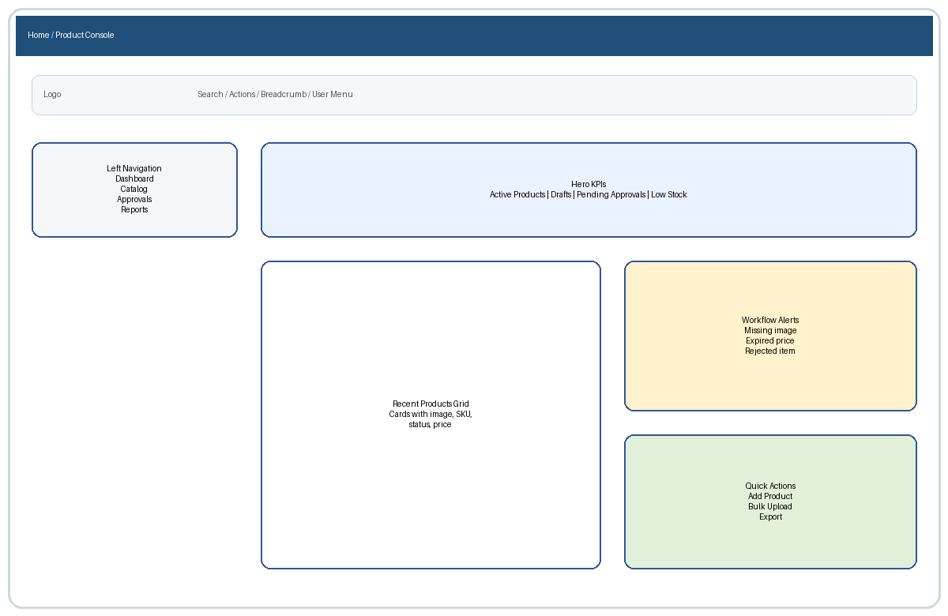
Wireframe reference - Home Product Console

Login Signup
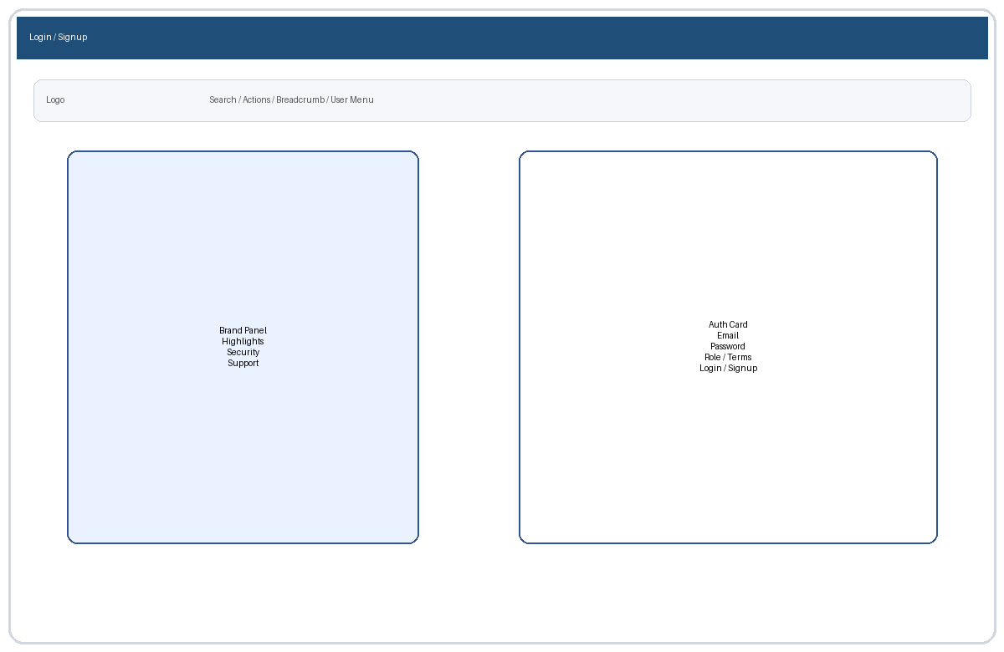
Wireframe reference - Login Signup

Product Listing PLP
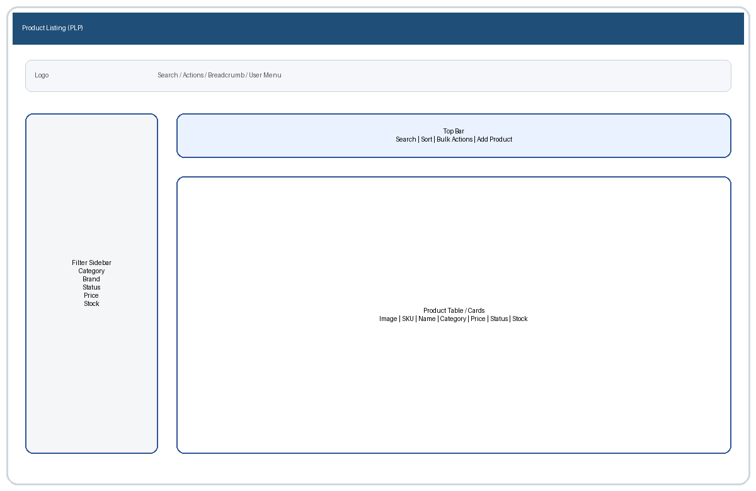
Wireframe reference - Product Listing PLP

Product Details Edit
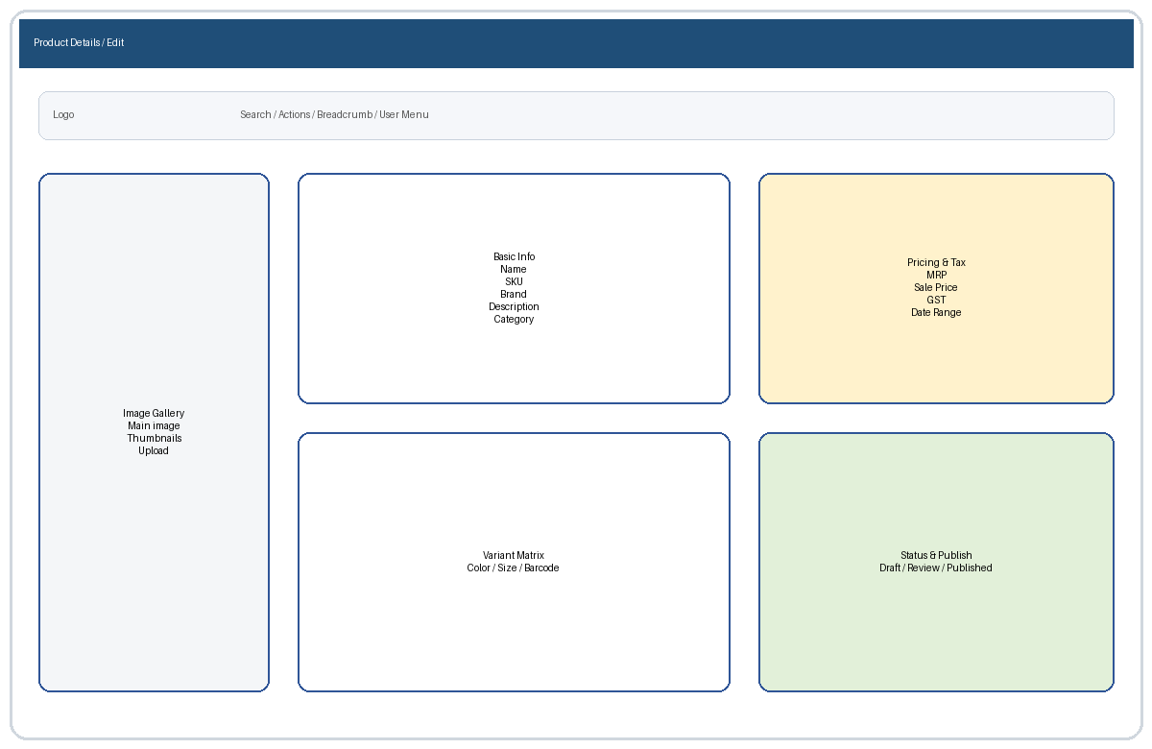
Wireframe reference - Product Details Edit

Cart Storefront Preview
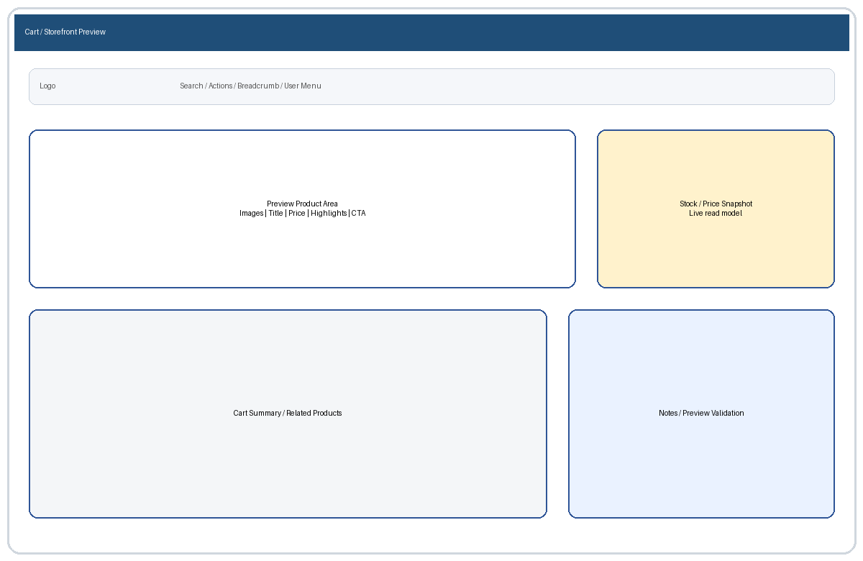
Wireframe reference - Cart Storefront Preview

Checkout Publish Wizard
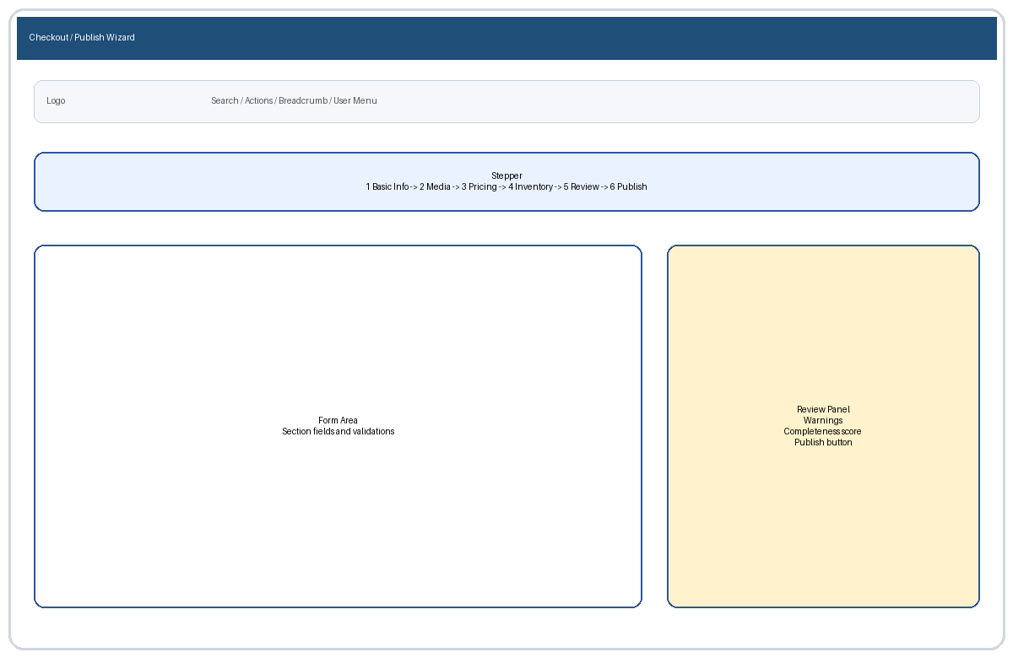
Wireframe reference - Checkout Publish Wizard

Order History Product Audit
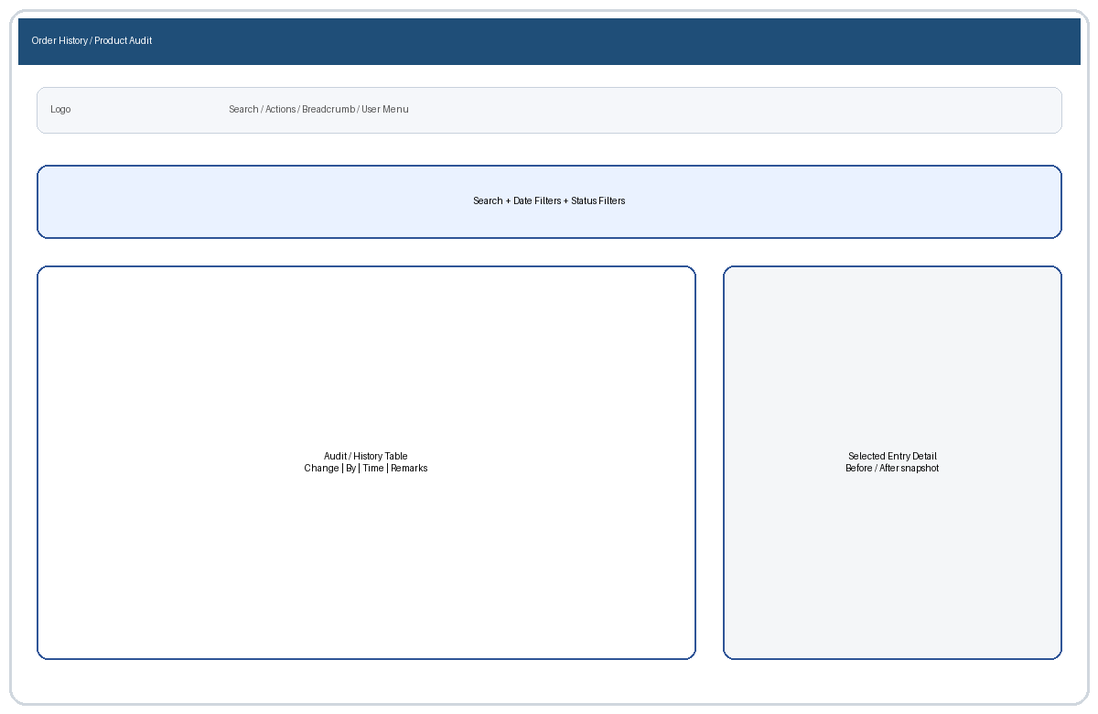
Wireframe reference - Order History Product Audit

Admin Dashboard
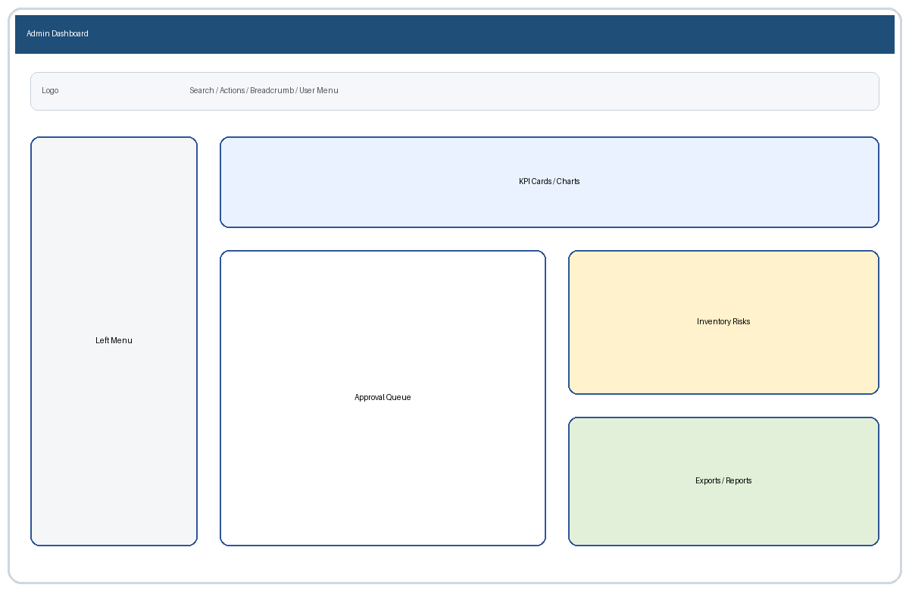
Wireframe reference - Admin Dashboard

Admin Product Management
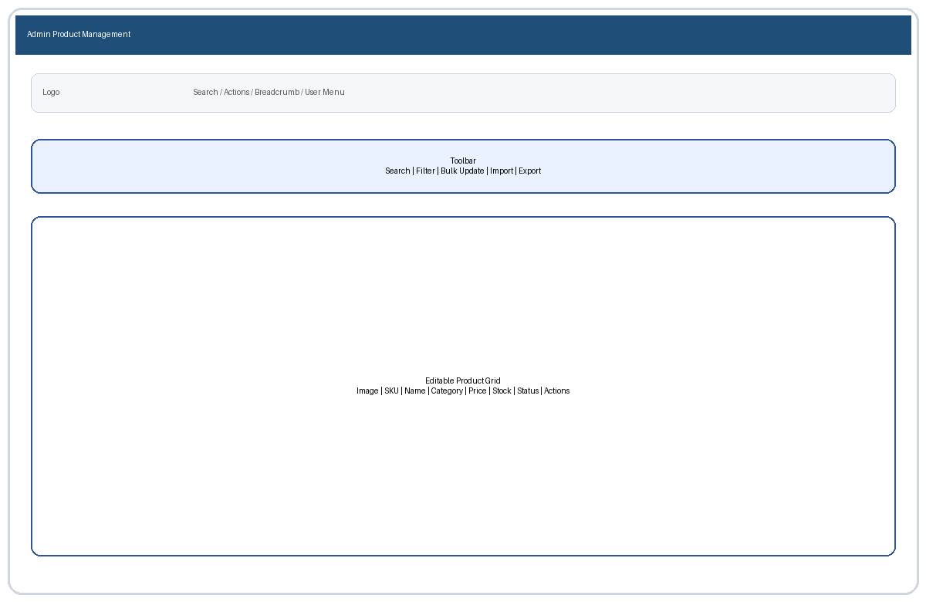
Wireframe reference - Admin Product Management

Admin Reports
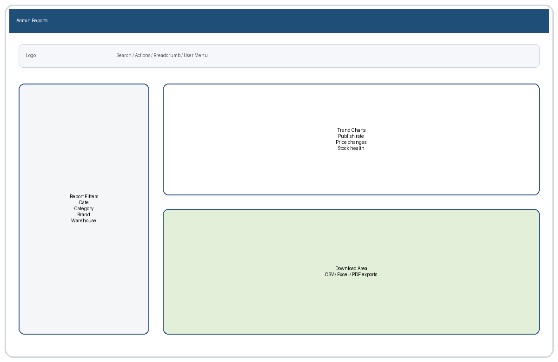
Wireframe reference - Admin Reports

