EXPERIMENT-7
NAME: Abhinandan ER
ROLL NO:240701006

USER INTERFACE DESIGN

Design an application layout using different colours, text styles, and visual elements. Share the design with users through a Google Form or any other feedback collection method to gather their responses. Based on the feedback received, refine and improve the design accordingly.

Initial Design (Before feedback):

An application layout named “TaskMate” was designed using different colors, text styles, and visual elements. The design included three screens: welcome screen, login screen, and home screen. The welcome screen contained the app title and a “Get Started” button. The login screen included email and password fields with a login button. The home screen displayed a list of tasks with an option to add new tasks. The design was made visually appealing using colors, fonts, and icons.

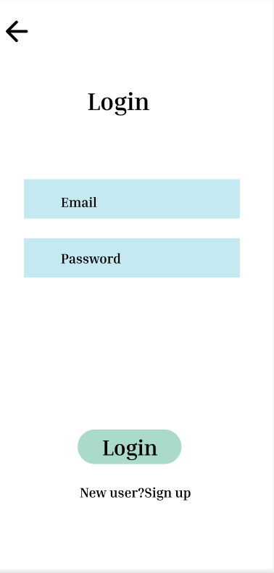
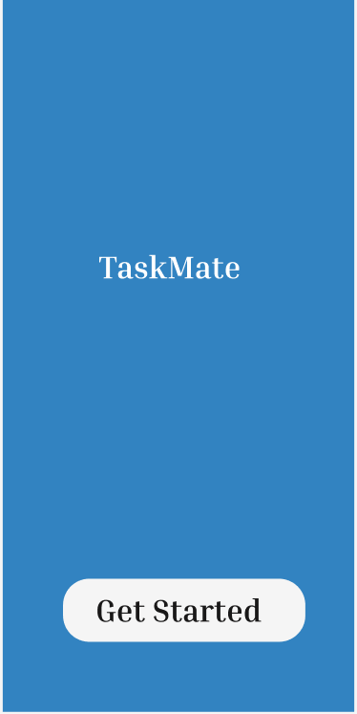

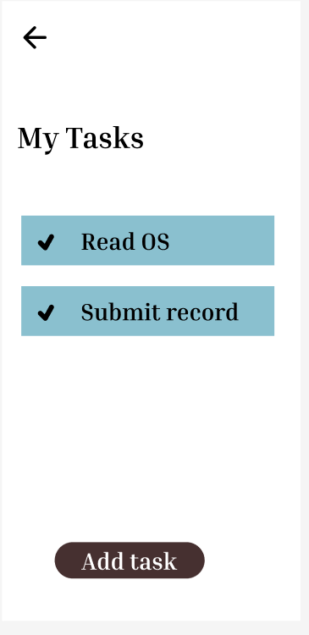
Feedback (Google Form):
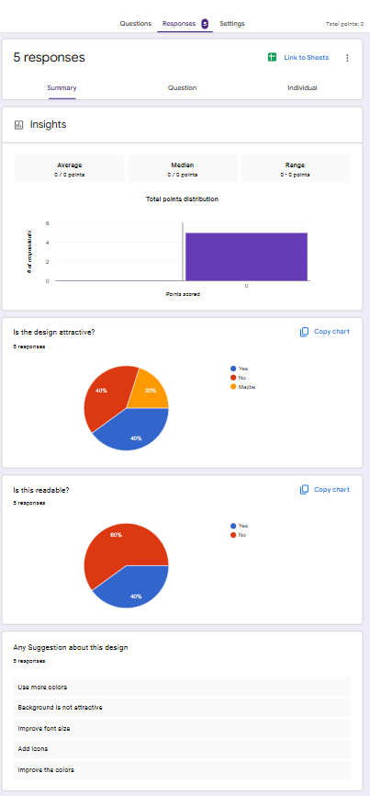

Suggestions
- Use more colors to make the design more attractive
- Improve the background appearance
- Increase the font size for better readability
- Add icons to enhance visual appeal
- Improve the color combination

Based on the feedback collected from users, it is clear that certain improvements are required to enhance the overall design quality. Many users felt that the current design looks simple and can be made more attractive by using better color combinations and a visually appealing background. Some users also suggested increasing the font size to improve readability and adding icons to make the interface more interactive. Overall, the feedback indicates that improving visual elements and layout will make the application more user-friendly and engaging.

Improved Design: (After feedback)
