A PROJECT REPORT

on

“Schema Builder: Full-Stack
Visual Database Schema Designer”

Submitted to

KIIT Deemed to be University

In Partial Fulfilment of the Requirement for the Award of

BACHELOR’S DEGREE IN

COMPUTER SCIENCE

BY

SHUBHAM KR THAKUR  SHREYA KUMARI  ABHAY GUPTA  ABHINANDAN SENGAR | 22052411  22052594  22052608  22053048

UNDER THE GUIDANCE OF

Asst. Prof PRASENJIT MAITI


SCHOOL OF COMPUTER ENGINEERING

KALINGA INSTITUTE OF INDUSTRIAL TECHNOLOGY

BHUBANESWAR, ODISHA - 751024

November 2025

on

“Schema Builder: Full-Stack Visual
Database Schema Designer”

Submitted to

KIIT Deemed to be University

In Partial Fulfilment of the Requirement for the Award of

BACHELOR’S DEGREE IN COMPUTER SCIENCE

BY

SHUBHAM KR THAKUR  SHREYA KUMARI  ABHAY GUPTA  ABHINANDAN SENGAR | 22052411  22052594  22052608  22053048

UNDER THE GUIDANCE OF

Asst. Prof PRASENJIT MAITI

SCHOOL OF COMPUTER ENGINEERING

KALINGA INSTITUTE OF INDUSTRIAL TECHNOLOGY

BHUBANESWAE, ODISHA -751024

November 2025

KIIT Deemed to be University

School of Computer Engineering
Bhubaneswar, ODISHA 751024

CERTIFICATE

This is certified that the project entitled

“Schema Builder: Full-Stack
Visual Database Schema Designer”

submitted by

SHUBHAM KR THAKUR | 22052411
SHREYA KUMARI | 22052594
ABHAY GUPTA | 22052608
ABHINANDAN SENGAR | 22053048

is a record of bonafide work carried out by them, in the partial fulfilment of the requirement for the award of Degree of Bachelor of Engineering Computer Science & Engineering at KIIT Deemed to be university, Bhubaneswar. This work is done during year 2025-2026, under our guidance.

Date: 09 / 11 / 2025

(Asst. Prof Prasenjit Maiti)
Project Guide

Acknowledgements

We are deeply thankful to Asst. Prof Prasenjit Maity, School of Computer Engineering, KIIT University, Bhubaneswar, for his valuable suggestions and support during this project. His guidance and motivation have contributed to the shaping of our work immensely, and we are deeply thankful to his academic enthusiasm.

A grateful thanks to the Director, School of Computer Engineering, KIIT University, for making available to us the resources needed and creating a conducive environment to make this project become a reality.

This work could not have been accomplished without the combined efforts of all who led, guided, and supported us throughout. Thank you! .....................

SHUBHAM KR THAKUR
SHREYA KUMARI
ABHAY GUPTA
ABHINANDAN SENGAR

ABSTRACT

Database schema design is critical for software development, ensuring data consistency, integrity, and scalability. This project proposes Schema Builder, a full-stack visual database schema designer with authentication, project management, multi-format code generation, and visual relationship mapping.
The application is built with Next.js, React, TypeScript, Prisma, TailwindCSS, and integrates NextAuth.js for secure multi-provider authentication. Users can create, edit, and export database schemas as SQL DDL, Prisma models, or MongoDB/Mongoose schemas.

The system supports multiple field types, primary/foreign keys, constraints, and relationship mapping. The tool enhances productivity and reduces human errors by providing a drag-and-drop interface, real-time validation, schema versioning, and batch export. This project demonstrates an efficient full-stack implementation of database schema management and visual code generation for modern web applications.

Keywords: Database Schema, Prisma, Next.js, React, TypeScript, Visual Designer, Code Generation

Contents
1 | Introduction |  |  | 1
2 | Basic Concepts/ Literature Review |  |  | 2
 | 2.1 | Background of Database Schema Design Tools |  | 2
 | 2.2 | Visual Programming and Low-Code Paradigms |  | 3
 | 2.3 | Code Generation in Database Systems |  | 3
 | 2.4 | Authentication, Authorization, and Role Management |  | 4
 | 2.5 | Related Works and Research Gaps |  | 4
3 | Problem Statement / Requirement Specifications |  |  | 5
 | 3.1 | Project Planning |  | 5
 | 3.2 | Project Analysis (SRS) |  | 6
 | 3.3 | System Design |  | 6
 |  | 3.3.1 | Design Constraints | 6
 |  | 3.3.2 | Block Diagram | 7
4 | Implementation |  |  | 9
 | 4.1 | Methodology |  | 9
 | 4.2 | Testing / Verification Plan |  | 10
 | 4.3 | Result Analysis |  | 12
 | 4.4 | Quality Assurance |  | 13
5 | Standard Adopted |  |  | 14
 | 5.1 | Design Standards |  | 14
 | 5.2 | Coding Standards |  | 14
 | 5.3 | Testing Standards |  | 15
6 | Conclusion and Future Scope |  |  | 16
 | 6.1 | Conclusion |  | 16
 | 6.2 | Future Scope |  | 17
References |  |  |  | 18
Individual Contribution |  |  |  | 19
Plagiarism Report |  |  |  | 23

Schema Builder: Full-Stack

Chapter 1

Introduction

In modern software development, database schema design plays a pivotal role in ensuring data consistency, efficiency, and scalability. Traditional schema design often requires manual scripting and complex coordination between developers and database administrators, which can be time-consuming and error-prone. As web technologies evolve, there is a growing demand for intelligent, visual, and interactive tools that simplify schema creation, foster collaboration, and automate code generation.

Schema Builder is a full-stack web application that addresses this need by enabling developers to visually design, manage, and export database schemas directly from an interactive canvas interface. The platform allows users to create tables, define fields, establish relationships, and generate database code in multiple formats such as SQL, Prisma, and Mongoose (MongoDB).

The project aims to reduce the technical friction in schema design by integrating visualization, data modeling, and code generation within a single tool. It helps developers, students, and data architects bridge the gap between conceptual database design and implementation-ready code. By including features like role-based access, schema persistence, and project management, Schema Builder serves as a robust platform for both individual learning and professional use.

This project not only demonstrates the practical implementation of full-stack principles but also explores modern approaches to schema management through automation, user experience design, and cross-format interoperability. The result is a developer-friendly solution that transforms the traditionally static process of database modeling into a dynamic, interactive, and efficient workflow.

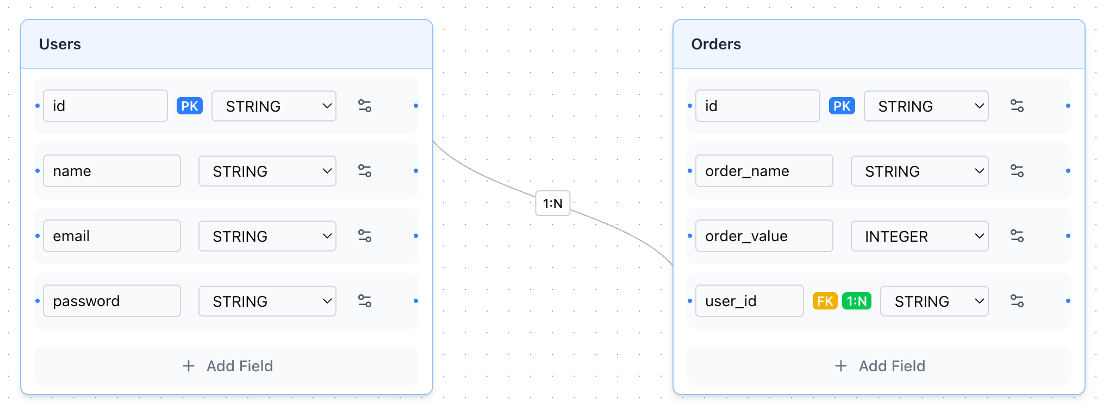

School of Computer Engineering, KIIT, BBSR 1

Schema Builder: Full-Stack

Chapter 2

Literature Review

This project utilizes React and Next.js for building a full-stack visual database schema designer and integrates Prisma ORM along with a multi-format code generation module for precise schema creation and export. The system combines a drag-and-drop visual editor with real-time validation and project management features to ensure accurate database design, relationship mapping, and code generation across SQL, Prisma, and MongoDB/Mongoose formats.

2.1 Background of Database Schema Design Tools

Database schema design has evolved significantly over the past few decades. In early relational systems, schema design was largely manual—developers used entity-relationship (ER) diagrams on paper or software like Microsoft Visio to conceptualize data models. These designs were later translated into Structured Query Language (SQL) scripts, introducing a high risk of human error. The emergence of Computer-Aided Software Engineering (CASE) tools in the 1990s, such as ERwin and IBM Rational Data Architect, allowed designers to visually represent entities and relationships. However, these tools were typically heavy, proprietary, and lacked real-time collaboration features.
The advent of open-source and web-based development environments has led to a new wave of lightweight, accessible schema design tools. Platforms like dbdiagram.io, DrawSQL, and Lucidchart provide online interfaces to design ER diagrams, but they often stop at visualization, requiring separate steps for implementation. Schema Builder builds upon this evolution by integrating visual schema modeling directly with code generation and database interaction, providing a complete workflow from design to deployment.

School of Computer Engineering, KIIT, BBSR 2

Schema Builder: Full-Stack

2.2 Visual Programming and Low-Code Paradigms

The concept of visual programming has gained traction across software engineering, aiming to make complex processes more intuitive. Tools like React Flow and Node-RED have demonstrated the potential of node-based graphical interfaces for representing logical and data flow. This paradigm has inspired applications in database schema management, where tables and relationships can be represented as interconnected nodes.

Low-code and no-code movements emphasize empowering users to create software solutions through minimal hand-coding. Schema Builder embraces this philosophy for database design—allowing users to drag, drop, and connect components rather than writing long SQL scripts. By doing so, it not only enhances accessibility for beginners but also accelerates productivity for experienced developers. Unlike purely low-code platforms, Schema Builder maintains flexibility by enabling exportable, editable code that integrates into existing development pipelines.

2.3 Code Generation in Database Systems

Automatic code generation bridges the gap between design and implementation. In traditional workflows, once a database schema is finalized, developers must manually write SQL, ORM models, and validation logic. This redundancy can lead to inconsistencies and version mismatches. Code generation frameworks such as Yeoman, Prisma Migrate, and Sequelize CLI partially address these issues by providing templates for schema creation. However, they rely on textual configuration rather than visual input.

Schema Builder extends this concept by integrating AI-assisted code generation and multi-format export, allowing users to instantly obtain database scripts for SQL, Prisma, and Mongoose. This capability supports hybrid application development, where relational and non-relational databases coexist. The generated code can serve as a starting point for backend developers, significantly reducing setup time and ensuring structural consistency across technologies.

School of Computer Engineering, KIIT, BBSR 3

Schema Builder: Full-Stack

2.4 Authentication, Authorization, and Role Management

Modern web applications emphasize data security and personalized experiences. Schema Builder incorporates NextAuth with multiple providers (Google, GitHub, and credentials) to handle authentication securely. Role-based access control (RBAC) ensures that schema modifications and project management are appropriately restricted to authorized users. This aligns with industry standards in cloud-based development environments, ensuring compliance and data integrity.
Studies have shown that integrating authentication early in the design phase leads to fewer vulnerabilities and smoother user experiences. By embedding these features directly within the tool, Schema Builder creates a balance between security and usability, encouraging best practices even in early-stage design processes.

2.5 Related Works and Research Gaps

While several tools exist for database visualization and management, few combine interactive design, persistent storage, and automated code generation within a unified web interface. For instance, dbdiagram.io focuses on visualization, Prisma Studio emphasizes schema editing, and MongoDB Atlas provides cloud schema management. Schema Builder’s uniqueness lies in combining these aspects within a full-stack, user-authenticated environment.

Research in database engineering emphasizes the need for tools that support rapid prototyping, schema versioning, and multi-database interoperability. Existing systems rarely address all three. Schema Builder contributes to this research gap by demonstrating how a single visual interface can adapt to multiple database paradigms while maintaining a consistent user experience and underlying code structure

School of Computer Engineering, KIIT, BBSR 4

Schema Builder: Full-Stack

Chapter 3

Problem Statement / Requirement Specifications

Designing and managing database schemas is a fundamental yet challenging task in modern software development. Traditional methods involve manual creation of ER diagrams or textual definitions, which are often error-prone, time-consuming, and difficult to modify, especially for large-scale projects. Developers face challenges in maintaining consistency, enforcing relationships, and generating backend code across multiple platforms (SQL, Prisma, MongoDB). The focus of this proposed research/project is to develop an interactive visual schema design tool that allows users to:
- Easily create and edit database tables and fields.
- Establish and visualize relationships between tables.
- Generate backend code automatically in SQL, Prisma, and MongoDB
- Minimize manual errors and enhance development efficiency through an intuitive UI and automated suggestions.
The system will combine React-based frontend visualization, Next.js API-driven backend, and AI-assisted code generation for optimal database design. The ultimate goal is to improve accuracy, speed, and usability in schema development while reducing human intervention.

3.1 Project Planning

The project execution follows a structured approach to ensure clarity and systematic development:
(a) Requirement Analysis & Dataset Preparation:
Identify functional requirements: table creation, field management, relationship editing, code generation, role-based access. Identify non-functional requirements: responsive UI, dark/light mode, real-time validation, and scalable architecture. Prepare initial data for testing: sample schemas, database examples, and predefined relationships for prototyping.

(b) Frontend Development:
Use React Flow (@xyflow/react) to implement a drag-and-drop canvas for tables and fields.Design responsive UI using TailwindCSS, with dark/light mode and accessibility features.

School of Computer Engineering, KIIT, BBSR 5
Schema Builder: Full-Stack

(c) Backend Development:
Set up Next.js API routes for CRUD operations on schema projects.
Integrate NextAuth for authentication with support for Google, GitHub, and credentials login. Use Prisma ORM with PostgreSQL for database persistence and type-safe operations.

(d) Code & Query Generation Module:
Implement scripts to convert schema data into SQL, Prisma, and MongoDB models. Incorporate AI-assisted optimization using OpenRouter + DeepSeek to validate generated code and query as per the users input.

3.2 Project Analysis

The project focuses on automating database schema creation, code generation, and visualization. The key challenges and considerations include:

(a) Schema Scale & Relationship Complexity:
The visual database designer must accommodate highly intricate schemas, including numerous entities, attributes, and all major relationship types (1:1, 1:N, N:N).​ Real-world schemas often enforce complex constraints such as cascades, foreign keys, uniqueness, defaults, and custom validations, requiring robust backend logic and resilient canvas rendering. At scale, large schemas—with dozens of tables, hundreds of fields, and complex interdependencies—can cause performance bottlenecks not only in the React Flow-powered canvas but also in backend query processing and schema export routines.​ Ensuring fluidity in UI interactions and rapid code generation for heavy schemas presents ongoing optimization challenges.
.
(b) AI-Powered Automation Accuracy:
AI models are leveraged for code generation (transforming schemas into SQL, Prisma, or Mongoose code) and for synthesizing mock data and queries.​ Effective conversion depends on the schema JSON's precision and the AI’s reliability—there is risk that rare field combinations, advanced constraints, or uncommon relationships may be incorrectly translated or missed altogether.For natural language querying, ensuring the OpenRouter DeepSeek model reliably converts user queries and schema context into safe, executable queries—without ambiguity or injection risk—requires continuous tuning and validation

School of Computer Engineering, KIIT, BBSR 6

Schema Builder: Full-Stack

3.3 System Design

(a) Design Constraints
- Software Requirements:
Frontend: React.js, Next.js, Tailwind CSS
Backend: Node.js, Express.js
Database: PostgreSQL -NenoDB (via Prisma ORM)
Code Generation & Validation: Prisma, Zod (for schema validation),
Custom export modules
Visualization & UI: D3.js / React Flow for drag-and-drop schema editor
- Development Environment:
VS Code or any IDE for coding, with Google Chrome for browser-based testing, Node.js for backend support, and Docker for containerized deployment.
- Hardware Requirements:
Any modern PC or laptop capable of running Google Chrome

(b) API Architecture
Primary Endpoints:
- /api/auth/* → Authentication via NextAuth.js
- /api/projects → CRUD operations for project management
- /api/schema → Save/load schema JSON data
- /api/generate → Export schema into SQL/Prisma/Mongoose formats
- /api/ai/query → Handle AI-driven query translation using OpenRouter’s DeepSeek model
Data Flow:
The frontend interacts with these routes using Axios or the Fetch API. Each request passes through validation middleware (Zod) and Prisma ORM for DB access.

(c) Block Diagram
The system begins with User Authentication, where users log in via NextAuth.js using providers like Google, GitHub, or email. Upon successful login, users can Create or Manage Projects, which are stored in the PostgreSQL database via Prisma ORM. The core functionality involves the Visual Schema Editor, built with React Flow, allowing users to design tables, define fields, set constraints, and establish relationships. The schema data is validated in real-time using Zod and stored in the database. Users can then Export Schema in various formats, including SQL DDL, Prisma schema, or MongoDB/Mongoose models, facilitated by custom export modules. The entire application is containerized using Docker for consistent development and deployment environments.

School of Computer Engineering, KIIT, BBSR 7

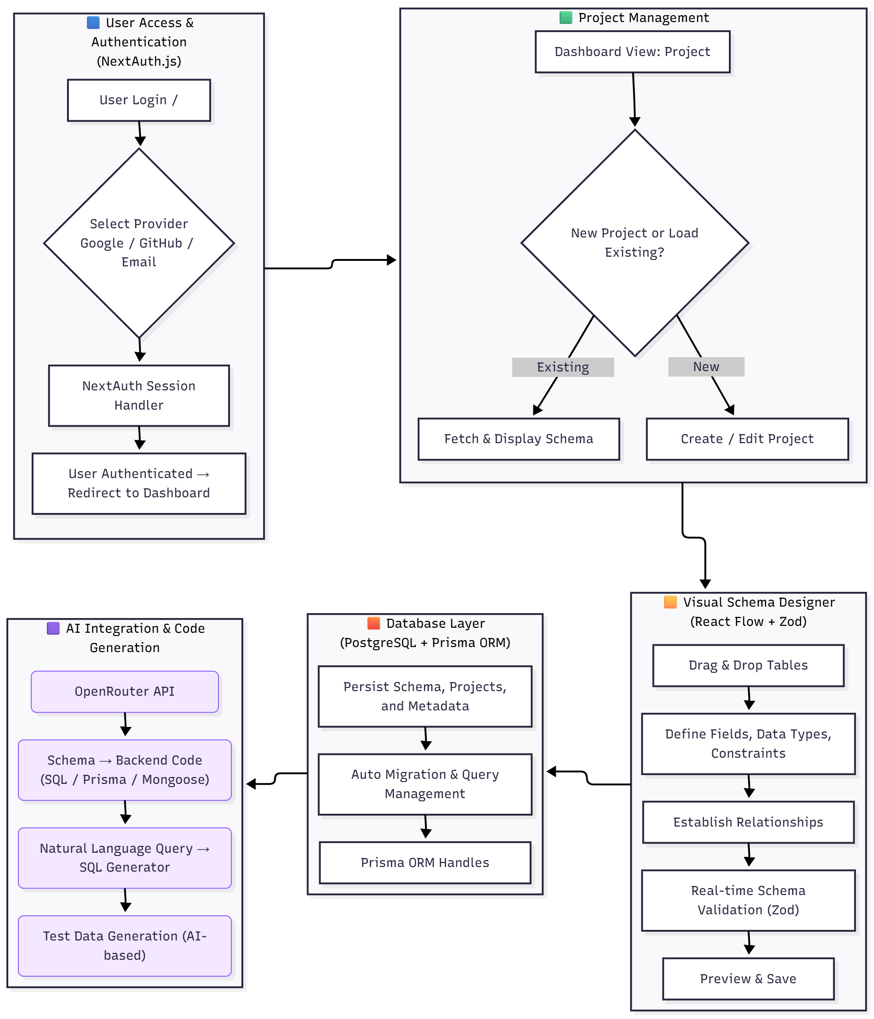

Figure 3.31: System Flow Diagram

School of Computer Engineering, KIIT, BBSR 8
Schema Builder: Full-Stack

Chapter 4

Implementation

The implementation of the Schema Builder project followed a structured methodology emphasizing modularity, scalability, and data integrity. The system integrates frontend visualization, backend API management, and AI-assisted code generation to provide a complete schema design and deployment solution.
The project development followed the Agile methodology, ensuring iterative development, testing, and integration. Each sprint focused on distinct modules — authentication, schema design, data persistence, code generation, and AI query translation.

4.1 Methodology

- Requirement Analysis & Environment Setup
Identified functional requirements: schema creation, visualization, authentication, and AI-based assistance. Configured development environment using Node.js, PostgreSQL, Prisma ORM, and Next.js. Set up Docker for containerized local testing.

- Frontend Development
Implemented the React Flow-based schema editor, enabling users to drag and drop tables, define attributes, and connect relationships. Created reusable UI components using Next.js, Tailwind CSS, and shadcn/radix UI. Implemented client-side validation using Zod to ensure real-time schema correctness.

- Backend API & Database Layer
Developed backend endpoints using Next.js API routes. Integrated Prisma ORM for database interactions with PostgreSQL. Created APIs for CRUD operations on projects, schema saving/loading, and schema export functionality.

- AI Integration (OpenRouter – DeepSeek Model)
Integrated OpenRouter’s DeepSeek model for two major functionalities: Schema-to-Code Conversion: Converts designed schema JSON into SQL, Prisma, or Mongoose code automatically. Natural Language Query Handling: Translates user queries into safe, parameterized SQL queries. Added safety validation layer to prevent SQL injection or unsafe execution.

School of Computer Engineering, KIIT, BBSR 9

Schema Builder: Full-Stack

- Authentication Module
Integrated NextAuth.js to handle multi-provider authentication (Google, GitHub, email). Managed user sessions securely using JWT tokens.

- Deployment & CI/CD
Containerized the project using Docker for cross-environment consistency.
Deployed frontend and backend via Vercel and configured CI/CD workflows for automated deployment and build validation.

4.2 Testing OR Verification Plan
For verification of the system, specific test cases were designed to evaluate the correctness of the schema creation, code generation, and AI-powered query conversion process.
The verification plan includes three main types of testing:

- Schema Construction Testing
The system allows users to visually create database tables and define relationships. To verify this, a schema consisting of User and Orders tables was constructed using the drag-and-drop editor.
- The User table was created with fields: id, username, and email.
- The Orders table was created with fields: id, amount, userId, and date.
- A 1-to-Many relationship (User → Orders) was established.

The system automatically validated:
- field data types
- primary/foreign key constraints
- relationship correctness
This ensures that the visual schema editor behaves consistently and produces a valid relational model.

- Code Generation Testing
Once the schema was created, the system’s export module was tested to verify the accuracy of the generated SQL code. The exported schema was checked to confirm that the table structures, data types, relationships, and constraints produced by the system matched the visual schema definition. This ensured that the code generation engine correctly translated visual designs into executable database code.

- AI-Based Query Verification
The system was further verified using its AI-powered natural language query module. A test query “Get the username of users who made orders of more than 3000.” was executed to validate whether the AI could correctly interpret the schema and generate a safe SQL query. The resulting SQL output was

School of Computer Engineering, KIIT, BBSR 10

Schema Builder: Full-Stack

compared against the expected join between User and Orders tables, ensuring that the AI correctly identified relationships, applied conditions, and produced injection-safe output.

Base prompt:
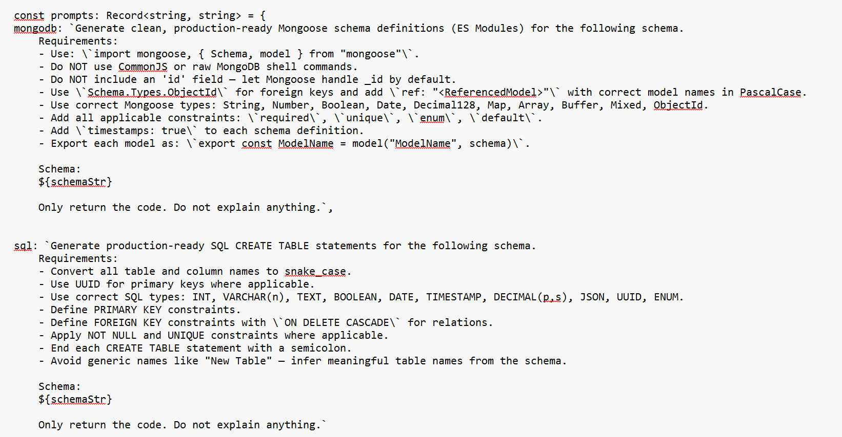

Code generation:
SQL Code:

CREATE TABLE users (
id UUID PRIMARY KEY,
username VARCHAR(255) NOT NULL,
email VARCHAR(255) NOT NULL UNIQUE,
created_at TIMESTAMP NOT NULL,
updated_at TIMESTAMP NOT NULL
);

CREATE TABLE orders (
id UUID PRIMARY KEY,
amount DECIMAL(10, 2) NOT NULL,
user_id UUID NOT NULL,
product_name VARCHAR(255) NOT NULL,
date TIMESTAMP NOT NULL,
status VARCHAR(50) NOT NULL CHECK (status IN ('pending', 'completed', 'cancelled')),
FOREIGN KEY (user_id) REFERENCES users(id) ON DELETE CASCADE
);

School of Computer Engineering, KIIT, BBSR 11
Schema Builder: Full-Stack

4.3 Result Analysis
The implementation of the Schema Builder project was completed successfully, and the system was evaluated through functional testing, code verification, and AI-assisted query validation. The results obtained from these evaluations demonstrate that the system performs reliably across all its major functionalities. The overall behavior of the application confirms that the design goals—visual schema modeling, accurate code generation, and intelligent query processing—were achieved effectively.
Key Results Observed
- Interactive Schema Design:
The drag-and-drop schema builder interface enabled users to create tables, define fields, and establish relationships in an intuitive and interactive manner. All structural changes appeared instantly on the visual canvas.

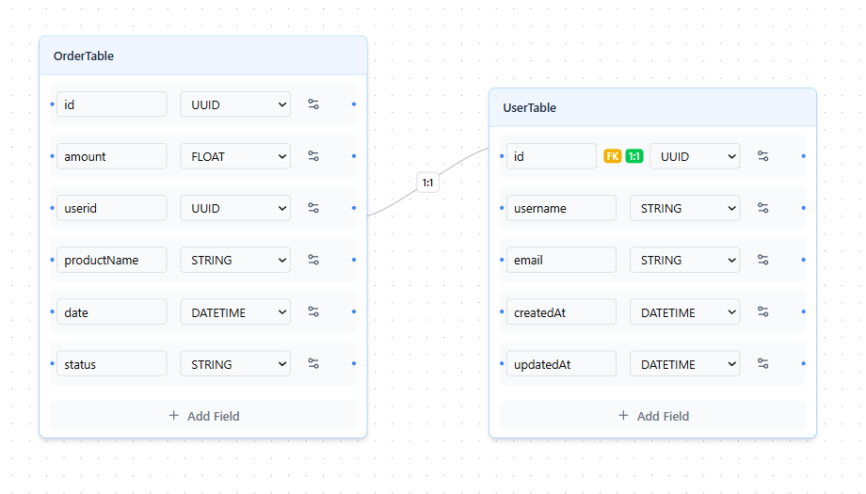

- Real-Time Schema Validation:
The system performed continuous validation using Zod, ensuring that only correct and logically consistent schema designs were accepted and stored. Errors such as invalid data types or incorrect relationships were detected immediately.

- Accurate AI-Powered Code and Query Generation:
The integrated AI model successfully converted natural language queries into secure, schema-aware SQL statements. Additionally, the system generated precise SQL, Prisma, and MongoDB code exports based on the user-defined schema.

School of Computer Engineering, KIIT, BBSR 12

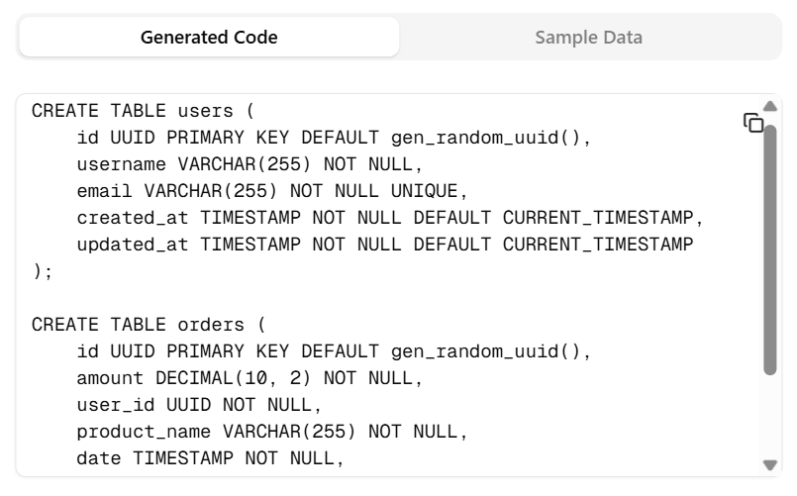

- Sample Data Generation
The sample data also enabled verification of SQL exports and join operations, such as retrieving usernames of users who placed orders above a specific amount. Overall, the generated dataset demonstrated that the system successfully supports realistic relational workloads and maintains consistency across all modules.

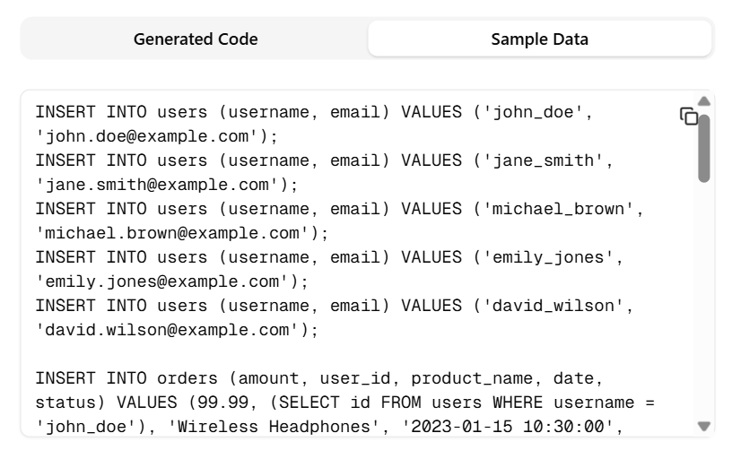

- Robust API Behavior:
All backend API endpoints returned stable, structured JSON responses. Error handling mechanisms worked correctly, allowing the system to gracefully manage invalid requests or unexpected inputs.

School of Computer Engineering, KIIT, BBSR 12
Schema Builder: Full-Stack

4.4 Quality Assurance
To ensure the project’s quality and maintainability, several measures were implemented:

- Code Quality Standards
Followed ESLint and Prettier configurations for consistent coding style.
Enforced TypeScript strict mode to prevent untyped variables.
- Performance & Reliability
Used Prisma’s optimized queries and caching for database efficiency.
Ensured asynchronous API handling to prevent blocking requests.
- Security & Validation
Applied server-side Zod validation for all API inputs. Sanitized AI-generated SQL queries before execution. Stored secrets securely using .env files (not committed to repo).
- Continuous Integration Checks
Automated lint, test, and build checks on every GitHub push. Docker builds tested on multiple systems for consistency. Quality Certification
The project adheres to standard Web Application Security Guidelines.
Ensured compliance with code review and peer-testing policies followed during development.

School of Computer Engineering, KIIT, BBSR 13
Schema Builder: Full-Stack

Chapter 5

Standards Adopted

5.1 Design Standards
The project conforms to recognized software engineering and system design standards to ensure consistency, quality, and maintainability:

- IEEE 830-1998: Standard for Software Requirements Specification, providing a structured approach to requirements documentation.
- IEEE 1471-2000: Standard for Software Architecture, guiding robust system design.
- ISO/IEC 9126: Software Quality Model, addressing maintainability, reliability, and usability aspects.
- UML (Unified Modeling Language): Utilized for clear visualization through block, activity, and sequence diagrams.
- ISO 25010: Defines quality attributes focusing on usability, security, and functionality.
- Database design employs normalization principles and Entity-Relationship modeling to ensure data integrity and consistency.

5.2 Coding Standards
To ensure readability, reusability, and efficiency, the project complies with established coding standards:
- TypeScript best practices: Strong typing and interface usage across the project. Consistent Formatting: Tailwind-based CSS conventions alongside Prettier and ESLint enforcement.
- Error Handling: Comprehensive use of try-catch blocks and error boundaries to prevent runtime failures.
- Logging: Advanced logging framework replacing console logs for effective debugging and monitoring.
- Next.js and React conventions strictly followed to maintain maintainable and scalable frontend architecture.

School of Computer Engineering, KIIT, BBSR 14

Schema Builder: Full-Stack

5.3 Testing Standards
For the purpose of system validation and verification, IEEE and ISO standards concerning software testing have been utilized:

- Jest and React Testing Library: For unit and integration testing of React components and frontend logic.
- Next.js API Route Testing: Using tools like Supertest to validate backend API endpoints.
- Prisma Client Testing: Ensures database interactions via Prisma ORM are accurate and consistent.
- End-to-End Testing: Cypress or Playwright for validating full user workflows through the UI.
- Code Coverage and Static Analysis: Tools integrated in CI pipelines to maintain code quality and catch regressions.
- Error and Exception Handling Tests: To verify graceful failure modes in both frontend and backend.
- Performance Testing: Monitoring and optimizing rendering and API response times for scalable schema management.
- Mock Data Generation: AI-generated test data used to seed databases and validate functional scenarios.

School of Computer Engineering, KIIT, BBSR 15

Schema Builder: Full-Stack

Chapter 6

Conclusion and Future Scope

6.1 Conclusion
The schema-builder project successfully demonstrates a full-stack, AI-powered solution for database schema design, code generation, and data querying. It provides an intuitive, interactive canvas that allows users to visually construct complex database schemas involving multiple tables, advanced constraints, and diverse relationship types. The seamless integration with AI enables automatic conversion of these visual schemas into production-ready code formats—including SQL, Prisma, and MongoDB/Mongoose—significantly accelerating backend development workflows.

Furthermore, the platform supports AI-driven generation of realistic mock data, facilitating comprehensive testing without manual data entry. Its natural language query interface, powered by OpenRouter’s DeepSeek model, empowers users to express complex database queries in plain English, which are then safely translated into executable, secure queries. This combination enhances accessibility for non-technical users while maintaining strong safeguards against injection and syntax errors.

Designed with scalability and extensibility in mind, the system efficiently handles large-scale schemas with hundreds of tables and fields, maintaining performance and responsiveness even under heavy use. The modular codebase, rigorous TypeScript standards, and clear separation of front-end, back-end, and AI components ensure maintainability and ease of future enhancements.

Overall, the project showcases a forward-thinking approach to simplifying database design and management by harnessing AI's strengths, making it a valuable tool for developers, analysts, and teams aiming to accelerate and secure their data workflows while reducing complexity.

School of Computer Engineering, KIIT, BBSR 16
Schema Builder: Full-Stack

6.2 Future Scope

- Enable real-time, multi-user collaboration on schema projects, including live cursor indicators and granular, role-based permissions.
- Introduce advanced schema validation with intelligent design suggestions and automated correction recommendations.
- Implement comprehensive version history and schema change tracking to facilitate auditing and seamless rollback capabilities.
- Develop a library of reusable schema templates covering common industry use cases.
- Extend support for additional data storage paradigms, such as NoSQL and graph databases.
- Deepen AI integration for context-aware schema recommendations and natural language-driven query generation.
- Enhance mock data generation to support a broader range of field types, relationships, and realistic data patterns.
- Expand code generation capabilities to cover additional backend frameworks and programming languages.
- Integrate with major cloud service providers for direct schema deployment and database provisioning from the platform.

School of Computer Engineering, KIIT, BBSR 17

Schema Builder: Full-Stack

References

[1] Vercel. Next.js Documentation: The React Framework for Production, 2025. Available: https://nextjs.org/docs
[2] Meta / React Team. React: A JavaScript Library for Building User Interfaces, 2025. Available: https://react.dev
[3] Prisma Data Inc. Prisma ORM Documentation: Modern Database Toolkit for TypeScript and Node.js, 2025. Available: https://www.prisma.io/docs
[4] PostgreSQL Global Development Group. PostgreSQL: The World's Most Advanced Open Source Database, 2025. Available: https://www.postgresql.org/docs
[5] React Flow Dev Team. React Flow: A Library for Building Node-Based Editors and Interactive Graphs, 2025. Available: https://reactflow.dev
[6] Tailwind Labs. Tailwind CSS Documentation: Utility-First CSS Framework, 2025. Available: https://tailwindcss.com/docs
[7] iFixit Inc. NextAuth.js Documentation: Authentication for Next.js Applications, 2025. Available: https://next-auth.js.org
[8] OpenRouter. OpenRouter API Documentation: Unified API Access to AI Models, 2025. Available: https://openrouter.ai/docs
[9] Docker Inc. Docker Documentation: Build, Ship, and Run Distributed Applications, 2025. Available: https://docs.docker.com
[10] Colinhacks. Zod: TypeScript-First Schema Validation with Static Type Inference, 2025. Available: https://zod.dev

School of Computer Engineering, KIIT, BBSR 18

Schema Builder: Full-Stack

INDIVIDUAL CONTRIBUTION REPORT:

SCHEMA BUILDER: FULL-STACK VISUAL
DATABASE SCHEMA DESIGNER

SHUBHAM KR THAKUR
22052411

Abstract: The backend of the Schema Builder provides secure APIs, user authentication, project management, and AI-powered query/code generation. Built using Next.js API routes and Prisma ORM, it ensures reliable communication between the frontend and database.

Individual contribution and findings: I handled the backend and API development, implementing CRUD operations, project handling routes, and secure schema storage. I integrated NextAuth for authentication using Google, GitHub, and email credentials. I also implemented RBAC and validated all inputs before saving. A major part of my work included integrating the AI module (OpenRouter + DeepSeek) to convert user queries and schema definitions into safe SQL. I ensured the backend remained modular, secure, and optimized.

Individual contribution to project report preparation: I wrote the sections on backend system design, API documentation, authentication flow, and AI integration. I described how the server processes requests and maintains security.

Individual contribution for project presentation and demonstration: I demonstrated how backend APIs save/load schemas, showed the authentication system, and explained how AI converts natural-language queries into SQL. I highlighted the system’s security and backend workflow.

Full Signature of Supervisor: Full signature of the student:
……………………………. ……………………………..

School of Computer Engineering, KIIT, BBSR 19

Schema Builder: Full-Stack

INDIVIDUAL CONTRIBUTION REPORT:

SCHEMA BUILDER: FULL-STACK VISUAL
DATABASE SCHEMA DESIGNER

SHREYA KUMARI
22052594

Abstract: The project uses PostgreSQL as the primary database, with Prisma ORM handling schema modeling and migrations. A normalized relational structure ensures efficient storage and retrieval of user projects and schema definitions.

Individual contribution and findings: I was responsible for the database design and ORM integration. I created the PostgreSQL schema and developed Prisma models for entities such as User, Project, Table, and Field. I ensured normalization up to 3NF and maintained referential integrity through primary and foreign keys. I also handled database migrations and optimized queries to improve backend performance and reliability.

Individual contribution to project report preparation: I prepared the database design, ER diagrams, Prisma schema, and migration documentation. I explained table relationships and how the backend interacts with the database layer.

Individual contribution for project presentation and demonstration: I presented the database structure, demonstrated Prisma Studio, and explained how project data, tables, and relationships are stored. I also answered queries related to data normalization and schema design.

Full Signature of Supervisor: Full signature of the student:
……………………………. ……………………………..

School of Computer Engineering, KIIT, BBSR 20

Schema Builder: Full-Stack

INDIVIDUAL CONTRIBUTION REPORT:

SCHEMA BUILDER: FULL-STACK VISUAL
DATABASE SCHEMA DESIGNER

ABHAY GUPTA
22052608

Abstract: The system features a code generation module that converts the visually designed schema into SQL, Prisma ORM models, and MongoDB (Mongoose) models. Comprehensive testing and CI/CD workflows ensure system stability and deployment readiness.

Individual contribution and findings: I developed the code generation engine, converting JSON-based schema structures into SQL, Prisma, and MongoDB code. I integrated live updates with the frontend preview panel. I conducted unit testing, integration testing, and user testing across frontend and backend modules. Additionally, I assisted in setting up the deployment pipeline using Vercel and Neon, ensuring smooth CI/CD operations.

Individual contribution to project report preparation: I contributed to testing methodology, code generation logic, and deployment documentation. I wrote test case descriptions, validation steps, and helped in final proofreading of the technical sections.

Individual contribution for project presentation and demonstration: I showcased how code is generated automatically as the schema changes, demonstrated test results, and explained the deployment process. I highlighted how automated testing improved system reliability.

Full Signature of Supervisor: Full signature of the student:
……………………………. ……………………………..

School of Computer Engineering, KIIT, BBSR 21

Schema Builder: Full-Stack

INDIVIDUAL CONTRIBUTION REPORT:

SCHEMA BUILDER: FULL-STACK VISUAL
DATABASE SCHEMA DESIGNER

ABHINANDAN SENGAR
22053048

Abstract: This project delivers a web-based Schema Builder that enables users to visually design database structures using an interactive canvas. React Flow powers the drag-and-drop interface, while real-time code previews help users generate SQL, Prisma, and MongoDB models efficiently.

Individual contribution and findings: I focused on the frontend development, implementing the complete UI/UX and the interactive schema canvas. I created table nodes, field forms, and connecting relationship edges using React Flow. I also developed responsive layouts, dark mode support, and Tailwind-based styling. I integrated the real-time code preview section, ensuring that any change in the schema immediately reflected in the generated code. My work ensured smooth user interaction and a clean, intuitive interface.

Individual contribution to project report preparation: I prepared the sections related to UI design, frontend architecture, and schema canvas implementation. I documented the working of the canvas, event handling, and UI components, along with adding screenshots and explanations.

Individual contribution for project presentation and demonstration: During the presentation, I demonstrated how users create tables, link relationships, and view generated code instantly. I explained the interface flow and highlighted the importance of an interactive schema design tool.

Full Signature of Supervisor: Full signature of the student:
……………………………. ……………………………..

School of Computer Engineering, KIIT, BBSR 22

