**Grafana Dashboard for JMeter Performance Monitoring**

**1, Creating Bucket in Influxdb:**

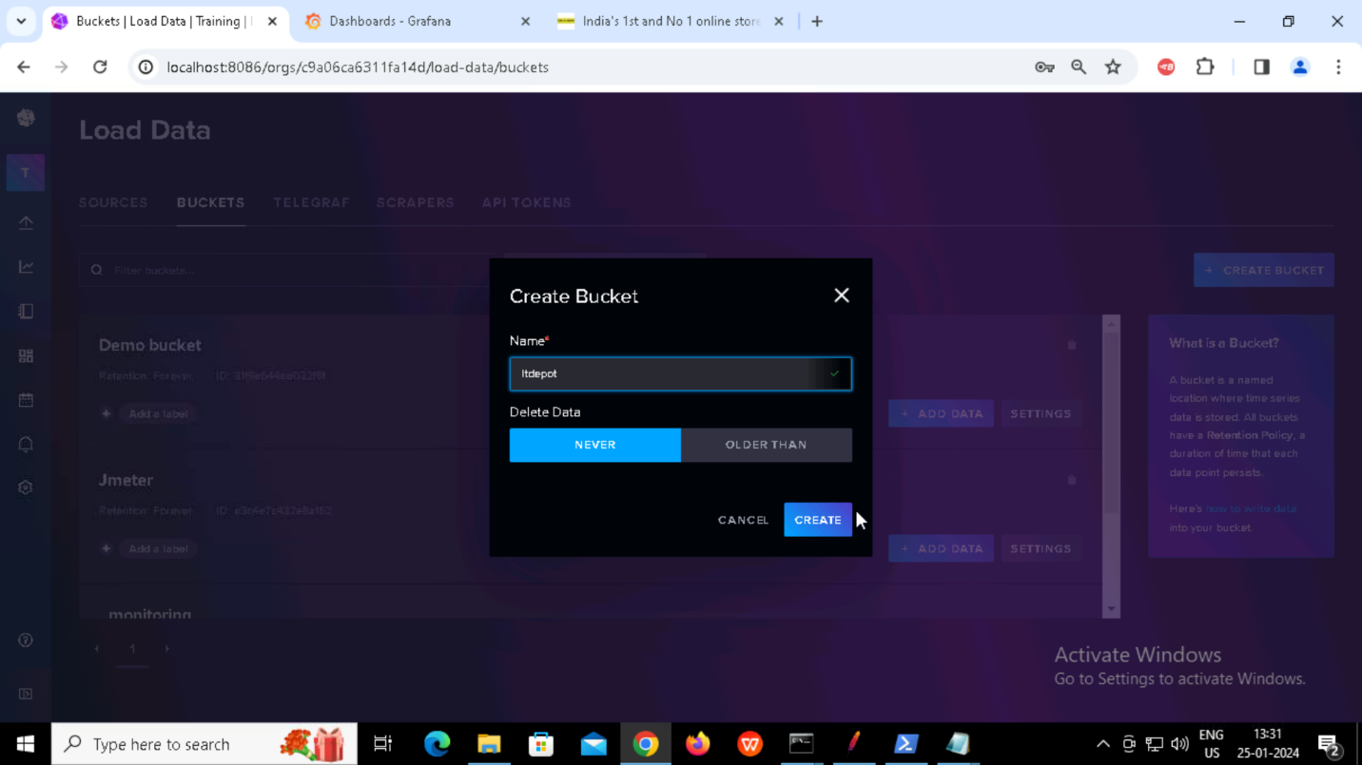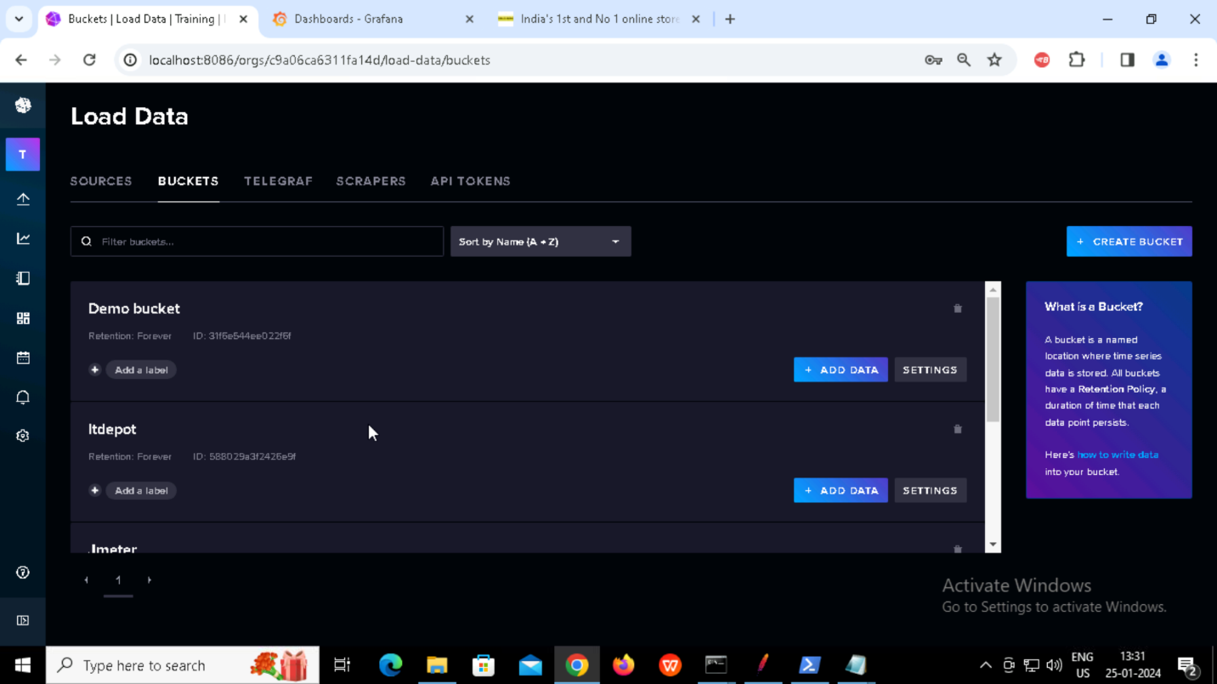

**2, Creating backend Listener for ITdepot HTTP Request:**

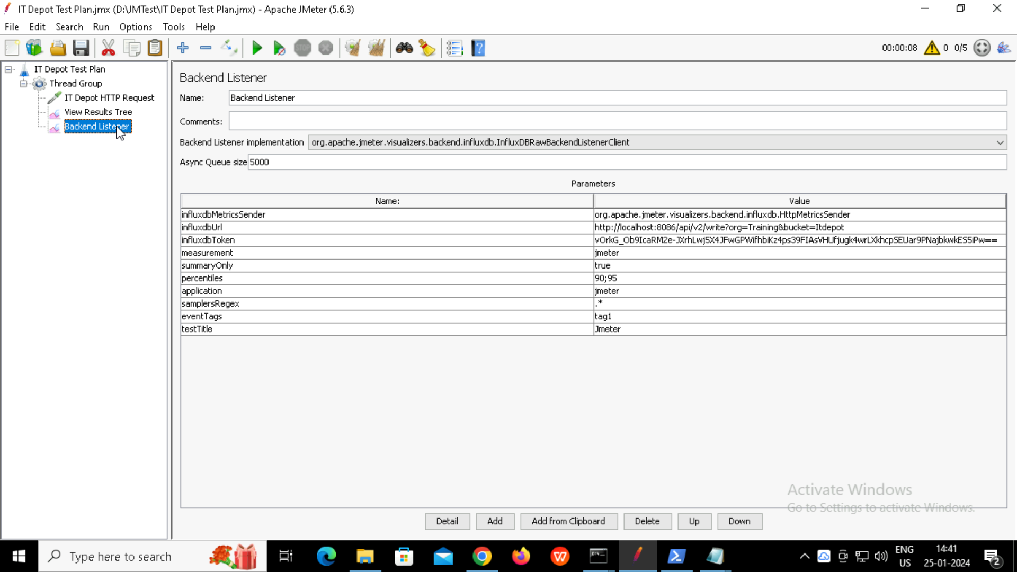

**3, Creating Data Explorer:**

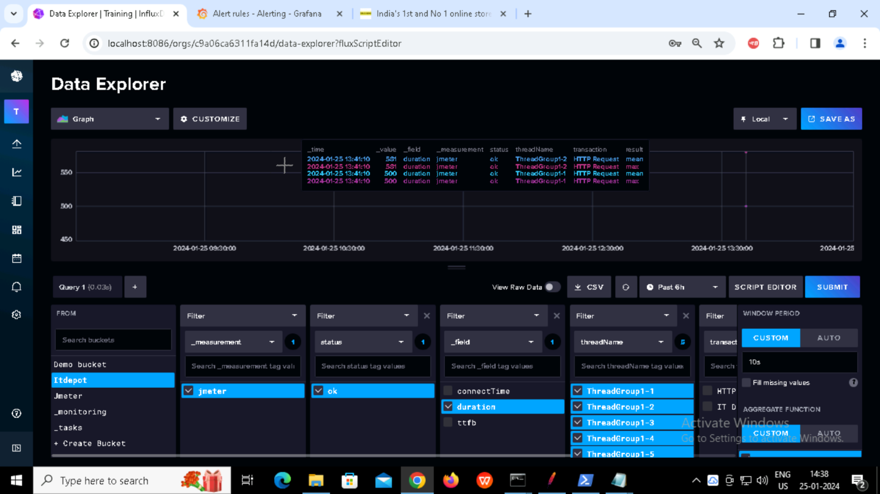

**4, Creating Data source in Grafana**

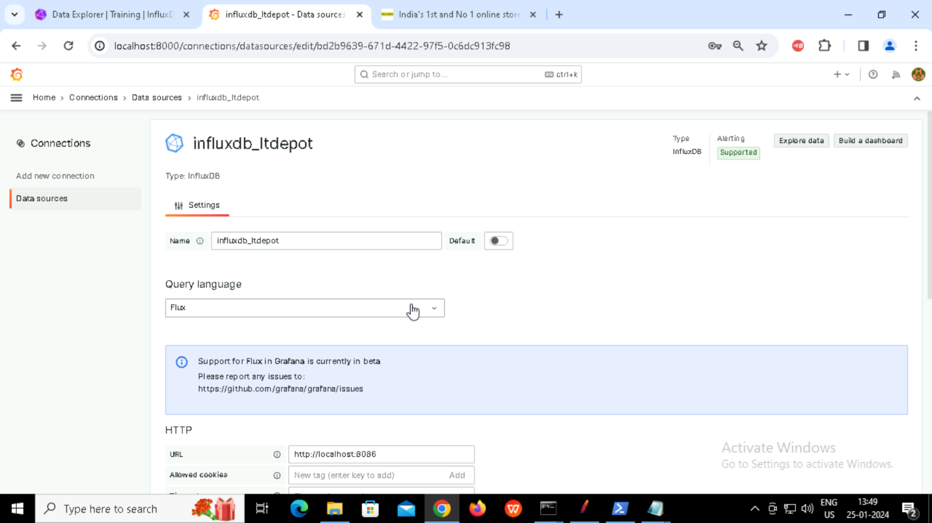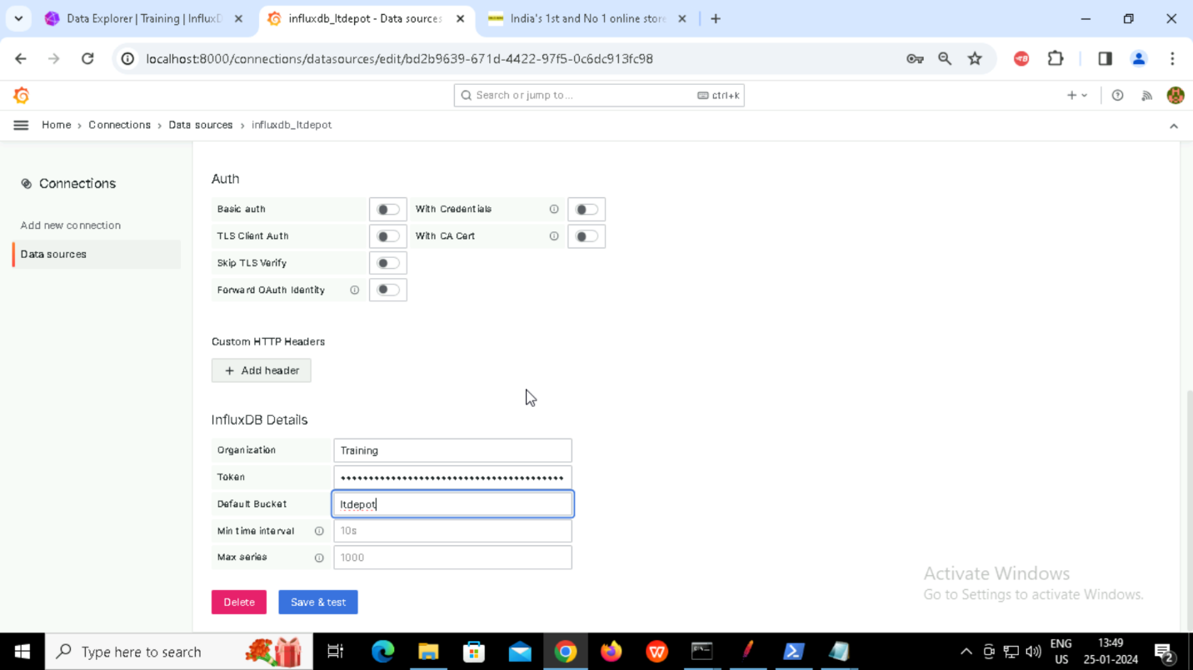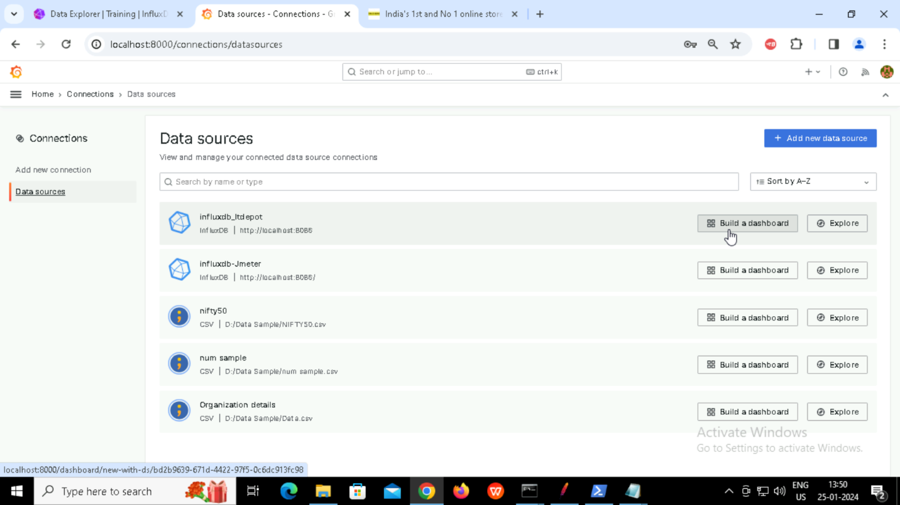

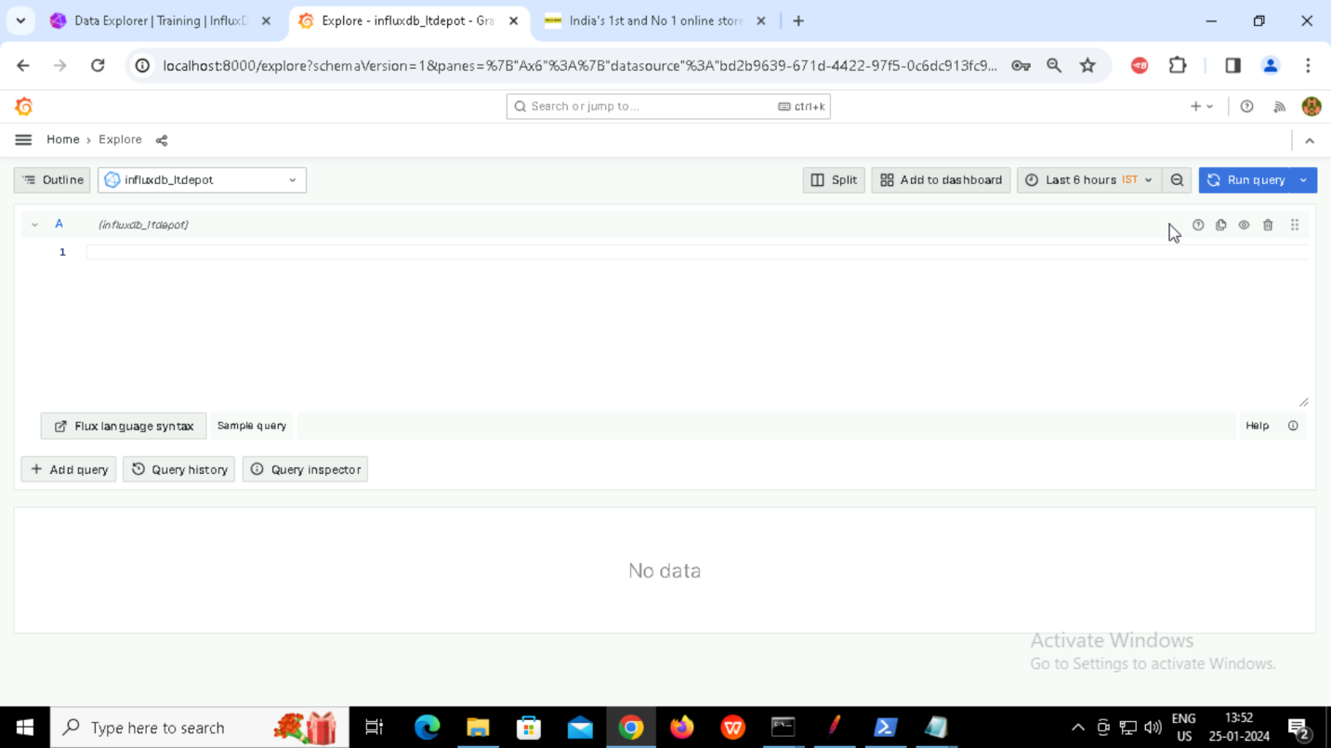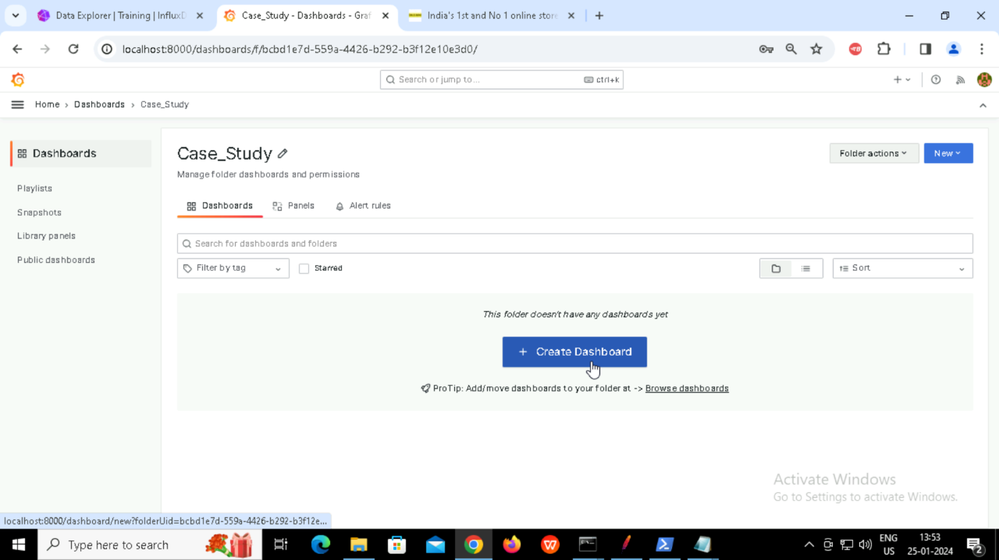

**Creating different Panels:**

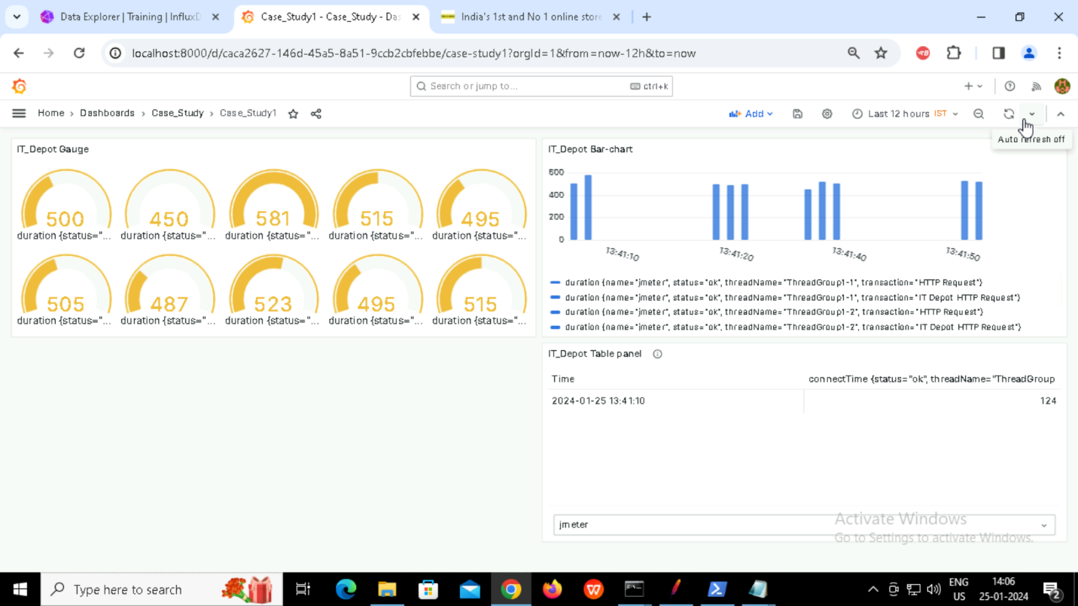

**Panel 1: Table**

Visualization Type: Table

Explanation: Showcase raw data with various columns like organization ID, name, location, and

**Panel 2: Bar Chart**

Visualization Type: Bar Chart

Explanation: Compare the number of employees in different organizations using a bar chart. Each bar represents an organization, and the height indicates the number of employees.

**Panel 3: Gauge**

Visualization Type: Gauge

Explanation: Use a gauge to represent a single metric, such as the average number of employees across all organizations. The gauge can show whether the metric is below, within, or above a target range.

**Creating Panels using Csv Data**

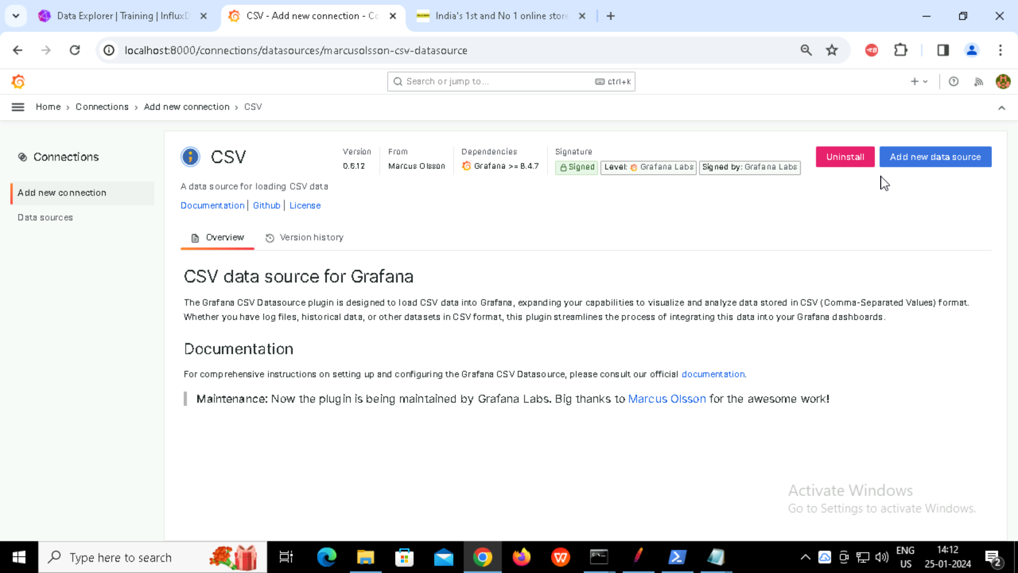

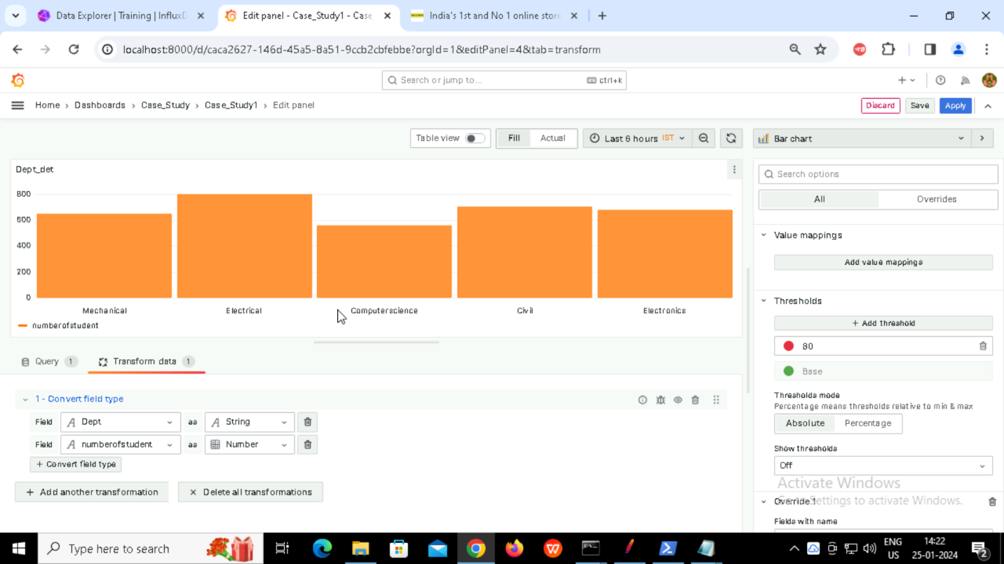

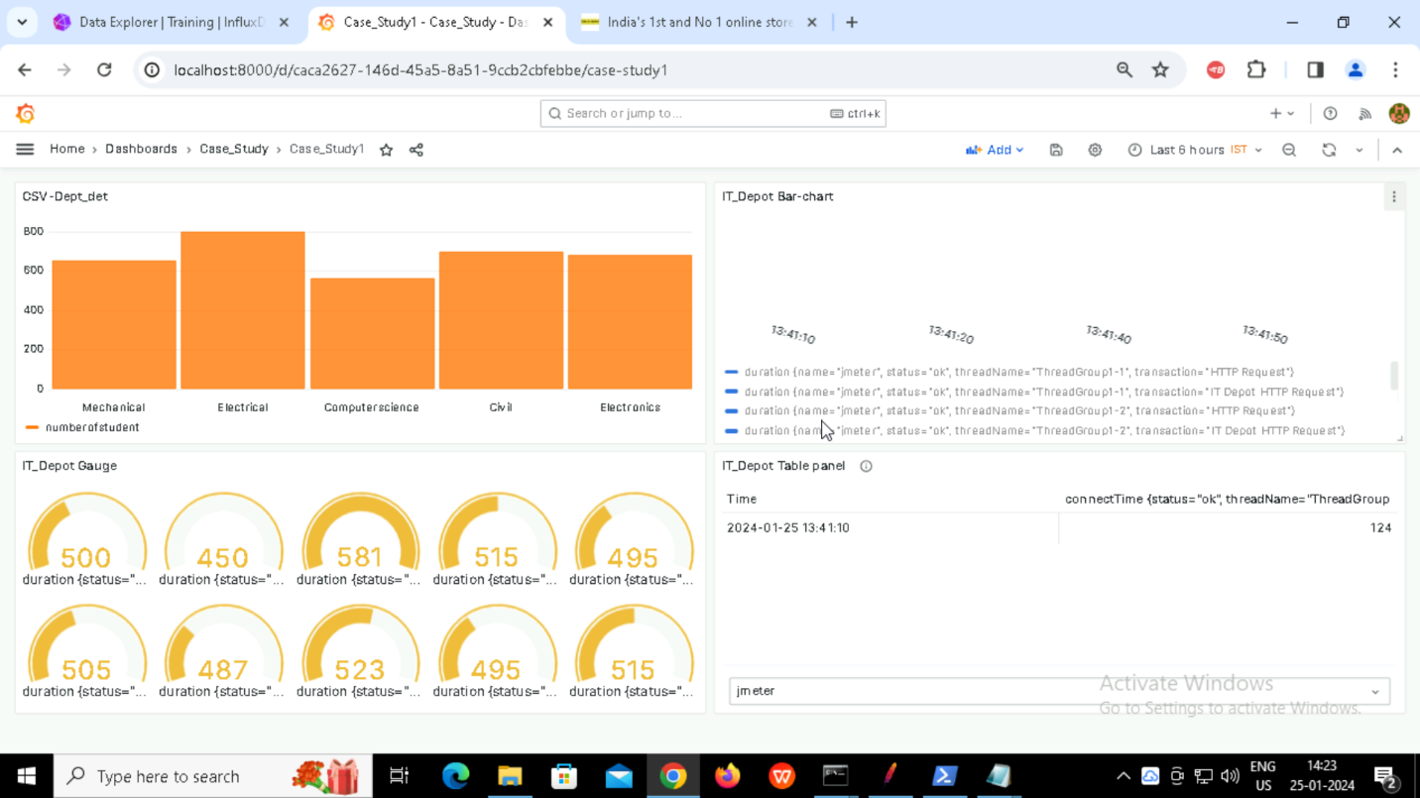

**Creating Alerts:**

