*Branch Accounts Classification and Setting Target Using Decision Tree*

Abhinand K S PG Scholar

Department of Computer Applications

Amal Jyothi College of Engineering Kottayam, Kerala [abhinandks2024a@mca.ajce.in](mailto:abhinandks2024a@mca.ajce.in)

Ms. Sona Maria Sebastian Assistant Professor

Department of Computer Applications

Amal Jyothi College of Engineering Kottayam, Kerala sonasebastian@amaljyothi.ac.in

***Abstract*—This project focuses on enhancing branch account management through the implementation of machine learning techniques for classification and target setting. By leveraging Decision Tree algorithm, the system effectively classifies branch accounts as profitable or not profitable based on historical financial data. Additionally, it incorporates a feature to set targets for branches categorized as not profitable, considering factors such as expense and the number of workers. The system aims to provide actionable insights into branch performance to facilitate informed decision-making and strategic planning. It offers a robust backend system capable of generating valuable insights to optimize resource allocation and financial management across the organization. Through the utilization of machine learning for classification and target setting, organizations can enhance budgeting, risk management, and strategic planning processes, leading to improved operational efficiency and financial outcomes.**

***Keywords—Decision tree, Branch, Target, Income, Expense***

1. INTRODUCTION

In today's competitive business landscape, efficient management of branch accounts is crucial for the sustainable growth and success of service providers. Profitability analysis and target setting for non-profitable branches play a vital role in optimizing resource allocation and enhancing overall organizational performance. However, manual assessment of branch profitability is time-consuming and prone to errors, making it essential to leverage advanced techniques like machine learning for accurate classification and target setting.

This project focuses on the classification of branches of a service provider based on profitability and the setting of targets for non-profitable branches. By utilizing machine learning algorithm such as Decision Tree Classifier, the system aims to accurately classify branches as profitable or non-profitable using historical financial data. For non- profitable branches, the system will dynamically set targets based on factors such as expenses and workforce size.

The project seeks to streamline branch account management processes, enabling service providers to make informed decisions, allocate resources effectively, and enhance overall organizational efficiency. By harnessing the power of machine learning, the system aims to optimize branch performance, drive profitability, and ensure long-term sustainability in the competitive service industry.

1. LITERATURE REVIEW

I. Met, A. Erkoç and S. E. Seker et al. [1] Setting targets and distributing them to bank branches and portfolio managers is crucial for strategic planning. This study focuses on predicting performance using machine learning algorithms, achieving 98% accuracy. The approach, applied at Ziraat Bank, resolves seasonality issues and boosts branch target success by 10%. Awarded for innovation, it offers a practical solution for the banking sector.

C.A. Knox Lovell, Jesús T. Pastor et al. [2] This paper evaluates the target setting process in a Spanish financial institution. It assesses branch performance against set targets and suggests reducing the target list without losing vital information. This streamlined approach enhances management evaluation of branch performance.

R. Zhou, C. Li, and X. Wang et al. [3] This study proposes an enhanced decision tree classification method addressing overfitting issues in traditional algorithms. Based on rough set theory, it reduces decision tree size, mitigating overfitting. Simulation results demonstrate reduced attribute scale, prediction time, and an accuracy rate exceeding 95%.

F. Yin et al. [4] This paper discusses the design and implementation of an accounting information system based on the decision tree classification algorithm. Decision trees offer advantages in classification tasks, requiring less training time and iterations compared to neural networks and Bayesian methods, making them suitable for large-scale datasets. The study proposes innovative event-driven accounting information systems, enhancing their application in accounting processes. It highlights the importance of accounting information systems as a core component of enterprise management, covering various functions such as system management, accounting, and budget management. Additionally, the paper introduces a specific classification algorithm tailored to streaming data characteristics, addressing the growing importance of data mining techniques in obtaining relevant knowledge from data.

W. Zhengjun, D. Zhiting, and D. Na et al. [5] This paper examines strategies for optimizing the application environment of management accounting in commercial banks. Despite the importance of management accounting in modern enterprise management, its application in Chinese

enterprises faces challenges, leading to suboptimal application environments. The study analyzes these challenges and proposes counter measures to enhance the application of management accounting in commercial banks, aiming to a drive progress and development in this area.

H. D. Narudin, U. Subramanian, and F. Kawi et al. [6] This study investigates the effectiveness of management accounting systems in Brunei's Small and Medium Enterprises (SMEs). By analyzing responses from 250 participants, the study explores how management accounting influences decision-making processes and aids in achieving business goals within the context of SMEs in Brunei.

I. Rahmatillah, E. Astuty, and I. D. Sudirman et al. [7] This study presents an enhanced decision tree model for predicting consumer decisions in a medium-sized grocery store based on demographic and purchasing behavior data. By optimizing the decision tree algorithm using transaction data from August 2022 to October 2022, the model achieved improved classification and prediction accuracy, with a final accuracy of 70.96%. The refined model parameters and criteria enable businesses to develop more effective sales strategies by understanding customer consumption behaviors.

Y. Wang et al. [8] This paper explores the application of modern computer technology in the automatic management of financial and accounting information, particularly in the context of the 5G era. With the rapid advancements in technology and the emergence of the Internet age, traditional manual accounting methods are no longer sufficient to meet the needs of enterprises operating in a global business market. To address these challenges, the paper proposes a financial management and decision analysis system based on an improved decision tree algorithm. By establishing a financial management and decision-making sample database and utilizing the reservoir sampling algorithm, the system enhances classification accuracy and establishes a financial early warning model. Experimental simulations demonstrate the effectiveness of the proposed algorithm, highlighting its potential value in modern financial management decision- making systems in various sectors, including colleges and universities. Finally, the paper offers recommendations on leveraging contemporary computer technology for automated financial and accounting management.

1. MOTIVATION

Effective management of branch accounts is vital for service providers to optimize resource allocation, enhance profitability, and ensure sustainable growth. By accurately classifying branches based on profitability and setting targets for non-profitable branches, service providers can streamline operations, improve decision-making, and drive overall organizational success.

To achieve this, leveraging machine learning techniques such as Decision Tree classifier is crucial. These methods offer a robust framework for analyzing historical financial data and identifying patterns that contribute to branch profitability. Unlike traditional manual methods, machine learning algorithms can handle complex non-linear relationships and

interactions between variables, making them well-suited for branch classification and target setting.

Moreover, the utilization of machine learning in branch account management has the potential to provide actionable insights that can significantly improve operational efficiency, reduce costs, and enhance profitability. By exploring the capabilities of these methodologies and developing more accurate models for branch classification and target setting, this project aims to empower service providers to make data- driven decisions, optimize branch performance, and achieve long-term success in a competitive market landscape.

1. METHODOLOGY

The methodology for branch classification and setting target using decision tree classifier which typically involves the following steps:

1. Data Collection
2. Data Pre-processing
3. Model Building
4. Result
5. Data collection: The first step is to collect relevant data from the database, including historical income data expense data and number of workers.
6. Data pre-processing: In this step, the collected data is cleaned and pre-processed. This involves handling missing values, removing outliers, and transforming the data into a suitable format for analysis.
7. Machine learning: Branch classification using decision tree is a popular machine learning technique that can help manage branches more accurately. This technique involves building predictive models that analyse historical accounts data and other relevant factors to make accurate predictions about future organization management.
8. . Build Model

Developing predictive models for branch classification using decision tree classifier technique occurs after the data has undergone preprocessing. The preprocessed data is then utilized to train the models. Leveraging input variables such as expenses, income, and workforce size, the trained models can forecast the profitability of branches and determine the target for non-profitable branches.

1. Import the required libraries

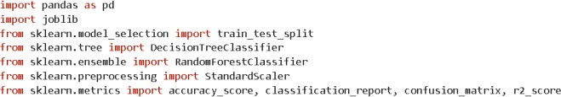

1. Load the dataset



1. Split the data into training and testing datasets.



1. Train a decision tree model



1. Make predictions on the testing data



1. Evaluate the model using the R-squared matric



1. . RESULT

This system uses more accurate decision tree classification algorithm

Accuracy of Decision tree

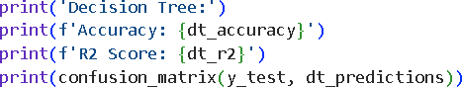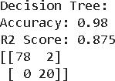

Classification of branches and setting target for non profitable branch

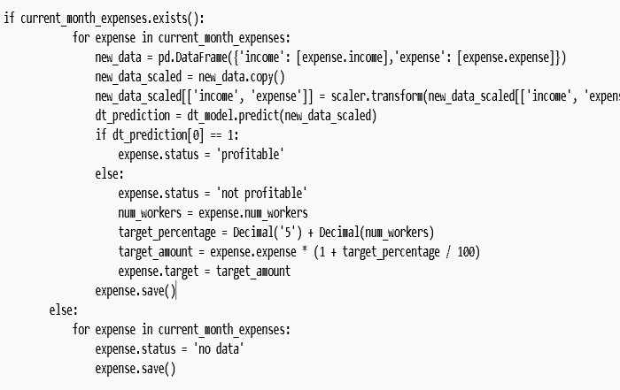

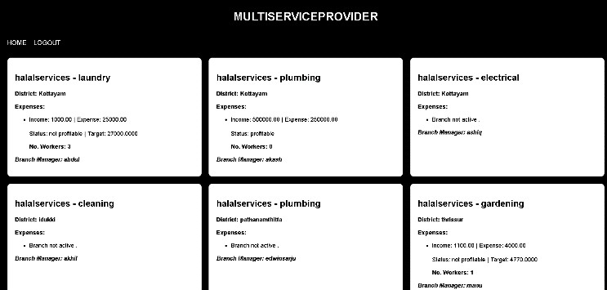

Figure 1. Output Classified branches and target

1. Conclusion

In conclusion, while conventional methodologies often fall short in fostering profitability within commercial enterprises, the integration of machine learning approaches emerges as a pivotal solution for crafting robust business strategies. By leveraging machine learning algorithms, organizations can meticulously analyze various factors influencing branch profitability and inform the development of comprehensive business plans. Instead of focusing solely on traditional metrics, this entails discerning factors such as branch income, expenses, number of workers, and historical performance to classify branch profitability and establish achievable targets. Through the utilization of historical data and pertinent factors, businesses can adeptly forecast profitability and set actionable targets. This informed approach enables enterprises to implement effective strategies, fostering sustainable growth and facilitating their success in competitive markets with confidence and agility.

1. References
2. I. Met, A. Erkoç and S. E. Seker, "Performance, Efficiency, and Target Setting for Bank Branches: Time Series With Automated Machine Learning," in IEEE Access, vol. 11, pp. 1000-1010, 2023, doi: 10.1109/ACCESS.2022.3233529.
3. C.A. Knox Lovell, Jesús T. Pastor, "Target setting: An application to a bank branch network," European Journal of Operational Research, vol. 98, no. 2, pp. 290-299, 1997, ISSN 0377-2217, doi: 10.1016/S0377-

2217(96)00348-7..

1. R. Zhou, C. Li and X. Wang, "Bank Customer Classification Algorithm Based on Improved Decision Tree," 2022 2nd Asia Conference on Information Engineering (ACIE), Haikou, China, 2022, pp. 30-33, doi: 10.1109/ACIE55485.2022.00014
2. F. Yin, "Design and Implementation of Accounting Information System Based on Decision Tree Classification Algorithm," 2023 Asia- Pacific Conference on Image Processing, Electronics and Computers (IPEC), Dalian, China, 2023, pp. 481-484, doi: 10.1109/IPEC57296.2023.00089
3. W. Zhengjun, D. Zhiting and D. Na, "Strategies for Optimizing the Application Environment of Management Accounting in Commercial Banks," 2021 International Conference on Public Management and Intelligent Society (PMIS), Shanghai, China, 2021, pp. 345-349, doi: 10.1109/PMIS52742.2021.00084.
4. H. D. Narudin, U. Subramanian and F. Kawi, "The Effectiveness of Management Accounting Systems in Brunei Small and Medium Enterprises," 2022 International Conference on Information Management and Technology (ICIMTech), Semarang, Indonesia, 2022, pp. 155-160, doi: 10.1109/ICIMTech55957.2022.9915080
5. I. Rahmatillah, E. Astuty and I. D. Sudirman, "An Improved Decision Tree Model for Forecasting Consumer Decision in a Medium Groceries Store," 2023 IEEE 17th International Conference on Industrial and Information Systems (ICIIS), Peradeniya, Sri Lanka, 2023, pp. 245- 250, doi: 10.1109/ICIIS58898.2023.10253592
6. Y. Wang, "Application of Modern Computer Technology in Automatic Management of Financial and Accounting Information," 2023 4th IEEE Global Conference for Advancement in Technology (GCAT), Bangalore, India, 2023, pp. 1-5, doi: 10.1109/GCAT59970.2023.10353289