**Experiment No.: 3**

**Aim**

Familiarization of linux commands

**CO2**

Perform system administration task

**Procedure**

1. pwd - Used to print the working directory.

After execution it shows the absolute path.

$pwd

**Output screenshot:**



2. ls - Used to list the files and content in the directory

$ls

**Output screenshot:**

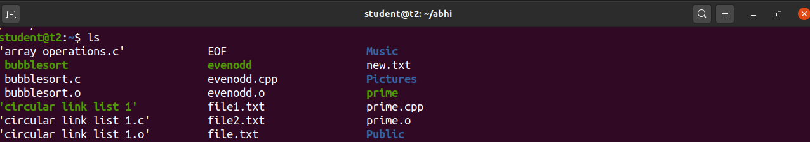

a. ls -R – It list the directory as well as the subdirectory

$ls -R

**Output screenshot:**

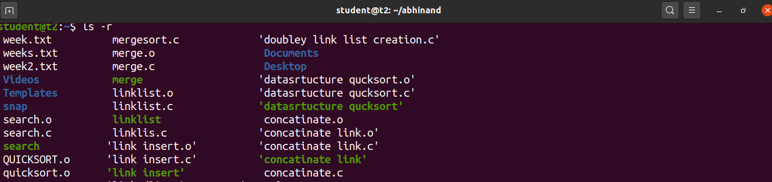

b. ls -l – Used to view the long list of content

$ls -l

**Output screenshot:**

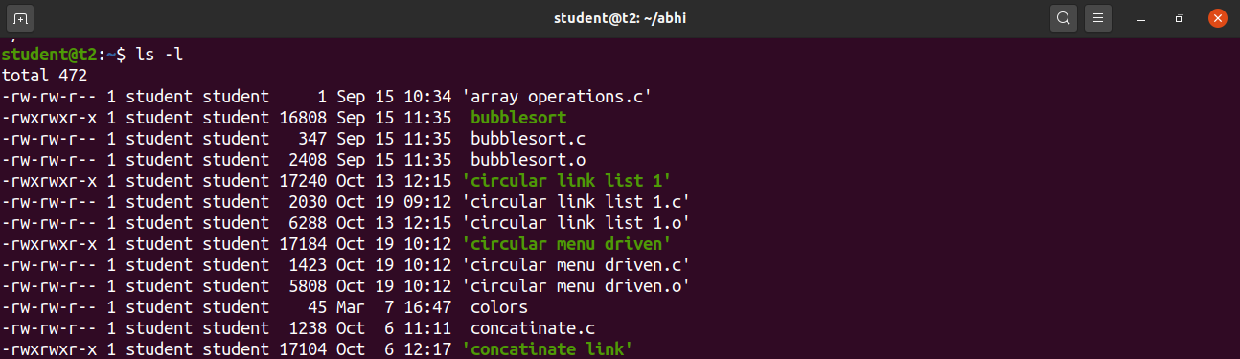

c. ls -a – Used to view the list in directory along with hidden files

$ls -a

**Output screenshot:**

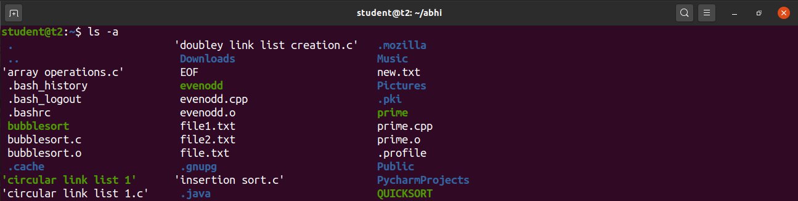

d. ls – al -Used to view the list in directory with detailed information along with hidden files

$ls – al

**Output screenshot:**

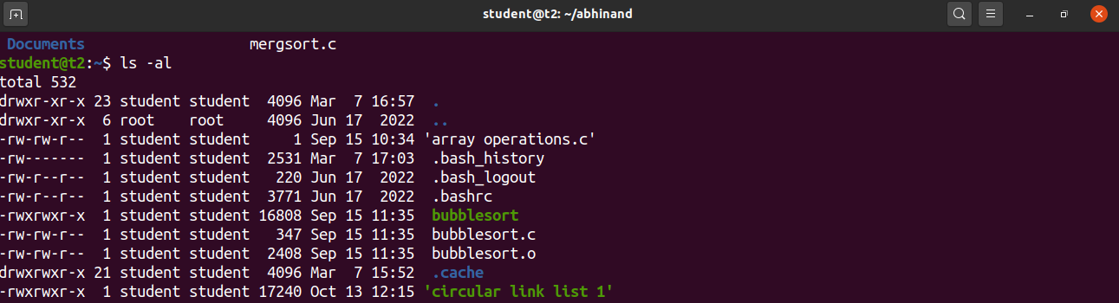

e. ls – t – Used to view the list in sorted order of last modified.

$ls – t

**Output screenshot:**

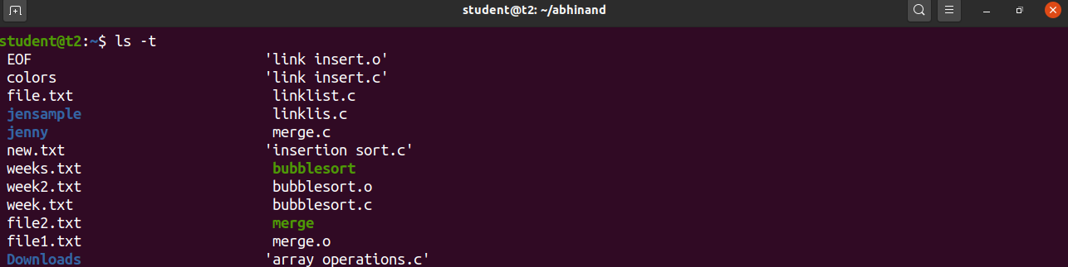

f. ls – r – Used to view the list in reverse order of last modified.

$ls – r

**Output screenshot:**



g. man ls – Used to learn and understand the existing commands we can learn and understand about different write from the shell using man command

$ man ls

**Output screenshot:**

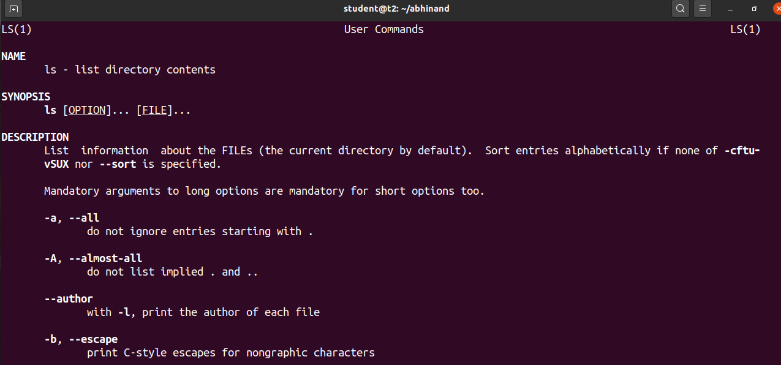

3. mkdir – Used to make new directory

$mkdir abhi

**Output screenshot:**



4. cd – Used to navigate through the directory

$cd abhi

**Output screenshot:**



5. cd -- Used to move one directory up

$cd –

**Output screenshot:**



6. history – Used to view the list of commands executed in a certain period of time.

$ history

**Output screenshot:**

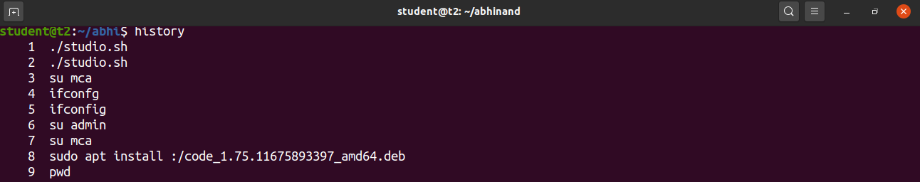

7. cat > - Used to create a new file

$cat > marvel

**Output screenshot:**

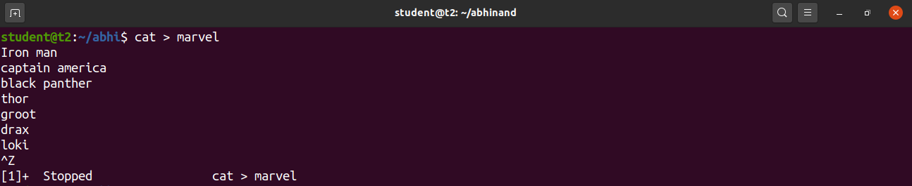

8. cat - Used to display the file

$cat marvel

**Output screenshot:**

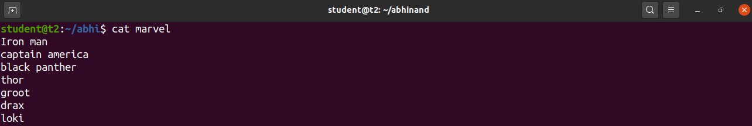

9. cat>> -Used to append content to an existing file

cat >> marvel

**Output screenshot:**

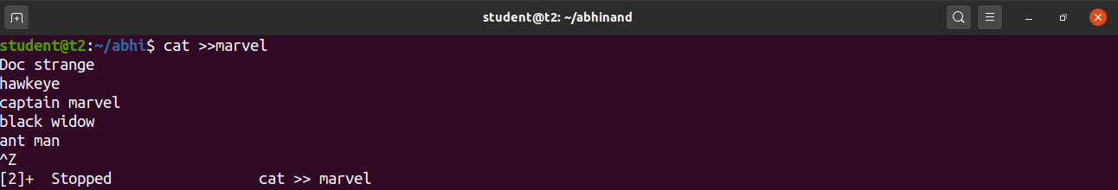

10. cat -n – Used to display content of file along with line number

$cat - n marvel

**Output screenshot:**

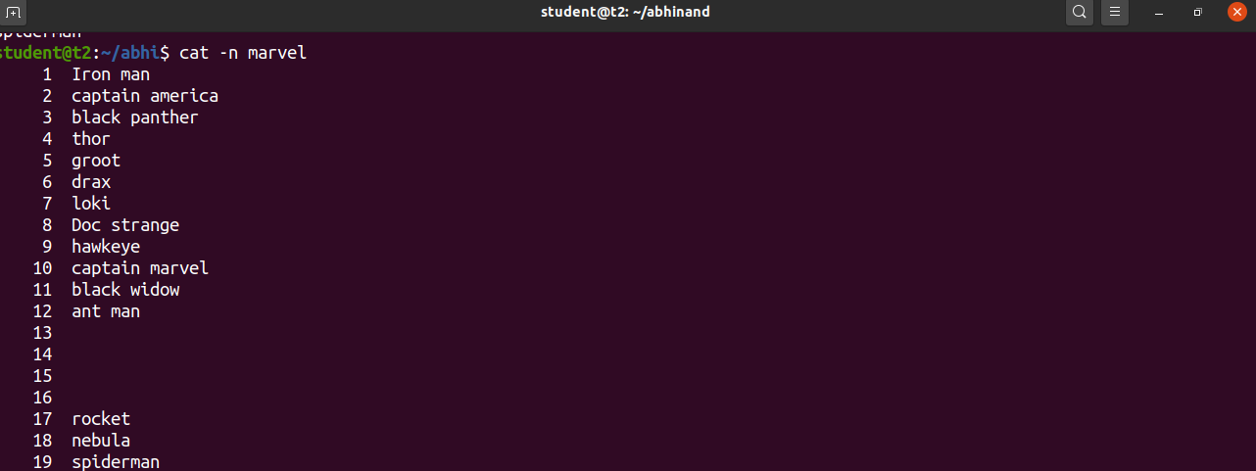

11. cat -b -Used to display content and number the lines that are not empty

$cat – b marvel

**Output screenshot:**

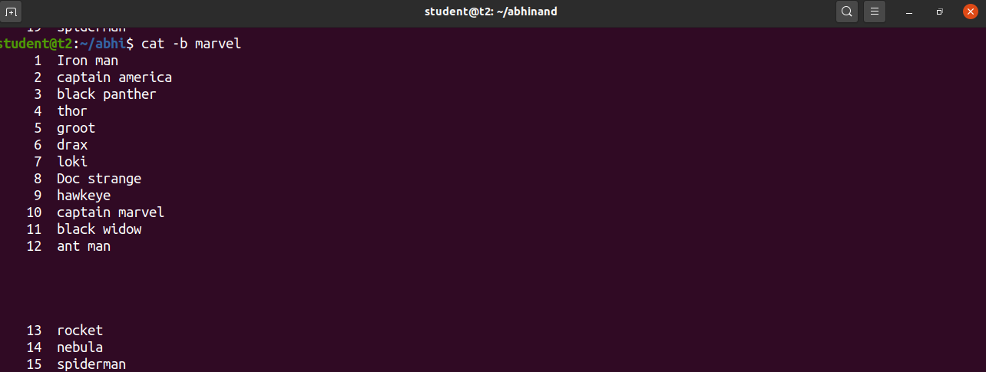

**Result**

The program was executed and the result was successfully obtained. Thus CO2 was obtained.

**Experiment No.: 4**

**Aim**

Familiarization of linux commands

**CO2**

Perform system administration task

**Procedure**

**1.cut** – to cut the contents of the file.

**a. cut -b** – to cut the contents of a file by byte position.

$ cut -b

 **Output screenshot:**

**b**. **cut -c**– to cut the contents of a file by character position.

$cut -c

**Output screenshot:**

**c. cut –d - -f1** – use delimiter to cut the contents at ‘-’ in the first column which is given by –f1.

$cut -d - -f1

**Output screenshot:**



**d. cut –complement -** usedto cut the content by complement pattern.

$cut -complement -c

**Output screenshot:**

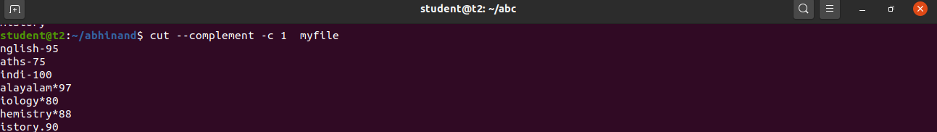

**2.paste -** to paste the content of a file to another.

**paste <*filename*> <*filename*>** – to paste the contents in file1 to file2.

$ paste <*filename*> <*filename*>

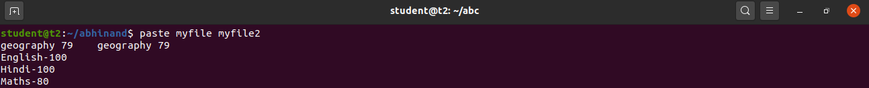 **Output screenshot:**

**3. cp** – to copy the contents of a file.

**a.cp *<filename> <filename>*** *–* to copy the contents of a file into another file or a new file.

$ cp *<filename> <filename****>***

**Output screenshot:**

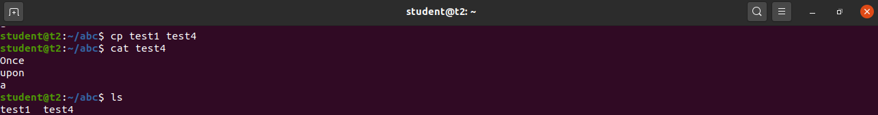

**b. cp <*filename*> <*directory*>** - to copy a file to a directory.

$ cp <*filename*> <*directory*>

**Output screenshot:**

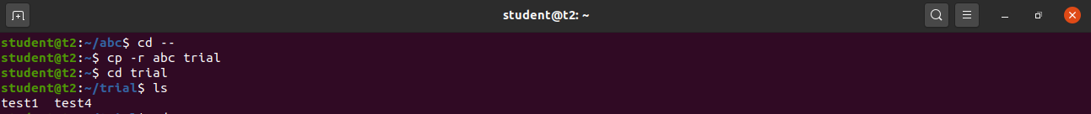

**Result**

The program was executed and the result was successfully obtained. Thus CO2 was obtained.