**ZOMATO**

(Revenue and Value Proposition)

Assignment 1

Robbin Singh (12582)

Zomato is widely used for restaurant search and provides various information about restaurants like cuisines, home delivery, dining-out, bars etc… Started in 2008, it is currently in India and 21 other countries.

**Revenue Model**

**Major sources of revenue**

Zomato has three major sources of revenue –

1. Advertising: Banner ads for restaurant are placed on their sites, which accounts for about 75% for Zomato’s revenue.
2. Event advertising: Promotes an event of restaurant on Zomato and book tickets for these events. This accounts about 5% of their revenue.
3. Counsulting Service: Zomato provides advice to restaurant chains on where to open their next outlet/branch. They scan all their data and finds where is the demand for specific outlet.

**Zomato Valuation**

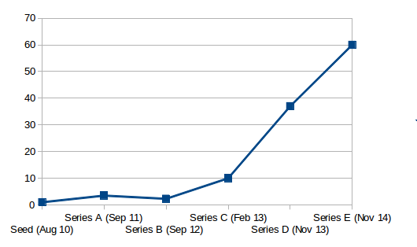

**Events(discontinued)**

Events section on Zomato was introduced in September 2011. Later Zomato shut down its events section and included some of the features into its restaurant’s home page .

**Funding**

1. Zomato (then known as Foodiebay) raised its first round of funding of US$1 million (₹4.7 crores) from Info Edge(India) in August 2010.
2. In Spetember 2011, they raised their second round of funding of US$3.5million (₹13.5 crores) from Info Edge(India).
3. In 2012 , Zomato raised its third round of funding of another US$2.5 million from Info Edge(India).
4. In early 2013 , Zomato raised its fourth round of funding worth US$10 million from Info Edge.
5. Total stake given to info Edge(India) till now was 57.9% .
6. In November 2013, Zomato raised US$37 million (₹227.6 crores) from Sequoia Capital and Info India. Info India now owns 50.1% on an investment ₹143 crores.
7. As of November 2013 Zomato has raised $53.5 million of funding.
8. In November 2014, Zomato’s post-money valuation was ~US$660 million, at this valuation Zomato closed a fresh round of funding of US$60 million which was being led jointly by Info Edge(India) and Vy Capital, with participation from Sequoia Capital.
9. Till now Zomato’s total funds is over US$113 million.
10. On April 10, 2015, the company had raised $50M in Series F funding from Info Edge, Sequoia Capital & One other investor.
11. On April 14, 2015 the company bought MaplePOS system for integration of B2B payments in the application.
12. **Total valuation of company is $1B.**

**Value Proposition**

Zomato have over 42k restaurants across 12 cities in India and over 4k in Dubai. They are in all major cities of India. It was first launch in Dubai in its International expansions plans.

They provide menus, pictures, locations, ratings, reviews about the restaurants. A clean and simple interface across mediums enables users to get what they want in three simple steps.

Users can also access Zomato wherever they are - be it online/on their smartphones/via the print guide which makes Zomato platform agnostic. They have mobile apps for all four platforms android, windows, ios and blackberry. The recently added social features also gives us an edge as users can engage with other foodies on Zomato and discover places to eat around them through user recommendations.

They also started online food delivering in some cities.

**What makes zomato different from others:**

Zomato is not different, rather they are much better. Zomato’s key focus area is coverage and depth. Zomato have listed almost twice the number of restaurants than any other restaurant directory portal in India. They have scanned menu cards for 96% restaurants in their database according to the CEO of company.