Walmart Sales Forecasting System
Technical Documentation

Machine Learning Fundamentals — Project 4
The Developers Arena Internship

1. Project Overview
This project implements an end-to-end machine learning pipeline that forecasts weekly retail sales across all 45 Walmart stores. The system ingests historical weekly sales data alongside external economic indicators such as temperature, fuel price, CPI, and unemployment, engineers time-series features, trains and compares multiple regression models, selects the best performer, and serves predictions through both a terminal interface and a Flask web dashboard.
The pipeline is fully modular: data preprocessing, model training, inference, and the web application each live in separate files under src/, making it easy to swap datasets, add models, or extend the API without touching unrelated code.

Targets Achieved
Property | Value
MAPE (Mean Absolute % Error) | 0.4% — Target: < 10% ✓
R² Score | 0.980 — Target: > 0.80 ✓
MAE (Mean Absolute Error) | $166,360 per week
RMSE (Root Mean Sq Error) | $206,592 per week
Best Model | Lasso Regression
Dataset | Walmart Sales Forecast — Kaggle
Forecast Horizon | 13 weeks (~3 months)
Training Data | 78 weeks | Test: 13 weeks held out

2. Dataset
The Walmart Store Sales Forecasting dataset is sourced from Kaggle. It contains weekly sales records from 45 stores across 99 departments, combined with store metadata and external economic and promotional features. All four files are merged and aggregated to produce a single weekly time-series of total sales across the entire store network.
Property | Value
train.csv | 421,570 rows — weekly sales per store per department (2010–2012)
features.csv | 8,190 rows — external features per store per week
stores.csv | 45 rows — store metadata: Type (A/B/C) and Size
test.csv | 115,064 rows — test set structure without sales labels
Date range | February 2010 – October 2012 (143 weeks total)
Aggregation | Weekly_Sales summed across all 45 stores per week

Key columns used: Weekly_Sales (target variable), IsHoliday, Temperature, Fuel_Price, CPI, Unemployment, and MarkDown1–5 (promotional discount amounts). Missing MarkDown values are filled with 0, representing weeks with no active promotions.
After merging all files and aggregating, the dataset contains 143 weekly rows. Feature engineering requires 52 weeks of lag history (for the lag_52 feature), leaving 91 usable rows. The last 13 of these are held out as the unseen test set, giving 78 training rows.

3. Pipeline Execution
The entire pipeline runs end-to-end with a single command: python src/main.py. It executes three sequential stages: data loading and preprocessing, model training with cross-validation and hyperparameter tuning, and 13-week iterative forecasting. Progress and results are printed to the terminal at each stage.
Figure 1 shows the model comparison table, hyperparameter tuning results, and held-out test evaluation with all four metrics: MAE, RMSE, R², and MAPE.
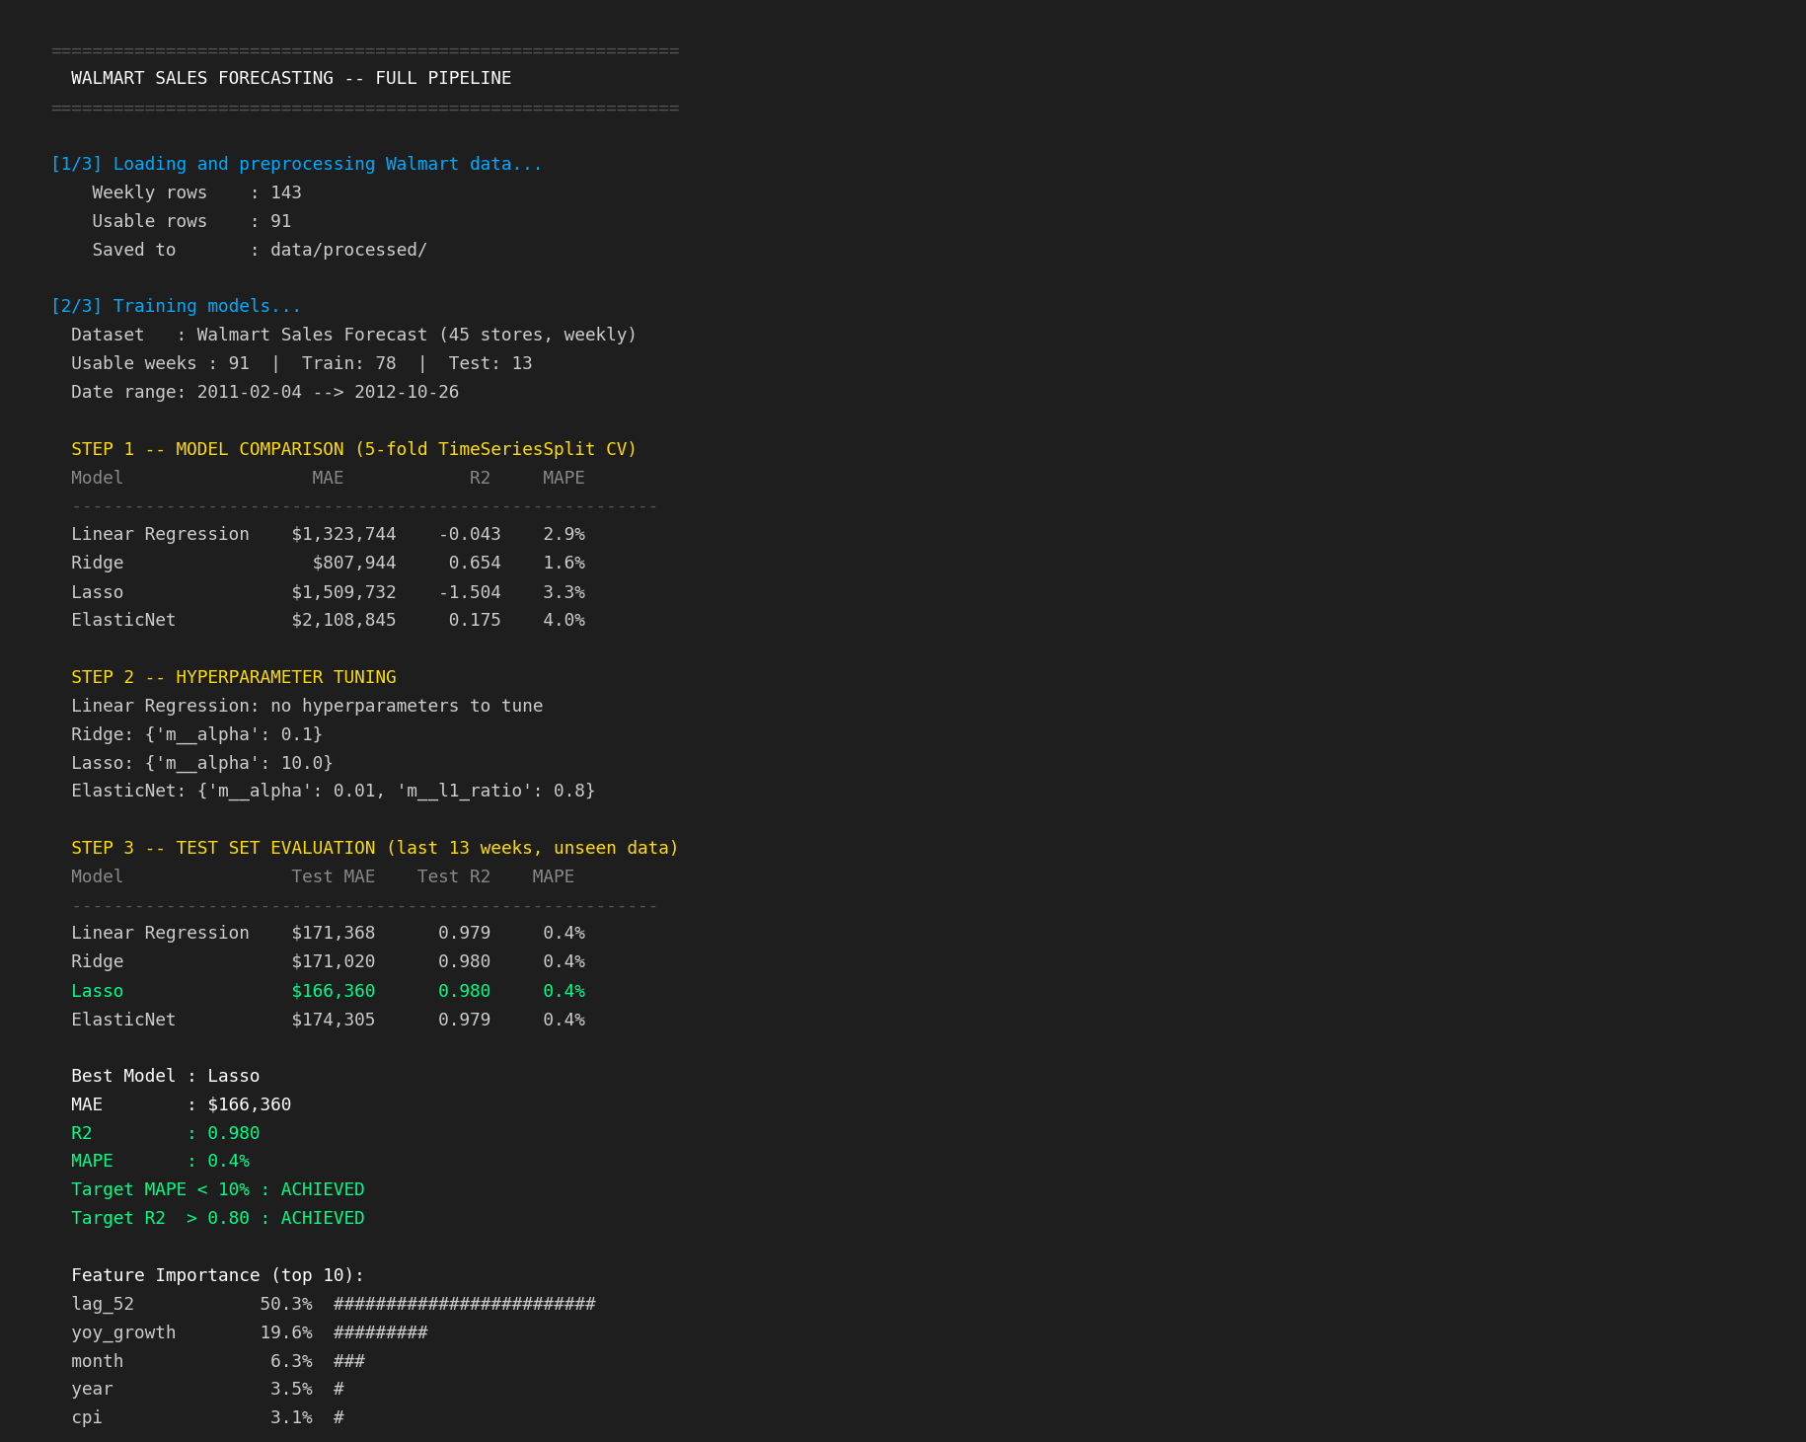
Figure 1 — Model comparison (MAE, RMSE, R², MAPE), hyperparameter tuning, and test evaluation
Figure 2 shows the business insights summary and the complete 13-week forecast with predicted weekly totals.
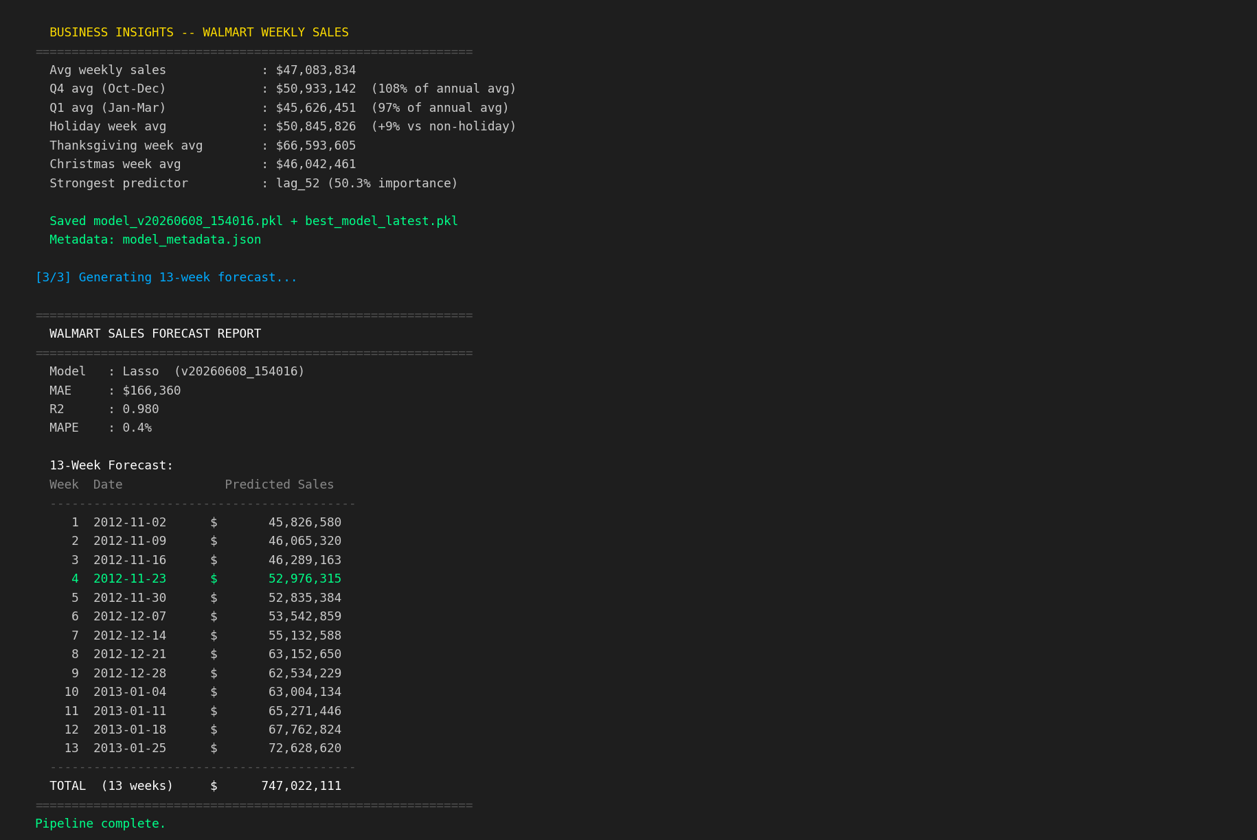
Figure 2 — Business insights and 13-week forecast with week-by-week predicted sales

4. Feature Engineering
The pipeline engineers 28 features from the raw weekly sales data. Feature engineering is the most critical step: the dominant predictor lag_52 alone explains 50.3% of model importance by capturing the strong year-over-year seasonal pattern inherent in retail sales. The second-most important feature, yoy_growth, captures how the current year is trending relative to the previous one.
Features fall into five categories: lag features (past sales values), rolling statistics (short-term trends), calendar and cyclical features (seasonality), specific holiday week flags (high-impact event weeks), and external economic indicators (macro environment).
Property | Value
lag_1, lag_2, lag_4, lag_8 | Weekly sales 1, 2, 4, and 8 weeks ago
lag_52 | Same week last year — strongest predictor (50.3% importance)
rolling_mean_4 | 4-week rolling average of prior weekly sales
rolling_mean_12 | 12-week rolling average (quarterly smoothing)
rolling_std_4 | 4-week rolling standard deviation (volatility measure)
yoy_growth | Year-over-year growth rate (19.6% importance)
week_sin, week_cos | Cyclical encoding of week-of-year (continuous seasonality)
is_thanksgiving_week | Week 47 flag — highest-sales week of the year
is_christmas_week | Week 52 flag
is_superbowl_week | Week 6 flag
is_q4, is_december, is_january | Seasonal quarter and month flags
temperature, fuel_price | Weekly average temperature and fuel price across stores
cpi, unemployment | Consumer Price Index and unemployment rate
total_markdown | Sum of MarkDown1–5 promotional discount amounts

5. Model Training
Four linear models are trained and compared. Tree-based models (Random Forest, Gradient Boosting) and a stacking ensemble were evaluated in earlier iterations but removed: the dominant lag_52 feature creates a near-linear relationship — this week ≈ same week last year × growth factor — that linear models capture perfectly with far less complexity.
Property | Value
Linear Regression | Baseline — ordinary least squares, no regularization
Ridge | L2 regularization — shrinks all coefficients, retains all features
Lasso | L1 regularization — drives irrelevant feature coefficients to zero
ElasticNet | Combined L1 + L2 regularization — balances sparsity and shrinkage

Training procedure:
1. 5-fold TimeSeriesSplit cross-validation on all four models using training data only. Folds are strictly chronological to prevent data leakage.
2. GridSearchCV hyperparameter tuning on all regularized models (Ridge alpha, Lasso alpha, ElasticNet alpha + l1_ratio), still using TimeSeriesSplit.
3. Final evaluation on the last 13 held-out weeks (completely unseen during all training and tuning). All four metrics — MAE, RMSE, R², MAPE — are reported.
4. Best model (lowest test MAE) is retrained on the full dataset before saving to models/best_model_latest.pkl.

Model Persistence and Versioning
Each training run saves two model files: a timestamped versioned file (model_v{timestamp}.pkl) and a fixed-name latest file (best_model_latest.pkl) for the web app and inference scripts to load. A human-readable model_metadata.json is also saved containing all metrics (MAE, RMSE, R², MAPE), feature importance rankings, and training configuration.

6. Web Application
A Flask web application provides a graphical interface to the forecasting system. It is launched with python src/web_app.py and is accessible at http://127.0.0.1:8501. The model is loaded once at startup; subsequent requests are served without reloading.
The application has two pages (Dashboard and Predict) and three JSON API endpoints, making it usable both as a human-facing tool and as a programmatic forecasting service.

6.1 Dashboard
The dashboard loads on the root URL (/). It displays five metric cards (MAE, RMSE, R², MAPE, Model name), an interactive line chart showing the last 52 weeks of historical sales alongside the 13-week forecast, a feature importance bar chart, and the full forecast table with predicted weekly totals.
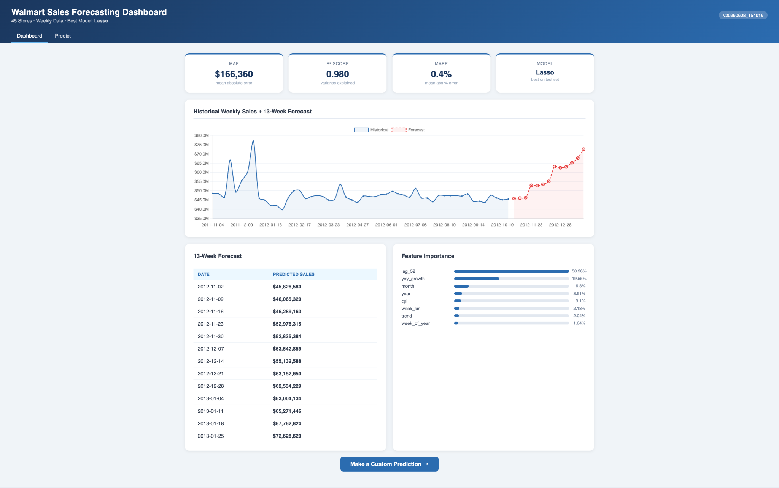
Figure 3 — Web dashboard: metric cards, historical + forecast chart, feature importance, and 13-week forecast table

6.2 Prediction Page
The Predict page (/predict) allows users to enter any year (2010–2030) and ISO week number (1–52) to generate a single-week total sales prediction. The result card shows the predicted value, a confidence interval derived from the model’s MAPE, and the confidence percentage. Input validation rejects out-of-range values before the model is called.
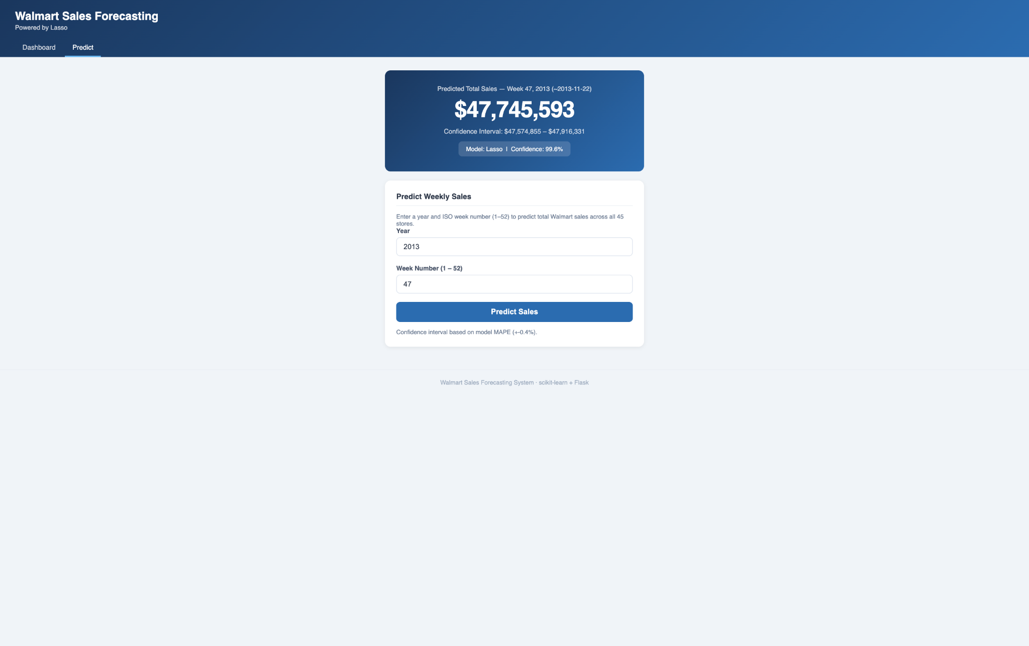
Figure 4 — Prediction page: Week 47, 2013 (Thanksgiving) forecast of $47.7M with 99.6% confidence interval

7. Testing
The test suite is in tests/test_pipeline.py and is run with python -m pytest tests/ -v. It contains 15 unit tests covering the full data pipeline and input validation layer, organised into four areas:
Data loading: verifies row counts, no negative sales values, presence of all external feature columns, and chronological date ordering.
Feature engineering: checks that all 28 FEATURE_COLS are present, contain no null values after lag computation, cyclical features are bounded between -1 and 1, and holiday flags are strictly binary (0 or 1).
Input validation: confirms that valid year/week combinations pass without error, and that out-of-range years (< 2010 or > 2030) and weeks (< 1 or > 52) raise ValueError with descriptive messages.
Schema: verifies FEATURE_COLS contains no duplicate entries and meets the minimum feature count.
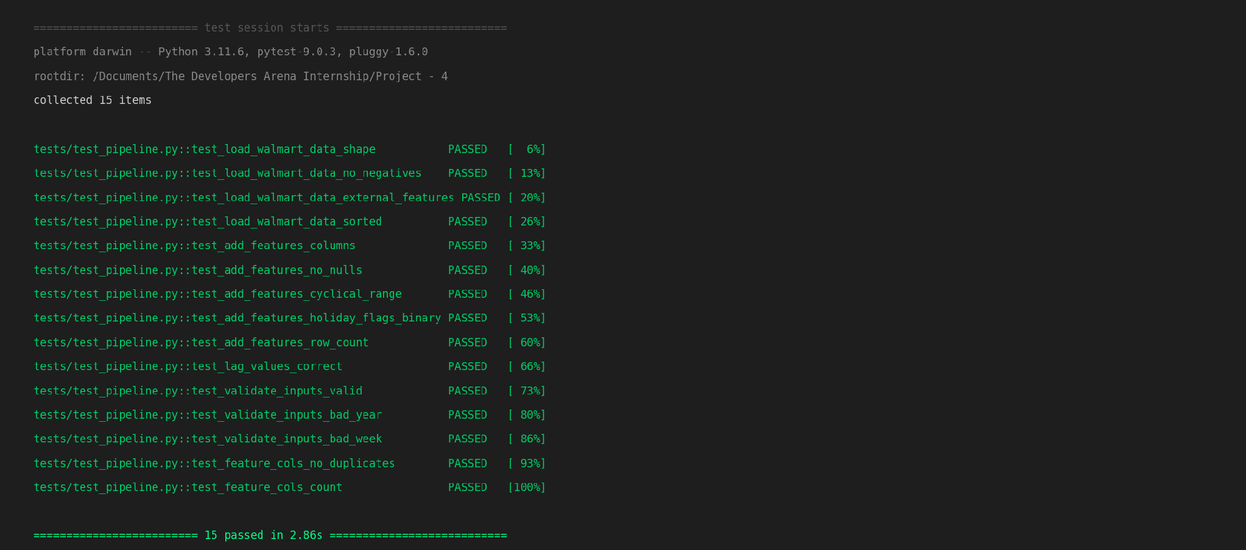
Figure 5 — All 15 unit tests passing in 2.86 seconds

8. API Reference
The Flask app exposes five endpoints. The three JSON endpoints (/api/*) can be consumed by any HTTP client, making it straightforward to integrate the forecasting system into dashboards, scripts, or downstream services.
Property | Value
GET / | Dashboard — full HTML page with metrics, chart, and forecast table
GET/POST /predict | Prediction form — input year + week, returns forecast and confidence interval
GET /api/forecast | JSON — 13-week forecast from the last date in the training data
GET /api/metrics | JSON — model name, version, MAE, RMSE, R², MAPE, and all comparison results
POST /api/predict | JSON — predict any year/week. Request body: {"year": 2013, "week": 47}

Example Request and Response
Predict total Walmart sales for Week 47, 2013 (Thanksgiving week):
curl -X POST http://localhost:8501/api/predict \
-H "Content-Type: application/json" \
-d '{"year": 2013, "week": 47}'
Example response:
{
"year": 2013,
"week": 47,
"date": "2013-11-22",
"predicted_sales": 47745593.0,
"lower_bound": 47574855.0,
"upper_bound": 47916331.0,
"confidence_pct": 99.6
}

Error Handling
All API endpoints return structured JSON error responses. Invalid inputs (e.g. week 53, year 2005) return HTTP 400 with an error key. If the model file is missing, all endpoints return HTTP 503 with a descriptive message, and the dashboard redirects to an error page prompting the user to run model_training.py first.

9. Project Structure
The project follows a standard modular layout. Source files, data, models, templates, tests, and documentation are each in their own directory, ensuring each component can be developed, tested, and replaced independently.
Property | Value
src/main.py | Entry point — orchestrates the full pipeline end-to-end
src/data_preprocessing.py | Loads, merges, and aggregates Walmart data; engineers 28 features
src/model_training.py | Trains 4 linear models, tunes hyperparameters, evaluates, saves best
src/model_inference.py | Loads saved model, forecasts 13 weeks iteratively, validates inputs
src/web_app.py | Flask app with dashboard, prediction form, and JSON API (port 8501)
data/raw/ | Source files: train.csv, test.csv, features.csv, stores.csv
data/processed/ | Generated files: weekly_sales.csv, featured_data.csv
models/ | Saved artifacts: best_model_latest.pkl, model_metadata.json
templates/ | Jinja2 HTML templates: index.html, predict.html, error.html
static/css/ | style.css — web app stylesheet
tests/test_pipeline.py | 15 unit tests covering data, features, and input validation
config/config.json | Configuration: test size, CV folds, web port, random seed
docs/ | documentation.md and documentation.docx
notebooks/eda.ipynb | Exploratory data analysis — 7 sections covering Walmart data
scripts/run_pipeline.sh | Bash script to run the full pipeline end-to-end
requirements.txt | Python dependencies

Run Commands
Property | Value
Full pipeline | python src/main.py
Web app only | python src/web_app.py
Install dependencies | pip install -r requirements.txt
Run tests | python -m pytest tests/ -v
Full bash script | bash scripts/run_pipeline.sh

10. Business Insights
Analysis of the aggregated Walmart weekly sales data reveals clear seasonal patterns, holiday-driven spikes, and year-over-year growth trends that directly inform inventory planning, staffing, and promotional strategy.
Property | Value
Average weekly sales | $47,083,834
Q4 avg (Oct–Dec) | $50,933,142 (+8% vs annual average)
Q1 avg (Jan–Mar) | $45,626,451 (-3% vs annual average)
Holiday week avg | $50,845,826 (+9% vs non-holiday weeks)
Thanksgiving week avg | $66,593,605 (+41% vs annual average)
Christmas week avg | $46,042,461 (near annual average)
13-week forecast total | $747,022,111 (Nov 2012 – Jan 2013)
Strongest predictor | lag_52 — same week last year (50.3% importance)
Second predictor | yoy_growth — year-over-year rate of change (19.6%)

Thanksgiving (Week 47) is the single highest-revenue week of the year, generating 41% above the annual weekly average. This spike is accurately captured by the model through the lag_52 feature combined with the is_thanksgiving_week binary flag.
Contrary to expectation, Christmas week (Week 52) does not show a similarly large spike. This reflects that peak holiday sales are concentrated in the weeks leading up to Christmas rather than the week itself, as consumers complete shopping earlier in December.
The Q4 premium of +8% over the annual average, combined with the Q1 dip of -3%, underscores the importance of accurate 13-week forecasts spanning the Q4-to-Q1 transition period for inventory and staffing decisions.

