**TASK-2**

Execute the following the network commands like ipconfig, tracert, tellnet, netsh, ping, nslookup, netstat

**Procedure**

**Step-1:**

Launch cisco packet tracer

Double the cisco packet tracer icon on your desktop or find it in your applications list and open the program

**Step-2:**

Create a simple network topology

1. Add devices

* Drag and drop a router and a switch from the device list on to the workspace
* Drag and drop two pc’s on to the workspace

1. Connect devices  
   Use the connection tool to connect the devices

* Connect one pc to the switch using the copper straight-through
* Connect the switch to the router using another copper straight-through cable
* Connect the second pc to the switch using copper straight-through cable
* Configure devices

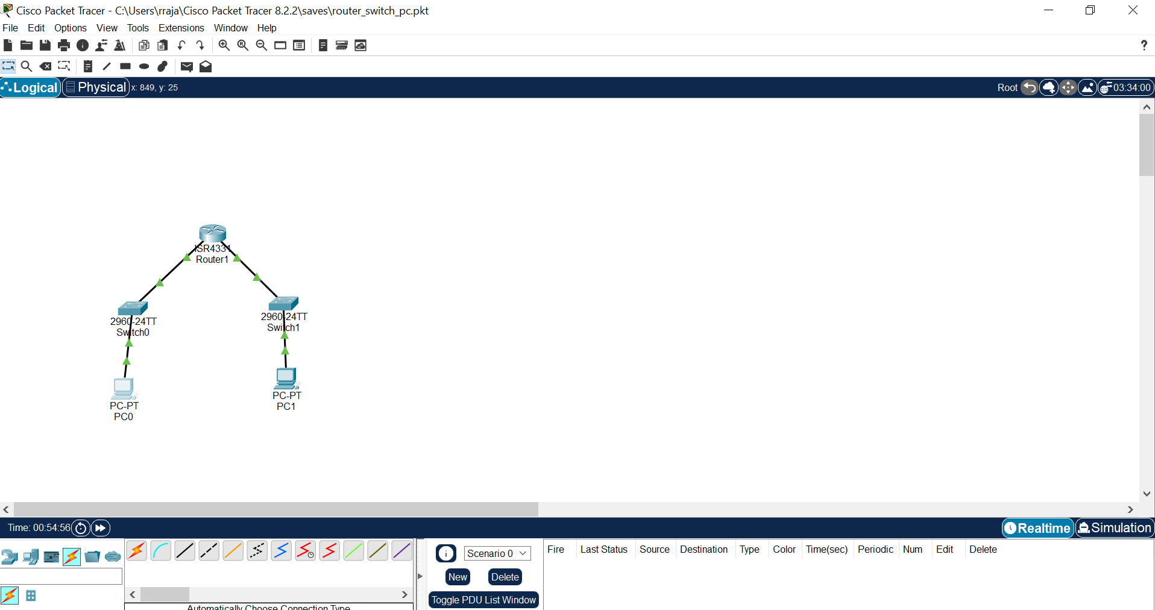

**Step-3:**

Click on the router

-Go to config tab  
-Assign IP addresses to the router interfaces   
Eg: PC-0:  
Interface G0/0: ip address 192.168.1.1, Subnet mask: 255.255.255.0  
PC-1:  
InterfaceG0/1: ip address 192.168.2.1, Subnet mask: 255.255.255.0

-Configure the pc  
-Click on each pc   
-go to the desktop option and then ip configuration  
-assign ip addresses to each pc   
Eg: PC0-   
IP address 192.168.1.2, Subset mask: 255.255.255.0, Default gateway: 192.168.1.1

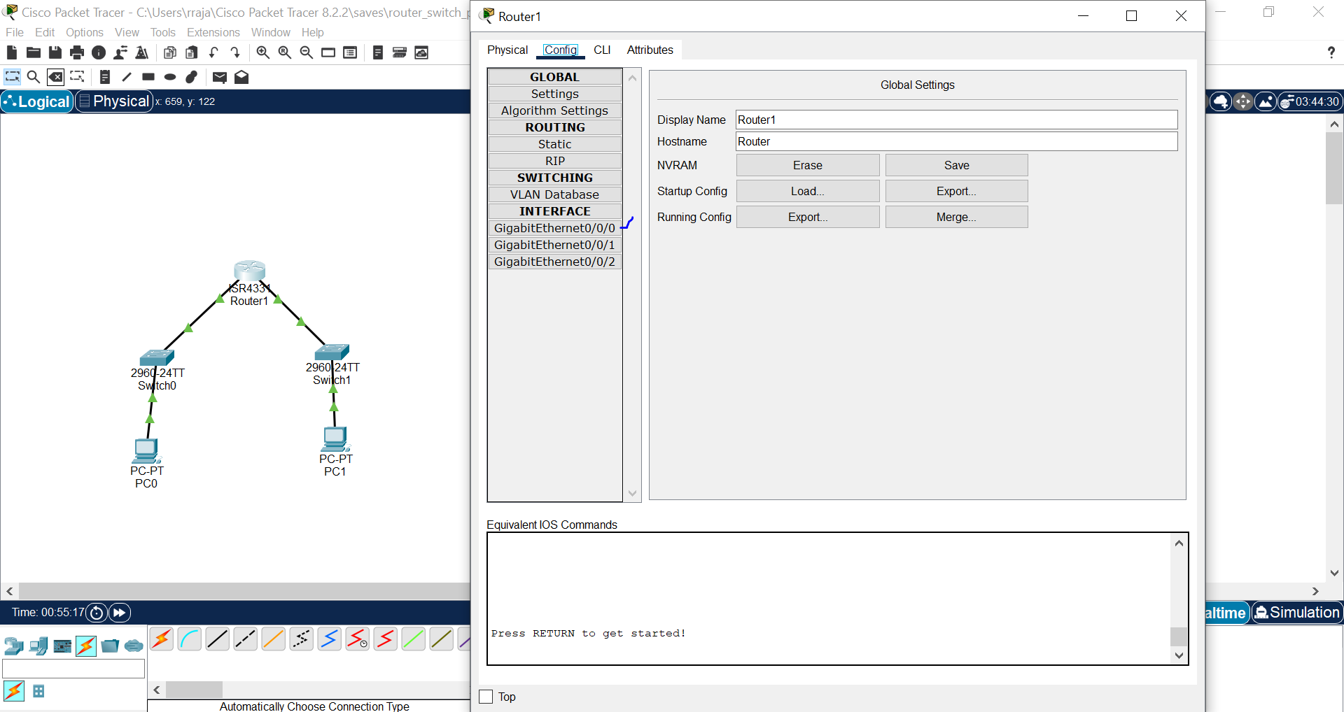

**Step-4:**

* Execute networking commands
* click on a pc0
* go to the desktop tab
* open the command prompt for pc0  
  **Command1: ipconfig**  
  This command displays all correct tcp ip network configuration values and all dh cp and pns settings

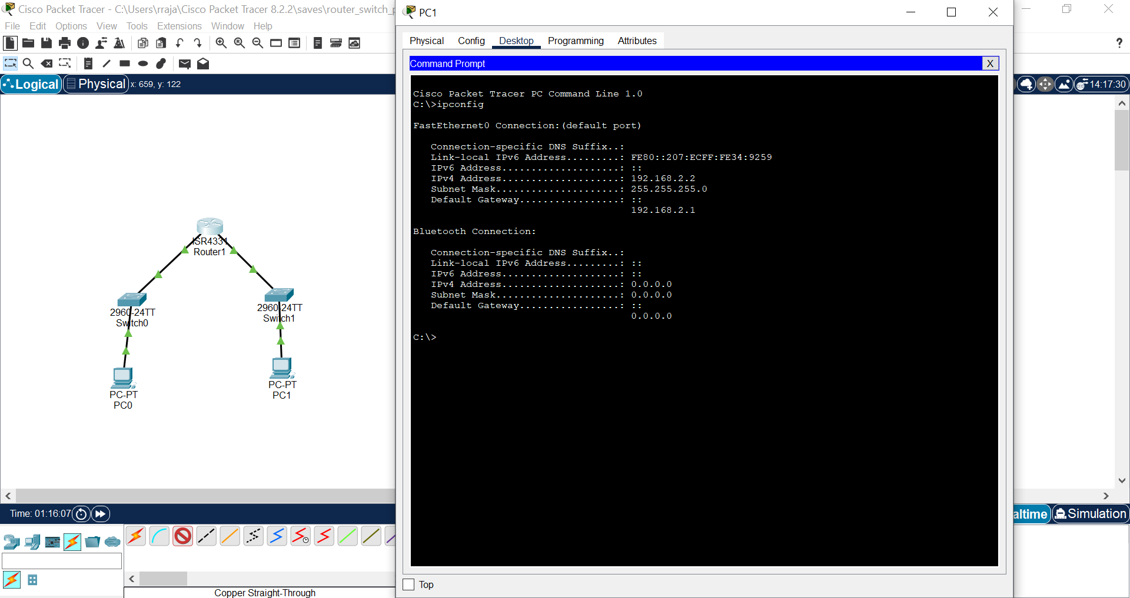

**Step5: Type tracert**   
This command traces the path taken to a destination by sending icmp echo request messages

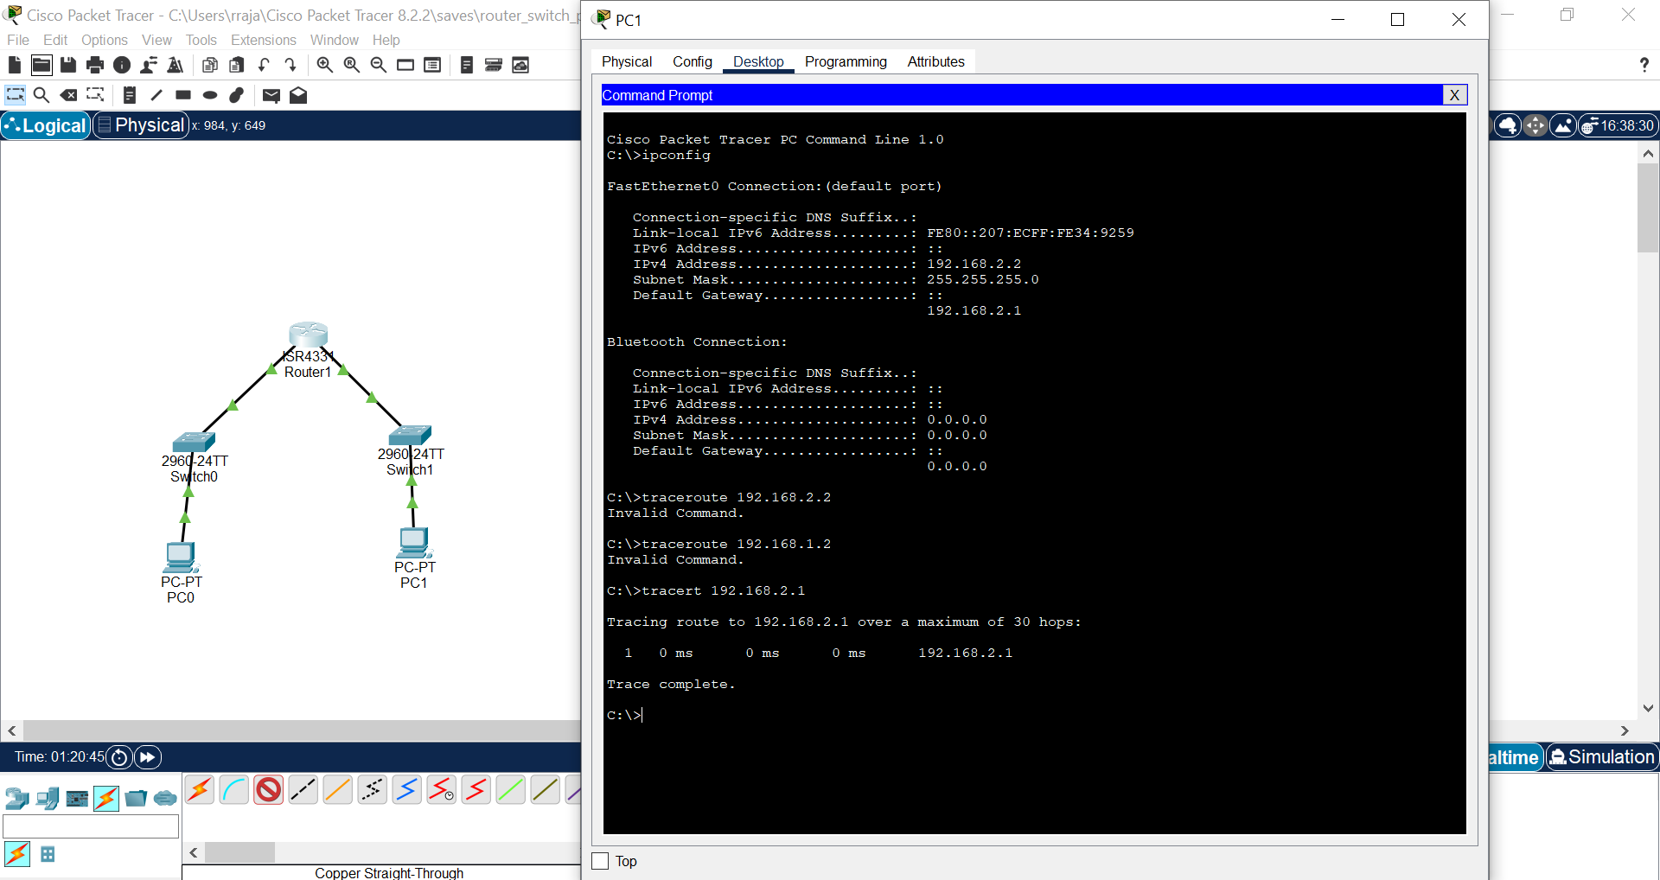

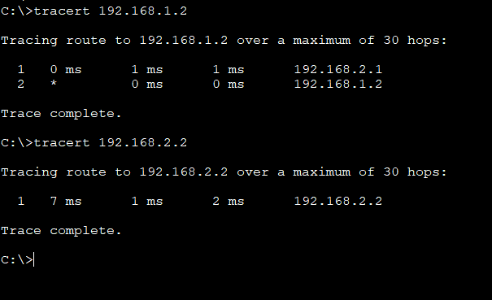

**Step6: telnet**  
Go to router and click on CLI and write below steps

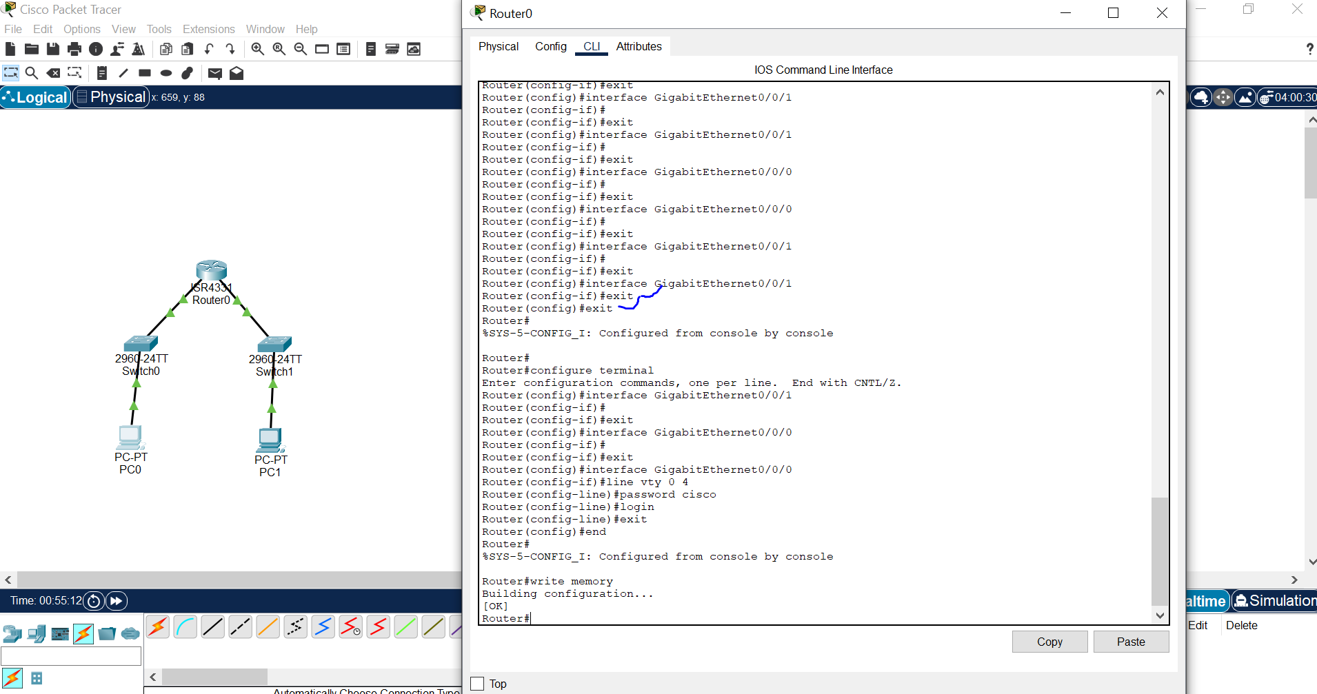

Go to pc -0 then desktop then command prompt then write telnet

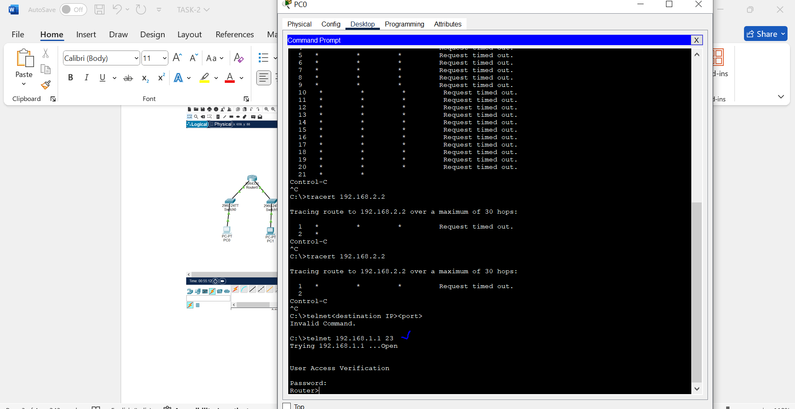

**Step7: IP BREIF INTERFACE**

**Type show ip interface brief to get below result**

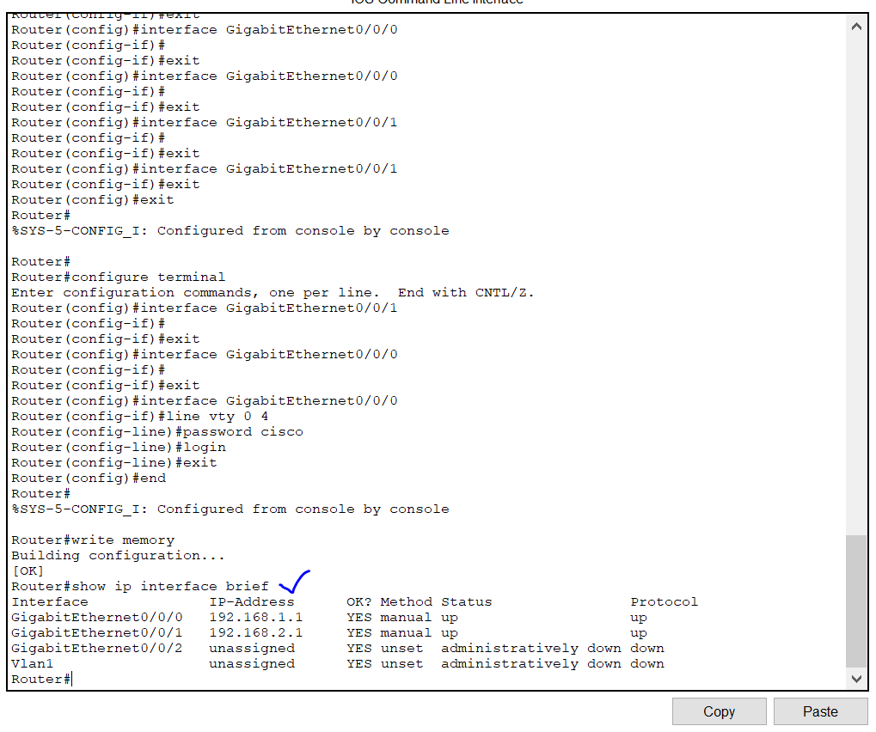

**Step8: PING:**

**Type ping 192.168.2.2**

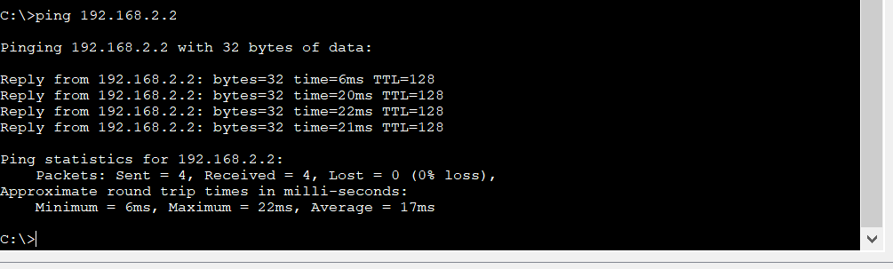

**Step9: NSLOOKUP:**

Step1 : take a server and connect it and user copper-straight wire

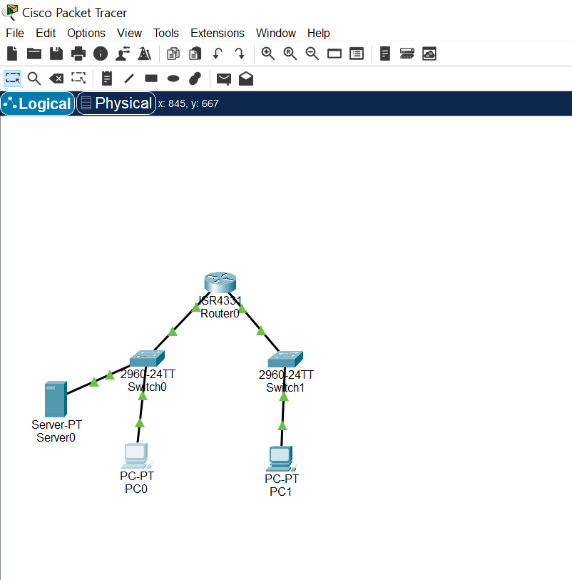

Step2: go to server 0  
 Then click on services  
 Click on DNS and click on “ON”

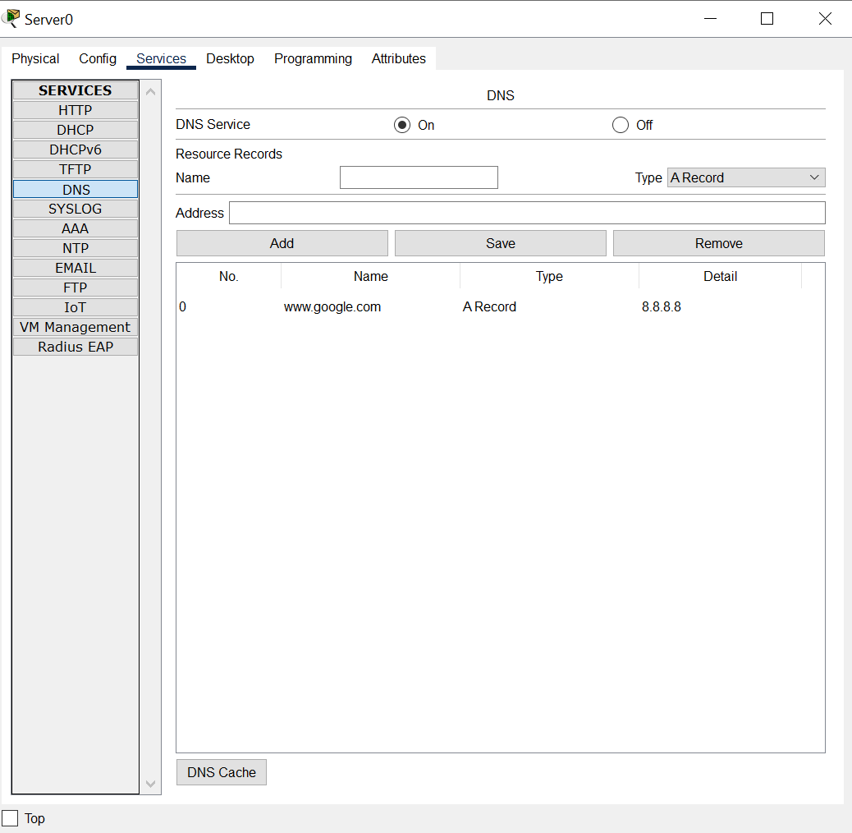

Then go to pc0 then click on desktop then type as below:

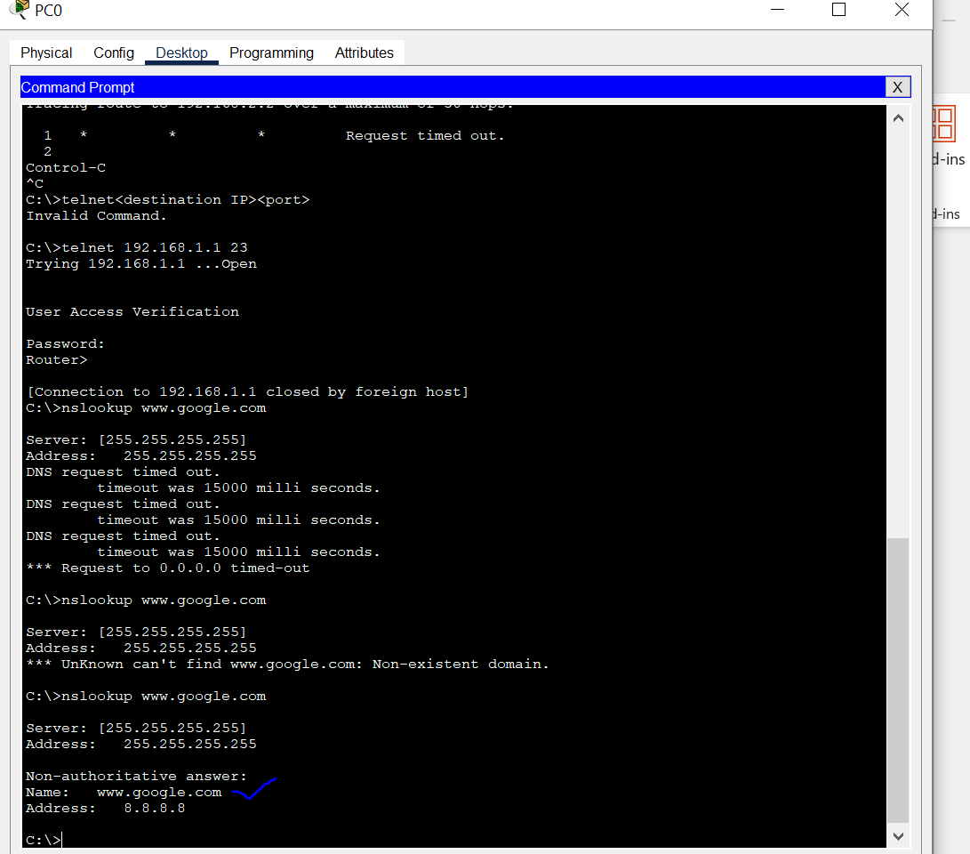

**Step10: Netstat**

This command displays network connections for the Transmission Control Protocol (TCP), routing tables, and a number of network interface and network protocol statistics.

The netstat command is used to display network connections, routing tables, interface statistics, masquerade connections, and multicast memberships.

