Paper No. NCEC-448

**ELECTRONIC OSCILLOSCOPE**

Mr. A Himanshu, USN-1DS21EC001, Mr. Abhinav Sundriyal, USN-1DS21EC006

Mr. Aditya Kiran Pawaskar, USN-1DS21EC016

V Sem ECE Students, Dayananda Sagar College of Engg., Bengaluru, Karnataka

Email : himanshuatchutha123@gmail.com, abhinavsundriyal08@gmail.com,

Email : adityapawaskar805@gmail.com

Phone : 9632054433 9148579436 8277521940

Mrs. Vibha T G , Asst. Prof., ECE, DSCE, Bangalore

Email : vibha-ece@dayanandasagr.edu Mob : 9740733220

***Abstract –*** This paper introduces a user-friendly Arduino Uno (ATmega328P) based oscilloscope, designed with simplicity, portability, and cost-effectiveness in mind, providing distinct advantages over traditional oscilloscopes. Using Arduino microcontroller, the project aims to offer a practical platform for signal visualization, emphasizing the display of signals. Through the programming of Arduino boards, it graphically indicates changes in the signal voltage, typically as a two-dimensional plot of one or more signals as a function of time. An oscilloscope depicts waveforms in order to show signal strength, wave shape, and the value of a signal. Options such as reset, shifting the signal upwards and downwards can also be done. This project particular focus on the practical aspects of displaying signal. Results obtained from an experiment can be displayed by the oscilloscope, showcasing its ability to display various signals, including but not limited to impulse, sine, cos, exponential, ramp, step and square signals. The OLED (organic light-emitting diode) display used causes the values and readings to be clear without any blurriness and better contrast in compared to LCD and other displays available. The user-friendly design of the Arduino-based oscilloscope is highlighted as a key feature, making it not only practical but also a cost-effective alternative to traditional, bulkier oscilloscopes. In conclusion, this project contributes to the understanding of signal recognition and display using an Arduino-based oscilloscope. Its simplicity, portability, and cost-effectiveness make it a valuable tool for various applications, offering a convenient alternative to those which are larger in size and expensive.

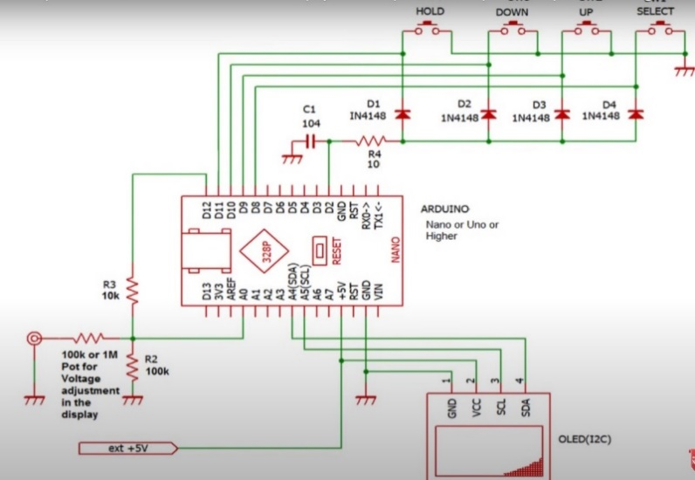 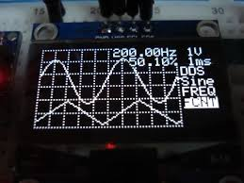

***Keywords -*** Oscilloscope, Arduino, Signal Visualization, OLED display, Continuous time signals, Inexpensive.