**ELECTRONIC OSCILLOSCOPE**

A. Himanshu, 1DS21EC001, V Sem, Dept. of ECE, DSCE, [himanshuatchutha123@gmail.com](mailto:himanshuatchutha123@gmail.com) , 9632054433

Abhinav Sundriyal, 1DS21EC006, V Sem, Dept. of ECE, DSCE, [abhinavsundriyal08@gmail.com](mailto:abhinavsundriyal08@gmail.com), 9148579436

Aditya K Pawaskar, 1DS21EC016, V Sem, Dept. of ECE, DSCE, [adityapawaskar805@gmail.com](mailto:adityapawaskar805@gmail.com), 8277521940

Mrs. Vibha T G, Assistant Professor, Dept. of ECE, Dayananda Sagar College of Engg., Bangalore

Email: [vibha-ece@dayanandasagar.edu](mailto:vibha-ece@dayanandasagar.edu) Mob: 9740733220.

***Abstract-***

The paper introduces a user-friendly Arduino Uno-based oscilloscope designed for simplicity, portability, and cost-effectiveness, offering advantages over traditional oscilloscopes. The project utilizes an Arduino microcontroller to provide a practical platform for signal visualization, graphically indicating changes in signal voltage over time. The oscilloscope displays various signals, including impulse, sine, cos, exponential, ramp, step, and square signals, using an OLED display for clear and precise readings. The paper emphasizes the practical aspects of signal display and highlights the user-friendly design and cost-effectiveness of the Arduino-based oscilloscope. It concludes that the project enhances understanding of signal recognition and display, offering a valuable and convenient alternative to larger, more expensive oscilloscopes.

***Keywords-*** Oscilloscope, Arduino Uno, Signal Visualization, Portability, Cost-Effectiveness, OLED Display, Signal Strength, Wave Shape, Voltage Measurement, User-Friendly Design, Alternative, Inexpensive.

***Introduction-***

Oscilloscope is a very important and integrated digital devices for signal conditioning, acquisition and analysis. Increasing modern electronic system, the various types of oscilloscopes is use for completing the task. This electronic instrument is use for so many purposes in day-to-day life that is in labs, collages etc. It will allow observation of various types signal and can measure maximum peak voltage. The digital oscilloscope has very useful for solve this problem of simple CRO. For digitalising analogue signal and transfer data are transfer via I2C interface. In this project we are using OLED display to improve the clarity of waveform.

***Literature Survey-***

|  |  |  |  |
| --- | --- | --- | --- |
| Sl.no | Paper name | Authors and date of publication | Ideas Implemented |
| 1. | Oscilloscope using Arduino for PWM testing | S. Sathyanarayan and Shashidhar Anbu.  Date: march,2018. | Low sensitivity voltage divider input |
| 2. | Design and construction of Arduino Based Oscilloscope | OSISIOGU, UKACHI OLUWASEUN  Date: -sept,2015. | Arduino Connections  In Analog Read pins |
| 3. | A Review Paper on I2C Communication Protocol | Vivek Kumar Pandey,  Sparsh Kumar, Vimal Kumar, Pankaj Goel.  Date: - jan,2018. | I2C interface for OLED display. |

***Objective of the work –***

1. Design an oscilloscope which can be used to show the various waveforms as a function of time.
2. Design an oscilloscope which is easy to design and cost efficient.
3. Design an oscilloscope which is easily portable.

***Problem statement –***

Oscilloscope are generally bulky and expensive and it is not portable. So we are designing a oscilloscope that is easy to design, cost efficient and portable.

***Methodology used -***

There are various methods for making an Arduino based Oscilloscope, the approach which we took has been explained below

1). Voltage divider network for sensitivity:

Based upon the resistor values selected in the input we can achieve better signal strength and less noise. Therefore, a voltage divider network comes handy here. Based on R1 and R2 values in parallel to taking the output the equivalent resistance drops to the lower value resistor making it sensitive for noise to get amplified as well. In order to achieve better output, we go with voltage divider network with higher values of resistance.

The equation goes like this:

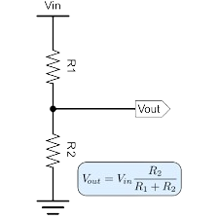

The input to the oscillator is given through Vin wire and the output here Vout is the wire going to Analog Read pin of Arduino.

2). Diode Circuit for push button(switch)

This approach has been utilized in almost everyday appliances to make sure current flows only in One direction. Basically, a diode consists of two terminals i.e., anode and cathode, only when voltage at anode is greater than the voltage at cathode does short happens in the circuit which makes the flow of current and voltage. Therefore, we are using diode as a switch which allows only one side flow. This method is being used in our project near the control buttons.

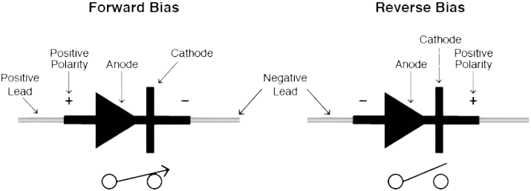

3). I2C interface to OLED display

Inter integrated circuit is the full form I2C. It is a synchronous bidirectional half duplex two wire serial interface bus. It is used to communicate between low-speed peripherals and microcontroller.it is a multimaster, multislave, packed switched interface. Firstly, the master device pulls the SCL of bus to high then the master device pulls the SDA low when SCL is at high then the master sends address of the slave to which communicate over SDA line. Then the master bit sends reads or write bit based on requirement. For write master waits for acknowledgement from slave after sending data. In read master sends data to slave. The block diagram is shown below

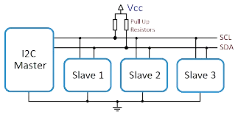

***Hardware and software used -***

Hardware: -

|  |  |  |
| --- | --- | --- |
| Component name | Value | Quantity |
| Create Your Own Electronics With Arduino - Full CourseArduino Uno | - | 1 |
| Resistor Icon at Vectorified.com | Collection of Resistor Icon free for ...  Resistor | 100k,10k | 1,3 |
| Image result for PCB Push Button  Pushbutton | - | 4 |
| Capacitor Vector Equipment PNG | Picpng  capacitor | 0.1nF | 1 |
| Diode | 1N4148 | 4 |

Software: - The programming software used for this project is Arduino IDE.

***BLOCK DIAGRAM-***

**OLED DISPLAY**

**Arduino Uno**

**Input signal**

**Power supply**

**Control button**

Arduino Uno: - It is a microcontroller board that will processes the raw data received from the input signal and send the processed data to OLED display through I2C interface.

Power supply: - In this project we are using +5V power supply to power the Arduino Uno microcontroller board and OLED display.

OLED display: -OLED is organic light emitting diode. In this project processed input signal by Arduino is then displayed on OLED display screen it can be any signal such as sinewave.

Control button: -In this project there are four control operation performed they are

1. Hold: -when the hold operation is performed even if the input signal is changed it will show last captured signal.
2. Up: - It is used to increase the frequency of the input signal or zoom in.
3. Down: - It is used to decrease the frequency of the input signal or zoomed out.
4. Select: -It is used to select the various parameter such as timescale, voltage.

Input signal: -input signal is given via voltage divider biased.

***Flowchart***

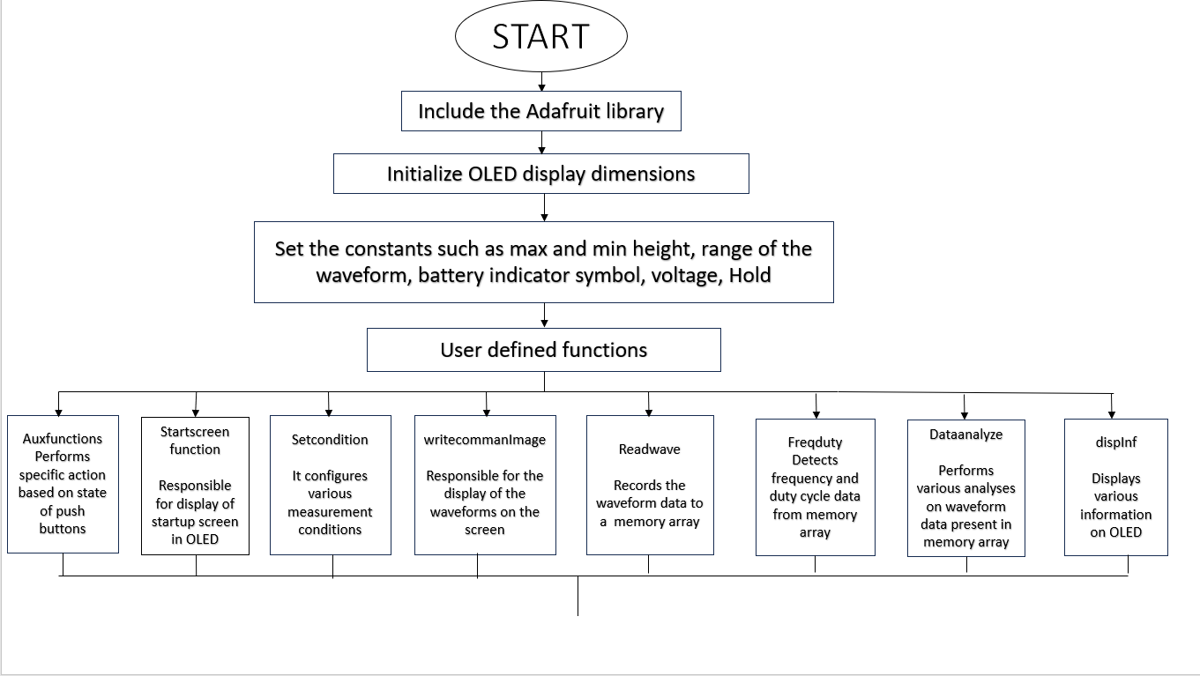



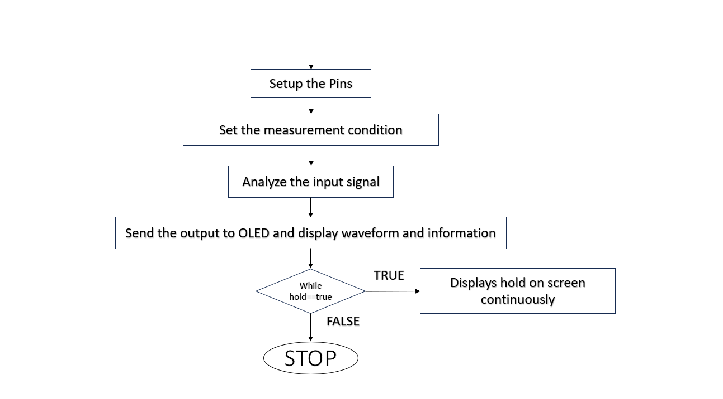



***Overall working of the system***

* ­­­­­­­­­The input of the system can be any type of signal which the user wants to see it on display.
* The signal is read through the analog input A0 and a digital pin D12 is also connected to the same.
* The digital pins D8, D9, D10, D11 is used for the control operations such as hold, frequency increase, frequency decrease and toggle options which are used for various purposes on the display.
* The Analog and digital pins via the ATmega 328P sample it convert it to digital format and sends the data over A4 and A5 pins which is also SDA and SCL pins of the OLED display which work as an I2C interface as explained in above chapter.
* Finally, the OLED display is used to display the signals which were taken as input to the system.
* Different types of signals such as sine, cosine, ramp, square, sawtooth and all types of signals can be displayed.
* Using the control options the peak-to-peak voltage can be measured along with the frequency of the signal. External supply of 5v only is required to power this device

**Circuit Diagram**

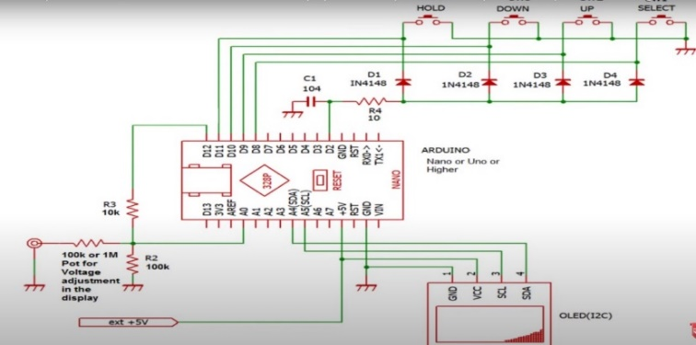

***Simulation and Experimental Results –***

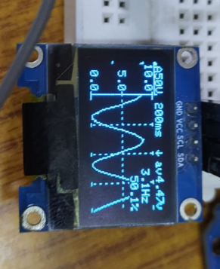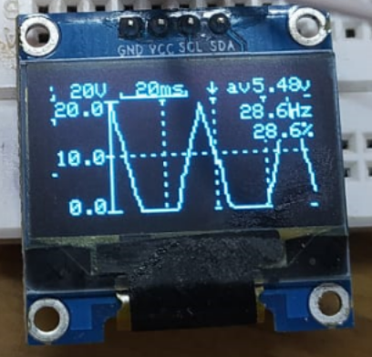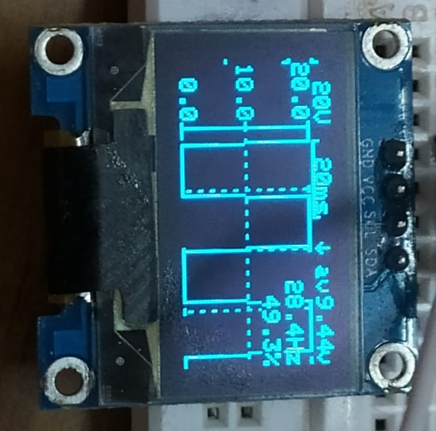

***Final conclusion***

Designed oscilloscopes is working very efficiently, all the wave forms were displayed accurately on OLED display and all the control operation such as hold, up, down and select was working as designed.

***Application and Advantages***

Application

1. It is used in engineering application for designing various analog circuits.
2. In telecommunication industry, oscilloscope will help to test and improve signal quality.
3. In medical application, medical devices such as ECG and EEG machines use oscilloscope technology to monitor heart and brain activities.

Advantages

1. It is cost efficient and easily portable.
2. It is easy to design.
3. It is easy to use.
4. It is used in debugging electronic circuit to give expected output.

***Future scope of the work***

1. This project will be further enhanced with larger OLED display that will improve clear analysis of waveform.
2. The oscilloscope can be enhanced to make it as a dual channel.

***References***

*1). DESIGN AND CONSTRUCTION OF ARDUINO BASED OSCILLOSCOPE/LOGIC ANALYSER by Osisiogu, Ukachi Oluwaseunin from electronic and computer engineering, Nnamdi Azikiwe university, Awka, Nigeria.* *NAU/2010364149, year-2010.*

# *2). ARDUINO-BASED OSCILLOSCOPE USING MOBILE DEVICE TECHNOLOGY AND BLUETOOTH LE from AMA computer college, East Rizal, Marcos Highway, Antipolo city. Year-2015.*

# *3). PC BASED OSCILLOSCOPE USING ARDUINO Rohit Tare, Rushikesh Bhonde, Prof. Suyog Gupta. (ICEMESM-2018).*

# *4).* [*https://www.youtube.com/watch?v=exiWoeLm4Wc&t=434s*](https://www.youtube.com/watch?v=exiWoeLm4Wc&t=434s) *for building the project*

# *5).* [*https://youtu.be/3fZsDloWDWY?si=oqkZ5Apo25tTLwyV*](https://youtu.be/3fZsDloWDWY?si=oqkZ5Apo25tTLwyV) *for information regarding function generator app.*