Self-Pruning Neural Network — Case Study Report

1. Why L1 Penalty on Sigmoid Gates Encourages Sparsity
In this self-pruning neural network, each weight is associated with a learnable gate parameter. These gate scores are passed through a sigmoid function to produce values between 0 and 1.
- A gate value close to 1 keeps the corresponding weight active.
- A gate value close to 0 effectively removes (prunes) the weight.
An L1 regularization term is applied to all gate values to encourage sparsity.
Why L1 promotes sparsity:
- The L1 norm encourages many values to become exactly zero.
- Minimizing the sum of gate values pushes them toward zero.
- This results in a sparser network by removing unnecessary connections.

2. Results: Effect of λ on Accuracy and Sparsity
Lambda (λ) | Test Accuracy (%) | Sparsity Level (%)
0.1 | 49.42% | 0.65%
1 | 49.51% | 3.86%
5 | 49.01% | 9.67%
Observations:
- Increasing λ increases sparsity.
- Higher sparsity slightly reduces accuracy.
- This shows the trade-off between efficiency and performance.

3. Gate Value Distribution
The histogram below shows the distribution of gate values for the best model (λ = 5).
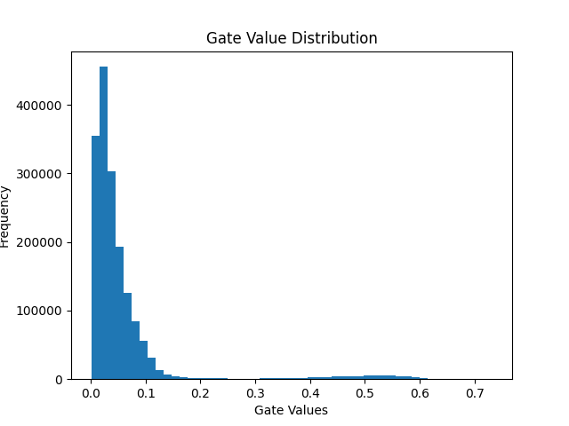
Interpretation:
- A spike near 0 indicates many pruned weights.
- A cluster away from 0 indicates important retained weights.
- This confirms successful self-pruning behavior.

4. Conclusion
The self-pruning neural network integrates pruning during training using gate parameters and L1 regularization. Increasing λ increases sparsity while slightly reducing accuracy. This demonstrates an effective trade-off between model compression and performance.

