AI Based Diabetes Prediction System

1.Problem Definition and Design Thinking

Developing an AI-powered diabetes prediction system involves addressing several complex challenges. The main problem can be defined as follows:

**Problem Statement:** Designing and implementing an AI-powered diabetes prediction system that accurately identifies individuals at risk of developing diabetes or predicts diabetes-related outcomes (e.g., blood glucose levels, complications) based on various input data, while ensuring ethical considerations, data privacy, and clinical validity.

Here are some key aspects and challenges associated with this problem:

1. **Data Collection and Quality:** Gathering high-quality and diverse data is crucial. This may include medical records, patient demographics, genetic information, lifestyle data, and more. Ensuring data accuracy, completeness, and relevance can be a significant challenge.

2. **Data Privacy and Security:** Protecting patient privacy and complying with healthcare data regulations (e.g., HIPAA in the United States) is paramount. Developing methods to de-identify and securely store sensitive health data is essential.

3. **Data Integration:** Integrating data from various sources and formats, such as electronic health records (EHRs), wearable devices, and genetic data, can be complex. Ensuring interoperability and compatibility is critical.

4. **Feature Engineering:** Selecting relevant features or variables from the data is important for building an effective predictive model. Identifying the most informative features and handling missing data are challenges.

5. **Model Development:** Developing machine learning or deep learning models that can accurately predict diabetes or related outcomes is a central challenge. This includes selecting appropriate algorithms, optimizing hyperparameters, and ensuring model interpretability.

6. **Model Validation:** Properly validating the model's performance using appropriate evaluation metrics and techniques is necessary. Overfitting and bias in the model must be addressed.

7. **Ethical Considerations:** Ensuring fairness and mitigating biases in the AI model's predictions is essential to prevent discrimination against certain groups. Developing a model that is unbiased and respects ethical guidelines is crucial.

8. **Clinical Validity:** The predictions made by the AI system must have clinical validity and be interpretable by healthcare professionals. Ensuring that the system aligns with medical knowledge and practice is vital.

9. **User Interface and Adoption:** Creating a user-friendly interface for healthcare professionals and patients to interact with the system is important for its adoption. Training and educating healthcare providers on using the AI system effectively are also challenges.

10. **Scalability and Maintenance:** The system should be scalable to handle a large volume of data and users. Regular maintenance, updates, and model retraining to adapt to changing healthcare conditions are necessary.

11. **Regulatory Compliance:** Ensuring compliance with healthcare regulations and standards, such as FDA approval for medical devices, if applicable, is crucial.

12. **Cost and Resource Allocation:** Developing and maintaining an AI-powered system can be resource-intensive. Managing costs and allocating resources effectively are important considerations.

In summary, developing an AI-powered diabetes prediction system is a multidisciplinary challenge that encompasses data collection, model development, ethics, and healthcare integration. Addressing these challenges is crucial to create a system that can help in early diabetes detection and management while maintaining patient privacy and safety.

2.Requirements for AI-powered diabetes prediction system

To create a successful AI-powered diabetes prediction system, you need to understand and address various requirements spanning technical, ethical, and practical considerations. Here is a list of key requirements for such a system:

1. **Data Access and Collection:**
- Access to comprehensive and diverse healthcare data, including electronic health records (EHRs), patient demographics, lab results, lifestyle data, and genetic information.
- Ethical and legal compliance for data acquisition, ensuring patient consent and data privacy (e.g., compliance with HIPAA regulations).

2. **Data Preprocessing and Cleaning:**
- Data cleaning to handle missing values, outliers, and errors.
- Data normalization and transformation to make it suitable for modeling.

3. **Feature Engineering:**
- Identification of relevant features or variables from the data.
- Feature selection and engineering techniques to extract meaningful information.

4. **Model Development:**
- Selection of appropriate machine learning or deep learning algorithms for diabetes prediction.
- Model training and optimization, including hyperparameter tuning.

5. **Model Validation:**
- Proper validation using appropriate evaluation metrics (e.g., accuracy, sensitivity, specificity, AUC-ROC).
- Cross-validation to assess model generalization.

6. **Ethical and Fairness Considerations:**
- Mitigation of bias in data and models to ensure fairness and avoid discrimination.
- Ensuring transparency and interpretability of the AI predictions.

7. **Clinical Validity:**
- Validation of the AI system's predictions against clinical knowledge and expertise.
- Involvement of healthcare professionals in model evaluation and validation.

8. **User Interface (UI) and User Experience (UX):**
- Development of an intuitive and user-friendly interface for healthcare professionals and patients.
- Designing alerts or notifications for timely intervention based on AI predictions.

9. **Interoperability:**
- Integration with existing healthcare systems, including EHRs and clinical decision support systems.
- Compatibility with different data formats and standards.

10. **Scalability and Performance:**
- Design for scalability to handle a large volume of data and user interactions.
- Consideration of real-time or near-real-time processing for timely predictions.

11. **Data Security and Privacy:**
- Robust data encryption and secure storage practices.
- Access controls to protect sensitive healthcare information.

12. **Regulatory Compliance:**
- Compliance with relevant healthcare regulations and standards, such as FDA approval if applicable.
- Adherence to data protection laws and patient rights.

13. **Training and Education:**
- Training healthcare providers on how to effectively use the AI system.
- Educational materials and resources for patients to understand the system's role in their healthcare.

14. **Maintenance and Updates:**
- Regular system maintenance, including updates to adapt to changing healthcare conditions and data.
- Monitoring for model drift and performance degradation.

15. **Cost and Resource Management:**
- Budgeting and resource allocation for development, deployment, and maintenance.
- Cost-effective solutions to minimize the financial burden on healthcare organizations.

16. **Patient Involvement and Informed Consent:**
- Involving patients in the decision-making process and obtaining informed consent for using their data in the AI system.
- Ensuring transparency in how patient data is used and protected.

17. **Feedback Mechanism:**
- Implementing a feedback loop for continuous improvement based on user and clinician feedback.

18. **Ethical Guidelines:**
- Adherence to ethical guidelines for AI in healthcare, promoting beneficence, non-maleficence, autonomy, and justice.

Meeting these requirements is essential to develop an AI-powered diabetes prediction system that is accurate, ethical, and clinically valuable, while also ensuring data privacy and regulatory compliance. Collaboration between data scientists, healthcare professionals, and legal experts is often necessary to navigate the complex landscape of healthcare AI.

3.Design System for AI-powered diabetes prediction system

Designing an AI-powered diabetes prediction system is a complex task that requires careful planning and consideration of various components. Below is a high-level plan outlining the design of such a system:

**1. Define Objectives and Scope:**
- Clearly define the objectives of the system, such as predicting diabetes risk, blood glucose levels, or complications.
- Determine the scope, including the target population (e.g., at-risk individuals, diabetes patients) and the specific predictions to be made.

**2. Data Collection and Integration:**
- Identify data sources, including electronic health records (EHRs), wearable devices, genetic data, and lifestyle data.
- Develop processes for data collection, ensuring compliance with data privacy regulations (e.g., HIPAA).
- Establish data pipelines for real-time or batch data ingestion and integration.

**3. Data Preprocessing and Cleaning:**
- Implement data preprocessing steps, including data cleaning, normalization, and feature extraction.
- Handle missing data and outliers appropriately.
- Ensure data quality and consistency.

**4. Feature Engineering:**
- Identify relevant features or variables for diabetes prediction.
- Use domain knowledge and data analysis to create informative features.
- Consider techniques like dimensionality reduction if needed.

**5. Model Selection and Development:**
- Choose appropriate machine learning or deep learning algorithms based on the problem and data characteristics.
- Develop and train predictive models using historical data.
- Optimize hyperparameters and perform cross-validation for model selection.

**6. Ethical and Fairness Considerations:**
- Implement measures to mitigate bias in data and models.
- Ensure fairness and transparency in predictions.
- Regularly audit the system for fairness and ethics.

**7. Model Validation and Evaluation:**
- Validate the models using relevant evaluation metrics (e.g., accuracy, F1-score, ROC-AUC).
- Assess the system's clinical validity through collaboration with healthcare professionals.
- Conduct user acceptance testing to ensure usability.

**8. User Interface (UI) and User Experience (UX):**
- Design an intuitive and user-friendly interface for healthcare professionals and patients.
- Incorporate features for visualization of predictions and trends.
- Implement notifications or alerts for timely interventions.

**9. Integration with Healthcare Systems:**
- Ensure interoperability with existing healthcare systems, such as EHRs and clinical decision support systems.
- Develop APIs for data exchange and integration.

**10. Security and Privacy:**
- Implement robust data encryption and access controls.
- Regularly audit and assess security measures.
- Continuously monitor for data breaches or unauthorized access.

**11. Regulatory Compliance:**
- Ensure compliance with relevant healthcare regulations, such as FDA requirements if applicable.
- Maintain documentation for regulatory audits.

**12. Scalability and Performance:**
- Design the system to handle increasing data volumes and user loads.
- Implement load balancing and resource scaling mechanisms.
- Monitor system performance and optimize as needed.

**13. Maintenance and Updates:**
- Establish a regular maintenance schedule for the system.
- Plan for model retraining to adapt to changing healthcare conditions and data.
- Implement version control for models and software components.

**14. Training and Education:**
- Develop training materials for healthcare providers on how to use the system effectively.
- Provide educational resources for patients to understand the system's role in their healthcare.

**15. Cost Management:**
- Budget for initial development and ongoing operational costs.
- Monitor and optimize costs to ensure cost-effectiveness.

**16. Patient Involvement and Informed Consent:**
- Involve patients in the design process where possible.
- Ensure informed consent for data usage and predictions.
- Communicate the benefits and risks of using the system to patients.

**17. Feedback Mechanism:**
- Implement a feedback loop to gather user and clinician feedback for continuous improvement.

**18. Documentation and Knowledge Transfer:**
- Maintain comprehensive documentation of system design, architecture, and processes.
- Ensure knowledge transfer to support and operational teams.

**19. Ethics and Compliance Oversight:**
- Establish an ethics committee or oversight body to monitor system behavior and ethical considerations.

**20. Pilot Testing and Deployment:**
- Conduct a pilot test with a small group of users or healthcare facilities to validate the system's functionality and performance.
- Gradually roll out the system to a wider user base.

This plan outlines the major steps and considerations for designing an AI-powered diabetes prediction system. It's essential to collaborate with domain experts, data scientists, software engineers, healthcare professionals, and legal experts throughout the design and development process to ensure the system meets its objectives while adhering to ethical and regulatory standards.

Techniques

1.Ensemble Methods for AI-powered diabetes prediction system

Ensemble methods can significantly improve the predictive performance and robustness of an AI-powered diabetes prediction system. Ensemble methods combine the predictions of multiple base models to produce a more accurate and stable final prediction. Here are several ensemble techniques you can explore for your diabetes prediction system:

1. **Bagging (Bootstrap Aggregating):**
- Bagging combines multiple models trained on bootstrap samples of the dataset (random subsets with replacement). Popular bagging algorithms include Random Forest and Bagged Decision Trees.

2. **Random Forest:**
- Random Forest is an ensemble of decision trees where each tree is built on a random subset of the data and features. It reduces overfitting and captures complex relationships in the data.

3. **Boosting:**
- Boosting algorithms train weak learners sequentially, with each learner focusing on the examples that the previous ones struggled with. Popular boosting algorithms include AdaBoost, Gradient Boosting, and XGBoost.

4. **AdaBoost (Adaptive Boosting):**
- AdaBoost assigns weights to data points and trains weak learners iteratively. It gives more weight to misclassified samples in each iteration, allowing the model to focus on difficult-to-predict cases.

5. **Gradient Boosting:**
- Gradient Boosting builds decision trees sequentially, with each tree correcting the errors of the previous one by optimizing a loss function. Algorithms like LightGBM and CatBoost are efficient implementations of gradient boosting.

6. **XGBoost (Extreme Gradient Boosting):**
- XGBoost is a popular and highly efficient gradient boosting algorithm that can handle missing data and offers regularization options to prevent overfitting.

7. **Stacking:**
- Stacking combines predictions from multiple base models using a meta-learner (higher-level model). The meta-learner learns to weigh the predictions of the base models to make a final prediction. Stacking can be particularly effective but requires careful tuning.

8. **Voting Ensembles:**
- Voting ensembles combine predictions from multiple models using a majority vote (hard voting) or by assigning weights to each model's prediction (soft voting). It can be used with various types of classifiers.

9. **Bootstrap Aggregating (Bagging) with Deep Learning:**
- Combine multiple neural networks trained on different subsets of the data to create an ensemble of deep models. This can improve the robustness of deep learning-based diabetes prediction.

10. **Ensemble of Heterogeneous Models:**
- Combine different types of machine learning models, including decision trees, support vector machines, neural networks, and gradient boosting, to leverage their complementary strengths.

11. **Feature-Level Ensemble:**
- Create ensemble models by combining predictions from different sets of features or feature engineering approaches, such as using genetic information separately from clinical data.

12. **Time Series Forecasting Ensembles:**
- For predicting blood glucose levels, consider ensembling various time series forecasting techniques, such as ARIMA, LSTM, and Prophet, to capture different aspects of the data.

When implementing ensemble methods, consider the following best practices:

- Ensure that the base models in the ensemble are diverse and have different sources of error.
- Regularize base models to prevent overfitting.
- Carefully tune hyperparameters, including the learning rates, number of iterations, and depth of decision trees.
- Cross-validate the ensemble to assess its performance and generalization.
- Monitor the ensemble's performance over time and retrain it as needed with new data.

Ensemble methods can significantly enhance the predictive accuracy and robustness of your AI-powered diabetes prediction system, making it more effective in identifying individuals at risk and assisting with diabetes management.

2.Deep learning architectures for AI-powered diabetes prediction system

Deep learning architectures have shown great promise in improving the accuracy and robustness of AI-powered diabetes prediction systems. Here are some deep learning architectures and techniques that you can explore for diabetes prediction:

1. **Recurrent Neural Networks (RNNs):**
- RNNs are well-suited for sequential data, making them valuable for time-series prediction tasks, such as predicting blood glucose levels. You can use Long Short-Term Memory (LSTM) or Gated Recurrent Unit (GRU) variants of RNNs to capture long-term dependencies in glucose data.

2. **Convolutional Neural Networks (CNNs):**
- CNNs can be used for feature extraction from medical images or wearable sensor data. For instance, they can analyze retinal images for diabetic retinopathy prediction or process data from glucose monitoring devices.

3. **Transformer-Based Models:**
- Transformer architectures, originally designed for natural language processing, have proven effective in various sequence-to-sequence tasks. You can adapt transformer-based models to capture complex temporal patterns in glucose data or clinical records.

4. **Autoencoders:**
- Autoencoders can be used for dimensionality reduction and feature extraction from high-dimensional medical data, such as electronic health records (EHRs). They can help in reducing the input data's complexity while retaining relevant information.

5. **Deep Neural Networks (DNNs):**
- Standard feedforward DNNs can be applied to feature-rich data like EHRs. You can experiment with different network architectures, including deep and wide neural networks, to learn complex patterns.

6. **Attention Mechanisms:**
- Incorporate attention mechanisms within RNNs or transformer-based models to focus on specific time steps or features in the data. This can be beneficial for capturing salient information in glucose time series or clinical notes.

7. **Temporal Convolutional Networks (TCNs):**
- TCNs are an alternative to RNNs for sequence modeling, offering parallelization and efficient training. They have shown promise in time-series forecasting tasks.

8. **Graph Neural Networks (GNNs):**
- GNNs can model relationships and dependencies between different patient attributes or healthcare entities, making them suitable for tasks involving structured data and patient networks.

9. **Bayesian Neural Networks:**
- Bayesian neural networks provide probabilistic predictions and can be used for uncertainty quantification in diabetes prediction. They offer a measure of confidence in the model's predictions, which is important for clinical decision-making.

10. **Transfer Learning:**
- Pretrain deep learning models on related healthcare data or tasks and fine-tune them for diabetes prediction. For example, you can use pretrained language models (e.g., BERT) on clinical text data and adapt them to your prediction task.

11. **Reinforcement Learning (RL):**
- Explore RL for personalized diabetes treatment recommendations. RL can optimize treatment plans based on patient responses and evolving health conditions, aiming for long-term health outcomes.

12. **Generative Models:**
- Consider using generative models like Variational Autoencoders (VAEs) to generate synthetic patient data for data augmentation, which can help improve model generalization.

13. **Ensemble of Deep Models:**
- Combine predictions from multiple deep learning models to create an ensemble. This can improve overall performance and model robustness.

When implementing deep learning architectures for a diabetes prediction system, it's important to consider factors such as data availability, model interpretability, computational resources, and ethical considerations. Collaborating with domain experts and healthcare professionals is essential to ensure that the models align with clinical practice and patient needs. Additionally, continuous monitoring and model updates are crucial to adapt to evolving healthcare conditions and improve model performance over time.

2.ALGORITHM

# Step 1: Data Collection
Load patient data from a dataset
# Data should include features like age, gender, BMI, family history, etc.

# Step 2: Data Preprocessing
Clean and preprocess the data
Handle missing values, outliers, and inconsistencies
Normalize or standardize numerical features

# Step 3: Feature Selection/Engineering
Select relevant features impacting diabetes risk
Create new features if necessary (e.g., calculate insulin resistance)

# Step 4: Splitting the Data
Split the dataset into a training set and a testing/validation set

# Step 5: Algorithm Selection
Choose a machine learning algorithm (e.g., logistic regression, decision trees, SVM, or neural networks)

# Step 6: Model Training
Train the selected algorithm on the training data
Optimize hyperparameters for better performance

# Step 7: Model Evaluation
Evaluate the model's performance on the testing/validation set
Calculate metrics like accuracy, precision, recall, F1-score, AUC-ROC

# Step 8: Hyperparameter Tuning
Fine-tune the model's hyperparameters for optimal performance
Prevent overfitting

# Step 9: Model Deployment
Deploy the trained model in a healthcare setting
Allow input of patient data and get diabetes risk prediction

# Step 10: Continuous Monitoring and Updating
Regularly update the model with new data
Ensure the model's accuracy and effectiveness are maintained

# Main Function
function main():
# Load and preprocess the data
data = load_and_preprocess_data()

# Feature selection/engineering
features = select_and_engineer_features(data)

# Split the data
train_data, test_data = split_data(features)

# Choose and train the algorithm
model = train_model(train_data)

# Evaluate the model
evaluation = evaluate_model(model, test_data)

# Deploy the model in a healthcare setting
deploy_model(model)

# Continuously monitor and update the model
while true:
update_model(model)

# Call the main function to start the system
main()

3.TOOLS AND TECHNOLOGIES

Developing an AI diabetes prediction system requires a combination of tools and technologies to collect, process, and analyze data, as well as to deploy and maintain the system. Here's a list of tools and technologies commonly used in building such systems:

1. **Programming Languages**:
- **Python**: Widely used for machine learning and data analysis due to its extensive libraries (e.g., NumPy, Pandas, Scikit-Learn).
- **R**: Popular for statistical analysis and visualization of healthcare data.

2. **Machine Learning and Deep Learning Frameworks**:
- **TensorFlow**: An open-source deep learning framework developed by Google.
- **PyTorch**: Another deep learning framework with a strong research focus.
- **Scikit-Learn**: A versatile library for machine learning in Python.
- **XGBoost**: A gradient boosting library for improved predictive accuracy.

3. **Data Preprocessing and Visualization**:
- **Pandas**: A Python library for data manipulation and analysis.
- **Matplotlib**, **Seaborn**, and **Plotly**: Tools for data visualization.
- **Tableau**: For creating interactive healthcare data dashboards.

4. **Collaboration and Version Control**:
- **Git**: For version control and collaborative development.
- **GitHub** or **GitLab**: Platforms for hosting and sharing code and collaborating with a team.

4.Loading and Preprocessing the Dataset.

Loading and preprocessing the dataset is a critical step in building an AI diabetes prediction system. This process involves gathering the data and preparing it for analysis. Here are the steps for loading and preprocessing the dataset:

1. **Data Collection**:
- Gather data from various sources, including electronic health records (EHR), surveys, genetic testing, or any other relevant healthcare data repositories.
- Ensure the data is in a format that can be easily imported into your chosen data processing tool or language.

2. **Data Exploration**:
- Load the dataset into your data analysis environment (e.g., Python with Pandas) to get a preliminary understanding of its structure and contents.
- Check for missing values, data types, and the distribution of features.

3. **Handling Missing Data**:
- Identify missing values and decide on an appropriate strategy for handling them (e.g., imputation, removal of rows/columns).
- Use techniques like mean, median, or machine learning imputation to fill missing values.

4. **Data Cleaning**:
- Clean the dataset to address outliers, inconsistencies, and errors in the data.
- Perform data validation to ensure data integrity.

5. **Data Transformation**:
- Convert data into a suitable format for analysis.
- Convert categorical variables into numerical representations (e.g., one-hot encoding).
- Normalize or standardize numerical features if necessary.

6. **Feature Engineering**:
- Create new features if relevant, such as calculating the body mass index (BMI) from height and weight or deriving an insulin resistance score.
- Select relevant features for the prediction task, considering domain knowledge.

7. **Data Splitting**:
- Split the dataset into two subsets: a training set and a testing/validation set. The training set is used to train the model, while the testing set is used to evaluate its performance.

ALGORITHM:LOGISTIC REGRESSION

Logistic regression is a commonly used algorithm in AI-based Diabetes Prediction Systems. It's particularly well-suited for binary classification tasks, such as predicting whether an individual is at risk of developing diabetes or not. Here's how logistic regression is applied in such systems:

**1. Data Collection**: Data related to individuals, including features like age, gender, family history of diabetes, BMI, blood glucose levels, and other relevant factors, is collected. The outcome variable, whether a person has diabetes or not (often encoded as 0 for non-diabetic and 1 for diabetic), is also part of the dataset.

**2. Data Preprocessing**: Data preprocessing steps are carried out, which may include handling missing values, normalizing or standardizing the data, and encoding categorical variables.

**3. Feature Selection/Engineering**: Relevant features are selected or engineered based on domain knowledge or using automated methods. In the context of diabetes prediction, important features might include age, BMI, and fasting blood glucose levels.

**4. Model Training**: Logistic regression models are trained using the prepared dataset. The algorithm fits a logistic curve to the data, which is a sigmoid-shaped curve that models the probability of an individual having diabetes based on the selected features.

**5. Parameter Estimation**: During training, logistic regression estimates the coefficients (weights) for each feature. These coefficients determine the impact of each feature on the probability of having diabetes. Positive coefficients indicate that as a feature's value increases, the probability of diabetes increases, while negative coefficients indicate the opposite.

**6. Prediction**: Once the logistic regression model is trained, it can be used to make predictions. For a new individual, the model calculates a probability score. If the score is above a certain threshold (often set at 0.5), the model predicts that the individual is at risk of developing diabetes.

**7. Model Evaluation**: The model's performance is evaluated using various metrics such as accuracy, precision, recall, F1-score, and area under the receiver operating characteristic curve (AUC-ROC). Cross-validation and testing on a separate dataset are typically used to assess the model's generalization performance.

**8. Interpretability**: One of the advantages of logistic regression is its interpretability. You can easily interpret the impact of each feature on the predicted outcome by examining the coefficient values.

Logistic regression is valuable in diabetes prediction systems due to its simplicity, interpretability, and effectiveness in binary classification tasks. However, it may not capture complex nonlinear relationships in the data as effectively as some other algorithms. Therefore, the choice of algorithm should be based on the specific characteristics of the dataset and the desired balance between interpretability and predictive accuracy. Often, a combination of algorithms is used to enhance the overall performance of the system.

PERFORMACE OF ALOGITTHM

The performance of a machine learning model, including logistic regression, in a Diabetes Prediction System is typically assessed using various evaluation metrics to gauge how well the model is making predictions. The choice of evaluation metrics depends on the specific goals of the system and the balance between different types of errors. Here are some common evaluation metrics used to assess the performance of a logistic regression model in a diabetes prediction system:

1. **Accuracy**: Accuracy measures the proportion of correctly classified instances (both true positives and true negatives) out of the total instances. While it's a straightforward metric, it may not be ideal when there's a class imbalance (e.g., a lot more non-diabetic cases than diabetic cases).

2. **Precision**: Precision is the ratio of true positives to the total number of instances predicted as diabetic. It tells us how many of the predicted diabetic cases are actually true diabetic cases. High precision means fewer false positives.

3. **Recall (Sensitivity)**: Recall measures the ratio of true positives to the total number of actual diabetic cases. It tells us how many of the true diabetic cases were correctly identified by the model. High recall means fewer false negatives.

4. **F1-Score**: The F1-Score is the harmonic mean of precision and recall. It provides a balanced measure of a model's accuracy, particularly when there's an uneven class distribution.

5. **Specificity**: Specificity is the ratio of true negatives to the total number of actual non-diabetic cases. It measures the model's ability to correctly identify non-diabetic cases.

6. **ROC Curve (Receiver Operating Characteristic Curve)**: The ROC curve is a graphical representation of the model's ability to distinguish between diabetic and non-diabetic cases. The area under the ROC curve (AUC-ROC) is a common metric that quantifies the model's performance. A higher AUC-ROC indicates a better ability to discriminate between the two classes.

7. **Confusion Matrix**: A confusion matrix provides a detailed breakdown of the model's predictions, showing the number of true positives, true negatives, false positives, and false negatives.

8. **Accuracy Paradox**: Sometimes, accuracy alone can be misleading, especially in imbalanced datasets. An accuracy paradox occurs when a high level of accuracy is achieved by simply predicting the majority class (e.g., non-diabetic) for all instances. In such cases, other metrics like precision, recall, and F1-score become more important.

9. **Cross-Validation**: Cross-validation techniques, such as k-fold cross-validation, are often used to assess how well the model generalizes to new, unseen data. It helps estimate the model's performance on an independent dataset.

The choice of the most appropriate evaluation metrics depends on the specific goals of your Diabetes Prediction System and the relative importance of minimizing false positives or false negatives. A well-balanced approach often involves considering a combination of these metrics to comprehensively assess the model's performance.

In practice, when using logistic regression for diabetes prediction, the model's performance is often measured in terms of accuracy, precision, recall, F1-score, and AUC-ROC, as these metrics provide a more comprehensive view of the model's ability to predict diabetes while considering both true positives and true negatives.

PROGRAM FOR DIABETES PREDICTION

1.Importing libraries

import pandas as pd
import numpy as np
import matplotlib.pyplot as plt
import seaborn as sns
2.Importing Dataset

dataset = pd.read_csv('../input/diabetes-data-set/diabetes.csv')

3.Viewing the dataset, its dimensions, features and statistical summary

dataset.head()

 | Pregnancies | Glucose | BloodPressure | SkinThickness | Insulin | BMI | DiabetesPedigreeFunction | Age | Outcome
0 | 6 | 148 | 72 | 35 | 0 | 33.6 | 0.627 | 50 | 1
1 | 1 | 85 | 66 | 29 | 0 | 26.6 | 0.351 | 31 | 0
2 | 8 | 183 | 64 | 0 | 0 | 23.3 | 0.672 | 32 | 1
3 | 1 | 89 | 66 | 23 | 94 | 28.1 | 0.167 | 21 | 0
4 | 0 | 137 | 40 | 35 | 168 | 43.1 | 2.288 | 33 | 1

dataset.info()

(768, 9)

dataset.info()

<class 'pandas.core.frame.DataFrame'>
RangeIndex: 768 entries, 0 to 767
Data columns (total 9 columns):
# Column Non-Null Count Dtype
--- ------ -------------- -----
0 Pregnancies 768 non-null int64
1 Glucose 768 non-null int64
2 BloodPressure 768 non-null int64
3 SkinThickness 768 non-null int64
4 Insulin 768 non-null int64
5 BMI 768 non-null float64
6 DiabetesPedigreeFunction 768 non-null float64
7 Age 768 non-null int64
8 Outcome 768 non-null int64
dtypes: float64(2), int64(7)
memory usage: 54.1 KB

sns.countplot(x = 'Outcome',data = dataset)

<Axes: xlabel='Outcome', ylabel='count'>
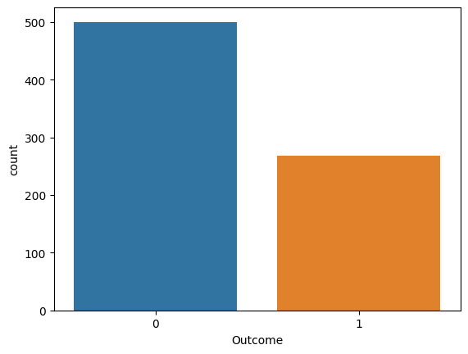

# Pairplot
sns.pairplot(data = dataset, hue = 'Outcome')
plt.show

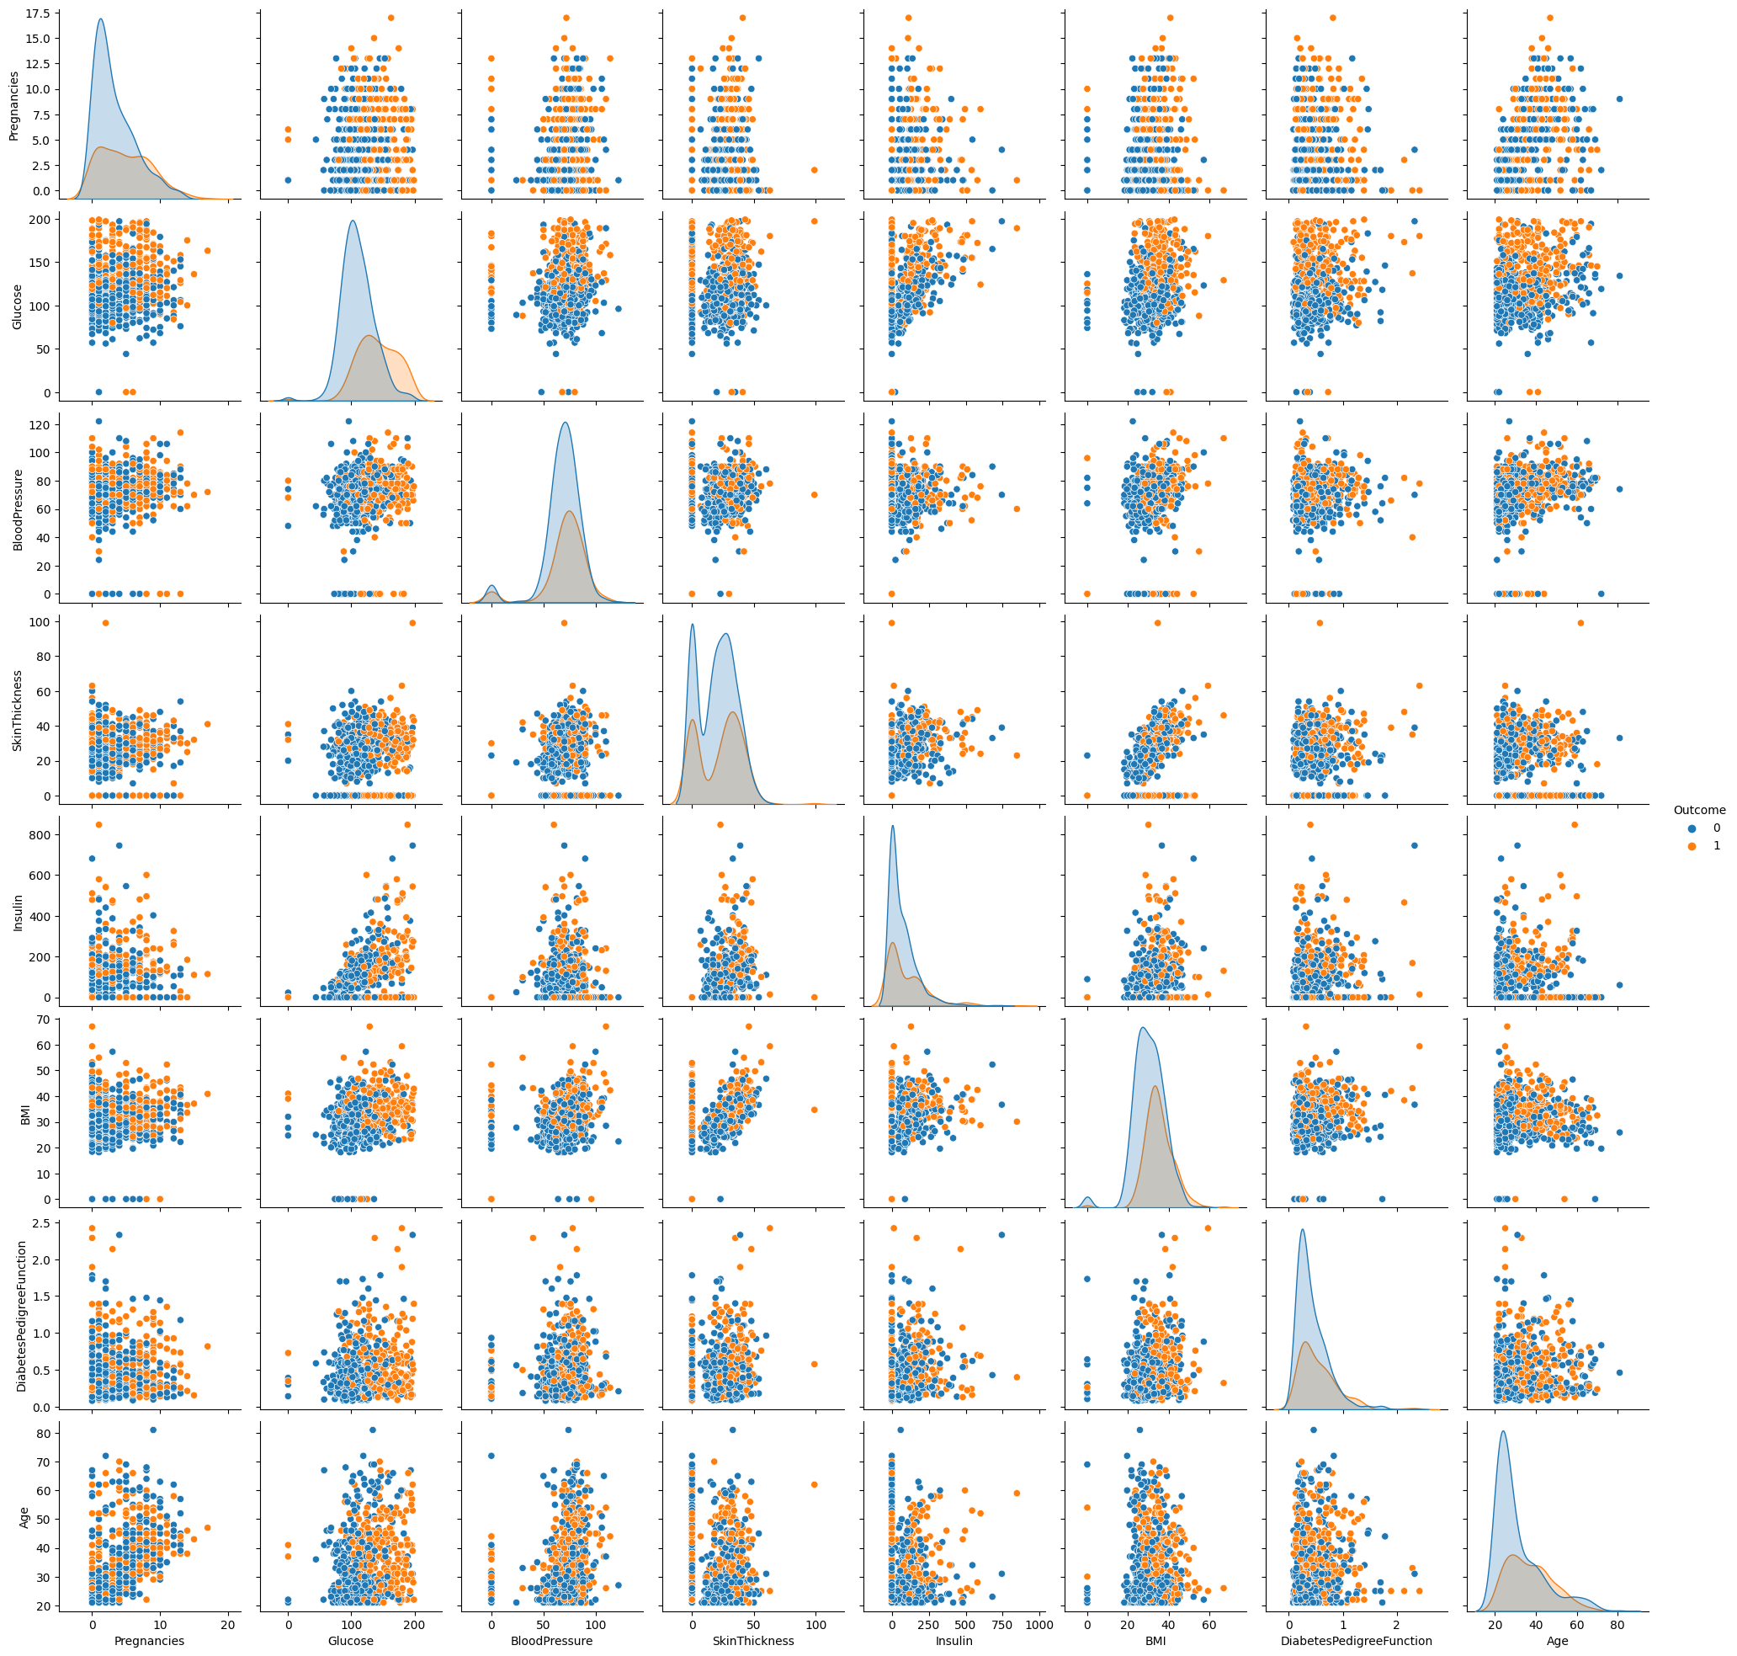

# Heatmap
sns.heatmap(dataset.corr(), annot = True)
plt.show()

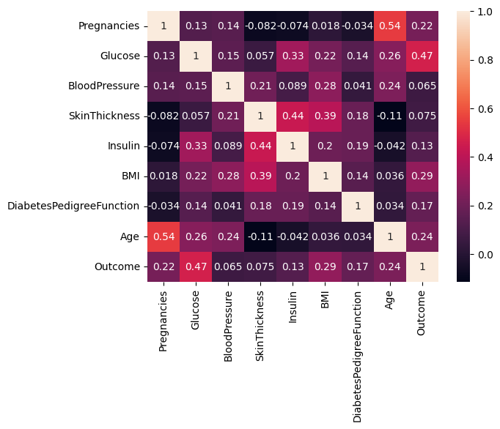

4.Processing the Data

# Replacing zero values with NaN
dataset_new = dataset
dataset_new[["Glucose", "BloodPressure", "SkinThickness", "Insulin", "BMI"]] = dataset_new[["Glucose", "BloodPressure", "SkinThickness", "Insulin", "BMI"]].replace(0, np.NaN)

# Count of NaN
dataset_new.isnull().sum()

Pregnancies 0
Glucose 5
BloodPressure 35
SkinThickness 227
Insulin 374
BMI 11
DiabetesPedigreeFunction 0
Age 0
Outcome 0
dtype: int64

# Replacing NaN with mean values
dataset_new["Glucose"].fillna(dataset_new["Glucose"].mean(), inplace = True)
dataset_new["BloodPressure"].fillna(dataset_new["BloodPressure"].mean(), inplace = True)
dataset_new["SkinThickness"].fillna(dataset_new["SkinThickness"].mean(), inplace = True)
dataset_new["Insulin"].fillna(dataset_new["Insulin"].mean(), inplace = True)
dataset_new["BMI"].fillna(dataset_new["BMI"].mean(), inplace = True)
dataset_new.isnull().sum()

Pregnancies 0
Glucose 0
BloodPressure 0
SkinThickness 0
Insulin 0
BMI 0
DiabetesPedigreeFunction 0
Age 0
Outcome 0
dtype: int64
5.Logistic Regression

y = dataset_new['Outcome']
X = dataset_new.drop('Outcome', axis=1)
# Splitting X and Y
from sklearn.model_selection import train_test_split
X_train, X_test, Y_train, Y_test = train_test_split(X, y, test_size = 0.20, random_state = 42, stratify = dataset_new['Outcome'] )
from sklearn.linear_model import LogisticRegression
model = LogisticRegression()
model.fit(X_train, Y_train)
y_predict = model.predict(X_test)
y_predict

array([1, 0, 0, 0, 0, 0, 0, 1, 0, 1, 0, 0, 0, 0, 0, 0, 1, 0, 1, 0, 0, 1,
0, 1, 0, 0, 1, 0, 0, 0, 0, 0, 0, 1, 1, 0, 0, 0, 1, 1, 0, 0, 0, 0,
0, 0, 0, 0, 1, 0, 0, 1, 0, 0, 0, 0, 1, 0, 1, 0, 1, 0, 0, 1, 0, 0,
1, 0, 0, 1, 0, 0, 0, 1, 0, 1, 0, 1, 0, 0, 0, 0, 0, 0, 0, 0, 0, 0,
0, 0, 1, 1, 0, 0, 0, 1, 1, 1, 1, 0, 0, 0, 0, 0, 1, 0, 1, 0, 1, 1,
0, 1, 0, 0, 0, 0, 0, 0, 1, 0, 1, 0, 0, 1, 0, 1, 1, 1, 0, 0, 0, 1,
0, 1, 1, 0, 0, 0, 0, 0, 0, 0, 0, 0, 0, 0, 0, 1, 0, 0, 0, 0, 1, 0])

# Confusion matrix
from sklearn.metrics import confusion_matrix
cm = confusion_matrix(Y_test, y_predict)
cm

array([[84, 16],
[25, 29]])

# Heatmap of Confusion matrix
sns.heatmap(pd.DataFrame(cm), annot=True)

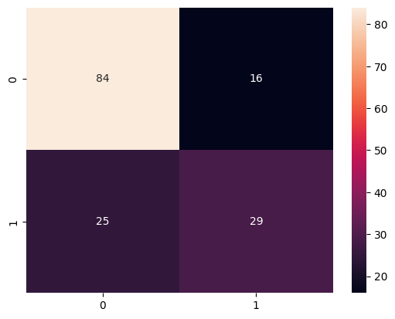

from sklearn.metrics import accuracy_score
accuracy =accuracy_score(Y_test, y_predict)
accuracy

0.7337662337662337

y_predict = model.predict([[1,148,72,35,79.799,33.6,0.627,50]])
print(y_predict)
if y_predict==1:
print("Diabetic")
else:
print("Non Diabetic")

Diabetic

CONCLUSION

In conclusion, an AI-based Diabetes Prediction System is a valuable tool in healthcare for early diagnosis and proactive management of diabetes. These systems use artificial intelligence and machine learning algorithms, with logistic regression being one of the commonly used models, to predict the risk of an individual developing diabetes.Overall, AI-based Diabetes Prediction Systems, with logistic regression and other machine learning algorithms, have the potential to assist healthcare professionals in the early diagnosis and management of diabetes, ultimately improving patient outcomes and quality of care. However, it's important to emphasize that these systems are designed to support healthcare professionals and not replace their expertise. They should be used as complementary tools to enhance healthcare decision-making.

