1. To check git version and make sure whether git is installed or not

🡪 git –version

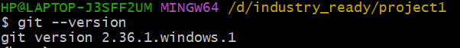

2. set-up of basic configuration w.r.to username & user email-id

🡪 git config --global user.name <"User_Name">

🡪git config --global user.email <"Email_Id">

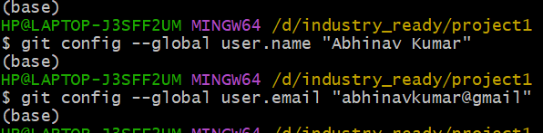

3. To initialize an empty git repository in the current directory

🡪 git init

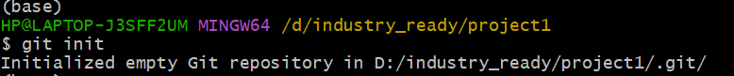

4. To check status of file, working directory and repository

🡪 git status



5. To add/track all files

🡪 git add .



6. To add all files in stagging environment

🡪 git commit -m "Added test.txt file for learning purpose"

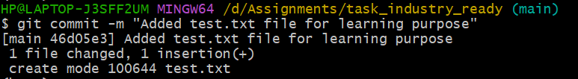

7. To create a remote repo pointing on your existing GitHub repository.

🡪 git add remote origin <"url of that repository">



8. To show the name and the url of the romte repositories.

🡪 git remote -v

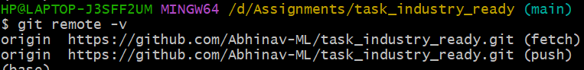

9. To create new branch

🡪 git branch <branch_name>

🡪egs. :- git branch developer1

10. To show all branch

🡪 git branch

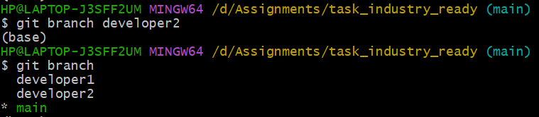

11. To move/switch into other branch.

🡪 git checkout <branch_name>

🡪 egs :- git checkout developer1



12. To delete branch

🡪 git branch -d <branch_name>

🡪 git branch -d developer1



13. To merge changes made by other branch into main branch

🡪 git merge <branch_name>

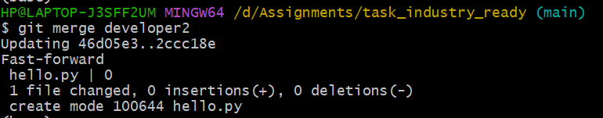

14. To check logs what changes has been made

🡪 git log

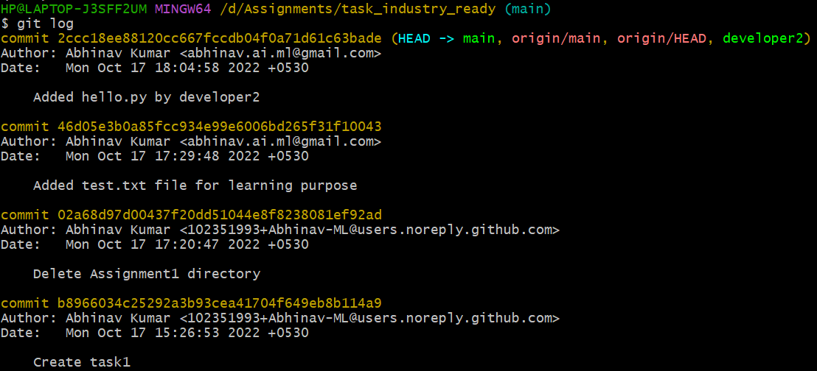

15. To fetches and merges changes on the remote server to our working directory.

🡪 git pull <repository url>

