3GPP TSG RAN WG1 Meeting #85 R1-163984
Nanjing, China 23rd - 27th May 2016
Agenda item: 7.1.2
Source: Samsung
Title: Discussion on phase noise modeling
Document for: Discussion and Decision

Introduction
At the 3GPP TSG RAN#71 meeting, new study item (SI) description regarding the “Study on New Radio Access Technology” was approved [1]. The objective of this new study item is to develop a “New Radio (NR)” access technology which provides a broad range of vertical services such as enhanced mobile broadband (eMBB), massive machine type communications (mMTC), and ultra-reliable low-latency communications (URLLC) in a single technical framework.
In the previous RAN1#84bis meeting, there were agreements on the evaluation of the numerology as follows [2]:
Agreements:
- RAN1 will continue further study and conclude between following alternatives in the next meeting
- Alt. 1:
- The subcarrier spacing for the NR scalable numerology should scale as
- f_{sc} = f₀ * 2^{m}
- where
  - f₀ is FFS
  - m is an integer chosen from a set of possible values
- Alt. 2:
- The subcarrier spacing for the NR scalable numerology should scale as
- f_{sc} = f₀ * M
- where
  - f₀ is FFS
  - M is an integer chosen from a set of possible positive values
- All companies are requested to analyze/evaluate following aspects
  - Realistic phase noise
  - How each alternative allows mixing different numerologies
- All companies are requested to propose exact values of
  - f₀, m, and M

In order to reflect realistic phase noise, a realistic oscillator phase noise model is required. This contribution discusses phase noise modeling and shows some preliminary evaluation results about phase noise impacts on OFDM subcarrier spacing.

Discussion

Phase noise model
Phase noise in oscillators is caused by noise in the active components and lossy elements which is up-converted to the carrier frequency. Frequency synthesizers generally consist of a reference oscillator (or clock), a voltage controlled oscillator (VCO), and a phase-locked loop (PLL) with frequency divider, phase-frequency detector charge pump, and loop filter. The characteristic of phase noise is usually explained from its power spectrum. Thus, several ways to make good approximation to practical phase noise spectra are developed for analysis. The simplest one is a single pole/zero model which is adopted in IEEE P802.15 [3]. However, it is a simple linear model for PLL so that it does not consider other phase noise sources. In [4], a new model considering three main noise sources such that reference clock, PLL, and VCO is proposed but loop bandwidth cannot be tuned easily. Therefore, as a compromised solution between easiness of analysis and good approximation to reflect practical phase noise characteristic, we proposed the multi-pole/zero model which is extended from a single pole/zero model by adding more pole/zero frequency terms as follows:
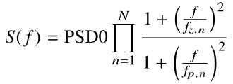, | (1)
where PSD0 is the power spectral density for zero frequency (f=0) in dBc/Hz, f_{z,n}’s are zero frequencies, and f_{p,n}’s are pole frequencies. The multi-pole/zero model has some advantages as follows:
- Provides an easy framework to convert the PSD of analog phase noise to that of discrete-time phase noise (i.e., baseband version) for simulation by using the bilinear transform with given pole/zeros.
- Practical phase noise power spectra can be well approximated with a few pole/zeros
Table 1 shows two parameter sets which are obtained from practical oscillators operating at 30GHz and 60GHz, respectively. We call them “Set-A” and “Set-B” for simplicity in this contribution.
Table 1. Example of parameter sets for the multi-pole/zero phase noise modeling
 | Parameter Set-A | Parameter Set-B
Carrier frequency (f_{c,base}) | 30GHz | 60GHz
PSD0 (dBc/Hz) | -79.4 | -70
Fp (MHz) | [0.1, 0.2, 8] | [0.005, 0.4, 0.6]
Fz (MHz) | [1.8, 2.2, 40] | [0.02, 6, 10]

In addition, if the operating carrier frequency is changed, the PSD is shifted by 20log₁₀ (f_{c} / f_{c,base}) dBc/Hz. Figure 1 shows the PSDs of the two parameter sets in 4GHz, 30GHz, and 70GHz center frequencies, respectively.
Proposal 1: Use multi-pole/zero model with configurable parameters such as PSD0 and multiple pole/zero frequencies for practical phase noise performance evaluations.
Proposal 2: Study how to decide the model parameters.
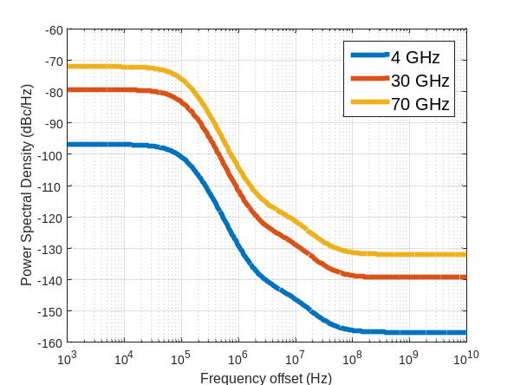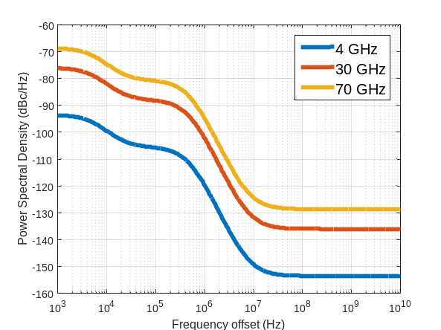
(a) Parameter Set-A (b) Parameter Set-B
Figure 1. Phase noise power spectral density

OFDM baseband signal model considering phase noise
When the mismatch of oscillator frequencies between transmitter and receiver occurs, the frequency difference implies a shift of the received signal spectrum at the baseband. In OFDM, this creates a misalignment between the bins of FFT and the peaks of the sinc pulses of the received signal. This breaks orthogonality between the subcarriers so that results in a spectral leakage between them. Each subcarrier interferes with every other (although the effect is dominant between adjacent subcarriers), and as there are many subcarriers this is a random process equivalent to Gaussian noise. Thus, this frequency offset lowers the SINR of the receiver. An OFDM receiver will need to track and compensate phase noise.
The baseband received signal in the presence of only phase noise, assumed that there is no additive white Gaussian noise (AWGN), is given as the following equation:
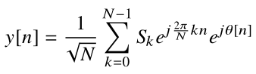, | (2)
where the transmitted signal is multiplied by a noisy carrier exp(jθ[n]).
The received signal is passed through the FFT in order to obtain the symbol transmitted on the m-th subcarrier in the OFDM symbol as follows:
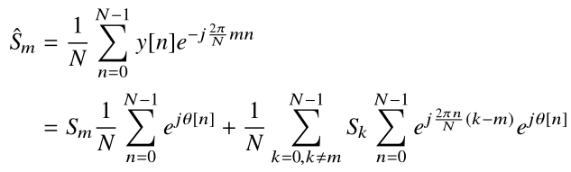, | (3)
Since the first term of the right hand side in (3) (i.e., mean of exp(jθ[n]) during one OFDM symbol duration) does not depend on subcarrier index m, it is called common phase error (CPE). This term causes common phase rotation in constellations of received symbols. The CPE can be estimated from the reference signals and removed. And the second term causes inter-carrier interference (ICI). The ICI due to phase noise creates a fuzzy constellation as shown in Figure 2.
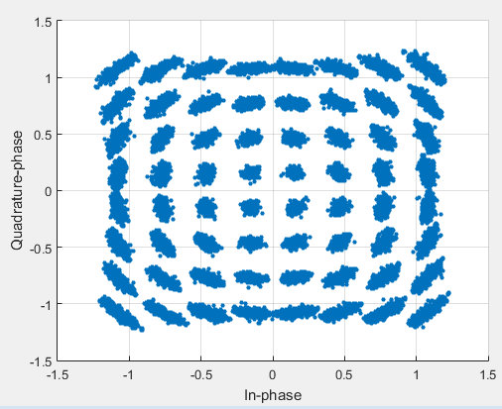
Figure 2. Phase noise impacts on constellations (64QAM)

Baseband phase noise generation
Baseband phase noise can be generated as shown in Figure 3. In multi-pole/zero modeling (including single pole/zero modeling), the phase noise PSD of contiguous time domain (or s-domain) can be easily converted to that of discrete time domain (or z-domain) by using bilinear transformation [5] with given phase noise parameter set (as shown in Table 1) and sampling frequency for baseband simulation.
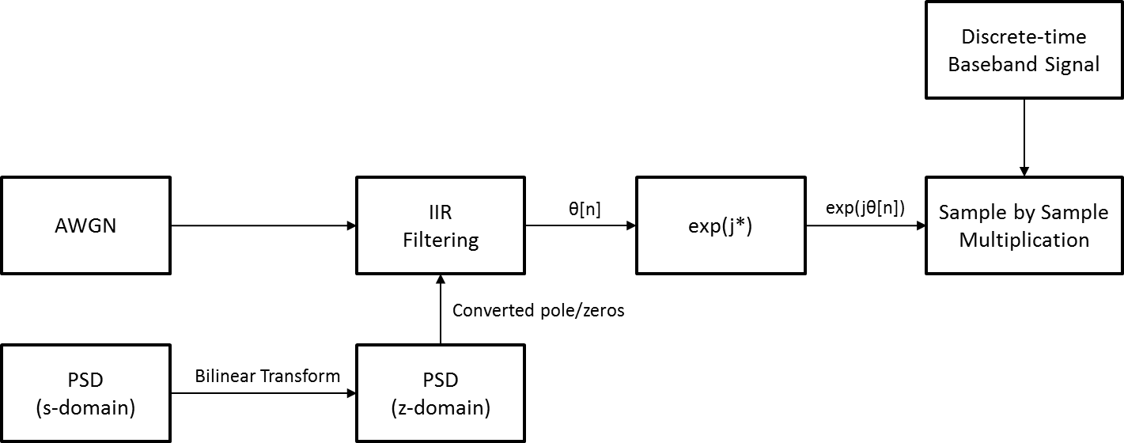
Figure 3. Phase noise generation procedure for baseband simulation

In Figure 4, the PSD of z-domain and the PSD estimate of generated phase noise according to the procedure as shown in Figure 3 are plotted for each phase noise parameter set, respectively. Here, the sampling frequency used for phase noise generation is 614.4MHz. The stop point of the PSD estimate is 307.2MHz, which is a half of the sampling frequency.
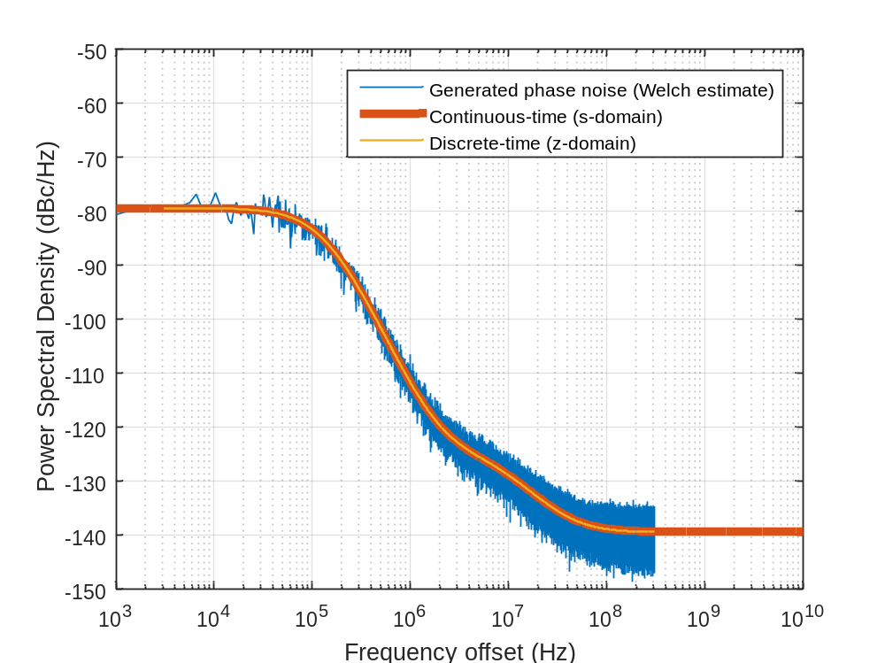
(a) Parameter Set-A (@30GHz)
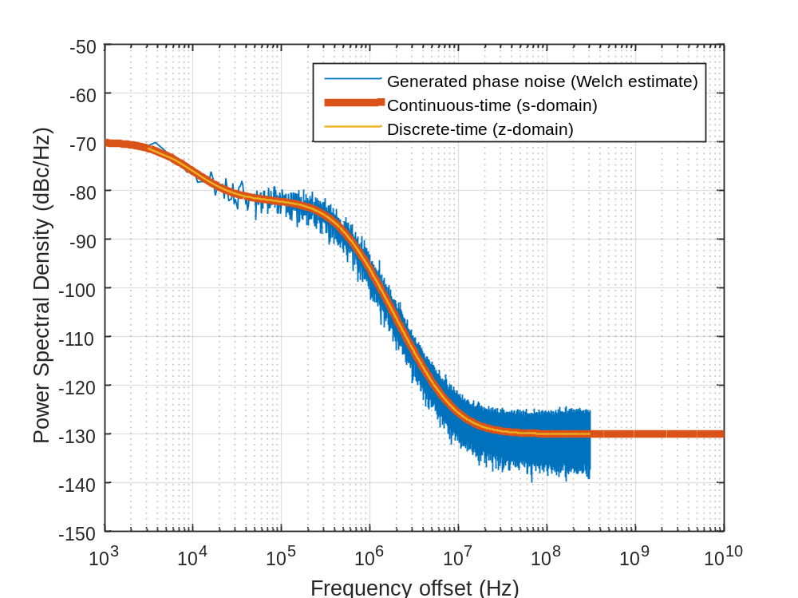
(b) Parameter Set-B (@60GHz)
Figure 4. Phase noise power spectral density comparison

Phase noise performance evaluation results
We considered the baseline subcarrier spacing 15kHz (same as in LTE) and the scaling factor one of {1, 2, 4, 5, 8, 10, 16, 20, 25, 32, 40, 50, 64} (2^{n}5^{m}). FFT size is fixed as 2,048 so the sampling frequency increases as the scaling factor goes larger. The number of data subcarriers is also fixed to be 1,200 (same as in LTE). We calculated error vector magnitude (EVM) of 64QAM symbols under two cases; one is EVM before CPE compensation (i.e., pure phase noise impacts) for performance lower bound and the other is EVM after Genie-based CPE compensation applied for performance upper bound. We applied phase noise impairment both at transmitter and receiver using the same parameter set. It is also assumed that there is no AWGN to see phase noise effects only.
Figure 5 shows EVM according to subcarrier spacing in case that parameter set-A is used at 30GHz, and Figure 6 shows EVM according to subcarrier spacing in case that parameter set-B is used at 70GHz. From the figures, we can observe the followings:
Observation 1: Discussion on the relationship between OFDM subcarrier spacing and phase noise is effective only when the CPE of phase noise is compensated properly.
Observation 2: Considering phase noise, large subcarrier spacing can help to enhance EVM performance when large bandwidth up to a few GHz needs to be supported in higher frequencies.
Observation 3: For higher frequencies, the f₀ * 2^{n} subcarrier spacing set shows too big EVM performance gap between adjacent subcarrier spacing values considering phase noise. On the other hand, the f₀ * 2^{n} * 5^{m} subcarrier spacing set with finite integers such that n=0,1,2,3,4,5,6,7,8 and m=0,1,2 seems to be good enough to support large bandwidth up to a few GHz in viewpoint of phase noise impacts.
Although larger subcarrier spacing helps to enhance EVM performance more but in time domain, OFDM symbol duration gets shorter so that CP overhead can be increased to support a given coverage. Therefore, OFDM numerology set for NR should be chosen carefully after detailed analysis.

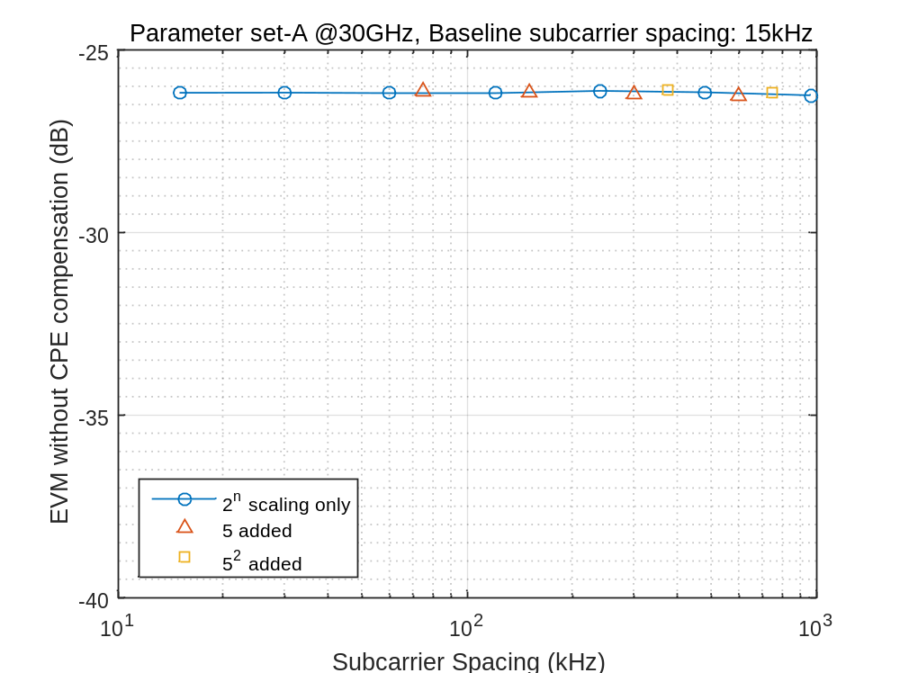
(a) Before CPE compensation

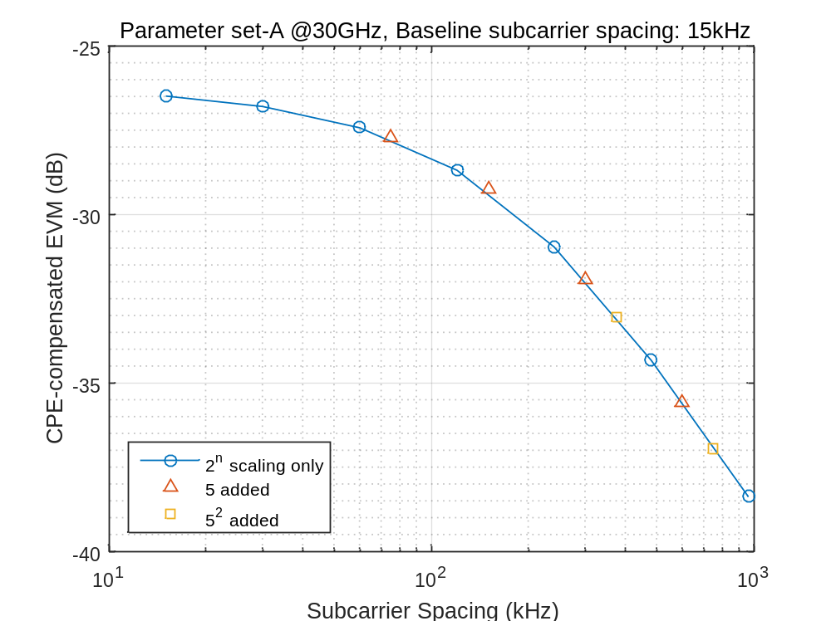
(b) After CPE compensation
Figure 5. EVM (dB) vs. OFDM subcarrier spacing (kHz) with parameter set-A at 30GHz
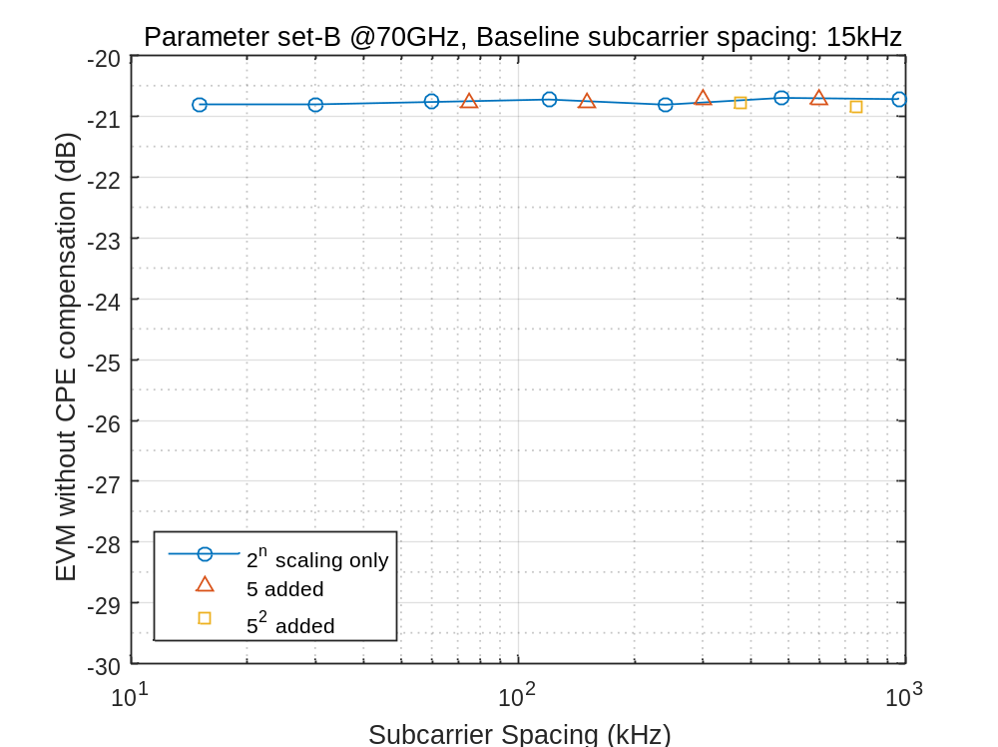
(a) Before CPE compensation

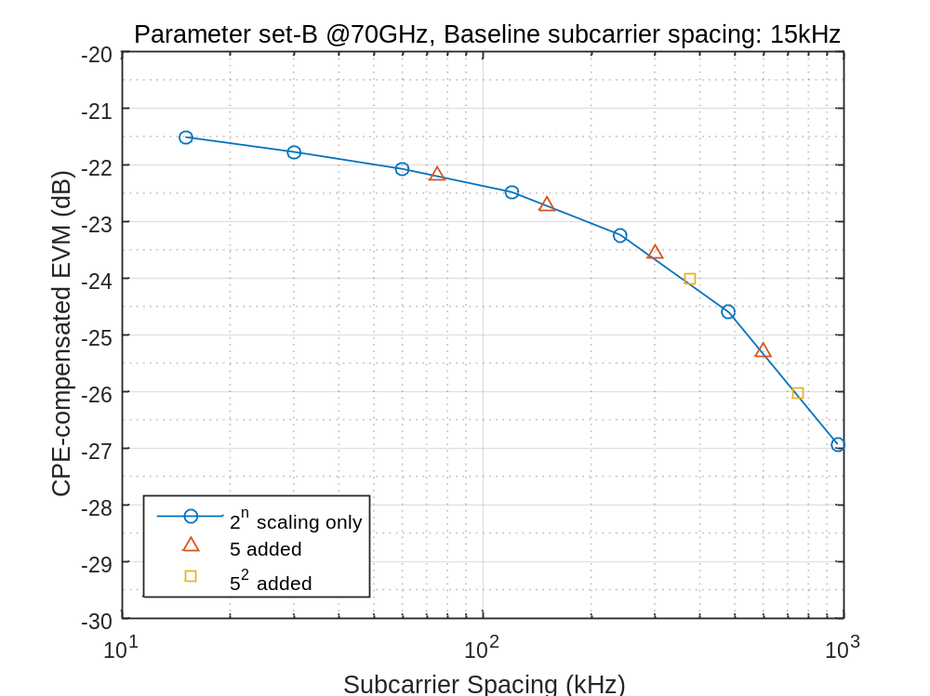
(b) After CPE compensation
Figure 6. EVM (%) vs. OFDM subcarrier spacing (kHz) with parameter set-B at 70GHz

Conclusion
In this contribution, we discussed phase noise modeling and showed some evaluation results about phase noise impacts on OFDM subcarrier spacing. The proposals and observations are as follows:
Proposal 1: Use multi-pole/zero model with configurable parameters such as PSD0 and multiple pole/zero frequencies for practical phase noise performance evaluations.
Proposal 2: Study how to decide the model parameters.
Observation 1: Discussion on the relationship between OFDM subcarrier spacing and phase noise is effective only when the CPE of phase noise is compensated properly.
Observation 2: Considering phase noise, large subcarrier spacing can help to enhance EVM performance when large bandwidth up to a few GHz needs to be supported in higher frequencies.
Observation 3: For higher frequencies, the f₀ * 2^{n} subcarrier spacing set shows too big EVM performance gap between adjacent subcarrier spacing values considering phase noise. On the other hand, the f₀ * 2^{n} * 5^{m} subcarrier spacing set with finite integers such that n=0,1,2,3,4,5,6,7,8 and m=0,1,2 seems to be good enough to support large bandwidth up to a few GHz in viewpoint of phase noise impacts.

References
[1] RP-160671, New SID Proposal: Study on New Radio Access Technology, NTT DOCOMO, RAN#71, March, 2016.
[2] RAN1 Chairman’s note, 3GPP TSG RAN WG1 Meeting#84bis, Busan, Korea, April, 2016.
[3] IEEE 802.15-06-0477-00-003c, RF Impairment models for 60GHz-band SYS/PHY Simulation, November, 2006.
[4] mmMAGIC D5.1, Initial Multi-Node and Antenna Transmitter and Receiver Architectures and Schemes, March, 2016.
[5] A. V. Oppenheim, et. Al., Discrete-Time Signal Processing, 2nd ed. (Chapter 7.1.2), Prentice-Hall, 1999.

