**Computer Architecture:-**

**Assignment-2**

**“Sorting Numbers in MARS simulator”**

**Project Report**

By:-

Abhinav Mahajan, IMT2020553

and

Shaurya Agrawal, IMT2020539

Using template provided(mips11.asm), in the required areas, code was edited to get desired result.

Steps:-

1. Numbers are copied from initial memory location to destination memory location to be sorted, as array at source memory location should remain unsorted.
2. Bubble sorting is the algorithm employed.
3. A loop is run from 0 to n-1. (loop variable i)
4. An inner loop is run from 0 to n-1-i. (loop variable k)
5. Swap if a[k+1] < a[k]
6. This way, the largest values get bubbled to the end and the array is sorted.
7. The functions of all the registers used and as to what variables they are used as in this algorithm, is commented.

Snapshots of input/output:-

Sample 1:-

Input:-

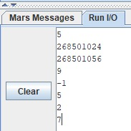

5 is number of numbers of array,

268501024 is memory location to store array

268501056 is memory location of sorted array

9, -1, 5, 2, 7 are the members of initial array

Output:-

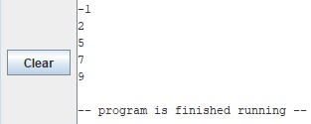

Registers look like:-

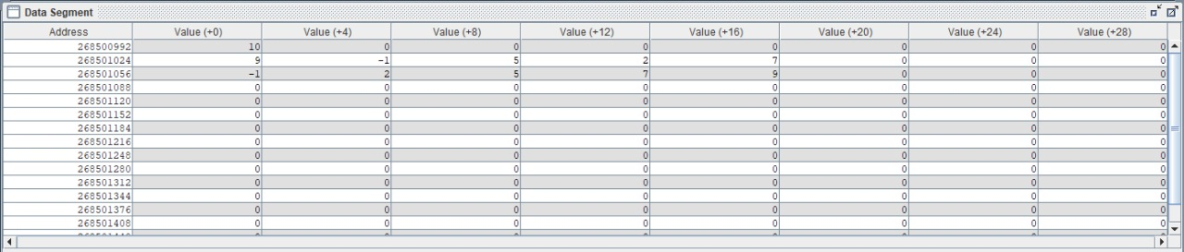

At memory location 268501024, Base array is stored, and remains unsorted.

At memory location 268501056, Destination array is sorted and stored.

Sample 2:-

Input:-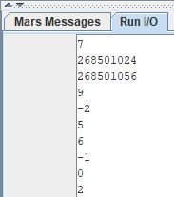

Output:-

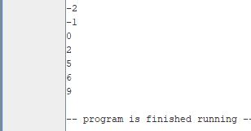

Registers:-

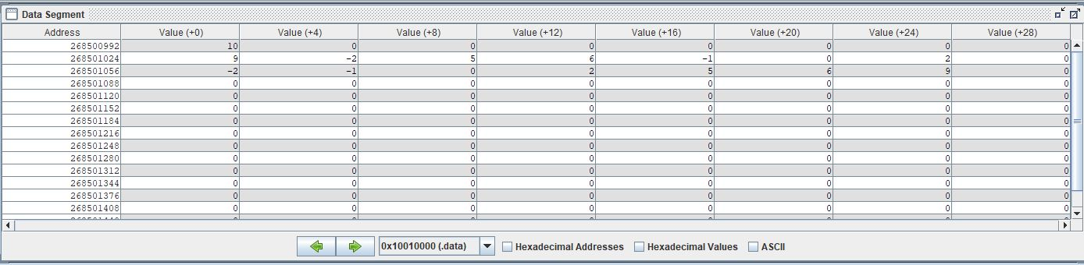

Sample 3:-

Input:-

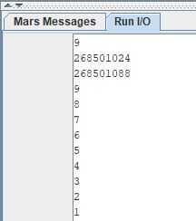

Output:-

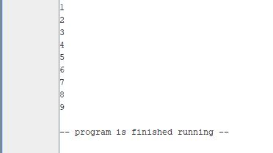

Registers:-

