Assignment – 2

Screenshot of all the test case of Bytestream passing:

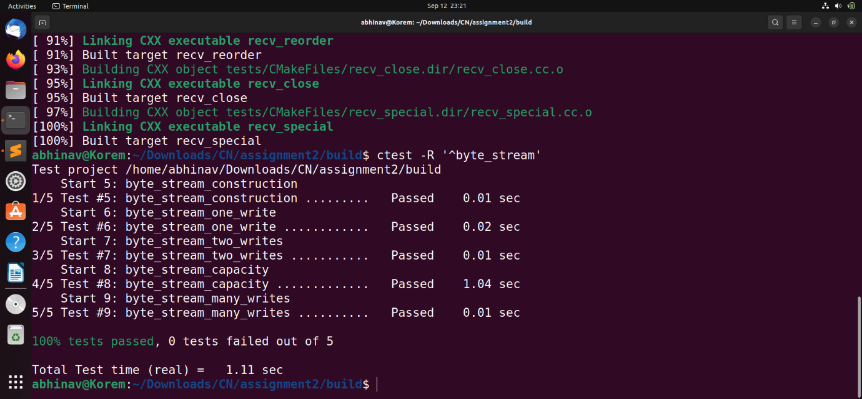

These are the variables that have been used to create the class ByteStream.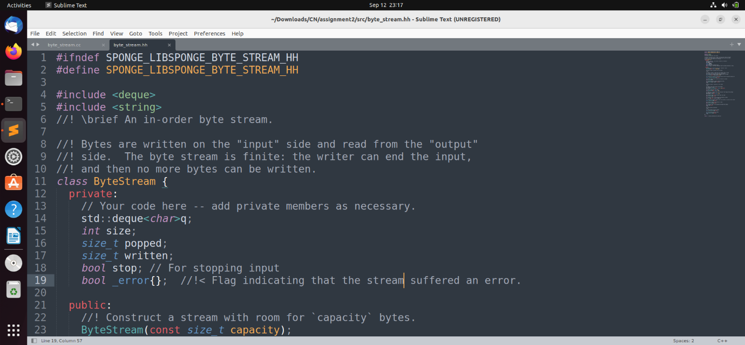

We have assumed that the functions other than the write, read, peek and pop are not affected by the _error flag being true and will function normally. The mentioned functions, however, will not work after the _error flag has been set to true.