Assignment3.1
Ch.Abhinav Reddy
Batch:-47-A
2303A54008

1:Zero-ShotPrompting(PalindromeNumberProgram)Prompt:-
- WriteaPythonfunctionis_palindrome(num:int) ->boolthatdeterminesifagivenintegerisa palindrome.Apalindrome number reads the same forwards andbackwards (e.g., 121,3443).
Requirements:
  - Input:Singleintegernum(canbepositive,negative,or zero)
  - Output:Trueifpalindrome,Falseotherwise
  - Handleedgecases:singledigits,zero,negativenumbers,numberswithleadingzerosin string form
  - Donotconverttostring—usemathematicaloperationsonly(reversedigits)
  - Timecomplexity:O(logn),Spacecomplexity:O(1)

  - Includedocstringandtypehints.Code(Python):-
defis_palindrome(num:int)->bool: ifnum
<0:
return False if num < 10: return True original_num = num reversed_num=0 while num > 0:
last_digit = num % 10 reversed_num = reversed_num * 10 + last_digit num //= 10 return original_num == reversed_num if name
== " main ": test_cases=[ (121, True),

(12321,True),
(1221,True),
(123,False),
(-121,False),
(0,True),
(5,True),
(10,False),
(101,True),
(1001,True),
(100,False),
(1234321,True),
(1234567,False),
(9999,True),
]
print("Testing is_palindrome function:") print("-" * 40) passed = 0 failed = 0 for test_num, expected in test_cases: result = is_palindrome(test_num) status
="✓PASS"ifresult==expectedelse"✗FAIL" if result

== expected:
passed+=1 else:
failed
+=1

print(f"is_palindrome({test_num:8})={result:5}|Expected:{expected:5}|{status}")

print("-"
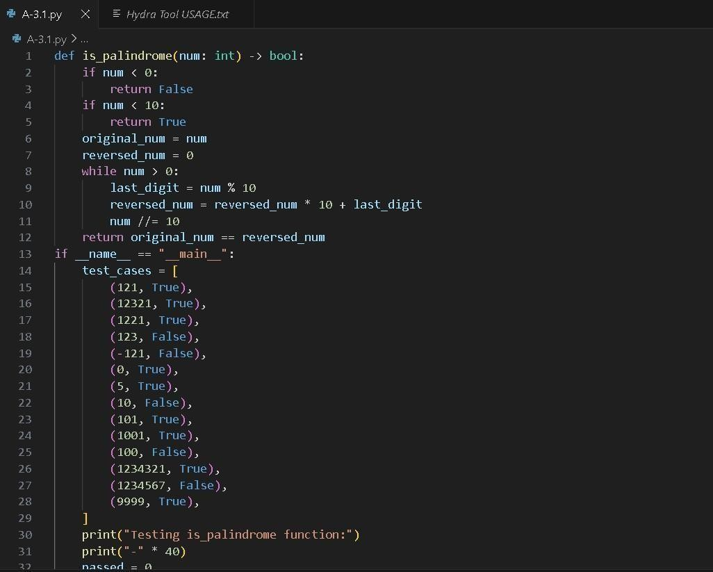
* 40)
print(f"Results:
{passed} passed,
{failed}failed")

Sampleoutput:-
Testingis_palindromefunction:

is_palindrome( 121)=True|Expected:True|✓PASSis_palindrome( 12321) =True | Expected:True | ✓ PASS is_palindrome( 1221) =

True|Expected:True|✓PASSis_palindrome( 123)=False|

Expected:False|✓PASSis_palindrome( -121)=False|Expected:False

| ✓ PASS is_palindrome( 0)=True|Expected:True|✓PASS is_palindrome(
5) =True | Expected:True | ✓ PASS is_palindrome( 10)=False| Expected:False|✓PASSis_palindrome( 101)=True|Expected:
True | ✓ PASS is_palindrome( 1001)=True|Expected:True| ✓PASS is_palindrome( 100)=False|Expected:False|✓PASSis_palindrome( 1234321) =True | Expected:True | ✓ PASS is_palindrome( 1234567) = False | Expected: False | ✓ PASS is_palindrome( 9999) =True | Expected:True | ✓ PASS

Results:14passed,0failed

2:One-ShotPrompting(FactorialCalculation)Prompt:-
WriteaPythonfunctionfactorial(n)thatcalculatesthefactorialofanon-negativeintegern.Thefactorialofn (denoted as n!) is the product of all positive integers less than or equal to n.
Provideoneexample:Forinput5,theoutputshouldbe120because5!=5×4×3×2×1=120. Requirements:
- Handlen= 0(0!=1bydefinition)
- Handlenegativeinputs(returnappropriateerror)•Useiterativeapproach(notrecursive)
- Include proper type hints and docstring Code(Python):- def factorial_one_shot(n: int) -> int: ifn<0: raise ValueError("Factorial is not defined for negative numbers")

ifn==0orn==1: return 1 result =
1 foriinrange(2,n+

1): result *= i returnresult def factorial_zero_shot(n):
if n<0: return
"Undefined" elifn==0: return
1 else:
result=1
foriinrange(1,n+1): result*=i returnresult

print("="*60)
print("FACTORIALCALCULATION-ONE-SHOTVSZERO-SHOTCOMPARISON")
print("="*60)
print("\nONE-SHOT SOLUTION (with example 5 → 120):") print("-"*40)test_cases=[5,0,1,7, -3,4]fornintest_cases:
try:
result=factorial_one_shot(n)
print(f"factorial_one_shot({n}) = {result}") exceptValueErroras e:
print(f"factorial_one_shot({n})raises:{e}")

print("\nZERO-SHOTSOLUTION(noexampleprovided):") print("-" * 40) for n in test_cases: result = factorial_zero_shot(n) print(f"factorial_zero_shot({n}) =
{result}")

print("\n" + "=" * 60) print("COMPARISONANALYSIS")
print("="*60)

print("\n1CODEQUALITY:")print("One-shot:Typehints,Propererrorhandling,Efficientloop (starts from 2)") print("Zero-shot: No type hints, Returns string for errors, Less efficient loop (starts from 1)")

print("\n2 EDGE CASE HANDLING:") print("One-shot: n=0 returns 1, n=1 returns 1,NegativeraisesValueError")print("Zero-shot:n=0returns1,n=1inefficient,Negativereturns string (mixed types)")

print("\n3DOCUMENTATION:")print("One-shot:Completedocstringwithexamples,parameters, and exceptions") print("Zero-shot: Minimal or no documentation")

print("\n4TESTOUTPUTS:")print("One-shot:Returnsintorraisesexception (consistent behavior)") print("Zero-shot: Returns int OR string
(inconsistentreturntypes)")print("\n"+"="*60) print("PERFORMANCE COMPARISON")
print("="*60)

importtimedeftime_function(func,n,iterations=100000):
start = time.perf_counter() for _ in range(iterations): ifn>= 0: func(n) end = time.perf_counter() return end - start n
= 10 iterations = 100000 one_shot_time = time_function(factorial_one_shot,n,iterations)zero_shot_time= time_function(factorial_zero_shot, n, iterations) print(f"\nPerformance test for n={n} (averaged over {iterations} iterations):") print(f"One-shot solution time: {one_shot_time:.6f} seconds") print(f"Zero-shot solution time: {zero_shot_time:.6f} seconds") if one_shot_time < zero_shot_time:
improvement=((zero_shot_time-one_shot_time)/zero_shot_time)*100 print(f"One-shotis
{improvement:.2f}%faster")else:
print(f"Zero-shotis{((one_shot_time-zero_shot_time)/one_shot_time)*100:.2f}%faster")

print("\n"+"="*60)
print("CONCLUSION") print("=" * 60) print("One-shot prompting produces more robust,efficient,andprofessionalcode")print("Theexample(5→120)helpedtheAI understand edge cases and requirements") print("One-shot solution follows Python best practices and has better error handling") Output:-
FACTORIALCALCULATION-ONE-SHOTVSZERO-SHOTCOMPARISON

- ONE-SHOTSOLUTION(withexample5→ 120):

factorial_one_shot(5)=120factorial_one_shot(0)=1factorial_one_shot(1)= 1 factorial_one_shot(7) = 5040 factorial_one_shot(-3) raises: Factorial is not defined for negative numbers
- ZERO-SHOTSOLUTION(noexample provided):

factorial_zero_shot(5)=120factorial_zero_shot(0)
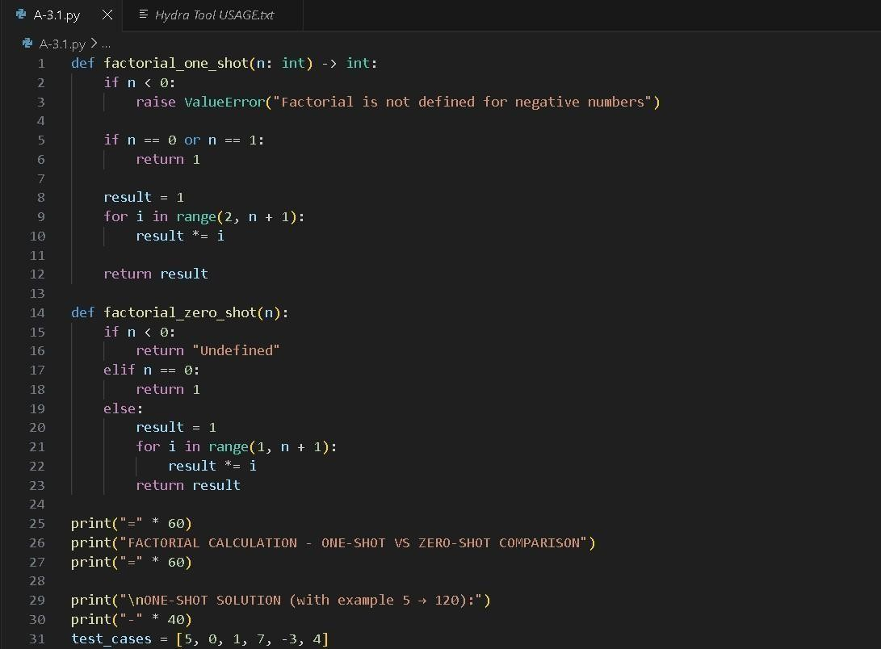

=1factorial_zero_shot(1)

=1factorial_zero_shot(7)=5040factorial_zero_shot(-3)
=Undefined

3:Few-ShotPrompting(ArmstrongNumberCheck)Prompt:-
WriteaPythonfunctionthatcheckswhetheragivennumberisanArmstrongnumber.AnArmstrongnumber is a number that is equal to the sum of its own digits each raised to the power of the number of digits.
Code(Python):-def is_armstrong(number):
# Input validation ifnotisinstance(number, int):
return"Invalidinput:notan integer" if number
<0:
return"Invalidinput:negativenumber"

digits= str(number) power= len(digits) total
=sum(int(digit)**powerfordigitindigits) iftotal
== number:

return"ArmstrongNumber"else:
return"NotanArmstrongNumber"print(is_armstrong(153))# Armstrong Number print(is_armstrong(370))# Armstrong

Numberprint(is_armstrong(123))#NotanArmstrongNumber

