Abhinav Singh  
CS 434

Homework #1

1. 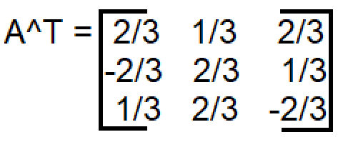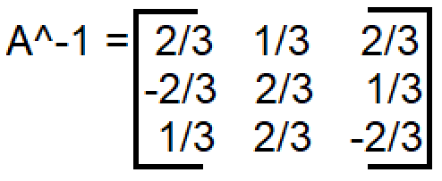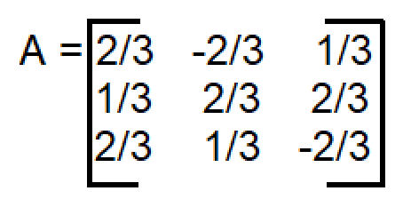A. False. Can have non independent cols.  
   B. False. Subtracts twice of the second column from the first.  
   C. True. Example:  
     
     
     
     
     
     
     
     
     
     
     
     
     
     
     
     
     
     
     
   D. True. All are linearly independent since they make up the basis, so the coefficients must all be 0.   
   E. False. The null space of A transpose does not correlate to the null space of A in such a manor. Therefore, we can also not claim that Rank(A) = 5.
2. A. Prove ATA is a symmetric matrix. For a matrix to be symmetric its transpose must be equal to itself.   
   (AT \* A)T = AT \* ((AT)T) (this is true because (AB)T = BTAT)  
   AT \* ((AT)T) = ATA (this is true because transpose of a transpose gets us back to the original matrix)  
     
   This shows that ATA is a symmetric matrix.  
     
   B. Prove Rank(AB) <= min{Rank(A), Rank(B)}  
   We can consider the new matrix A,B as a linear combination of A and B. Specifically we can see each column as a combination of the columns of A (as it is multiplied to B). Therefore, the column space of AB is included in A meaning that the rank is less than or equal to A’s rank. Similarly, each row in AB is a combination of the rows of B (as it is multiplied by A). That means that the row space of AB is included in B. The dimension of the row space is equal to that of the column space, meaning that as we did with A, we can say that the rank of AB is less than or equal to B’s.
3. A.   
   3x + 2y = 10 -> 6x + 4y = 20  
   6x + 4y = b  
     
   Subtracting second equation from the first: 0 = 20 – b.  
   Infinitely many solutions when b = 20, no solutions for any other value. For example, if b = 5 then we get 0 = 15, therefore no solution.  
     
   B. dim(N(A)) = n – r. Therefore, there are either 0 or infinite solutions.
4. 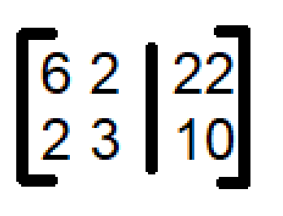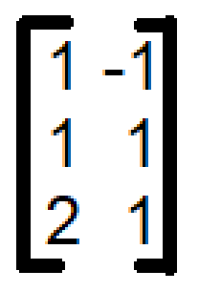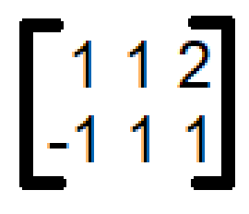x – y = 2  
   x + y = 4  
   2x + y = 8  
     
   Adding first and second: 2x = 6 -> x = 3  
   Adding first and third: 3x = 10 -> x = 10/3  
     
   No solution, must do least squares. Ax = B  
     
   A =   
    AT=   
     
     
     
     
     
     
     
     
     
     
     
     
     
     
   B =   
     
     
     
     
     
     
     
     
     
   ATAx = ATb  
     
   ATA = [6 2, 2 3]  
   ATb = [22 10]  
     
   Using row reduction -> [6 2, 0 7 | 22 8] (row 2 = row2\*3 – row 1)  
   [6 2, 0 1 | 22 8/7] (row 2 = row 2 / 7)  
   [6 0, 0 1 | 138/7 8/7]  
   [1 0 , 0 1 | 23/7 8/7]  
     
   x = [23/7 8/7]
5. A. Eigenvalues of matrix A2 = (eigenvalues of A)2  
   By the definition of eigenvalues we have Ax = lambda x. In order to get A2 we can multiply both sides getting A2x = A lambda x. Since lambda is a constant we can right it as lambda (Ax). Our very first equation of Ax = lambda x can be substituted back here to get A2x = lambda (lambda x). This evaluates to A2x = lambda2x showing our original proof to be true.   
     
   B. lambda (A – sigma I) = (lambda(A) – sigma)  
   by the properties of eigenvalues we can say that lambda (A – sigma I) = lambda (A) – lambda (sigma I). From here we get a diagonal matrix with the values of sigma. The eigenvalues of a diagonal matrix are simply the elements along the diagonal meaning that lambda (sigma I) = sigma. This gets us a final equation of lambda(A) – sigma, proving the above statement.