Abhinav Singh  
ECE 434

Homework #2

1. A. 2nd column of the Fourier matrix, which is [ej0 ejθ ej2θ . . . ej(N−1)θ]T3rd column of the Fourier matrix is [ej0 ej2θ ej4θ . . . ej2(N−1)θ]T  
   For a vector to be orthogonal to another vector, they’re dot product is zero. Calculating the dot product is not just the sum of the products of the corresponding entries. It is the sum of the first entry and the complex conjugate of the second. This is also defined as sum from 1 to n of xi \* complex conjugate of yi. Using this we can simply find the dot product of our two columns. Doing so we can calculate this as  
     
   dot product = 1 + ejθe-j2θ + ej2θe-j4θ …. + ej(N−1)θ e-j2(N−1)θWhat we can see here as that the first term gets us a value of 1, while the rest of the dot product will sum up to the value of -1. As a result we can see that our dot product is zero and therefore these two columns are orthogonal.   
     
   B. The 2nd column of the Fourier matrix, which is [ej0 ejθ ej2θ . . . ej(N−1)θ]T will hold this property of being orthogonal to all other columns as well. If we take the Kth column of the Fourier matrix we will get [ej0 ej(K-1)θ ej2(K-1)θ . . . ej(K-1)(K−1)θ]T. Using the same process as last time we can compute the dot product with the complex conjugates.  
     
   dot product = 1 + ejθe-j(K-1)θ + ej2θe-j(2K-1)θ …. + ej(N−1)θ e-j(K-1)(K−1)θHere we can clearly see the same thing as last time, with the summation of all of the dot product coming out to zero. As a result, the 2nd column and any other column will be orthogonal.   
     
   C. We can attempt to do the same process as the previous two parts to prove orthogonality. With the Kth column and Lth column we get [ej0 ej(K-1)θ ej2(K-1)θ . . . ej(K-1)(K−1)θ]T and [ej0 ej(L-1)θ ej2(L-1)θ . . . ej(L-1)(L−1)θ]T respectively.   
   dot product = 1 + ej(K-1)θe-j(L-1)θ + ej2(K-1)θe-j(2L-1)θ …. + ej(K−1)(K-1)θ e-j(L-1)(L−1)θWe can prove that this sums out to zero as well. However, a simpler way of proving this is via the rules of orthogonality. We already know that both­ columns are orthogonal to column 2. Given that K != L, then we know that these two columns must be orthogonal to each other. If two vectors are orthogonal to another and not scalar multiples of each other, then they must be orthogonal to each other.
2. 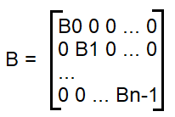A.   
   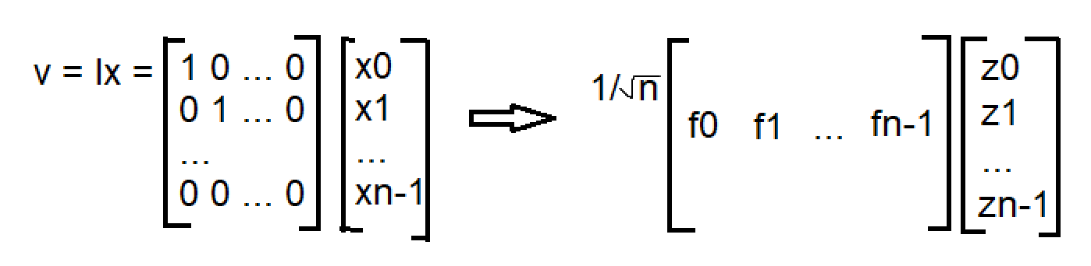  
   B.   
     
     
     
     
     
     
     
     
   where b is n x n  
     
   C. z = Bw  
   zib = z F-1, where z = [f0, f1, … fn-1]  
     
   D. final = B(Fv)F-1  
     
   E. A = S ΛS-1  
     
   F. What Eigendecomposition does is reduce a matrix into its eigenvectors and eigenvalues. This can make it easier­ for us to carry out certain operations with the matrix as needed. By multiplying matrix A with vector x, you are getting just the main components.
3. A. In sports there are different criteria for winning awards that can be expressed in different ways. For example, the NBA MVP award has several factors that go into voting. One such basis for this could be {narrative, stats, wins}. Another such basis would be {media story, on court impact, team success}.  
   ­  
   B. This transform is the NBA MVP transform.
4. A. 0.25 milliseconds / sample = 0.00025 seconds / sample  
   sampling rate = 1/.00025 = 4000  
   sampling rate = 4000 Hz  
     
   B. N = 1000   
   sampling rate / N = 4000 Hz / 1000 = 4 Hz  
   Frequency resolution R = 4 Hz  
     
   C. False. This only applies to the real values of the FFT.  
     
   D. True. When you shift xn by k samples you shift the DFT to xm \* ej2pi…. This is in the form given in Yf, therefore Yf is a shifted DFT. Running the IDFT on Yf we would get a shifted signal on xn.
5. A. x[n] = cos(2πf1nts) + 2 sin(2πf1nts) + sin(4πf1nts)   
   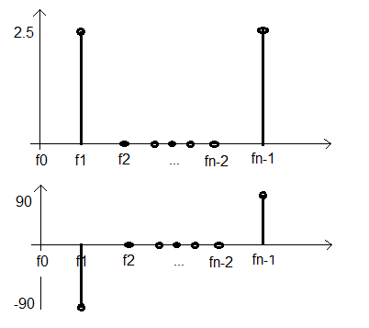  
     
   B. Prove that DFT is linear, i.e., DFT(a1x[n] + a2y[n]) = a1Xf +a2Yf , where Xf and Yf are the DFTs of x[n] and y[n], respectively.  
     
   final dft = 1/ sqrt(N) \* sum from n=0 to n-1 (a1x[n] + a2y[n])e-j2(pi/N)\*f\*n  
   = 1/sqrt(N) \* ∑ n=0 to n-1 (a1x[n])e-j2(pi/N)\*f\*n + 1/sqrt(N) \* ∑ n=0 to n-1 (a2y[n])e-j2(pi/N)\*f\*n= a1/sqrt(N) \* ∑ n=0 to n-1 (x[n])e-j2(pi/N)\*f\*n + a2/sqrt(N) \* ∑ n=0 to n-1 (y[n])e-j2(pi/N)\*f\*n  
   inside the summation we get Xf and Yf proving that DFT is independent
6. 