A PROJECT ON

GESTURE CONTROLLED VLC MEDIA PLAYER

USING PYTHON & ARDUINO

A PROJECT REPORT SUBMITTED TO

DR APJ ABDUL KALAM TECHNICAL UNIVERSITY, LUCKNOW

IN THE PARTIAL FULFILLMENT OF REQUIREMENTS FOR THE AWARD OF DEGREE OF

BACHELOR OF TECHNOLOGY

**IN**

COMPUTER SCIENCE AND ENGINEERING

(2018-2022)

SUBMITTED BY

ABHAY PRATAP SINGH PARIHAR 1816410007

ABHINAV SHUKLA 1816410011

AKASHDEEP SONI 1816410036



UNDER GUIDANCE OF

SIR KUMAR SAURABH

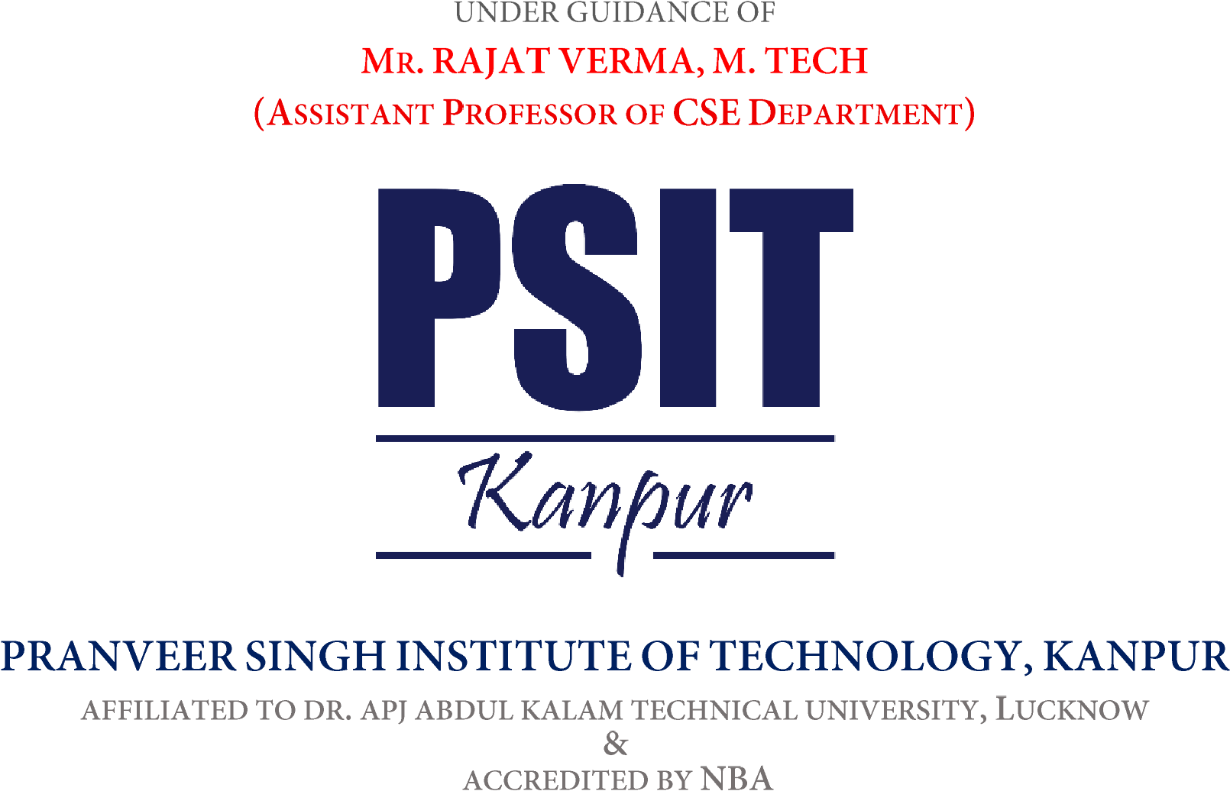

PRANVEER SINGH INSTITUTE OF TECHNOLOGY, KANPUR

AFFILIATED TO DR. APJ ABDUL KALAM TECHNICAL UNIVERSITY, LUCKNOW

&

ACCREDITED BY NBA

CERTIFICATE

PRANVEER SINGH INSTITUTE OF TECHNOLOGY, KANPUR

AFFILIATED TO DR. APJ ABDUL KALAM TECHNICAL UNIVERSITY, LUCKNOW

&

ACCREDITED BY NBA

This is to certify that the project work entitled as “**GESTURE CONTROLLED VLC MEDIA PLAYER*”*** is being Submitted by -

1816410007, **ABHAY PRATAP SINGH PARIHAR**

1816410011, **ABHINAV SHUKLA**

1816410036, **AKASHDEEP SONI**

In the partial fulfillment for the award of the degree of “**Bachelor of Technology**” in **“COMPUTER SCIENCE AND ENGINEERING”** in the academic duration 2018 - 2022.

**Under the Guidance of Head of the Department**

**SIR KUMAR SAURABH Dr. Vishal Nagar**

**(Head of CSE department)**