

**SMART VOTING**

**(Online Voting System)**

***A PROJECT REPORT***

**Submitted to the Faculty of Computer Science of**

**SARASWATI DEGREE VIDYA MANDIR, NEELAKANTHA NAGAR,**

**BERHAMPUR, ODISHA,760002**

**In Partial Fulfillment of the requirements for the award of degree**

**Bachelor in Science**

***With specialization***

***Computer Science***

***By***

**R Rohan Reddy (SV2022821)**

***Under the Guidance of***

**Mrs. B Payal Subudhi**

**Mr. Santosh Kumar Raul**

**Mr. T Mohan Rao**



***Department of Computer Science***

**SARASWATI DEGREE VIDYA MANDIR,NEELAKANTHA NAGAR,**

***(Affiliated to Berhampur University)***

***Berhampur, Ganjam***

***Odisha-760002***

***2019-2022***

**DECLARATION**

I here declare that the project work entitled “**SMART VOTING-Online Voting System**” is developed by R Rohan Reddy under the guidance of my faculty **Mr. Santosh Kumar Raul**. This project is submitted for partial fulfillment of the requirement as per the curriculum of B.Sc. final year. This original work is done by me and no part of it has been ever submitted for any degree or diploma of any institutions previously under my knowledge.

R Rohan Reddy Regd. no: **21759/2019**

Roll no: SV2022821 +3 final year (2019-2022)

**ACKNOWLEDGEMENT**

This is a golden opportunity for me to work on the project “**SMART**

**VOTING-Online Voting System**” with the permission of **Mr. Santosh Kumar Raul**. I am deeply indebted to my faculty who is also my guide in this project **Mr. Santosh Kumar Raul** for selecting such a nice topic to work with. His constantsupport, guidance and valuable suggestions helped me to carry out my project work smoothly. I am also thankful to all my teachers for their kind suggestions during the development process of the

evaluation of this project.

**With Best Regards**

**R Rohan Reddy**

**(SV2022821)**



**CERTIFICATE OF AUTHENTICATED WORK**

This is to certify that the Project Report entitled “**SMART VOTING**

**Online Voting System**” submitted to **SARASWATI DEGREE VIDYA**

**MANDIR, NEELAKANTHA NAGAR, BERHAMPUR** for partial

fulfillment of the requirement for the award of the degree of BSc. Final

year is an original work carried out by "**R Rohan Reddy**”

**Roll no: SV2022821** under our guidance. The subject matter

embodies in this project is authentic and genuine work done by the

students and no parts of this project has been submitted to this

university or to any other University/Institute for the fulfillment of

any course of studies.

***(Mr. Santosh Kumar Raul)***



**SARASWATI SISHU VIDYA MANDIR,**

**BERHAMPUR**

**CERTIFICATE**

This is to certify that “**SMART VOTING - Online Voting System**”

embodies the original work done by "**R Rohan Reddy**"

during **2020-21** project submission as a partial fulfillment of the

requirement for the projects for the completion of Bachelor of

Science (B.Sc.) in Computer Science at **Saraswati Degree Vidya**

**Mandir, Berhampur**.

***Signature of External Signature of HoD***

***(Dept. of CSC)***

**INDEX**

|  |  |  |
| --- | --- | --- |
| **Ch** | **Contents** | **Page.no** |
| **1** | **ABSTRACT** | **8-9** |
| **2** | **OBJECTIVES OF THE PROJECT** | **10** |
| **3** | **INTRODUCTION** | **11-12** |
|  | About project | **11-12** |
| **4** | **PROJECT ANALYSIS** | **13-14** |
|  | Background Analysis | **13** |
|  | Significance of study | **15** |
|  | Old methods of voting | **16** |
|  | Existing methods of voting | **18** |
|  | Problem with existing methods of voting | **19** |
| **5** | **SYSTEM DESIGN** | **21-32** |
|  | ER DIAGRAM | **24** |
|  | FLOW CHART | **25** |
|  | DFD | **26** |
|  | DFD LEVEL 0 | **26** |
|  | DFD LEVEL 1 | **27** |
|  | DFD LEVEL 2 | **28** |
|  | DATABASE DESIGN | **29** |
|  | DATABASE STRUCTURE | **31** |
| **6** | **APPLICATIONS** | **33** |
| **7** | **FUTURE ENHANCEMENTS** | **34** |
| **8** | **TECHNOLOGY DETAILS** | **36-59** |
|  | HTML | **36** |
|  | CSS | **40** |
|  | JavaScript | **44** |
|  | PHP | **50** |
|  | MySQL | **57** |
|  | XAMPP | **57** |
|  | XAMPP SCREENVIEW | **59** |
|  | MYSQL SCREENVIEW | **59** |
| **9** | **HARDWARE & SOFTWARE SPECIFICATIONS** | **60** |
|  | Hardware requirements | **60** |
|  | Software requirements | **60** |
| **10** | **PROJECT SNAP SHOTS** | **61-67** |
|  | Project snap shots | **61** |
| **11** | **SOURCE-CODE** | **68-93** |
|  | Project source code | **68** |
| **12** | **PROPOSED SYSTEM** | **94** |
| **13** | **CONCLUSION** | **96** |
| **14** | **BIBLIOGRAPHY** | **97** |

**1.ABSTRACT**

**Resources Required: -**

**Development Tool**: - PHP

**Database**- My Sql

**Server-** XAMPP Server

# The word “vote” means to choose from a list, to elect or to determine.

# The main goal of voting (in a scenario involving the citizen of

# a given country) is to come up with leaders of the people’s

# choice.

Most countries have problems when it comes to voting. Some of the problems involved include ridging votes during election, insecure or inaccessible polling stations, inadequate polling materials and also inexperienced personnel.

This online voting/polling system seeks to address the above issues. It should be noted that with this system in place, the users, citizens in this case shall be given ample time during the voting period. They shall also be trained on how to vote online before the election time.

In this system people who have citizenship of INDIA and have VOTER ID can give his\her vote online without going to any polling booth. There is a DATABASE which is maintained by the ELECTION DEPARTMENT in which all the names of voter with complete information are stored.

**2.OBJECTIVES OF THE PROJECT**

The specific objectives of the project include:

* Reviewing the existing/current voting process or approach in India.
* Coming up with an automated voting system in India.
* Implementing an automated/online voting system;
* Validating the system to ensure that only legible voters are allowed to vote.

**3.INTRODUCTION**

**About Project:**

**3.1**

“SMART VOTING” is an online voting technique. In this system people who have citizenship of India and whose age is above 18 years of age and have a VOTER ID can give his\her vote online without going to any physical polling station. There is a database which is maintained in which all the names of voters with complete information are stored.

In “ONLINE VOTING SYSTEM” a voter can use his\her voting right online without any difficulty. He\She has to be registered first for him/her to vote. Registration is mainly done by the voter itself using his/her unique VOTER ID. The system administrator will confirm the VOTER ID on a special site of the system visited by him. Citizens seeking registration are expected to contact the system administrator after submitting their details. After the validity of them being citizens of India has been confirmed by the system administrator by comparing their details submitted with those in existing databases such as those as the Registrar of Persons, the citizen is then registered as a voter.

After registration, the voter will login using his/her VOTER ID and password. The voter can log into the system and enjoy services provided by the system such as voting. If invalid/wrong details are submitted, then the citizen is not registered to vote. After the voting is done a confirmation pdf will be available to download. The pdf must be stored with voter for later purpose.

**4.PROJECT ANALYSIS**

**Background Analysis:**

The Smart Voting also known as Online Voting is a term encompassing several different types of voting embracing both electronic means of counting votes. Electronic voting technology can include punched cards, optical scan voting systems and specialized voting kiosks (including self-contained direct-recording electronic voting systems or DRE). It can also involve transmission of ballots and votes via telephones, private computer networks, or the internet.

Online voting is an electronic way of choosing leaders via a web driven application. The advantage of online voting over the common “queue method” is that the voters have the choice of voting at their own free time and there is reduced congestion. It also minimizes on errors of vote counting. The individual votes are submitted in a database which can be queried to find out who of the aspirants for a given post has the highest number of votes.

This system is geared towards increasing the voting percentage in an area/constituency/company since it has been noted that with the old voting method {the Queue System}, the voter turnout has been a wanting case and the ongoing COVID epidemic. With system in place also, if high security is applied, cases of false votes shall be reduced.

With the “SMART VOTING”, a voter can use his\her voting right online without any difficulty. He\She has to register as a voter first before being authorized to vote. The registration should be done prior to the voting date to enable data update in the database.

However, not just anybody can vote. For one to participate in the elections, he/she must have the requirements. For instance, he/she must be a registered citizen i.e., must have a VOTER ID. As already stated, the project ‘Online Voting' provides means for fast and convenient voting and access to this system is limited only to registered voters.

Internet voting systems are appealing for several reasons which include; People are getting more used to work with computers to do all sorts of things, namely sensitive operations such as shopping and home banking and they allow people to vote far from where they usually live, helping to reduce absenteeism rate.

**SIGNIFICANCE OF STUDY:**

The main purposes of SMART VOTING include:

* Provision of improved voting services to the voters through fast, timely and convenient voting.
* Reduction of the costs incurred by the Election Commission of India during voting time in paying the very many clerks employed for the sake of the success of the manual system.
* Check to ensure that the members who are registered are the only ones to vote. Cases of “Dead People” voting are also minimized.
* “SMART VOTING” will require being very precise or cost cutting to produce an effective election management system.
* Therefore, crucial points that this Online Voting System emphasizes on are listed below.

1. Require a smaller number of staff during the election.
2. This system is a lot easier to independently moderate the elections and subsequently reinforce its transparency and fairness.
3. Less capital, less effort, and less labor intensive, as the primary cost and effort will focus primarily on creating, managing, and running a secure online portal.

Increased number of voters as individual will find it easier and more convenient to vote, especially those who live far away from his voting booth.

**OLD METHODS OF VOTING OF VOTING**

1. **Paper-based voting**: The voter gets a blank ballot and use a pen or a marker to indicate he want to vote for which candidate. Hand-counted ballots is a time and labor consuming process, but it is easy to manufacture paper ballots and the ballots can be retained for verifying, this type is still the most common way to vote.
2. **Lever voting machine**: Lever machine is peculiar equipment, and each lever is assigned for a corresponding candidate. The voter pulls the lever to poll for his favorite candidate. This kind of voting machine can count up the ballots automatically. Because its interface is not user-friendly enough, giving some training to voters is necessary.
3. **Direct recording electronic voting machine**: This type, which is abbreviated to DRE, integrates with keyboard; touch screen, or buttons for the voter press to poll. Some of them lay in voting records and counting the votes is very quickly. But the other DRE without keep voting records are doubted about its accuracy.
4. **Punch card**: The voter uses metallic hole-punch to punch a hole on the blank ballot. It can count votes automatically, but if the voter’s perforation is incomplete, the result is probably determined wrongfully.
5. **Optical voting machine**: After each voter fills a circle correspond to their favorite candidate on the blank ballot, this machine selects the darkest mark on each ballot for the vote then computes the total result. This kind of machine counts up ballots rapidly. However, if the voter fills over the circle, it will lead to the error result of optical-scan.

Recent years, a considerable number of countries has adopted E-voting for their official elections. These countries include; India, America, Belgium, Japan and Brazil.

**EXISTING METHODS OF VOTING IN INDIA VOTING**

**Electronic Voting** is the standard means of conducting elections using Electronic Voting Machines, sometimes called "**EVMs**" in India. The use of EVMs and electronic voting was developed and tested by the state-owned Electronics Corporation of India and Bharat Electronics in the 1990s. They were introduced in Indian elections between 1998 and 2001, in a phased manner. Prior to the introduction of electronic voting, India used paper ballots and manual counting. The paper ballots method was widely criticized because of fraudulent voting and booth capturing, where party loyalists captured booths and stuffed them with pre-filled fake ballots. The printed paper ballots were also more expensive, requiring substantial post-voting resources to count hundreds of millions of individual ballots. Embedded EVM features such as "electronically limiting the rate of casting votes to five per minute", a security "lock-close" feature, an electronic database of "voting signatures and thumb impressions" to confirm the identity of the voter, conducting elections in phases over several weeks while deploying extensive security personnel at each booth have helped reduce electoral fraud and abuse, eliminate booth capturing and create more competitive and fairer elections. Indian EVMs are stand-alone machines built with once write, read only memory. The EVMs are produced with secure manufacturing practices, and by design, are self-contained, battery-powered and lack any networking capability. They do not have any wireless or wired internet components and interface. The M3 version of the EVMs includes the VVPAT system.

**Problems with the Existing Voter Registration System**

* Large space and manpower are required to setup voting booths in multiple areas around city or village.
* High security has to be maintained on the date of election.
* Voter must visit the place where voting booth is arranged.
* Sometimes, voter needs to stand in a queue for a long time.
* Again, manpower is required for volunteering and assistant of voters at the place of voting.
* Voting process is done manually on voting machine.
* Vote counting is done with the manual process.
* Then there is a gap of few days for results to be displayed.
* So, if we see, here in traditional voting system, we need lot of manpower, energy, and time to conduct this process.

**5.SYSTEM DESIGN**

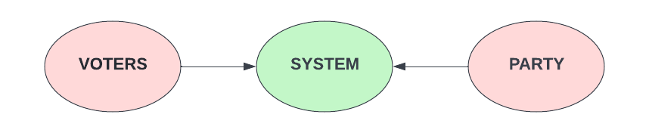

1. **VOTERS**

Voters are the people who will first sign up on online voting panel. And then at the time of voting, they will login and do vote to their respective group or candidate via system.

Following data from voter side will be provided to the system at the time of registration:

* Name
* Voter ID
* Address
* Status
* Votes
* Role (voter/group)
* Photo
* Password

**Voter responsibilities:**

* Registration on system
* Login to system
* Voting for the candidate
* Download PDF

1. **SYSTEM**

System is an online platform where election process is held. So, the voters and groups are registered here. And with the help of system, voters can do voting and groups can monitor their status. Users can avail the PDF confirmation after casting the vote. Users can ask for help/support from the system admin.

**System responsibilities:**

* Registration of both voter and candidate
* Display of registered candidates with respective votes on homepage
* Display of registered candidates on voter dashboard if any
* Display of profile info and voting status on voter dashboard
* Display of profile info, voting status, and votes on

candidate dashboard

* Maintaining record for each candidate and voter without making any duplicate record.

1. **PARTY**

Groups/Candidates/Parties are those who will be given votes at the time of voting. And they can monitor their status by just doing login into system.

Following data from group/party side will be provided to the system at the time of registration:

* Name
* VOTER ID
* PAN ID
* Party name
* Password
* Address
* Upload party symbol

**Party responsibilities:**

* Registration on system

**ER DIAGRAM**

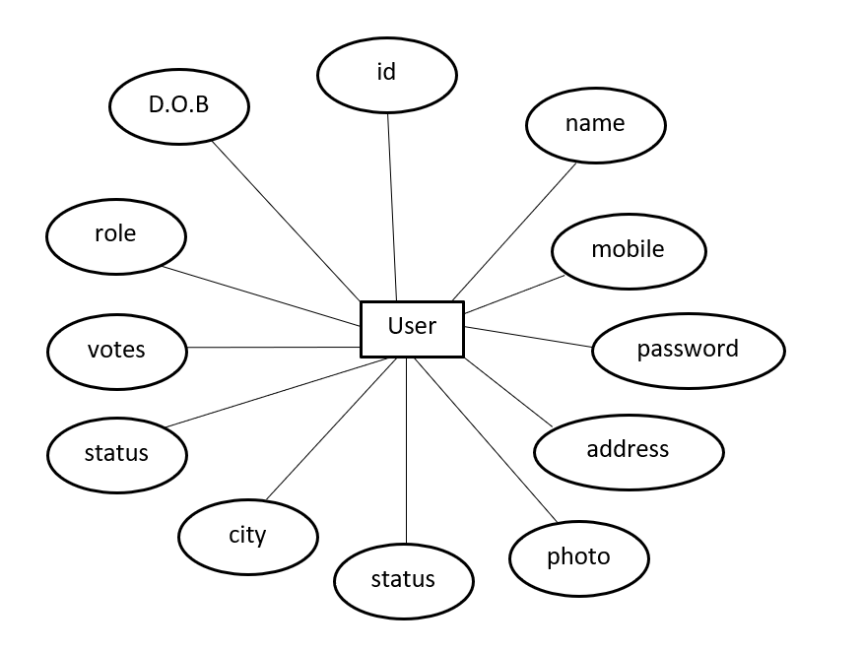

**FLOW CHART**

**Group - Sign up**

**Voter - Sign up**

**Voting P**

**Voter Login**

**Online Voting System**

**Group - Login**

**Results**

**DFD (DATA FLOW DIAGRAM)**

**DFD(DATA FLOW DIAGRAM) LEVEL 0**

User or Administrator

Output

System

**DFD(DATA FLOW DIAGRAM) LEVEL 1**

**Login**

**Process**

**Voting**

**Process**

**Voter information checking process**

**Voter**

**Registration**

**Process**

**Final**

**Report**

**DFD(DATA FLOW DIAGRAM) LEVEL 2**

**Voter Dashboard**

* **Profile info**
* **Groups display**
* **Voting status**
* **Logout**
* **PDF download**

**Voter Login**

**Group Login**

**Voter Registration**

**Voter id**

**Password**

**role**

**Voter id**

**Password**

**role**

**Name**

**Mobile**

**Password**

**Confirm password**

**Address**

**Image**

**Role**

**Group Dashboard**

* **Profile info**
* **Groups display**
* **Voting status**
* **Self no of votes**
* **Logout**

**DATABASE DESIGN**

**Database design**

* MySQL is a technology which is used to maintain overall data of voters and candidates in this system.
* We created a database with name *“****vote”*** in MySQL.
* We created a table called contacts inside database.
* Then we created a table called ***user*s** inside database

Following fields are created in ***users*** table:

* Id
* Name
* Vid
* Address
* Status
* Votes
* Role (voter/group)
* Photo
* Password
* Pan-id
* Party name
* Dt

Following fields are created in ***contacts*** table:

* Id
* Email
* Question
* Comment
* dt

**DATABASE STRUCTURE**

**Database Structure**

**vote**

**user**

Table name

Database name

**id**

**name**

**mobile**

**password**

**address**

**photo**

**role**

Fields

**votes**

**status**

**How to create database, table, and fields**

* Open XAMPP application.
* Click on ***Start*** button right next to MySQL module.
* Click on ***Admin*** button next to ***Start*** button on MySQL module.
* You’ll see ***phpMyAdmin*** panel opened browser. There is a list of default databases on left hand side. So, click on ***New***, give the name XYZ, and click on ***Create***.
* New database in created with the name of XYZ. Now inside XYZ database, there is an option ***New*** to create tables.
* Click on ***New*** and you’ll see option to add table name on top and below it the names of fields.
* Now add fields inside table like name, email, mobile, etc.
* Once all this done, you have finished the process of creating database, tables, and fields.

**How to run project**

* Suppose project name is XYZ. So place the XYZ project folder in “***xampp/htdocs/****”* location in your respective drive.
* Open XAMPP Control Panel and Start ***Apache*** and ***MySQL.***
* Open browser and type “*localhost/XYZ*”.
* You will see the output in browser.

**6.APPLICATIONS**

This system is applicable in below fields for election purpose:

* **School**
* **College**
* **Industry**
* **Corporate**
* **Government**
* **Hospital**
* **Food and Restaurant**
* **Tourism**
* **Sports**
* **Entertainment**
* **Production**
* **Investment**
* **News and Media**
* **Technology**

**7.FUTURE ENHANCEMENTS**

**ADMIN ACCESS**

* Admin functionality would be used to control overall election process. Admin, means election committee or election authority, could maintain overall election process.
* Like voter and candidate verification. Admin would verify and authenticate whether voter or candidate is qualified to take part or not. Admin could also start and stop election process.
* Admin could monitor voting process, like total number of votes given, total number of remaining votes, voting percentage, etc.
* Admin could get results in excel sheet once voting is completed.

**EMAIL VERIFICATION**

* Three times voter would have to go through email verification process.
* First, at the time of registration. Second, at the time of voting and third when someone has forgotten his or her password.
* Once verification is completed, he or she would be qualified for voter position.

**8.TECHNOLOGY DETAILS**

**HTML**

**HTML** stands for Hypertext Markup Language. It is used to design web pages using a markup language. HTML is the combination of Hypertext and Markup language. Hypertext defines the link between the web pages. A markup language is used to define the text document within tag which defines the structure of web pages. This language is used to annotate (make notes for the computer) text so that a machine can understand it and manipulate text accordingly.

Most markup languages (e.g., HTML) are human-readable. The language uses tags to define what manipulation has to be done on the text. HTML is a markup language used by the browser to manipulate text, images, and other content, in order to display it in the required format. HTML was created by Tim Berners-Lee in 1991. The first-ever version of HTML was HTML 1.0, but the first standard version was HTML 2.0, published in 1999.

**Elements and Tags:** HTML uses predefined tags and elements which tell the browser how to properly display the content. Remember to include closing tags. If omitted, the browser applies the effect of the opening tag until the end of the page.

**HTML page structure:**The basic structure of an HTML page is laid out below. It contains the essential building-block elements (i.e., doctype declaration, HTML, head, title, and body elements) upon which all web pages are created.

**<DOCTYPE! html>:** This is the document type declaration (not technically a tag). It declares a document as being an HTML document. The doctype declaration is not case-sensitive.

[**<html>**](https://www.geeksforgeeks.org/html-html-tag/)**:** This is called the HTML root element. All other elements are contained within it.

[**<head>**](https://www.geeksforgeeks.org/html-head-tag/#:~:text=The%20tag%20in%20HTML,head%3E%20element%20can%20be%20omitted.)**:** The head tag contains the “behind the scenes” elements for a webpage. Elements within the head aren’t visible on the front-end of a webpage. HTML elements used inside the <head> element include:

* [<style>](https://www.geeksforgeeks.org/html-style-tag/)
* [<title>](https://www.geeksforgeeks.org/html-title-tag/)
* [<base>](https://www.geeksforgeeks.org/html-base-tag/)
* [<noscript>](https://www.geeksforgeeks.org/html-noscript-tag/)
* [<script>](https://www.geeksforgeeks.org/html-script-tag/)
* [<meta>](https://www.geeksforgeeks.org/html-meta-tag/#:~:text=The%20tag%20in%20HTML,keywords%2C%20document%20author%2C%20etc.)
* [<link>](https://www.geeksforgeeks.org/html-link-tag/)

[**<body>**](https://www.geeksforgeeks.org/html-body-tag/#:~:text=The%20tag%20in%20HTML,well%20as%20an%20ending%20tag.)**:** The body tag is used to enclose all the visible content of a webpage. In other words, the body content is what the browser will show on the front-end.

An HTML document can be created using any text editor. Save the text file using **.html** or **.htm**. Once saved as an HTML document, the file can be opened as a webpage in the browser.

**Note**: Basic/built-in text editors are Notepad (Windows) and TextEdit (Macs). Basic text editors are entirely sufficient for when you’re just getting started. As you progress, there are many feature-rich text editors available which allow for greater function and flexibility.

**Features of HTML:**

* It is easy to learn and easy to use.
* It is platform-independent.
* Images, videos, and audio can be added to a web page.
* Hypertext can be added to the text.
* It is a markup language.

**Why learn HTML?**

* It is a simple markup language. Its implementation is easy.
* It is used to create a website.
* Helps in developing fundamentals about web programming.
* Boost professional career.

**Advantages:**

* HTML is used to build websites.
* It is supported by all browsers.
* It can be integrated with other languages like CSS, JavaScript, etc.

**Disadvantages:**

* HTML can only create static web pages. For dynamic web pages, other languages have to be used.
* A large amount of code has to be written to create a simple web page.
* The security feature is not good.

**CSS**

* Cascading Style Sheets (CSS) is a [style sheet language](https://en.wikipedia.org/wiki/Style_sheet_language) used for describing the [presentation](https://en.wikipedia.org/wiki/Presentation_semantics) of a document written in a [markup language](https://en.wikipedia.org/wiki/Markup_language) such as [HTML](https://en.wikipedia.org/wiki/HTML).[[1]](https://en.wikipedia.org/wiki/CSS#cite_note-1) CSS is a cornerstone technology of the [World Wide Web](https://en.wikipedia.org/wiki/World_Wide_Web), alongside HTML and [JavaScript](https://en.wikipedia.org/wiki/JavaScript).[[2]](https://en.wikipedia.org/wiki/CSS#cite_note-2)
* CSS is designed to enable the separation of presentation and content, including [layout](https://en.wikipedia.org/wiki/Page_layout), [colors](https://en.wikipedia.org/wiki/Color), and [fonts](https://en.wikipedia.org/wiki/Typeface).[[3]](https://en.wikipedia.org/wiki/CSS#cite_note-3) This separation can improve content [accessibility](https://en.wikipedia.org/wiki/Accessibility), provide more flexibility and control in the specification of presentation characteristics, enable multiple [web pages](https://en.wikipedia.org/wiki/Web_page) to share formatting by specifying the relevant CSS in a separate .css file which reduces complexity and repetition in the structural content as well as enabling the .css file to be [cached](https://en.wikipedia.org/wiki/Cache_(computing)) to improve the page load speed between the pages that share the file and its formatting.
* Separation of formatting and content also makes it feasible to present the same markup page in different styles for different rendering methods, such as on-screen, in print, by voice (via speech-based browser or [screen reader](https://en.wikipedia.org/wiki/Screen_reader)), and on [Braille-based](https://en.wikipedia.org/wiki/Braille_display) tactile devices. CSS also has rules for alternate formatting if the content is accessed on a [mobile device](https://en.wikipedia.org/wiki/Mobile_device).[[4]](https://en.wikipedia.org/wiki/CSS#cite_note-4)
* The name cascading comes from the specified priority scheme to determine which style rule applies if more than one rule matches a particular element. This cascading priority scheme is predictable.
* The CSS specifications are maintained by the [World Wide Web Consortium](https://en.wikipedia.org/wiki/World_Wide_Web_Consortium) (W3C). Internet media type ([MIME type](https://en.wikipedia.org/wiki/MIME_media_type)) text/css is registered for use with CSS by [RFC 2318](https://tools.ietf.org/html/rfc2318) (March 1998). The W3C operates a free [CSS validation service](https://en.wikipedia.org/wiki/W3C_Markup_Validation_Service#CSS_validation) for CSS documents.[[5]](https://en.wikipedia.org/wiki/CSS#cite_note-5)
* In addition to HTML, other markup languages support the use of CSS including [XHTML](https://en.wikipedia.org/wiki/XHTML), [plain XML](https://en.wikipedia.org/wiki/Plain_Old_XML), [SVG](https://en.wikipedia.org/wiki/Scalable_Vector_Graphics), and [XUL](https://en.wikipedia.org/wiki/XUL).

**Advantages of CSS**

* **CSS saves time** − You can write CSS once and then reuse same sheet in multiple HTML pages. You can define a style for each HTML element and apply it to as many Web pages as you want.
* **Pages load faster** − If you are using CSS, you do not need to write HTML tag attributes every time. Just write one CSS rule of a tag and apply it to all the occurrences of that tag. So, less code means faster download times.
* **Easy maintenance** − To make a global change, simply change the style, and all elements in all the web pages will be updated automatically.
* **Superior styles to HTML** − CSS have a much wider array of attributes than HTML, so you can give a far better look to your HTML page in comparison to HTML attributes.
* **Multiple Device Compatibility** − Style sheets allow content to be optimized for more than one type of device. By using the same HTML document, different versions of a website can be presented for handheld devices such as PDAs and cell phones or for printing.
* **Global web standards** − Now HTML attributes are being deprecated and it is being recommended to use CSS. So, it’s a good idea to start using CSS in all the HTML pages to make them compatible to future browsers.

## **Who Creates and Maintains CSS?**

CSS is created and maintained through a group of people within the W3C called the CSS Working Group. The CSS Working Group creates documents called specifications. When a specification has been discussed and officially ratified by the W3C members, it becomes a recommendation.

These ratified specifications are called recommendations because the W3C has no control over the actual implementation of the language. Independent companies and organizations create that software.

**NOTE** − The World Wide Web Consortium, or W3C is a group that makes recommendations about how the Internet works and how it should evolve.

**JAVASCRIPT**

* JavaScript often abbreviated as JS, is a [programming language](https://en.wikipedia.org/wiki/Programming_language) that conforms to the [ECMAScript](https://en.wikipedia.org/wiki/ECMAScript) specification.[[7]](https://en.wikipedia.org/wiki/JavaScript#cite_note-tc39-7) JavaScript is [high-level](https://en.wikipedia.org/wiki/High-level_programming_language), often [just-in-time compiled](https://en.wikipedia.org/wiki/Just-in-time_compilation), and [multi-paradigm](https://en.wikipedia.org/wiki/Programming_paradigm). It has [curly-bracket syntax](https://en.wikipedia.org/wiki/List_of_programming_languages_by_type#Curly-bracket_languages), [dynamic typing](https://en.wikipedia.org/wiki/Dynamic_typing), [prototype-based](https://en.wikipedia.org/wiki/Prototype-based_programming) [object-orientation](https://en.wikipedia.org/wiki/Object-oriented_programming), and [first-class functions](https://en.wikipedia.org/wiki/First-class_function).
* Alongside [HTML](https://en.wikipedia.org/wiki/HTML) and [CSS](https://en.wikipedia.org/wiki/CSS), JavaScript is one of the core technologies of the [World Wide Web](https://en.wikipedia.org/wiki/World_Wide_Web).[[8]](https://en.wikipedia.org/wiki/JavaScript#cite_note-8) JavaScript enables interactive [web pages](https://en.wikipedia.org/wiki/Web_page) and is an essential part of [web applications](https://en.wikipedia.org/wiki/Web_application). The vast majority of [websites](https://en.wikipedia.org/wiki/Website) use it for [client-side](https://en.wikipedia.org/wiki/Client-side) page behavior,[[9]](https://en.wikipedia.org/wiki/JavaScript#cite_note-deployedstats-9) and all major [web browsers](https://en.wikipedia.org/wiki/Web_browser) have a dedicated [JavaScript engine](https://en.wikipedia.org/wiki/JavaScript_engine) to execute it.
* As a multi-paradigm language, JavaScript supports [event-driven](https://en.wikipedia.org/wiki/Event-driven_programming), [functional](https://en.wikipedia.org/wiki/Functional_programming), and [imperative](https://en.wikipedia.org/wiki/Imperative_programming) [programming styles](https://en.wikipedia.org/wiki/Programming_paradigm). It has [application programming interfaces](https://en.wikipedia.org/wiki/Application_programming_interface) (APIs) for working with text, dates, [regular expressions](https://en.wikipedia.org/wiki/Regular_expression), standard [data structures](https://en.wikipedia.org/wiki/Data_structure), and the [Document Object Model](https://en.wikipedia.org/wiki/Document_Object_Model) (DOM). However, the language itself does not include any [input/output](https://en.wikipedia.org/wiki/Input/output) (I/O), such as [networking](https://en.wikipedia.org/wiki/Computer_network), [storage](https://en.wikipedia.org/wiki/Data_storage), or [graphics](https://en.wikipedia.org/wiki/Computer_graphics) facilities, as the host environment (usually a web browser) provides those APIs.
* JavaScript engines were originally used only in web browsers, but they are now embedded in some [servers](https://en.wikipedia.org/wiki/Server_(computing)), usually via [Node.js](https://en.wikipedia.org/wiki/Node.js). They are also embedded in a variety of applications created with [frameworks](https://en.wikipedia.org/wiki/Software_framework) such as [Electron](https://en.wikipedia.org/wiki/Electron_(software_framework)) and [Cordova](https://en.wikipedia.org/wiki/Apache_Cordova).
* Although there are similarities between JavaScript and [Java](https://en.wikipedia.org/wiki/Java_(programming_language)), including language name, [syntax](https://en.wikipedia.org/wiki/Syntax_(programming_languages)), and respective [standard libraries](https://en.wikipedia.org/wiki/Standard_library), the two languages are distinct and differ greatly in design.

## **Client-Side JavaScript**

Client-side JavaScript is the most common form of the language. The script should be included in or referenced by an HTML document for the code to be interpreted by the browser.

It means that a web page need not be a static HTML, but can include programs that interact with the user, control the browser, and dynamically create HTML content.

The JavaScript client-side mechanism provides many advantages over traditional CGI server-side scripts. For example, you might use JavaScript to check if the user has entered a valid e-mail address in a form field.

The JavaScript code is executed when the user submits the form, and only if all the entries are valid, they would be submitted to the Web Server.

JavaScript can be used to trap user-initiated events such as button clicks, link navigation, and other actions that the user initiates explicitly or implicitly.

## **Advantages of JavaScript**

The merits of using JavaScript are −

* **Less server interaction** − You can validate user input before sending the page off to the server. This saves server traffic, which means less load on your server.
* **Immediate feedback to the visitors** − They don't have to wait for a page reload to see if they have forgotten to enter something.
* **Increased interactivity** − You can create interfaces that react when the user hovers over them with a mouse or activates them via the keyboard.
* **Richer interfaces** − You can use JavaScript to include such items as drag-and-drop components and sliders to give a Rich Interface to your site visitors.

## **Limitations of JavaScript**

We cannot treat JavaScript as a full-fledged programming language. It lacks the following important features −

* Client-side JavaScript does not allow the reading or writing of files. This has been kept for security reason.
* JavaScript cannot be used for networking applications because there is no such support available.
* JavaScript doesn't have any multi-threading or multiprocessor capabilities.

Once again, JavaScript is a lightweight, interpreted programming language that allows you to build interactivity into otherwise static HTML pages.

## **JavaScript Development Tools**

One of major strengths of JavaScript is that it does not require expensive development tools. You can start with a simple text editor such as Notepad. Since it is an interpreted language inside the context of a web browser, you don't even need to buy a compiler.

To make our life simpler, various vendors have come up with very nice JavaScript editing tools. Some of them are listed here −

* **Microsoft FrontPage** − Microsoft has developed a popular HTML editor called FrontPage. FrontPage also provides web developers with a number of JavaScript tools to assist in the creation of interactive websites.
* **Macromedia Dreamweaver MX** − Macromedia Dreamweaver MX is a very popular HTML and JavaScript editor in the professional web development crowd. It provides several handy prebuilt JavaScript components, integrates well with databases, and conforms to new standards such as XHTML and XML.
* **Macromedia Home Site 5** − Home Site 5 is a well-liked HTML and JavaScript editor from Macromedia that can be used to manage personal websites effectively.

## **Where is JavaScript Today?**

The ECMAScript Edition 5 standard will be the first update to be released in over four although both the languages still support the features that are not a part of the standard. Years. JavaScript 2.0 conforms to Edition 5 of the ECMAScript standard, and the difference between the two is extremely minor.

The specification for JavaScript 2.0 can be found on the following site: <http://www.ecmascript.org/>

Today, Netscape's JavaScript and Microsoft's JScript conform to the ECMAScript standard.

**PHP**

* Hypertext Preprocessor is a server-side scripting language designed for web development and also used as a general-purpose programming language. It was originally created by Rasmus Lerdorf in 1994. The php reference is now produced by the php group. Php originally stood for personal home page. But now it stands for recursive initialism php hypertext preprocessor.
* Php code may be embedded into html code. It can be used in combination with various web template systems, web content management systems, and web frameworks. Php code is usually processed by a php interpreter implemented as a module in the web server or as a common gateway interface executable. The web server combines the results of interpreted and executed php code, which may be any type of data, including images, with the generated web page. Php code may also be executed with a command line interface and can be used to implement standalone graphical applications.
* The standard php interpreter, powered by the Zend engine, is free software released under the php license. Php has been widely ported and can be deployed on most web servers on almost every operating system and platform, free of charge.
* The php language evolved without a written formal specification or standard until 2014, with the original implementation acting as the de facto standard which other implementations aimed to follow. Since 2014 work has gone on to create a formal php specification

## **What is a PHP File?**

* PHP files can contain text, HTML, CSS, JavaScript, and PHP code
* PHP code are executed on the server, and the result is returned to the browser as plain HTML
* PHP files have extension ".php"

## **What Can PHP Do?**

* PHP can generate dynamic page content
* PHP can create, open, read, write, delete, and close files on the server
* PHP can collect form data
* PHP can send and receive cookies
* PHP can add, delete, modify data in your database
* PHP can be used to control user-access
* PHP can encrypt data

With PHP you are not limited to output HTML. You can output images, PDF files, and even flash movies. You can also output any text, such as XHTML and XML.

## **Why PHP?**

* PHP runs on various platforms (Windows, Linux, UNIX, Mac OS X, etc.)
* PHP is compatible with almost all servers used today (Apache, IIS, etc.)
* PHP supports a wide range of databases
* PHP is free. Download it from the official PHP resource: [www.php.net](http://www.php.net/)
* PHP is easy to learn and runs efficiently on the server side

PHP is an amazing and popular language!

It is powerful enough to be at the core of the biggest blogging system on the web (WordPress)!  
It is deep enough to run the largest social network (Facebook)!  
It is also easy enough to be a beginner's first server-side language!

**Advantages of PHP:**

The reason behind the popularity of PHP is its several advantages. PHP is most suited for the purpose of web development. The advantages of PHP are discussed briefly below:

1. **Cross Platform.**

* All the PHP based applications can run on various types of platforms. PHP is supported by majority of Operating Systems, some of which includes Solaris, UNIX, Windows and Linux. The mentioned platforms can be used to write codes in PHP and also view web pages or run the PHP based applications.
* PHP easily interfaces with MySQL and Apache both. An effortless integration of PHP can be done with various other technologies like Java and there is no requirement of re-development. Therefore, saving both time and money, giving it an important advantage.

1. **Easy database connection.**

* A programming language like PHP is widely used on the internet and needs to connect to the database very often. Therefore, having a feature that could help PHP to connect to database easily is mandatory. Several websites such as the ecommerce websites require good database management system.
* PHP has a built-in module that helps it in connecting with database easily. Therefore, PHP has a great demand in the field of web development where a data driven website needs to be developed. PHP significantly reduces the time needed in developing the web application that needs an efficient database management system.

**C. Easy to use.**

* PHP is widely used because it is easy to use. In contrast with other programming languages that are complex, PHP is simple, fluent, clean and organized; hence it is a boon for the new users. PHP has a well-organized syntax which is logical at the same time.
* PHP does not require any intensive studying or manual to use it. Command functions of PHP are easily understood as the user can easily figure out from the name of the commands itself what it does. A person who is new to PHP can still code because the syntax is somewhat similar to C.
* A person who is new to PHP can still code because the syntax is somewhat similar to C. Hence, if a person who knows C can easily code in PHP. Hence, it is easier to create and optimize the application using PHP.

**D. Speed**

* Speed is the primary need of web development. There are people who face the challenge of slow internet connection and slow data speed. Furthermore, a fast-loading website is always preferred by people across the globe. When compared to other programming languages, PHP is found to be the fastest programming language.
* In normal circumstances, it takes a lot of time to connect to the database, when you attempt to fetch certain data from the database. It takes a lot of time in connecting to the database, then executing the statement and finally getting the data. PHP performs these set of tasks faster than other scripting languages. PHP is faster in both connecting to the database and in using other important applications.
* The high speed of PHP gives it an advantage over other scripting languages and gives it an application in important administrations such as the server administration and mail functionalities.

**E. Open source.**

* One of the important advantages of PHP is that it is Open Source. Therefore, PHP is readily available and is entirely free. In contrast to other scripting languages used for web development which requires the user to pay for the support files, PHP is open to everyone, anytime and anywhere.
* A beginner in PHP need not worry about the support as PHP is maintained and developed by a large group of PHP developers which helps in creating support community of PHP that helps people in PHP implementation and manipulation.

**MYSQL**

MYSQL is an open-source software. It is actually a relational database management system (RDBMS). This SQL stands for Structured Query Language. It is the most popular and best RDBMS used for developing a variety of web-based software applications. With the help of MYSQL, it is possible to organize the information, manage, retrieve and update the data whenever you wish to do. 

**XAMPP**

XAMPP is an open-source free software developed by [Apache friends](https://www.apachefriends.org/download.html). XAMPP software package contains Apache distributions for Apache server, MariaDB, PHP, and Perl. And it is basically a local host or a local server. This local server works on your own desktop or laptop computer. You can just install this software on your laptop or desktop and test the clients or your website before uploading it to the remote web server or computer. This XAMPP server software gives you suitable environment for testing MYSQL, PHP, Apache and Perl projects on the local computer.

The full form of XAMPP is X stands for Cross-platform, (A) Apache server, (M) MariaDB, (P) PHP and (P)Perl. The Cross-platform usually means that it can run on any computer with any operating system.

Next MariaDB is the most famous database server and it is developed by MYSQL team. PHP usually provides a space for web development. PHP is a server-side scripting language. And the last Perl is a programming language and is used to develop a web application.

### What are the Main Tools of XAMPP and its definition?

XAMPP contains tools such as Apache, MYSQL, PHP, and Perl. We will see these tools.

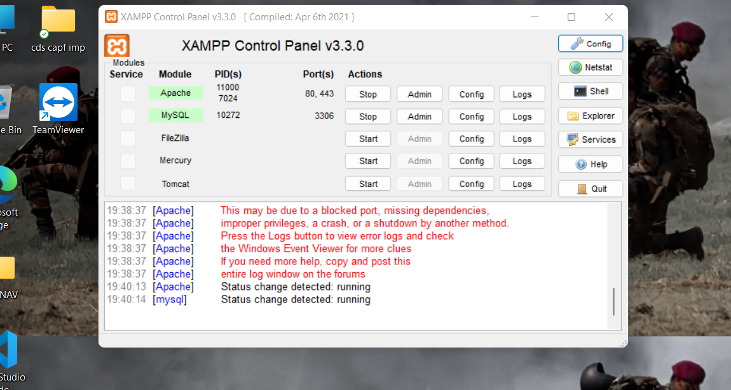**XAMPP screen view**

**MySQL screen view**

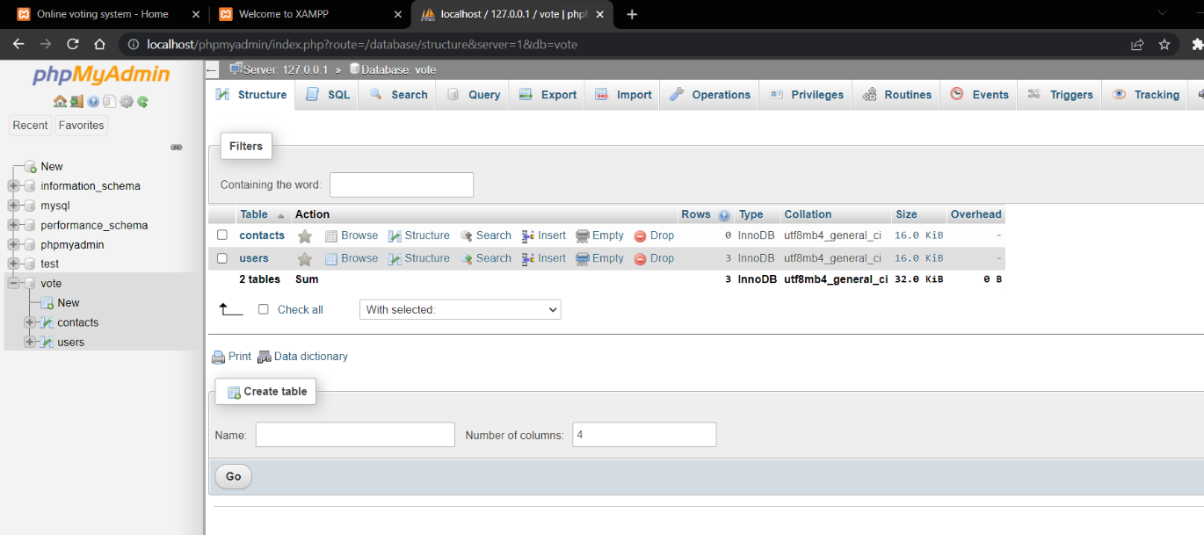

**9.HARDWARE & SOFTWARE REQUIREMENT SPECIFICATION**

**HARDWARE SPECIFICATION**

[**Operating system**](https://en.wikipedia.org/wiki/Operating_system) **:** Windows Server 2008 and later Windows Vista and later Mac OS X 10.6 and later

CentOS, Ubuntu, Fedora, Gen too, Arch, SUSE

**Platform** : IA-32 (Windows package only) and x64 (macOS and Linux packages only)

**Size** : Windows: 156 MB Linux: 150 MB

macOS: 161 MB

**SOFTWARE SPECIFICATION**

**Database :** MySQL

**Server :** Apache

**10.PROJECT SNAPSHOTS**

**PROJECT SNAPSHOTS**

**LOGIN PAGE**

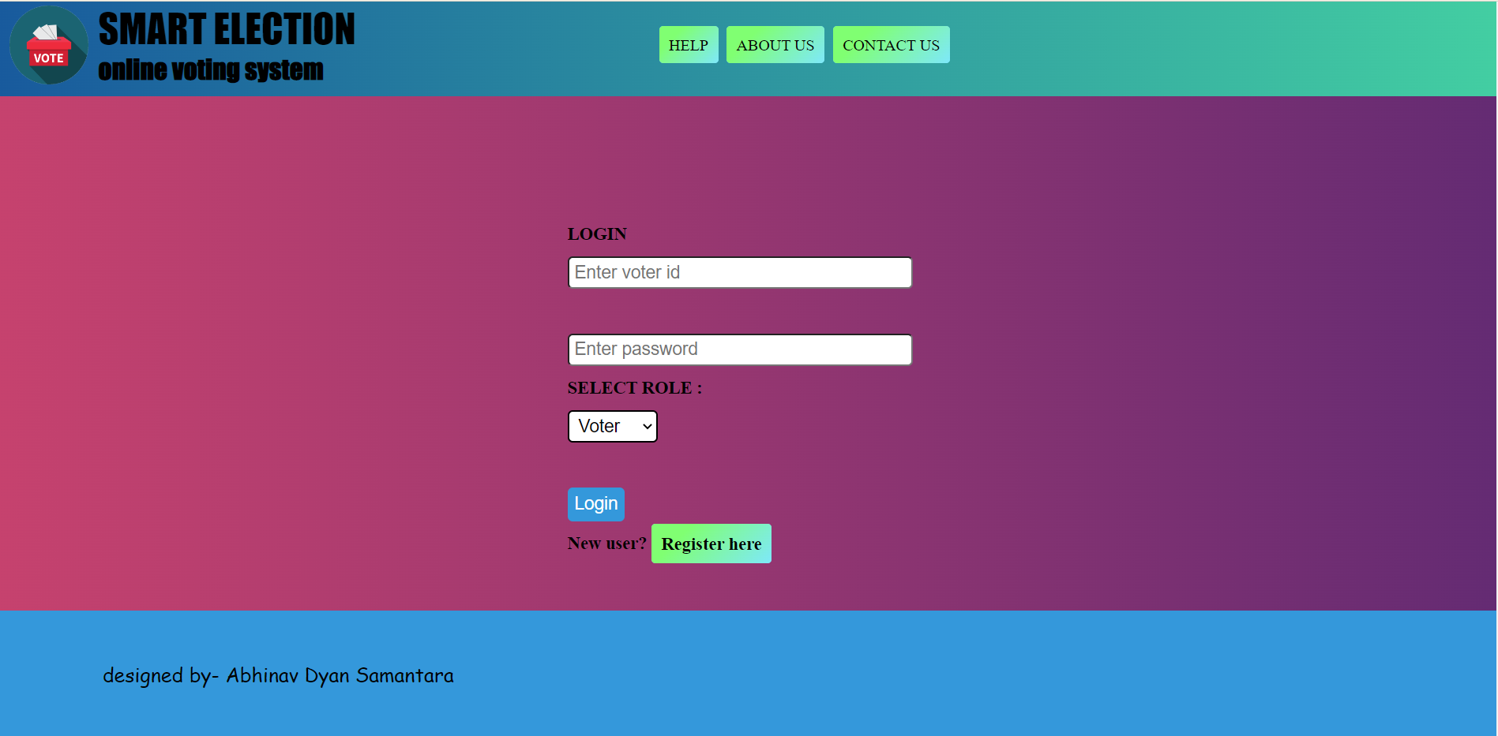

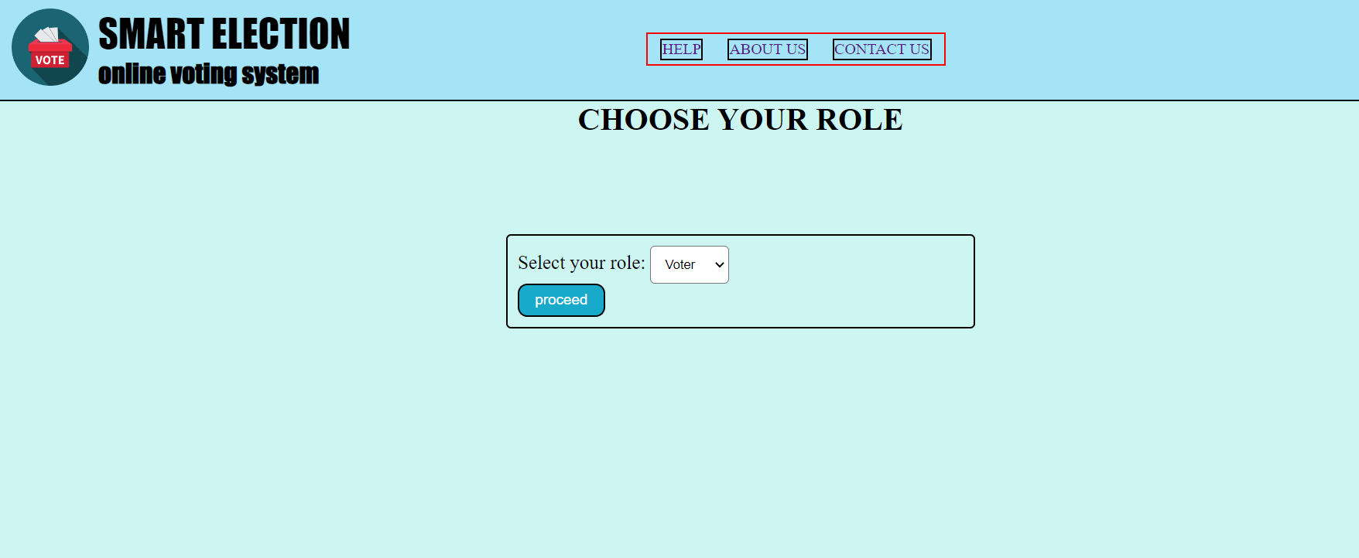**CHOOSE ROLE**

**VOTER REGISTRATION**

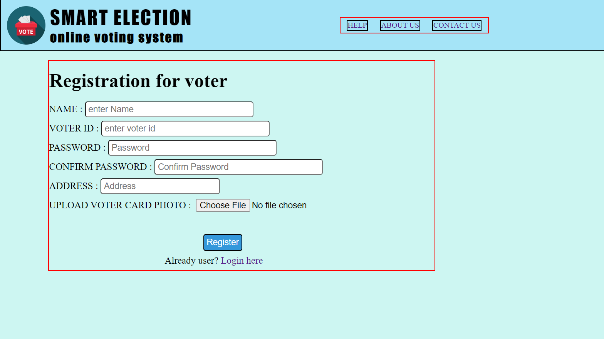

**PARTY REGISTRATION**

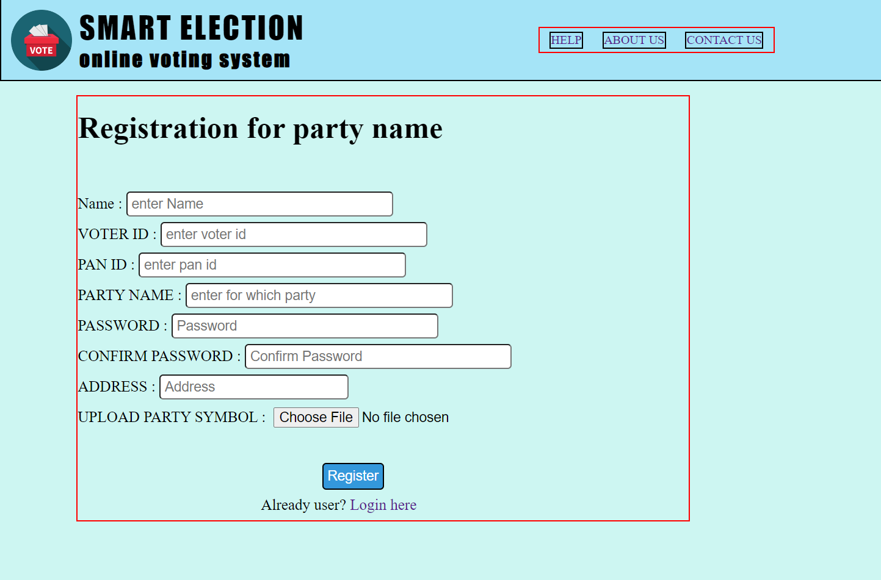

**DASHBOARD BEFORE VOTING**

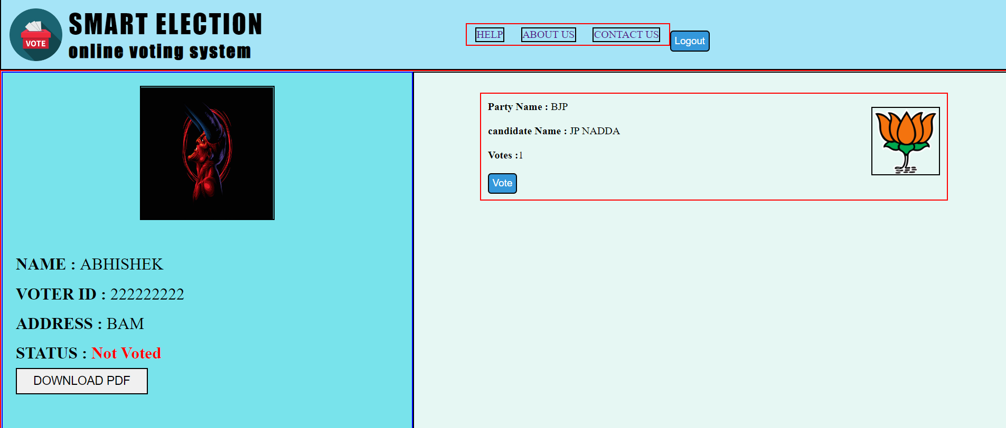

**DASHBOARD AFTER VOTING**

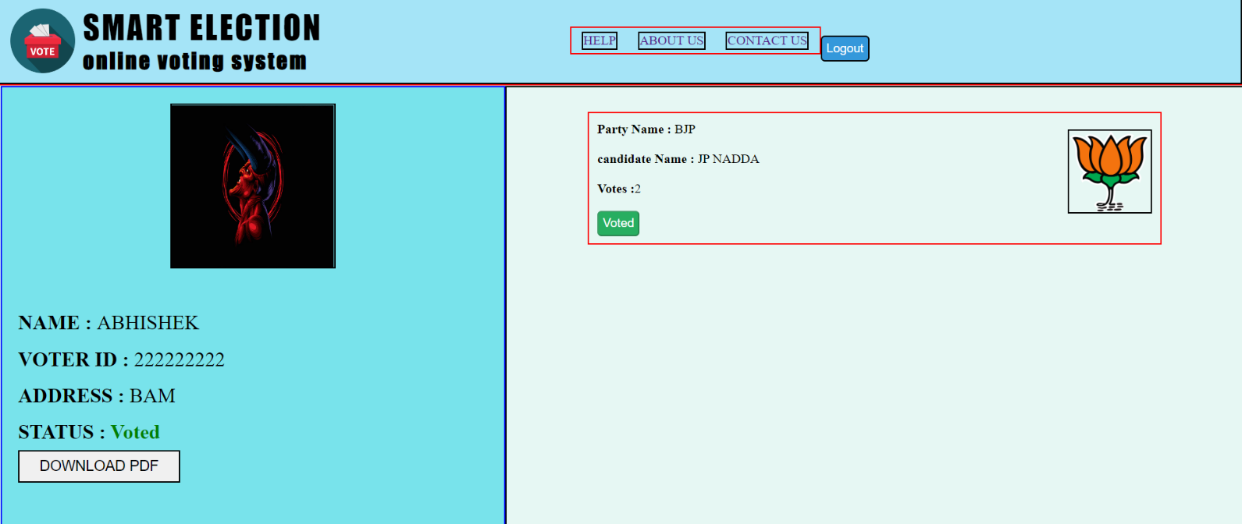

**PDF**

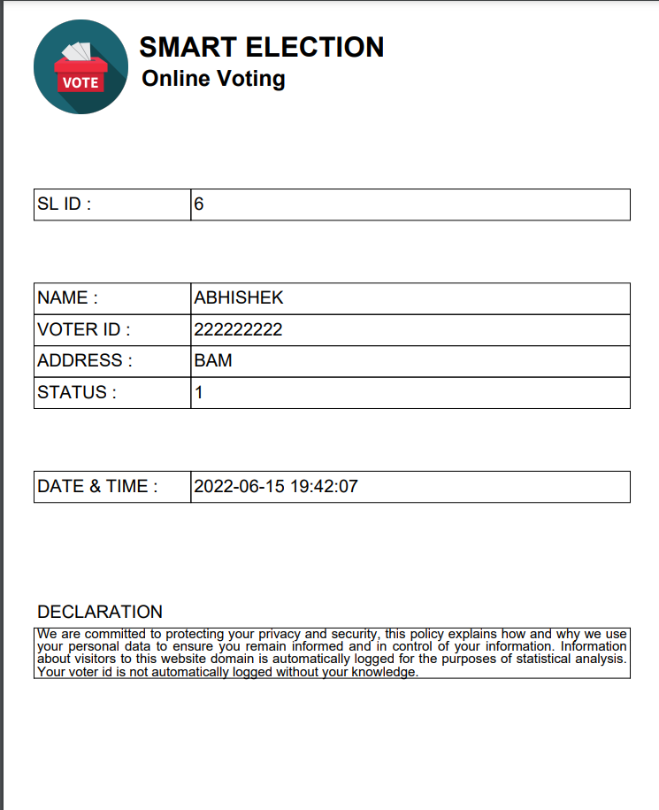

**CONTACT US**

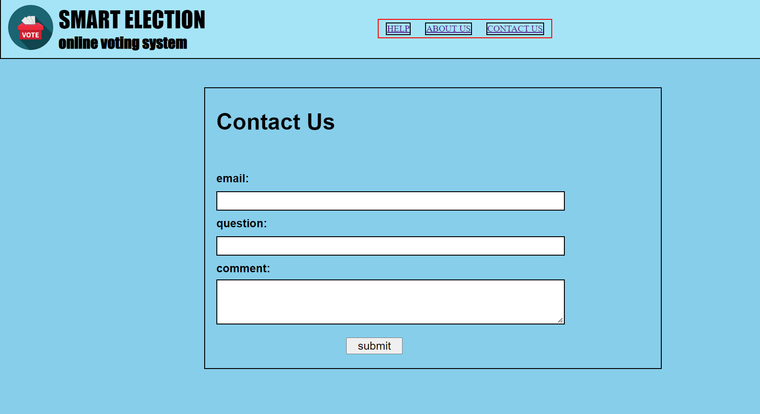

**HELP**

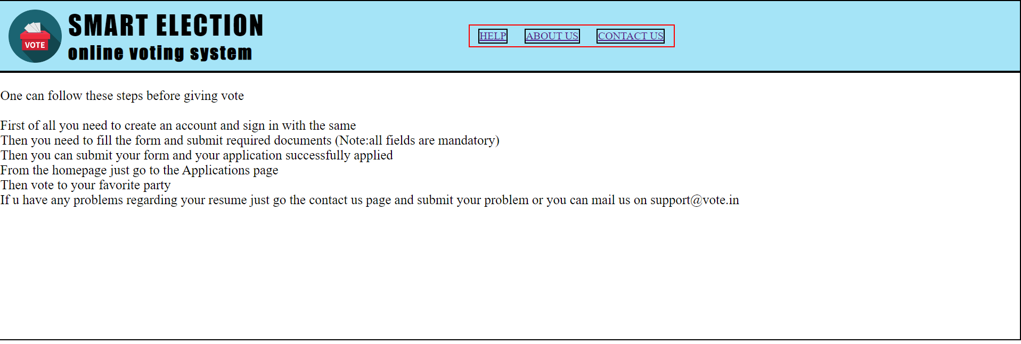

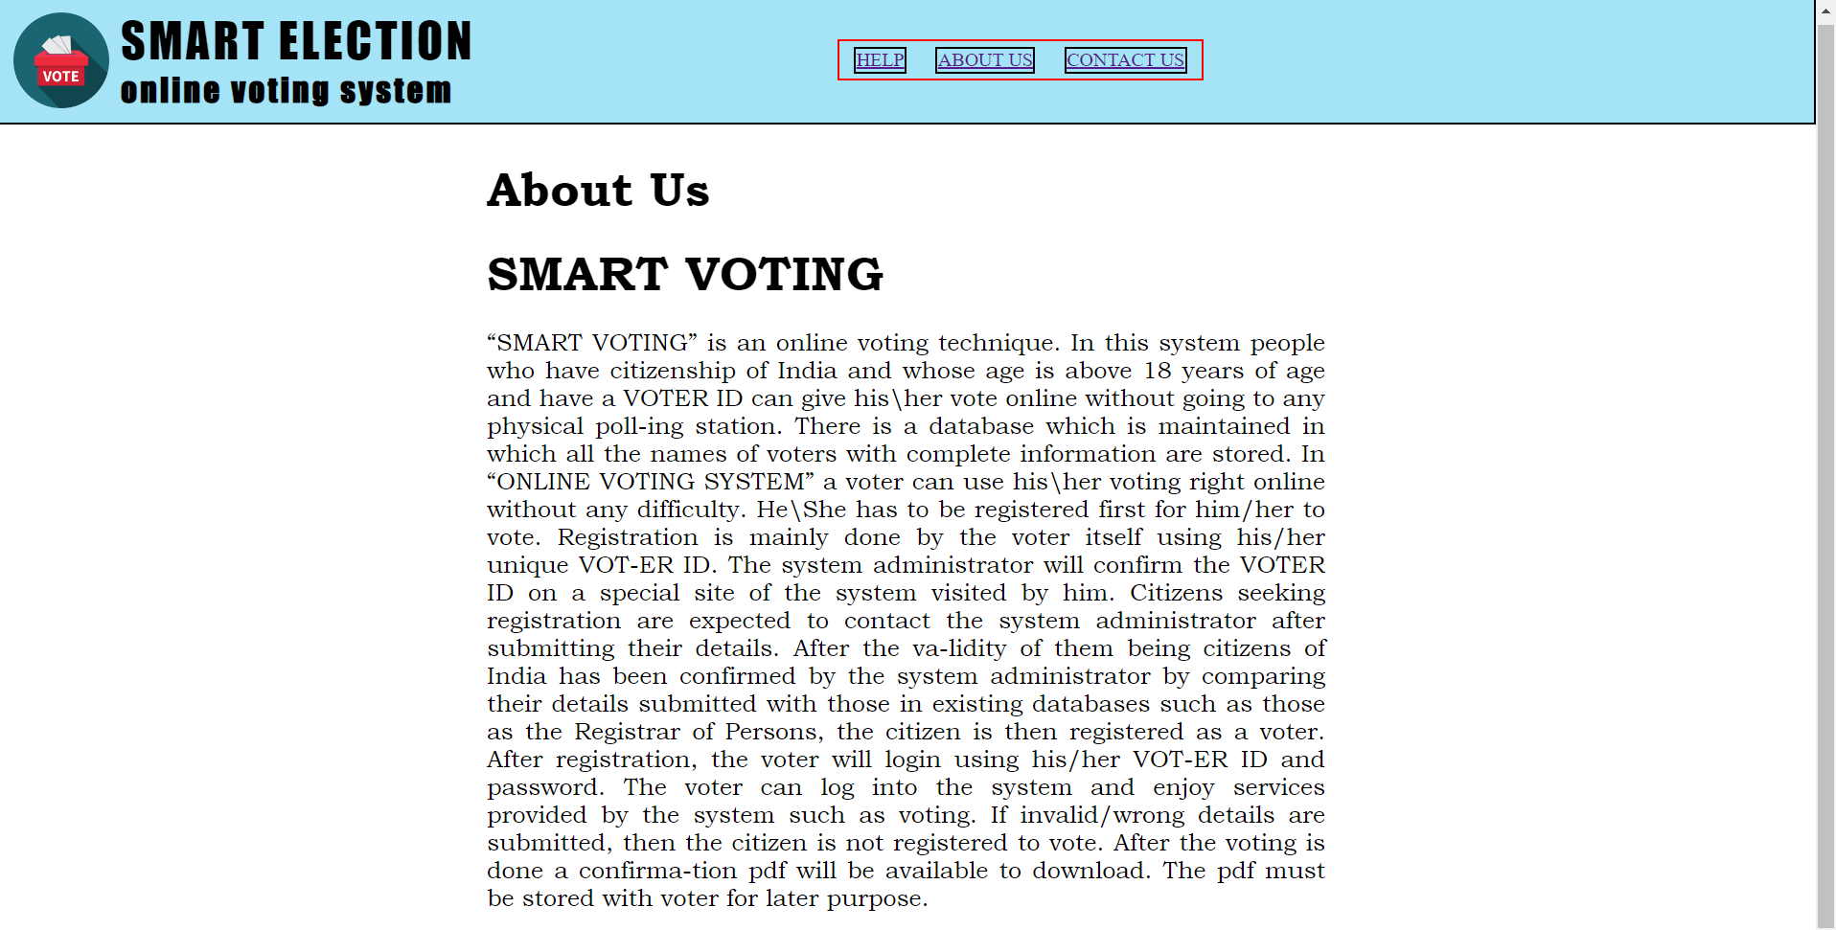**ABOUT US**

**MY SQL DATABASE**

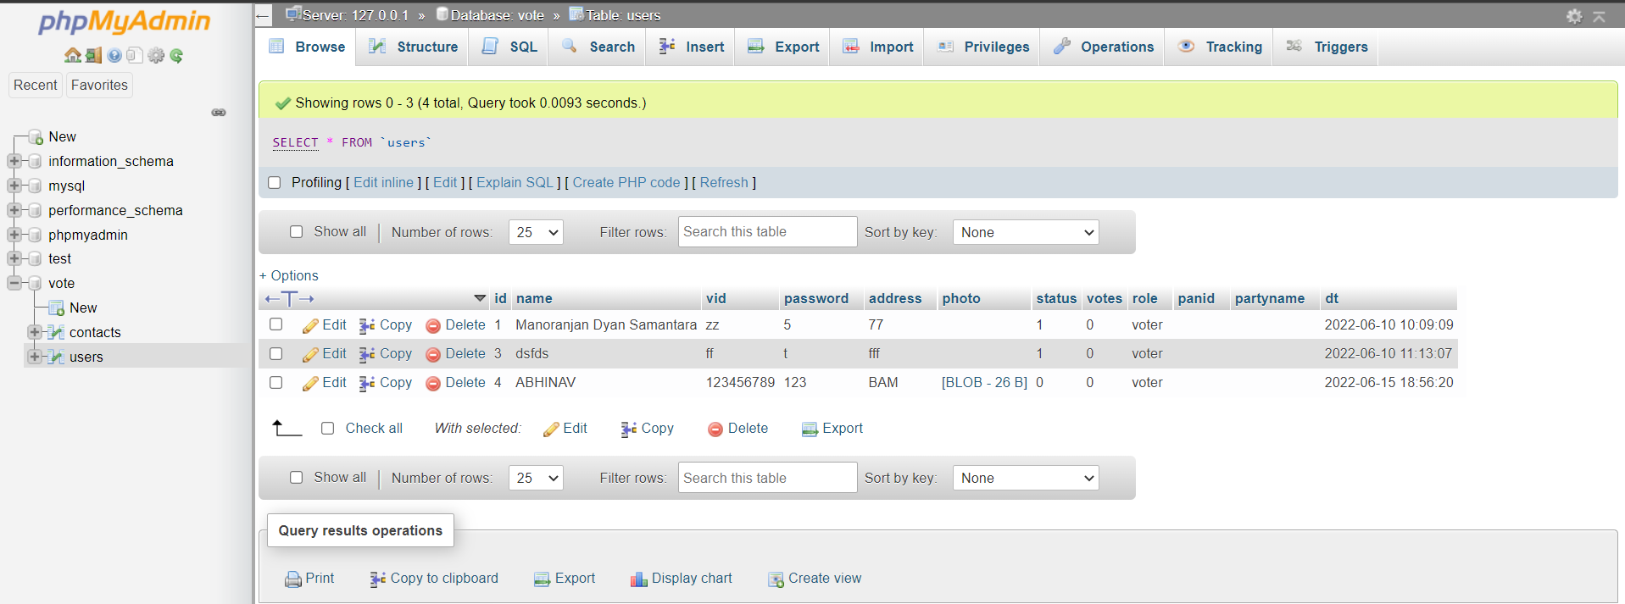

**MY SQL TABLE STRUCTURE(USERS)**

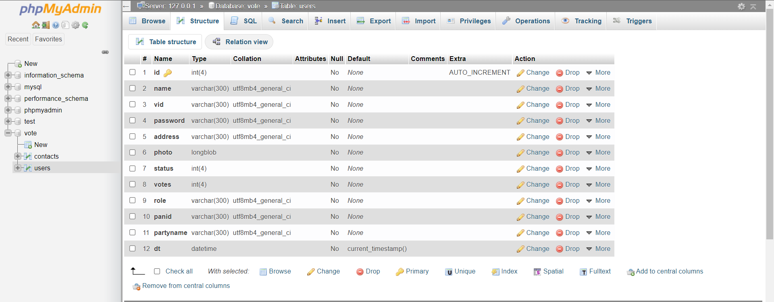

**MY SQL TABLE STRUCTURE(CONTACTS)**



**11.SOURCE CODE**

**PROJECT SOURCE CODE**

**LOGIN**

<html>

<head>

    <title>Online voting system - Home</title>

    <link reel="stylesheet" href="css/stylesheet.css">

</head>

<body>

    <?php

    include("header-menu.php");

?>

        <div id="main-content-div">

            <div id="logintitlediv">

                <div id="logintitle">

                    LOGIN HERE <br> VOTE ONLINE <br> BE UNIQUE

                </div>

            </div>

            <div id="loginSection">

                <form id="loginform" action="login.php" method="POST">

                    VOTER ID : <br> <input id="tb" type="text" name="vid" placeholder="Enter voter id" required><br> PASSWORD : <br><input id="tb" type="password" name="pass" placeholder="Enter password" required><br> SELECT ROLE : <br>

                    <select id="tb" name="role" style="width: 15%; border: 2px solid black">

                    <option value="voter">Voter</option>

                    <option value="group">Group</option>

                </select><br>

                    <br>

                    <button id="loginbtn" type="submit" name="loginbtn">Login</button><br> New user? <a href="register.php">Register here</a>

                </form>

            </div>

        </div>

</body>

</html>

**LOGIN API**

<?php

    include("connection.php");

    $vid = $_POST['vid'];

    $pass = $_POST['pass'];

    $role = $_POST['role'];

    $check = mysqli_query($con, "select * from users where vid='$vid' and password='$pass' and role='$role' ");

    if(mysqli_num_rows($check)>0){

        $getGroups = mysqli_query($con, "select name, photo, votes, partyname, id from users where role='group' ");

        session_start();

        if(mysqli_num_rows($getGroups)>0){

            $groups = mysqli_fetch_all($getGroups, MYSQLI_ASSOC);

            $_SESSION['loggedin'] = true;

            $_SESSION['groups'] = $groups;

        }

        $data = mysqli_fetch_array($check);

        $_SESSION['id'] = $data['id'];

        $_SESSION['status'] = $data['status'];

        $_SESSION['vid'] = $data['vid'];

        $_SESSION['data'] = $data;

        // echo '<script>

        //         window.location = "dashboard.php";

        //     </script>';

        header("location: dashboard.php");

    }

    else{

        echo '<script>

                alert("Invalid credentials!");

            </script>';

            header("location: index.php?invalidcredentials");

    }

?>

**REGISTRATION**

<!DOCTYPE html>

<html lang="en">

<head>

    <meta charset="UTF-8">

    <meta http-equiv="X-UA-Compatible" content="IE=edge">

    <meta name="viewport" content="width=device-width, initial-scale=1.0">

    <title>User type</title>

    <link rel="stylesheet" href="css/stylesheet.css">

</head>

<body>

    <?php

        include("header-menu.php")

    ?>

<form action="register.php" method="post">

<h1 style="margin: auto; width: max-content;">CHOOSE YOUR ROLE</h1>

<div id="usertypediv" style="width: 30% ; font-size: 20px;">

     Select your role:

      <select name="role">

          <option value="voter">Voter</option>

          <option value="group">Group</option>

      </select><br>

      <button id="usertypebtn">proceed</button>

     </div><br>

</form>

<?php

if($_SERVER["REQUEST_METHOD"]=="POST"){

    $type = $_POST["role"];

if ($type == 'voter') {

    header("location: regvoter.php");

}

if ($type=='group') {

    header("location: regparty.php");

}

}

?>

</body>

<style>

#usertypebtn{

    width:90px;

    height: 35px;

    font-size: 15px;

    color: white;

    border-radius: 10px;

   background: rgb(24, 170, 203);

}

</style>

</html>

**REGISTRATION FOR PARTY**

<html>

<head>

    <title>Online voting system - Registratrion</title>

    <link rel="stylesheet" href="css/stylesheet.css">

</head>

<body>

    <?php

    include("header-menu.php");

    ?>

<br>

        <form class="regform" action="regparty.php" method="POST" enctype="multipart/form-data">

            <h1>Registration for party name</h1><br>

            Name : <input id="tb" type="text" name="name" placeholder="enter Name" required><br>

            VOTER ID : <input id="tb" type="text" name="vid" placeholder="enter voter id" required><br>

            PAN ID : <input id="tb" type="text" name="panid" placeholder="enter pan id" required><br>

            PARTY NAME : <input id="tb" type="text" name="partyname" placeholder="enter for which party" required><br>

            PASSWORD : <input id="tb" type="password" name="pass" placeholder="Password" required><br>

            CONFIRM PASSWORD : <input id="tb" type="password" name="cpass" placeholder="Confirm Password" required><br>

            ADDRESS : <input id="tb" style="width: 31%" type="text" name="add" placeholder="Address" required><br>

                UPLOAD PARTY SYMBOL : <input id="tb" type="file" id="profile" name="image" ><br><br>

            <button id="registerbtn" type="submit" name="registerbtn">Register</button><br>

            <div style="margin:0 30%">Already user? <a href="index.php">Login here</a></div>

        </form>

    </body>

</html>

<?php

if ($_SERVER["REQUEST_METHOD"] == "POST") {

    include("connection.php");

    $name = $_POST['name'];

    $vid = $_POST['vid'];

    $pass = $_POST['pass'];

    $cpass = $_POST['cpass'];

    $add = $_POST['add'];

    $image = $_FILES['image']['name'];

    $tmp_name = $_FILES['image']['tmp_name'];

    $role = "group";

    $partyname = $_POST["partyname"];

    $panid =  $_POST["panid"];

// check wether this user name exists or not

$existsql = "select * from `users` where vid = '$vid'";

$result = mysqli_query($con, $existsql);

$numrow = mysqli_num_rows($result);

    if ($numrow>0) {

        $showerror = "vid already exists";

    }

    else{

        if($pass==$cpass){

            move_uploaded_file($tmp_name,"uploads/$image");

            $insert = mysqli_query($con, "INSERT INTO users (`name`, `vid`, `password`, `address`, `photo`, `status`, `votes`, `role`,`panid`,`partyname`, `dt`) values('$name', '$vid', '$pass', '$add', '$image', 0, 0, '$role','$panid','$partyname', current_timestamp()) ");

            if($insert){

                header("location: /v3/regparty.php?registrationsuccess=true");

                exit();

            }

        }

        else{

            $showerror = "passwords do not match";

        }

    }

    header("location: /v3/regparty.php?registrationsuccess=fasle&error=$showerror");

}

?>

**REGISTRATION FOR VOTER**

 <html>

    <head>

        <title>Online voting system - Registratrion</title>

        <link rel="stylesheet" href="css/stylesheet.css">

    </head>

    <body>

            <?php

            include("header-menu.php")

            ?>

<br>

                <form class="regform" action="regvoter.php" method="POST" enctype="multipart/form-data">

                    <h1>Registration for voter</h1>

                    NAME : <input id="tb" type="text" name="name" placeholder="enter Name" required><br>

                    VOTER ID : <input id="tb" type="text" name="vid" placeholder="enter voter id" required><br>

                    PASSWORD : <input id="tb" type="password" name="pass" placeholder="Password" required><br>

                    CONFIRM PASSWORD : <input id="tb" type="password" name="cpass" placeholder="Confirm Password" required><br>

                    ADDRESS : <input id="tb" style="width: 31%" type="text" name="add" placeholder="Address" required><br>

                    UPLOAD VOTER CARD PHOTO : <input id="tb" type="file" id="profile" name="image" ><br><br>

                    <button id="registerbtn" type="submit" name="registerbtn">Register</button><br>

                    <div style="margin :0 30%">Already user? <a href="index.php">Login here</a></div>

                </form>

    </body>

</html>

**DASHBOARD API**

<?php

    session_start();

    if(!isset($_SESSION['id'])){

        header("location: index.php");

    }

    $data = $_SESSION['data'];

    if($_SESSION['status']==1){

        $status = '<b style="color: green">Voted</b>';

    }else{

        $status = '<b style="color: red">Not Voted</b>';

    }

?>

<html>

<head>

    <title>Online voting system - Dashboard</title>

    <link rel="stylesheet" href="css/stylesheet.css">

</head>

<body>

    <?php

        include("header-menu.php")

    ?>

    <div id="mainSection">

        <div id="profileSection">

            <center><img src="uploads/<?php echo $data['photo']?>"  id="profilephoto"></center><br>

            <b>NAME : </b><?php echo $data['name'] ?><br>

            <b>VOTER ID : </b><?php echo $data['vid'] ?><br>

            <b>ADDRESS : </b><?php echo $data['address'] ?><br>

            <b>STATUS : </b><?php echo $status ?><br>

            <a  href="pdf.php?rowid=<?php echo $data['id'] ?>"><button id="downloadbtn">DOWNLOAD PDF</button></a>

        </div>

        <div id="groupSection">

            <?php

                if(isset($_SESSION['groups'])){

                    $groups = $_SESSION['groups'];

                    for($i=0; $i<count($groups); $i++){

                        echo '<div id="groupdiv">

                        <img src="uploads/'.$groups[$i]['photo'].'" style="width:100px; height:100px;border:2px solid black;float: right; margin:10px 10px 0 0 ;">

                        <b>Party Name : </b>'.$groups[$i]['partyname'].'<br><br>

                        <b>candidate Name : </b>'.$groups[$i]['name'].'<br><br>

                        <b>Votes :</b>'.$groups[$i]['votes'].'<br><br>

                        <form method="POST" action="vote.php">

                        <input type="hidden" name="gvotes" value="'.$groups[$i]['votes'] .'">

                        <input type="hidden" name="gid" value="'.$groups[$i]['id'] .'">';

                        if($_SESSION['status']==1){

                            echo '<button disabled

                            style="padding: 5px; font-size: 15px; background-color: #27ae60; color: white; border-radius: 5px;"

                            type="button">Voted</button>';

                        }else{

                            echo '<button

                            style="padding: 5px; font-size: 15px; background-color: #3498db; color: white; border-radius: 5px;"

                            type="submit">Vote</button>';

                        }

                        echo ' </form>

                        </div>';

                    }

                }else{

                    echo '  <div style="border-bottom: 1px solid #bdc3c7; margin-bottom: 10px">

                    <b>No groups available right now.</b>

                    </div>';

                }

            ?>

        </div>

    </div>

</body>

</html>

**PDF**

<?php

require("fpdf/fpdf.php");

$pdf =new FPDF();

$pdf -> addpage();

$pdf ->setfont('arial','B',25);

// for logo in pdf page

$pdf -> cell(30, 30,$pdf -> image('img/logo.png', 10, 6, 30,30),0, 0, 'L');

$pdf -> cell(0, 10, ' SMART ELECTION',0,1, 'L');

$pdf ->setfont('arial','B',20);

$pdf -> cell(0, 10, '                 Online Voting',0,1, 'L');

$pdf -> cell(0, 10, '',0,1, 'L');

$pdf -> cell(0, 10, '',0,1, 'L');

$pdf -> cell(0, 10, '',0,1, 'L');

$pdf ->setfont('arial','',16);

include('connection.php');

$sql = " SELECT * FROM `users` WHERE `id` = ".$_GET['rowid'];

$result = mysqli_query($con, $sql);

while($row = mysqli_fetch_assoc($result)){

$pdf -> cell(50, 10, 'SL ID : ',1,0, 'L');

$pdf -> cell(0, 10, $row['id'],1,1, 'L');

$pdf -> cell(0, 10, '',0,1, 'L');

$pdf -> cell(0, 10, '',0,1, 'L');

$pdf -> cell(50, 10, 'NAME : ',1,0, 'L');

$pdf -> cell(0, 10, $row['name'],1,1, 'L');

$pdf -> cell(50, 10, 'VOTER ID : ',1,0, 'L');

$pdf -> cell(0, 10, $row['vid'],1,1, 'L');

$pdf -> cell(50, 10, 'ADDRESS : ',1,0, 'L');

$pdf -> cell(0, 10, $row['address'],1,1, 'L');

$pdf -> cell(50, 10, 'STATUS : ',1,0, 'L');

$pdf -> cell(0, 10, $row['status'],1,1, 'L');

$pdf -> cell(0, 10, '',0,1, 'L');

$pdf -> cell(0, 10, '',0,1, 'L');

$pdf -> cell(50, 10, 'DATE & TIME : ',1,0, 'L');

$pdf -> cell(0, 10, $row['dt'],1,1, 'L');

}

$pdf -> cell(0, 10, '',0,1, 'L');

$pdf -> cell(0, 10, '',0,1, 'L');

$pdf -> cell(0, 10, '',0,1, 'L');

$pdf -> cell(0, 10, 'DECLARATION',0,1, 'L');

$pdf ->setfont('arial','',12);

$pdf -> multicell(0, 4, 'We are committed to protecting your privacy and security, this policy explains how and why we use your personal data to ensure you remain informed and in control of your information. Information about visitors to this website domain is automatically logged for the purposes of statistical analysis. Your voter id is not automatically logged without your knowledge.',1, 'J');

$pdf -> output();

?>

**VOTE API**

<?php

    session_start();

    include("connection.php");

    $votes = $_POST['gvotes'];

    $total_votes= $votes+1;

    $gid = $_POST['gid'];

    $uid = $_SESSION['id'];

    $update_votes = mysqli_query($con, "update users set votes='$total_votes' where id='$gid'");

    $update_status = mysqli_query($con, "update `users` set `status`=1 where id='$uid'");

    if($update_status and $update_votes){

        $getGroups = mysqli_query($con, "select name, photo, votes, id from users where role=2 ");

        $groups = mysqli_fetch_all($getGroups, MYSQLI_ASSOC);

        $_SESSION['groups'] = $groups;

        $_SESSION['status'] = 1;

        echo '<script>

                    alert("Voting successfull!");

                    window.location = "dashboard.php";

                </script>';

    }

    else{

        echo '<script>

                    alert("Voting failed!.. Try again.");

                    window.location = "dashboard.php";

                </script>';

    }

?>

**CONNECTION**

<?php

$con = mysqli_connect("localhost", "root", "", "vote") or die("connection failed!");

?>

**CONTACT**

<!DOCTYPE html>

<html lang="en">

<head>

    <meta charset="UTF-8">

    <meta http-equiv="X-UA-Compatible" content="IE=edge">

    <meta name="viewport" content="width=device-width, initial-scale=1.0">

    <title>Document</title>

    <link rel="stylesheet" href="css/contact.css">

</head>

<body>

    <?php

        include("header-menu.php");

        echo '<form id="contactform" action="" method="">

           <h1>Contact Us</h1>

           <br>

            email: <br>

            <input name="email" class="contacttb" type="text"><br>

            question:<br>

            <input name="question" class="contacttb" type="text"><br>

            comment:<br>

            <textarea name="comment" id="commentarea" cols="30" rows="5"></textarea><br>

            <button id="contactsubmitbtn">submit</button>

        </form>';

    ?>

</body>

</html>

**ABOUT**

<?php

include("header-menu.php");

echo '

<div id="privacydiv" style="width: 700px; text-align: justify; margin: 30px auto; font-size:20px; font-family:Bookman Old Style;">

<h1>About Us</h1><br>

<h1>SMART VOTING</h1><br>

“SMART VOTING” is an online voting technique. In this system people who have citizenship of India and whose age is above 18 years of age and have a VOTER ID can give his\her vote online without going to any physical poll-ing station. There is a database which is maintained in which all the names of voters with complete information are stored.

In “ONLINE VOTING SYSTEM” a voter can use his\her voting right online without any difficulty. He\She has to be registered first for him/her to vote. Registration is mainly done by the voter itself using his/her unique VOT-ER ID. The system administrator will confirm the VOTER ID on a special site of the system visited by him. Citizens seeking registration are expected to contact the system administrator after submitting their details. After the va-lidity of them being citizens of India has been confirmed by the system administrator by comparing their details submitted with those in existing databases such as those as the Registrar of Persons, the citizen is then registered as a voter.

After registration, the voter will login using his/her VOT-ER ID and password. The voter can log into the system and enjoy services provided by the system such as voting. If invalid/wrong details are submitted, then the citizen is not registered to vote. After the voting is done a confirma-tion pdf will be available to download. The pdf must be stored with voter for later purpose.

</div>

';

?>

**HELP**

<?php

include("header-menu.php");

echo '

<div style="border:2px solid black; height:400px; font-size:20px">

<p><br>One can follow these steps before giving vote</p>

<br>

<ol>

    <li>First of all you need to create an account and sign in with the same</li>

    <li>Then you need to fill the form and submit required documents (Note:all fields are mandatory)</li>

    <li>Then you can submit your form and your application successfully applied</li>

    <li>From the homepage just go to the Applications page  </li>

    <li>Then vote to your favorite party</li>

    <li>If u have any problems regarding your resume just go the contact us page and submit your problem or you can mail us on support@vote.in</li>

</ol>

</div>

';

?>

**LOGOUT**

<?php

    session_start();

    session_destroy();

    header("location: index.php");

?>

**CONTACT CSS**

body {

    background-color: skyblue;

}

#contactform {

    border: 2px solid black;

    width: 50%;

    font-size: 20px;

    font-family: Arial, Helvetica, sans-serif;

    margin: 50px auto;

    font-weight: bold;

    line-height: 2;

    padding: 20px;

}

#contactsubmitbtn {

    width: 100px;

    height: 30px;

    font-size: 20px;

    margin: 10px 0 0 30%;

}

.contacttb {

    width: 80%;

    height: 30px;

    font-size: 20px;

    border: 2px solid black;

}

#commentarea {

    width: 80%;

    border: 2px solid black;

}

**HEADERSTYLE CSS**

* {

    margin: 0;

    padding: 0;

}

#logo {

    width: 80px;

    margin: 0 0 0 10px;

}

#headerSection {

    padding: 2px;

    border: 2px solid black;

    height: 100px;

    display: flex;

    align-items: center;

    background-color: rgb(165, 228, 247);

}

#headertitle {

    margin: 0 0 0 10px;

    font-size: 40px;

    width: max-content;

    height: max-content;

    font-family: Impact;

    letter-spacing: 2.5;

}

#menubar {

    list-style: none;

    display: flex;

    width: 20%;

    height: 30px;

    border: 2px solid red;

    justify-content: space-around;

    margin: 0 0 0 20%;

    align-items: center;

}

#menubar li {

    border: 2px solid black;

    height: max-content;

    width: max-content;

}

**STYLESHEET CSS**

* {

    margin: 0;

    padding: 0;

}

body {

    background-color: rgb(205, 246, 242);

}

#main-content-div {

    display: flex;

    background-color: blue;

    height: 80vh;

}

#logintitlediv {

    width: 40%;

    background-image: linear-gradient(to right bottom, red, skyblue);

}

#logintitle {

    width: max-content;

    font-size: 50px;

    margin: 10% auto;

    line-height: 1.5;

    font-family: arial black;

}

#loginSection {

    width: 60%;

    background-image: linear-gradient(to right top, skyblue, red);

}

#tb {

    padding: 10px;

    border-radius: 5px;

    height: 33px;

    width: 350px;

    font-size: 18px;

    padding: 0 0 0 5px;

}

#loginform {

    line-height: 2.5;

    font-size: 18px;

    margin: 5% auto;

    font-weight: bold;

    width: 80%;

}

select {

    padding: 10px;

    border-radius: 5px;

}

#usertypediv {

    padding: 10px;

    border-radius: 5px;

    border: 2px solid black;

    margin: 100px auto;

}

#loginbtn {

    padding: 5px;

    font-size: 18px;

    background-color: #3498db;

    color: white;

    border-radius: 5px;

}

#reglink {

    padding: 5px;

    font-size: 15px;

    background-color: #3498db;

    color: white;

    border-radius: 5px;

    text-decoration: none;

}

a {

    text-decoration: none;

}

#mainSection {

    display: flex;

    width: 100%;

    height: max-content;

    border: 2px solid red;

}

#profileSection {

    width: 40%;

    height: 500px;

    background-color: rgb(120, 227, 235);

    padding: 20px;

    border: 2px solid blue;

    font-size: 25px;

    line-height: 1.8;

}

#profilephoto {

    width: 200px;

    height: 200px;

    border: 2px solid black;

}

#groupSection {

    width: 60%;

    background-color: rgb(230, 247, 243);

    padding: 20px;

    border: 2px solid black;

}

#groupdiv {

    width: 80%;

    height: 150px;

    border: 2px solid red;

    margin: 10px auto;

    padding: 10px 0 0 10px;

}

#back-button {

    float: left;

    margin-left: 20px;

    margin-top: 20px;

    padding: 5px;

    font-size: 15px;

    background-color: #3498db;

    color: white;

    border-radius: 5px;

}

#logout-button {

    float: right;

    margin-right: 20px;

    margin-top: 20px;

    padding: 5px;

    font-size: 15px;

    background-color: #3498db;

    color: white;

    border-radius: 5px;

}

.regform {

    border: 2px solid red;

    line-height: 2;

    width: 800px;

    font-size: 20px;

    margin-left: 100px;

}

#registerbtn {

    padding: 5px;

    font-size: 18px;

    background-color: #3498db;

    color: white;

    border-radius: 5px;

    margin: 0 40%;

}

#downloadbtn {

    width: 200px;

    height: 40px;

    font-size: 18px;

    border: 2px solid black;

}

#downloadbtn:hover {

    font-weight: bold;

    background-color: blue;

    color: white;

}

**12.PROPOSED SYSTEM**

* Now as we all know, almost everything can be done online.
* Like Money transfer, Shopping, Booking, Teaching, Data sharing, Admissions, Job search, etc. And so many other activities are done with the help of internet.
* So, with the easy access and use of internet, we are going to take this existing voting system on advance level.
* We are going to develop an online platform with high security so that the same process could be done easily without the waste of time, afford, and energy.
* So firstly, voters and groups/candidates are required to register on online voting system.
* Once registration is done, voter can easily vote to their respected candidate or group by just signing in with the comfort of his/her home.
* And similarly, groups/candidates can do the same as well as also monitor their status with the comfort of home.
* So, this system will save a lot of time, energy, and afford for both voters and groups.

**13.CONCLUSION**

So the final conclusion we make here is that our new online voting system is much better and easy to use than traditional voting system. Almost all problems that we have discussed in existing voting system are resolved by the help of this application. So the launch of this application would create many opportunities for those who are frequently involved in conducting elections for different purposes.

**14. BIBLIOGRAPHY**

* Visual Studio download:

[**https://code.visualstudio.com/download**](https://code.visualstudio.com/download)

* XAMPP download**:**

[**https://www.apachefriends.org/download.html**](https://www.apachefriends.org/download.html)

* PHP Concepts:

[**https://www.w3schools.com/php/php_intro.asp**](https://www.w3schools.com/php/php_intro.asp)

* HTML Concepts:

[**https://www.w3schools.com/html/html_intro.asp**](https://www.w3schools.com/html/html_intro.asp)

* CSS Concepts**:**

[**https://www.w3schools.com/css/css_intro.asp**](https://www.w3schools.com/css/css_intro.asp)