Project Documentation: Nyaya - Agentic RAG for Consumer Law
This document provides a comprehensive overview of the modules, algorithms, and techniques used in the Nyaya Agentic RAG system, designed for Indian Consumer Law.
---

1. System Architecture (Data Flow Diagram)
The following diagram illustrates the flow of data from a user query through the multi-step agentic pipeline to the final verified answer.
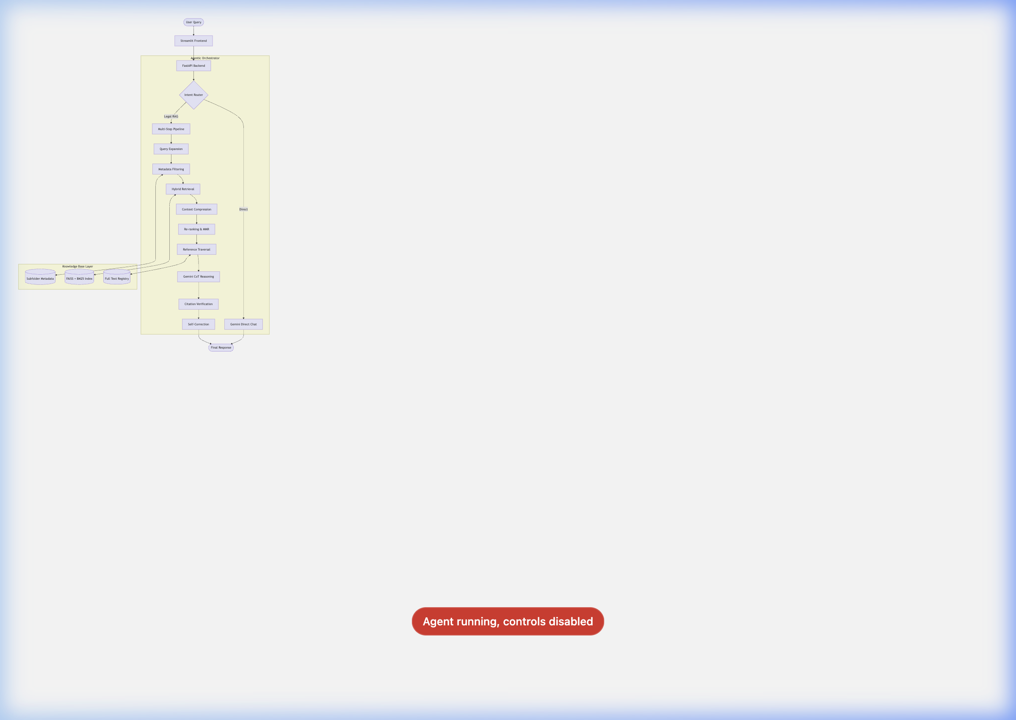
API --> Intent{Intent Router}
Intent -- Direct --> LLM_Direct[Gemini Direct Chat]
Intent -- Legal RAG --> Pipeline[Multi-Step Pipeline]
Pipeline --> Step1[Query Expansion]
Step1 --> Step2[Metadata Filtering]
Step2 --> Step3[Hybrid Retrieval]
Step3 --> Step4[Context Compression]
Step4 --> Step5[Re-ranking & MMR]
Step5 --> Step6[Reference Traversal]
Step6 --> Step7[Gemini CoT Reasoning]
Step7 --> Step8[Citation Verification]
Step8 --> Step9[Self-Correction]
Step3 <--> SearchIndex[(FAISS + BM25 Index)]
Step2 <--> Metadata[(Subfolder Metadata)]
Step6 <--> ChunkRegistry[(Full Text Registry)]
LLM_Direct --> Response([Final Response])
Step9 --> Response
---

2. Modules Overview
Module | Location | Responsibility
**Orchestrator** | `agent/planner.py` | Manages the 9-step execution flow and intent routing.
**Ingestion Engine** | `ingest.py` | Processes PDF/Docx, extracts metadata, and builds indices.
**Hybrid Search** | `retrieval/hybrid_search.py` | Combines Vector and Lexical search results.
**Query Expansion** | `retrieval/query_expansion.py` | Generates legal synonyms and expanded queries via Gemini.
**Metadata Filter** | `retrieval/metadata_filter.py` | Dynamic filtering based on jurisdiction, dates, and domain.
**Reranker** | `context/reranker.py` | Uses Cross-Encoders to prioritize the most relevant chunks.
**Traversal** | `context/reference_traversal.py` | Follows internal citations (e.g., "Section 12 of Act X").
**Citation Mgr** | `agent/citation.py` | Extracts and validates citations against source text.
**Memory Mgr** | `agent/memory.py` | Session-based history and context summary management.
**LLM Client** | `llm/gemini_client.py` | Wrapper for Google Gemini (1.5 Flash/Pro) interaction.

---

3. Algorithms & Techniques

A. Intent Routing (Step 0)
- **Algorithm**: Hybrid Rule-based + LLM Classification.
- **How it's used**: Fast regex checks identify greetings; Gemini handles nuanced legal vs. general intent.
- **Why**: Saves cost and latency by bypassing the RAG pipeline for simple "Hello" or "Who are you?" queries.

B. Hybrid Retrieval (Step 3)
- **Technique**: Convex Combination (Weighted Sum).
- **Algorithms**:
- **FAISS (Vector)**: Semantic search using `all-MiniLM-L6-v2`.
- **BM25 (Keyword)**: Lexical search for specific legal terms.
- **How it's used**: Merges results from both indices to ensure we catch both "meaning" and "specific keywords."

C. Context Compression & MMR (Steps 4 & 5)
- **Technique**: Boilerplate Removal + Maximal Marginal Relevance (MMR).
- **How it's used**: Chunks are cleaned of redundant text. MMR ensures that the top-K chunks passed to the LLM are diverse and not repetitive.
- **Why**: Maximizes information density within the LLM's context window.

D. Reference Traversal (Step 6)
- **Algorithm**: Recursive Lookup.
- **How it's used**: If a retrieved chunk mentions "Section 35 of the Consumer Protection Act," the system automatically fetches that specific section from the knowledge base, even if it wasn't in the initial search results.

E. Reasoning & Verification (Steps 7, 8, 9)
- **Technique**: Chain-of-Thought (CoT) + Self-Correction Loop.
- **How it's used**:
- Gemini generates an answer with explicit **STEP** markers.
- A citation module extracts and verifies every section mention.
- If a hallucination is detected (unverified citation), a **Self-Correction Prompt** is sent back to Gemini to fix the error.

F. Pecuniary Jurisdiction Logic
- **Algorithm**: Threshold-based logic.
- **How it's used**: Automatically identifies the correct forum (District/State/National) based on the user-provided "Claim Value" ($₹$).
---

4. Technology Stack
- **LLM**: Google Gemini 1.5 Flash.
- **Vector DB**: FAISS (Local).
- **Embeddings**: Sentence-Transformers.
- **Document Processing**: PyPDF2, python-docx.

