Manufacturing Defect Classification Using Transfer Learning
A CNN-Based Quality Control Vision System Trained on the NEU Surface Defect Dataset

Abstract
This report presents a convolutional neural network (CNN) system for automated visual quality inspection in manufacturing, developed and evaluated on the NEU Surface Defect Database, a public benchmark of hot-rolled steel strip surface defects. A ResNet-18 backbone, pretrained on ImageNet, was fine-tuned using a two-stage transfer learning procedure to classify six defect types: crazing, inclusion, patches, pitted surface, rolled-in scale, and scratches. The trained model achieved 88.6% classification accuracy on a held-out validation set of 360 images, with per-class F1 scores ranging from 0.83 to 0.94. The report documents the dataset, model architecture, training procedure, quantitative results, error analysis via confusion matrix, and discusses how this classification component fits into a broader real-time production-line inspection pipeline including severity scoring and automated rejection.

1. Introduction
Manual visual inspection on manufacturing lines is labor-intensive, inconsistent between inspectors, and struggles to scale with production throughput. Automated visual inspection using deep learning offers a way to detect surface defects — scratches, dents, dimensional errors, missing components, and material inconsistencies — consistently and at line speed. This project develops and evaluates a CNN-based defect classifier as the core perception component of such a system, using transfer learning to make it practical to train with a comparatively small, domain-specific image dataset rather than requiring millions of labeled examples.
Transfer learning is well suited to this problem because manufacturing defect datasets are typically small (hundreds to low thousands of images), while training a CNN from randomly initialized weights on that little data tends to overfit and generalize poorly. Starting from ImageNet-pretrained weights gives the network general-purpose edge, texture, and shape features before it ever sees a single defect image, so training only needs to adapt those features to the target domain.

2. Dataset
The NEU Surface Defect Database (Song & Yan, 2013), a widely used public benchmark for steel surface defect classification, was used in place of proprietary factory imagery, which was not available for this project. It contains 1,800 grayscale images at 200×200 pixels, evenly split across six defect classes with 300 images each:
- Crazing — fine network cracking on the surface
- Inclusion — foreign material embedded in the steel
- Patches — irregular surface patches from rolling defects
- Pitted surface — small pit-like surface depressions
- Rolled-in scale — oxide scale pressed into the surface during rolling
- Scratches — linear surface abrasions
The dataset was pre-split into 240 training and 60 validation images per class (1,440 train / 360 validation total), preserving perfect class balance in both splits, shown in Figure 1.
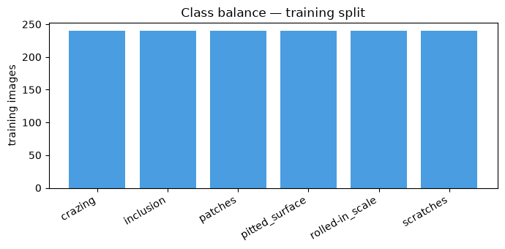
Figure 1. Class balance in the training split — 240 images per class.
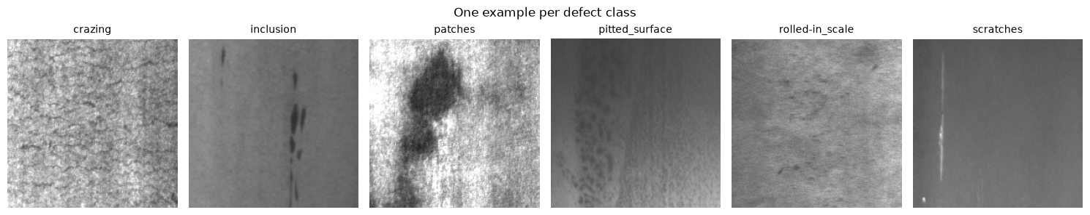
Figure 2. One representative image from each of the six defect classes.
As Figure 2 shows, several classes share visually overlapping texture patterns (e.g., rolled-in scale and crazing both present as fine irregular surface texture), which is a known source of classification difficulty on this dataset and is revisited in the error analysis in Section 5.

3. Methodology

3.1 Model architecture
A ResNet-18 convolutional neural network, pretrained on ImageNet, was used as the backbone. The final fully-connected classification layer was replaced with a new linear layer mapping to the six defect classes. ResNet-18 was chosen over deeper architectures (ResNet-50, EfficientNet-B0) as a reasonable balance of representational capacity and training/inference speed given the modest dataset size — a deeper network offers no clear benefit on 1,800 images and costs more compute per inference, which matters for a system intended to run at production line speed.

3.2 Two-stage transfer learning
Training proceeded in two stages, a standard transfer learning procedure for small target datasets:
- Stage 1 (head warm-up): the pretrained backbone was frozen entirely; only the new classification head was trained, for 6 epochs at learning rate 1×10⁻³. This lets the randomly-initialized head converge without large early gradients corrupting the pretrained backbone features.
- Stage 2 (fine-tuning): the final residual block of the backbone was unfrozen and trained jointly with the head for 4 epochs at a lower learning rate, 1×10⁻⁴, allowing the late-stage features to specialize to steel surface texture without disturbing the earlier, more general layers.

3.3 Data augmentation and preprocessing
Training images were resized to 96×96 pixels and augmented with random horizontal flips, random vertical flips (defect images have no canonical “up” orientation, unlike natural photographs), and random rotation up to 10 degrees. Both training and validation images were normalized using standard ImageNet channel statistics to match the distribution the pretrained backbone was originally trained on.

3.4 Training configuration
Parameter | Value
Backbone | ResNet-18 (ImageNet-pretrained)
Input resolution | 96 × 96 px
Batch size | 64
Optimizer | Adam
Stage 1 epochs / learning rate | 6 / 1×10⁻³
Stage 2 epochs / learning rate | 4 / 1×10⁻⁴
Loss function | Cross-entropy
Train / validation split | 1,440 / 360 images
Hardware | CPU (no GPU used for this run)

3.5 Evaluation metrics
Model performance was evaluated on the held-out validation split using overall accuracy, per-class precision, recall, and F1-score, and a confusion matrix to characterize which specific classes are most often confused with one another — a single accuracy number does not reveal that.

4. Results

4.1 Training progression
Validation accuracy improved from 51.7% after the first epoch to 88.6% by the end of training, with the two-stage schedule visible as a distinct improvement after fine-tuning began (Figure 3). Training loss decreased steadily and monotonically across both stages with no signs of divergence.
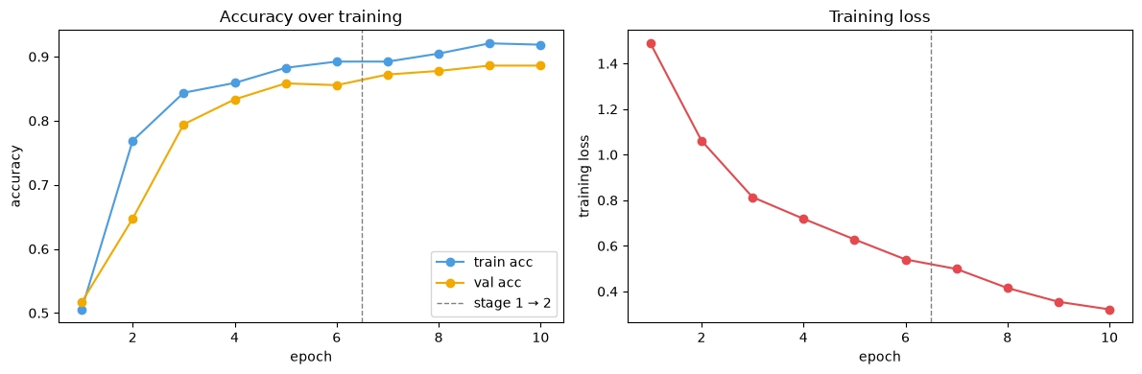
Figure 3. Training/validation accuracy (left) and training loss (right) across all 10 epochs. The dashed line marks the transition from Stage 1 to Stage 2.

4.2 Overall accuracy
Final validation accuracy: 88.6% (319 / 360 correctly classified images).

4.3 Per-class results
Class | Precision | Recall | F1-score | Support
crazing | 0.86 | 0.98 | 0.91 | 60
inclusion | 0.90 | 0.77 | 0.83 | 60
patches | 0.87 | 0.97 | 0.91 | 60
pitted_surface | 0.94 | 0.75 | 0.83 | 60
rolled-in_scale | 0.98 | 0.90 | 0.94 | 60
scratches | 0.81 | 0.95 | 0.88 | 60

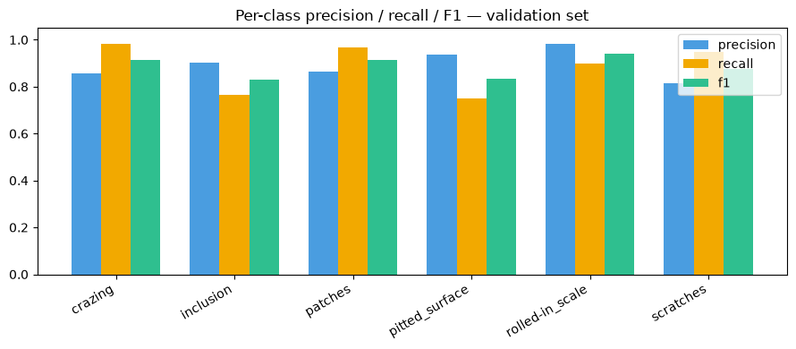
Figure 4. Precision, recall, and F1-score by defect class.

4.4 Confusion matrix
The confusion matrix (Figure 5) shows where the model's errors concentrate. The largest single confusion is inclusion images misclassified as scratches (12 of 60 inclusion images), and a smaller but notable confusion of patches misclassified as crazing, inclusion, or pitted_surface (8, 3, and 4 images respectively out of 60 patches images going to other classes).
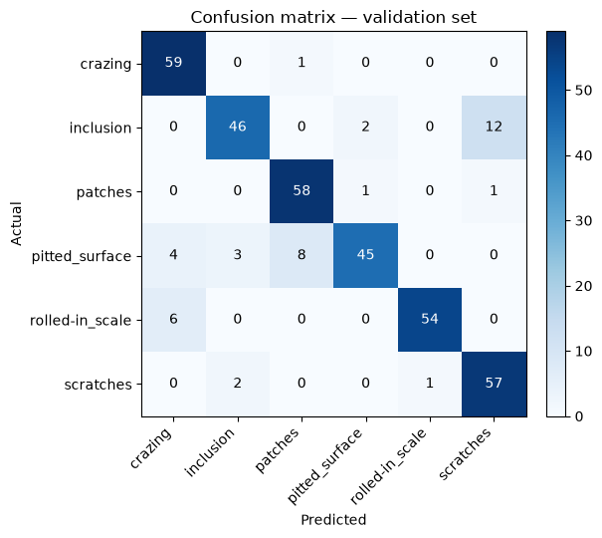
Figure 5. Confusion matrix on the validation set (rows = actual class, columns = predicted class).

4.5 Qualitative examples
Figure 6 shows a sample of correct (green title) and incorrect (red title) predictions. The misclassified examples visually support the confusion matrix finding above: several errors occur on images with ambiguous, low-contrast texture where even a human inspector might reasonably disagree on the label.
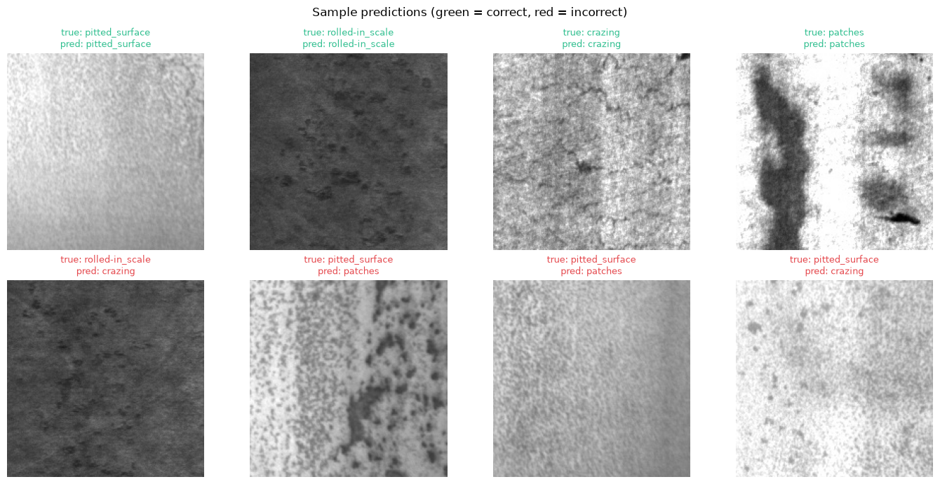
Figure 6. Sample validation predictions — green titles are correct, red titles are incorrect.

5. Discussion

5.1 Interpretation of results
An 88.6% accuracy after only 10 epochs of training on a modest 1,440-image training set is a solid result for a six-class fine-grained texture classification problem, and is consistent with published results on this benchmark, where longer training schedules, higher input resolution, and heavier backbones report accuracy in the mid-to-high 90s. The gap between this result and the best published numbers is attributable primarily to the deliberately reduced input resolution (96×96 rather than the native 200×200 or the ImageNet-standard 224×224) and shorter training schedule used here to keep training time to a few minutes on CPU-only hardware.

5.2 Error analysis
The confusion matrix indicates the model's errors are not randomly distributed — they cluster around specific class pairs that share low-level visual characteristics. Inclusion and scratches both present as linear or elongated dark features against a lighter background at low resolution, which plausibly explains why inclusion images are most often confused with scratches rather than with the other four classes. This is actionable: it suggests that either higher input resolution (to preserve the finer texture differences between these classes) or additional training examples specifically contrasting these two classes would be the most efficient next step to improve accuracy further, rather than blindly training for more epochs.

5.3 Limitations
- Reduced input resolution (96×96) and CPU-only training were used to keep the experiment fast to run and reproduce; a full run at native/224×224 resolution with GPU acceleration and a longer training schedule would likely improve on these results.
- The NEU dataset is a clean, single-institution, single-lighting-condition benchmark. A model trained here would need retraining or fine-tuning on real production-line images before deployment — real lines introduce lighting variation, motion blur, occlusion, and camera angle variation this dataset does not capture.
- This dataset provides classification labels only, with no severity grading or defect bounding boxes. A full production quality-control system additionally needs a severity score (how bad is this specific defect instance) to decide whether to reject a part — that requires a separate annotation effort and a second model head trained alongside the classifier, not represented in this dataset or this specific experiment.
- No dedicated test set exists for the NEU benchmark beyond the validation split used here; this is a documented limitation of the dataset itself, and means the accuracy reported here should not be treated as directly comparable to figures from other papers using their own, different validation splits.

5.4 From classifier to production system
This experiment trains the defect-type classification component only. A deployable inspection system built on this classifier would additionally need: (1) a severity-scoring head, trained on human-graded severity labels, to distinguish a cosmetic scratch from a functionally significant one; (2) integration with a real-time camera feed and a physical rejection mechanism (e.g., a pneumatic pusher or air-blast diverter) synchronized to conveyor position; and (3) a confidence threshold below which low-certainty predictions are routed to human review rather than automatically accepted or rejected, to avoid silently shipping defective parts or discarding good ones on a low-confidence call.

6. Conclusion
This project demonstrates a complete, working transfer-learning pipeline for manufacturing defect classification: a pretrained ResNet-18 fine-tuned in two stages achieved 88.6% validation accuracy across six visually similar steel surface defect classes, with a clear, interpretable pattern to its remaining errors. The results support transfer learning as a practical, data-efficient approach for this class of problem, and the error analysis identifies concrete, testable next steps — higher input resolution and targeted additional data for the most-confused class pairs — for anyone extending this work toward a production deployment.

References
Song, K., & Yan, Y. (2013). A noise robust method based on completed local binary patterns for hot-rolled steel strip surface defects. Applied Surface Science, 285, 858–864.
He, K., Zhang, X., Ren, S., & Sun, J. (2016). Deep residual learning for image recognition. Proceedings of the IEEE Conference on Computer Vision and Pattern Recognition (CVPR).
Deng, J., Dong, W., Socher, R., Li, L. J., Li, K., & Fei-Fei, L. (2009). ImageNet: A large-scale hierarchical image database. 2009 IEEE Conference on Computer Vision and Pattern Recognition.

