WEEK 2 DATA SCIENCE TASK

Advanced Data Visualization and Storytelling with Python

Netflix Movies & TV Shows Dataset

Student Name: ABHINAV KUMAR SHARMA
Course / Branch: B.Tech – CSE (Data Science)
Date: 03 September 2026

1. Introduction
This Week 2 project focuses on advanced data visualization and data storytelling using the Netflix Movies and TV Shows dataset. While Week 1 focused mainly on data acquisition, cleaning, and exploratory analysis, this project goes one step further by transforming analytical results into a coherent visual narrative that can be understood by a non-technical audience. The goal is not only to create attractive charts, but also to select appropriate visual forms, explain why each visualization was chosen, identify patterns and anomalies, and connect those patterns to potential business implications.

2. Dataset and Domain
The analysis uses the uploaded Kaggle Netflix dataset containing 8,807 records and 17 original columns. The domain is digital entertainment and streaming content. The dataset includes title information, content type, country, date added, release year, rating, duration, genres, and descriptions.
Dataset source: Kaggle – Netflix Movies and TV Shows dataset (Shivam Bansal).

3. Project Objectives
- Transform cleaned data into clear visual narratives.
- Identify trends, changes in content mix, geographic concentration, and rating patterns.
- Use different chart types according to the analytical question.
- Annotate and interpret every visualization for a non-technical audience.
- Translate analytical findings into potential business implications.

4. Methodology
The dataset was loaded with Pandas and date_added was converted to a datetime field. A year_added feature was derived from date_added. Missing ratings were labeled Unknown for categorical analysis. Country values were split and exploded to support country-level counting. The duration field was parsed into a numeric value so movie lengths could be compared across ratings. Six complementary visualizations were then developed using Matplotlib and Pandas plotting.

5. Visual Analysis and Storytelling

5.1 Content Growth Over Time
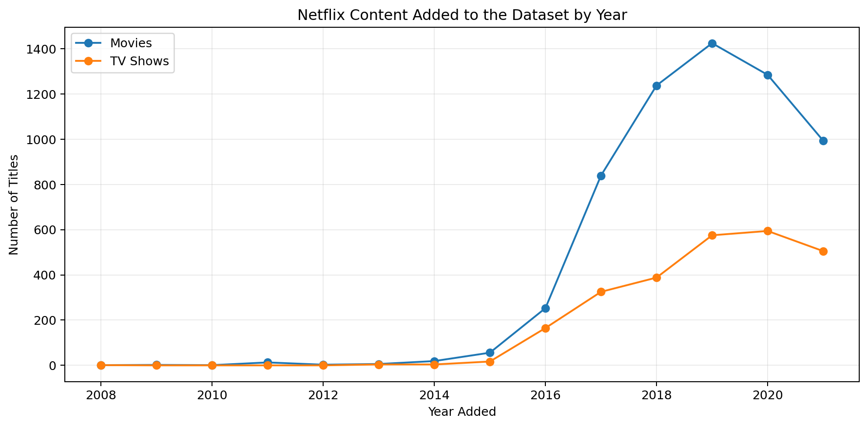

Why this visualization?
A line chart is appropriate because the question is temporal: how has the number of titles added changed over time? Two lines allow the audience to compare Movies and TV Shows while preserving the time sequence.

What does it tell us?
The chart shows that the number of titles added varies considerably across years and that the balance between Movies and TV Shows changes over time. The later period contains a strong concentration of additions.

Potential business implication
For a streaming platform, changes in annual additions can indicate content acquisition strategy, expansion, or shifts in audience demand. Monitoring these trends can support content-budget and catalog-planning decisions.

5.2 Content Mix Over Time
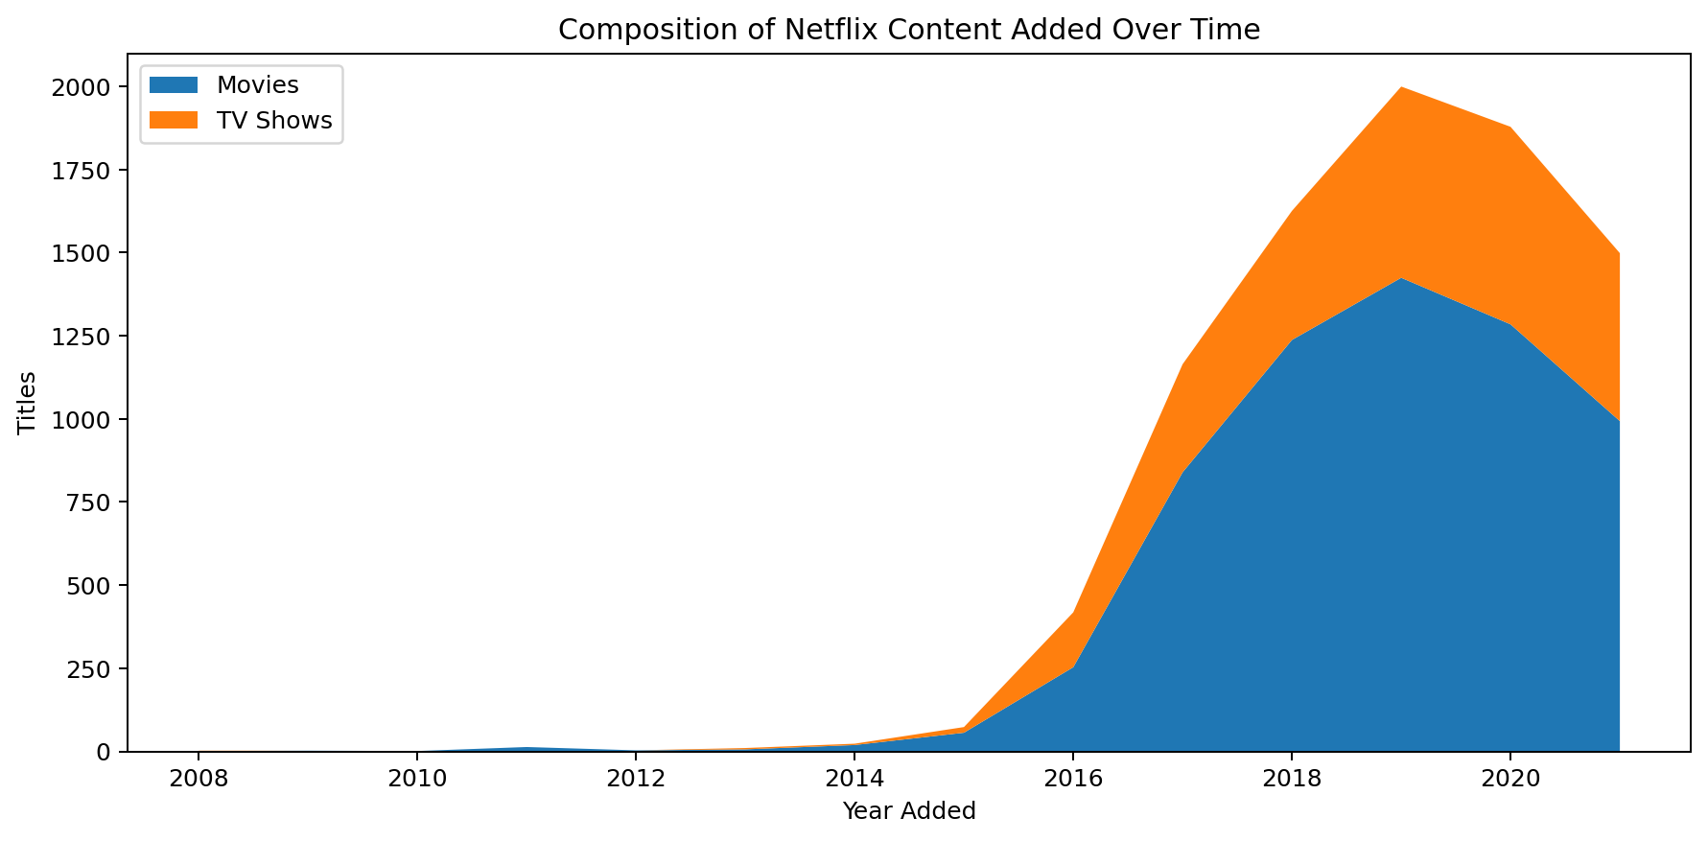

Why this visualization?
A stacked area chart emphasizes the overall volume of content while simultaneously showing how Movies and TV Shows contribute to that total.

What does it tell us?
The visual makes it easier to see the changing composition of the catalog. Movies generally occupy the larger share, while TV Shows form an important and visible component.

Potential business implication
A changing content mix can influence retention, engagement, and programming strategy. A platform can use this type of analysis to balance long-form episodic content with movies.

5.3 Geographic Content Concentration
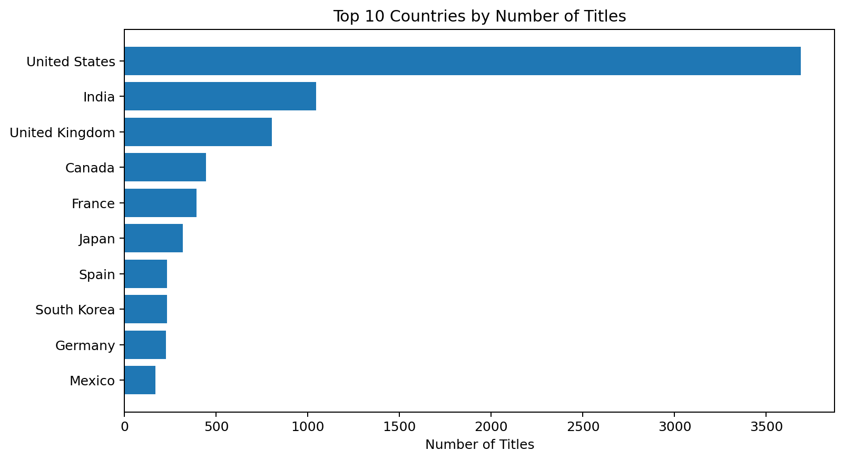

Why this visualization?
A horizontal bar chart is used because country names can be long, and ranking is easier to read when categories are ordered from smallest to largest.

What does it tell us?
The analysis shows strong geographic concentration. United States is the most frequently represented country in the exploded country field, with 3,689 title-country associations.

Potential business implication
Country-level concentration can help streaming services evaluate regional content strategies, localization, licensing, and opportunities to expand representation in under-served markets.

5.4 Content Rating Distribution
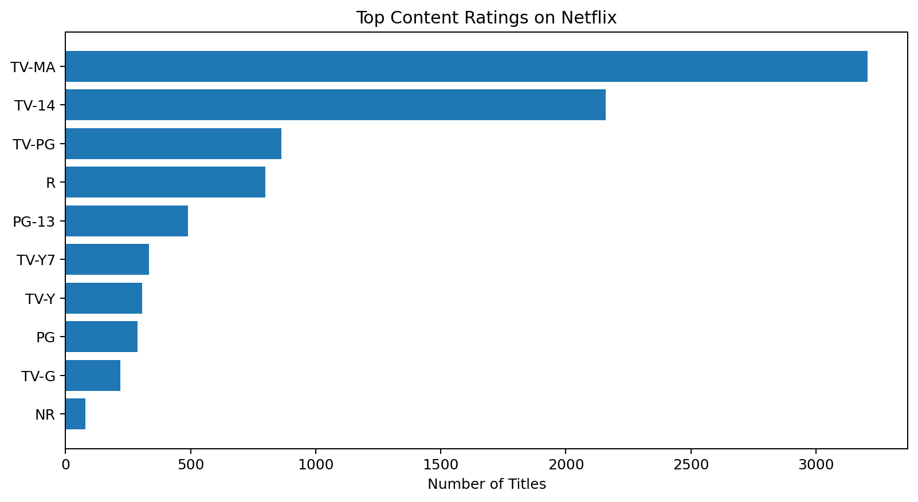

Why this visualization?
A ranked bar chart is suitable for comparing discrete rating categories and immediately identifying the most common content classifications.

What does it tell us?
The most frequent rating category in the dataset is TV-MA, appearing 3,207 times. The distribution indicates that Netflix's catalog contains a broad mix of audience classifications.

Potential business implication
Rating composition can inform parental controls, audience segmentation, content acquisition, and recommendation strategies. A platform can compare rating demand with viewing behavior to identify gaps.

5.5 Movie Duration by Rating
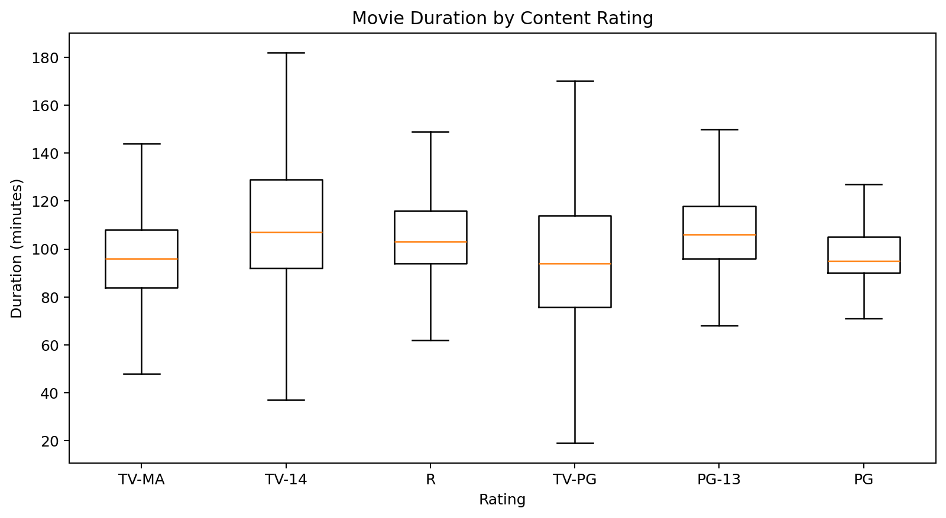

Why this visualization?
A box plot is used because it compares the central tendency and spread of movie duration across multiple rating groups and can reveal differences without being dominated by extreme values.

What does it tell us?
The average duration of movies with available numeric duration is approximately 99.6 minutes. The box plot allows comparison of typical duration and variability across ratings.

Potential business implication
Duration differences can support content planning and recommendation systems. For example, users with limited time may benefit from short-content recommendations, while longer sessions may support longer films.

5.6 Year-by-Type Heatmap
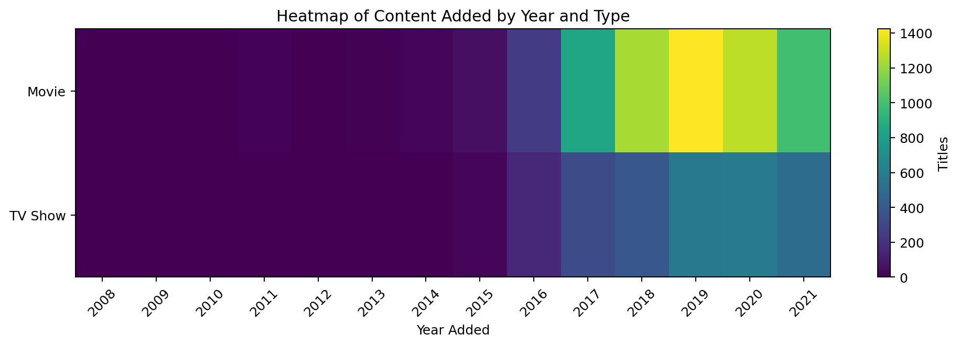

Why this visualization?
A heatmap encodes the number of titles by year and content type using intensity, allowing periods of high and low activity to be recognized quickly.

What does it tell us?
The heatmap provides a compact overview of when Movies and TV Shows were most heavily added. It complements the line and area charts by making concentration patterns visually obvious.

Potential business implication
A heatmap can help analysts and decision-makers identify periods of accelerated catalog expansion and compare the timing of movie and TV-show additions.

6. Overall Data Story
Taken together, the visualizations tell a consistent story: Netflix's catalog is large and diverse, but content additions are not evenly distributed across time, content type, geography, or audience rating. Movies form a substantial part of the catalog, while TV Shows provide a meaningful second content stream. The geographic view highlights the importance of regional production and licensing, and the rating analysis shows that the catalog serves multiple audience groups. Finally, movie duration demonstrates that even within one content type, viewing characteristics vary across rating categories. Presenting these findings as a sequence of related visuals makes the analysis more accessible to business stakeholders.

7. Business and Scientific Implications
- Content strategy: historical addition patterns can support decisions about future content acquisition and production.
- Audience segmentation: rating and duration patterns can help design more targeted recommendations.
- Regional strategy: country-level concentration can identify markets with strong existing content and markets where additional local content may create differentiation.
- Catalog management: year-wise content trends can help identify periods of rapid expansion and guide portfolio reviews.
- Dashboard design: the selected visuals can be combined into an executive dashboard for content and strategy teams.

8. Key Findings
- The dataset contains 8,807 titles, including 6,131 Movies and 2,676 TV Shows.
- The dataset shows substantial variation in the number of titles added across years; the highest addition year in the available date-added field is 2019 with 1,999 titles.
- United States is the most represented country in the country association analysis.
- TV-MA is the most common rating category.
- Movie duration varies across rating categories, making duration useful for audience and recommendation analysis.
- Combining multiple visual encodings provides a clearer story than relying on a single chart.

9. Tools and Technologies
- Python
- Pandas
- NumPy
- Matplotlib
- Seaborn
- Jupyter Notebook / Google Colab
- Microsoft Word

10. Conclusion
This Week 2 project demonstrates how advanced visualization can convert a raw analytical dataset into a structured data story. The six visualizations were selected for different analytical purposes: trend comparison, composition, ranking, distribution, group comparison, and matrix-based pattern detection. The accompanying explanations connect each chart to a specific question and show how the resulting insights could support real-world business decisions. The workflow provides a strong foundation for future dashboarding, recommendation-system analysis, and machine-learning projects.

11. Python Code Appendix
import pandas as pd
import numpy as np
import matplotlib.pyplot as plt
import seaborn as sns
df = pd.read_csv("netflix_titles.csv")
# Date preprocessing
df["date_added"] = pd.to_datetime(df["date_added"], errors="coerce")
df["year_added"] = df["date_added"].dt.year
# Missing categorical values
df["rating"] = df["rating"].fillna("Unknown")
# Extract numeric duration
df["duration_num"] = pd.to_numeric(
df["duration"].str.extract(r"(\d+)")[0],
errors="coerce"
)
# 1. Content growth
ct = pd.crosstab(df["year_added"], df["type"]).sort_index()
ct.plot(figsize=(10,5), marker="o")
plt.title("Netflix Content Added by Year")
plt.show()
# 2. Stacked content mix
ct.plot.area(figsize=(10,5))
plt.title("Content Mix Over Time")
plt.show()
# 3. Top countries
countries = df["country"].dropna().str.split(", ").explode()
countries.value_counts().head(10).sort_values().plot(kind="barh")
plt.title("Top 10 Countries")
plt.show()
# 4. Ratings
df["rating"].value_counts().head(10).sort_values().plot(kind="barh")
plt.title("Top Content Ratings")
plt.show()
# 5. Movie duration by rating
movie = df[df["type"] == "Movie"].copy()
movie.boxplot(column="duration_num", by="rating", figsize=(10,5))
plt.title("Movie Duration by Rating")
plt.suptitle("")
plt.show()
# 6. Heatmap
heat = ct.T
plt.figure(figsize=(11,4))
sns.heatmap(heat, annot=False, cmap="Blues")
plt.title("Content Added by Year and Type")
plt.show()

12. Dataset Reference
Kaggle: Netflix Movies and TV Shows dataset by Shivam Bansal.
Repository recommendation: include this report, the Jupyter notebook, visualizations, and README in the Week 2 GitHub project.

