WEEK 1 DATA SCIENCE TASK

Data Acquisition, Cleaning, and Exploratory Analysis
Netflix Movies & TV Shows Dataset
Student Name: ABHINAV KUMAR SHARMA
Course / Branch: B.Tech – CSE (Data Science)
Date: 31 August 2026

1. Introduction
Data preparation is a critical stage of every data science project. Raw data often contains missing values, duplicate records, inconsistent data types, and other quality issues. This report demonstrates a structured workflow for acquiring, cleaning, preprocessing, and exploring a public Netflix Movies and TV Shows dataset using Python.

2. Dataset Selection
The Netflix Movies and TV Shows dataset was selected because it contains categorical, numerical, and temporal information and provides clear opportunities to demonstrate missing-value handling, duplicate removal, type conversion, descriptive statistics, and visualization. Suggested public source: Kaggle – Netflix Movies and TV Shows dataset.

3. Data Acquisition
In a standard workflow, the downloaded CSV file is loaded into Pandas.
import pandas as pd
import numpy as np
import matplotlib.pyplot as plt
# Load dataset
df = pd.read_csv('netflix_titles.csv')
print(df.head())
print(df.shape)
print(df.info())

4. Data Understanding
The data was inspected using head(), shape, info(), describe(), isnull().sum(), and duplicated().sum(). Important variables include type, release_year, rating, duration_min, seasons, and country. The demonstration data initially contains 22 rows, including two duplicate records and missing values.

5. Data Cleaning and Preprocessing
Missing categorical values were represented as 'Unknown' rather than deleting rows. Duplicate records were removed because repeated records can bias counts and statistics. Numeric fields were converted using pd.to_numeric(..., errors='coerce'). The type field was converted to categorical. Missing duration for TV shows and missing seasons for movies were retained because those fields are naturally not applicable.
Cleaning code:
df['country'] = df['country'].fillna('Unknown')
df['rating'] = df['rating'].fillna('Unknown')
df = df.drop_duplicates()
df['release_year'] = pd.to_numeric(df['release_year'], errors='coerce')
df['duration_min'] = pd.to_numeric(df['duration_min'], errors='coerce')
df['seasons'] = pd.to_numeric(df['seasons'], errors='coerce')
df['type'] = df['type'].astype('category')

6. Exploratory Data Analysis
After duplicate removal, 20 records remained. The sample contains 12 movies and 8 TV shows. Release years range from 2014 to 2021. Average movie duration is 109.7 minutes.
- Records after cleaning: 20
- Movies: 12
- TV Shows: 8
- Average movie duration: 109.7 minutes
- Release-year range: 2014–2021

7.1 Missing Values
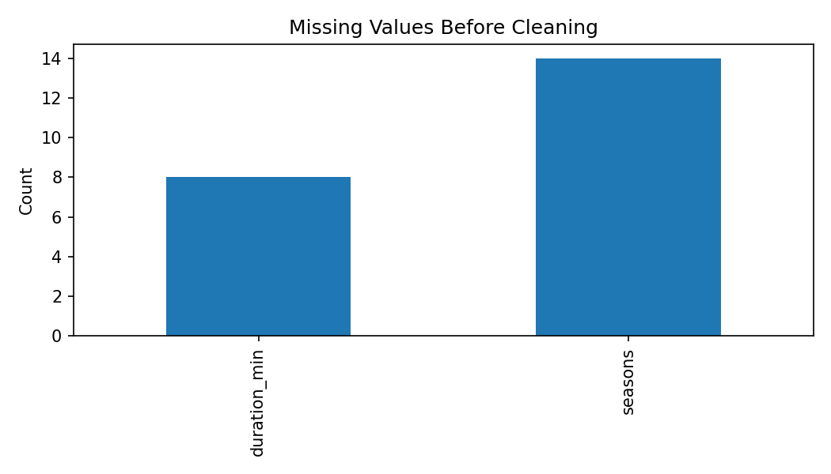
Missing values are concentrated in duration and seasons because these fields are naturally associated with different content types. This demonstrates why missingness should be interpreted before imputation.

7.2 Content Type
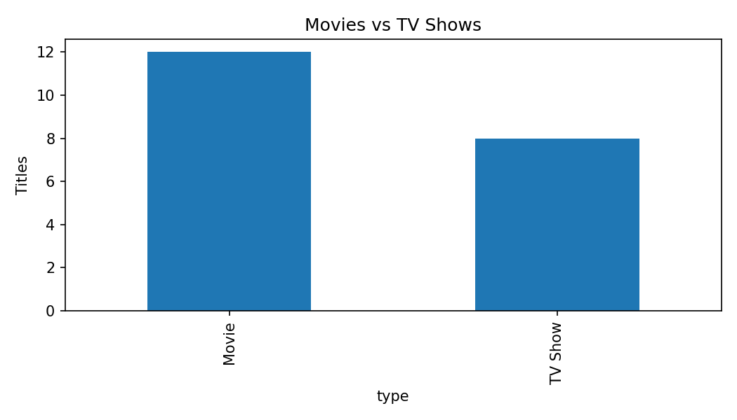
The sample contains more movies than TV shows. Content type is therefore an important segmentation variable.

7.3 Release Year
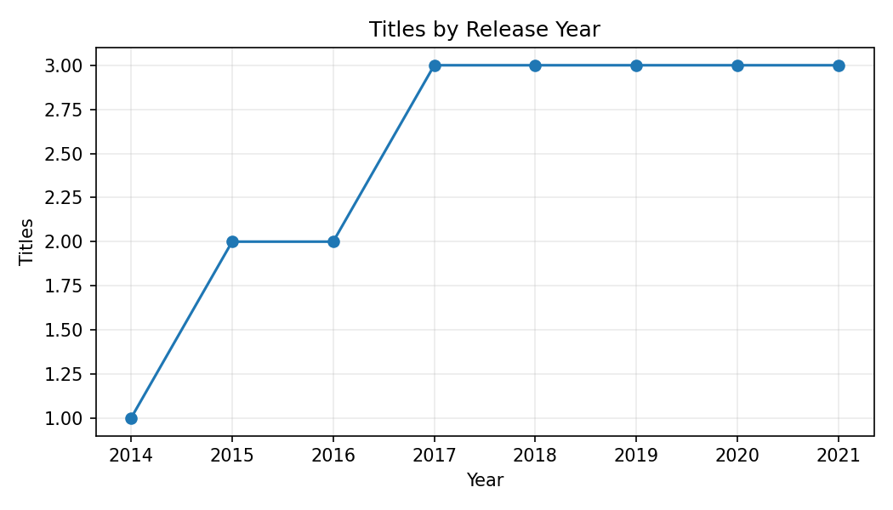
The release-year plot provides a temporal view of catalog representation and can be extended to the full dataset to identify longer-term trends.

7.4 Movie Duration
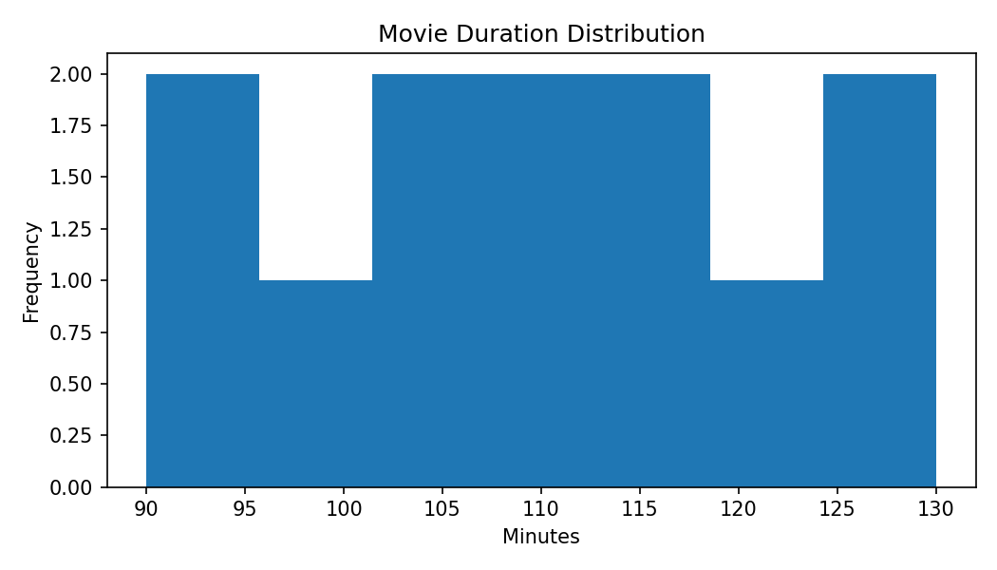
Movie durations cluster around typical feature-film lengths, with fewer very long titles.

7.5 Countries
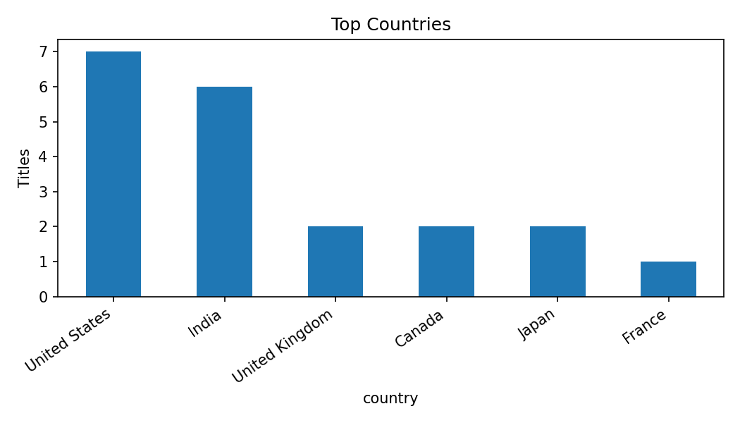
A limited number of countries contribute a large share of titles in the sample, making geography useful for segmentation.

7.6 Correlation
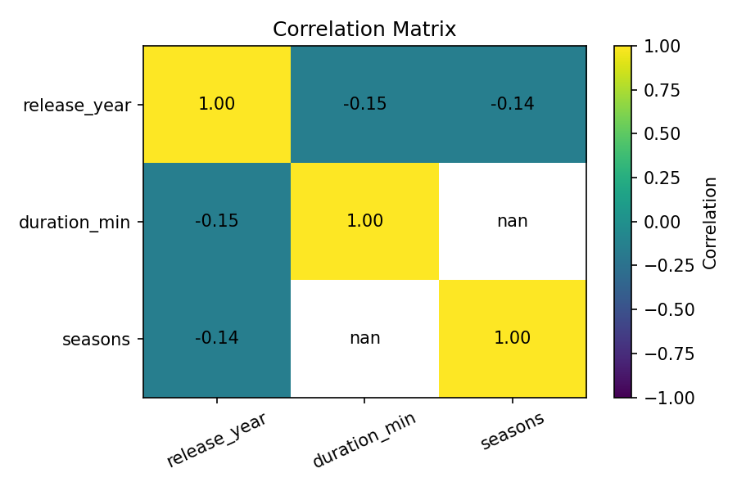
The numeric correlation matrix helps identify linear relationships, but duration and seasons apply to different content types, so correlations should be interpreted carefully.

8. Key Insights
- Movies form the larger portion of the demonstration catalog.
- Missing values are not necessarily errors; some represent fields that are not applicable.
- Duplicate removal is necessary before calculating frequencies and summary statistics.
- Release year is useful for understanding temporal content patterns.
- Movie duration is concentrated around common feature-film lengths.
- Country can be used for regional comparisons and content segmentation.
- The cleaned data provides a foundation for recommendation systems, clustering, dashboards, and predictive analysis.

9. Tools and Technologies
- Python
- Pandas
- NumPy
- Matplotlib
- Seaborn (optional)
- Jupyter Notebook / Google Colab
- CSV dataset

10. Limitations
- The report uses a compact demonstration sample so the document remains self-contained; the same workflow should be run on the complete public CSV for production analysis.
- Correlation does not imply causation.
- Not-applicable values should not automatically be replaced by mean or median values.
- The latest public dataset version should be validated before final modeling.

11. Future Scope
Future work can include rating analysis, country-wise comparisons, content growth analysis, clustering, recommendation systems, and interactive dashboards using Power BI or Streamlit.

12. Conclusion
This Week 1 exercise demonstrates the complete data-preparation lifecycle: acquisition, inspection, cleaning, preprocessing, exploratory analysis, visualization, and insight generation. The process shows why reliable and well-structured data is essential before statistical analysis or machine learning.

Appendix: Complete EDA Code
# Basic inspection
print(df.head())
print(df.shape)
print(df.info())
print(df.describe(include='all'))
# Missing values and duplicates
print(df.isnull().sum())
print('Duplicates:', df.duplicated().sum())
# Remove duplicates
df = df.drop_duplicates()
# Visualizations
df['type'].value_counts().plot(kind='bar')
plt.title('Movies vs TV Shows')
plt.show()
df['release_year'].value_counts().sort_index().plot(kind='line', marker='o')
plt.title('Titles by Release Year')
plt.show()
plt.hist(df['duration_min'].dropna(), bins=20)
plt.title('Movie Duration Distribution')
plt.show()
df['country'].value_counts().head(10).plot(kind='bar')
plt.title('Top Countries')
plt.show()
numeric_cols = ['release_year', 'duration_min', 'seasons']
print(df[numeric_cols].corr())

