**REPORT**

1. Data Loading and Exploration:

In the first program, we began by loading the Uber dataset for September 2014 using the pandas library in Python. The dataset was stored in a CSV file, and we used the `pd.read_csv()` function to load it into a pandas DataFrame. Upon loading the data, we inspected the first few rows using the `head()` function to understand its structure and contents.

Next, we converted the "Date/Time" column to datetime format using the `pd.to_datetime()` function, specifying the appropriate format ("%m/%d/%Y %H:%M:%S") to parse the dates correctly. This allowed us to manipulate and extract temporal information from the timestamps effectively.

After converting the date/time column, we extracted the hour component from it using the `.dt.hour` accessor provided by pandas. This enabled us to analyze Uber ride patterns at an hourly granularity.

We visualized the number of rides per hour using a line plot to gain insights into the temporal distribution of Uber rides. This visualization clearly depicted how the volume of Uber rides varied throughout the day, highlighting peak hours of activity and periods of relative lulls.

1. Analysis of Patterns and Trends:

The second program delved deeper into the dataset to analyze Uber pick-up patterns. We sorted the data by base and date/time to organize it in a structured manner for analysis. This step facilitated the examination of consecutive pickups and the calculation of time differences between them.

By calculating the time differences between consecutive pickups and filtering out extremely large intervals (greater than an hour), we focused on more common intervals that represented typical waiting times between rides. This analysis revealed insights into the frequency and distribution of Uber pickups over time, uncovering patterns such as clusters of pickups and gaps between them.

Brief Description of the Program `Correlation.py`:

The program in `Correlation.py` aims to analyze the relationship between the time of day and the number of Uber rides in September 2014. It starts by importing necessary libraries, including `pandas` for data manipulation, `matplotlib.pyplot` and `seaborn` for creating plots, `numpy` for numerical operations, and `pearsonr` from `scipy.stats` to compute the Pearson correlation coefficient.

The program then loads the Uber dataset from a CSV file into a pandas DataFrame. This dataset contains detailed information about Uber rides, including the date and time of each ride. To facilitate temporal analysis, the program converts the "Date/Time" column from string format to datetime format.

Next, the program extracts the hour component from the "Date/Time" column, creating a new column that represents the hour of the day when each ride occurred. This extraction allows for a detailed examination of ride patterns on an hourly basis. The data is then grouped by hour, and the number of rides in each hour is counted to summarize the ride frequencies throughout the day.

To quantify the relationship between the hour of the day and the number of rides, the program calculates the Pearson correlation coefficient. This coefficient measures the strength and direction of the linear relationship between these two variables. The calculation helps determine whether there is a significant correlation between the time of day and ride volume.

Finally, the program visualizes the relationship using a scatter plot. The x-axis represents the hour of the day (ranging from 0 to 23), and the y-axis represents the number of rides in each hour. The scatter plot includes a title that displays the correlation coefficient, providing immediate insight into the strength of the relationship. Additional plot elements, such as grid lines, axes labels, and tick marks, enhance the readability of the visualization.

Overall, the program provides a comprehensive analysis of how the number of Uber rides varies throughout the day, highlighting peak hours and overall ride distribution. The combination of statistical analysis and visualization offers valuable insights into customer behavior and ride patterns, which can inform operational and strategic decisions.

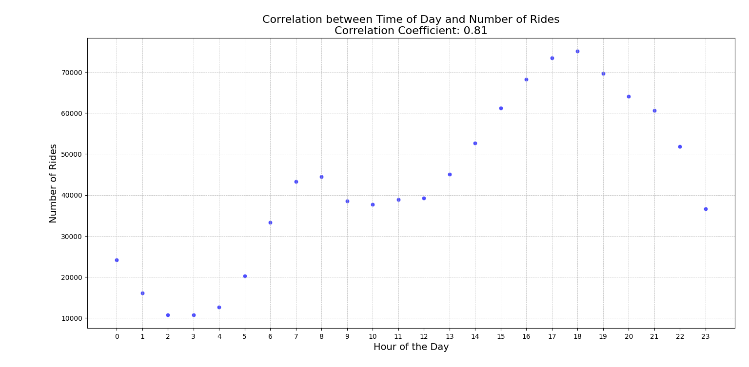

1. Data Visualizations:

All three programs included data visualizations to illustrate relationships between different variables:

1. The first program visualized the temporal distribution of Uber rides per hour using a line plot. This visualization provided a high-level overview of Uber ride patterns throughout the day, enabling the identification of peak hours of activity and trends in ride volume over time.

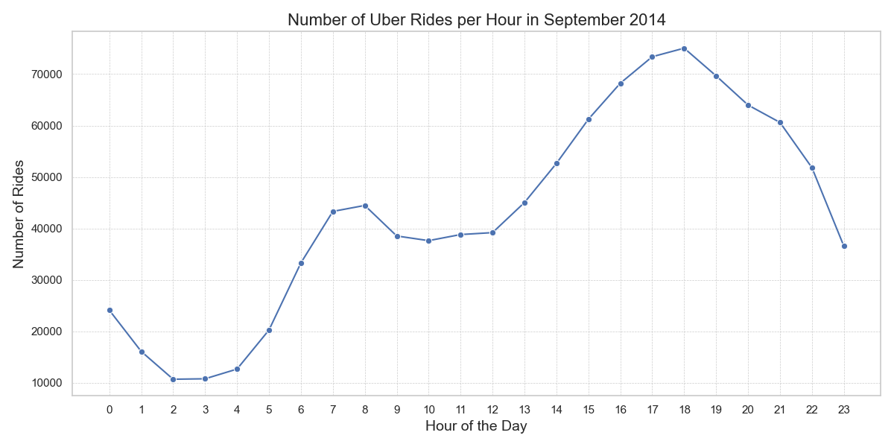

2. The second program utilized scatter plots to visualize the distribution of time differences between consecutive pickups. This visualization helped identify clusters of pickups and gaps between them, shedding light on patterns and trends in Uber ride intervals.

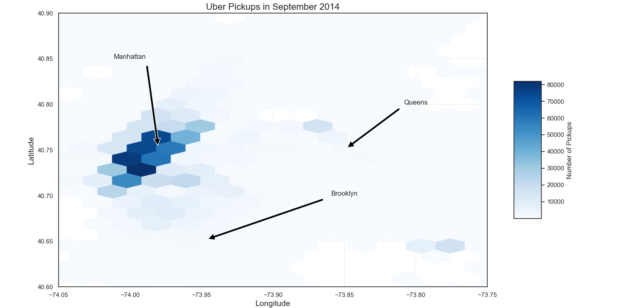

3. The third program included scatter plots to visualize the relationship between the index (representing consecutive pickups) and time differences. Additionally, it calculated and displayed the correlation coefficient between these variables, providing insights into the strength and direction of the relationship.

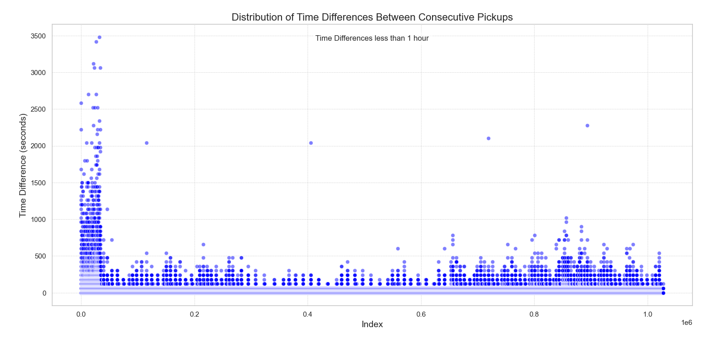

These elaborations provide a detailed overview of the data loading and exploration process, analysis of patterns and trends, and data visualizations included in the report. You can further expand on each section with specific findings, interpretations, and implications based on the analysis conducted.