**Analysis of Mortality Rates Before and After the Introduction of Handwashing**

**Overview**

This document provides an analysis of mortality rates in clinics before and after the introduction of handwashing in 1847. The analysis includes calculating and plotting mortality rates using different visualization libraries such as Matplotlib, Seaborn, and Bokeh.

**Libraries Used**

- Pandas: For data manipulation and analysis.

- Matplotlib: For creating static, animated, and interactive visualizations in Python.

- Seaborn: For making statistical graphics.

- Bokeh: For interactive visualizations.

**Data Loading**

The data is loaded from two CSV files:

- `monthly_deaths.csv`: Contains monthly death and birth data.

- `yearly_deaths_by_clinic.csv`: Contains yearly death and birth data for different clinics.

Code:-

**monthly_deaths = pd.read_csv('monthly_deaths.csv')**

**yearly_deaths_by_clinic = pd.read_csv('yearly_deaths_by_clinic.csv')**

**Calculating Mortality Rates**

The mortality rates are calculated by dividing the number of deaths by the number of births for both monthly and yearly datasets.

Code:-

**monthly_deaths['mortality_rate'] = monthly_deaths['deaths'] / monthly_deaths['births']**

**yearly_deaths_by_clinic['mortality_rate'] = yearly_deaths_by_clinic['deaths'] / yearly_deaths_by_clinic['births']**

**Splitting Data Based on Handwashing Implementation**

The year 1847 is marked as the year when handwashing was introduced. The data is split into two periods: before and after handwashing.

```python

**handwashing_start_year = 1847**

**before_handwashing = yearly_deaths_by_clinic[yearly_deaths_by_clinic['year'] < handwashing_start_year]**

**after_handwashing = yearly_deaths_by_clinic[yearly_deaths_by_clinic['year'] >= handwashing_start_year]**

```

**Average Mortality Rates**

The average mortality rates for the periods before and after handwashing are calculated.

```python

**average_mortality_before = before_handwashing['mortality_rate'].mean()**

**average_mortality_after = after_handwashing['mortality_rate'].mean()**

```

**Visualizations**

**1. Yearly Mortality Rates by Clinic:-**

A scatter plot with lines is created to visualize the yearly mortality rates for each clinic. A vertical red dashed line marks the introduction of handwashing.

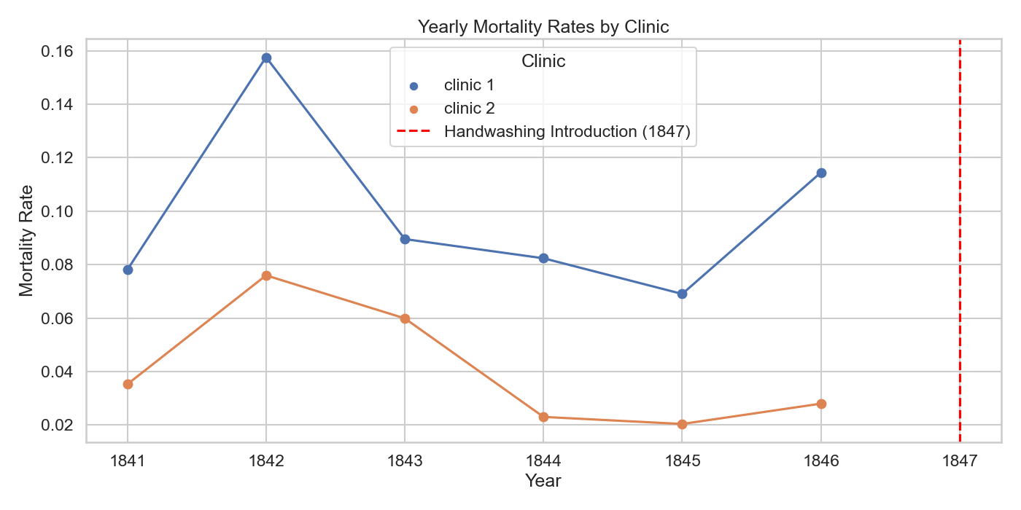

**2. Monthly Mortality Rates:-**

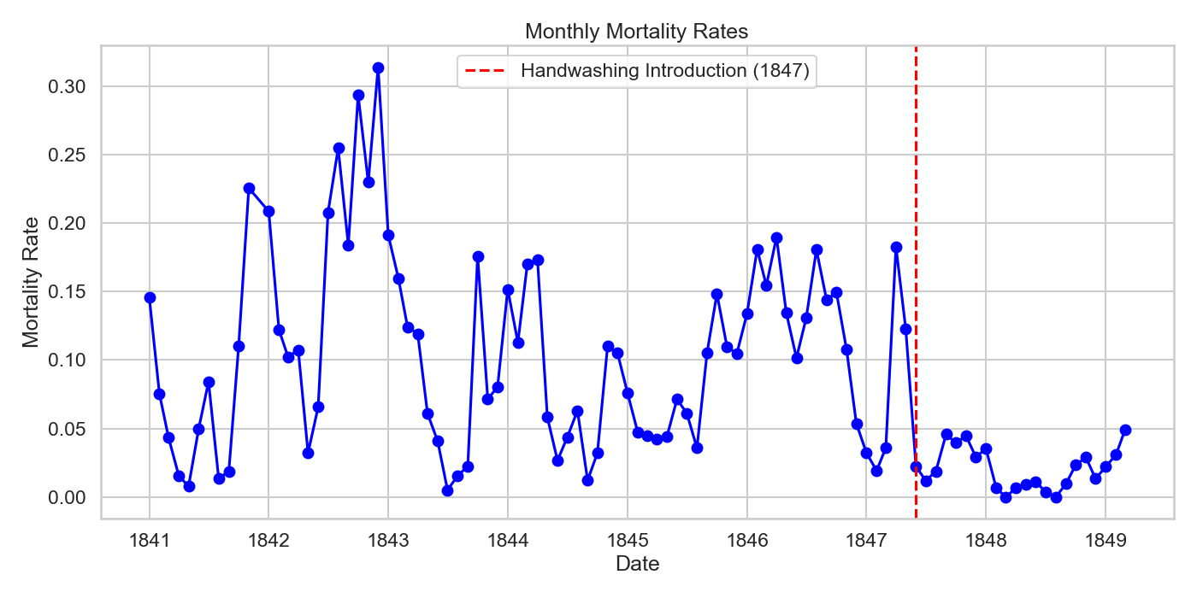A scatter plot with lines is created to visualize the monthly mortality rates. A vertical red dashed line marks the introduction of handwashing.

**3. Bubble Plot of Monthly Mortality Rates by Year:-**

A bubble plot is created to visualize the monthly mortality rates over the years, with bubble sizes proportional to the number of births.

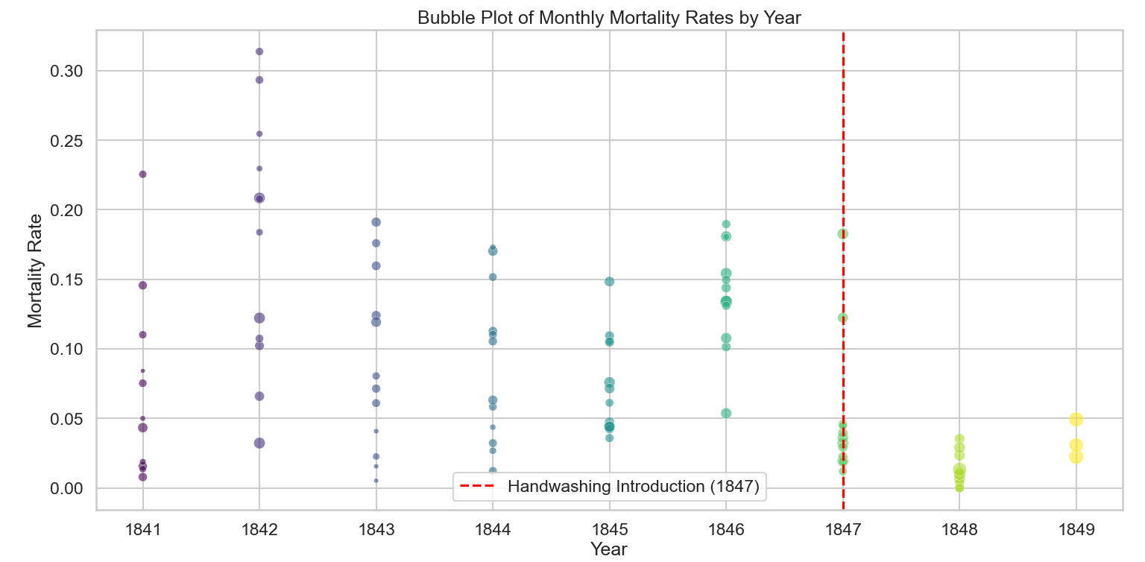

**4. Bokeh Plot of Average Mortality Rates:-**

An interactive Bokeh plot is created to compare the average mortality rates before and after handwashing was introduced.

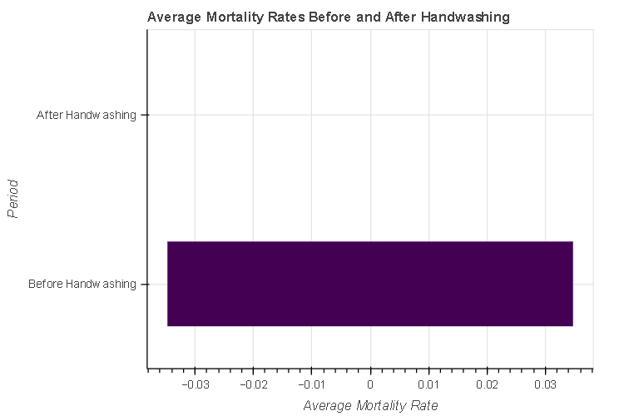

**Conclusion**

The analysis shows a significant reduction in mortality rates after the introduction of handwashing in 1847. The visualizations effectively highlight this change, demonstrating the impact of handwashing on reducing mortality rates in the clinics.