**AUTOMATA FORMAL LANGUAGES AND LOGIC**

(UE22CS343A)

ASSIGNMENT

SYNTAX VALIDATION IN PYTHON

AAKANKSH SEELIN(PES2UG22CS003)

ABHINAV SANKARSHANA DASU(PES2UG22CS017)

**CONSTRUCT-1**

**FOR:**

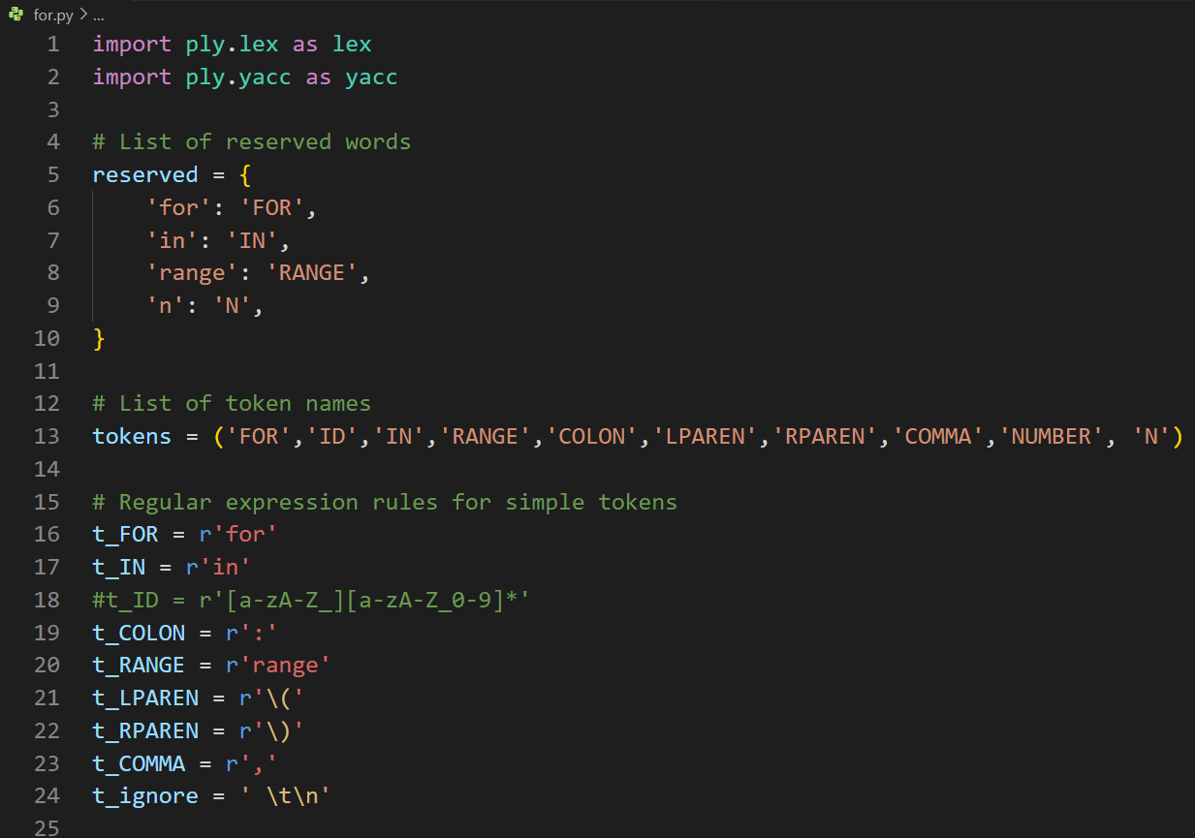

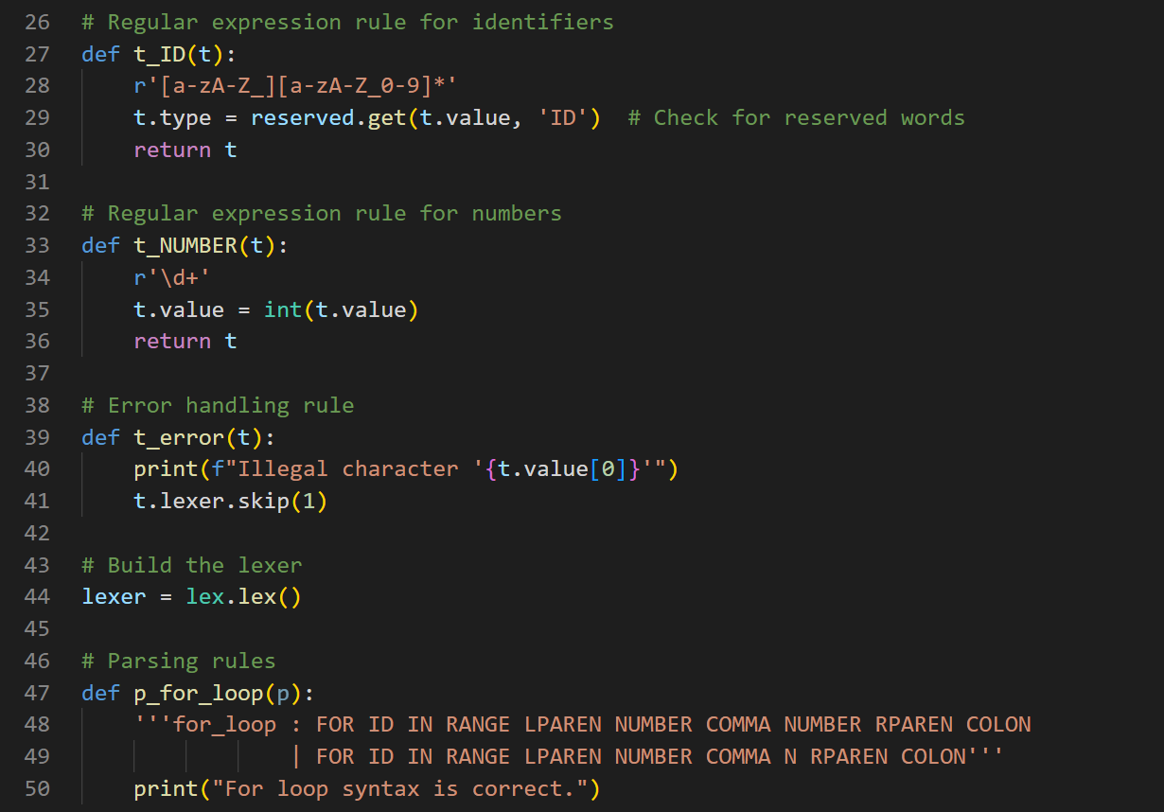

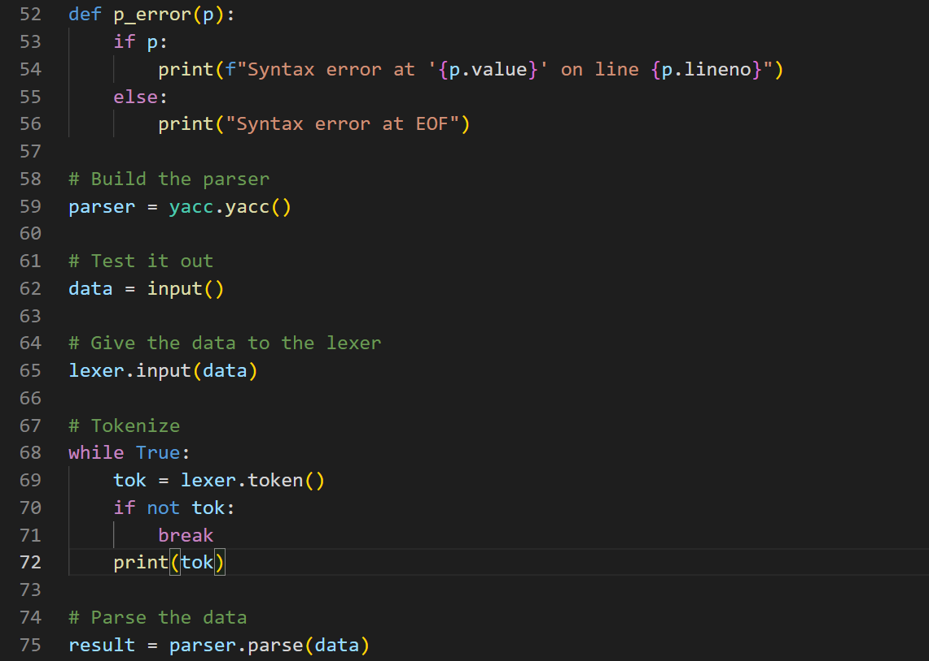

**CORRECT SYNTAX:**

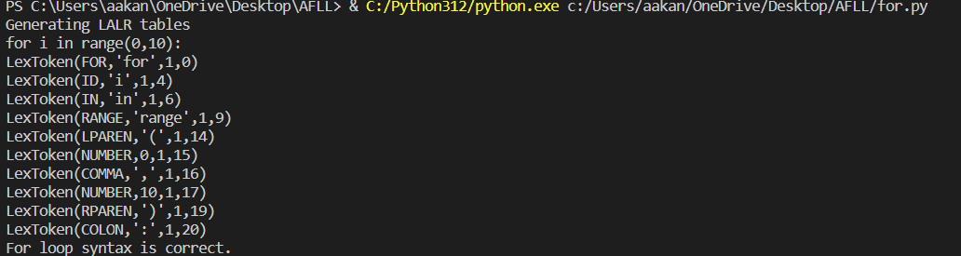

**INCORRECT SYNTAX:**

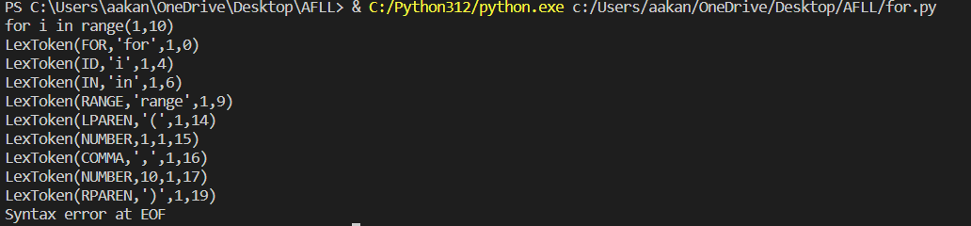

**CONSTRUCT-2**

**IF:**

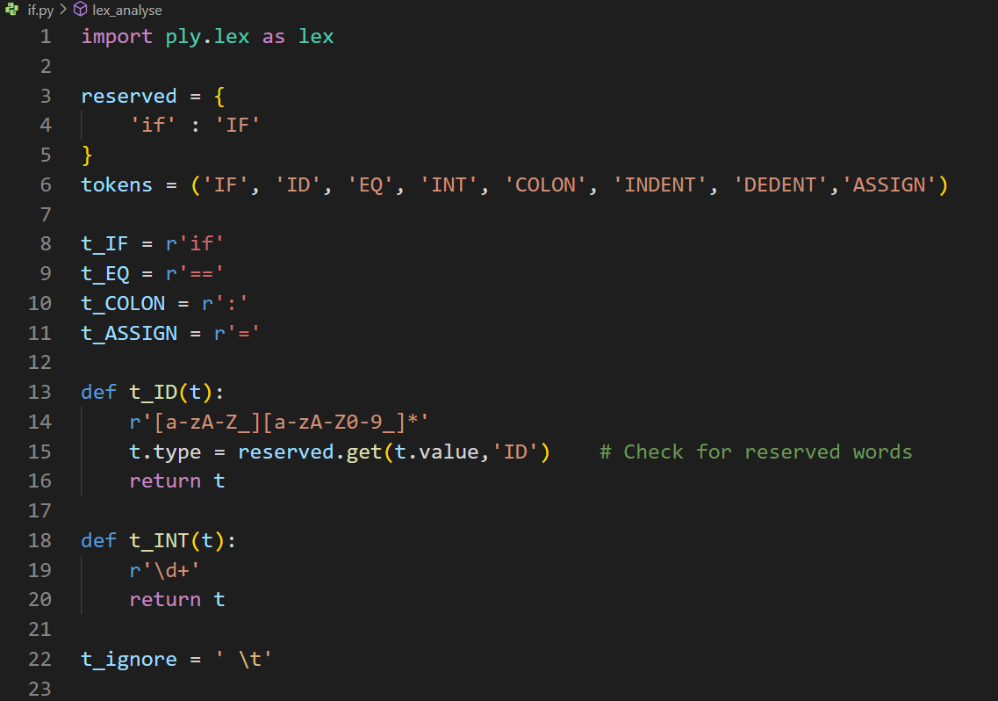

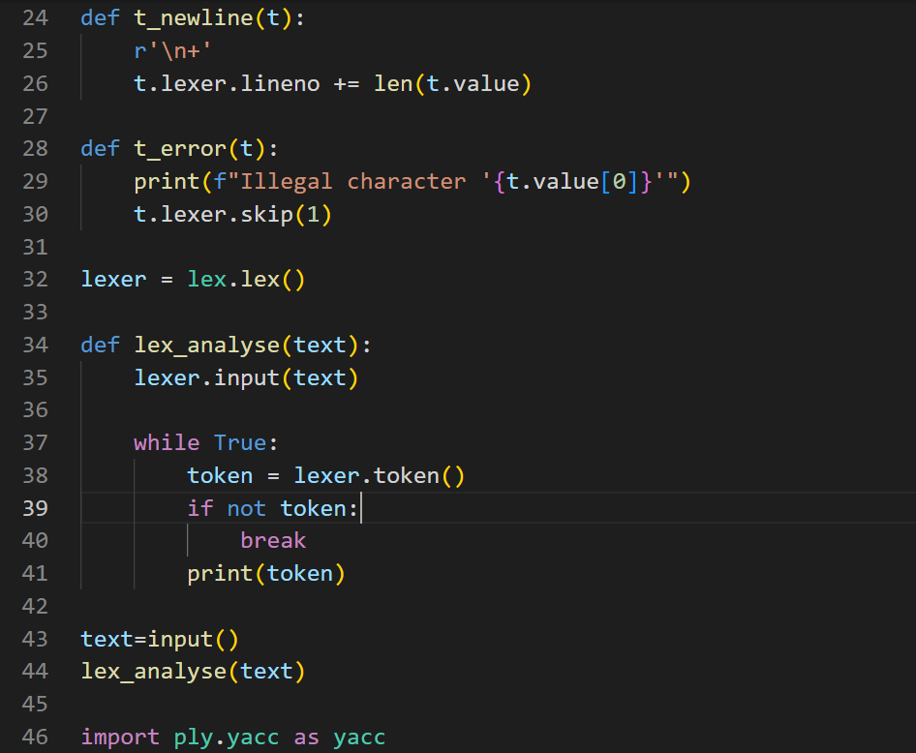

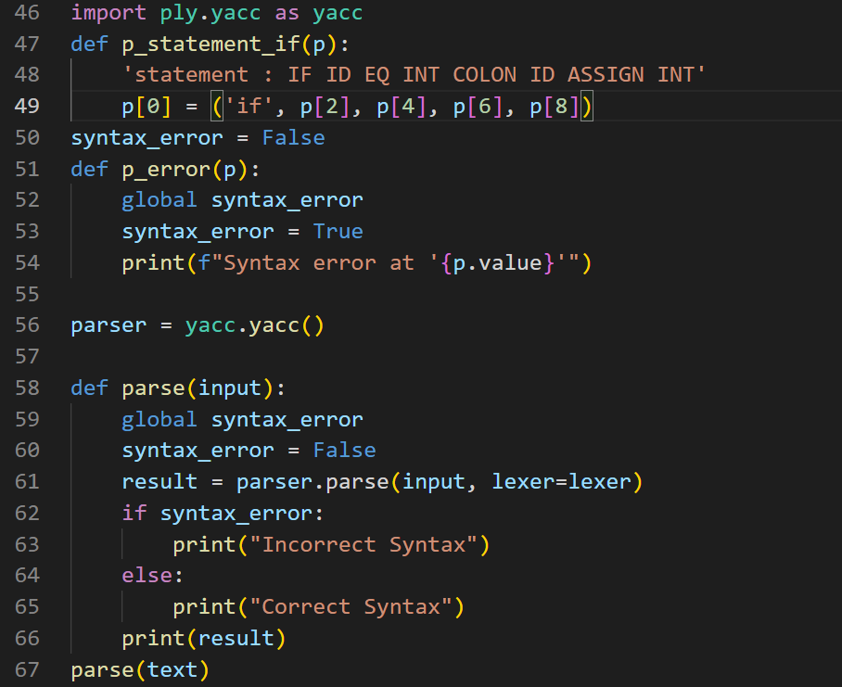

**CORRECT SYNTAX:**

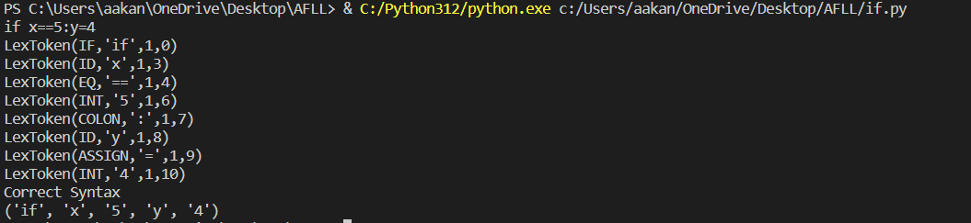

**INCORRECT SYNTAX:**

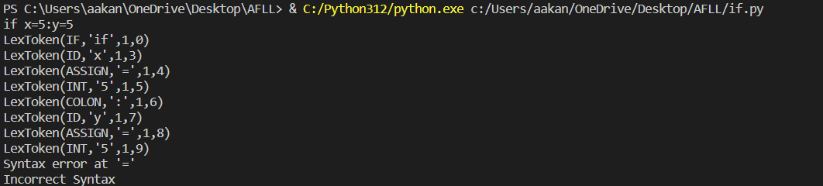

CONSTRUCT-3

**IF-ELSE**

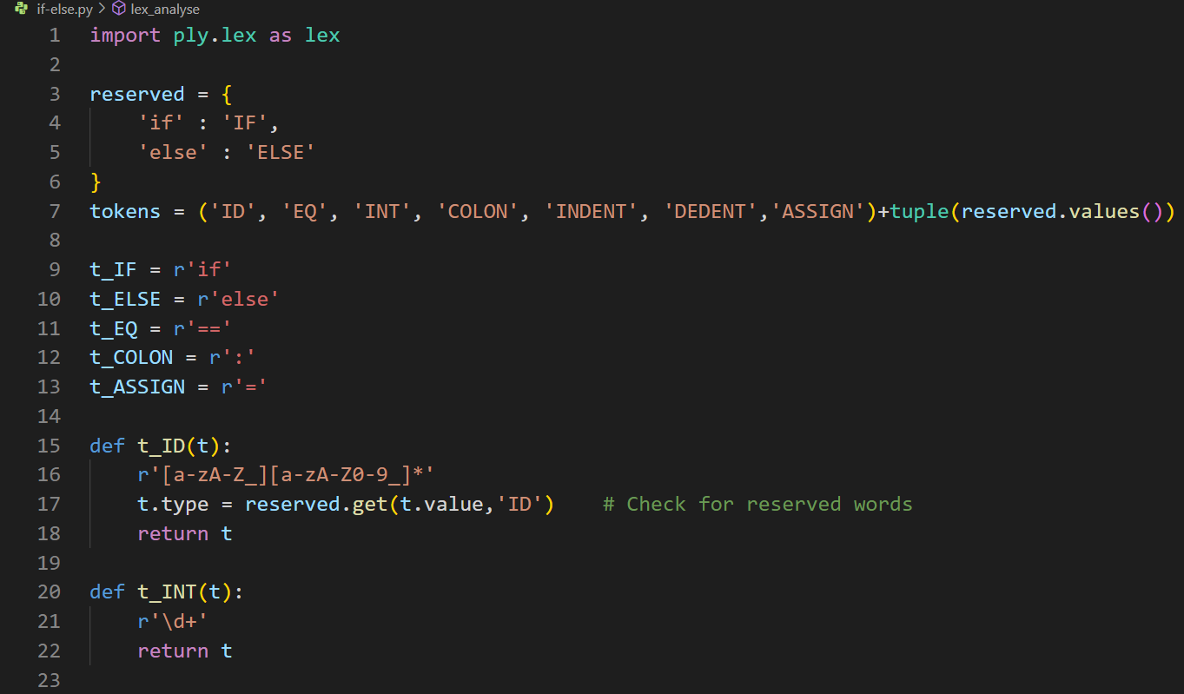

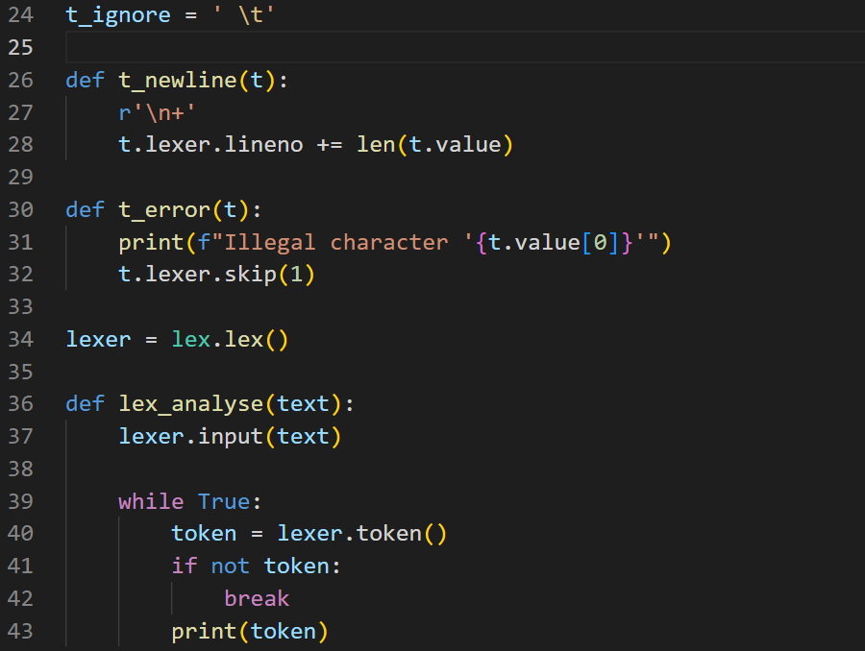

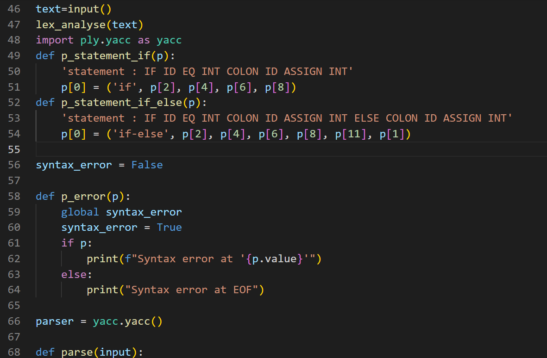

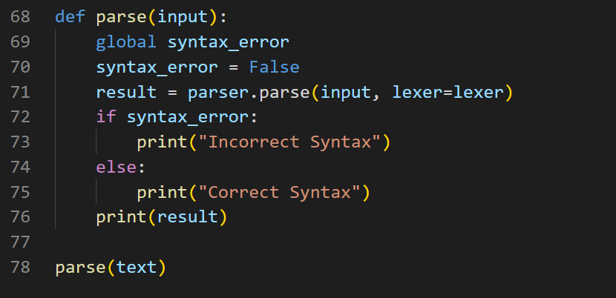

CORRECT SYNTAX:

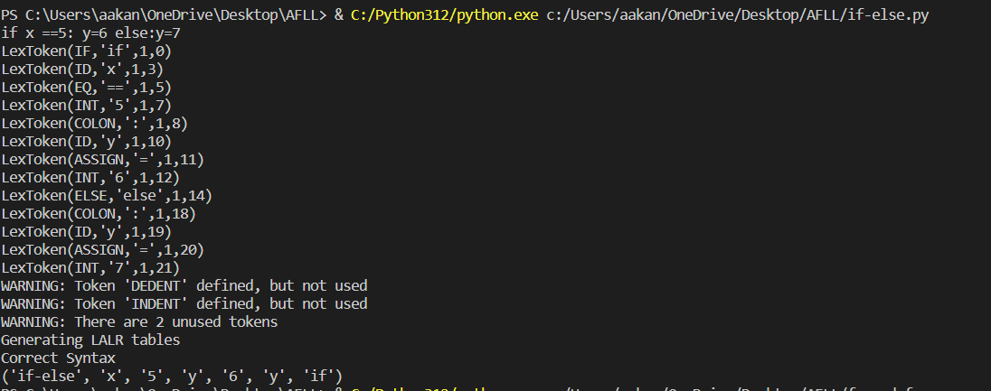

INCORRECT SYNTAX:

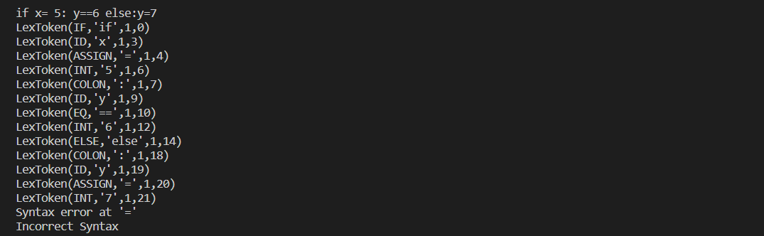

**CONSTRUCT-4**

**WHILE:**

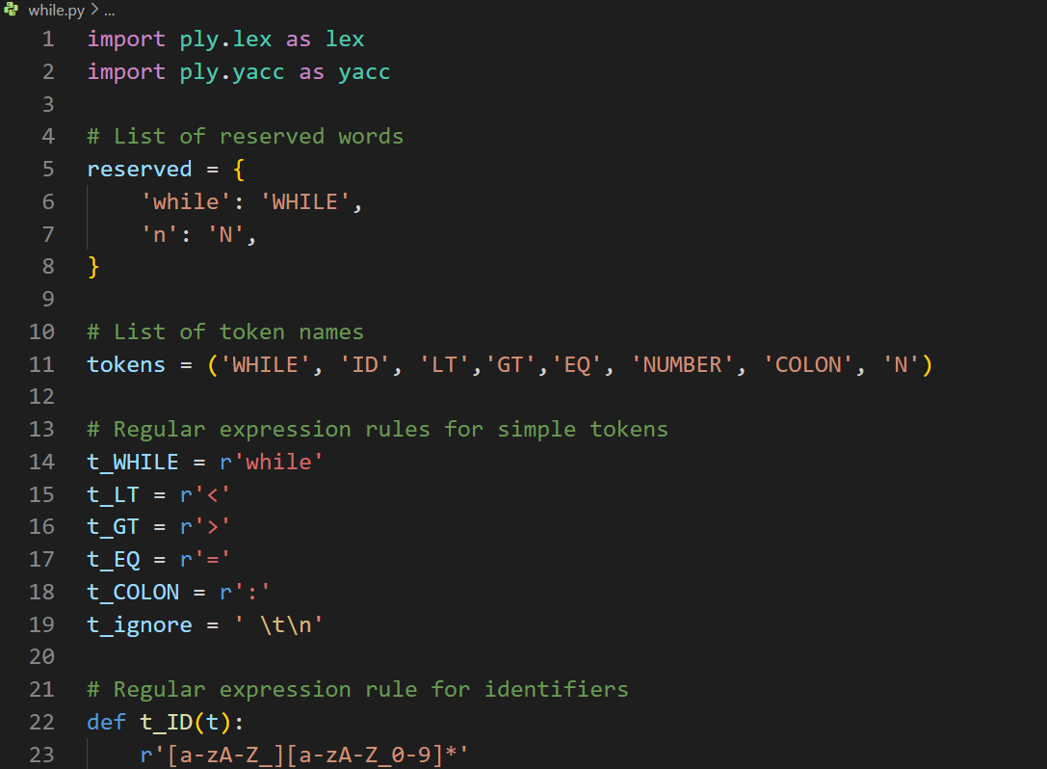

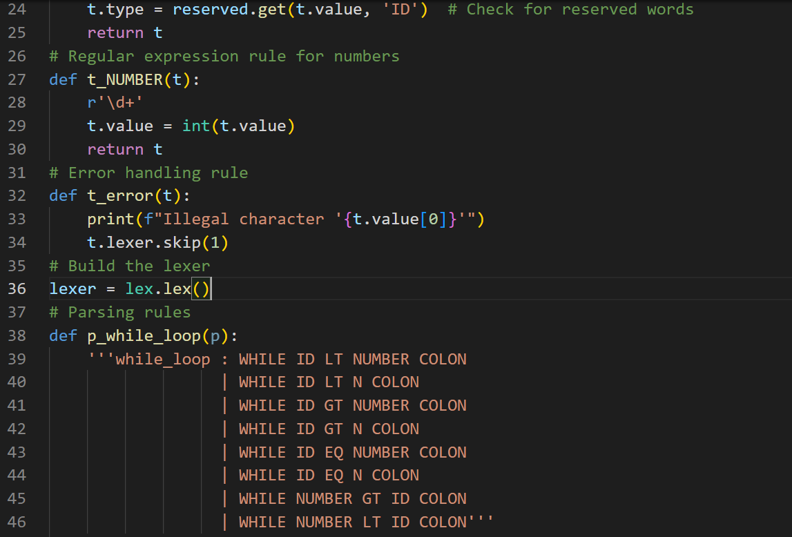

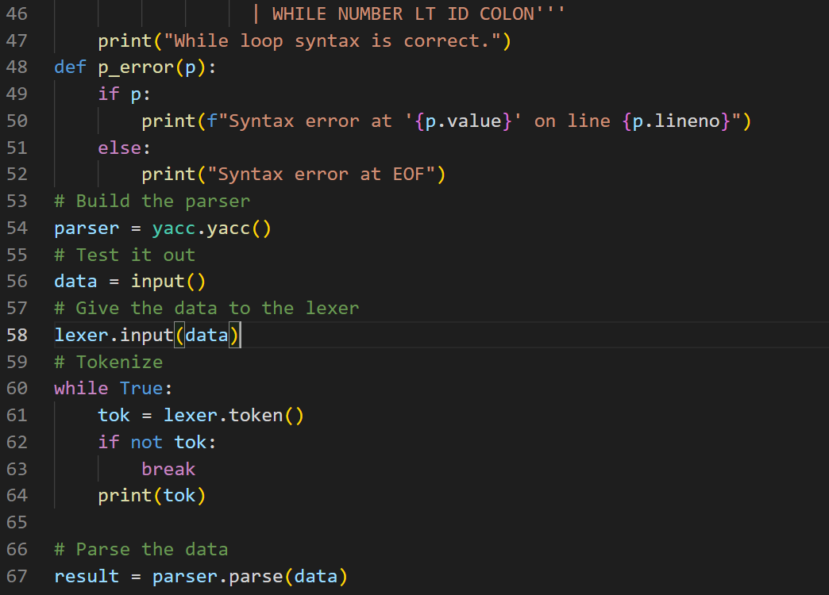

CORRECT SYNTAX:

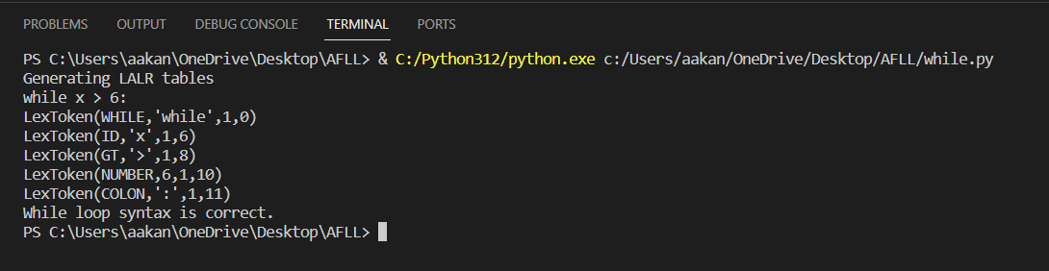

INCORRECT SYNTAX:

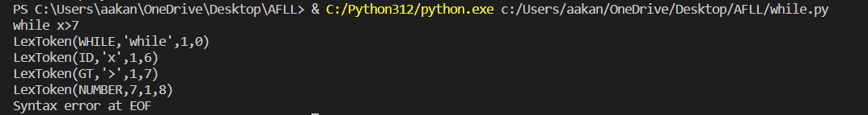

**CONSTRUCT-5:**

**FUNCTION-DEFINITION**

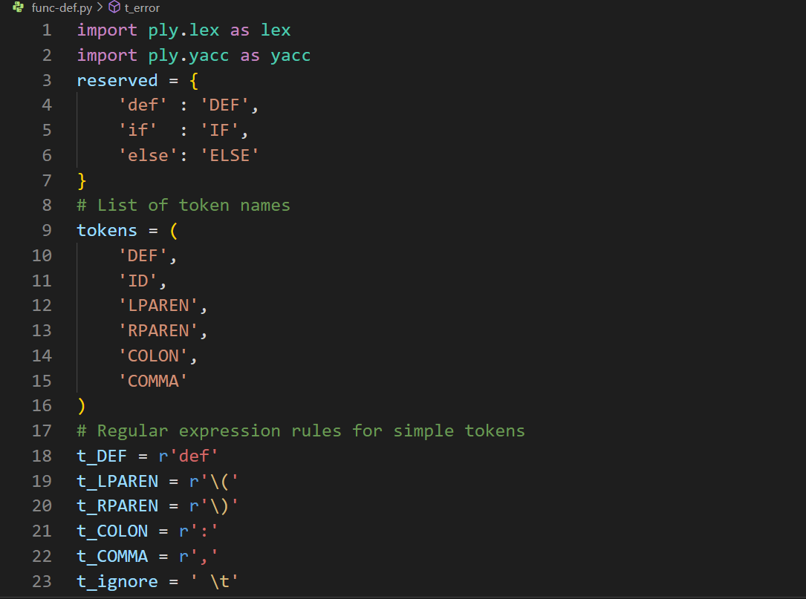

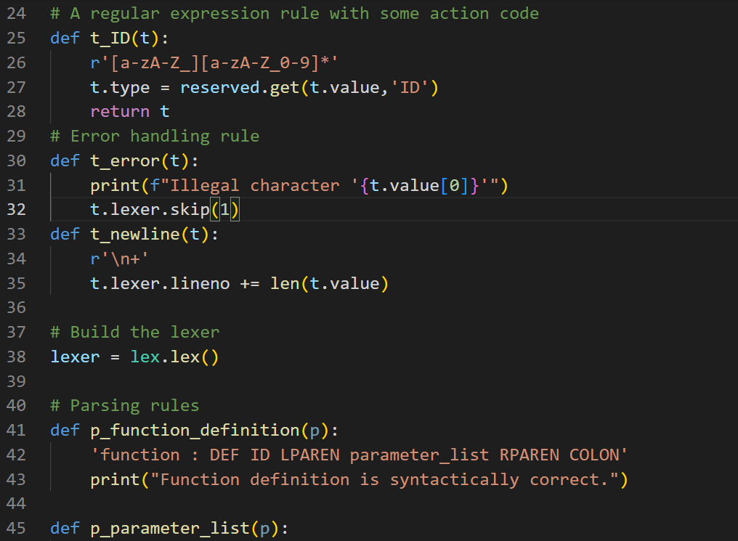

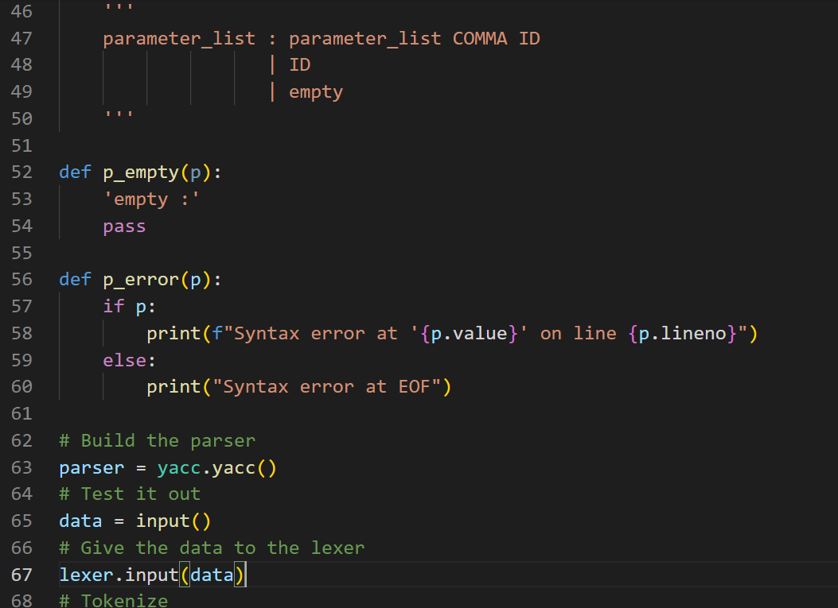

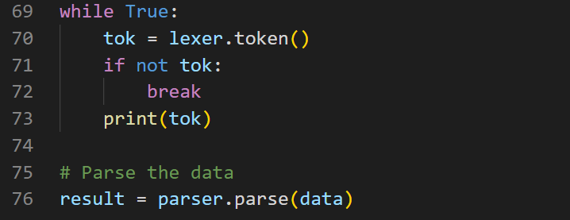

**CORRECT SYNTAX:**

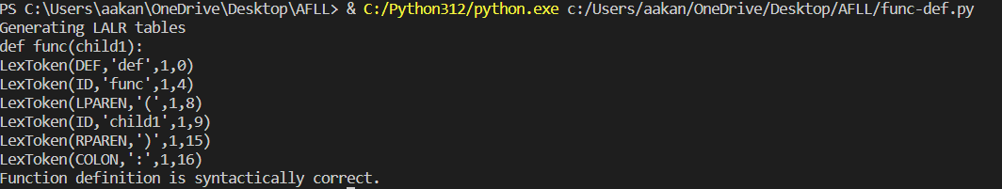

**INCORRECT SYNTAX:**

