| **Name: Abhinav Sankarshana Dasu** | **SRN: PES2UG22CS017** | **Section: A** |
| --- | --- | --- |
| **Date:09-10-2023** | **Unit 2 Assignment Exercise** |

## PROBLEM STATEMENT2 (for odd number SRNs):

## TASK 1

Q1) Write a code to get the output shown below using SVG

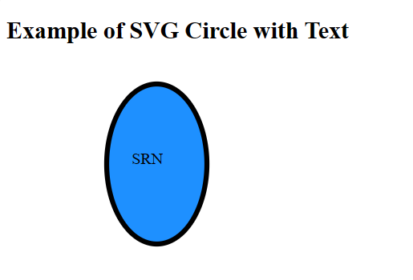

NOTE: Replace ‘’ SRN’’ with your srn.

Ans1)

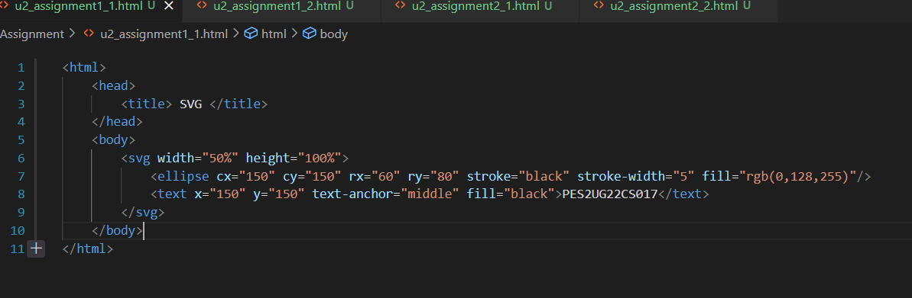

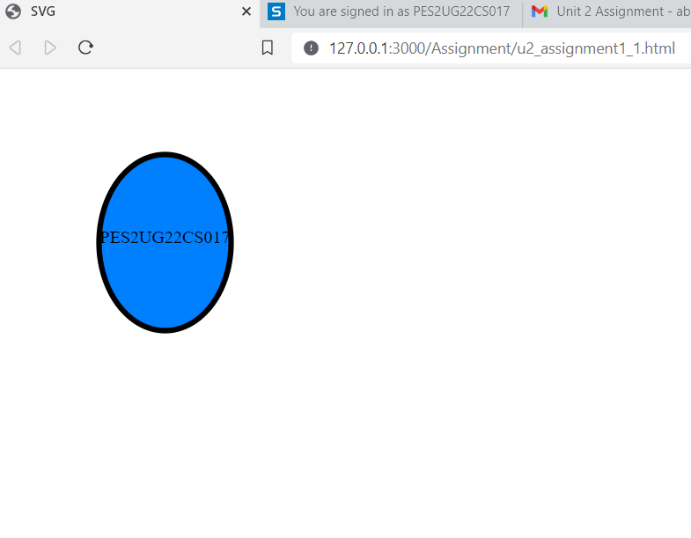

## Q2) Create a Div element which contains a header element for displaying “Halo 2 video game” and also a paragraph element for displaying “price $50.00”. Both header and paragraph elements are registered for click event.

## When the paragraph element is clicked, change the font color to red and increase the fontsize

## When the header element is clicked pop up an alert message saying “the discount sale is going to end” using addEventListener() Capturing phase.

Before onclick



## When the paragraph element is clicked

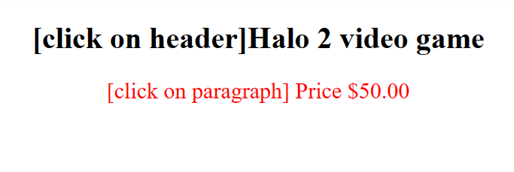

## When the header element is clicked

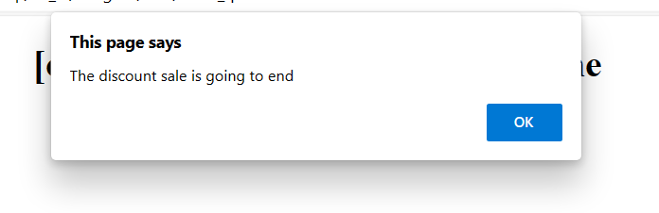

Ans2)

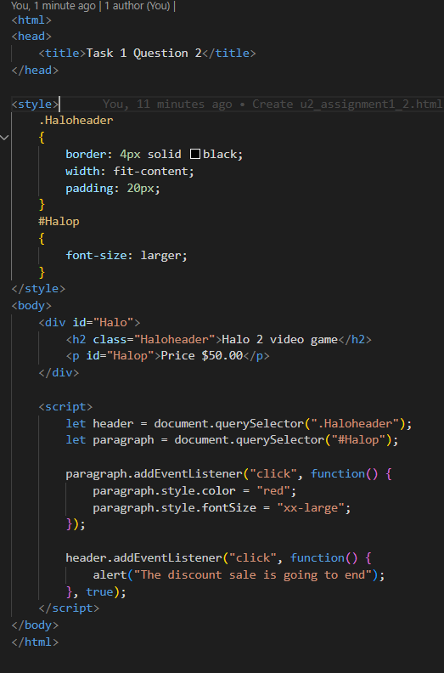

Before Onclick

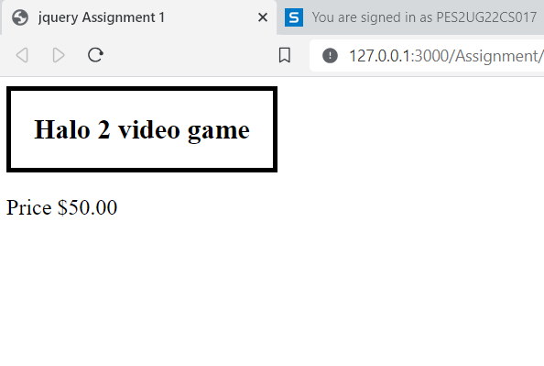

When Paragraph element is clicked

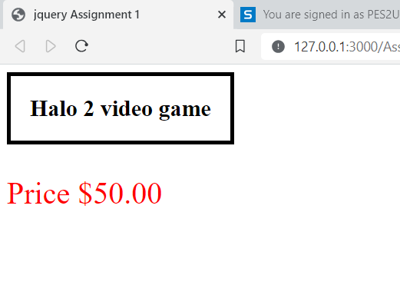

When Header element is clicked

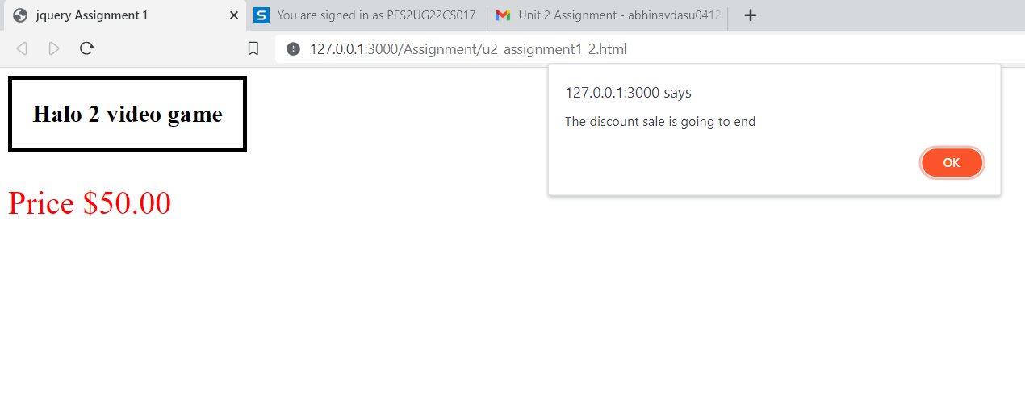

**TASK 2 : Write jQuery code to accomplish the following:**

Q1) Insert the html element **<b>"I love jQuery!!!" </b>**at the beginning of a p element.

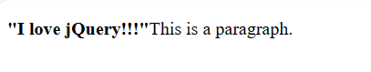

Ans1)

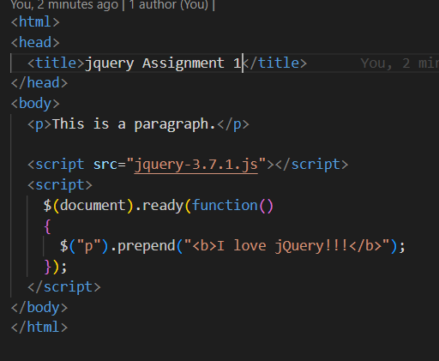

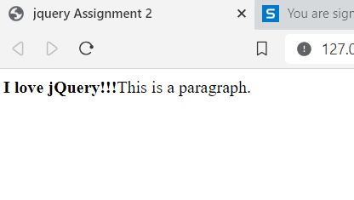

Q2) Create an HTML button with the text "Toggle Element." Include a hidden <div> element on the page. Initially, this <div> should be hidden using CSS (display: none;).Write jQuery code that, when the button is clicked, toggles the visibility of the hidden <div> element. Clicking the button should show the hidden <div> if it's hidden and hide it if it's visible.

Use fade-in and fade-out animations to make the toggling smooth and visually appealing.

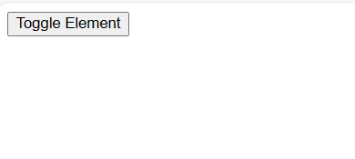

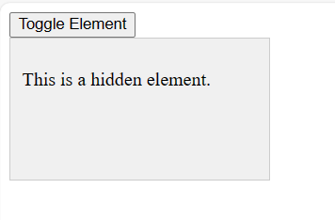

Ans2)

